|  |  |
| --- | --- |
| politecnico di torino | |
| Master’s degree in Computer Engineering | |
| Information Systems Project | |
| riequilibrium web agency | |
|  | |
| Students:  Franco Ruggeri, s265682  Enrico Loparco, s261072  Elia Migliore, s228279  Ndekoua Sandjo Jean Thibaut, s256770 | Professor:  Maurizio Morisio |
| accademic year 2018-2019 | |

# Contents

1 Organization 1

1.1 Organizational factors 1

1.2 Business Model Canvas 2

1.3 Critical Success Factors 2

1.4 AS IS 3

1.4.1 Organizational chart 3

1.4.2 Linear Responsibility Chart 3

1.5 TO BE 4

1.5.1 Improvements 4

1.5.2 Organizational chart 4

1.5.3 Linear Responsibility Chart 5

1.6 Process selection 5

2 Process 6

2.1 AS IS 6

2.1.1 BPMN 6

2.1.2 UML 7

2.2 TO BE 9

2.2.1 BPMN 9

2.2.2 UML 10

2.3 KPIs 11

2.4 IT technological model 13

2.5 Evaluation 13

2.5.1 TCO 13

2.5.2 ROI 13

3 Conclusion 15

# 

# Organization

## Organizational factors

Riequilibrium is a company based in Cuneo that provides a complete consulting on Web Marketing strategies, from *Search Engine Optimization* (SEO) to the creation of websites and ecommerce platforms optimized for mobile devices. In addition, it plans and realizes advertising campaigns on the most popular social networks and search engines. For further information, see https://www.riequilibrium.com.

The company is composed of 12 employees:

* 1 CEO
* 6 developers
* 1 secretary
* 1 marketing expert
* 2 accounting employees
* 1 credit recovery responsible

The physical resources include:

* Meeting room
* Developer rooms
* Accounting room
* Reception
* Server rooms
* 16 computers

The turnover of the last year has been about €550000.



## Business Model Canvas

External agency investment (dividend, percentage of gain, etc.)

Revenues from customers

Variable cost:

Consulting (external expert to handle peak of work)

Amazon web services (variable depending on the usage of the server)

Facilities cost (heat, electricity)

Fixed cost:

Facilities cost (cleaning service)

Computer rates

Employees salary + benefit (ticket restaurant, agency phone, etc.)

External web services (Internet services, hosting services)

Insurance

Niche market

Mass market (when there are not important clients)

Website

Meetup in conference (world conference of website)

Social network

Marketer

Appointment at office

Personal phone assistance at help desk

Mail customer dialog

Chatbox on website

Dedicated FAQ section on internal support area of the website

Provide personalized and near to the customer adaptable software

Help to automate operations

Help to develop public image of the Agency

Best quality high-end services

Physical: computers, servers

Software: Wordpress, Android Studio, XCode, Sublime Text, Filezilla, generic office tool (suite office, mail manager, accounting alert manager)

Humans resources: developers, project manager, accounting/managing people

Web development

App development

Content marketing

SEO

IT consulting

Customer service

Local partner synergy

Poland partner from International Automotive Business Meeting (IABM)

Gamma Computer for discount on new PCs

Vodafone Business Internet Provider

## Critical Success Factors

Considering the company strategy, the CSFs are:

* Customer satisfaction (referred in the following as CSF1).
* Reduction of the process cost (referred in the following as CSF2).
* Software quality (referred in the following as CSF3).
* Top skills of employees (referred in the following as CSF4).

## AS IS

### Organizational chart

The company has a mainly horizontal organization and the structure is functional because the employees are divided in groups depending on their responsibilities. Moreover, the employees are not specialized in a specific technology and there is a low level of formalization.

### Linear Responsibility Chart

|  |  |  |  |  |  |  |  |  |  |
| --- | --- | --- | --- | --- | --- | --- | --- | --- | --- |
| Processes | Organization’s structures | | | | | | | External actors | |
| CEO | Application development | Website development | Media marketing | Payment credits | Credit recovery | Administration | Customer | External consultant |
| Application development | P | P |  |  |  |  |  | C | P |
| Website development | P |  | P |  |  |  |  | C | P |
| Payment procedure | P |  |  |  | P |  | P |  |  |
| Customer service | P |  |  |  |  |  |  | C |  |
| Credit recovery |  |  |  |  |  | P |  |  |  |
| Marketing and advertising |  |  |  | P |  |  |  |  |  |

## TO BE

### Improvements in the organization view

Observing the LSR (see paragraph 1.4.2), it is clear that the CEO participates in too many processes and so there is an overload. As a consequence, in the AS IS situation, some customer requests have to be rejected for lack of time of the CEO and developers have a lot of downtime waiting for new projects.

The proposed improvement is to lighten the workload of the CEO by delegating some activities (see paragraph 1.5.5 and 2.2.1) and, in particular, by hiring a software analyst for the requirement analysis and the quality assurance. In this way, the CEO can focus on meeting with customers and on acquiring new ones and developers do not waste time. In addition to this, the requirements are understood better by a skilled person (software analyst), reducing misunderstandings.

### Improvements in the functional view (process)

To increase the customer satisfaction and reduce the cost of the process, a further activity is added to check if the customer is trusted (regular customer or agency with a good reputation). If so, the deployment starts without waiting for the initial payment (30%) with the result of increasing parallelism and reducing lead time (see paragraph 2.2.1).

### Improvements in the technological view

Another change involves the standardization of the bill generation according to the current law regulations (see section 2.5).

### Organizational chart

The modification with respect to the AS IS situation is the addition of the software analyst, a role dedicated to requirement analysis and quality assurance.

### Linear Responsibility Chart

|  |  |  |  |  |  |  |  |  |  |  |
| --- | --- | --- | --- | --- | --- | --- | --- | --- | --- | --- |
| Processes | Organization’s structures | | | | | | | | External actors | |
| CEO | Software analyst | Application development | Website development | Media marketing | Payment credits | Credit recovery | Administration | Customer | External consultant |
| Application development | C | P | P |  |  |  |  |  | C | P |
| Website development | C | P |  | P |  |  |  |  | C | P |
| Payment procedure | C |  |  |  |  | P |  | P |  |  |
| Customer service | P |  |  |  |  |  |  |  | C |  |
| Credit recovery |  |  |  |  |  |  | P |  |  |  |
| Marketing and advertising |  |  |  |  | P |  |  |  |  |  |

As you can see, some activities have been delegated to other people. As a result, the CEO participates in less processes and has more time for meeting customers and acquiring new ones.

## Process selection

Among the processes listed in the LRC (see paragraph 1.4.2), the development (app/website) process has been chosen for the analysis, considering its potential improvement. Notice that, despite the name, this process goes from the customer request to the delivery of the service. Also, the focus is not on the software lifecycle, since it is not objective of this course.

# Process

## AS IS

### BPMN

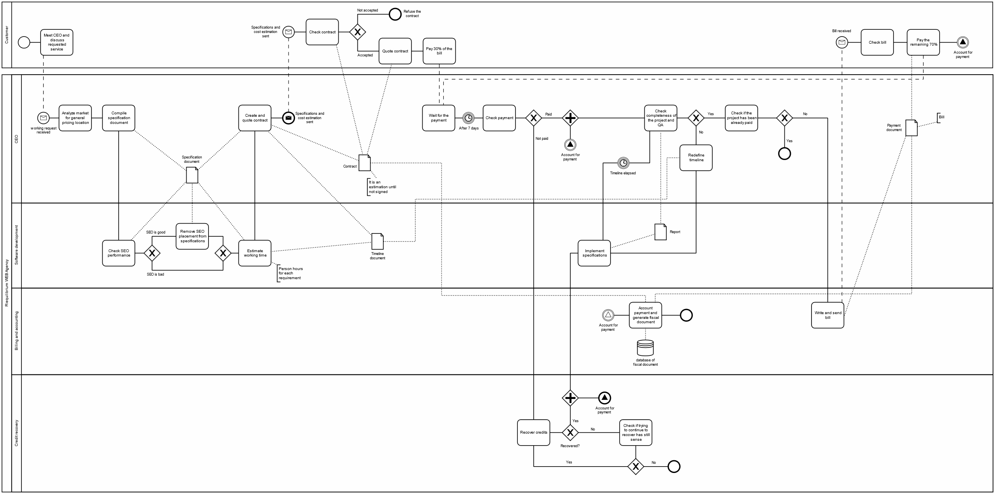

### UML

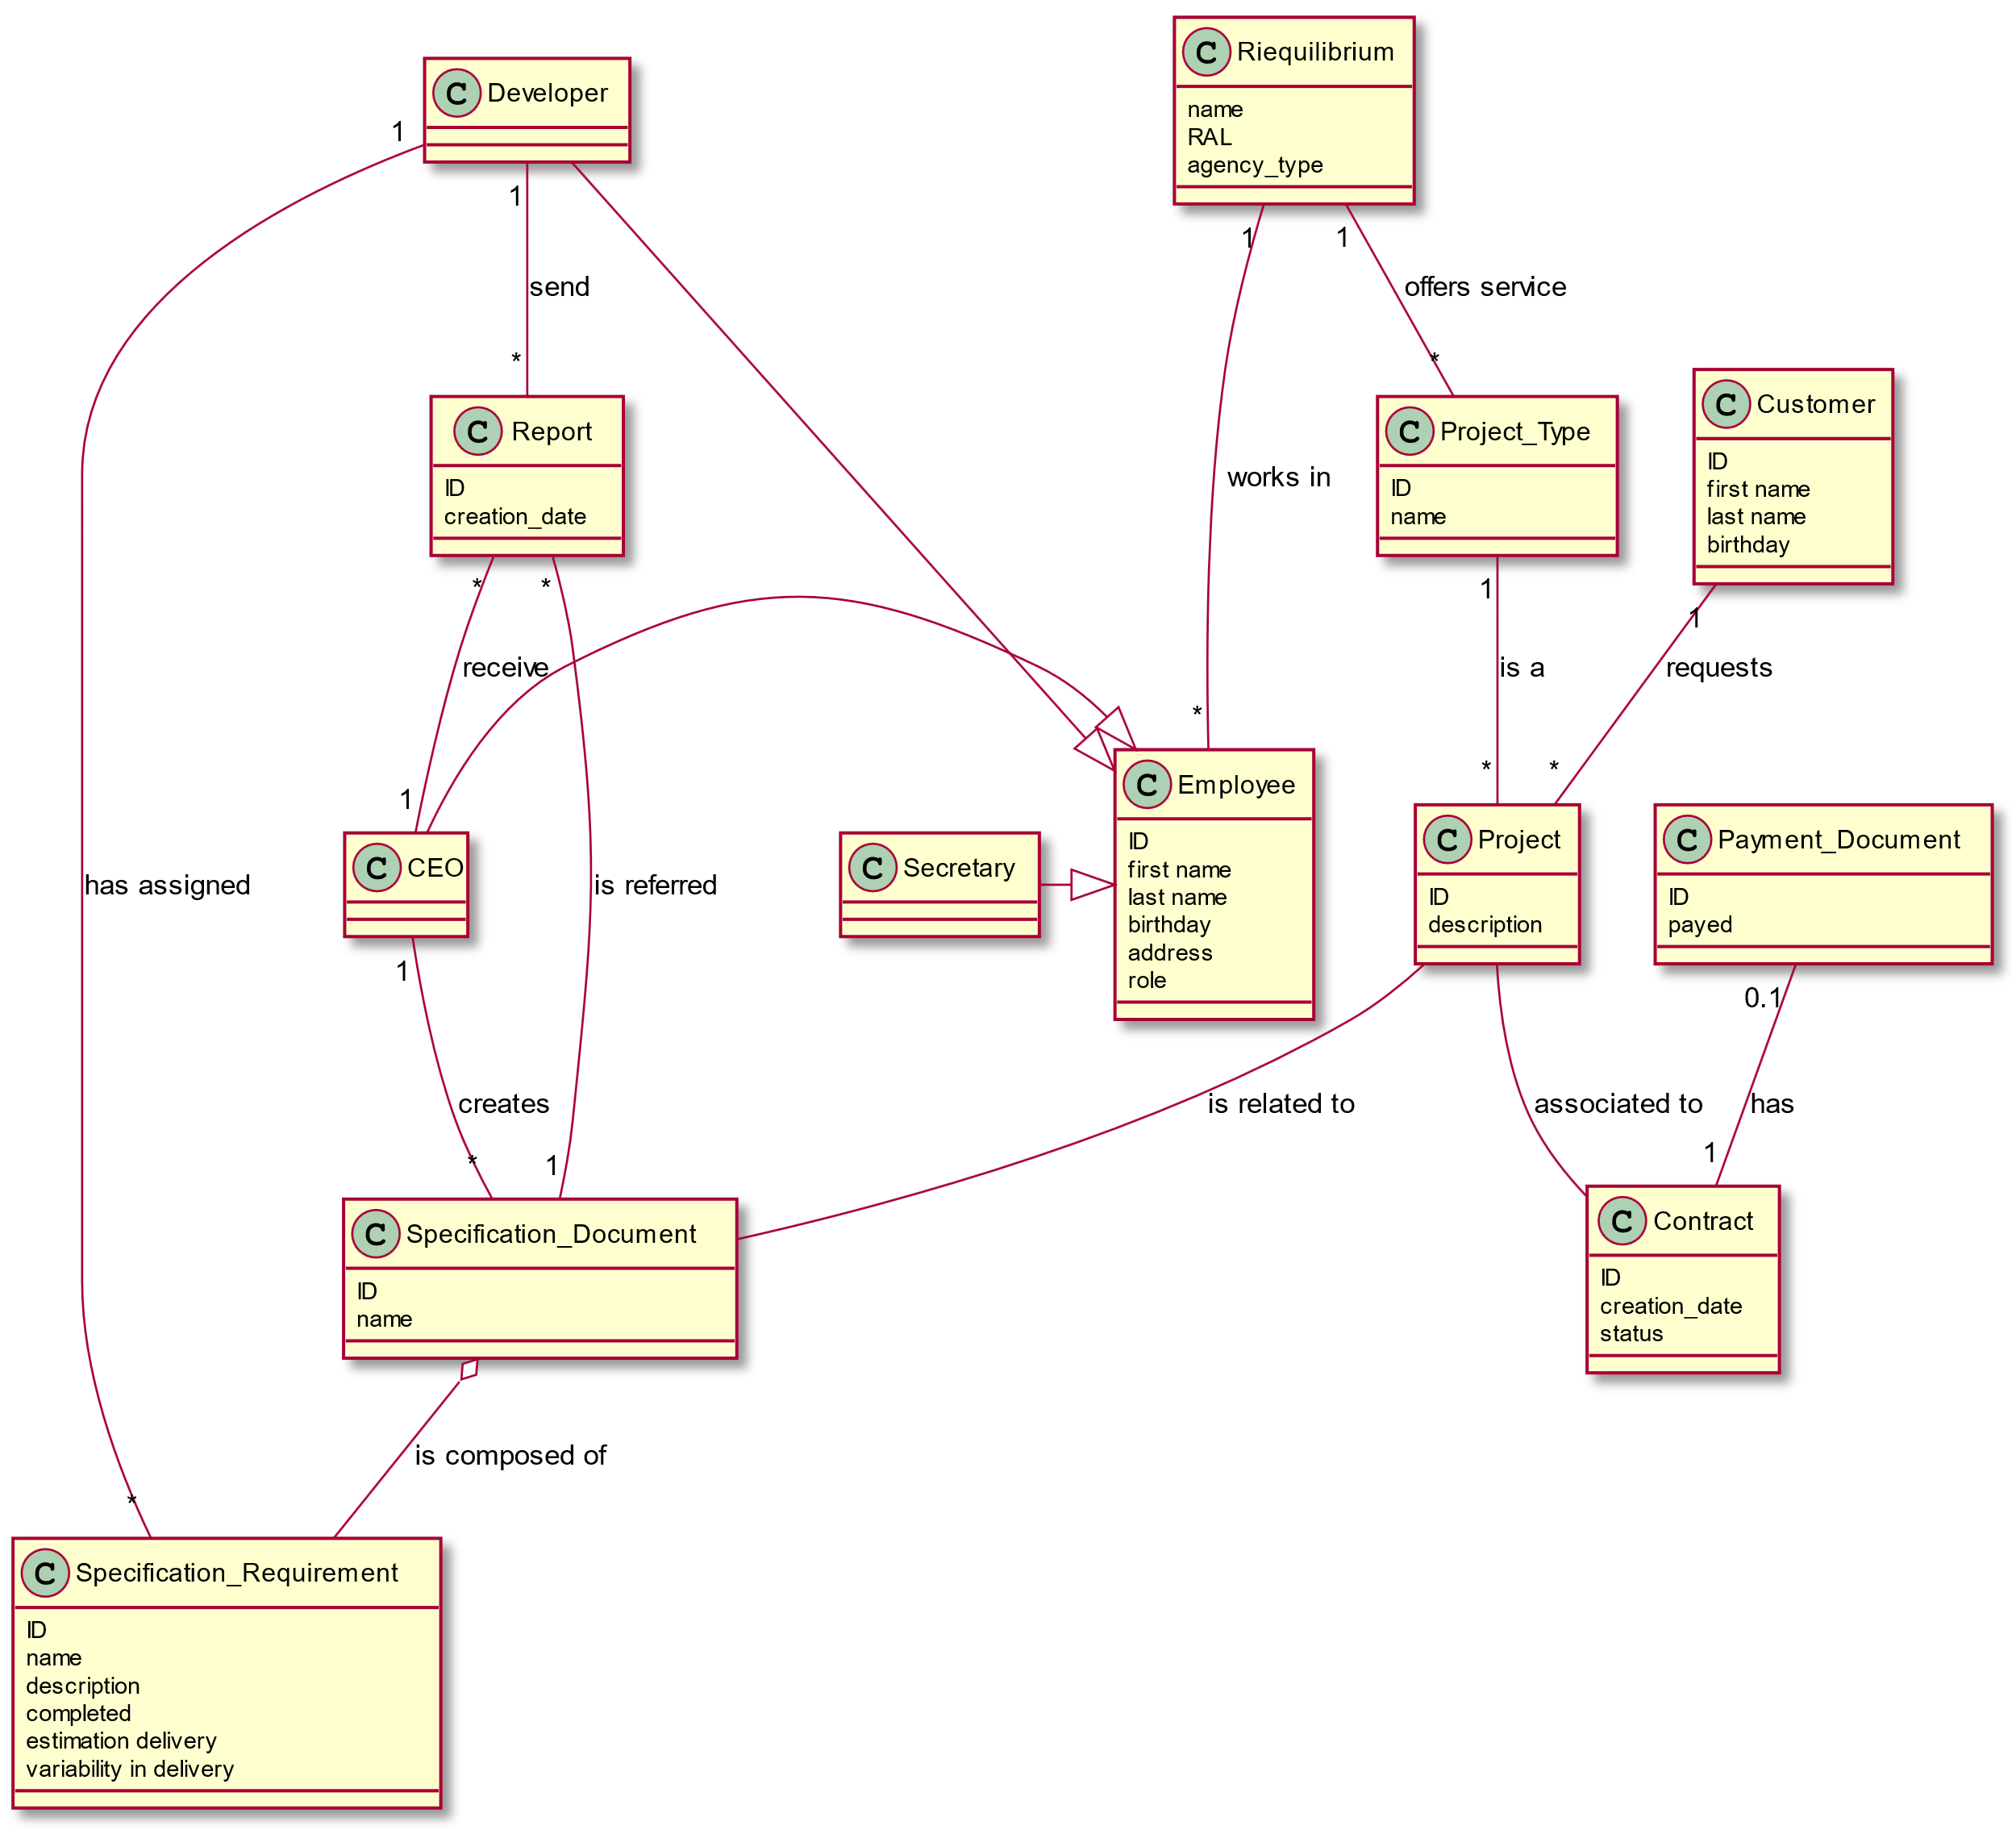

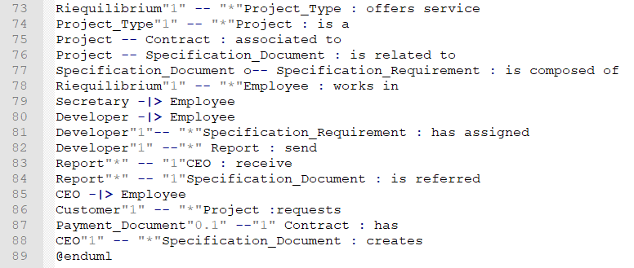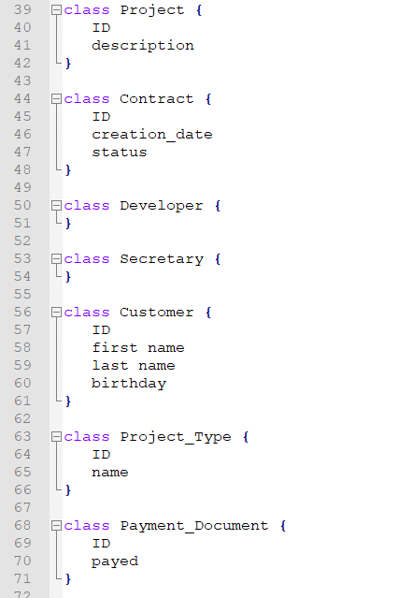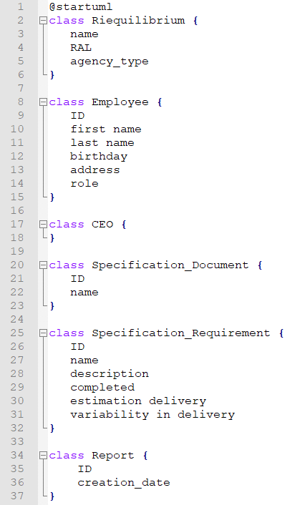

Figure 1: Code to generate UML

## TO BE

### BPMN

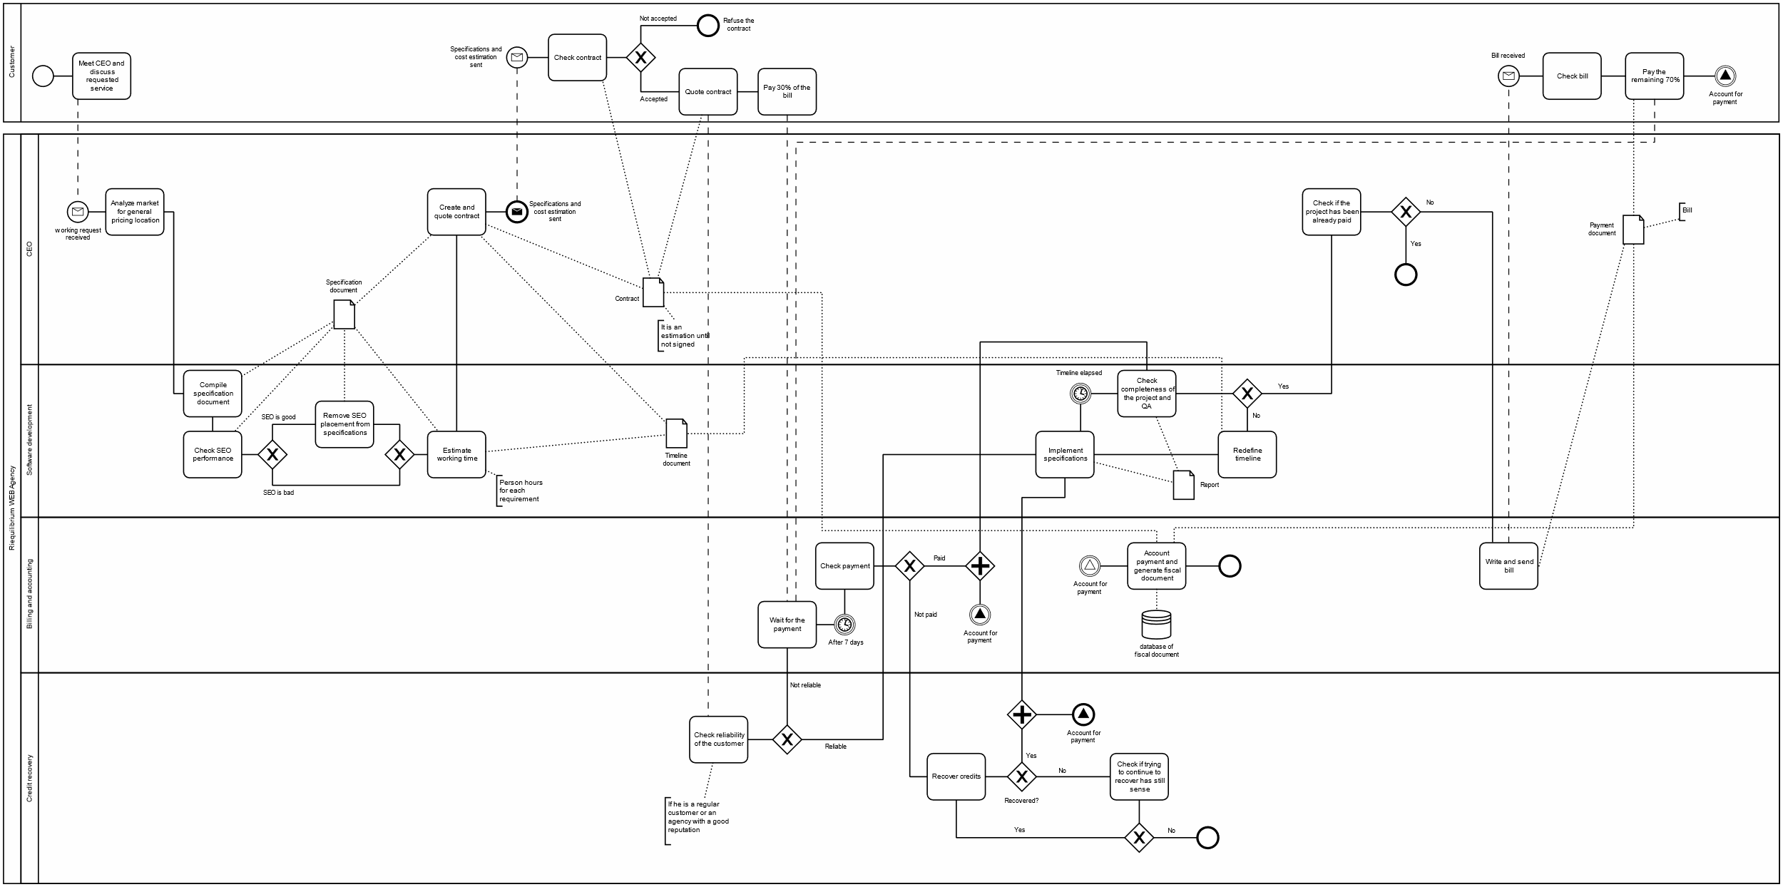

Some activities have been moved from the CEO to other people (delegated) and the customer reliability check is introduced.

### UML

You can notice that a new class Software_Analyst has been added.

## KPIs

|  |  |  |  |  |
| --- | --- | --- | --- | --- |
| CSF | KPI | | | |
|  | Category | Description | | Unit of measure |
|  | GENERAL | Input volume | # service requests  # customer |  |
|  | Output volume | # services accepted |  |
|  | Human resources | # full-time employees  # part-time employees |  |
|  | Non-human resources | Documents (specification document, timeline documents, software report, contract)  # Computer and supplies |  |
| CSF2 | EFFICIENCY | Cost per unit | Total cost / # services accepted  Total cost = salary of employees + infrastructure and resources | Euros (€) |
| CSF2  CSF4 | Productivity (volume/resource) | # services accepted / # employees |  |
| CSF2  CSF3  CSF4 | Utilization | # effective hours  worked / total payed hours |  |
| CSF1  CSF2  CSF3 | QUALITY | Conformity | # services with defects / # services delivered  Defects caused by incomplete/wrong requirements |  |
| CSF1 | Customer satisfaction | Complaints/feedback from customers (website/call center) |  |
| CSF1 | SERVICE | Lead time | Time from customer request to service delivered | Days or months |
| CSF1 | Flexibility | # changes in requirements from customers / # total requirements |  |

|  |  |  |  |
| --- | --- | --- | --- |
| KPI | | AS IS | TO BE |
| Category | Description |  |  |
| GENERAL | # service requests  # customers |  | May increase because the customer satisfaction rises and the CEO has more time dedicated to find/meet customers. |
| # services accepted |  | Increases because the work is more distributed among different employees. |
| # full-time employees  # part-time employees |  | Number of full-time employees increases (new software analyst). |
| Documents (specification document, timeline documents, software report, contract)  # computer and supplies |  | No changes. |
| EFFICIENCY | Total cost / # services accepted  Total cost = salary of employees + infrastructure and resources |  | Total cost increases because of new employee and software changes (see paragraph 2.5), but also the number of services accepted increases. Overall, the cost per service decreases. |
| # services accepted / # employees |  | Increased, no overload because the employees have less wasted time. |
| # effective hours worked / total payed hours |  | Improved, less wasted time. |
| QUALITY | # services with defects / # services delivered  defects caused by incomplete/wrong requirements |  | Improved because the requirement analysis and the QA are done by the software analyst (skilled). |
| complaints/feedbacks from customers (website/call center) |  | Almost the same. |
| SERVICE | Lead time (from customer request to service delivered) |  | Slightly improved because the response time between the appointment request and the meeting date is reduced. |
| # changes in requirements from customers / # total requirements |  | No changes. |

## IT technological model

The used architecture is 2-tiers client-server:

* The server hosts the administrative website, the APIs and the database containing the core information about applications and employees.
* Clients interact with it through a browser.

## Evaluation

### TCO

The development of the website extension module for electronic billing is done internally because, beyond using it inside the company, the purpose is to sell it as a service to customers (as a plug-in inserted in e-commerce to autogenerate the bill without manual interaction). In addition to this, it treats sensible data and it is an upgrade of a legacy software developed in the same agency (most of the code was already written, so the cost of extending it is lower than outsourcing).

|  |  |
| --- | --- |
| Phase | Cost |
| Construction | Requirement, design and development of the extension of the existing IT application |
| Deployment | Deployment of the application, training of employees |
| Operation + maintenance | Hardware infrastructure operation and maintenance, application operation and maintenance |
| Dismissal | Uninstall and data porting to new application |

### ROI

Internal management software:

|  |  |  |  |  |  |
| --- | --- | --- | --- | --- | --- |
| Year / cost or saving | Year 1 | Year 2 | Year 3 | Year 4 | Year 5 |
| Cost | C + D |  |  |  |  |
| Cost | O + M | O + M | O + M | O + M | O + M + D |
| Saving | S | S | S | S | S |

Assuming dismissal after 5 year:

* # hours required to develop: ~300
* total cost = average salary per house (gross) * # hours
* income = average income per project * # projects
* saving = income – total cost

Unfortunately, it is extremely difficult to estimate the saving due to the high range of variation on number of projects and employee salary (external consultants) in a middle-sized company. The only factor easy to evaluate is the number of hours required to develop the module.

# Conclusion

Considering the saving defined in the paragraph 2.5.2, we can suppose that it will have a negative value in the first year (the agency cannot recover all the money spent for the website plugin and for hiring the software analysis). However, starting from the second or, in the worst case, the third year, the significant increase in the number of accepted projects influences the income making the saving positive.

In addition to this, since the lead time is reduced and the conformity is increased thanks to the introduction of a software analyst, the customer satisfaction is improved.

Overall, the investment is surely worth.