PROJECT TITLE: SMART WATER SYSTEM

Project Definition:

The aim of this project is to manage and plan the usage of water using IoT. This system can be easily installed inresidential societies. Water level measurement is very important in some water related fields

Smart Water Monitoring and Management Systems, based on the combination of sensors, big data and AI technologies, can provide to water utility operators, farmers and companies the ability to measure, monitor and control their water distribution networks as well as the quality of the water distributed..

Design Thinking:

Water Sensors : A water sensor is a transducer system which is essentially contact based sensor which measures the measurable such as presence of water in pipe and discharge, velocity & entropy using Active and Passive Water Sensor respectively.

Objectives:

A smart water management system for agriculture using IoT can improve crop fields providing farmers with the oversight they need to avoid water waste. Sensors monitor multiple parameters, like temperature, humidity, and soil moisture to calculate how much water crops need.

**water quality sensors:**

* PH Sensor.
* Conductivity Sensor.
* Residual Chlorine Sensor.
* Turbidity Sensor.
* Dissolved Oxygen Sensor.
* ORP Sensor.
* COD Sensor.
* Ammonia Nitrogen Ion Sensor.

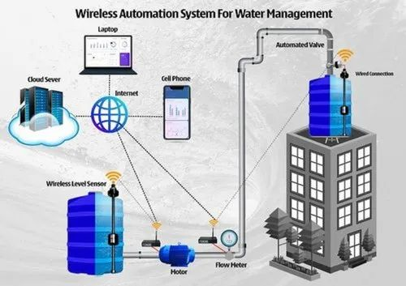

* Instrumented: the ability to detect, sense, measure, and record data.
* Interconnected: the ability to communicate and interact with system operators and managers.
* Intelligent: the ability to analyze the situation, enable quick responses, and optimize troubleshooting solutions.