Abstract :

Water is one of the fundamental resources that aid life and there are speculations that estimate at 2025 almost half of the urban population will live under short supply and water stress. With the usage of new technological advancements in IoT (Internet of Things) powered smart devices for water management, it can become a worthy implementation towards avoiding the predicted water depletion. In the past years up until recently, water monitoring and management were manually carried out with intensive power requirements and high capital expense with low efficiency recorded. Overflow take so long to discover. The proposed model addresses problems mentioned above by the application of portable smart systems with interoperability and easily configurable to handle automated management of water supply with energy efficiency and a reduction in power cost in both homes and enterprise environment within smart cities as well as reduction of the rate of building degradation as a result of overflow from overhead tanks. Our model also integrates the application of Natural Language Processing for speech recognition as an alternate medium useful

in operating the system.

Introduction:

Overflowing tanks and reservoirs are arguably amongst the biggest cause of water wastage

across urban and rural areas. Often time results from forgetful control of the pump switches and

the absence of timely human presence to turn off the running

begins to overflow. Thus the need to proffer cost-effective smart automated systems for water management. A lot of buildings

degrade over a short period due to consistent overflow of high rise tanks and reservoirs. Other than the overall worries of freshwater shortage for a household reason, there are rising

worries for the shortage of water for agrarian purposes.To handle the difficulties of water shortage, Smart water management and automation can greatly address the water crisis by

eliminating endless running of pumping motors even after water tanks are filled to maximum.

Hardware and Software Requirements :

A laser sensor of VL53LOX for precise water level indication in storage tanks can be utilized. This type of sensor can sense the water level in real-time and with an attached HC12 transmitter for data transfer to the cloud platform. Components within the transmitter can comprise of an Arduino and NodeMcu utilizing low

power and transmitting data using any of the wireless technology such as Zigbee, Low Power Wide Area Networks (LPWANs), RFID or Wi-Fi / Wi-Fi HaLow. The use of such transmitters combined can enable automated water level detection and system controlled refilling of water storage tanks.

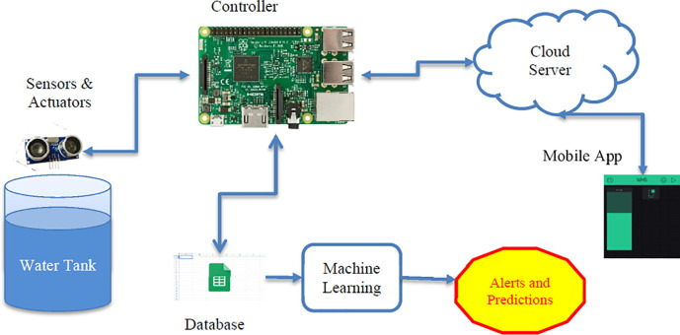

Program:

"python

￼Copy code

import RPi.GPIO as GPIO

import time

# GPIO pins

PUMP_PIN = 17

WATER_SENSOR_PIN = 18

# Set up GPIO

GPIO.setmode(GPIO.BCM)

GPIO.setup(PUMP_PIN, GPIO.OUT)

GPIO.setup(WATER_SENSOR_PIN, GPIO.IN)

def turn_on_pump():

GPIO.output(PUMP_PIN, GPIO.HIGH)

def turn_off_pump():

GPIO.output(PUMP_PIN, GPIO.LOW)

def is_water_level_low():

return GPIO.input(WATER_SENSOR_PIN) == GPIO.LOW

try:

while True:

if is_water_level_low():

turn_on_pump()

print("Water level low - Pumping water.")

else:

turn_off_pump()

print("Water level normal - Pump turned off.")

time.sleep(5) # Check water level every 5 seconds

except KeyboardInterrupt:

print("Program terminated by user.")

GPIO.cleanup()"

<https://chat.openai.com/c/3bedae6c-5e56-4d3e-9dd5-ab19347e3a42#:~:text=Python%20Code%3A-,python,seconds%0A%0Aexcept%20KeyboardInterrupt%3A%0A%20%20%20%20print(%22Program%20terminated%20by%20user.%22)%0A%20%20%20%20GPIO.cleanup(),-Explanation%3A>

Conclusion and future scope

Achieved:.

We proposed a flexible, economical, easily configurable portable system for water management and wastage reduction. The implementation described above can be expanded to smart agricultural processes of watering plants and gardens. In present days liquid level monitoring is essential in oil sectors, automotive, and many others. The proposed solution can automate the process of liquid detection and optimum management as well as use analytics with insights for detecting leakages, vandalism, or any form of damages along supply tracks. A high percentage of wastage can be greatly reduced and accurate billing reading for the used resource can be achieved. In the future, we look forward to integrating speech recognition using the Adafruit IO web interface. This will extend the remote activation or deactivation of the motor using voice commands.