Lecture 3 - Simulation methods

Patrick Waelbroeck

November 2004

Introduction
Many problems in economics and econometrics are difficult to treat analytically or by using traditional numerical methods. Three applications of simulation tools. First, simulation methods make it possible to optimize mathematical functions of irregular form, where other optimization methods would do not converge. Secondly, simulations methods allow the fast evaluation of integrals. For example, in the models with discrete choices, the estimators of the maximum of probability requires the effective evaluation of multiple integrals of the multivariate Gaussian density. Finally, Bayesian inference often requires the evaluation of the distribution a posteriori parameters of interests. This one is often impossible to calculate analytically, but can be expressed in the form of integral which one can again evaluate numerically by simulation.

Basic simulation tools
All the methods in a form or another try to obtain a sample x⁽¹⁾, ..., x^{(T)} of observations of a random variable x of density f(x) and of c.d.f. F(x) for a given sample size T.

Inverse cdf or probability transform

Algorithm 1

for t from 1 to T do
draw u a uniformly distributed random number between 0 and 1
x_{t} ← F⁻¹(u)
end for
■

It is easy to check that this algorithm works by writing:

p(x ≤ y) = p(F⁻¹(u) ≤ y) = p(u ≤ F(y)) = F(y)

Example
To obtain a random number from the standard normal distribution truncated in the interval [a, b], a < b, we can use the inverse cdf method by noticing that F(x) = [Φ(x) – Φ(a)] / [Φ(b) – Φ(a)] if Φ(x) denotes the density of the standard normal law evaluated at x. Thus F⁻¹(x) = Φ⁻¹(x [Φ(b) – Φ(a)] + Φ(a)). This method is however not efficient. It is better to use Robert (1995) algorithm.

Rejection method
It is often difficult to obtain the analytical form of the probability distribution. The rejection method makes it possible to draw from density f provided that it is possible to draw form g(x) such that g(x) > f(x) for all x.

Algorithm 2
t = 1
while t <= T do
draw y from g
draw u fro U(0; 1)
if u < f(y) / g(y)
x_{t} ← y
t ← t+1
end if
end while
■

It is easy to check how the method works.

p(x) = p(y=x, accept y)
= p(accept y | y = x) p(y = x)
= {f(x) / [g(x)]} g(x)
= f(x)

MCMC

When one works with vectors of size higher than 2 and when the density functions have irregular shapes, iterative simulation methods are more powerful. These methods are often used in Bayesian statistics where one needs to evaluate complex high order integrals. The idea is to simulate a Markov chain whose stationary distribution is the target distribution

Let f(x) be the target distribution, which one wishes to simulate. Let q(y | x) be the transition (possible vector) density. Let x₀ be an arbitrary starting point.

Algorithme 3 (Metropolis-Hasting)
t ← 0
Repeat
t ← t + 1
Given x_{t}, draw y_{t} from q(y_{t} |x_{t})
draw u from U(0; 1)
if u < ρ_{t} = min {1, [f(y_{t}) / f(x_{t})] / [q(y_{t} | x_{t}) / q(x_{t} | y_{t})]}
x_{t+1} ← y_{t}
else x_{t+1} ← x_{t}
if convergence exit repeat loop
end repeat
■

The denominator of the ratio ρ_{t} is the joint law of x_{t} and y_{t}, while the numerator is the joint law of the reverse chain. This last expression can be also seen like the ratio of the densities [f(y_{t}) / f(x_{t})] corrected by the factor [q(y_{t} | x_{t}) / q(x_{t} | y_{t})].

Interpretation: Let us suppose that q(y_{t} | x_{t}) = q(x_{t} | y_{t}). Then ρ_{t} = Min {1, f(y_{t}) / f(x_{t})}. Thus,

if f(y_{t}) > f(x_{t}): we always accept y_{t}
if f(y_{t}) ≈ 0: we reject y_{t}
if f(y_{t}) < f(x_{t}): we sometimes accept y_{t}.

The method can thus be interpreted as a stochastic optimization algorithm that always accepts draws that maximize f(⋅) but that accepts unfavorable draws from time to time. n

Idea of the proof:

(Step 1) Show that the simulated sequence converges to a unique stationary distribution. This holds as long as the Markov chain in irreducible, aperiodic and not transient. [Note that the chain is irreducible if the chain a strictly positive probability to reach any state from any other state]. This is especially true if the Gibbs algorithm has strictly positive conditional transition distribution. Weaker conditions are provided by mixing and other ergodic conditions. See Mayne and Tweedie (199?) and Kemeny and Snell (196?)

(step 2) Show that the stationary distribution is the target distribution (for the symmetric case). Show that for f(y_{t}) > f(x_{t}) conditionally on the fact that x is drawn form the target distribution f(x): p(x_{t+1} = y, x_{t} = x) = p(x_{t+1} = x, x_{t} = y):

p(x_{t+1} = y, x_{t} = x) = q(y | x) f(x)
p(x_{t+1} = x, x_{t} = y) = q(x | y) f(y) f(x)/f(y) = q(y | x) f(x)

by symmetry of q(. | .). Thus the stationary is symmetric and the marginal distribution are the same and thus the target distribution is f(x).

Remarks:
Firstly, the method is correct if certain conditions on the Markov chain generated are respected and if the support of q(⋅ | ⋅) includes the support of f(⋅).

Secondly, even if the convergence of the Markov chain is guaranteed, it remains to check the speed of convergence. It will be necessary for each case to control that the Markov chains has indeed converged towards its stationary distribution.

Thirdly, it is not optimal to have a too high rate of acceptance. Indeed, if this rate is very close to 1 then the method always accepts favorable movements which are concentrated around the modes. The chain does not have many opportunities to visit the tails of distribution. Therefore, the speed of convergence is likely to be slow.

Special case: The Gibbs sampler
The Gibbs sampler is a particular type MCMC of algorithm, which always accepts simulated draws and exclusively uses conditional probabilities. Let f(x) = f(x₁, x₂, …, x_{p}) denote the target distribution and assume we know

x₁ | (x₂, …, x_{p}) ∼ f₁,
…,
x_{p} | (x₁, …, x_{p−1}) ∼ f_{p}.

The algorithm proceeds in the following way. Conditionally on x^{t}, the algorithm draws x₁^{t+1} | (x₂^{t}, …, x_{p}^{t}), …, x_{p}^{t+1} | (x₁^{t+1}, …, x_{p−1}^{t+1}). This corresponds to a stochastic optimization one direction at a time. The algorithm works when the support of f(⋅) = X_{i} support of f_{i}(⋅).

Algorithme 4 (Gibbs)
Initialize x⁽⁰⁾
t ← 0
Repeat T times
t ← t + 1
draw x_{1,t+1} from f(x₁ | x_{2,t}, ..., x_{p,t})
draw x_{1,t+1} from f(x₂ | x_{1,t+1}, x_{3,t}, ..., x_{p,t})
...
draw x_{p,t+1} fro, f(x_{p} | x_{1,t+1}, ..., x_{p−1,t+1})
end repeat
■

Illustration
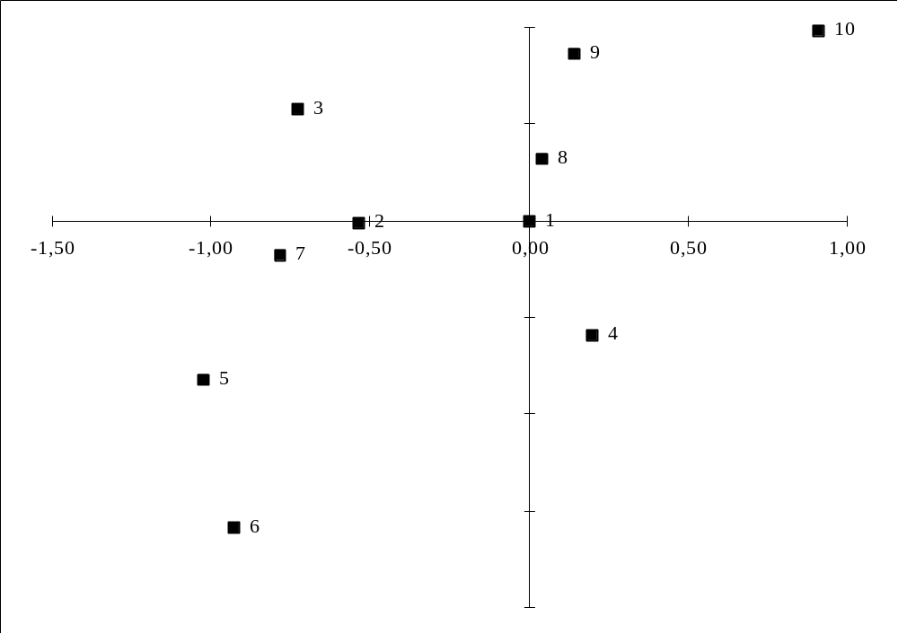

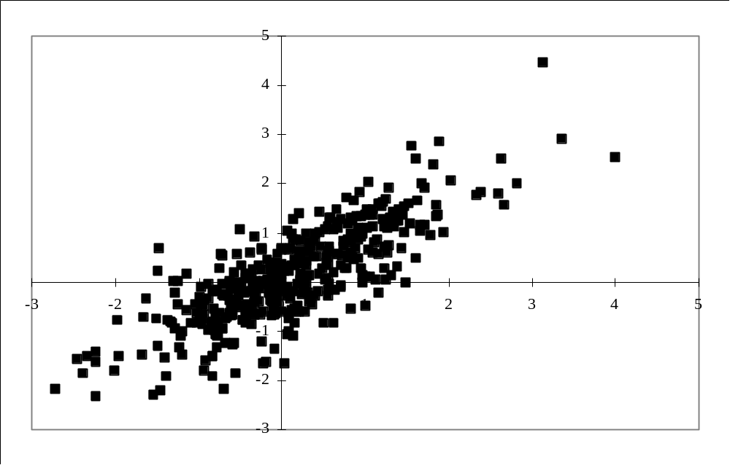

Monte Carlo integration

The problem is to evaluate the following integral

I = ∫ h(x) f(x) dx, where ∫ h²(x) f(x) dx < ∞ (1)

Crude frequency
Let X₁, …, X_{R} be R i.i.d. random variables, each with density f. The idea is to estimate I = Ä_{f} h(X_{r}) for r = 1, …, R by the quantity

i^{CF} = R⁻¹ ∑_{r} h(X_{r})

This estimator is unbiased because E (i^{CF}) = R⁻¹ ∑_{r} E_{f} h(X_{r}) = I. Moreover, Var(i^{CF}) = R⁻¹ Var(h(X₁)) can be estimated by R⁻¹ ∑_{r} (h(X_{r}) − i^{CF})² / R. This simulator is in general not very efficient. The following two estimators are more precise.

Importance sampling
Suppose g is a density and X₁, …, X_{R} are i.i.d. random variables with density g. We rewrite (1) as

I = ∫ [h(x) f(x) / g(x)] g(x) dx

Then we can estimate I by

i^{IS} = R⁻¹ ∑_{r} h(X_{r}) f(X_{r}) / g(X_{r})
This importance sampling estimator is unbiased and its variance is

R⁻¹ ∫ (h(x)f(x)/g(x) − I)² g(x) dx

We want to choose g(⋅) that mimics h(⋅)f(⋅) so that the variance of the importance sampling estimator is close to zero.

Control variate
Let m(⋅) be a function the expectation of which is easy to compute and let X₁, …, X_{R} be R random variables with density f. We can write I as

I = ∫ m(x) f(x) dx + ∫ (h(x) − m(x)) f(x) dx

Then we can estimate I by

i^{CV} = ∫ m(x) f(x) dx + R⁻¹ ∑_{r} (h(X_{r}) − m(X_{r}))

This control variate estimator is unbiased and its variance is

Var[h(X₁) − m(X₁)] / R = [Var(h(X_{r})) + Var(m(X_{r})) − 2Cov(h(X_{r}), m(X_{r}))] / R

The quantity R⁻¹ ∑_{r} m(X_{r}) is called a control variate for the crude frequency estimator R⁻¹ ∑_{r} h(X_{r}). We see that in order to minimize the variance of i^{CF}, we need a function m(⋅) that mimics h(⋅) well. Then, the control variate is positively correlated with the crude frequency estimator.

Application: GHK
The objective of the method is to calculate the integral of a multivariate normal distribution. This integral appears in discrete choice models with qualitative variables, in the calculation of market shares of differentiated products, in the aggregation of consumers.

The problem considered is the numerical evaluation of the integral:

H = ∫ 1(x ∈ B) h(x) φ(x; μ, Ω) dx (2)

where φ(x; μ, Ω) is the density of the multivariate normal distribution with mean μ and covariance Ω, and B = {x ∈ ^{p}: a_{j} < x_{j} < b_{j}, j = 1, ..., p} is the domain of integration. It is a integral of dimension p difficult to evaluate in an efficient way by traditional numerical methods. The idea of procedure GHK is to use the importance sampling in order to obtain an efficient estimator.

Let Γ be triangual matrix such that Γ Γ′ = Ω. Let y be a vector of dimension p from N(0; I_{p}). We know that μ + Γ y has density N(μ; Ω). We can thus rewrite H in the following way:

H = ∫ 1(μ+Γy ∈ B) h(μ+Γy) ∏_{j} φ(y_{j}) dy

Let y_{<j} = (y₁, ..., y_{j−1})′ and Γ_{j,<j} = (Γ_{j,1}, ..., Γ_{j,j−1}). We now develop the indicator function 1(μ+Γy ∈ B):

1(μ+Γy ∈ B) = 1(a₁ < μ₁ + Γ_{1,1} y1 < b₁, a₂ < μ₂ + Γ_{2,1} y₁ + Γ_{2,2} y₂ < b₂,
..., a_{p} < μ_{p} + Γ_{p,1} y₁ + ... + Γ_{p,p} y_{p} < b_{p})

But event {a_{j} < μ_{j} + Γ_{j,1} y₁ + ... + Γ_{j,j} y_{j} < bj} is the same as B_{j}(y_{<j}) = {(a_{j} −m_{j} − Γ_{j,1} y₁ − ... − Γ_{j,j−1} y_{j−1})/Γ_{j,j} < y_{j} < (b_{j} − μ_{j} − Γ_{j,1} y₁ − ... − Γ_{j,j−1} y_{j−1})/Γ_{j,j}}. Thus we can rewrite the indicator function as:

1(μ+Γy ∈ B) = ∏_{j} 1(y_{j} ∈ B_{j}(y_{<j})) (j = 1, ..., p)

So,

H = ∫ h(μ+Γy) ∏_{j} φ(y_{j}) 1(y_{j} ∈ B_{j}(y_{<j})) dy

We now construct the importance function. First we remark that the density of a random variable N(0; 1) truncated in the interval B_{j}(y_{<j}) is

φ(y_{j} | B_{j}(y_{<j})) = φ(y_{j}) 1(y_{j} ∈ B_{j}(y_{<j})) / Φ(B_{j}(y_{<j}))

where Φ(B_{j}(y_{<j})) = Φ[(b_{j} − μ_{j} − Γ_{j,<j} y_{<j})/Γ_{j,j}] − Φ[(a_{j} − μ_{j} − Γ_{j,<j} y_{<j})/Γ_{j,j}]. Thus we can use φ(y_{j} | B_{j}(y_{<j})) as the importance function. It is easy to draw from this distribution. First, one draws y₁ from the normal distribution N(0; 1) truncated in B₁(y_{<1}) = [(a₁ − μ₁)/Γ_{1,1}, (b₁ − μ₁)/Γ_{1,1}]. Secondly, given y₁, one draws y₂ from N(0; 1) truncated in B₂(y_{<2})and so on.

We can now rewrite the integral in its IS form:

H = ∫ h(μ+Γy) ∏_{k} Φ(B_{k}(y_{<k})) ∏_{j} φ(y_{j} | B_{j}(y_{<j})) dy

The GHK estimator of H is given by

H^{GHK} = T⁻¹ ∑_{t} h(μ + Γy_{t}) ∏_{j} Φ(B_{j}(y_{t,<j}))
= T⁻¹ ∑_{t} h(μ + Γy_{t}) ∏_{j} Φ[(b_{j} − μ_{j} − Γ_{j,<j} y_{t,<j})/Γ_{j,j}] − Φ[(a_{j} − μ_{j} − Γ_{j,<j} y_{t,<j})/Γ_{j,j}]

To make this estimator operational, we need a procedure which makes it possible to simulate observations resulting from the normal law N(0; 1) in an interval [a, b].

Stochastic Optimization: Simulated annealing

The method of simulated annealing is a stochastic optimization method based on an analogy from statistical mechanics. The most significant benefit of this method is its capacity to avoid the trap of local optima by almost always making it possible to reach the global solution of the problem. Indeed, all the deterministic methods, such as the method of Newton-Raphson, converges towards the optimal solution in the vicinity of the initial guess. Stochastic methods in general, and the method of simulated annealing in particular, make it possible to avoid this issue in complex optimization problems.

The method of simulated annealing results from analogy with the cooling of a liquid or a metal. Let us take the example of a liquid such as water. If one cools water very slowly, one obtains a configuration where the atoms form a pure crystal and are aligned perfectly. The state of energy is then minimum and this corresponds to a total optimum from a mathematical point of view. On the other hand, if one cools the liquid too quickly, the atoms do not have time to be aligned perfectly and one can obtain a stable configuration corresponding to an energy level higher than the precedent. From a mathematical point of view, one obtains a local solution. To avoid this solution, one can slightly increase the energy of the system and lower it again, in order to the optimal configuration. The method of simulated annealing proceeds in this manner by simulating increase of energy.

Given a configuration of energy E₀ and a temperature T, a new configuration of energy is simulated E₁ according to the algorithm of Metropolis and the distribution of Boltzmann:

p = Min {1, exp(−(E₁ − E₀)/kT)} (1)

where k represents the Boltzmann constant. Thus, if the new configuration makes it possible to reach a lower energy level (E₁ < E₀) then the algorithm always accepts (p = 1) this configuration. On the other hand, if the new configuration reaches a higher energy level (E₁ > E₀), then this one is accepted with a probability p = exp(−(E₁ − E₀)/kT).

Therefore, for a given temperature, the probability of accepting a configuration decreases with the increase in energy which it generates. In the same way, for a given change of energy, the probability of accepting the new configuration increases with the temperature. The probability of accepting a new configuration which generates a significant increase in energy at a very low temperature becomes negligible.

The idea of the simulated annealing is to exploit the analogy with the example of statistical mechanics. The method requires the following elements:

1. A configuration x = (x₁, ..., x_{m})′
2. A random generator of new configurations
3. An objective function to minimize E(x)
4. A control parameter T and a method to determine: when to reduce the temperature (N) and by which amount (ε)

Parameter T has the most influence on success of the method. At each stage, the new configuration is accepted according to the equation (1).

Algorithme 5
initialize T₀, x₀
while (terminal condition not satisfied) do
repeat N times
generate a new configuration x₁
compute ΔE = E(x₁) − E(x₀)
if ΔE < 0 or rand < p = e^{−ΔE/kT} then
x₀ ← x₁
end if
end repeat
reduce T
end while

where rand is drawn from the uniform distribution on [0, 1], N is the number of changes of configuration carried out before a reduction of the temperature. 

To finish the description of the algorithm, it remains to define (1) the way in which the new configurations are generated, (2) the way in which the parameter of control is modified and (3) the way in which the algorithm finishes.
(1) There are several ways of generating a new configuration. If the variables take values in the set of integers, the simplest way to generate new configuration is:

X ₁ = X ₀ + U

where U ∈ Z ^{m} is a vector of numbers drawn in a random way in {- 1, 0, 1}.

If the variables take values in R^{m}, then there are mainly two new manners of generating configurations. The first is the method of Vanderbilt and Louie (1984):

X ₁ = X ₀ + Q U

where U is a vector of random number random drawn in the interval (- √3, √3), Q is a triangular matrix resulting from the decomposition of Cholesky of the matrix S. This matrix is defined by recurrence at stage T by

S _{T} = (1−α) S _{T −1} +αω X

where X is the matrix of variance covariance of the followed paths and α and ω are parameters which controls the rate into which the information of X is integrated in S. the idea is to force research in the directions which resulted in a the best improvements in the objective function. The second manner of proceeding is due to Parks (1990) and also forces research in the directions which brought the most success. Here

X ₁ = X ₀ + D U

where U is a vector of uniform draws in the interval (−1, 1), D is a diagonal matrix the maximum change of each variable and which is adjusted in the following way

D _{T} = (1 −α) D _{T −1} +αω R

where R is a diagonal matrix which counts for each variables the number of new accepted configurations, and α and ω play the same role as before.

(2) It is about the most critical part of the method. Indeed, a too fast reduction of control forces the algorithm to accept fewer unfavourable configurations and one is thus likely to be stuck around a local minimum. On another side, a too slow reduction involves a loss of effectiveness. It seems that at the present time, the choice of the technique of reduction still includes a significant subjective part. Two aspects are dominating. First of all, it is necessary to determine the initial value of control, T₀. A too low value can lead the algorithm towards a local solution. It seems that a judicious choice is to fix an initial value such as 80 to 90% of the unfavourable configurations are accepted. Then, it is a question of determining the speed and the amplitude of the reduction of control. Two principal techniques are used to reduce the value of control T. The first is a linear reduction, namely T_{t} = T_{t −1} − ε. The second is an exponential reduction, namely T_{t} = ε T_{t−1}. The two approaches seem to give similar results.

References
Press et al, Numerical Recipes in C, Chap7: random number generation
Gelman et al. Bayesian data analysis, chap. 11: MCMC
Robert, C.P. 1995, Simulation of truncated normal variables," Statistics and Computing, 5: 121-125
Goffe, (1994), J. Econometrics: Simulated annealing
Geweke et al. (199?), Review of Economics and Statistics GHK
Geweke et al (199?), J. Econometrics, GHK
Kemeny and Snell (196?): Markov chain with countable states
Mayne and Tweedie (199?): Convergence of general Markov chains

Computer exercise 3 (due by the end of the course)

Question 1
Simulate 100 uniformly random variables between [0, 1] to compute ∫₀¹ x dx = 0.5 using

(1) a crude-frequency estimator,
(2) an importance sampling estimator with the c.d.f. G(x) = (exp(x) − 1)/(exp(1) − 1) and g(x) = dG(x)/dx = exp(x)/exp(1)−1 [Hint: you need to use the inverse cdf method to draw from g],
(3) a rejection method with density g(x), and
(4) a control variate estimator with m(x) = exp(x).

Assess the relative precision of the different estimators by comparing their variance.

Question 2
Let x be a random vector of dimension p from the multivariate normal distribution with mean μ and covariance Σ, N(μ; Σ). The conditional distribution of x_{j} given x₁, ..., x_{j−1}, x_{j+1}, ..., x_{p} is normal with mean μ_{j|−j} and covariance Σ_{j|−j}, for 1 < j < k (and obvious change of notations for j=1 and j=p):

x_{j} | x_{−j} ~ N(μ_{j|−j}; σ_{j|−j})

with

μ_{j|−j} = μ_{j} + Σ_{−j,j}′ Σ_{−j,−j}⁻¹ (x_{−j}−μ_{−j})
σ_{j|−j} = Σ_{j,j} − Σ_{−j,j}′ Σ_{−j,−j} Σ_{−j,j}

where Σ_{−j,j} is the jth column of Σ wihout its element j, Σ_{−j,−j} is the matrix by removing line j and column j from matrix Σ, and x_{−j} and μ_{−j} are the vectors obtained by removing the element in position j of vectors x and μ respectively.

Use the Gibbs sampler to draw a sample of 1000 simulated draws for the distribution N(0, Σ), with Σ = [1, 0.8; 0.8, 1]. Start the algorithm at (0, 0) and (-2.5,-2.5). Assess the speed of convergence by analyzing the sample path of the mean and covariance of simulated draws.

EXTRA CREDIT
Use a normal jumping distribution to draw for the bivariate normal N(0, I₂) distribution using the Metropolis algorithm with scale factor 0.2: p(y | x) = N(x, 0.2 I₂)

Question 3
Comment on the the GHK algorithm (using the program available on web page) and compute the probability p(y ≥ 0), where y ∼ N(μ, Ω), where μ = (1, −1, 1, −1, 1, −1,1)′ and

⎡ 1 .3 .3 .3 .3 .3 −.1 ⎤
⎢ .3 1 .3 .3 .3 .3 −.1 ⎥
⎢ .3 .3 1 .3 .3 .3 −.1 ⎥
⎢ .3 .3 .3 1 .3 .3 −.1 ⎥
Ω = ⎢ .3 .3 .3 .3 1 .3 −.1 ⎥
⎢ .3 .3 .3 .3 .3 .1 −.1 ⎥
⎣ −.1 −.1 −.1 −.1 −.1 −.1 1 ⎦

using R = 50, 100, 500 and 1000 repetitions. [Hint: Look at the programs on Hajivassiliou's web page http://econ.lse.ac.uk/staff/vassilis/index_own.html]

