Student Final Marks Prediction
(Machine Learning with Streamlit Web Application)

A PROJECT REPORT

SUBMITTED BY
Roll Number | Registration Number | Student Code | Student Name
24103460104 | 24103002886 | BWU/BCA/24/109 | Animesh Roy

In partial fulfillment for the award of the degree
BACHELOR OF COMPUTER APPLICATION
IN
DEPARTMENT OF COMPUTATIONAL SCIENCE

BRAINWARE UNIVERSITY
398, Ramkrishnapur Road, Barasat, North 24 Parganas, Kolkata - 700 125
ABSTRACT
The Student Final Marks Prediction system is a machine learning project, written in Python, that predicts a student's final exam marks (out of 100) from five everyday academic factors: attendance, Internal Test 1, Internal Test 2, assignment score and daily study hours. The main objective is to demonstrate a complete data science workflow, from dataset loading and preprocessing to exploratory data analysis, model training, evaluation, prediction and deployment as an interactive web application.
The project uses a Kaggle dataset of 2,000 student records (1,997 after three duplicate rows are removed once the Student_ID column is dropped). The five input features are used to predict one continuous target, the final exam marks, which makes this a regression problem. The preprocessing stage removes duplicates, fills missing values with the median and scales the features inside a scikit-learn Pipeline, so that no information leaks from the test set into training.
Four regression models (Linear Regression, Ridge Regression, Random Forest and Gradient Boosting) are trained with an 80/20 train-test split and 5-fold cross-validation, and compared using R², MAE and RMSE. Ridge and Linear Regression perform best (test R² of 0.839 and MAE of about 3.5 marks), which shows that the relationship between the inputs and the marks is mostly linear. Permutation importance ranks Internal Test 2, Internal Test 1 and Attendance as the most influential features. All trained models are saved so they can be reused without retraining.
A Streamlit application (app.py) provides the user interface. The user sets five sliders and presses one button; the app calls the prediction module and shows the predicted final marks out of 100 together with a progress bar. The tool helps teachers and students to estimate likely results in advance and to see which factors matter most.
INDEX
- ABSTRACT
- LIST OF FIGURES
- LIST OF TABLES
- 1. INTRODUCTION
- 2. LITERATURE SURVEY
- 3. SYSTEM ANALYSIS AND DESIGN
- 4. IMPLEMENTATION
- 5. OUTPUT SCREENSHOTS
- 6. TESTING AND DEBUGGING
- 7. CONCLUSION AND FUTURE ENHANCEMENT
- 8. REFERENCES

List of Figures
Fig. 3.1 :- Layered Architecture of the System
Fig. 3.2 :- System Flow Chart
Fig. 3.3 :- DFD Level 0
Fig. 3.4 :- DFD Level 1
Fig. 5.1 to 5.18 :- Output graphs and screenshots (Chapter 5)

List of Tables
Table 3.1 :- Dataset Attributes
Table 3.2 :- Project Files and Their Roles
Table 3.3 :- Layers and Their Responsibilities
Table 3.4 :- Models Used
Table 3.5 :- Processes and Data Stores in the DFD
Table 4.1 :- Inputs in the Web Application
Table 6.1 :- Model Evaluation Results
Table 6.2 :- Test Cases

1. INTRODUCTION
A student's final examination result depends on many things: how regularly the student attends class, how well the student performs in internal tests, how consistently assignments are completed and how many hours are spent studying each day. Teachers usually notice a problem only after the final results are published, which is too late to help. A system that estimates the likely result in advance from these everyday factors can give an early warning and a chance to act.
Machine learning is well suited to this task. A model can learn from thousands of past student records how the factors combine to produce a final score, and can then estimate the marks of a new student immediately.
The Student Final Marks Prediction project implements a complete machine learning pipeline for this purpose. It reads a dataset of 2,000 students, prepares the data, explores it visually, trains and compares four regression models, saves the trained models and offers a simple Streamlit web application in which anyone can enter a student's details and receive predicted final marks.
The project is divided into the following stages:
- Dataset Loading and Preprocessing -- preprocessing.py loads data/Final_Marks_Data.csv, drops Student_ID, renames columns, removes duplicates, fills missing values and builds the scaling pipeline and train/test split.
- Exploratory Data Analysis -- eda.py prints statistics, checks outliers and saves distributions, a correlation heatmap and scatter plots to results/figures.
- Model Training -- train_models.py trains four regression models, cross-validates them, saves every model and plots actual-vs-predicted, residuals and feature importance.
- Prediction -- predict.py loads the best saved model and predicts marks for one student, from code or from the command line.
- Web Application -- app.py provides the interactive Streamlit interface.
- Testing -- tests/test_pipeline.py checks the pipeline with pytest.
The project is built with Python, NumPy and pandas for data handling, scikit-learn for modelling, matplotlib and seaborn for visualisation, joblib for model storage, Streamlit for the user interface and pytest for testing.

2. LITERATURE SURVEY
The project is based on Educational Data Mining (EDM) and Learning Analytics, two fields that apply data analysis to educational data in order to understand and improve learning. A large part of this research focuses on predicting student outcomes such as final grades, pass or fail results and dropout, so that teachers can support students early.
Many studies report that earlier assessment results, attendance and study time are among the most reliable predictors of later performance. Internal tests are especially useful because they measure the same subject under similar conditions as the final examination. These findings explain the choice of input features in this project, where the two internal tests turn out to be the strongest predictors.
Linear models such as Linear Regression and Ridge Regression are common starting points because they are fast and easy to interpret. Ridge Regression adds a penalty on large coefficients, which helps when features are correlated. Ensemble methods such as Random Forest and Gradient Boosting combine many decision trees, can capture non-linear relationships and often give higher accuracy on tabular data, at the cost of being harder to explain. Comparing a simple model with a more complex one is standard practice, because it shows whether the extra complexity is actually needed. In this project the simple linear models perform best, which indicates that the data is mostly linear.
A good evaluation also separates training from testing. Using a held-out test set and k-fold cross-validation gives a more honest estimate of how a model will behave on new students than training accuracy alone, and keeping preprocessing inside a Pipeline prevents information from the test data leaking into training.
On the deployment side, Streamlit has become a popular way to turn a Python machine learning script into a web application without writing HTML or JavaScript. It allows data science projects to be shared and tested by non-programmers quickly, which is the purpose of the demo application in this project.

3. SYSTEM ANALYSIS AND DESIGN
System analysis and design defines what the system must do, the data it works on, and how its components are arranged. It ensures that the implementation is clear and easy to maintain.

3.1 System Analysis
Existing System: Student performance is normally reviewed only after exams, using mark sheets and attendance registers. Teachers rely on experience to decide which students need help, and students have no simple way to see how their test scores, attendance and study habits affect the final result.
Problems in the Existing System:
- Problems are found late, after the results are published.
- There is no objective, data-based estimate of a student's likely final marks.
- The effect of attendance, study hours and assignments is not measured.
- Manual review of many students is slow and inconsistent.
- Students cannot easily try "what if" changes to see the possible effect.
Proposed System: The proposed system is a machine learning pipeline with a web interface. It learns from 2,000 student records and predicts the final marks of a new student from five inputs, so that students who may do poorly can be identified early.
Advantages of the Proposed System:
- Instant prediction of final marks from five easy-to-collect inputs.
- Four models are compared with cross-validation, so the best one is chosen using evidence.
- Preprocessing is inside a Pipeline, so there is no data leakage and no manual scaling at prediction time.
- Trained models are saved and reused, so no retraining is needed for each prediction.
- A simple slider-based interface that needs no technical knowledge.

3.2 System Design
Dataset: The file data/Final_Marks_Data.csv was downloaded from Kaggle (Student Academic Performance Dataset, by sonalshinde123). It contains 2,000 rows. Three rows are exact duplicates once Student_ID is dropped, so 1,997 rows remain for modelling. The attributes are described in Table 3.1; the slider ranges are those used in the web application.
Table 3.1 :- Dataset Attributes
Attribute | Role | Description / Range
Student_ID | Dropped | Identifier only; removed because it carries no predictive information
Attendance | Input | Attendance percentage (app slider 50 to 100)
Internal Test 1 | Input | Marks out of 40 (app slider 0 to 40)
Internal Test 2 | Input | Marks out of 40 (app slider 0 to 40)
Assignment score | Input | Marks out of 10 (app slider 0 to 10)
Daily study hours | Input | Hours studied per day (app slider 0 to 8)
Final Exam Marks | Target | Final exam marks out of 100 (regression target)

Project files and their roles are listed in Table 3.2.
Table 3.2 :- Project Files and Their Roles
File / Folder | Role
src/config.py | Holds paths, column names and constants used by all modules.
src/preprocessing.py | Loads and cleans the data, builds the preprocessing pipeline and the train/test split.
src/eda.py | Exploratory analysis: statistics, outliers, distributions, correlation heatmap and scatter plots saved to results/figures.
src/train_models.py | Trains and compares four models, saves them to models/ and writes metrics and plots to results/.
src/predict.py | Provides load_model() and predict_marks() and a command-line demo.
app.py | Streamlit web application.
tests/test_pipeline.py | Automated tests run with pytest.
notebooks/student_performance_prediction.ipynb | Notebook version of the whole workflow.
data/ | Contains Final_Marks_Data.csv.
models/ | Saved models (.pkl), including best_model.pkl.
results/ | figures/, model_results.csv, correlation_matrix.csv and other outputs.
requirements.txt | Python dependencies: numpy, pandas, matplotlib, seaborn, scikit-learn, joblib, streamlit, pytest, jupyter.

Modules of the System:
- Preprocessing Module -- Loads, cleans, imputes and scales the data inside a Pipeline.
- EDA Module -- Studies distributions, outliers and relationships between variables.
- Model Training Module -- Trains, cross-validates, compares and saves the regression models.
- Prediction Module -- Loads the saved best model and returns predicted marks.
- Web Interface Module -- Collects the five inputs and shows the predicted marks.
Technologies Used:
- Language: Python 3
- Data processing: NumPy, pandas
- Machine learning: scikit-learn (LinearRegression, Ridge, RandomForestRegressor, GradientBoostingRegressor, Pipeline)
- Visualisation: matplotlib, seaborn
- Web interface: Streamlit
- Model storage: joblib (.pkl files)
- Testing and notebook: pytest, Jupyter

3.3 Theory Architecture
The system is arranged in five layers. Each layer uses only the layer below it, which keeps the code easy to test and change. The web application never reads the data directly; it asks the prediction module, which uses the saved models.
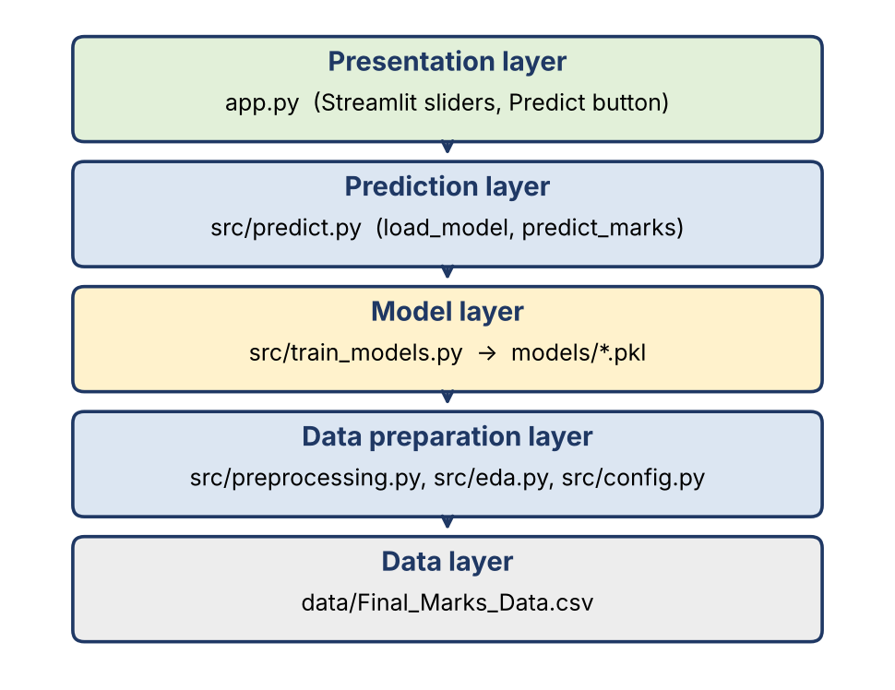
Fig. 3.1 :- Layered Architecture of the System
Table 3.3 :- Layers and Their Responsibilities
Layer | Main parts | Responsibility
Presentation | app.py, Streamlit | Shows the sliders, collects five inputs and displays the predicted marks.
Prediction | src/predict.py | Loads the saved model and returns the predicted marks.
Model | src/train_models.py, models/ | Trains, evaluates and stores the regression models.
Data preparation | src/preprocessing.py, src/eda.py, src/config.py | Cleans, imputes and scales the data and explores it.
Data | data/Final_Marks_Data.csv | Stores the 2,000 student records.

Models Used
Table 3.4 :- Models Used
Model | Task | Main idea
Linear Regression | Regression | Fits a straight-line relationship between the inputs and the marks. Simple baseline.
Ridge Regression | Regression | Linear regression with a penalty on large coefficients to reduce over-fitting.
Random Forest Regressor | Regression | Averages the predictions of many decision trees; handles non-linear patterns.
Gradient Boosting Regressor | Regression | Builds trees one after another, each correcting the errors of the previous ones.

Each model is stored as a scikit-learn Pipeline (median imputer, scaler and model), so the same preprocessing steps are applied automatically at prediction time. The application passes five raw values to the prediction function and does not need to scale or transform them itself.

3.4 System Flow
The flow chart shows the steps from loading the dataset to showing the prediction to the user.
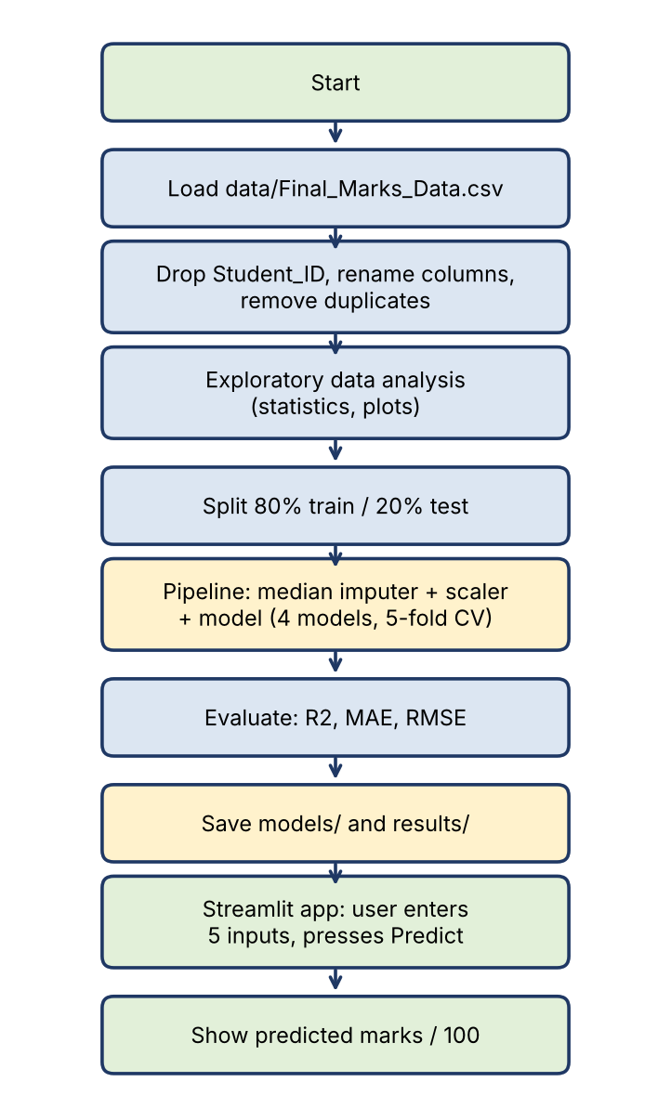
Fig. 3.2 :- System Flow Chart

3.5 Data Flow Diagrams
A Data Flow Diagram shows how data moves between the user, the processes and the stored data.

DFD Level 0 (Context Diagram)
Level 0 shows the whole system as one process. The student's five inputs go in, and the predicted marks come out. The system uses the stored dataset and saved models (D1).
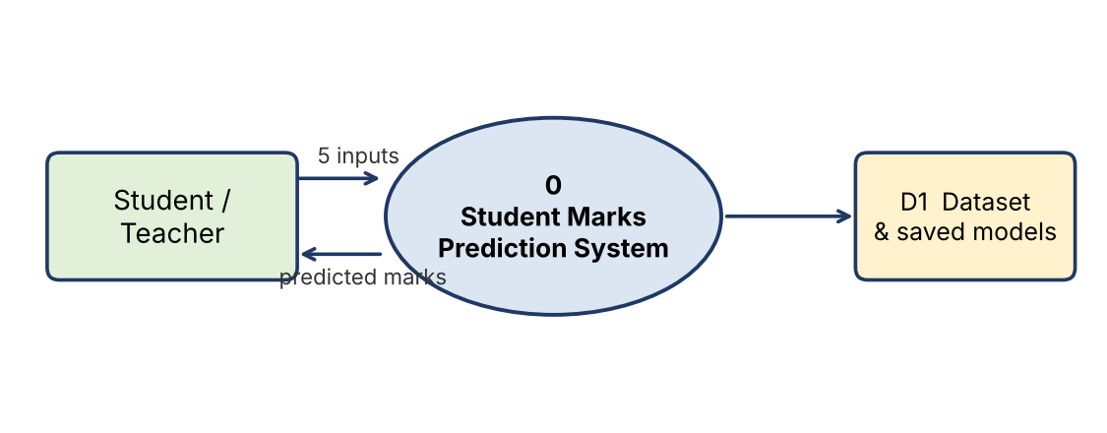
Fig. 3.3 :- DFD Level 0

DFD Level 1
Level 1 splits the system into three processes and two data stores.
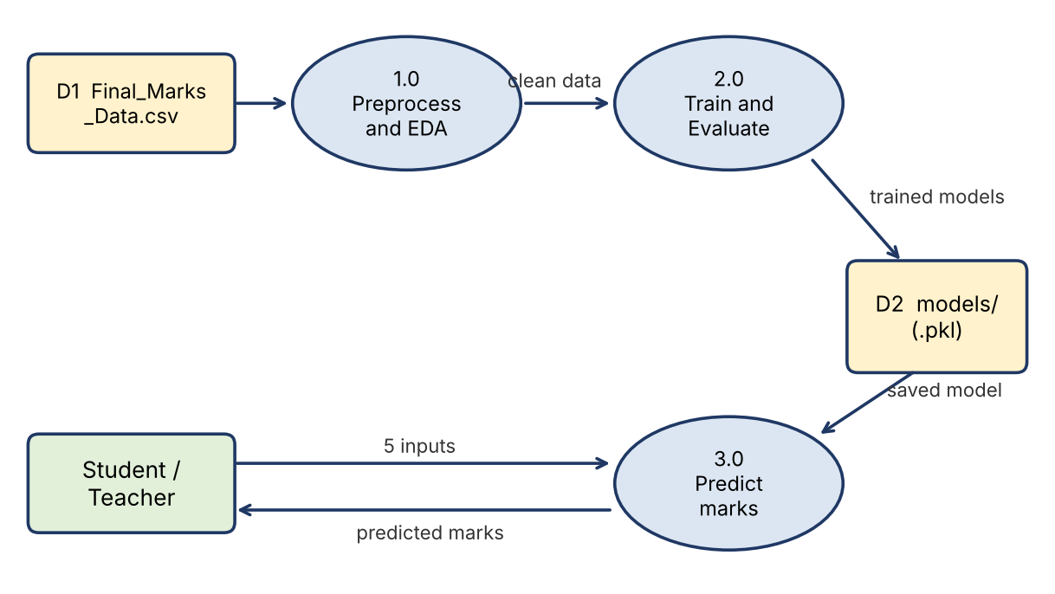
Fig. 3.4 :- DFD Level 1
Table 3.5 :- Processes and Data Stores in the DFD
Item | Name | What it does
1.0 | Preprocess and EDA | Reads the dataset, removes duplicates, fills missing values, scales features and draws charts.
2.0 | Train and Evaluate Models | Trains the four regression models, calculates metrics and saves the models and results.
3.0 | Predict Marks | Loads the saved best model and predicts the marks for the five inputs given by the user.
D1 | Final_Marks_Data.csv | Dataset of 2,000 student records.
D2 | models/ | Saved models (.pkl) including best_model.pkl, with results/model_results.csv.

4. IMPLEMENTATION
The project is organised into the src folder (config, preprocessing, EDA, training and prediction modules), the data, models, results, notebooks and tests folders, app.py, requirements.txt and README.md. All dependencies are installed with pip install -r requirements.txt. The full pipeline is run in the order shown below.
pip install -r requirements.txt
python src/eda.py # EDA: statistics and plots
python src/train_models.py # trains 4 models, saves models/ and results/
python src/predict.py # example prediction
streamlit run app.py # web app
pytest # run tests

4.1 Dataset Loading and Preprocessing
preprocessing.py loads data/Final_Marks_Data.csv and prepares it for modelling. It drops the Student_ID column, renames the columns to short names, removes duplicate rows (three in this dataset) and then splits the data 80/20 into training and test sets. Missing values are filled with the median and the features are scaled; both steps are placed inside a scikit-learn Pipeline together with the model. Because the Pipeline is fitted only on the training data, no information from the test set leaks into training.

4.2 Exploratory Data Analysis
eda.py prints the shape, data types, missing values, duplicates and descriptive statistics of the data, detects outliers with the IQR rule, and saves charts in results/figures: distributions of each variable, a correlation heatmap and scatter plots of each feature against the final marks. The correlation matrix is also saved as results/correlation_matrix.csv. No plot windows open when the script runs, because the charts are saved as image files.

4.3 Model Training and Evaluation
train_models.py trains four regression models (Linear Regression, Ridge, Random Forest and Gradient Boosting) to predict the final marks. Each model is evaluated with 5-fold cross-validation on the training data and on the 20% test set, using R², MAE and RMSE. Every trained model is saved as a .pkl file in the models folder, the best one is also stored as models/best_model.pkl, and the comparison is written to results/model_results.csv. The script also plots actual versus predicted marks, the residuals and a feature-importance chart based on permutation importance.

4.4 Prediction Module
predict.py provides load_model(), which loads models/best_model.pkl, and predict_marks(attendance, test1, test2, assignment, hours, model=None), which returns the predicted final marks for one student. If the model file does not exist, load_model() raises a FileNotFoundError that tells the user to run train_models.py first. The script can also be run from the command line:
python src/predict.py --attendance 90 --test1 30 --test2 35 --assignment 8 --hours 3

4.5 Streamlit Web Application
app.py builds the user interface. It places the src folder on the Python path, imports load_model and predict_marks, and loads the model once at the start. If the model file is missing, the app shows the error message and stops (st.stop()). Otherwise it shows five sliders, listed in Table 4.1, and a Predict button.
Table 4.1 :- Inputs in the Web Application
Input | Unit | Slider range | Default
Attendance | % | 50 to 100 | 85
Internal Test 1 | out of 40 | 0 to 40 | 32
Internal Test 2 | out of 40 | 0 to 40 | 32
Assignment score | out of 10 | 0 to 10 | 7
Daily study hours | hours | 0 to 8 | 3

When the user presses Predict, the five values are passed to predict_marks() together with the loaded model. The result is shown as a metric, "Predicted final marks: xx.x / 100", with a progress bar and a caption stating that the estimate comes from a model trained on about 2,000 students with a typical error of 3 to 4 marks.
if st.button("Predict"):
score = predict_marks(attendance, test1, test2, assignment, hours, model=model)
st.metric("Predicted final marks", f"{score:.1f} / 100")
st.progress(min(int(score), 100))

5. OUTPUT SCREENSHOTS
This chapter shows all the graphs produced by the project: the distributions and boxplots of the variables, the relationships between the features and the final marks, the correlation analysis, the model comparison, the prediction error plots and the feature importance of the trained models. Each graph is shown with its name and a short explanation.

5.1 :- Final Marks Distribution and Boxplot
The histogram of the target variable is roughly bell-shaped and centred near 65 marks, with most students between about 50 and 80. The boxplot confirms a median of about 65 and shows a few low outliers (around 25 to 35 marks) and one student at 100.
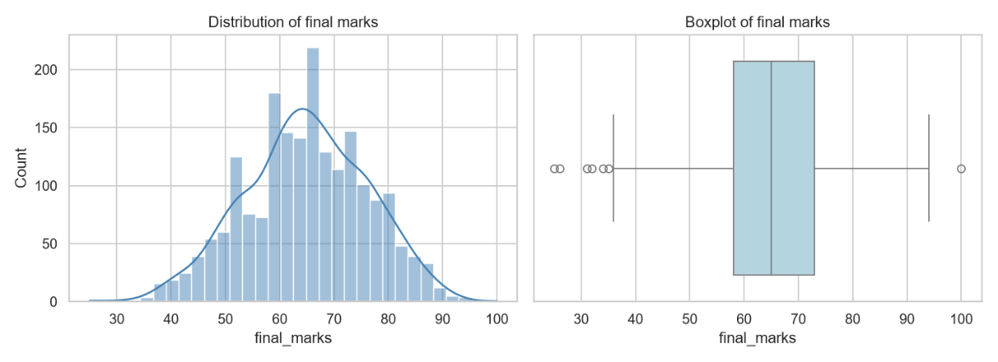
Fig. 5.1 :- Distribution of final marks and Boxplot of final marks

5.2 :- Attendance Distribution
Attendance runs from about 52% to 100% and is centred around 85%. The distribution has a longer tail on the low side, and a small group of students sits at 100%.
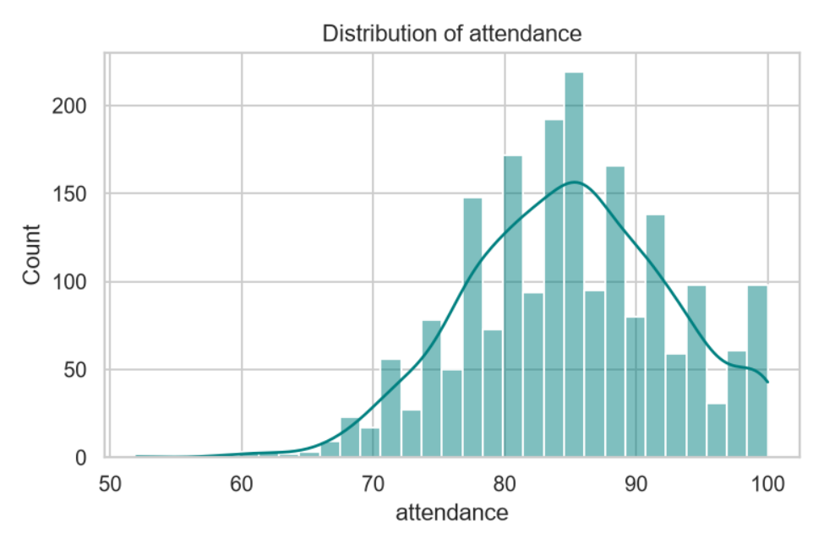
Fig. 5.2 :- Distribution of attendance

5.3 :- Internal Test 1 Distribution
Marks in Internal Test 1 range from about 18 to 40 and are centred around 32. The distribution is skewed towards the high side of the scale, with a visible group of students at the maximum of 40.
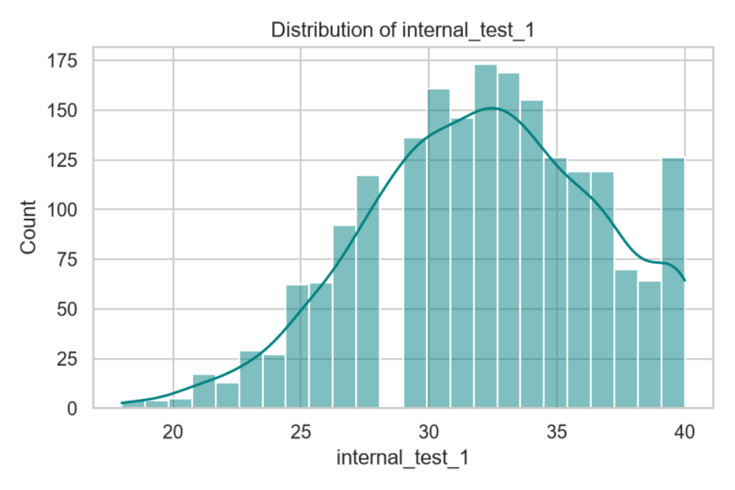
Fig. 5.3 :- Distribution of internal_test_1

5.4 :- Internal Test 2 Distribution
Marks in Internal Test 2 range from about 16 to 40 with a centre near 33. There are two spikes: one at about 28 to 29 marks and one at the maximum of 40.
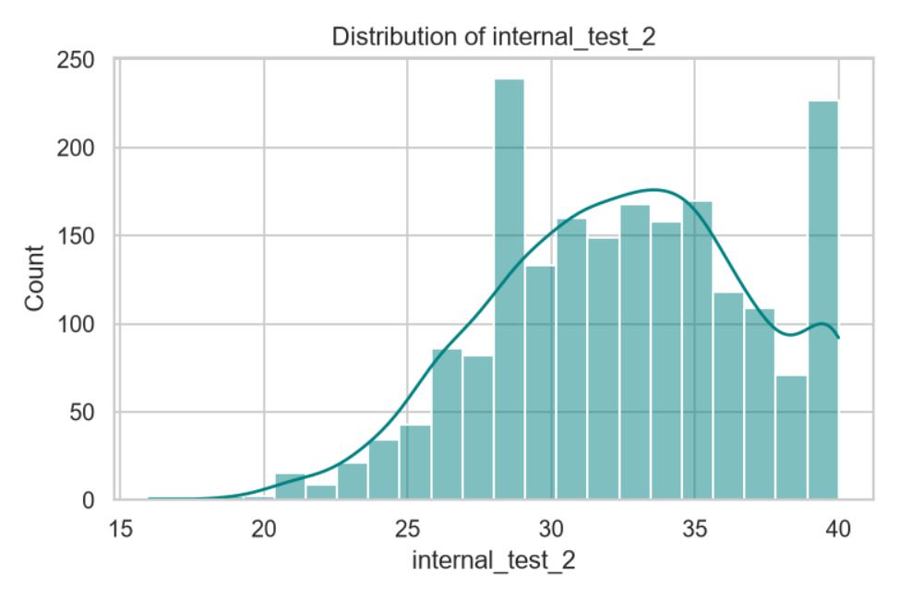
Fig. 5.4 :- Distribution of internal_test_2

5.5 :- Assignment Score Distribution
Assignment scores take whole values from 4 to 10. Most students score 7 or 8 (about 650 and 720 students), followed by 9 and 6, while very few score 5 or 10.
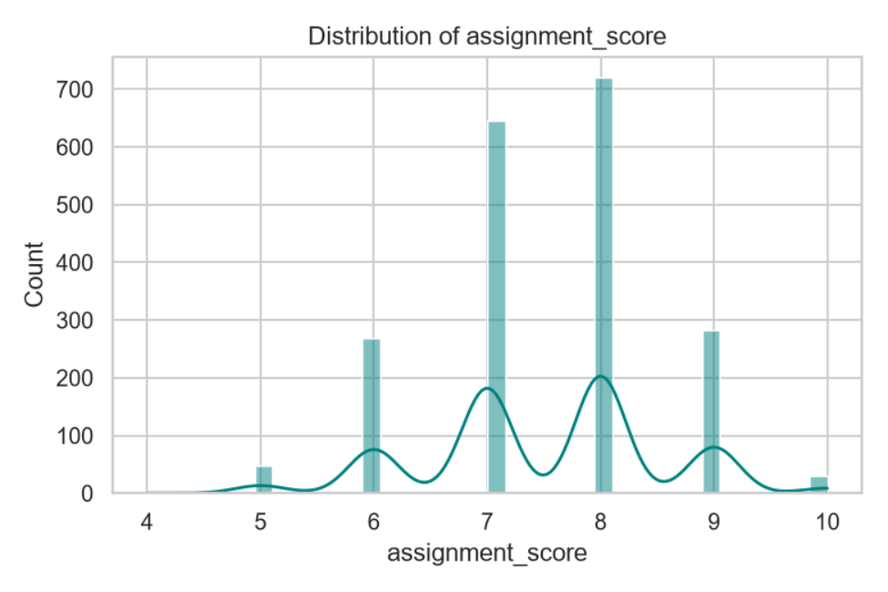
Fig. 5.5 :- Distribution of assignment_score

5.6 :- Study Hours Distribution
Daily study hours take whole values from 1 to 5. Most students study 3 hours a day (over 1,200 students), about 530 study 2 hours and about 200 study 4 hours. Values of 1 and 5 hours are very rare.
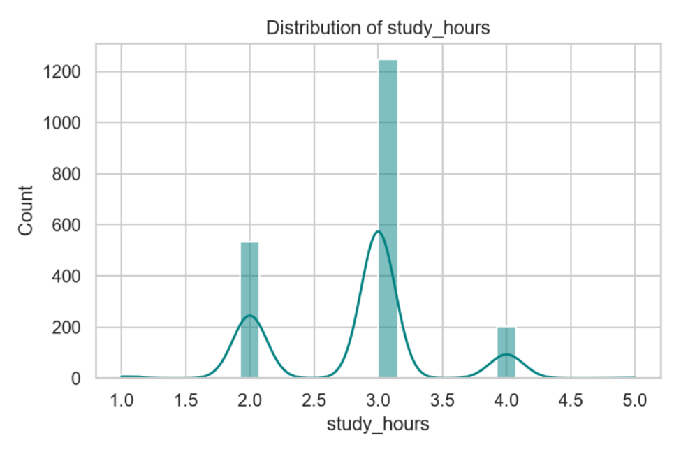
Fig. 5.6 :- Distribution of study_hours

5.7 :- Boxplots of the Input Features
The boxplots show the median and spread of each input. Attendance has a median of about 85 with low outliers below 65. The two internal tests have medians of about 32 and 33 with a few low outliers. Assignment score has a median of 8, and study hours has a median of 3 with a single high value at 5.
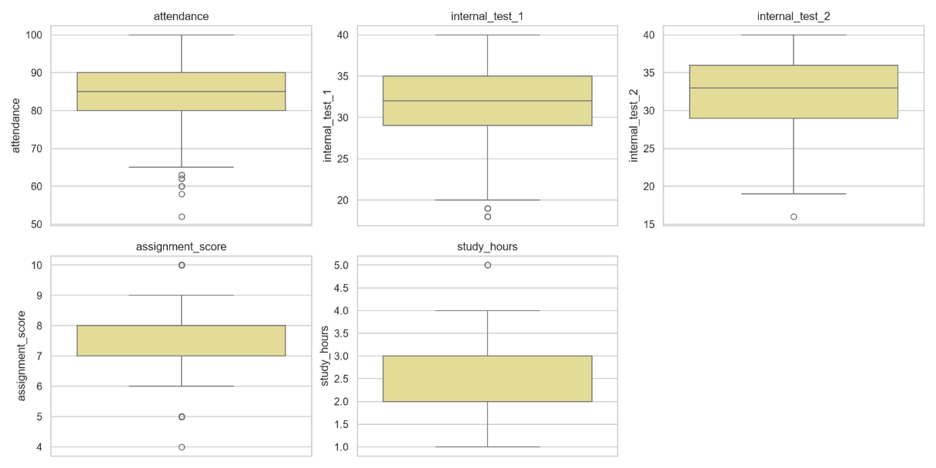
Fig. 5.7 :- Boxplots of attendance, internal_test_1, internal_test_2, assignment_score and study_hours

5.8 :- Features vs Final Marks
Each input is plotted against the final marks with a fitted regression line. All five relationships are positive and close to a straight line. Attendance and the two internal tests show the tightest upward trend, while assignment score and study hours take only a few distinct values, so their points form vertical columns. This supports the choice of linear models.
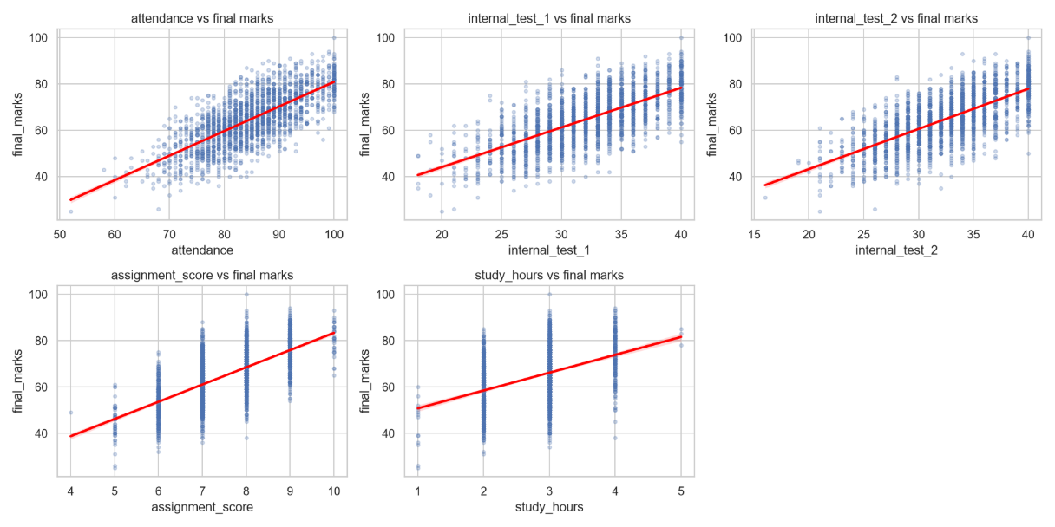
Fig. 5.8 :- Attendance, Internal Test 1, Internal Test 2, Assignment Score and Study Hours vs Final Marks

5.9 :- Correlation Heatmap
Every input is positively correlated with the final marks: attendance 0.73, Internal Test 1 0.69, Internal Test 2 0.69, assignment score 0.67 and study hours 0.41. The inputs are also moderately correlated with each other (for example, Internal Test 1 and assignment score 0.57, attendance and Internal Test 1 0.50), so the features carry partly overlapping information.
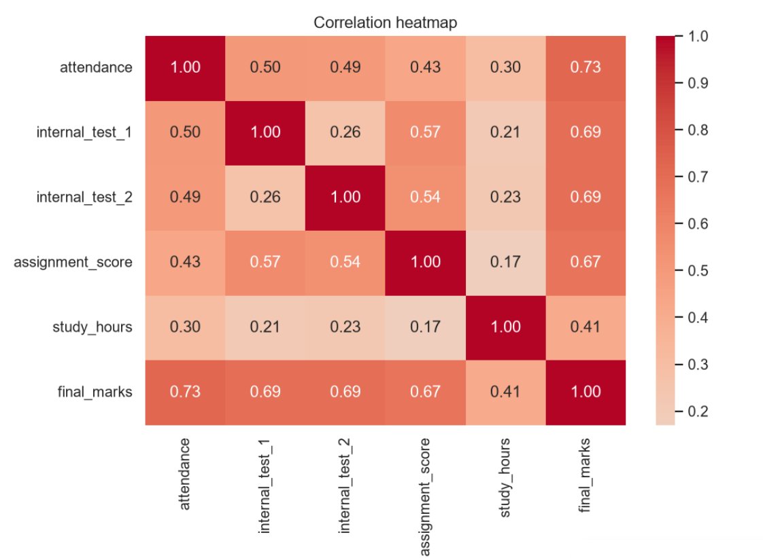
Fig. 5.9 :- Correlation Heatmap

5.10 :- Top Correlations with Final Marks
The bar chart ranks the inputs by their correlation with the final marks. Attendance is first, followed by Internal Test 2, Internal Test 1 and assignment score, which are close together. Study hours has the weakest relationship.
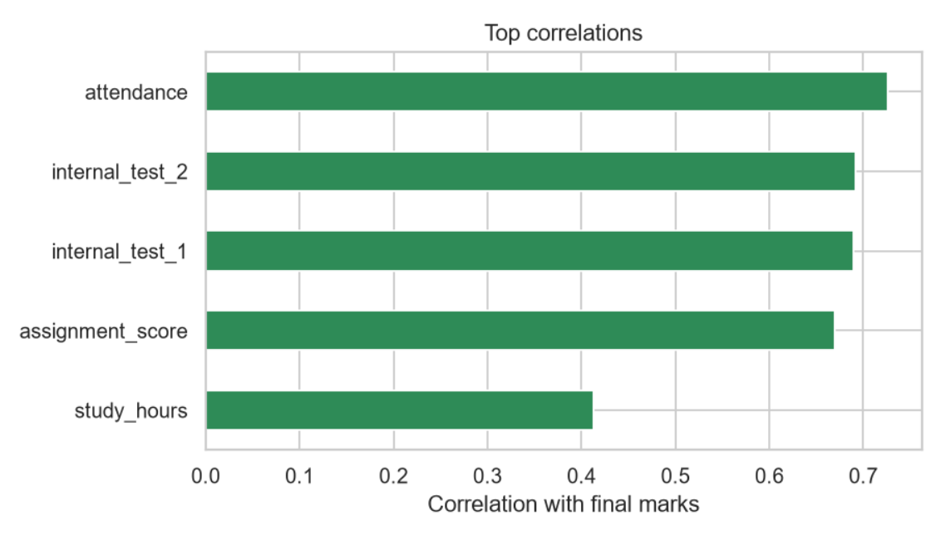
Fig. 5.10 :- Top Correlations with Final Marks

5.11 :- Model Comparison
The bar chart compares the test R² of the four models. Ridge and Linear Regression are highest and equal (about 0.84), Gradient Boosting is slightly lower (about 0.82) and Random Forest is lowest (about 0.80).
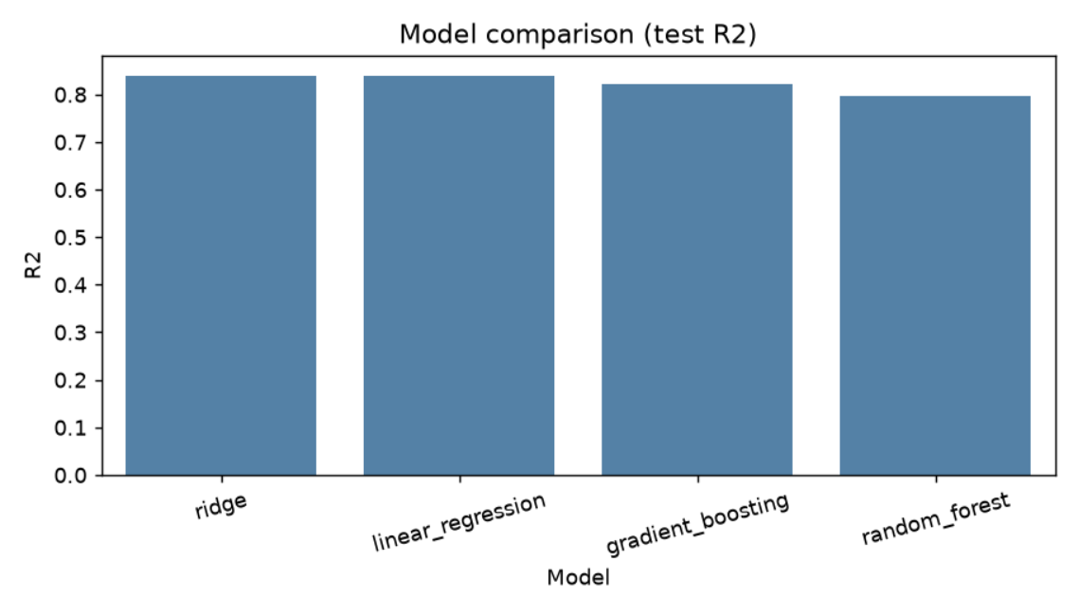
Fig. 5.11 :- Model comparison (test R²)

5.12 :- Actual vs Predicted Marks (Ridge)
Each point is one student in the test set. The points lie close to the red dashed line of perfect prediction across the whole range from about 26 to 88 marks, which shows that the model predicts well. The spread around the line corresponds to the typical error of about 3.5 marks.
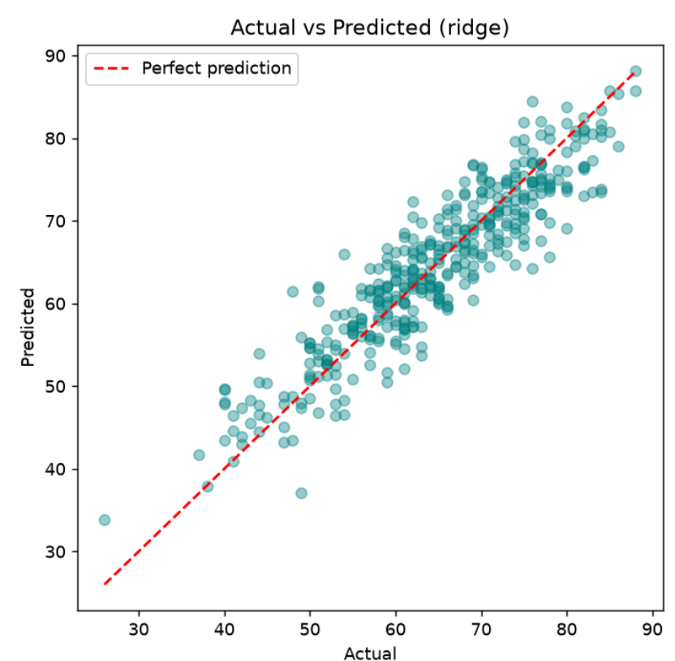
Fig. 5.12 :- Actual vs Predicted (ridge)

5.13 :- Residuals vs Predicted
The residuals (actual minus predicted) are scattered randomly around zero, mostly between -10 and +10 marks, with no curve or funnel shape. This means the model has no obvious bias and its errors do not grow with the predicted marks.
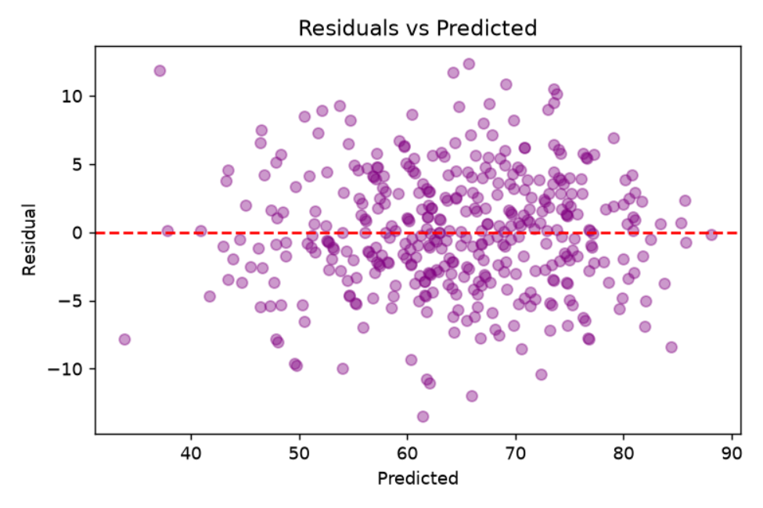
Fig. 5.13 :- Residuals vs Predicted

5.14 :- Residuals Histogram
The prediction errors form a bell-shaped curve centred close to zero and ranging from about -13 to +12 marks. This is what is expected from a well-fitted linear model.
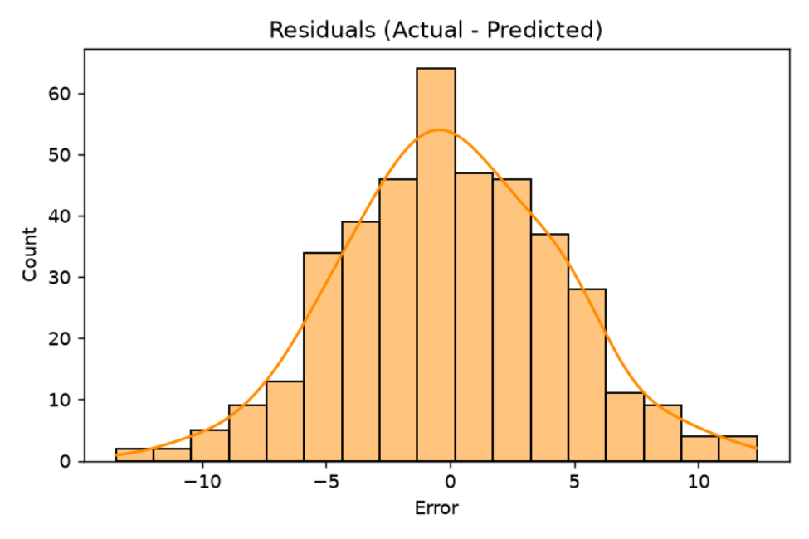
Fig. 5.14 :- Residuals (Actual - Predicted)

5.15 :- Permutation Importance (Ridge)
Permutation importance measures how much the R² drops when a feature is shuffled. For the best model, Internal Test 2 (about 0.27) and Internal Test 1 (about 0.26) matter most, followed by attendance (about 0.15). Study hours and assignment score matter least.
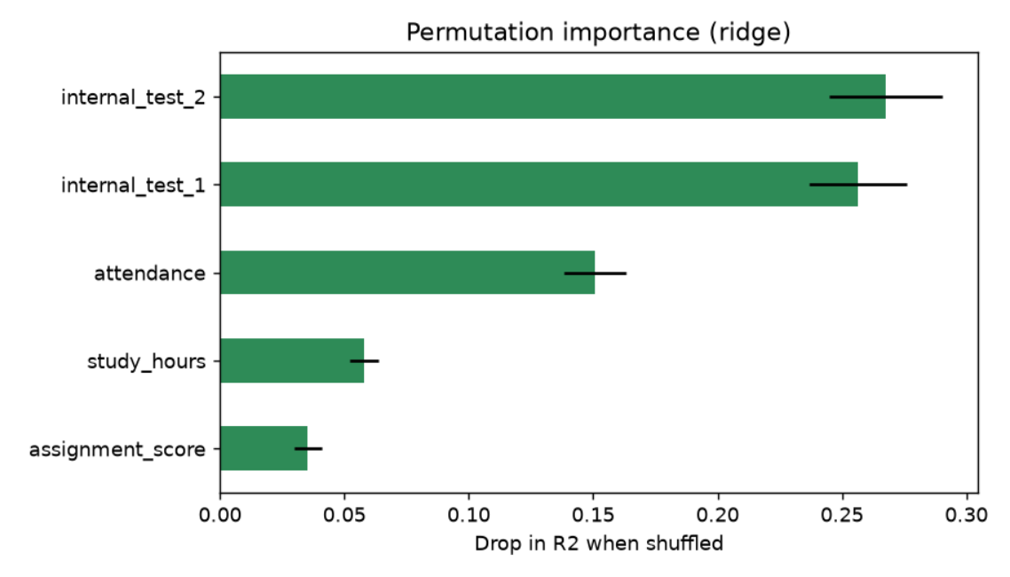
Fig. 5.15 :- Permutation importance (ridge)

5.16 :- Feature Importance - Random Forest
In the Random Forest model, attendance has the highest importance (about 0.37), followed by Internal Test 2 (0.26) and Internal Test 1 (0.25). Assignment score (0.09) and study hours (0.03) contribute little.
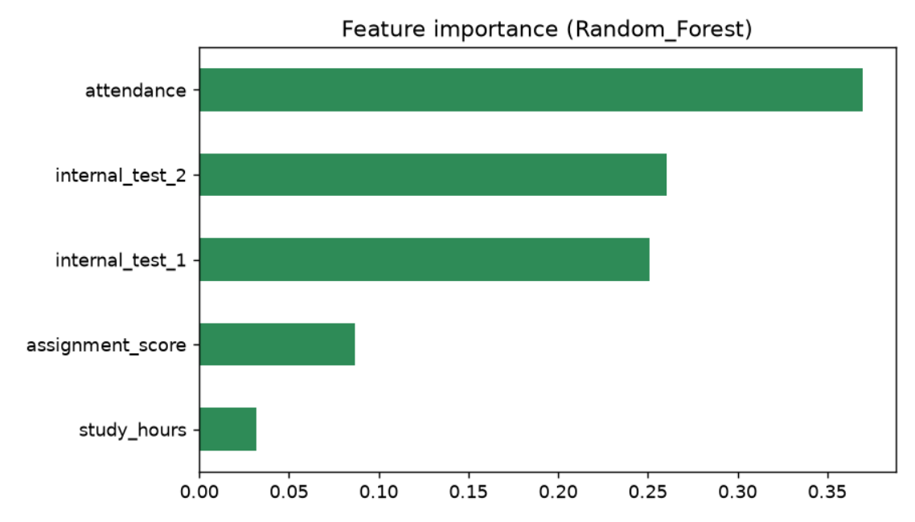
Fig. 5.16 :- Feature importance (Random Forest)

5.17 :- Feature Importance - Gradient Boosting
Gradient Boosting gives the same order as Random Forest: attendance (about 0.31), Internal Test 2 (0.26), Internal Test 1 (0.26), assignment score (0.12) and study hours (0.04). The tree models rank attendance first, whereas the permutation importance of the linear model ranks the two internal tests first; in all three charts the top three features are the same.
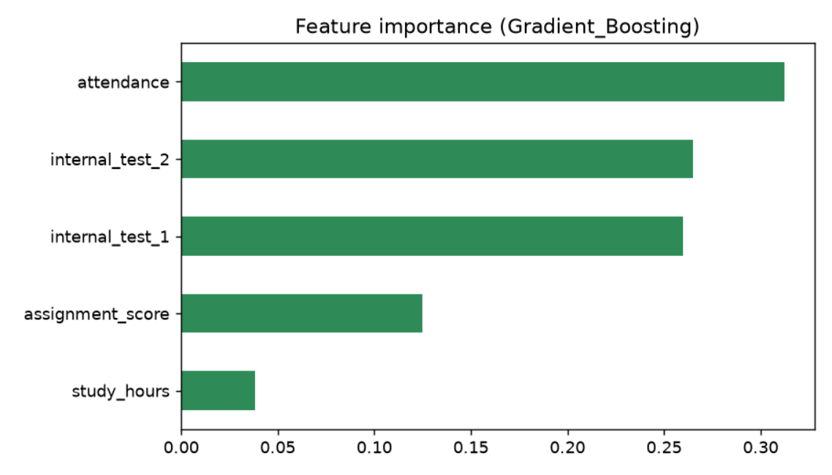
Fig. 5.17 :- Feature importance (Gradient Boosting)

5.18 :- Streamlit Web Application
The web application shows the five sliders, the Predict button and the predicted marks with the progress bar.
[ Insert screenshot: browser window of streamlit run app.py ]
Fig. 5.18 :- Streamlit Web Application

6. TESTING AND DEBUGGING

Introduction
Testing confirms that each part of the system works correctly and that the models give reliable results; debugging finds and removes errors. In this project testing covers data checks, automated pipeline tests, model evaluation on unseen data and the behaviour of the web application.

Types of Testing
1. Unit Testing. Individual parts of the pipeline are tested separately with pytest using the file tests/test_pipeline.py, which is run with the command pytest.
2. Integration Testing. The link between app.py and predict.py, and between predict.py and models/best_model.pkl, was checked to make sure that five input values return a predicted score.
3. System Testing. The complete flow, from EDA to training and then to a prediction in the browser, is run in the order given in the README.
4. Model Evaluation. Models are evaluated on test data that was not used for training, and also with 5-fold cross-validation. For regression the measures are R², MAE and RMSE.
Table 6.1 :- Model Evaluation Results
Model | R² (test) | MAE (marks) | CV R² | Best?
Ridge Regression | 0.839 | 3.48 | 0.834 | Yes (tied)
Linear Regression | 0.839 | 3.48 | 0.834 | Yes (tied)
Gradient Boosting | 0.821 | 3.65 | 0.815 | No
Random Forest | 0.796 | 3.94 | 0.797 | No
The values in Table 6.1 are taken from the project README (results of train_models.py). Ridge and Linear Regression give identical scores because the data is simple and well-behaved. The linear models beat the tree models, which suggests that the relationship between the inputs and the marks is mostly linear. The typical error of the best model is about 3.5 marks.

Debugging Notes
- If the message "best_model.pkl not found" appears, run python src/train_models.py first so that the model files exist.
- If an import fails or a file is not found, open the terminal inside the project folder before running the commands.
- If the error "No module named ..." appears, run pip install -r requirements.txt again in the same terminal (or python -m pip install -r requirements.txt; on Mac or Linux use python3).
- No plot windows open when eda.py or train_models.py run. This is normal, because the plots are saved as images in results/figures.
- app.py adds the src folder to the Python path relative to its own location, so streamlit run app.py works from the project folder.
TEST CASES:-
Table 6.2 :- Test Cases
Test Id | Description | Input | Expected Result | Actual Output | Status
TC-1 | Dataset loads | data/Final_Marks_Data.csv | 2,000 rows; 1,997 after duplicates removed | [ fill in ] | Pending
TC-2 | EDA outputs | python src/eda.py | Statistics printed; plots saved in results/figures | [ fill in ] | Pending
TC-3 | Model training | python src/train_models.py | 4 models, best_model.pkl and model_results.csv saved | [ fill in ] | Pending
TC-4 | Command-line prediction | python src/predict.py | Predicted marks printed | [ fill in ] | Pending
TC-5 | Automated tests | pytest | All tests pass | [ fill in ] | Pending
TC-6 | Prediction in the app | Default sliders, click Predict | Marks shown as xx.x / 100 with progress bar | [ fill in ] | Pending
TC-7 | Missing model file | Run app before training | Error message shown and app stops | Handled by try/except and st.stop() in app.py | Pass
TC-8 | Input limits | Move sliders to their ends | Values stay within 50-100, 0-40, 0-40, 0-10, 0-8 | Enforced by slider ranges in app.py | Pass
Status "Pass" for TC-7 and TC-8 was confirmed by reading the code in app.py. The cases marked "Pending" need the project to be run; fill in the actual output and change the status after running them.

Overall Conclusion
The application logic (error handling and input limits) behaves as designed, and the models reach a test R² of about 0.84 with a typical error of 3.5 marks. The remaining test cases should be recorded in Table 6.2 after the project is executed.

7. CONCLUSION AND FUTURE ENHANCEMENT
The Student Final Marks Prediction system shows how a complete machine learning workflow can be applied to an education problem. Starting from a dataset of 2,000 students, the project prepares the data, explores it, trains and compares four regression models, saves the trained models and makes them available through a simple Streamlit web application. A teacher or student can enter five values and instantly receive predicted final marks.
The results show that the two internal tests and attendance are the strongest predictors, and that a simple linear model (R² of 0.839, MAE of 3.48 marks) performs better than the more complex tree-based models. The project strengthens understanding of preprocessing with pipelines, model comparison, cross-validation, model persistence, testing and web deployment.

Limitations
- Predictions can be off by about 3 to 4 marks on average, and by more for individual students; they show a statistical relationship, not a guarantee.
- The dataset may be synthetic. The Kaggle dataset description should be checked and this stated if it is the case, because results on synthetic data may not carry over to real students.
- After removing duplicates only 1,997 records are used, which is a small sample.
- The five inputs do not include other important factors such as teaching quality, health, prior grades or family support.
- The app does not store results or history and has no user login.

Future Enhancement
- Model Tuning: Use hyper-parameter search (GridSearchCV) to try to improve the Gradient Boosting and Random Forest models.
- Explainability: Show which inputs raised or lowered each prediction using SHAP values.
- Performance Categories: Convert the predicted marks into bands such as Excellent, Good, Average and At Risk.
- Advice Engine: Suggest practical changes, such as more study hours or better attendance, and show the expected improvement.
- Database and Login: Store predictions in a database and add teacher and student logins with progress tracking.
- Online Deployment: Deploy the app online using Streamlit Community Cloud or a similar service.
With these improvements, the system can grow into a complete academic advisory tool for schools and colleges.

8. REFERENCES
Kaggle -- Student Academic Performance Dataset
https://www.kaggle.com/datasets/sonalshinde123/student-academic-performance-dataset
(Source of the dataset used in this project)
Python -- Official Documentation
https://docs.python.org/3/
(For core language syntax and standard libraries)
scikit-learn -- Machine Learning in Python
https://scikit-learn.org/stable/
(For regression models, pipelines, cross-validation and metrics)
Streamlit -- Documentation
https://docs.streamlit.io/
(For building the interactive web application)
pandas -- Documentation
https://pandas.pydata.org/docs/
(For loading and analysing the dataset)
NumPy -- Documentation
https://numpy.org/doc/
(For numerical computing)
matplotlib and seaborn
https://matplotlib.org/stable/ , https://seaborn.pydata.org/
(For EDA charts and correlation plots)
joblib -- Documentation
https://joblib.readthedocs.io/
(For saving and loading the trained models)
pytest -- Documentation
https://docs.pytest.org/
(For automated testing)
Class notes and study materials provided by Brainware University

