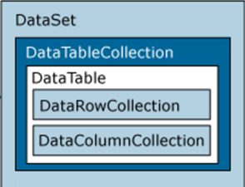

DataView

DataView is a databindable, customized view of a [Data](https://msdn.microsoft.com/en-us/library/system.data.datatable(v=vs.110).aspx)[Table](https://msdn.microsoft.com/en-us/library/system.data.datatable(v=vs.110).aspx) for sorting, filtering, searching, editing, and navigation. The DataView does not store data, but instead represents a connected view of its corresponding [DataTable](https://msdn.microsoft.com/en-us/library/system.data.datatable(v=vs.110).aspx). Changes to the DataView’s data will affect the [DataTable](https://msdn.microsoft.com/en-us/library/system.data.datatable(v=vs.110).aspx). Changes to the [DataTable](https://msdn.microsoft.com/en-us/library/system.data.datatable(v=vs.110).aspx)’s data will affect all DataViews associated with it.

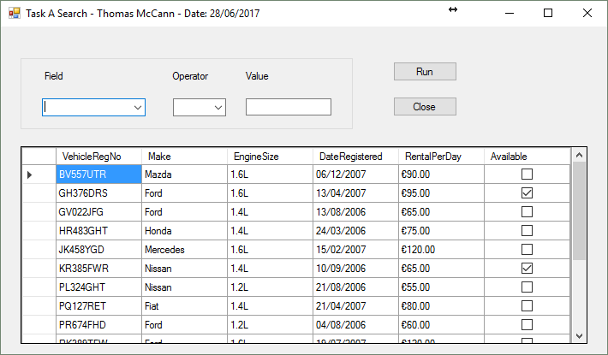

The DataSource of the DatGridView can be either a DataTable or a DataView.

(We create and use a DataView as we can apply a filter to our DataView.)

DataView RowFilter =

Make = ‘Ford Focus’

**ds.Tables[“tables”]**

**OR ds.Tables[0]**

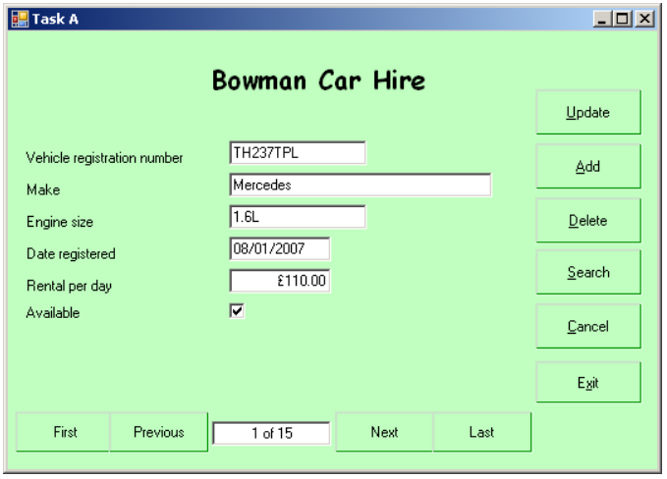

BindingSource

Encapsulates a data source for binding to controls. We use this to bind controls on the form to our data (in our DataSet).

SqlDataAdapter provides the communication between the Dataset and the SQL database. We can use SqlDataAdapter Object in combination with Dataset Object.

SqlCommandBuilder

SQLDataAdapter

Automatically generates single-table commands (INSERT, UPDATE, DELETE) that are used to reconcile changes made to a DataSet.

Multiple Databases (.**mdf** database files)

**Microsoft SQL SERVER**

**(LocalDB is a light version that comes with Visual studio)**