Intelli-fridge – a technological invention for reducing the amount of food wasted.

The main purpose of this project is to reduce the amount of food wasted at any venue. It can be our houses, offices, buffets, or any other place. It can be achieved by using something known as OCR which stands for optical character recognition. I consider the project to be implemented in fridges, pantries and/or any other food storage areas.

I was asking my mother for some candy and when she opened the fridge, it turned out it was expired so my mother simply threw it away. I started pondering about what just happened. I thought that the food and money were simply wasted. It then came to my mind to think of a solution for this because this probably happens at almost every home. I brainstormed several ideas until one stuck out to me the most. I started think about what to use and came up with a list. I started working on a plan and got to a rough idea. I started ordering the apparatus necessary for my project and my computer science teacher at school for guidance. I started to get more technical and think about the libraries to use in the code and after hours of research I knew I was going to use OCR in my project. I got the libraries for OCR and then started writing the code. After I wrote the code, I installed all the hardware which had arrived. I ran several tests to make sure everything worked, and I kept on thinking of ways to improve it. For example, adding the expired good to a digital inventory list. Finally, I consulted my computer science teacher to guide and supervise me.

I am going to use a Raspberry Pi for my project as it is a compact computer which can process images and handle running OCR. Here are the devices used:

* RPI 8MP Camera board, version 2, Sony IMX219 8-Megapixel sensor.
* Raspberry Pi 4 Model B, BCM2711 SoC, 4GB DDR4 RAM, USB 3.0, PoE Enabled along with 32 GB MicroSD card.

Here is how my project will function in a step-by-step guide:

1. The client will point the consumable’s best before date towards the camera.
2. The camera will read the best before date.
3. The camera will then run the best before date image into its OCR module in order to convert the image into characters for the Raspberry pi to read.
4. The raspberry pi will store the image in its database.
5. Then it will keep on giving alerts three days prior, then two and then finally one day prior.
6. When the last alert is received, and the client doesn’t to anything with the product. It is assumed by the raspberry Pi the best before date is overdue, so this results in the pi deleting the date from its database.

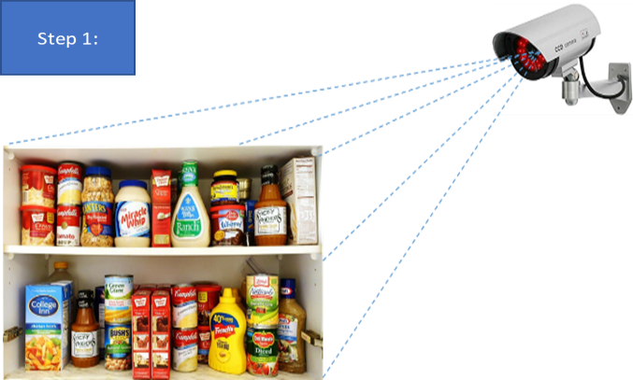

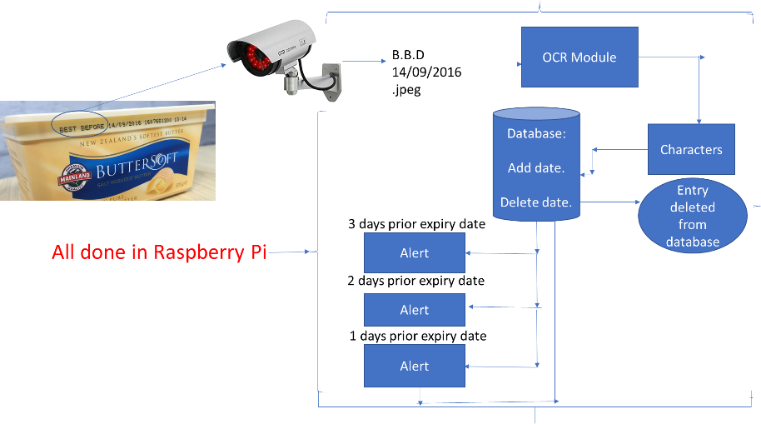

Step 2:

