Name: Ellie Parobek

Course: ISTE-120-03-2171

HW: #1

Object Method Calls:

new Square()

square1.makeVisible()

square1.changeColor(“black”)

square1.changeSize(50)

square1.moveDown()

square1.moveRight()

new Square()

square2.makeVisible()

square2.changeColor(“magenta”)

square2.moveDown()

square2.moveRight()

square2.moveVertical(10)

square2.moveHorizontal(-10)

new Triangle()

triangle1.makeVisible()

triangle1.changeSize(80, 100)

triangle1.moveDown()

triangle1.moveRight()

triangle1.moveHorizontal(-5)

triangle1.moveVertical(5)

new Triangle()

triangle2.makeVisible()

triangle2.changeSize(60, 70)

triangle2.moveDown()

triangle2.moveRight()

triangle2.moveHorizontal(-5)

triangle2.moveVertical(10)

new Triangle()

triangle3.makeVisible()

triangle3.changeSize(35, 40)

triangle3.moveDown()

triangle3.moveRight()

triangle3.moveHorizontal(-5)

new Circle()

circle1.makeVisible()

circle1.changeSize(15)

circle1.changeColor(“red”)

circle1.moveUp()

circle1.moveRight()

circle1.moveVertical(20)

circle1.moveHorizontal(-3)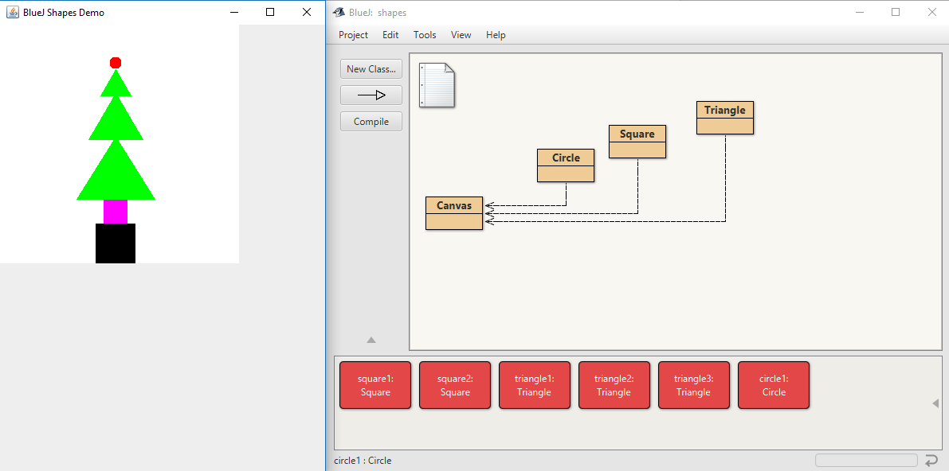

State of Objects:

object name = square1

size = 50

xPosition = 120

yPosition = 250

color = “black”

isVisible = true

object name = square2

size = 30

xPosition = 130

yPosition = 220

color = “magenta”

isVisible = true

object name = triangle1

height = 80

width = 100

xPosition = 145

yPosition = 140

color = “green”

isVisible = true

object name = triangle2

height = 60

width = 70

xPosition = 145

yPosition = 85

color = “green”

isVisible = true

object name = triangle3

height = 35

width = 40

xPosition = 145

yPosition = 55

color = “green”

isVisible = true

object name = circle1

diameter = 15

xPosition = 137

yPosition = 40

color = “red”

isVisible = true