**Exercise 1**

**Good Feedback:**

The iPhone has a custom display when plugged in to show it is charging (Figure 1). This display is both on the lock and unlock screen (Figure 2). The lock screen actually will have 2 indicators to allow you to quickly see in the center of screen what your battery is at. The color of the “battery” image turns to green instead of white and has a lightning bolt next to it. This indicates that the battery is actively charging.

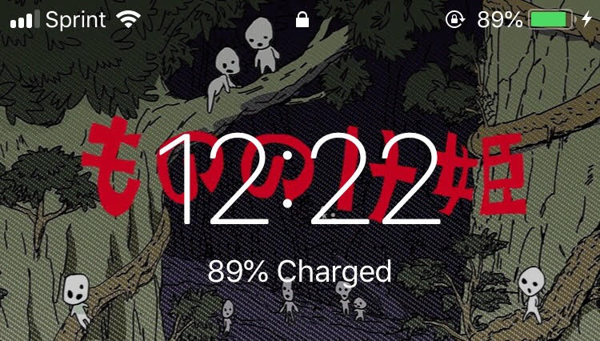

**Figure 1:** Top of the iPhone lock screen showing it is charging both in the center and in the top right.

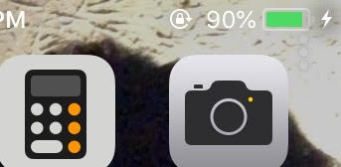

**Figure 2:** Top right of the iPhone unlock screen showing it is charging.

**Good Visibility of a System State:**

Some similar internet connectivity symbols are on almost any device (that connects to the internet) and can show you how well connected you are to WiFi. Most devices will have the same symbol or close to the same being 3-5 bars that get bigger in a triangle shape (Figure 3). As your connectivity gets worse, less bars will be shown / will be grayed out. With no connection, all bars will be grayed out or the symbol will not show up at all.



**Figure 3:** Having full bars/ full connection to WiFi (left) and having no connection, the bars being grayed out (right).

**Bad Mapping:**

The faucet in our bathtub (Figure 4) is supposed to work in one direction starting hot and getting colder. The problem is, the knob stops turning halfway around the expected turning radius (facing straight down). That point is only warm instead of cold water. You have to turn the knob all the way back off and into the other direction to get cold water. Along with this, there aren’t any color indicators to which direction is which temperature such as the usual red = hot, blue = cold.

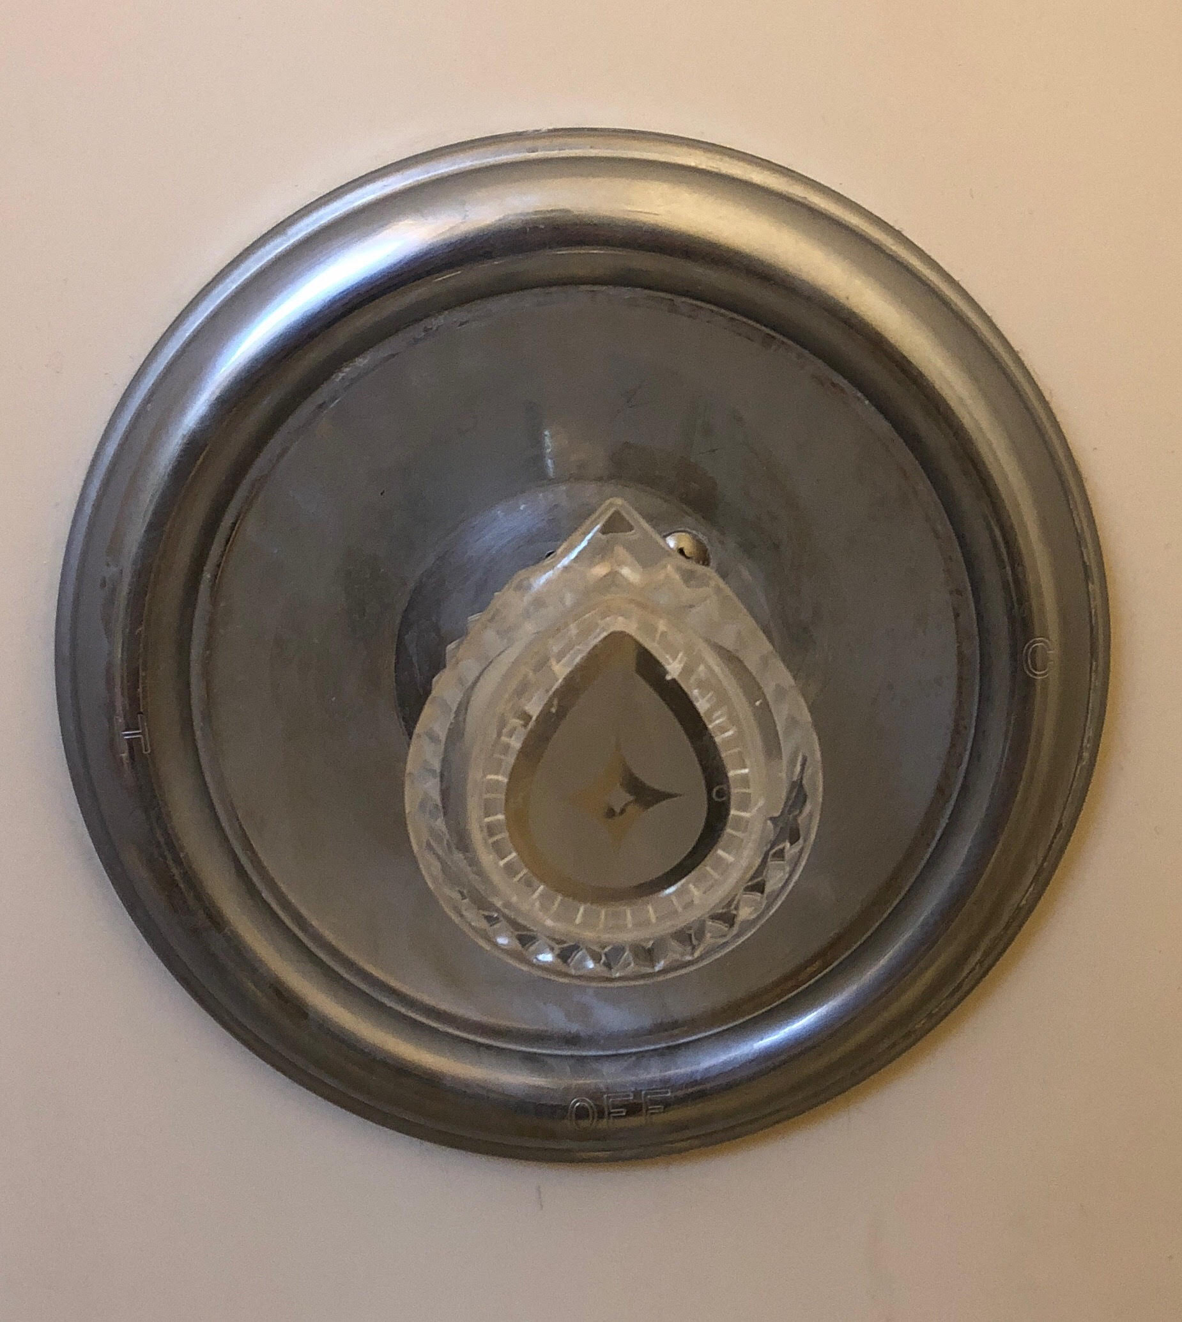

**Figure 4:** My shower faucet that has poor mapping. Turning left is cold water and turning right is hot - warm water. The current position is off.

**Bad Affordances / Signifiers:**

A bad affordance is one of the lamps in my house (Figure 5). It has a knob that affords twisting near the top where the light is which one may assume is how you turn it on, but twisting them does nothing. The actual way to turn the light on is by pushing the knob in which is a hidden affordance. It looks like you would twist the knob and based on past experiences, most lamps with this type of design are twisted but instead you have to push it.

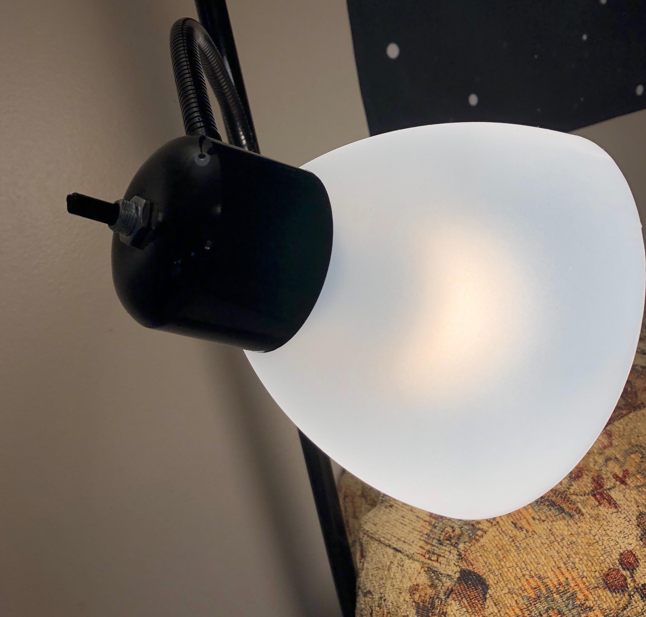

**Figure 5:** A lamp with a knob that affords twisting but must actually be pushed in to turn the lamp on.

**Bad Constraints:**

Many products will oversimplify aspects as to help older people or people unfamiliar with the product. This can make people who are used to the product frustrated with how slowly things go and how limited they are. A specific example of this is with video games. Most games have a tutorial at the start of the game that teaches you how to play the game such as in the Pokemon games (Figure 6). This helps newer people but is an annoyance to returning players as they already know how to play yet are limited in what they can do and cannot skip unnecessary learning tutorials.

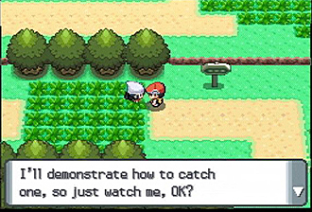

**Figure 6:** The start of the Pokemon games begins you with limited actions and makes you listen to someone explain how to play the game.