**Usability Test:** “PenPal”

**Team 1 (Red):** John Hill, Ellie Parobek, Kathy Deng, Nick Mancini, Yogi Adhikari

**Critical Task**

Users must navigate and compose an email based on their desired template. The users should be able to navigate the menus easily and quickly understand how to accomplish the given tasks.

**Goal**

The goal of this test is to test the ease of use and different functionalities of PenPal’s interface such as the “sign up”, “edit profile”, “upload resume”, and “compose email” features. Aesthetics and color schemes of the interface can also be observed. The user will be tasked with navigating through PenPal’s options based on a given goal in mind. We will observe any complications, errors, or confusion to better rethink and redesign our program to be easier and quicker to use.

**Task Scenario**

Users will walk into a classroom with a variety of other students. They will then be greeted by a proctor and then sat down for questions/tasks. One proctor is going to time the test subject for each of the tasks listed above. There is no set limit, in which, the subject must complete the tasks, so the proctor will try to keep the clock hidden. This will attempt to eliminate any anxiety/stress one might gain from being timed. The subject’s clicks will also be measured to see if our UI can be optimized to mitigate needless clicks and prevent time from being wasted. Once the subject has completed all of the tasks, the proctor will interview the subject based on their experience and ask them to measure how aesthetically pleasing the program’s UI was.

**Testing Procedure**

**Measurements: Time and Number of clicks to accomplish task**

**Survey: Aesthetically pleasing visuals with a rating scale of 1-10**

1. Sign up for an account
2. You already forgot your password, you need to reset it
3. Login, then edit your profile information
4. Upload a resume to your account
5. As a Student, write a ‘Job Inquiry Email’, correct it, attach your resume, and then send it.

Debriefing: A few minutes will dedicated to interviewing the participant about how they performed their tasks and what made them use their process.

**Data Recording**

**Data to record:** Number of clicks to reach a goal, time to complete a goal

**User 1:** PKJ

Task: Edit profile and write a job inquiry as a student

Number of Clicks: 8

Time: 44.01

Data: Simple enough, didn’t have any extra clicks to do anything. Got where they needed to be.

**User 2:** MR

Task: Edit profile and write a job inquiry as a student

Number of Clicks: 10

Time: 1:02.76

Data: Same as User 1, no comments.

**User 3:** BD

Task: Edit profile and write a job inquiry as a student

Number of Clicks: 9

Time: 27.40

1. Is the color scheme aesthetically pleasing?

Yes, looks good

1. How easy is the system to navigate?

Everything is easily labelled, simple to know where you are.

1. How useful is this product?

Looks good for what it is supposed to be.

1. How often would you use this product?

Use it if needed to send a resume or something similar.

1. Any other comments?

Like handshake but not really only how it targets jobs. Would probably pay for it if it was a small cost for an app.

Data: Commented that it looked very professional and went through everything easily.

**User 4:** MF

Task: Edit profile and write a job inquiry as a student.

Number of Clicks: 19

Time: 2:30:17

1. Is the color scheme aesthetically pleasing?
2. How easy is the system to navigate?

Dropdowns are a bit confusing, switch dropdowns to be “Student-Employer-Other roles” instead of how the student drops down to the student options. The dropdown is the roles and the abilities the roles can do could be buttons below or something similar.

1. How useful is this product?
2. How often would you use this product?
3. Any other comments?

Keep dropdown but have select role and then it brings up the new template, previous, next, etc page. Role should change what options are presented on the next page.

Data: Error clicking text boxes to log in. Went through pretending to edit the text boxes and clicking around everything. Went to see what all the dropdowns did. Got lost trying to open the student role and our program stopped working so he didn’t finish the task. Thought you log in as a student or as an employer instead of choosing the role later.

**User 5:** NN

Task: Edit profile and write a job inquiry as a student.

Number of Clicks: 9

Time: 42.95

1. Is the color scheme aesthetically pleasing?

Minimalistic, easy, straightforward, and no junk in the way. Logo looks good.

1. How easy is the system to navigate?

Function gets lost a little but with more functionality it would make sense. If everything worked, it would be easy to tell what it would do.

1. How useful is this product?
2. How often would you use this product?
3. Any other comments?

Data: Assumed text boxes didn’t work. Got through task easily. Thought you log in as a student or as an employer instead of choosing the role later.

**User 6:** DB

Task: Edit profile and write a job inquiry as a student.

Number of Clicks: 13

Time: 2:03.0

1. Is the color scheme aesthetically pleasing?
2. How easy is the system to navigate?

“Create new” and “new template” don’t know what the difference is (old wireframe). Three main buttons make more sense even if we don’t know what they are supposed to do. Have more information / be more specific on what to do.

1. How useful is this product?

If gotten as an app, would have a better idea of the purpose.

1. How often would you use this product?
2. Any other comments?

The employer looked like an option/ task like it would be a student (top dropdown) responding to employer (bottom dropdown). Similar to Grammarly or fixed emails.

Data: Went to employer instead of student. Definitely got lost getting to student.

**User 7:** JA

Task: Edit profile and write a job inquiry as a student.

Number of Clicks: 12

Time: 1:49.26

1. Is the color scheme aesthetically pleasing?
2. How easy is the system to navigate?

Very lost, have a site map or better navigation. Lost on the student/employer screen. Can’t remember what was just clicked, map whether it was a student job inquiry or what it may be.

1. How useful is this product?
2. How often would you use this product?
3. Any other comments?

Data: Not sure if we were at the edit profile page or not. No confirmation if profile was edited. Tried to go to employer again.

**User 8:** SV

Task: Edit profile and write a job inquiry as a student.

Number of Clicks: 11

Time: 1:59.65

1. Is the color scheme aesthetically pleasing?

Looks good, buttons for everything, looks fun.

1. How easy is the system to navigate?

If everything was working the functionality would have been fine.

1. How useful is this product?

Think that it is great for a student with disabilities. Something that can help someone do things easier is awesome.

1. How often would you use this product?
2. Any other comments?

Data: Edit profile disappears when you click the dropdown. Didn’t go to edit profile. Not sure what the purpose of the application was entirely.

**User 9:** CP

Task: Reset password, edit profile, send email as a student with a job inquiry and grammar/ spell check it.

Number of Clicks: 21

Time: 1:11

1. Is the color scheme aesthetically pleasing?

5

1. How easy is the system to navigate?

Mostly easy. Drop downs are weird because you can be both options

1. How useful is this product?

9

1. How often would you use this product?

Weekly

1. Any other comments?

Good job, guys

Data:

**User 10:** AJV

Task: Reset password, edit profile, send email as a student with a job inquiry and grammar/ spell check it.

Number of Clicks: 20

Time: 1:09

1. Is the color scheme aesthetically pleasing?

10. Functional and not too bold

1. How easy is the system to navigate?

Issue clicking the buttons. Pointer is too big (Balsamiq wireframe issue)

1. How useful is this product?

Pretty good.

1. How often would you use this product?

10 times a week

1. Any other comments?

Flowed pretty easily and quickly. Spellcheck was really helpful.

Data: Paused on save email page.

**User 11:** SN

Task: Reset password, edit profile, send email as a student with a job inquiry and grammar/ spell check it.

Number of Clicks: 22

Time: 1:18

1. Is the color scheme aesthetically pleasing?

10. It’s good

1. How easy is the system to navigate?

Easy. Flowed fine.

1. How useful is this product?

Would use it every single day

1. How often would you use this product?

7 times a week

1. Any other comments?

Why is the PenPal logo different fonts? Other than that, I like it a lot

Data: Got stuck editing the profile. Had to go to my account first and then edit profile

**User 12:** LD

Task: Reset password, edit profile, send email as a student with a job inquiry and grammar/ spell check it.

Number of Clicks: 25

Time: 1:17

1. Is the color scheme aesthetically pleasing?

Colors are nice

1. How easy is the system to navigate?

Pretty easy to find stuff. Got confused at *I am..* page

1. How useful is this product?

Really useful

1. How often would you use this product?

Daily

1. Any other comments?

Pretty easy to use.

Data:

**User 13:** BMG

Task: Reset password, edit profile, send email as a student with a job inquiry and grammar/ spell check it.

Number of Clicks: 23

Time: 1:32

1. Is the color scheme aesthetically pleasing?

Color scheme is dated.

1. How easy is the system to navigate?

Most everything was how he expected. *I am..* Page was misleading

1. How useful is this product?

Template feature seems useful. As an entire product not sure if he would use it.

1. How often would you use this product?

As an extension, would only use it for professional emails and needed a template. Would use when making first contact.

1. Any other comments?

No.

Data:

**User 14:** SH

Task: Reset password, edit profile, send email as a student with a job inquiry and grammar/ spell check it.

Number of Clicks: 24

Time: 1:44

1. Is the color scheme aesthetically pleasing?

10.

1. How easy is the system to navigate?

A little issue at the welcome page. When to template instead of compose email

1. How useful is this product?

Pretty useful.

1. How often would you use this product?

Fairly often. Need to find a job.

1. Any other comments?

No.

Data: Got distracted with mouse physics. Got confused when composing email- went straight to templates.

**User 15:** KV

Task: Reset password, edit profile, send email as a student with a job inquiry and grammar/ spell check it.

Number of Clicks: 22

Time: 2:03

1. Is the color scheme aesthetically pleasing?

Old-fashioned not too overdone or appealing.

1. How easy is the system to navigate?

On my account page, compose email should be visible. Same on all pages

1. How useful is this product?

Personally, wouldn’t use an automatic email generator. Can tell it is too cookie cutter if the product catches on. Worried employers will find out he is using a template. Could be useful for long emails

1. How often would you use this product?

Wouldn’t use it.

1. Any other comments?

Instead of separating by student or employer, just show templates.

Data: got held up at my account when moving on to the third task. Drop-down didn’t work as expected. Took to a new page instead of populating box. Should already spell check since it’s a template.

**User 16:** RMS

Task: Sign up, forgot password, edit profile, attach resume, as a student write job   
 inquiry email.

Number of Clicks: 39

Time: 2:40.37

1. Is the color scheme aesthetically pleasing?

Easy on the eyes, font is readable, not distracting and bright.

1. How easy is the system to navigate?

Straight forward.

1. How useful is this product?

A lot of students don’t know how to write emails properly and would be a good starter to edit more personally and faster.

1. How often would you use this product?

Wouldn’t personally unless needed help with it.

1. Any other comments?

A lot of information, some words/ phrases are different.

Data: Went to compose email straight after adding resume. Tried to scroll: doesn’t work.

**User 17:** EK

Task: Sign up, forgot password, edit profile, attach resume, as a student write job   
 inquiry email.

Number of Clicks: 36

Time: 2:44:60

1. Is the color scheme aesthetically pleasing?

Color theory blue = trust so good.

1. How easy is the system to navigate?

Seems like an initial learning curve, didn’t know you could compose email from any page. Good to have that button on every page

1. How useful is this product?

Can see people using it

1. How often would you use this product?

Not a lot, (lazy) but once per a resume.

1. Any other comments?

The point is sending an email with your resume can fix any mistakes.

Data: Logged in instead of sign up. Kept going back instead of clicking compose email button. Wasn’t sure if resume was uploaded.

**User 18:** JR

Task: Sign up, forgot password, edit profile, attach resume, as a student write job   
 inquiry email.

Number of Clicks: 36

Time: 1:57.89

1. Is the color scheme aesthetically pleasing?

Easy to read and see.

1. How easy is the system to navigate?

Wasn’t hard to find things.

1. How useful is this product?

Useful for applying for jobs to become easier.

1. How often would you use this product?

Whenever wanted to apply for a job.

1. Any other comments?

Looks good

Data: Tried to put in info. Went straight to compose email from resume upload. Didn’t know which template to use.

**User 19:** WK

Task: Sign up, forgot password, edit profile, attach resume, as a student write job   
 inquiry email.

Number of Clicks: 43

Time: 2:57.25

1. Is the color scheme aesthetically pleasing?

Not overly bright, doesn’t hurt eyes.

1. How easy is the system to navigate?

Fairly easy, usually assume ahead of time from using other applications, but somebody might not be able to find how to write a job inquiry specifically but should be able to.

1. How useful is this product?

Not entirely sure that it is necessary, kind of streamlines process but this process is already fairly easy (LinkedIn, handshake already there). Viable option as a competitor for streamlining service easily but should have more customization options.

1. How often would you use this product?

Use if trying to do formal emails to find a job, but only used for that really, not for any other types of emails (don’t use email much anyways). For what it’s used for would use a lot.

1. Any other comments?

More customization options to be different from LinkedIn/handshake like finding jobs. Helpful as email aid though. Could be easily done with a google extension instead. Or app that connects to browser in the background, so you don’t have to think about it until it comes up, integrates with what they already do. But maybe have both options to have a full interface too. Have popup that asks if you want to write professionally or not.

Data: Sign up screen = cool. Didn’t save profile changes at first. Looked to see resume and explored stuff. Went all the way back to compose email.

**User 20:** JF

Task: Sign up, forgot password, edit profile, attach resume, as a student write job   
 inquiry email.

Number of Clicks: 36

Time: 2:25.33

1. Is the color scheme aesthetically pleasing?

Liked colors, overall cute

1. How easy is the system to navigate?

Fairly easy, my account section is a little odd having my resume in there. Makes sense after clicked but at first not sure where to go. Possibly another button for resume instead of in my account.

1. How useful is this product?

Fairly useful, nice.

1. How often would you use this product?

Don’t send a lot of emails so not super frequently, if applying to job would use more often but not day to day.

1. Any other comments?

Compose email button was with the back on every page and not that the purpose is understood it makes sense but the location / position or the layout seems strange. Maybe try moving to top left corner to separate from the back button.

Data: Tried to edit profile, went well. Went all the way back to compose email. Tried to scroll to see info.

# Data Gathering Tools

1. **Stopwatch**
2. **Paperback Survey**
3. **Balsamiq and XD Prototype**
4. **Windows 10 Laptop**

Usability testing was conducted through prototypes primarily created in Balsamiq with additional enhancements with Adobe XD. The prototype had limited functionality for testing purposes with a plain color scheme and very generic buttons and screen layout.

The test user’s actions were guided by a set of guidelines for the tasks to be performed. The screenshots below show some of the PenPal’s test screens as presented to the users.

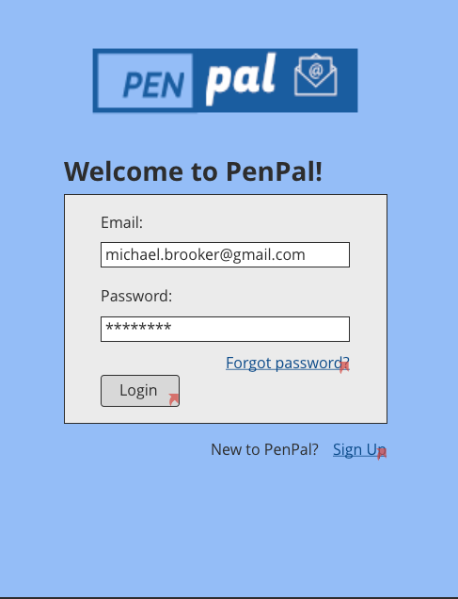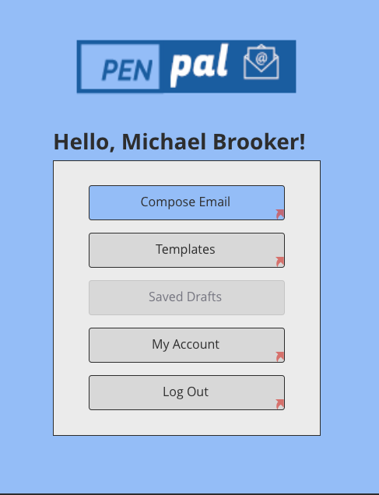

*Fig 1. PenPal login page Fig 2. PenPal main menu page*

Fig. 1 and 2 shows PenPal’s login page and main menu respectively. The login page allows the user to login with an existing account, reset password if forgotten, and sign up for a new account. The red arrows indicate navigable links in the prototype that was generated in Balsamiq. The navigation links were functional during user testing.

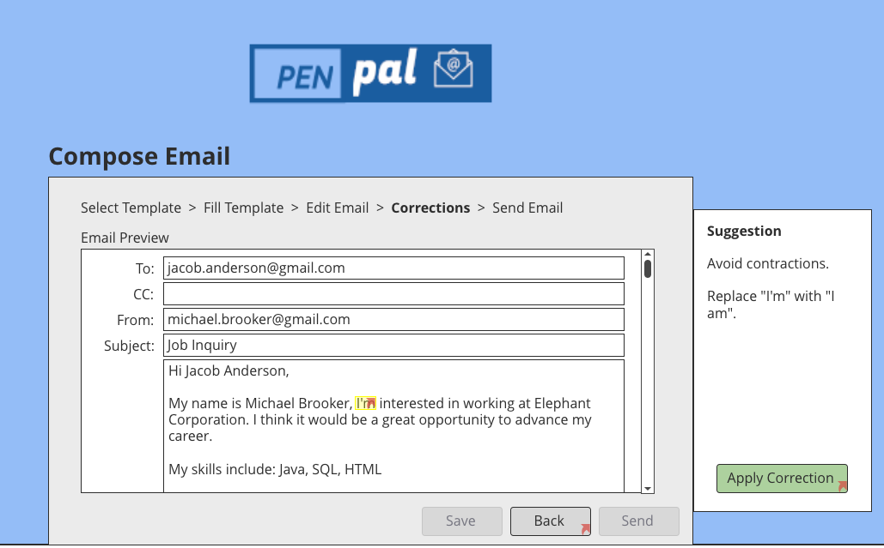

*Fig. 3 Compose Email screen with error correction*

Screenshot displaying email composition box (Fig. 3) with editable text fields and error correction feature. The top-row within the dialog-box displays the system status information to inform user of the past steps taken, with the current step in bold font. The pop-up screen to the right provides suggested corrections to the email.

**User Survey**

**The following survey is scaled from 1-10 (10 being strongly agree and 1 being strongly disagree)**

1. Is the color scheme aesthetically pleasing?
2. How easy is the system to navigate?
3. How useful is this product?
4. How often would you use this product?
5. Any other comments?

**Data Summary**

The graphs were split into the different days because we changed our prototype each day based on the feedback we received. We also changed the tasks based on our modified prototypes so it wouldn’t make sense to compare the different days to one another.

Below are the graphs of the number of clicks that it took for each user to complete the given tasks.

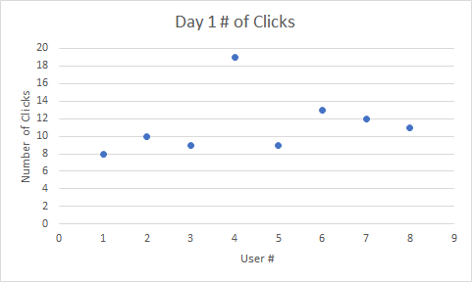

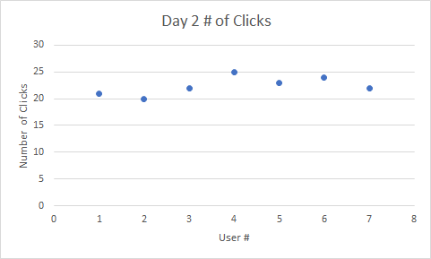

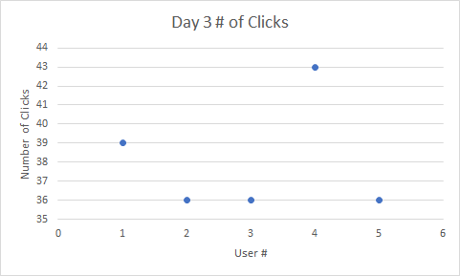

Below are the graphs that show how long it took each user to complete the given tasks:

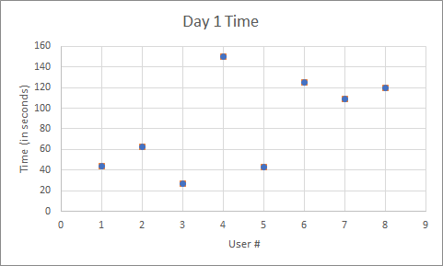

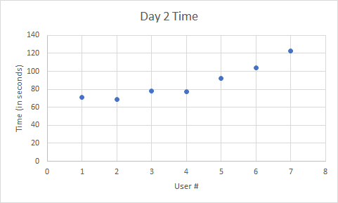

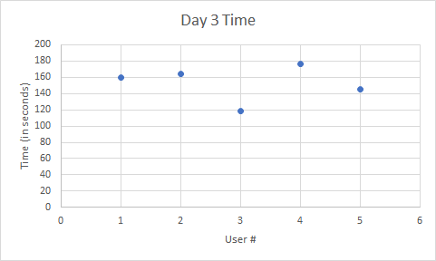

**Conclusions**

The three days of usability testing were very useful in order to incrementally improve our application. After getting feedback each day, we refactored our application to make it more usable. We also updated the tasks to better suit our refactored application.

**From Day 1, the primary feedback we received:**

It was confusing to navigate around completely. Subjects were getting confused with the student and employer drop downs and didn’t understand what they really meant.

**From Day 2, the primary feedback we received:**

The product is much better, navigability was much more understood, and more pages were added. Some dropdown links seemed a bit confusing still. Almost all participants went through the whole program without a problem.

One of the main hangups that participants had was with the “I am” screen being that our testers assumed that the program would be able to recognize whether they were students or employers. They thought that it was unnecessary for them to be required to choose their current occupation which we fixed after day 2. This is how the page looked before we changed it:

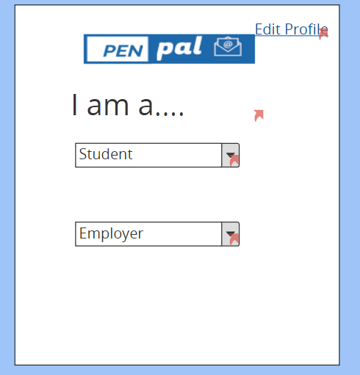

**Summary:**

In conclusion, our product by day 3 was much more improved from day 1. The aesthetics were somewhat boring and simple but kept it minimalistic as most subjects seemed to like them. The navigability was best understood once gone through once and would be best understood after multiple uses of the product but otherwise was not too complicated. Overall, most participants said they would use this product from time to time for professional use. Our best feedback was one participant who said our product would be best used as a chrome extension or something similar where it would automatically give feedback from the side of a screen when typing, and to be toggled on or off.

**How could we improve our experiment design?**

It would have been beneficial to have a preset script that we said to each person. This way no matter who was administering the test there would be a consistent test experience for the user. Also, I think it would have been useful to give the user a little background information

Have the users verbalize their thoughts when they are going through the tasks to get further insight to what they are thinking/feeling.

**Task Scenario**

Throughout each testing day we were improving the task to be done. It started simple with just “edit profile and write a job inquiry as a student” but we found that wasn’t receiving much data. The second day our task was “reset password, edit profile, send email as a student with a job inquiry and grammar/ spell check it”. Which provided much better and varied results as more pages and clicks had to be gone through. The third day was much improved as the task was “sign up, forgot password, edit profile, attach resume, and as a student write job inquiry email”. This lead to the most specific results with many pages being visited. The best task we could have, if we had more time and more pages, would be to visit all the pages or as many as possible to collect the best data while getting genuine feedback on each page.

**Testing Procedure**

It was difficult to maintain an accurate count of the number of clicks as we were also communicating with the participant at the same time. If there was a way to have the computer measure the number of clicks that would be beneficial for the most accurate data.

**User Survey**

It could be beneficial to have more questions, and maybe more questions that were from a scale of 1-10 but the open ended questions seemed to give more thought and better responses from some people.

**How should we modify our prototype based on the testing?**

We modified our prototype a couple times throughout the testing process.

**After day one we:**

* Added “I am a …..” above the dropdown menu
* Made it easier to navigate to other templates after selecting the wrong one by mistake

**After day two we:**

* We removed the dropdown menus
* Made the theme of the application more consistent
* Had a landing page after the user logged in
* Added new versions of the following pages: template, resume and accompanying landing pages, sign up, forgot password, verification for forgot password, and the home page. Made them more user friendly based on the feedback taken from day 2. We also made the color scheme more consistent with the rest of the pages.
* Fixed corrections page to provide user with more information on what grammar/spelling mistakes the program was trying to fix as well as how it intends to fix them

**Conclusion:**

If we were to make changes after the last testing day, we could add functionality for more pages. The color scheme could be expanded to be more colorful if we decided it was too simple. The “compose email” button could be moved to a static location closer to the top of the page as some participants suggested along with giving the button a more visible look as it is the most important button. Having more breadcrumbs may help with navigability even further.

**Blank Consent Form**

**Rochester Institute of Technology**

**Department of Information Technology**

**Informed Consent Form**

**Project: USABILITY TESTING – PenPal; V1.0**

**Principal Investigators**:

The usability test you have volunteered to participate in will help us to better understand problem solving, decision-making, and perception in individuals as they use various types of software, products and/or equipment**.** We do not anticipate taking more than 10 minutes of your time. Performance in the usability test will not be assigned an academic grade.

## **RISKS**

We do not foresee any risks associated with your participation in this study.

## **BENEFITS**

This project is intended to get feedback from users and/or to gain an understanding of the usability of a product. In addition, you will gain the experience of being involved in a “real” usability test.

## **CONFIDENTIALITY**

Data will be compiled and analyzed in an anonymous manner and will only be reported in the aggregate and never by name. Publications related to this work will not make reference to individuals. The summary may include discussion of the demographics of the subjects. The session may be recorded on video and/or audio tape, and notes will be taken to record your opinions and actions. You will also be observed through a one-way viewing window. This document states that you agree to be video/audio taped and observed while participating in this study. This information, including the video tape, may be used to improve products and/or interfaces. It may also be shared with others for educational or promotional purposes. We will hold as confidential your personal information (such as name and phone number, and any images showing facial views) and use it only for research purposes.

## **CONTACT**

If you have questions at any time about the study or the procedures, you may contact the researchers: at (585)555-5555.

## **PARTICIPATION**

Your participation in this study is voluntary; you may decline to participate without penalty. If you decide to participate, you may withdraw from the study at any time without penalty and without loss of benefits to which you are otherwise entitled.

## **CONSENT**

**I have read and understand the above information. I have received a copy of this form. I agree to participate in this study.**

**Participant’s signature _____________________________________**

**Date _________________**

**Participant’s name (printed) _____________________________________**

**Investigator's signature _____________________________________ Date _________________**

**Parent’s signature _____________________________________ Date _________________**

**(if student is under 18)**

**Blank Data Sheet**

**User:**

**Tasks Given:**

1. Sign up for an account
2. You already forgot your password (you dummy), you need to reset it
3. Login, then edit your profile information
4. Upload a resume to your account
5. As a Student, write a ‘Job Inquiry Email’, correct it, attach resume, and then send it

**Number of clicks to achieve task:**

**Time to achieve task:**

**Data:**