*Software Engineering Project*

*Group – 9*

***‘Online Medical File’***

***ABOUT THE PROJECT***

* *Our project on system for patient and private doctors. It is and non- profitable app. If people need treatment or any consultation from doctors. For that, 1st the patient have to open his/ her account in the system. Then patient can take appointment from the doctor. They also Search for the doctor. And also pay the doctor’s fee by this system.*

***Dose The Project have a clear target market or audience?***

* *Our system is about taking treatment or counseling.*

***Problems or Opportunity***

* *People/ patient need to take treatment or counseling, they have to go to Clinic or hospital. But the here the patient can take treatment or counselling from home by this system. They have to go to the clinic or hospital for taking appointment for the doctor but here they can take appointment by this system and after that also can pay the fees by this system. So as this is a online system through the software, people from anywhere can take the facilities which will be very helpful for the patients.*

***Is the project’s purpose and basic functionality easily understood?***

* *The purpose of this project is to save the time and the people can easily take the appointment of the doctor.*

***Use Case Diagram***

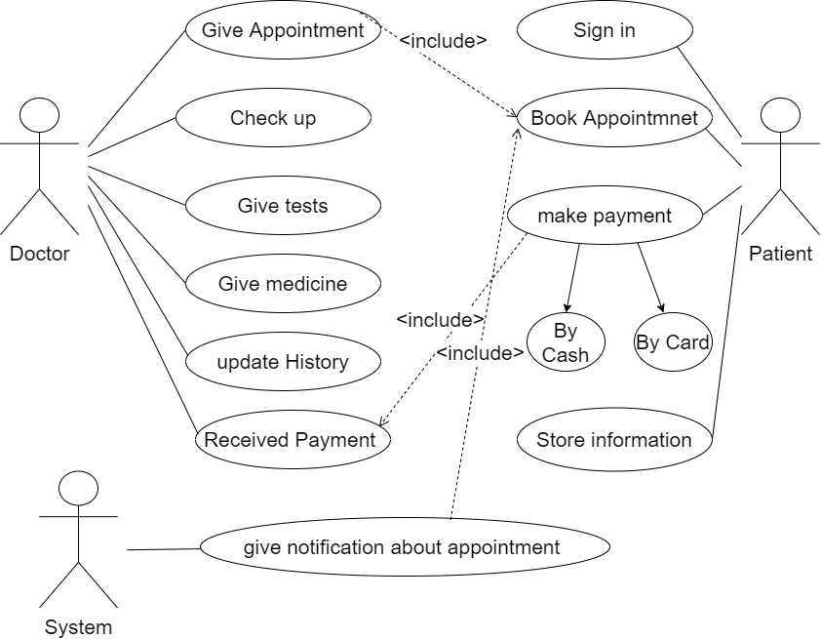

***UI Design***

