Time-dependent System Reliability Analysis with Repairable or Non-Repairable Components

M.D. Pandey and T. Cheng

University of Waterloo, Waterloo, ON, Canada

ABSTRACT: A genetic methodology is presented for time-dependent reliability analysis of systems consisting of repairable and/or non-repairable components. Each component has a random life time and repair time described by general (non-exponential).probability distributions. The time-dependent failure and repair rates are derived for each individual component of the system by solving a set of renewal equations. System failure rate and availability are computed based on the component level information. The value of the proposed method is illustrated by the optimization of the life cycle cost of a structural system. It is noted that most of the literature on structural system reliability analysis focuses on systems with non-repairable components only. Thus the proposed approach is a significant generalization of the current state of the art. The proposed method can be applied to a variety of infrastructure systems, such as bridges, buildings and power systems. .

# Introduction

System reliability analysis of structures is a well established topic of research in civil engineering. Approximate methods based on First-Order Reliability Method (FORM) and simulation models have been developed for time-invariant and time-dependent systems.

The paper presents a generalization by considering that failed components can be repaired/replaced and put back in the service.

Uncertainty associated with the occurrence of failure of a component is modeled by treating the time to failure as a random variable. For example, corrosion of reinforcement in concrete structures would make the time to failure with respect to a specified limit state a random variable. The output of the corrosion model can be given in terms of the time to failure probability distribution, such as the Weibull or lognormal distribution.

What happens to a component after the failure is important from the analysis point of view. If the component can be repaired in finite, though random, time and put back in the service, the component is referred to as repairable. In this case, the time to repair can be modeled as a random variable. If after the first failure, the component can not be renewed by repair or replacement, it is said to be non-repairable.

For the sake of clarity of discussion, we present the model development through an example of a system as shown in Figure 1. There are four independent components in this system, denoted as *Ci*, *i* = 1-4. There are two parallel sub-systems, {*C1*, *C2*} and {*C3*, *C4*}, connected in a series.

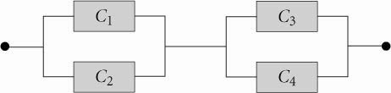

Figure 1: Reliability block diagram of the example system

In this paper, the reliability of this system will be evaluated considering that all the components are non-repairable as well as repairable. Finally, the computation of life cycle cost will also be illustrated.

# System with non-repairable components

First we consider a case in which all the components are non-repairable. This assumption is implicit in many papers analyzing the reliability of structural systems. Suppose the time to failure or uptime distribution of a components is denoted as *U* and its CDF and PDF are denoted as *FU*(*t*) and *fU*(*t*), respectively. The unavailability, *Q*(*t*), of the component at time *t* is the component’s probability of failure before time *t*, which is given by the CDF. The probability of failure in a small interval, *t* < *U* ≤ *t* + d*t*, is equivalent to the probability density in this interval, i.e., *fU*(*t*)*dt.* This is similar to the failure rate, *w*(*t*), defined in the next section for repairable components. Thus, we can write

 (1)

The system reliability problem can be easily solved using the rules of combining probabilities of independent events. The CDF and PDF of the first parallel sub-system in Figure 1 are respectively given as

 (2)

Note that the PDF is obtained by differentiating the CDF. Similarly for second parallel sub-system, *M*2, the results are obtained as

 (3)

Since these two sub-systems are in series, the system failure before time *t* takes place by the failure of one OR the other subsystem. The CDF of time to system failure is thus given as

 (4)

The PDF is obtained in usual way by differentiating the CDF and the result is

 (5)

Since there is no repair involved, Eq. (4) basically describes the probability of “first failure” of the system.

# System with repairable components

This section shows that when all the components of the system are considered repairable, the reliability analysis changes dramatically. Suppose the time to repair including the downtime is modeled by a random variables, *D*, with CDF and PDF given as *FD*(*t*) and *fD*(*t*), respectively. Distributions of the time to failure and time to repair are independent of each other.

The state of the repairable component at time *t* can be either *U*(*t*), up state, or *D*(*t*), down state. The modeling is based on the theory of stochastic alternating renewal process (Birolini 1999). We introduce two other events: (1) *W*(*t*) is the occurrence of failure in interval *t* and *t* + d*t*, and (2) *R*(*t*) is the completion of repair in interval *t* and *t* + d*t*.

The following sections define important terms related to component reliability analysis, and then they will be integrated at the system level.

## Failure Rate

The failure rate, *w*(*t*), is defined as the probability that the component at time *t* enters in the down state in a small time interval (*t*, *t* + d*t*]. This can happen in two mutually exclusive ways.

Firstly, the component remains in the up state until it fails in (*t*, *t* + d*t*]. The probability of this event is *fU*(*t*)d*t*. Secondly, the component has been in up and down states many times before failing again at time *t*, as shown in Figure 2. We assume that at the outset (*t* =0), the components is in the up state.

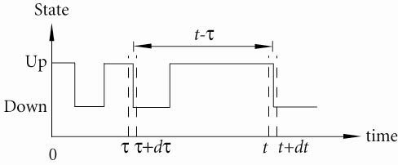

Figure 2: The component failed in (*τ*, *τ* + d*τ*] and fails again in (*t*, *t* + d*t*].

Note that





Then the probability of the event as shown in Figure 2 is equal to *fU*\**fD*(*t-τ*)*w*(*τ*)d*τ*d*t*, integrating which with respect to *τ* gives the probability of the second event as



Summing up the probabilities of the two subevents gives



 (6)

It is a renewal equation, which can be solved by taking the Laplace transform of both sides of the equations. Simplification leads to

 (7)

where *L* denotes the Laplace transform. The inverse Laplace transform of the above equation gives solution of *w*(*t*).

Generally, *fU*(*x*) and *fD*(*x*) are complicated, which makes it difficult to use the Laplace transform method. Therefore we directly solve integral Eq. (6) in a recursive manner by discretizing the time horizon and the PDFs involved in this equation.

## Repair Rate and Unavailability

Suppose that the last failure before *t* is in (*τ*, *τ* + d*τ*], event *R*(*t*) and *D*(*t*) are shown in Figures 3 and 4.

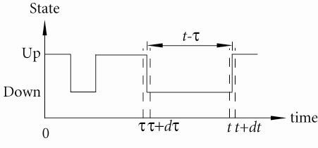

Figure 3: The component failed in (*τ*, *τ* + d*τ*] and is renewed in (*t*, *t* + d*t*].

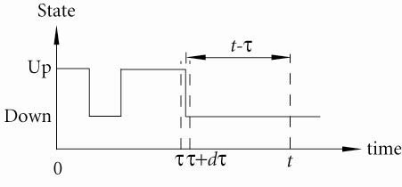

Figure 4: The component failed in (*τ*, *τ* + d*τ*] and keeps in the down state from then to *t*.

Note that





Hence the probabilities of the events as shown in Figures 3 and 4 are equal to *w*(*τ*)*fD*(*t*-*τ*)d*τ*d*t* and *w*(*τ*)*SD*(*t*-*τ*)d*τ*, respectively. Integrating them with respect to *τ* gives P{*R*(*t*)} and P{*D*(*t*)}. The repair rate at time *t*, *r*(*t*), is the probability that the component enters in the up state in a small time interval (*t*, *t* + d*t*]. Then

 (8)

The unavailability at time *t*, *Q*(*t*), is defined as the probability of the component being in down state, which is given as

 (9)

Once *w*(*t*) is solved from equation (6), *r*(*t*) and *Q*(*t*) can be obtained from the above equations. We can also use Laplace transform to obtain *r*(*t*) and *Q*(*t*). Note that



where *s* is in the frequency domain. The Laplace transforms for repair rate and unavailability are given as

 (10)

 (11)

## Subsystem and System Reliability Analysis

In the following, we use superscript *M* and *S* to denote subsystem and system, respectively, and subscript *i* to denote the *i*th component or subsystem. For example, *D*1*M*(*t*) refers to the event that the first subsystem is down at *t*, and *Q*1(*t*) refers to the unavailability of *C*1 at *t*.

### Subsystem Analysis

Consider the first subsystem, *M*1 = {*C1*, *C2*}. Since *M*1 is a parallel system, *M*1 is down if and only if (iff) both *C1* and *C2* are down. Hence

 (12)

 (13)

From equation (12) we have

 (14)

Note that *W*1*M*(*t*) implies *M*1 is up at *t* and becomes down at *t* + d*t*. Hence



Then substituting equations (12) and (13) into the above equation gives



Validly neglecting orders greater than 1 in the above equation gives

 (15)

Note that *R*1*M*(*t*) implies *M*1 is down at *t* and becomes up at *t* + d*t*, i.e.



Similar to *w*1*M*(*t*), we can obtain

 (16)

and the information of the second subsystem *M*2 = {*C3*, *C4*}.

### System Analysis

Since the system is a series system consisting of subsystems *M*1 and *M*2, the system is down at *t* iff at least one of the subsystems is down at *t*. Hence

 (17)

 (18)

Then equation (17) gives

 (19)

Similar to *W*1*M*(*t*) and *R*1*M*(*t*), *WS*(*t*) implies the system is up at *t* and becomes down at *t* + d*t*, while *RS*(*t*) implies the system is down at *t* and becomes up at *t* + d*t*. Hence





Similar to deriving *w*1*M*(*t*) and *r*1*M*(*t*), substituting equations (17) and (18) into the above equations, we can obtain

 (20)

 (21)

# life-cycle cost analysis

To budget for a finite time horizon, (0, *t*], the cumulative cost *C*(*t*) in this interval should be predicted first. *C*(*t*) consists of the following three parts



where *CRi* and *NRi*(*t*) are the unit repair cost and the number of repairs of *Ci* in (0, *t*], *CD* and *CF* are the loss due to system outage per unit time and that due to system failure per time, *TS*(*t*) and *NS*(*t*) are the total system outage time and the number of system failures in (0, *t*], respectively. Note that



To compute E{*TS*(*t*)}, we derive the following result.

Let *T*(*t*) be the total outage time of a component , a subsystem, or a system up to *t* and *Q*(*t*) the corresponding unavailability. Then

 (22)

The proof of this result is given in the Appendix.

Then the expected cumulative cost of the system can be obtained

 (23)

In the case that all the components are non-repairable, *QS*(*t*) and *wS*(*t*) are actually the CDF and the PDF of the life time of the system. Then life cycle cost can be evaluated from equation (23) as

 (24)

# example

## Input Data

The distributions of the time to failure and repair are described in Table for all four components of the system shown in Figure 1.

Table 1: Distributions of lifetime and repair time of components in the system

__________________________________________________

Life time Repair time

_____________________ ______________________

Distribution Mean COV* Distribution Mean COV

_____ ______

years years

__________________________________________________

*C*1 Exponential 40 1 Exponential 0.5 1

*C*2 Weibull 30 0.3 Exponential 1 1

*C*3 Exponential 30 1 Exponential 0.5 1

*C*4 Weibull 20 0.25 Exponential 1 1

__________________________________________________

* Coefficient of variation

Using this data, the failure rate, repair rate and unavailability of individual components were calculated using the formulae given in previous sections.

## System with Repairable Components

The reliability characteristics of individual components can be obtained from equations (6)(8) and (9), and are plotted in Figures 5a, 5b, and 5c. We can see that for all the components, failure rate *w*(*t*) is almost the same with repair rate. That is because the repair time is much less than life time. Failed components almost immediately get renewed. Therefore in time interval (0, *t*], the number of failures is almost equal to that of renewal. Recall that *w*(*t*) and *r*(*t*) are the expected number of failures and renewals per unit time, respectively, hence *w*(*t*) is almost equal to *r*(*t*).

Substitute the results from individual components into equations (14)(15) and (16) to solve subsystem information. Finally, the system information can be obtained from equations (19)(20) and (21), as shown in Figures 6a, 6b, and 6c.

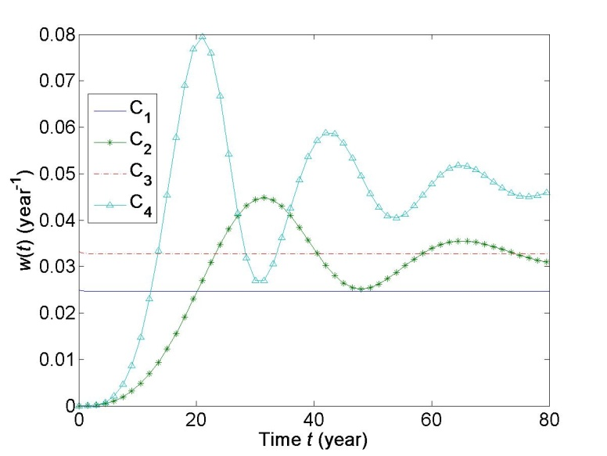

Figure 5 (a): Failure rate of repairable components

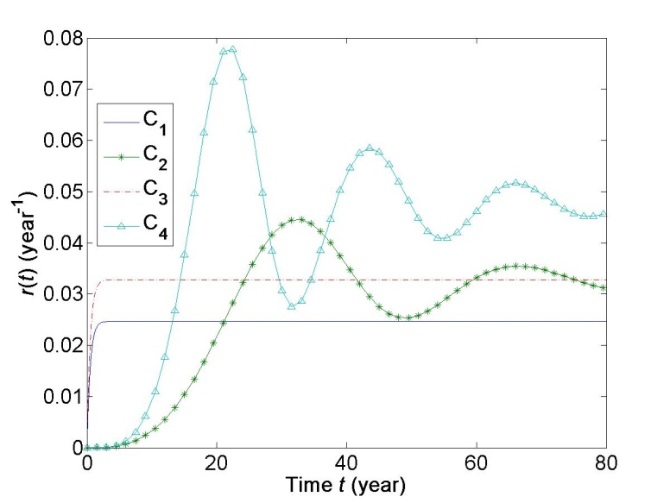

Figure 5 (b): Repair rate of repairable components

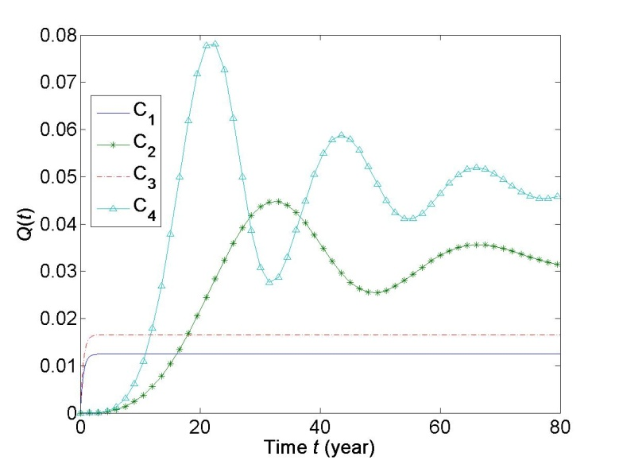

Figure 5(c): Unavailability of repairable components

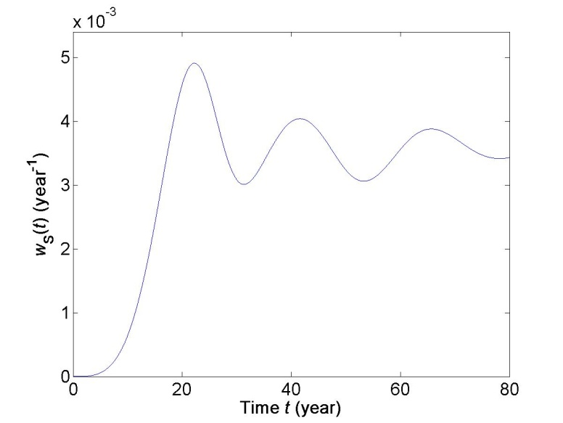

Figure 6(a): Failure rate of the repairable system

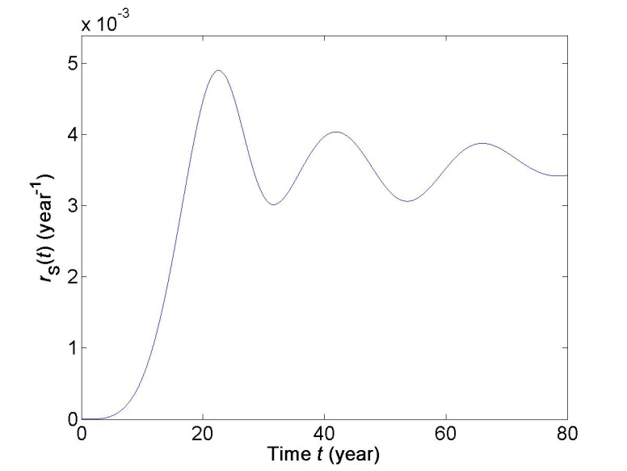

Figure 6(b): Repair rate of the repairable system

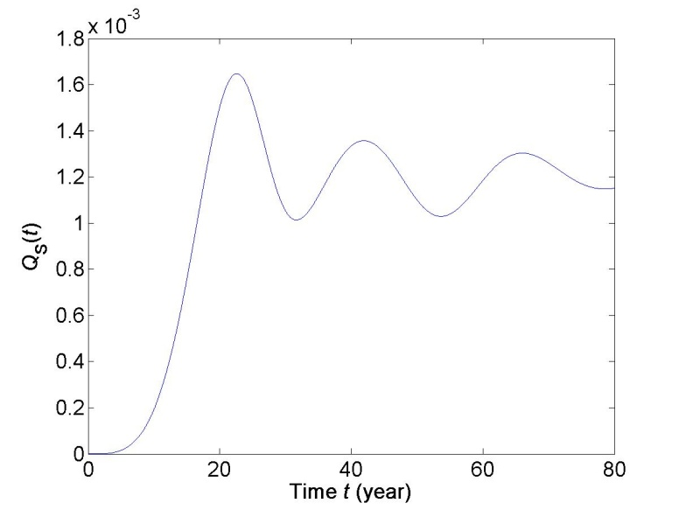

Figure 6(c): Unavailability of the repairable system

## System with Non-Repairable Components

If all the components are non-repairable the CDF and the PDF of the life time of the system can be obtained by using equations (4) and (5), as shown in Figures 7a and 7b. Comparing Figure 7a and 6c, we can see that the system with non-repairable components has much worse reliability.

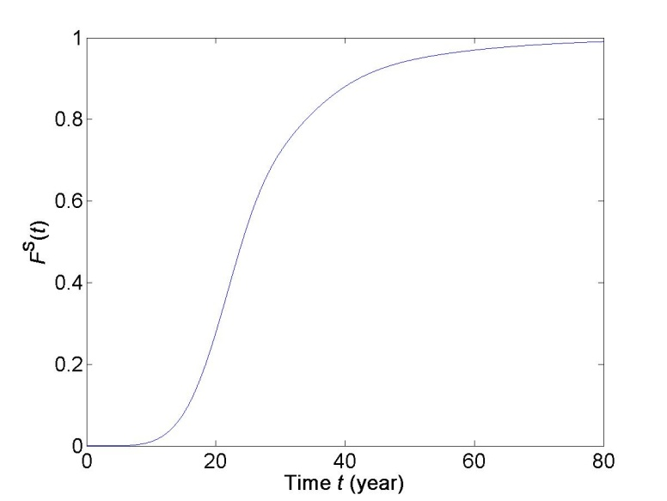

Figure 7(a): Unavailability of the non-repairable system

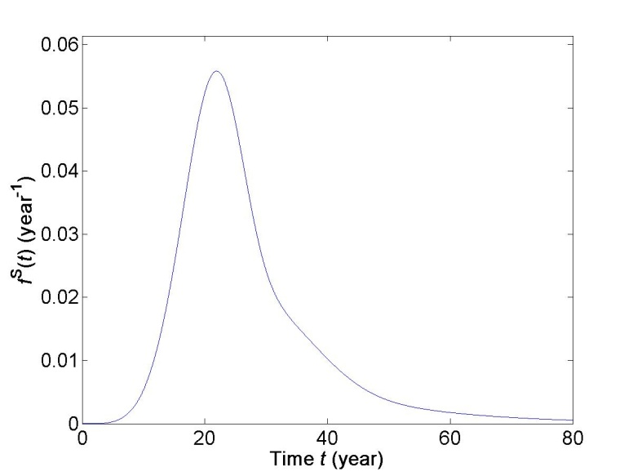

Figure 7(b): Failure rate of the non-repairable system

## Life-Cycle Cost Comparison

Suppose that the loss due to system outage per unit time is *CD*= 20 $/year, the loss due to per system failure is *CF*= 100 $, and the repair costs for any repairable components are all *CR*= 20 $. Then the expected cumulative cost can be obtained from equation (23) for the repairable system and from equation (24) for the non-repairable system. The expected annual cost *E*{*ΔC*(*n*)} = *E*{*C*(*n*) - *C*(*n-1*)}, *n* = 1, 2, …, in the both cases are plotted in Figure 9.

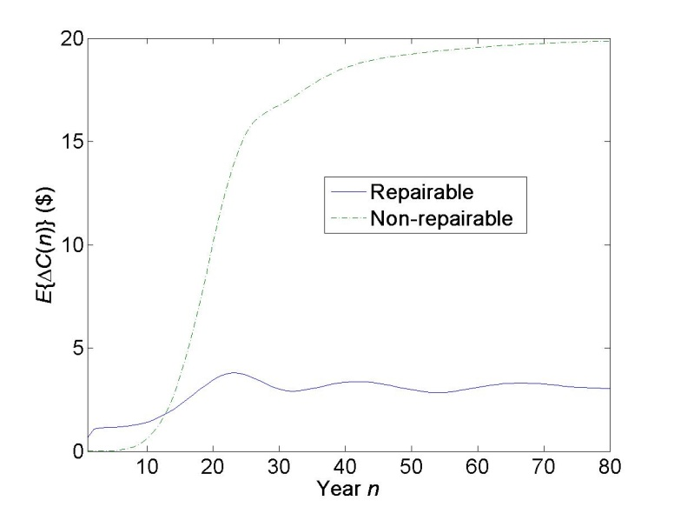

Figure 8: Expected annual costs for repairable and non-repairable systems

We can see that the expected annual cost is less for the non-repairable system before *n* = 13 years, which is because there is no repair cost incurred for the non-repairable system. After 13 years, the non-repairable system has a much higher expected annual cost than the repairable system, which is because that the outage time of the former is larger than the latter then since the former cannot be repaired. Hence if the design time is large, it is better to use repairable components.

# conclusion

This paper derives reliability characteristics of a system in which there are two series subsystems and each subsystem consists of two parallel repairable components. Time-dependent failure rate, repair rate, and unavailability for each hierarchy of the system are derived. The three reliability characteristics are important in the analysis of system reliability. As mentioned in Section5, the maintenance cost of the system in a finite time horizon can be easily predicted using these characteristics, which is useful in the system design phase.

The method used in this paper is generic since it can be easily extended to other systems consisting of independent parallel subsystems. Furthermore, this method is not just used for repairable components with random life time and repair time. It can also be used in other more complicated maintenance models, e.g. periodic inspection policy (Pandey, Cheng, & Xie, 2008), as long as the time-dependent reliability of individual components can be obtained.

references

Birolini A. 1999. *Reliability Engineering: Theory and Practice*. Berlin: Springer.

Henley J.E., & Kumamoto, H. 1981. *Reliability Engineering and Risk Assessment*. Englewood Cliffs, N.J.: Prentice-Hall.

Pandey, M.D., & Cheng, T., & Xie, W.C. 2008. Stochastic renewal process model for infrastructure asset management. *Inaugural International Conference of the Engineering Mechanics Institute*.

Vesely, W.E. 1970. A time-dependent methodology for fault tree evaluation. *Nuclear Engineering and Design* 13: 337-360.

# Appendix

Let *T*(*t*) be the total outage time of a component, a subsystem or a system up to *t* and *Q*(*t*) the corresponding unavailability. Then

 (A1)

This result can be proved in the following way. Let *ΔT*(*t*) be the outage time in the interval (*t*, *t* + d*t*]. Then use the law of total expectation by conditioning on the states at *t* and *t* + d*t*

 (A2)

Note that both *E*1 and *E*2 are of order not less than (d*t*)2 since both *E*{*ΔT*(*t*)|*W*(*t*)} and *E*{*ΔT*(*t*)|*R*(*t*)} are less than d*t*. The event {*U*(*t*), *U*(*t* + d*t*)} implies being up in (*t*, *t* + d*t*]. Therefore *E*{*ΔT*(*t*)|*U*(*t*), *U*(*t* + d*t*)} = 0, i.e. *E*3 = 0. The event {*D*(*t*), *D*(*t* + d*t*)} implies being down in (*t*, *t* + d*t*]. Therefore *E*{*ΔT*(*t*)|*D*(*t*), *D*(*t* + d*t*)} = d*t*. Note that



Hence *E*4 = *Q*(*t*) - *r*(*t*)d*t*. Substituting *E*1– *E*4 into equation (A2) and neglecting orders greater than d*t* yield



Then integrating the above equation with respect to *t* gives equation (A1).