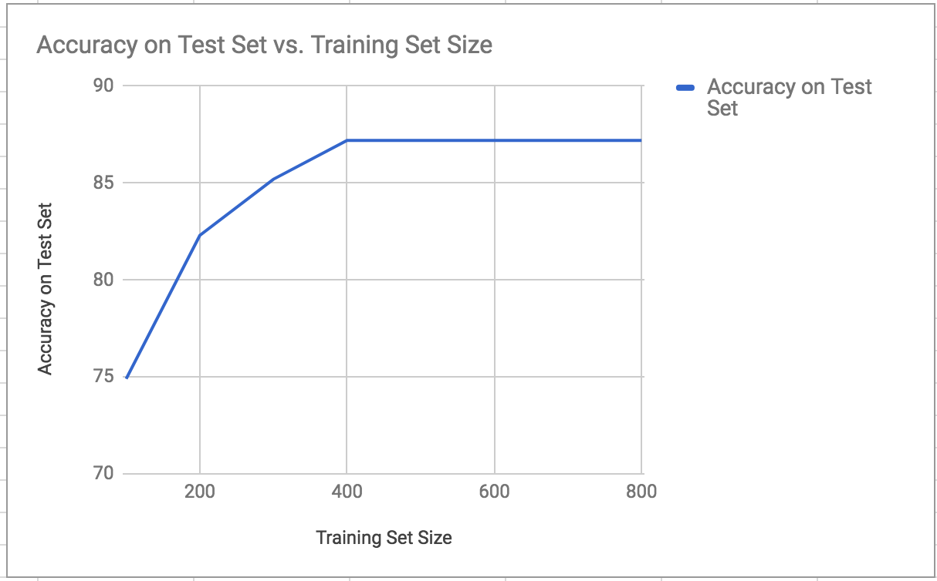

**Briefly comment on the shape of the curve. Does it exhibit the usual properties of a learning curve?**

Yes, the shape of the curve exhibits the usual properties of a learning curve. The curve is at first steeper and lower accuracy in the smaller training set sizes, but starts to flatten out at the same higher accuracy after the set is larger than 400.