SVFITS: A pre-processor for GMRT SPOTLIGHT Raw Visibility Files
Jayaram N Chengalur
Oct 2025

Overview and Background:

The NSM-SPOTLIGHT HPC at the GMRT is configured as an instrument to enable real time transient radio source detection as well as localization (See e.g. Roy, Chengalur et al. 2024) The system accepts digitized GMRT antenna data, and produces up to 2000 post-correlation (Roy, Chengalur & Pen 2018) beams which are searched for transient radio emission. The search is done over a range of Dispersion Measures (DM) and is sensitive to bursts from both galactic (pulsars, RRATs, magnetars etc.) as well as extra-galactic (e.g. FRBs) radio sources.

For each candidate event identified by the trigger software, visibilities at 1.3ms time resolution (and with duration depending on the DM, with a maximum duration of about 30s) are written to disk. Imaging of these visibilities are the principal method for source localization.

This note describes the first part of the pipeline for processing these visibilities to produce an image of the transient event. It describes how the data subset containing the burst signal is identified, pre-processed and then converted into a standard format, so that further processing can be done using existing interferometric packages. This is done in a program called svfits. The note also describes how additional ancillary visibility sets, as well as diagnostic plots, which could be useful for astrometry and other cross checks, can be created from the raw visibility dump. Details of how these are converted into images using routines from the CASA package will be given in a separate note.

Data and Meta data details: On receiving a confirmation that a given stretch of data contains a candidate burst, the SPOTLIGHT correlator software dumps a set of visibility files to disk. There are a total of 16 such files, with the visibilities time multiplexed across the files. Each visibility record (which has a 1.31072 ms integration time), consists of 4096 spectral channels in each of 1056 baselines. (SPOTLIGHT produces self and cross correlations for 32 input streams, corresponding to the 30 GMRT antennas plus two dummy inputs generally labeled C07 and S05, which do not correspond to physically existing antennas). Each visibility consists of two half-floats (i.e. 16bit float) which encode the real and imaginary parts of the visibility. The order of the baselines is Samp0*Samp0,Samp0*Samp1,...Samp0*SampN, for the RR/XX polarizations, followed by the same set of baselines for the LL/YY polarizations. A set of 50 such visibility records corresponds a time-slice, these time slices are the units over which time division multiplexing is done. That is the first time slice is contained in the first visibility record file, the second time slice in the second file and so on. Consequently contiguous time slices in a given file are separate by a slice-interval of 0.01048576 seconds (=16*50*1.3ms). The data for each time slice is preceded by an unix timeval structure (16 bytes) that gives the start time (the same for all 16 files) as well as a 32bit integer giving the index (i.e. the order of this slice in the set of 16, the order is the same for all time slices in a given file). This metadata is used for timekeeping. The size of a time-slice is hence 865075220 bytes.

Currently the mapping between the data streams and the physical antennas is provided via an antsamp.hdr file that is read when the conversion program (svfits) is executed. This header file also provides the X,Y,Z coordinates and signal delays for each antenna. Metadata for the candidate burst signal (including for e.g. the start MJD, the DM, the pointing co-ordinates for the post-correlation beam in which the burst was detected, etc. ) are supplied via an key-value format parameter file (i.e. svfits_par.txt, see Appendix 2). Meta data about the observation (e.g. the phase centre of the visibilities, the observing frequencies and other set up parameters) can also be provided in this file. This data can also be read from the binary headers (corr and scan structures) dumped by the SPOTLIGHT correlator software along with the visibility files. At the moment though, there are some inconsistencies in these binary headers which are being resolved, so the primary mode of passing on observation meta data is via the svfits_par.txt file. The svfits_par.txt file also contains various directives that the user can select to decide what kind of preprocessing to do.

SVFITS Modes There are three, mutually exclusive, kinds of data pre-processing that can be done by svfits. These are called the “BURST” (default), “ALL_CHAN” and “ALL_DATA” modes. Each is described briefly below.

BURST Mode In this mode the parametrization of the burst provided by the trigger software (e.g. the burst arrival time, the burst intrinsic width, burst DM, etc) are used to identify the visibilities that contain the burst signal. The initial step is to identify the start and end records which contain the burst signal. Following this for each record the channels which contain the burst signal are identified (the number of channels containing signal at a given time depend on the intrinsic width of the burst as well as the DM). Only these channels of these records are written out to the FITS file, resulting in a minimally sized output file. Since FITS files have to have a fixed number of channels, in this case the output FITS file is written as a single channel file, i.e. the file consists of random groups which have data for two stokes parameters and a single spectral channel. The frequency of the channel is set to the frequency of the first channel in the FITS file and the (u,v,w) coordinates of the group are scaled appropriately (i.e. u’ = u(f0/f) where u’ is the coordinate stored in the random group, f is the true frequency of the channel, and f0 is the frequency of the first channel in the input file) so that the imaging software will associate this visibility with the correct (u,v,w) coordianate.

The (u,v,w) coordinates of the visibilities in the raw visibility files are computed in the apparent coordinates at the date and time of the observation, using the antenna position parameters available in the meta-data as well as the hour angle that is computed from the apparent coordinates of the phase centre. The hour angle is computed in exactly the same way as it is by the online correlator software, (including the dut1=UT1-UTC correction to be read from the IERS BulletinA) with the exception that the precession and nutation calculations as well as the computation of the equation of the equinoxes are done using the NOVASC routines, as opposed to the STARLINK SLA routines used by the online software. This change was made since the STARLINK SLA routines appear to be no longer maintained.

The (u,v,w) coordinates are then rotated to the J2000 reference frame. The rotation to the J2000 frame is done in essentially the same way as is done when converting GMRT lta files to FITS (see Chengalur, 2003). There is a compile time flag which allows the coordinate conversion and vector rotation uses routines from the NOVAS library as opposed to the Starlink SLA library used in gvfits. (The Starlink SLA library appears to be no longer maintained), but this is not fully tested. Currently it is recommended to use the SLA library for the rotation (i.e. the compile time default). Basically the (u,v,w) vector is rotated from the inteferometric frame (i.e. where the ‘w’ axis points towards the phase centre) to the equatorial frame, after which standard NOVAS library routines are used to correct for the nutation and precession to bring the vector to the J2000 frame. Finally, the baseline vector is rotated back to the interferometric frame. The correction for aberration is taken to be a shift and is corrected for by transforming the phase centre coordinates from the apparent coordinates on the date of observation to the mean coordinates at J2000. In addition there is an option to move the phase centre to the pointing centre of the post-correlation beam in which the burst was detected. This is described in more detail below.

There are some optionally preprocessing steps that can be done prior to writing the visibilities to the FITS file. The first is “de-basing”, where the signal free visibilities in the time-slice are used to compute an per channel average “baseline” which is subtracted from the signal. The other is “bandpass”, where the signal free visibilties of the time-slice are used to compute an amplitude “bandpass”. These are similar to the preprocessing done in the CELIBI pipeline for CRAF at ASKAP (see e.g. Scott 2023). Finally, the statistics of the visibilities of with the signal can be used to do a median absolute deviation (MAD) based threshold flagging on the signal. These three preprocessing steps can significantly improve the statistics of the signal, as shown in Figure 1 below.

In addition, as a diagnostic, svfits also produces a post-correlation beam dynamic spectrum (svfits_postcorr.dat) along with a listing in the svfits.log file of the channels identified as containing the signal. These can be plotted (using plot_postcorr.py) as a diagnostic (e.g. Figure 1).

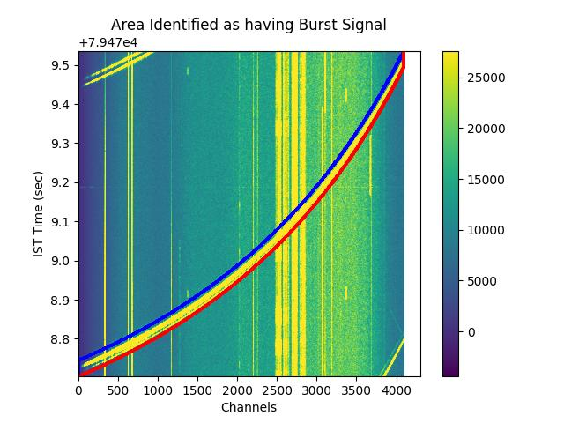
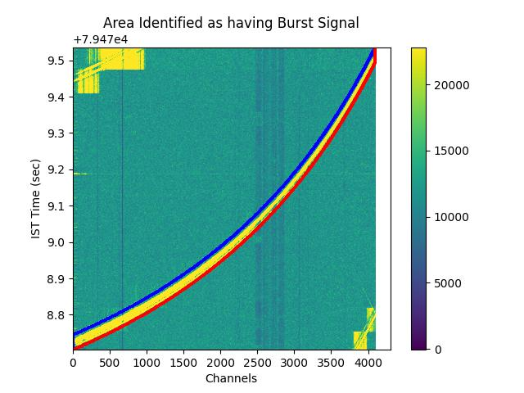

Figure 1: These show the dynamic spectrum produced from the post-correlation beam made by svfits from the 1.3ms raw visibility files from a GMRT Band 3 observation of PSR 0329+54. Left Panel: The Dynamic Spectrum made from the raw data, i.e. without any pre-processing. The burst signal as identified by svfits is shown by the region between the blue and red lines. Note that part of the pulses before and after the pulse picked up for conversion to fits can be seen at the top left and bottom right of the dynamic spectrum. Right Panel: The same data, but with pre-processing as described in the text. As can be seen the pre-processing significantly improves the contrast of the signal. The artifacts seen at the top left and bottom right are related to the signals from the pulses before and after the pulse chosen for conversion to FITS. These would not be present in the situation of a transient where there is only one burst in the time interval of interest.

ALL CHAN Mode Some imaging processing tasks in the CASA image processing package appear to be inefficient at dealing with files with only one spectral channel. As a possible alternative for this, there is a mode in which all channels of records containing a burst are copied to the output FITS file, resulting in a 4096 channel FITS file. The channels which do not contain the burst signal are flagged. Note that since typically only a few channels in a given record contain the burst signal (because of the dispersion smear, see for e.g. Figure 1 above), this could result in a FITS file which could be a few 100 times larger than the FITS file where only the burst signal is converted to FITS.

ALL DATA Mode This mode is meant to convert all of the raw visibilities to FITS regardless of whether the visibilities contain the burst signal or not. In this mode one has the option of averaging in channels as well as in time in order to reduce the data size. This file could be of use for making diagnostic images and/or for identifying the locating of background sources for checking astrometry, etc.

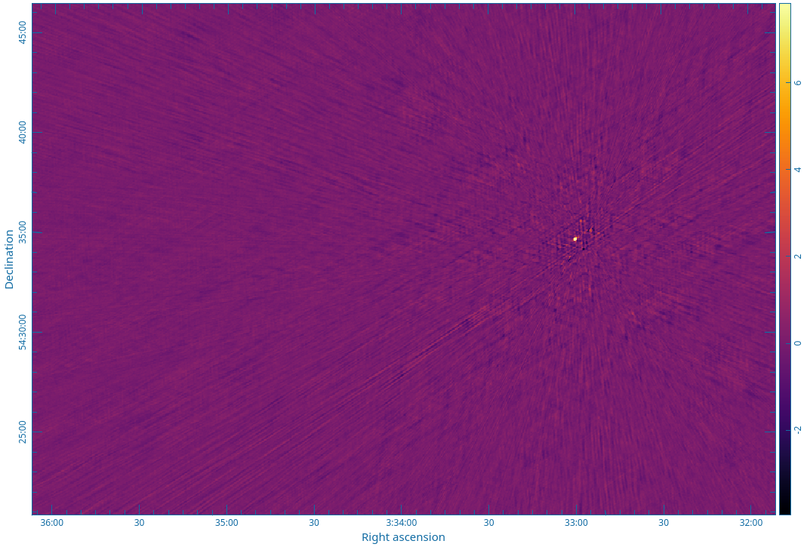

Figure 2A. Image made from only the burst signal for one pulse from the pulsar B0329+54. As discussed in the text, the background has been subtracted in the visibility pre-processing, leaving behind only the signal from the pulse.

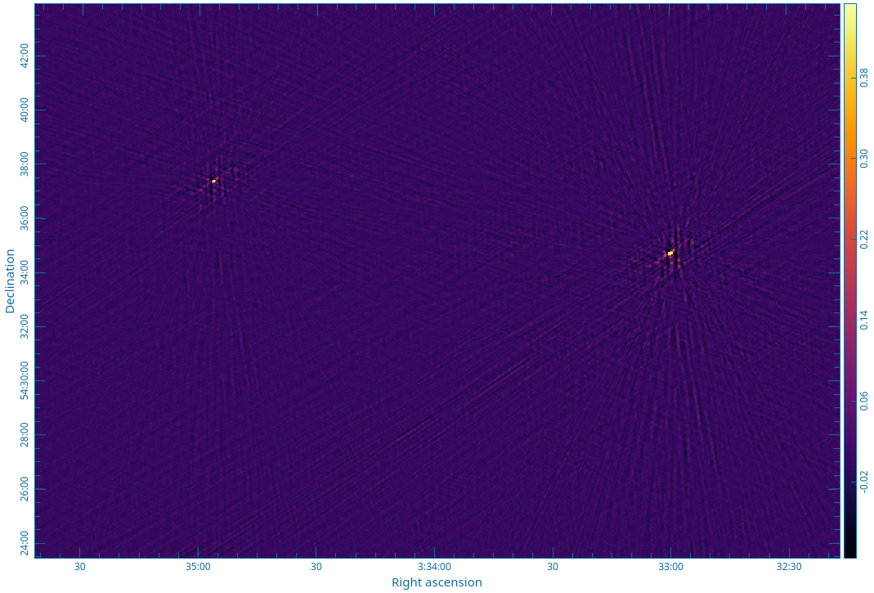

Figure 2B. Image made using the ALL_DATA option. This shows all the emission in the field, including another continuum source. This could be helpful for doing astrometry cross checks, as discussed in the text.

There is also the option (available in all modes, not just the ALL DATA mode) for rotating the visibilities to change the phase centre to the pointing centre of the beam in which the burst was detected. This would allow the location to be done using a small sized image, without the need to do wide field corrections etc. The visibility rotation can of course be done in CASA or AIPS, but the option is given here, since apparently the single channel file structure leads to the CASA phase-shift routine being quite slow. The calculation in svfits is parallelized and is quite fast, however note that it has not been fully tested, and so should be used with caution.

The the change of phase centre is achieved by (a) correcting the phase of each visibility by 2.0*[u*l+v*m+w*(n-1)], where (l,m,n) are the direction cosines of the new phase centre and (u,v,w) are the coordinates of the visibility, and (b) rotating each baseline vector to the coordinate system centered at the new phase centre. This is achieved by multiplying the baseline vector (u,v,w) by the matrix:$A=\left[\begin{matrix}cos\left(α−α_{0}\right) & sin\left(δ_{0}\right)sin\left(α−α_{0}\right) & cos\left(δ_{0}\right)sin\left(α−α_{0}\right) \\ sin\left(δ_{0}\right)sin\left(α−α_{0}\right) & sin\left(δ_{0}\right)sin\left(δ\right)cos\left(α−α_{0}\right)+cos\left(δ_{0}\right)cos\left(δ\right) & sin\left(δ_{0}−δ\right) \\ cos\left(δ\right)sin\left(α−α_{0}\right) & cos\left(δ_{0}\right)sin\left(δ\right)cos\left(α−α_{0}\right)−sin\left(δ_{0}\right)cos\left(δ\right)cos\left(δ_{0}\right) & cos\left(δ_{0}\right)cos\left(δ\right)cos\left(α−α_{0}\right)+sin\left(δ_{0}\right)sin\left(δ\right)\end{matrix}\right]$

Where (α₀,δ₀) are the coordinates of the original phase centre and (α,δ) are the coordinates of the
new phase centre. All of the coordinates are in the J2000 coordinate system, i.e. this correction is made after rotating the visibilities to the J2000 frame. Images made before and after the shift of phase centre are shown in Figure 2 below.

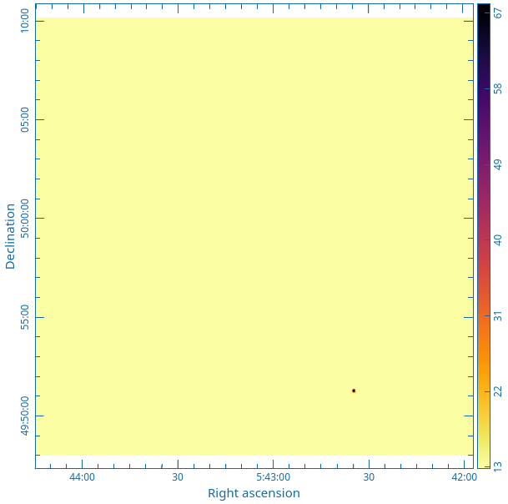
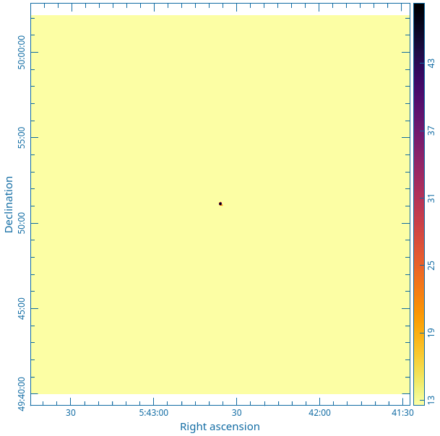

Figure 2: Left panel shows the image of 3C147 made in the ALL_DATA mode. The phase centre was selected to have 3C147 offset towards the south-west. Right Panel: Image made with the same data but after changing the phase centre to the position of 3C147 inside svfits.

References:

- Chengalur, J. N. “J2000 coordinates in GMRT UV-FITS files”, GMRT Technical Report (2003).

- Roy J., Chengalur J. N. & Pen U-L “A Post-correlation Beamformer for Time-domain Studies of Pulsars and Transients”, Ap.J. 864, 160 (2018)

- J. Roy, J. N. Chengalur and the SPOTLIGHT team, “SPOTLIGHT: A Probe of the Fast Radio Transient Sky”, URSI-RCRS, 2024

- Scott D. R., Cho H, Day, C. K. et al. “CELEBI: The CRAFT Effortless Localisation and Enhanced Burst Inspection pipeline”, Astronomy & Computing, Vol 44, (2023).

