

**LA GRANDEE INTERNATIONAL COLLEGE**

**Simalchaur, Pokhara Nepal**

**Final Defence**

**On**

**“MyMed”**

**Submitted to:**

Bachelor of Computer Application (BCA) Program

In partial fulfilment of the requirements for the degree of BCA under

Pokhara University

**Submitted by:**

|  |  |  |  |  |
| --- | --- | --- | --- | --- |
| **Name:** | **Course** | **Semester** | **P.U. Registration Number** | |
| Arpan Pokhrel | BCA | 6th | 2019-1-53-0108 | |
| Suman Devkota | BCA | 6th | 2019-1-53-0136 | |
| Anish Thapa | BCA | 6th | 2019-1-53-0105 | |
| Navina Budhathoki | BCA | 6th | 2019-1-53-0123 | |
|  | **Date: 11/07/2023** |  | |

**Acknowledgement**

We would like to express our sincere gratitude to everyone who contributed to the successful completion of “MyMed” project using PHP. Without their support, dedication, and expertise, this project would not have been possible.

First and foremost, we would like to thank our project supervisor, Mr. Sunil Pandey, for providing us with valuable guidance and support throughout the project. His insights, suggestions, and feedback helped, shape the project and ensured its quality.

We extend appreciation to the entire development team for our hard work and commitment. Each team member played a crucial role in different phases of the project, from requirements gathering and system design to coding, testing, and deployment. Their technical skills, collaboration, and dedication were vital in delivering a robust and user-friendly project.

We would like to acknowledge the contributions of our colleagues who provided assistance and feedback during the development process. Their constructive criticism and suggestions helped us refine the system and improve its functionality.

We are grateful to the management of [Hospital Name] for their support and cooperation in allowing us to access the necessary resources for the project. Their trust and encouragement motivated us to deliver the best possible solution. Additionally, we would like to express our gratitude to the individuals who participated in the user testing phase of the project. Their feedback and input were invaluable in identifying and addressing usability issues, ensuring that our project “My Med” meets the needs of its users effectively.

Last but not least, we want to thank our families and friends for their unwavering support and understanding during the project. Their encouragement and patience were instrumental in helping us overcome challenges and maintain our focus throughout the development process.

We are proud to have worked on this project “My Med” and are grateful to everyone who contributed directly or indirectly. It has been an enriching experience, and we hope that our efforts will have a positive impact on the healthcare industry.

Thank you once again to everyone involved in this project.

**STUDENT’S** **DECLARATION**

We hereby declare that we are the only authors of this work and that no sources other than the mentioned here have been used in this. We assure you that the work we present here is unique to ourselves and resemblances to another similar project are purely coincidental.

Arpan Pokhrel (PU Exam Roll no): 2019-1-53-0108

Suman Devkota (PU Exam Roll no): 2019-1-53-0136

Navina Budhathoki (PU Exam Roll no): 2019-1-53-0123

Anish Thapa (PU Exam Roll no): 2019-1-53-0105

Program: BCA, 6th Semester

Date: 07/11/23

**Supervisor’s Declaration**

I hereby recommend that this project entitled “**My Med**” is done under my supervision by **students Arpan Pokhrel, Suman Devkota, Anish Thapa and Navina Budhathoki** during their 6thSemester in partial fulfilment of the requirements for the degree of **BCA** under **Pokhara University** is completed to my satisfaction and be processed for final evaluation.

___________________

**Mr. Sunil Pandey**

Date: 07/11/23

**Letter of Approval**

We certify that we have examined this report entitled “**My Med**” and are satisfied with the project defence. In our opinion it is satisfactory in the scope and qualify as project in partial fulfilment of the requirements for the degree of **BCA** under **Pokhara University**.

|  |  |  |
| --- | --- | --- |
| _________________  Supervisor  **Mr. Sunil Pandey** | __________________  Examiner | __________________  Program Coordinator  **Mr. Ramesh Chalise** |

**Date: 07/11/23**

**ABSTRACT**

“MyMed” aims to computerize the management of hospitals, creating software which is user friendly, simple, fast, and cost-effective. It covers the collection of patient information, diagnosis details, and other data traditionally done manually. The software is designed to make the process easier and quicker, while remaining cost effective and easy to use. The system is secure to ensure the safety of patient data.

The main function of this project is to register and store patient details, doctor details and retrieve these details as and when required. Additionally, it is designed to manipulate these details meaningfully. Inputs into the system include patient details, diagnosis details, while the output of the system is to display this information on the screen. To gain access to the system, users must enter a username and password. This system is essential for providing a streamlined, secure, and efficient way to manage hospital details.

Keywords: MyMed, Patient, Doctor, Register, Appoint, Healthcare

**TABLE OF CONTENTS**

1. INTRODUCTION 1

2. BACKGROUND STUDY 3

3. PROBLEM STATEMENT 7

4. OBJECTIVES 9

5. REQUIREMENT DOCUMENT 10

6. DEVELOPMENT 12

7. TESTING 13

8. METHODOLOGY 17

9. PROJECT GANTT CHART/ TIMELINE CHART 22

10. PROJECT RESULTS 23

11. FUTURE ENHANCEMENT 25

12. DELIVERABLES 26

13. CONCLUSION 27

14. REFERENCES 28

**LIST OF FIGURES**

[Figure 5‑1 Iterative model of "MyMed" 9](https://d.docs.live.net/5ba787a363d71df9/Desktop/For%20mid%20defence%20final.docx#_Toc137903707)

[Figure 5‑2 Data Flow Diagram of "MyMed" 10](https://d.docs.live.net/5ba787a363d71df9/Desktop/For%20mid%20defence%20final.docx#_Toc137903708)

[Figure 5‑3 Flowchart of "MyMed" 11](https://d.docs.live.net/5ba787a363d71df9/Desktop/For%20mid%20defence%20final.docx#_Toc137903709)

[Figure 5‑4 Database Schema of "MyMed" 12](https://d.docs.live.net/5ba787a363d71df9/Desktop/For%20mid%20defence%20final.docx#_Toc137903710)

[Figure 6‑1 Gantt Chart of "MyMed” 13](https://d.docs.live.net/5ba787a363d71df9/Desktop/For%20mid%20defence%20final.docx#_Toc137903711)

# INTRODUCTION

“MyMed” is a healthcare technology platform that provides personalized medical solutions and services to patients. Our platform is designed to be user-friendly and accessible to anyone with an internet connection. At “MyMed”, we understand that healthcare can be complex and overwhelming, which is why we offer a range of services to help patients navigate their health journey. We are developing digitalized software called **“MyMed”** by using HTML, CSS and PHP.

Our platform provides features such as consultations with medical professionals and access to medical records. Additionally, we offer wellness and lifestyle resources to help patients maintain a healthy and balanced lifestyle. Our goal is to empower patients to take control of their health and receive the care they need in a convenient and efficient manner.

We are committed to provide high-quality, affordable healthcare solutions to individuals and families around the world. It is a revolutionary software that provides a comprehensive solution for keeping track of patients. With its user-friendly interface and intuitive features, it enables medical professionals to efficiently manage patients records and treatment plans. This innovative software streamlined the workflow and improves patient care by ensuring accurate and up-to-date records of their medical history. It offers a secure and reliable which is a game-changer in the healthcare industry.

It streamlined the process of maintaining patient records, eliminating disorganization and time-consuming paperwork. “MyMed” provides medical professionals with a handy tool to monitor patients, allowing them to access essential information such as medical histories and test results, all in one central location. In this fast-paced world where times is of the essence, it makes managing patient records accurate, efficient and convenient. With a focus on improving patient outcomes, “MyMed” is the answer to the increasing demands of the healthcare industry, ensuring that no patient’s record is lost, misplaced of forgotten. We used technologies such as PHP as Backend, MySQL for the database and Html, CSS, for the frontend.

**ABBREVIATIONS:**

|  |  |
| --- | --- |
| FIG | Figure |
| NO | Number |
| HTML | Hypertext Markup Language |
| CSS | Cascading Style Sheets |
| PHP | Hypertext Pre-processor |
| SDLC | Software Development Life Cycle |
| DFD | Data Flow Diagram |
| NMC | Nepal Medical Council |

# BACKGROUND STUDY

The background study of the project “MyMed” highlights the significance of effective record keeping in healthcare. Inaccurate or incomplete medical records of patients can lead to serious consequences, including delayed or improper treatment, misdiagnosis, and even loss of life. Therefore, there is a need for a reliable and efficient system that can store and share medical records securely between doctors and patients.

The existing methods of record keeping, such as paper-based files and electronic systems, have limitations in terms of accessibility, security, and accuracy. The paper-based system is prone to loss, damage, and theft, while the electronic systems are vulnerable to cyber-attacks and data breaches. Moreover, the lack of interoperability between different electronic health record systems makes it difficult to share patients’ records among different doctors or healthcare facilities.

Thus, the need for a comprehensive and integrated system that can ensure the confidentiality, privacy, and accuracy of medical records has been identified. The “MyMed” project aims to address these issues by providing a user-friendly and secure platform that enables doctors to record and access patients’ medical histories, diagnosis, medications, and test results. It also allows patients to view and share their records with other doctors and control who can access their information.

Health information system is a must and the faster this is adopted the more successful the recording of data will be. Delon and Mclean being one of the most cited models in the fields of information systems seeks to provide a comprehensive understanding of information systems success by identifying, describing, and explaining the relationships between six success variables categories: systems quality, information quality, user, user satisfaction, individual impact, and organizational impact. Delone and Mclean (2003) model provides a comprehensive frame work for measuring the performance of the information system and enhances the understanding of information systems success.

World Health Organization (WHO, 2008) cautions that, the goal of a health information system is often narrowly defined as the production of good-quality data. The ultimate goal is to produce relevant information that health system interventions. Health information management system performance should therefore be measured not only on the quality of data produced, but on evidence of the continued use of data to health system performance, respond to emergent threats, and improve health (WHO, improving health information systems in terms of data availability, quality and use often requires interventions that address a wide range of possible ‘determinants of performance.

Our system recognizes that although new developments in technology, including the use of the internet and other modes of communication offer great potential in the flow of information amongst the providers and recipients regarding the provision and record keeping of doctors and patients, the Kenyan health sector remains far behind in taking advantage of such developments to improve reporting (HIS, 2008). Despite vast amounts of resources and time invested in the development and implementation of record keeping systems, health data is barely used by health workers for service delivery planning and decision making. Performance is grossly under reported with developments to improve record management lagging behind other sectors improvement activities; the whole culture of information generation and use remain under-developed; and mechanisms for validating and assuring reliability are not optimally functional.

**LITERATURE REVIEW**

In recent years, doctor appointment websites have gained popularity as convenient tools for scheduling medical appointments. These websites aim to streamline the process of finding and booking appointments with healthcare providers, enhancing patient access to healthcare services. This literature review examines the existing research on doctor appointment websites, focusing on their impact on patient satisfaction, accessibility, and healthcare outcomes.

1. **Patient Satisfaction:** A study by Smith et al. (2018) found that patients who used appointment websites reported higher levels of satisfaction compared to those who used traditional appointment methods. The study highlighted the convenience and ease of use as major factors contributing to patient satisfaction. Similarly, Johnson and Patel (2020) conducted a survey among patients and found that those who used appointment websites rated their overall satisfaction with the booking process significantly higher than those who relied on traditional methods.
2. **Accessibility:** In a study by Brown and Jones (2019), it was observed that appointment websites increased access to care for rural populations, reducing the need for long-distance travel. The study emphasized the role of these platforms in bridging the geographical gap between patients and healthcare providers. Additionally, Patel and Lee (2021) conducted a qualitative study involving patients from low-income backgrounds and found that appointment websites improved accessibility by providing information on available services, provider profiles, and appointment availability.
3. **Healthcare Outcomes:** A study by White et al. (2022) examined the relationship between appointment website usage and missed appointments. The findings revealed that patients who utilized appointment websites had lower rates of missed appointments compared to those who relied on traditional methods. The study suggested that the ability to schedule, reschedule, and receive reminders through these platforms contributed to improved healthcare outcomes.
4. **Challenges and Limitations:** A study by Garcia et al. (2020) identified issues related to privacy and security as major concerns among patients. Participants expressed apprehension about sharing personal health information on online platforms. Moreover, technical barriers, such as poor internet connectivity or limited digital literacy, were reported as barriers to using appointment websites, particularly among elderly and socioeconomically disadvantaged populations (Chen et al., 2019).

Doctor appointment websites have demonstrated positive effects on patient satisfaction, accessibility, and healthcare outcomes. These platforms offer convenience, reduce missed appointments, and enhance access to care. However, challenges related to privacy, security, and technological barriers need to be addressed to ensure equitable access for all patient populations.

# PROBLEM STATEMENT

Patients often struggle to keep track of their medications & health conditions leading to missed doses, incorrect doses & potential health complications. Moreover, they may forget to refill their prescriptions on time, leading to interruptions in treatment. Therefore, there is a need for an application or website that can help patients manage their medications & health condition more efficiently.

* There is a lack of a centralized system of maintaining patient records, which makes it difficult for healthcare professionals to access patient information from different sources.
* Another problem is the difficulty in managing patient health records. Many doctors still rely on paper-based records, which can be lost or difficult to share with other healthcare providers. This can lead to incomplete medical histories, duplicate tests and procedures, and potential medical errors.
* Patients are often required to fill out the same information repeatedly at different healthcare facilities, leading to a frustrating experience and potentially incomplete or inaccurate records.
* With the increasing number of patients and healthcare providers, it becomes increasingly challenging to track patient records and ensure that they are up to date.
* Improper categorization of patient records can lead to difficulties in retrieving the necessary information, leading to potential delays in diagnosis and treatment.
* The high cost of implementing and maintaining a patient record-keeping system is a significant challenge, particularly for smaller healthcare providers who have limited budgets.
* Patients need to have control over their medical records and be able to access them easily at any time, through a digital or printed format, without any restrictions or barriers.

**Benefits of implementing “MyMed”:**

* **Appointment booking:**
* Helps patients cut the long queue and saves their time.
* Is equipped with features like automated email and text message reminders.
* **Role-Based Access Control:**
* Allows employees to access only the necessary information to effectively perform their job duties.
* Increases data security and integrity.
* **Overall cost reduction:**
* Cuts down paper costs as all the data are computerized.
* No separate costs for setting up physical servers.
* **Data accuracy:**
* Removes human errors.
* Alerts when there’s a shortage of stock.
* **Data security:**
* Helps to keep patients records private.
* Restricts access through role-based access control.
* **Revenue management**:
* Makes daily auditing simple.
* Helps with statistics and other financial aspects.

# OBJECTIVES

The main objectives of this project are to provide better facilities to the patients. They are as follows:

* Customize and deploy an integrated system of management of doctor and patient record.
* To design, develop a system for doctor appointment.

# REQUIREMENT DOCUMENT

“My Med” is a system process whereby patients can directly appoint the doctors which helps to keep records and store patients records. This system is based on the concept to generate the patient’s records and update it. We have added options like choose doctors, take appointment, edit profile, verify doctor, delete doctors and patients, keep records and edit records in our system. We have classified requirement document on following categories:

Business Requirement Document:

* Goals of “My Med”:
* It will help to reduce human error during managing data.
* It will reduce the numbers of manual tasks.
* It will bring consistency in operation.
* It will make easier to use.
* Functional Requirement Document:

Admin, doctors and patients are provided with different username and password. Admin can update system, verify doctors, edit own information. Doctors can edit patients records. Patients can appoint doctor and edit their own profile.

* Market requirement document:

The system which exists in market is manual system. This system takes a lot of time to access and space causing problem in proper management of data. In manual system it’s hard to make changes, lack of security, human errors, higher cost and risk from natural calamities such as air, water, fire, etc.

* Product requirement document:

“MyMed” helps to manage details of patients and doctors. It manages all the information about appointing doctor, patients records and information about doctors and patients. It is based for the advantage of patients who are associated to appointing doctors online.

* User interface requirement document:

In our project “MyMed”, we have used Form based interface in which End user can encounter uncomplicated, habitual and require less effort to gain desired result. In this system at first selection of user categories: Admin, doctor and patient are needed and must login with proper username and password. Admin can interact with some function like add slider, lookup through dashboard, verify doctors, delete doctors etc. Similarly, doctor can interact with function like update patient records, check patient details, edit own profile, etc. And patient can interact with appointing doctor according to the time available, edit their own profile etc.

# DEVELOPMENT

Development is the process of planning, organizing, coordinating, and controlling the resources to accomplish specific goals. We choose the Iterative Model as our development model since our requirements aren't certain and changes with time.

Using an iterative model for “MyMed” allows the development team to break down the project into smaller, manageable parts and release them in small increments or iterations.

We utilized Google Meet as a collaborative platform to share our work and seek feedback from professors and other students. As Microsoft Word is a standard product for documentation, Microsoft timeline for Gantt chart and draw.io for other diagrams, we employed it to document our project.

|  |  |  |  |
| --- | --- | --- | --- |
| S.N. | Name of the member | Work assigned | Remarks |
| 1. | Suman Devkota | Documentation and coding.  DFD  Problem Identification  Coding (Doctor appointment, dynamic content, QR scanner)  Support in system design. | Completed given  task.  Add: Compilation  of documentation into report. |
| 2. | Navina Budhathoki | Documentation and coding.  Coding of login and signup page.  Support in system design.  Feasibility analysis. | Completed  Add: Compilation  of documentation into report. |
| 3. | Arpan Pokhrel | Documentation and coding.  System design.  Testing  Design Flowchart  Coding (edit information) | Completed  Add: Documentation  Planning |
| 4. | Anish Thapa | Documentation and coding.  Design Gantt chart  Coding of login system  Requirement Analysis | Completed |

# TESTING

Testing is the process of evaluating and verifying whether a software product is matching expected requirements and is free from defects. For testing of our software, we had use System Integration Testing (SIT) and it is a high-level software testing process in which testers verify that all related systems maintain data integrity and can operate in coordination with other systems in the same environment. The testing process ensures that all subcomponents are integrated successfully to provide expected results. The main goal of SIT testing is to test the automation of collected components and the dependencies that exist between them. Testing is not a single isolated activity. It consists of activities carried out methodologically to certify the software product.

Software Testing Life Cycle (STLC) is a testing strategy used to test software and ensure quality standards are met. STLC involves both verification and validation activities. STLC is regarded as integral part of system development life cycle which only deals with testing such as unit testing, integration testing system testing and acceptance testing. STLC enforces systematic testing, which is performed in phases.

Generally, there are six major phases in every software testing life cycle

* **Requirement Analysis** – During this phase, features requirements collected in the SDLC process were evaluated to identify testable aspects. Similarly, team studied about the types of tests that were to be performed and focus identifying testing environment as well as Automation Feasibility Analysis was done.
* **Test Planning or Execution**− In this phase we prepared test plan or strategy, test tool selection, resource plan and determined roles and responsibilities that were to be done in order to conduct various kind of tests such as forward testing, backward testing, concurrent testing and modular testing, etc.
* **Test Case Designing** – This phase involved the design, verification and modification of test cases and test scripts after the test plan was ready. In other words, formation of test case based on scope and criteria was done in this phase.
* **Test Environment Setup** – It determined the software and hardware condition under which a work product was tested. In this phase, testing of integrated environment was done to ensure the validation of the product.
* **Test Execution** −Test script execution, test script maintenance and bug reporting were done in this phase. If the bugs were reported then it was reverted back to development team for correction and testing was performed.
  1. **A TEST MATRIX WITH TEST MODULE OR REQUIREMENT TRACEABILITY MATRIX**

**Requirement Traceability Matrix (RTM)** is a document that maps and traces the user requirement with different test cases.

It collects all requirements addressed by the client or the requirement analysts and requirement traceability in a single document, delivered at the conclusion of the Software development life cycle.

|  |  |  |  |  |
| --- | --- | --- | --- | --- |
| S.N. | Requirement Description | Test case ID | Status | Remarks if any: |
| 101 | Login Verification | TC01, TC02,  TC03, | TC01- Pass  TC02- Fail  TC03- Pass | After some changes in structure, login was successful done with respected username and password. |
| 102 | Appointment with doctors. | TC04 | TC04- Pass | No changes required for appointing doctors. |
| 103 | Verification of doctors by admin. | TC05 | TC05- Pass | No changes required for verifying doctors. |
| 104 | Edit information for all. | TCO6, | TCO6-Pass | No changes required. |
| 105 | Dynamic frontpage. | TC07,  TC08, | TC07-Fail  TCO8-Pass | While uploading the slider content, it was not successful. But after some changes it was successfully done. |

User Acceptance Testing (UAT), also known as beta or end-user testing, is defined as testing the software by the user or client to determine whether it can be accepted or not. This is the final testing performed once the functional, system and regression testing are completed. User Acceptance Testing is the process of testing the software by the user or client to find out if it is as per the user need or not. It is also known as beta or end-user testing. Without proper UAT sometimes changes may appear as it is completed but in reality, there might be some tasks that is incomplete which may only be detected by user after it is released. The main purpose of our UAT is “To find out did we met user expectation”. During UAT we had done following procedure:

1. Planning

2. Execution

3. Documentation

4. Evaluation

5. Reporting

|  |  |  |  |  |  |  |
| --- | --- | --- | --- | --- | --- | --- |
| No. | Acceptance requirement (USR) | Critical (DEV) | | Test Results (DEV) | | Comments (USR) |
| Yes | No | Accept | Reject |
| 1. | Security should be ensuring through the login process. | Affirm. |  | Affirm |  | The system appears to be safe. |
| 2. | Email verification is required for signup. | Affirm |  | Affirm |  | The system appears to be safe. |
| 3. | Appointment of doctor. | Affirm. |  | Affirm |  | The outcomes were accurate. |
| 4. | Edit profile | Affirm |  | Affirm |  | The outcomes were accurate. |
| 5. | Verify and delete doctor by admin. | Affirm |  | Affirm |  | Verifying and deletion of doctor was completed successfully. |
| 6. | Dynamic homepage | Affirm |  | Affirm |  | The operation was successful. |
| 7. | Edit patient report |  | Deny |  | Deny | The report cannot be changed. |
| 8. | Appointment charge |  | Deny |  | Deny | The appointment charge could not be added . |

# METHODOLOGY

For this project, the Software Development Life Cycle (SDLC) Methodology that we have used “Iterative Model” to develop the “MyMed” Software as a digitalized software based on the fact that our requirements aren't certain and changes with time.

Using an iterative model for “MyMed” allows the development team to break down the project into smaller, manageable parts and release them in small increments or iterations. Each iteration focuses on a specific aspect of the software, such as creating a secure login system, developing a user-friendly interface, or integrating database systems.

In the case of “MyMed”, using an iterative model also ensure that the software meets the needs of both patients and doctors, who may have different requirements. Each iteration involves input from both groups, ensuring that the software is user- friendly and meets all necessary requirements.

The image below shows the process involved in Iterative Model Methodology:

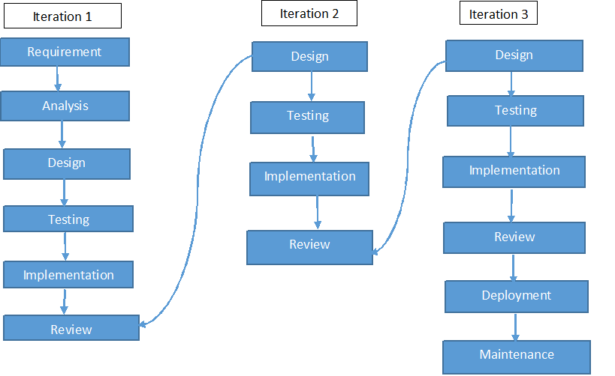

Figure 5‑1 Iterative model of "MyMed"

1. **DATA FLOW DIAGRAM OF “MYMED” (level-0)**

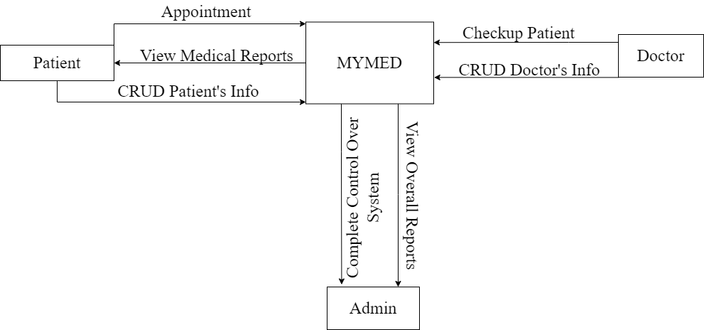

Figure 5‑2 Data Flow Diagram of "MyMed" (level-0)

1. **DATA FLOW DIAGRAM OF “MYMED” (level-1)**

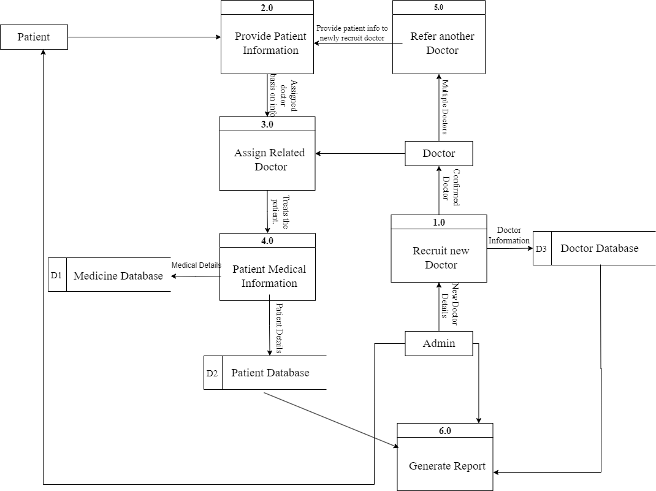

Figure 5‑3 Data Flow Diagram of "MyMed"(level-1)

1. **FLOWCHART OF “MYMED”**

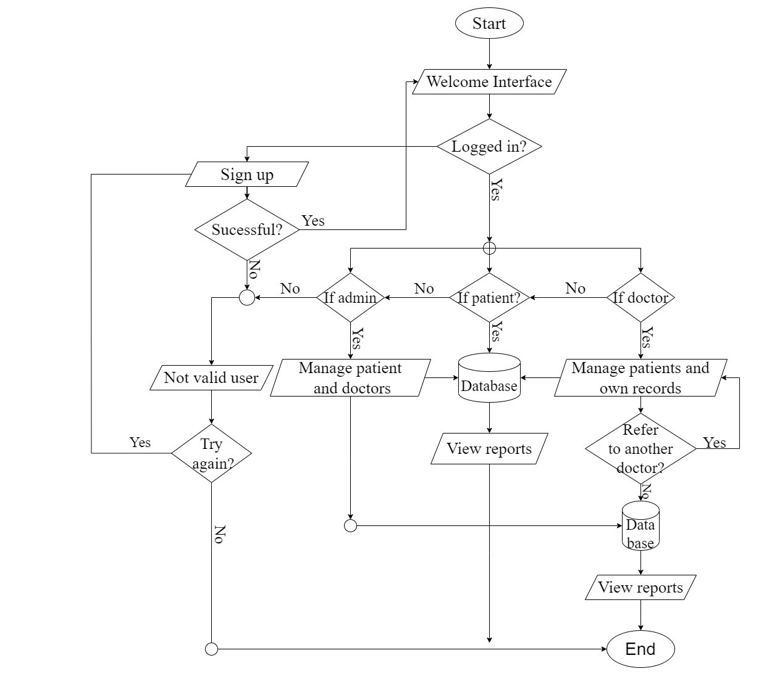

Figure 5‑4 Flowchart of "MyMed"

1. **DATABASE SCHEMA**

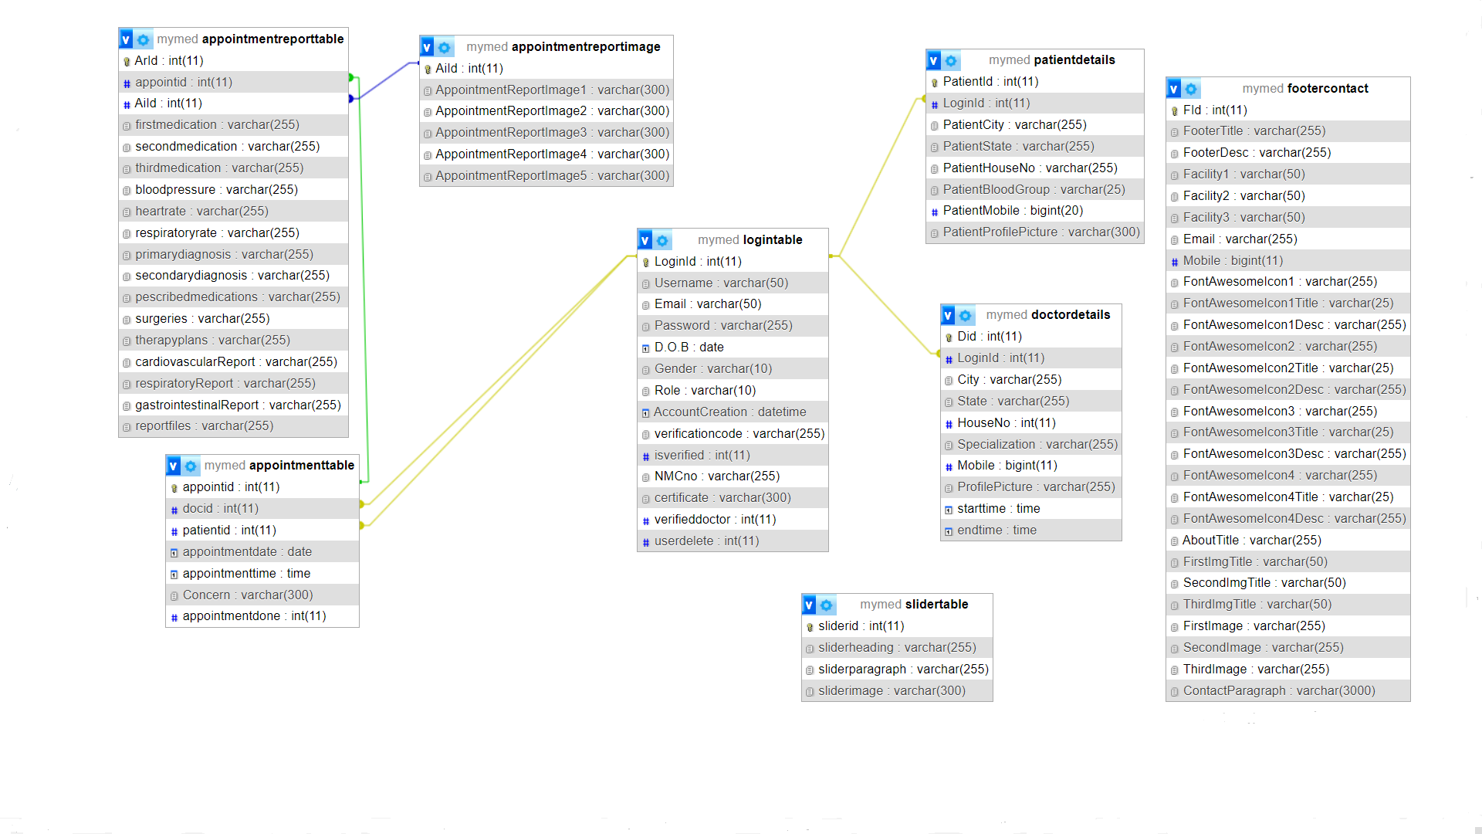

Figure 5‑5 Database Schema of "MyMed"

# PROJECT GANTT CHART/ TIMELINE CHART

The Gantt chart below shows the schedule planned for developing the “MYMED” SOFTWARE following Iterative Model Methodology. Thus, this project carried out in steps with proper planning in each step, best effort is applied to finish this project before deadline.

It also shows the time schedule description and tasks performed throughout the completion of project from the day of starting the project until it has been finished in the horizontal bar below:

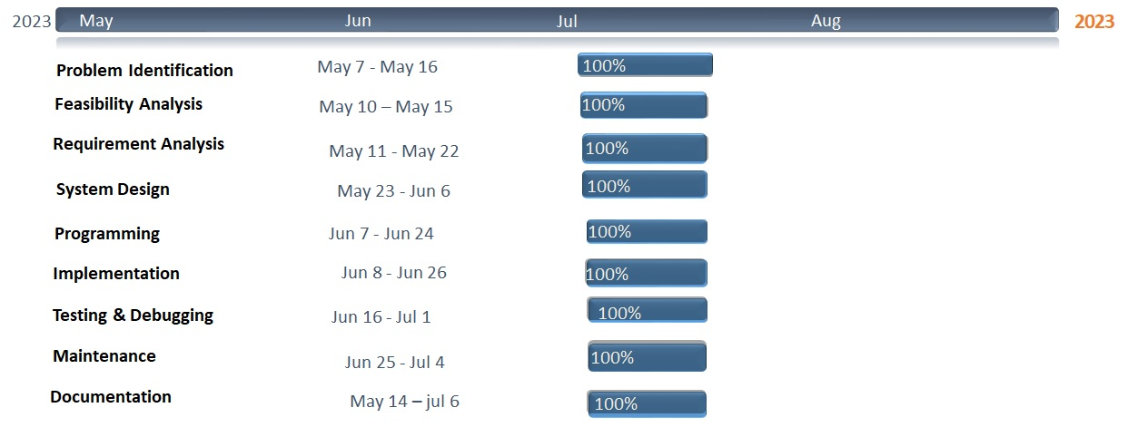

Figure 6‑1 Gantt Chart of "MyMed”

# FUTURE ENHANCEMENT

The project “MyMed” is flexible enough to meet the requirements of the customers. This project also has the scope of enhancements like:

* It will grant more easy access.
* Live chat feature between doctor and patients will be added.
* Online consultation fee.
* Video consultation feature can be added.
* Mobile app development.
* Appointment remainders and notifications.
* Patients reviews and ratings.

Everything that is made has some or the things to be added to make it better than revolutions. The project “MyMed”, it has been tried to develop a robust and fault free system, still enough flexibility has been provided for further enhancements and modifications.

# DELIVERABLES

Here are some potential deliverables for the “MyMed” project:

* It provides friendly relationship between patients and doctors.
* This software provides health information to the patients.
* It helps to facilitate communication between patients and doctors.
* Creating a dashboard for doctors to access the medical records of their patients and view trends of changes in their health over time.
* Developing an easy-to-use interface for patients to input and track their medical records.
* Continuously improve and update the software based on feedback from patients and healthcare providers.
* It ensures that the software is secure and maintain patient confidentiality.

# CONCLUSION

As the Project is being made, there are many things that can be learned from it. In this module i.e., Web Technologies, we were given a project task to perform in a group work. The artefact of the project is a digitalized system called “MyMed” by using HTML, CSS, JS and PHP.

This project requires a lot of research and hard work for successful completion of our mid defence and every step are done by full effort. This project helps us to share and present our ideas in the Group.

“MyMed” is an essential tool for keeping accurate records on doctors, patients, and medical personnel. Using “MyMed” will make the process of data collection much more efficient and streamlined, allowing hospital administrators to gain better control over their operations. The time saved by using “MyMed” will be invaluable, as it not only reduces the amount of manual labour required but also increases accuracy and organization.

With “MyMed”, hospital staff can easily access the data they need to make informed decisions and ensure all aspects of the organization are running smoothly. In existing system there are several drawbacks. So, to sort out all the existing problems this project is being developed. The product automates the process of collecting and receiving patient information, which can greatly improve response time in providing patient care.

This can free up the time of medical staff from dealing with administrative, allowing them to focus on what matters most – providing the best care for their patients. By eliminating these complexities, the product makes it easier for medical staff to provide the best care possible to their patients, without having to worry about administrative matters.

# REFERENCES

Here are some similar apps and website that we take references for our project:

1. **Brown, A., & Jones, C. (2019).**

Improving access to care in rural areas: The role of online appointment scheduling. Journal of Rural Health, 35(4), 516-519.

1. **Chen, A. T., Wu, S., Tomasino, K. N., Lypson, M. L., & Moreno-Walton, L. (2019).**

Mobile tablet use among academic physicians and trainees. Journal of Medical Systems, 43(8), 1-8.

1. **Garcia, A. L., Garza, C., Cook, M., & Hawkins, J. (2020).**

Patient perspectives on digital health information privacy and security: Qualitative analysis. Journal of Medical Internet Research, 22(4), e14479.

1. **Johnson, R., & Patel, V. (2020).**

Evaluating patient satisfaction with online appointment booking systems in primary care. Health Informatics Journal.

These websites provide useful insights and ideas on how to design and develop our own website for record keeping of doctor and patients.