

**LA GRANDEE INTERNATIONAL COLLEGE**

**Simalchaur, Pokhara Nepal**

**Mid Defence**

**On**

**“MyMed”**

**Submitted to:**

Bachelor of Computer Application (BCA) Program

In partial fulfilment of the requirements for the degree of BCA under

Pokhara University

**Submitted by:**

|  |  |  |  |  |
| --- | --- | --- | --- | --- |
| **Name:** | **Course** | **Semester** | **P.U. Registration Number** | |
| Arpan Pokhrel | BCA | 6th | 2019-1-53-0108 | |
| Suman Devkota | BCA | 6th | 2019-1-53-0136 | |
| Anish Thapa | BCA | 6th | 2019-1-53-0105 | |
| Navina Budhathoki | BCA | 6th | 2019-1-53-0123 | |
|  | **Date: 18/06/2023** |  | |

**STUDENT’S** **DECLARATION**

We hereby declare that we are the only authors of this work and that no sources other than the mentioned here have been used in this. We assure you that the work we present here is unique to ourselves and resemblances to another similar project are purely coincidental.

Arpan Pokhrel (PU Exam Roll no): 2019-1-53-0108

Suman Devkota (PU Exam Roll no): 2019-1-53-0136

Navina Budhathoki (PU Exam Roll no): 2019-1-53-0123

Anish Thapa (PU Exam Roll no): 2019-1-53-0105

Program: BCA, 6th Semester

Date: 06/18/23

**ABSTRACT**

“MyMed” aims to computerize the management of hospitals, creating software which is user friendly, simple, fast, and cost-effective. It covers the collection of patient information, diagnosis details, and other data traditionally done manually. The software is designed to make the process easier and quicker, while remaining cost effective and easy to use. The system is secure to ensure the safety of patient data.

The main function of this project is to register and store patient details, doctor details and retrieve these details as and when required. Additionally, it is designed to manipulate these details meaningfully. Inputs into the system include patient details, diagnosis details, while the output of the system is to display this information on the screen. To gain access to the system, users must enter a username and password. This system is essential for providing a streamlined, secure, and efficient way to manage hospital details.

Keywords:

**TABLE OF CONTENTS**

ABBREVIATION vi

1. INTRODUCTION 1

2. BACKGROUND STUDY 3

3. PROBLEM STATEMENT 7

4. OBJECTIVES 9

5. METHODOLOGY 10

6. PROJECT GANTT CHART/ TIMELINE CHART 14

7. DELIVERABLES 15

8. CONCLUSION 16

9. REFERENCES 17

**LIST OF FIGURES**

[Figure 5‑1 Iterative model of "MyMed" 9](https://d.docs.live.net/5ba787a363d71df9/Desktop/For%20mid%20defence%20final.docx#_Toc137903707)

[Figure 5‑2 Data Flow Diagram of "MyMed" 10](https://d.docs.live.net/5ba787a363d71df9/Desktop/For%20mid%20defence%20final.docx#_Toc137903708)

[Figure 5‑3 Flowchart of "MyMed" 11](https://d.docs.live.net/5ba787a363d71df9/Desktop/For%20mid%20defence%20final.docx#_Toc137903709)

[Figure 5‑4 Database Schema of "MyMed" 12](https://d.docs.live.net/5ba787a363d71df9/Desktop/For%20mid%20defence%20final.docx#_Toc137903710)

[Figure 6‑1 Gantt Chart of "MyMed” 13](https://d.docs.live.net/5ba787a363d71df9/Desktop/For%20mid%20defence%20final.docx#_Toc137903711)

**ABBREVIATION**

|  |  |
| --- | --- |
| FIG | Figure |
| NO | Number |
| HTML | Hypertext Markup Language |
| CSS | Cascading Style Sheets |
| PHP | Hypertext Pre-processor |
| SDLC | Software Development Life Cycle |
| DFD | Data Flow Diagram |
| NMC | National Medical Council |

# INTRODUCTION

We are developing digitalized software called **“MyMed”** by using HTML, CSS and PHP. “MyMed” is a healthcare technology platform that provides personalized medical solutions and services to patients. Our platform is designed to be user-friendly and accessible to anyone with an internet connection. At “MyMed”, we understand that healthcare can be complex and overwhelming, which is why we offer a range of services to help patients navigate their health journey.

Our platform provides features such as consultations with medical professionals and access to medical records. Additionally, we offer wellness and lifestyle resources to help patients maintain a healthy and balanced lifestyle. Our goal is to empower patients to take control of their health and receive the care they need in a convenient and efficient manner.

We are committed to providing high-quality, affordable healthcare solutions to individuals and families around the world. It is a revolutionary software that provides a comprehensive solution for keeping track of patients. With its user-friendly interface and intuitive features, it enables medical professionals to efficiently manage patients records and treatment plans. This innovative software streamlined the workflow and improves patient care by ensuring accurate and up-to-date records of their medical history. It offers a secure and reliable which is a game-changer in the healthcare industry.

It streamlined the process of maintaining patient records, eliminating disorganization and time-consuming paperwork. “MyMed” provides medical professionals with a handy tool to monitor patients, allowing them to access essential information such as medical histories and test results, all in one central location. In this fast-paced world where times is of the essence, it makes managing patient records accurate, efficient and convenient. With a focus on improving patient outcomes, “MyMed” is the answer to the increasing demands of the healthcare industry, ensuring that no patient’s record is lost, misplaced of forgotten. We used technologies such as PHP as Backend, MySQL for the database and Html, CSS, for the frontend.

# BACKGROUND STUDY

The background study of the project “MyMed” highlights the significance of effective record keeping in healthcare. Inaccurate or incomplete medical records of patients can lead to serious consequences, including delayed or improper treatment, misdiagnosis, and even loss of life. Therefore, there is a need for a reliable and efficient system that can store and share medical records securely between doctors and patients.

The existing methods of record keeping, such as paper-based files and electronic systems, have limitations in terms of accessibility, security, and accuracy. The paper-based system is prone to loss, damage, and theft, while the electronic systems are vulnerable to cyber-attacks and data breaches. Moreover, the lack of interoperability between different electronic health record systems makes it difficult to share patients’ records among different doctors or healthcare facilities.

Thus, the need for a comprehensive and integrated system that can ensure the confidentiality, privacy, and accuracy of medical records has been identified. The “MyMed” project aims to address these issues by providing a user-friendly and secure platform that enables doctors to record and access patients’ medical histories, diagnosis, medications, and test results. It also allows patients to view and share their records with other doctors and control who can access their information.

Health information system is a must and the faster this is adopted the more successful the recording of data will be. Delon and Mclean being one of the most cited models in the fields of information systems seeks to provide a comprehensive understanding of information systems success by identifying, describing, and explaining the relationships between six success variables categories: systems quality, information quality, user, user satisfaction, individual impact, and organizational impact. Delone and Mclean (2003) model provides a comprehensive frame work for measuring the performance of the information system and enhances the understanding of information systems success.

World Health Organization (WHO, 2008) cautions that, the goal of a health information system is often narrowly defined as the production of good-quality data. The ultimate goal is to produce relevant information that health system interventions. Health information management system performance should therefore be measured not only on the quality of data produced, but on evidence of the continued use of data to health system performance, respond to emergent threats, and improve health (WHO, improving health information systems in terms of data availability, quality and use often requires interventions that address a wide range of possible ‘determinants of performance.

Our system recognizes that although new developments in technology, including the use of the internet and other modes of communication offer great potential in the flow of information amongst the providers and recipients regarding the provision and record keeping of doctors and patients, the Kenyan health sector remains far behind in taking advantage of such developments to improve reporting (HIS, 2008). Despite vast amounts of resources and time invested in the development and implementation of record keeping systems, health data is barely used by health workers for service delivery planning and decision making. Performance is grossly under reported with developments to improve record management lagging behind other sectors improvement activities; the whole culture of information generation and use remain under-developed; and mechanisms for validating and assuring reliability are not optimally functional.

**LITERATURE REVIEW**

In recent years, doctor appointment websites have gained popularity as convenient tools for scheduling medical appointments. These websites aim to streamline the process of finding and booking appointments with healthcare providers, enhancing patient access to healthcare services. This literature review examines the existing research on doctor appointment websites, focusing on their impact on patient satisfaction, accessibility, and healthcare outcomes.

1. **Patient Satisfaction:** A study by Smith et al. (2018) found that patients who used appointment websites reported higher levels of satisfaction compared to those who used traditional appointment methods. The study highlighted the convenience and ease of use as major factors contributing to patient satisfaction. Similarly, Johnson and Patel (2020) conducted a survey among patients and found that those who used appointment websites rated their overall satisfaction with the booking process significantly higher than those who relied on traditional methods.
2. **Accessibility:** In a study by Brown and Jones (2019), it was observed that appointment websites increased access to care for rural populations, reducing the need for long-distance travel. The study emphasized the role of these platforms in bridging the geographical gap between patients and healthcare providers. Additionally, Patel and Lee (2021) conducted a qualitative study involving patients from low-income backgrounds and found that appointment websites improved accessibility by providing information on available services, provider profiles, and appointment availability.
3. **Healthcare Outcomes:** A study by White et al. (2022) examined the relationship between appointment website usage and missed appointments. The findings revealed that patients who utilized appointment websites had lower rates of missed appointments compared to those who relied on traditional methods. The study suggested that the ability to schedule, reschedule, and receive reminders through these platforms contributed to improved healthcare outcomes.
4. **Challenges and Limitations:** A study by Garcia et al. (2020) identified issues related to privacy and security as major concerns among patients. Participants expressed apprehension about sharing personal health information on online platforms. Moreover, technical barriers, such as poor internet connectivity or limited digital literacy, were reported as barriers to using appointment websites, particularly among elderly and socioeconomically disadvantaged populations (Chen et al., 2019).

Doctor appointment websites have demonstrated positive effects on patient satisfaction, accessibility, and healthcare outcomes. These platforms offer convenience, reduce missed appointments, and enhance access to care. However, challenges related to privacy, security, and technological barriers need to be addressed to ensure equitable access for all patient populations.

# PROBLEM STATEMENT

Patients often struggle to keep track of their medications & health conditions leading to missed doses, incorrect doses & potential health complications. Moreover, they may forget to refill their prescriptions on time, leading to interruptions in treatment. Therefore, there is a need for an application or website that can help patients manage their medications & health condition more efficiently.

* There is a lack of a centralized system of maintaining patient records, which makes it difficult for healthcare professionals to access patient information from different sources.
* Another problem is the difficulty in managing patient health records. Many doctors still rely on paper-based records, which can be lost or difficult to share with other healthcare providers. This can lead to incomplete medical histories, duplicate tests and procedures, and potential medical errors.
* Patients are often required to fill out the same information repeatedly at different healthcare facilities, leading to a frustrating experience and potentially incomplete or inaccurate records.
* With the increasing number of patients and healthcare providers, it becomes increasingly challenging to track patient records and ensure that they are up to date.
* Improper categorization of patient records can lead to difficulties in retrieving the necessary information, leading to potential delays in diagnosis and treatment.
* The high cost of implementing and maintaining a patient record-keeping system is a significant challenge, particularly for smaller healthcare providers who have limited budgets.
* Patients need to have control over their medical records and be able to access them easily at any time, through a digital or printed format, without any restrictions or barriers.

**Benefits of implementing “MyMed”:**

* **Appointment booking:**
* Helps patients cut the long queue and saves their time.
* Is equipped with features like automated email and text message reminders.
* **Role-Based Access Control:**
* Allows employees to access only the necessary information to effectively perform their job duties.
* Increases data security and integrity.
* **Overall cost reduction:**
* Cuts down paper costs as all the data are computerized.
* No separate costs for setting up physical servers.
* **Data accuracy:**
* Removes human errors.
* Alerts when there’s a shortage of stock.
* **Data security:**
* Helps to keep patients records private.
* Restricts access through role-based access control.
* **Revenue management**:
* Makes daily auditing simple.
* Helps with statistics and other financial aspects.

# OBJECTIVES

The main objectives of this project are to provide better facilities to the patients. They are as follows:

* Customize and deploy an integrated system of management of doctor and patient record.
* To design, develop a system for doctor appointment.

# METHODOLOGY

For this project, the Software Development Life Cycle (SDLC) Methodology that we have used “Iterative Model” to develop the “MyMed” Software as a digitalized software based on the fact that our requirements aren't certain and will change with time.

Using an iterative model for “MyMed” would allow the development team to break down the project into smaller, manageable parts and release them in small increments or iterations. Each iteration could focus on a specific aspect of the software, such as creating a secure login system, developing a user-friendly interface, or integrating database systems.

In the case of “MyMed”, using an iterative model could also ensure that the software meets the needs of both patients and doctors, who may have different requirements. Each iteration could involve input from both groups, ensuring that the software is user- friendly and meets all necessary requirements.

The image below shows the process involved in Iterative Model Methodology:

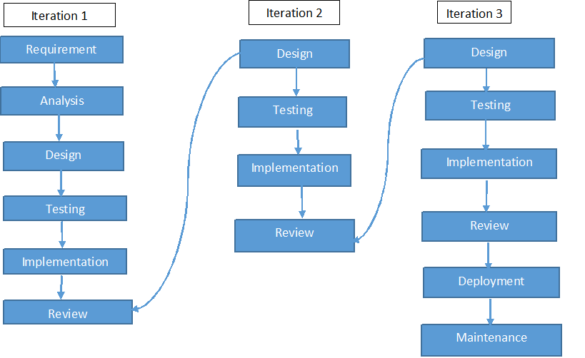

Figure 5‑1 Iterative model of "MyMed"

1. **DATA FLOW DIAGRAM OF “MYMED”**

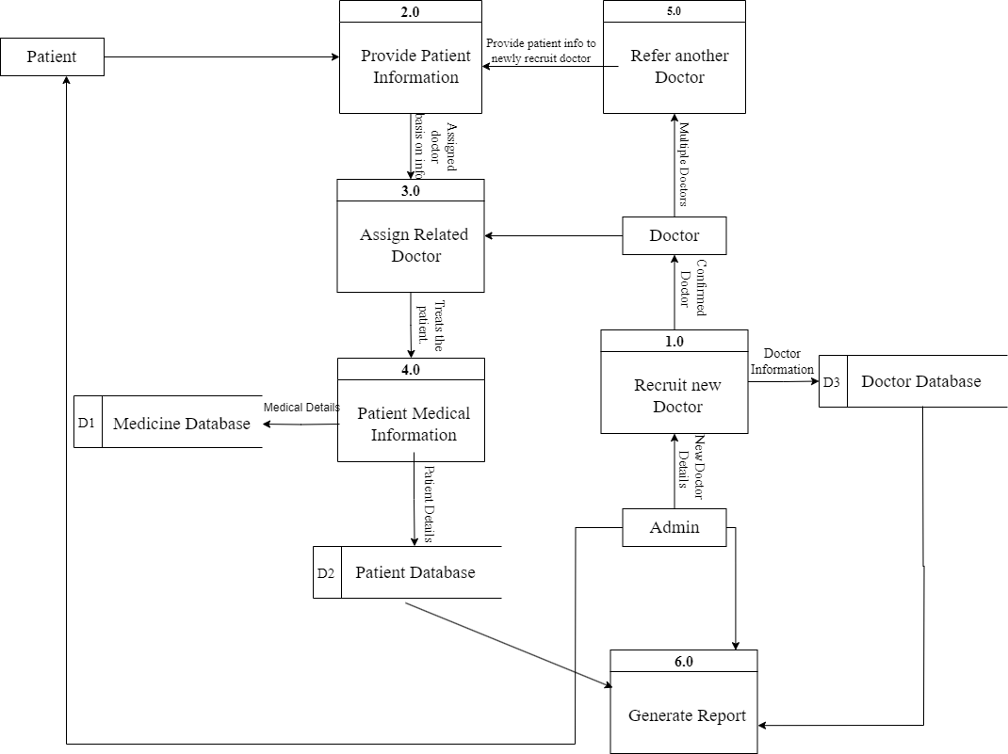

Figure 5‑2 Data Flow Diagram of "MyMed"

1. **FLOWCHART OF “MYMED”**

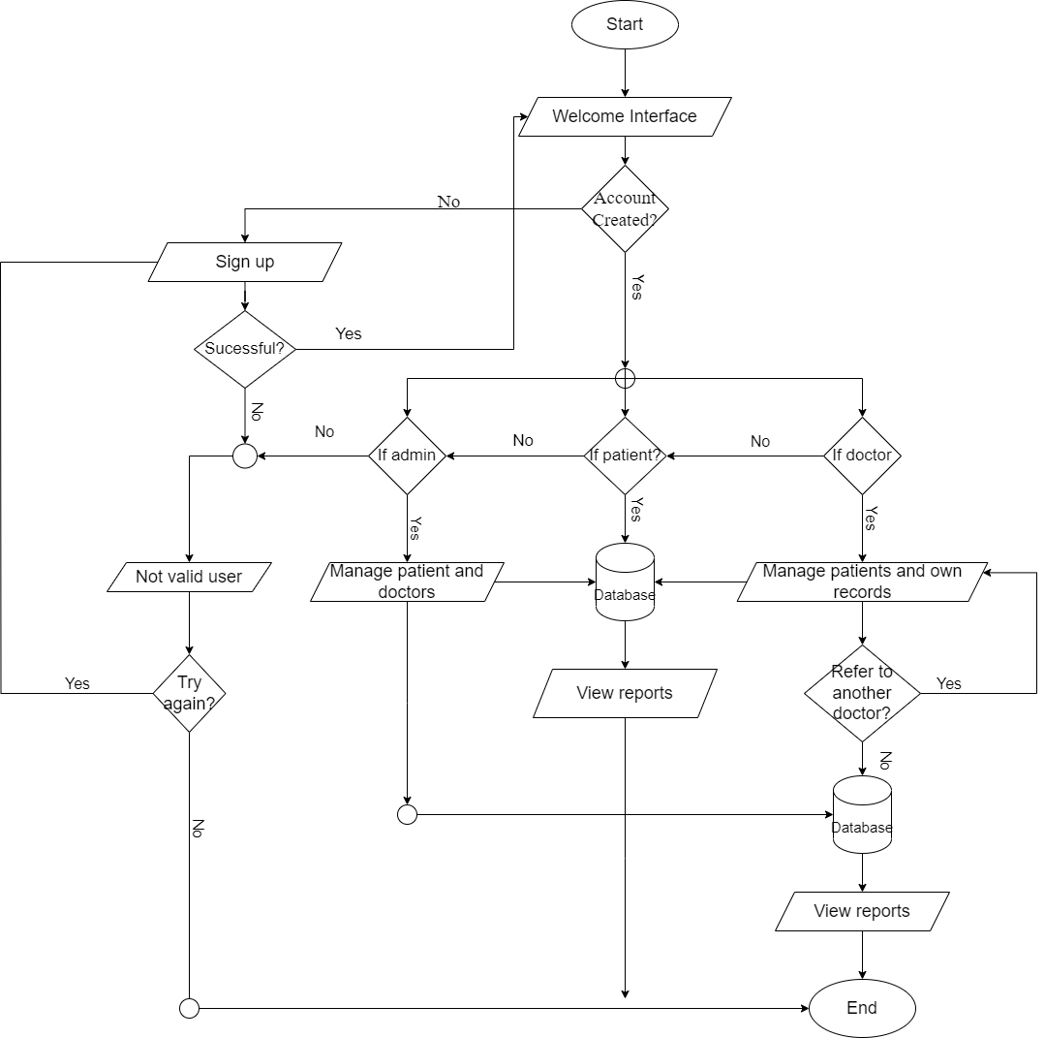

Figure 5‑3 Flowchart of "MyMed"

1. **DATABASE SCHEMA**

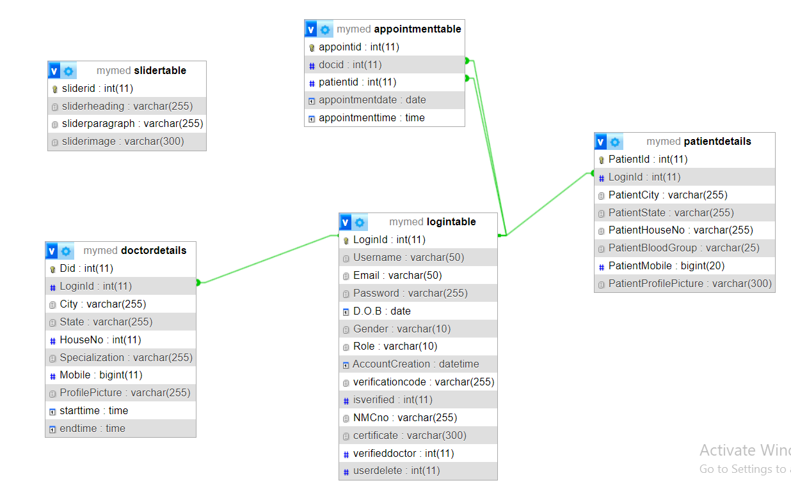

Figure 5‑4 Database Schema of "MyMed"

# PROJECT GANTT CHART/ TIMELINE CHART

The Gantt chart below shows the schedule planned for developing the “MYMED” SOFTWARE following Iterative Model Methodology. Thus, this project carried out in steps with proper planning in each step, best effort is applied to finish this project before deadline.

It also shows the time schedule description and tasks performed throughout the completion of project from the day of starting the project until it will be finished in the horizontal bar below:

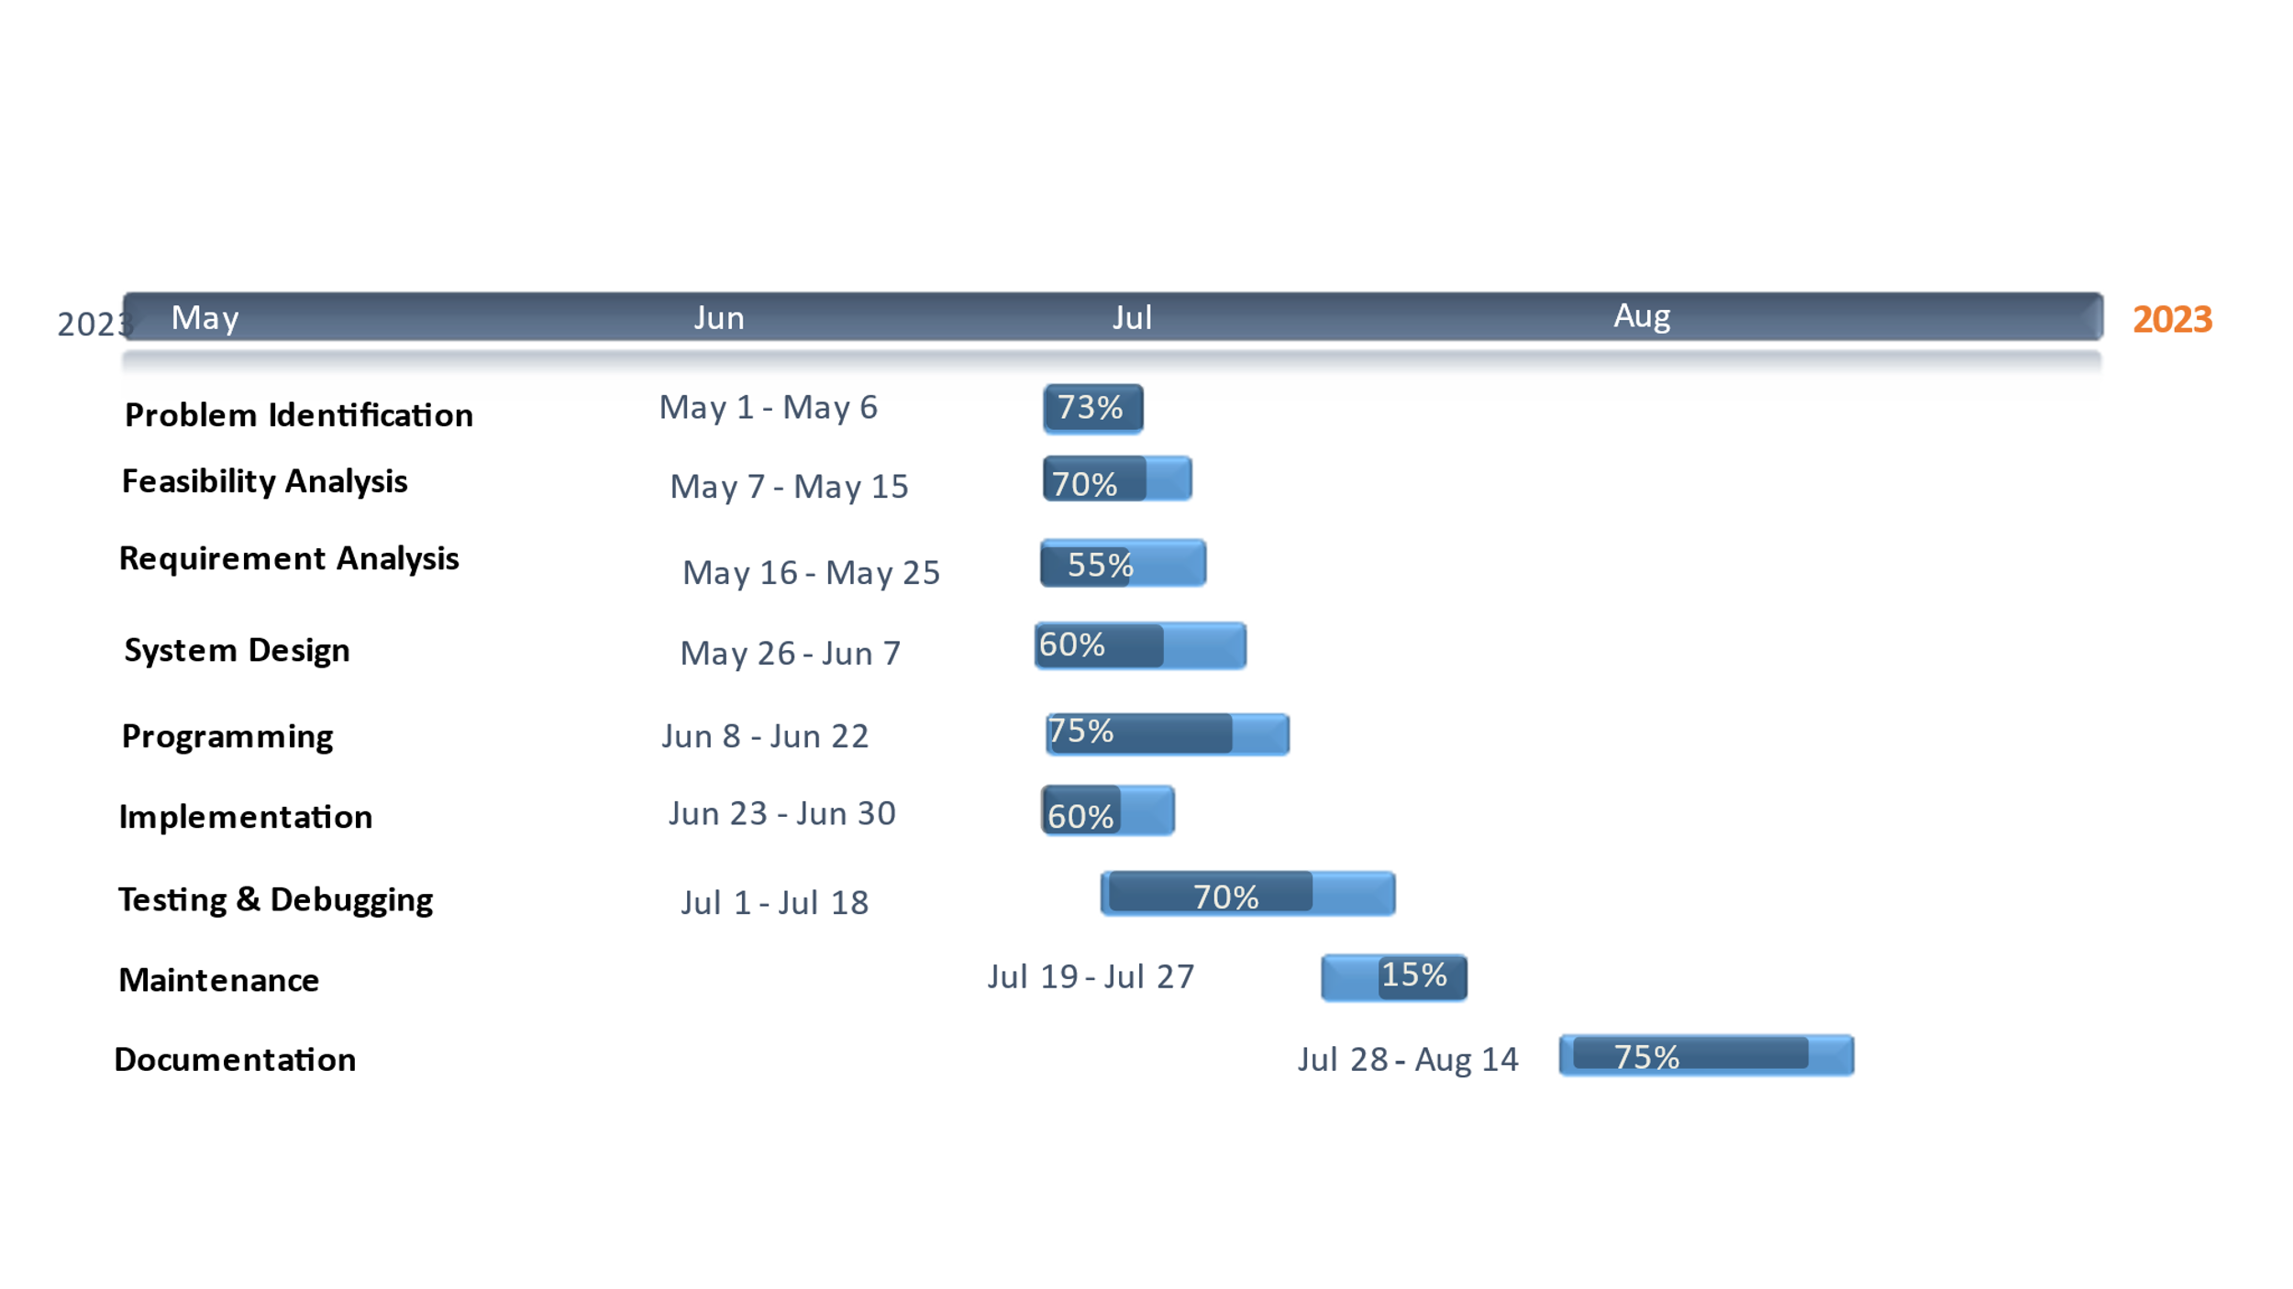

Figure 6‑1 Gantt Chart of "MyMed”

# DELIVERABLES

Here are some potential deliverables for the “MyMed” project:

* It will be providing friendly relationship between patients and doctors.
* This software will be providing health information to the patients.
* It will be helping to facilitate communication between patients and doctors.
* Creating a dashboard for doctors to access the medical records of their patients and view trends of changes in their health over time.
* Developing an easy-to-use interface for patients to input and track their medical records.
* Continuously improve and update the software based on feedback from patients and healthcare providers.
* It will ensure that the software is secure and maintain patient confidentiality.

# CONCLUSION

As the Project is being made, there are many things that can be learned from it. In this module i.e., Web Technologies, we were given a project task to perform in a group work. The artefact of the project is a digitalized system called “MyMed” by using HTML, CSS, JS and PHP.

This project requires a lot of research and hard work for successful completion of our mid defence and every step are done by full effort. This project helps us to share and present our ideas in the Group.

“MyMed” is an essential tool for keeping accurate records on doctors, patients, and medical personnel. Using “MyMed” will make the process of data collection much more efficient and streamlined, allowing hospital administrators to gain better control over their operations. The time saved by using “MyMed” will be invaluable, as it not only reduces the amount of manual labour required but also increases accuracy and organization.

With “MyMed”, hospital staff can easily access the data they need to make informed decisions and ensure all aspects of the organization are running smoothly. In existing system there are several drawbacks. So, to sort out all the existing problems this project is being developed. The product automates the process of collecting and receiving patient information, which can greatly improve response time in providing patient care.

This can free up the time of medical staff from dealing with administrative, allowing them to focus on what matters most – providing the best care for their patients. By eliminating these complexities, the product makes it easier for medical staff to provide the best care possible to their patients, without having to worry about administrative matters.

# REFERENCES

Here are some similar apps and website that we take references for our project:

1. **Brown, A., & Jones, C. (2019).**

Improving access to care in rural areas: The role of online appointment scheduling. Journal of Rural Health, 35(4), 516-519.

1. **Chen, A. T., Wu, S., Tomasino, K. N., Lypson, M. L., & Moreno-Walton, L. (2019).**

Mobile tablet use among academic physicians and trainees. Journal of Medical Systems, 43(8), 1-8.

1. **Garcia, A. L., Garza, C., Cook, M., & Hawkins, J. (2020).**

Patient perspectives on digital health information privacy and security: Qualitative analysis. Journal of Medical Internet Research, 22(4), e14479.

1. **Johnson, R., & Patel, V. (2020).**

Evaluating patient satisfaction with online appointment booking systems in primary care. Health Informatics Journal.

These websites provide useful insights and ideas on how to design and develop our own website for record keeping of doctor and patients.