

**LA GRANDEE INTERNATIONAL COLLEGE**

**Simalchaur, Pokhara Nepal**

**Mid Defence**

**On**

**“MyMed”**

**Submitted to:**

Bachelor of Computer Application (BCA) Program

In partial fulfilment of the requirements for the degree of BCA under

Pokhara University

**Submitted by:**

|  |  |  |  |  |
| --- | --- | --- | --- | --- |
| **Name:** | **Course** | **Semester** | **P.U. Registration Number** | |
| Arpan Pokhrel | BCA | 6th | 2019-1-53-0108 | |
| Suman Devkota | BCA | 6th | 2019-1-53-0136 | |
| Anish Thapa | BCA | 6th | 2019-1-53-0105 | |
| Navina Budhathoki | BCA | 6th | 2019-1-53-0123 | |
|  | **Date: 17/06/2023** |  | |

**STUDENT’S DECLARATION**

We hereby declare that we are the only authors of this work and that no sources other than the mentioned here have been used in this. We assure you that the work we present here is unique to ourselves and resemblances to another similar project are purely coincidental.

Arpan Pokhrel (PU Exam Roll no): 2019-1-53-0108

Suman Devkota (PU Exam Roll no): 2019-1-53-0136

Navina Budhathoki (PU Exam Roll no): 2019-1-53-0123

Anish Thapa (PU Exam Roll no): 2019-1-53-0105

Program: BCA, 6th Semester

Date: 06/17/23

**ABSTRACT**

This project aims to computerize the management of hospitals, creating software which is user friendly, simple, fast, and cost-effective. It covers the collection of patient information, diagnosis details, and other data traditionally done manually. The software is designed to make the process easier and quicker, while remaining cost effective and easy to use. The system is secure to ensure the safety of patient data.

The main function of this project is to register and store patient details, doctor details and retrieve these details as and when required. Additionally, it is designed to manipulate these details meaningfully. Inputs into the system include patient details, diagnosis details, while the output of the system is to display this information on the screen. To gain access to the system, users must enter a username and password. This system is essential for providing a streamlined, secure, and efficient way to manage hospital details.

Keywords:

The database is a secure and efficient way to store data. It is easily accessible from any internet-enabled device by either an administrator or receptionist, and only they can add data the database. Furthermore, the data are protected for personal use and make data processing very fast. This ensures that the data remains secure and accessible to only those with the proper authorization. Additionally, the data can be retrieved quickly and easily, providing the users with the information they need in a timely manner.

**TABLE OF CONTENTS**

ABBREVIATION v

1. INTRODUCTION 1

2. BACKGROUND STUDY 3

3. PROBLEM STATEMENT 6

4. OBJECTIVES 7

5. METHODOLOGY 8

6. PROJECT GANTT CHART/ TIMELINE CHART 12

7. DELIVERABLES 13

8. CONCLUSION 14

9. REFERENCES 15

Figure I Iteration Model of MyMed 8

Figure II:DFD Of MyMed 9

Figure III:FlowChart Of MyMed 10

Figure IV:Database Schema of MYMed 11

Figure V:Gantt Chart of MyMed 12

# ABBREVIATION

|  |  |
| --- | --- |
| **FIG** | **Figure** |
| **NO** | **Number** |
| **HTML** | **Hypertext Markup Language** |
| **CSS** | **Cascading Style Sheets** |
| **PHP** | **Hypertext Pre-processor** |
| **SDLC** | **Software Development Life Cycle** |
| **DFD** | **Data Flow Diagram** |
|  |  |

# INTRODUCTION

We are developing digitalized software called **“MyMed”** by using HTML, CSS and PHP. “MyMed” is a healthcare technology platform that provides personalized medical solutions and services to patients. Our platform is designed to be user-friendly and accessible to anyone with an internet connection. At “MyMed”, we understand that healthcare can be complex and overwhelming, which is why we offer a range of services to help patients navigate their health journey.

Our platform provides features such as consultations with medical professionals and access to medical records. Additionally, we offer wellness and lifestyle resources to help patients maintain a healthy and balanced lifestyle. Our goal is to empower patients to take control of their health and receive the care they need in a convenient and efficient manner.

We are committed to providing high-quality, affordable healthcare solutions to individuals and families around the world. It is a revolutionary software that provides a comprehensive solution for keeping track of patients. With its user-friendly interface and intuitive features, it enables medical professionals to efficiently manage patients records and treatment plans. This innovative software streamlined the workflow and improves patient care by ensuring accurate and up-to-date records of their medical history. It offers a secure and reliable which is a game-changer in the healthcare industry.

It streamlined the process of maintaining patient records, eliminating disorganization and time-consuming paperwork. “MyMed” provides medical professionals with a handy tool to monitor patients, allowing them to access essential information such as medical histories and test results, all in one central location. In this fast-paced world where times is of the essence, it makes managing patient records accurate, efficient and convenient. With a focus on improving patient outcomes, “MyMed” is the answer to the increasing demands of the healthcare industry, ensuring that no patient’s record is lost, misplaced of forgotten. We used technologies such as PHP as Backend, MySQL for the database and Html, CSS, for the frontend.

With MyMed, healthcare professionals and patients alike can experience greater efficiency, accuracy, and transparency in managing medical records. Our state-of-the-are technology securely stores and organizes patient information, including medical history, test results, and treatment plans, improving communication and collaboration among healthcare providers while enhancing the quality of care delivered. With features such as appointment scheduling, prescription management, and real-time updates, MyMed provides a comprehensive solution for healthcare facilities and practitioners looking to streamline their operations and deliver better patient outcomes. Out project aims to revolutionize the way medical records are stored and managed, transforming healthcare delivery into a more patient-centric and efficient system.

# BACKGROUND STUDY

The background study of the project “MyMed” highlights the significance of effective record keeping in healthcare. Inaccurate or incomplete medical records of patients can lead to serious consequences, including delayed or improper treatment, misdiagnosis, and even loss of life. Therefore, there is a need for a reliable and efficient system that can store and share medical records securely between doctors and patients.

The existing methods of record keeping, such as paper-based files and electronic systems, have limitations in terms of accessibility, security, and accuracy. The paper-based system is prone to loss, damage, and theft, while the electronic systems are vulnerable to cyber-attacks and data breaches. Moreover, the lack of interoperability between different electronic health record systems makes it difficult to share patients’ records among different doctors or healthcare facilities.

Thus, the need for a comprehensive and integrated system that can ensure the confidentiality, privacy, and accuracy of medical records has been identified. The “MyMed” project aims to address these issues by providing a user-friendly and secure platform that enables doctors to record and access patients’ medical histories, diagnosis, medications, and test results. It also allows patients to view and share their records with other doctors and control who can access their information.

Health information system is a must and the faster this is adopted the more successful the recording of data will be. Delone and Mclean being one of the most cited models in the fields of information systems seeks to provide a comprehensive understanding of information systems success by identifying, describing, and explaining the relationships between six success variables categories: systems quality, information quality, user, user satisfaction, individual impact, and organizational impact. Delone and Mclean (2003) model provides a comprehensive frame work for measuring the performance of the information system and enhances the understanding of information systems success.

World Health Organization (WHO, 2008) cautions that, the goal of a health information system is often narrowly defined as the production of good-quality data. The ultimate goal is to produce relevant information that health system interventions. Health information management system performance should therefore be measured not only on the quality of data produced, but on evidence of the continued use of data to health system performance, respond to emergent threats, and improve health (WHO, improving health information systems in terms of data availability, quality and use often requires interventions that address a wide range of possible ‘determinants of performance.

Our system recognizes that although new developments in technology, including the use of the internet and other modes of communication offer great potential in the flow of information amongst the providers and recipients regarding the provision and record keeping of doctors and patients, the Kenyan health sector remains far behind in taking advantage of such developments to improve reporting (HIS, 2008). Despite vast amounts of resources and time invested in the development and implementation of record keeping systems, health data is barely used by health workers for service delivery planning and decision making. Performance is grossly under reported with developments to improve record management lagging behind other sectors improvement activities; the whole culture of information generation and use remain under-developed; and mechanisms for validating and assuring reliability are not optimally functional.

1. **LITERATURE REVIEW**

# PROBLEM STATEMENT

Patients often struggle to keep track of their medications & health conditions leading to missed doses, incorrect doses & potential health complications. Moreover, they may forget to refill their prescriptions on time, leading to interruptions in treatment. Therefore, there is a need for an application or website that can help patients manage their medications & health condition more efficiently.

* There is a lack of a centralized system of maintaining patient records, which makes it difficult for healthcare professionals to access patient information from different sources.
* Another problem is the difficulty in managing patient health records. Many doctors still rely on paper-based records, which can be lost or difficult to share with other healthcare providers. This can lead to incomplete medical histories, duplicate tests and procedures, and potential medical errors.
* Patients are often required to fill out the same information repeatedly at different healthcare facilities, leading to a frustrating experience and potentially incomplete or inaccurate records.
* With the increasing number of patients and healthcare providers, it becomes increasingly challenging to track patient records and ensure that they are up to date.
* Improper categorization of patient records can lead to difficulties in retrieving the necessary information, leading to potential delays in diagnosis and treatment.
* The high cost of implementing and maintaining a patient record-keeping system is a significant challenge, particularly for smaller healthcare providers who have limited budgets.
* Patients need to have control over their medical records and be able to access them easily at any time, through a digital or printed format, without any restrictions or barriers.

# OBJECTIVES

The main objectives of this project are to provide better facilities to the patients. They are as follows:

* Customize and deploy an integrated system of management of doctor and patient record.
* To design, develop a system for doctor appointment.

# METHODOLOGY

For this project, the Software Development Life Cycle (SDLC) Methodology that we have used “Iterative Model” to develop the “MyMed” Software as a digitalized software based on the fact that our requirements aren't certain and will change with time.

Using an iterative model for “MyMed” would allow the development team to break down the project into smaller, manageable parts and release them in small increments or iterations. Each iteration could focus on a specific aspect of the software, such as creating a secure login system, developing a user-friendly interface, or integrating database systems.

In the case of “MyMed”, using an iterative model could also ensure that the software meets the needs of both patients and doctors, who may have different requirements. Each iteration could involve input from both groups, ensuring that the software is user- friendly and meets all necessary requirements.

The image below shows the process involved in Iterative Model Methodology:

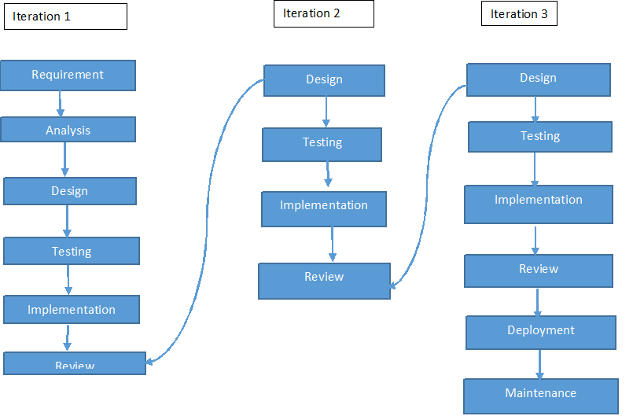

Figure I Iteration Model of MyMed

1. **DATA FLOW DIAGRAM OF “MYMED”**

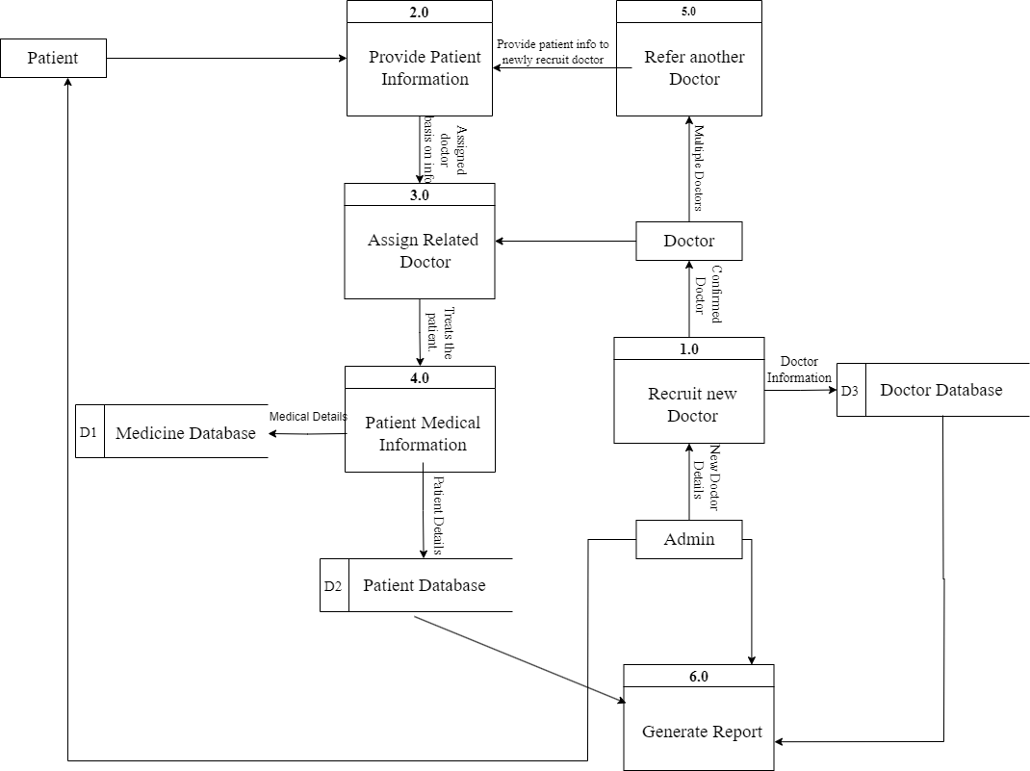

Figure II:DFD Of MyMed

1. **FLOWCHART OF “MYMED”**

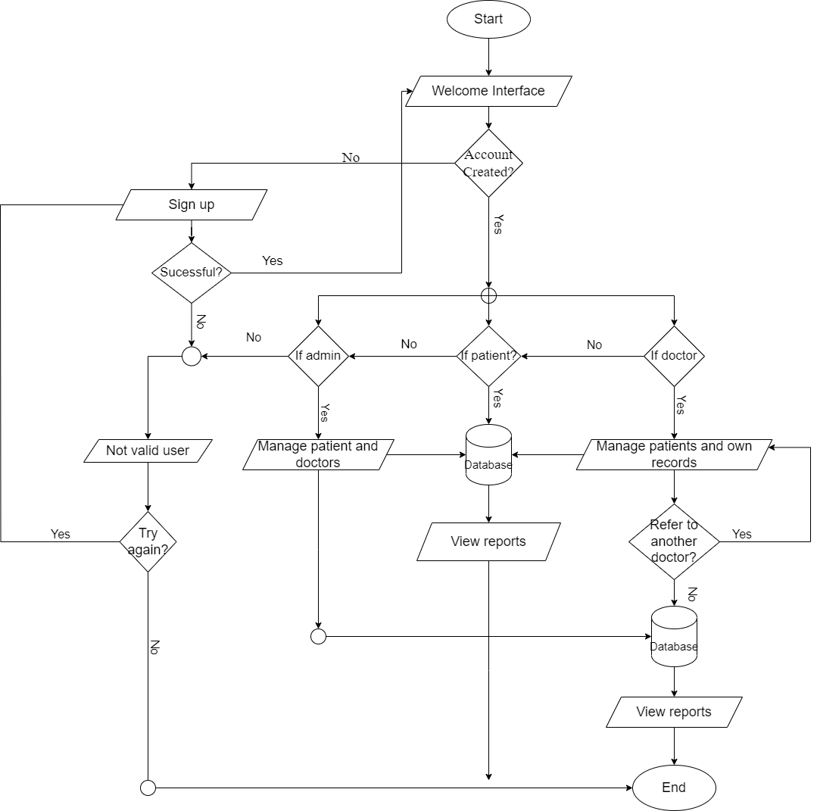

Figure III:FlowChart Of MyMed

1. **DATABASE SCHEMA**

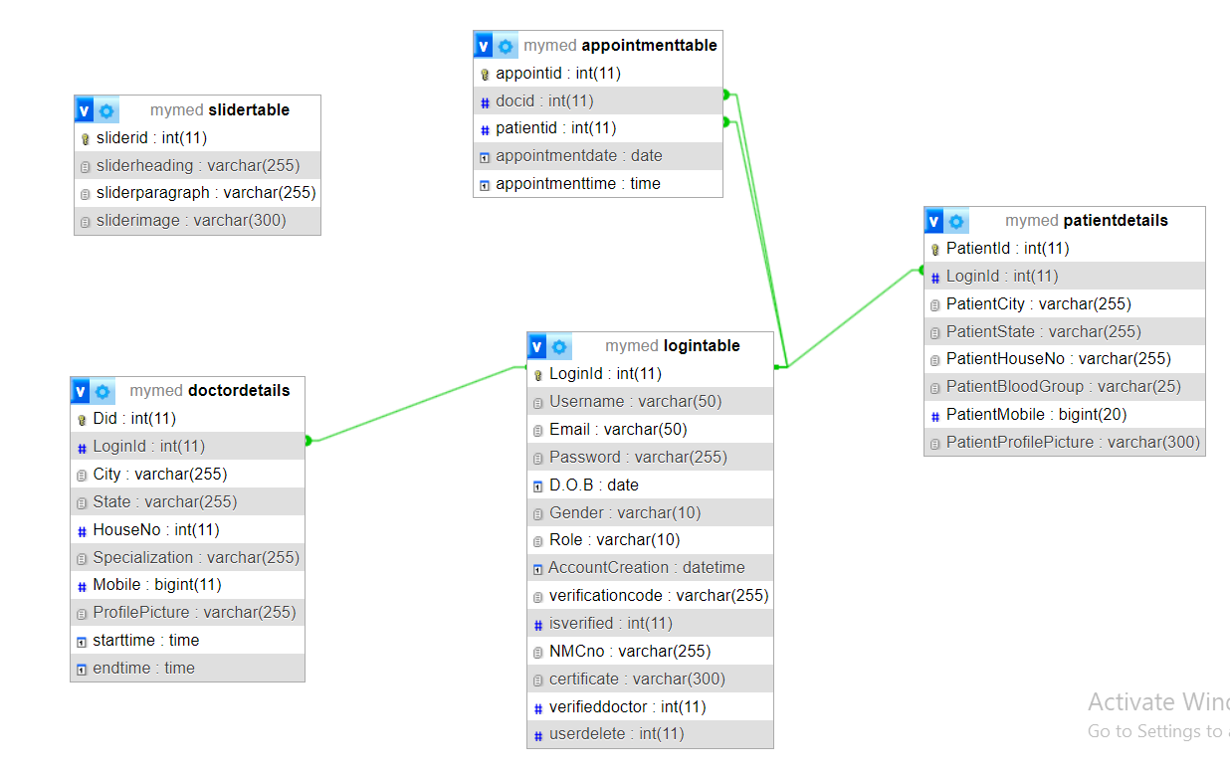

Figure IV:Database Schema of MYMed

# PROJECT GANTT CHART/ TIMELINE CHART

The Gantt chart below shows the schedule planned for developing the “MYMED” SOFTWARE following Iterative Model Methodology. Thus, this project carried out in steps with proper planning in each step, best effort is applied to finish this project before deadline.

It also shows the time schedule description and tasks performed throughout the completion of project from the day of starting the project until it will be finished in the horizontal bar below:

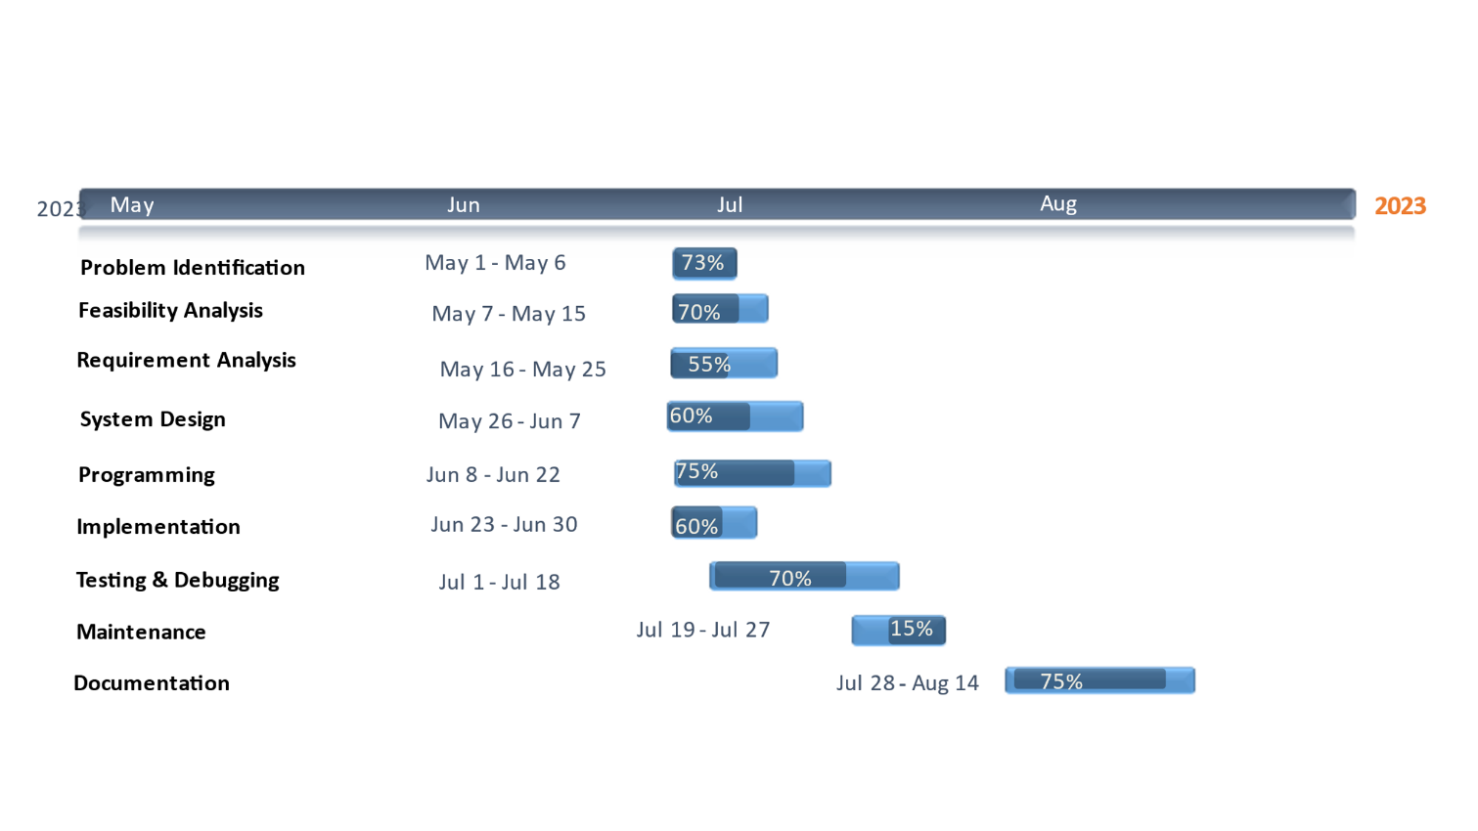

Figure V:Gantt Chart of MyMed

# DELIVERABLES

Here are some potential deliverables for the “MyMed” project:

* It provides friendly relationship between patients and doctors.
* This software provides health information to the patients.
* It helps to facilitate communication between patients and doctors.
* Creating a dashboard for doctors to access the medical records of their patients and view trends of changes in their health over time.
* Developing an easy-to-use interface for patients to input and track their medical records.
* Continuously improve and update the software based on feedback from patients and healthcare providers.
* It ensures that the software is secure and maintains patient confidentiality.

# CONCLUSION

As the Project is being made, there are many things that can be learned from it. In this module i.e., Web Technologies, we were given a project task to perform in a group work. The artefact of the project is a digitalized system called “MyMed” by using HTML, CSS, JS and PHP in VS-Code.

This project requires a lot of research and hard work for successful completion of our mid defence and every step are done by full effort. This project helps us to share and present our ideas in the Group, as well as helps us to share and present our ideas in the Group.

“MyMed” is an essential tool for keeping accurate records on doctors, patients, and medical personnel. Using “MyMed” will make the process of data collection much more efficient and streamlined, allowing hospital administrators to gain better control over their operations. The time saved by using “MyMed” will be invaluable, as it not only reduces the amount of manual labour required but also increases accuracy and organization.

With “MyMed”, hospital staff can easily access the data they need to make informed decisions and ensure all aspects of the organization are running smoothly. In existing system there are several drawbacks. So, to sort out all the existing problems this project is being developed. The product automates the process of collecting and receiving patient information, which can greatly improve response time in providing patient care.

This can free up the time of medical staff from dealing with administrative, allowing them to focus on what matters most – providing the best care for their patients. By eliminating these complexities, the product makes it easier for medical staff to provide the best care possible to their patients, without having to worry about administrative matters.

# REFERENCES

Here are some similar apps and website that we take references for our project:

1. J.Doe, “MYMed: A web-based system for doctor-patient record keeping,” in proc. Of the IEEE international Conference on Healthcare informatics, 2021, pp. 50-55.
2. MyChart – MyChart is a patient portal app that allows patients to access their medical records, schedule appointments, and communicate with their healthcare providers. https://www.mychart.org/LoginSignup
3. Doctor On Demand – Doctor on Demand is a telemedicine app that allows patients to consult with licensed doctors and behavioural health providers through video calls. https://doctorondemand.com
4. HealthTap – HealthTap is an online platform that connects patients with doctors and medical experts for personalized health advice and second opinions. https://www.healthtap.com
5. CareZone – CareZone is a medication management and health tracking app that helps patients keep track of their medications, health measurements, and appointments. https://carezone.com
6. Medisafe – Medisafe is a medication reminder and pill tracker app that helps patients adhere to their medication schedule and avoid medication errors. https://www.medisafe.com
7. Zocdoc – Zocdoc is an online platform that allows patients to book appointments with doctors in their area and read verified reviews from other patients. https://www.zocdoc.com
8. Practo – Practo is a healthcare platform that allows patients to find doctors, book appointments, and access their medical records and prescriptions online. https://www.practo.com

These apps provide useful insights and ideas on how to design and develop our own website for record keeping of doctor and patients.

IEEE