

**LEARNING RESOLUTION**

**(Unit 3: Multiplexing and Switching-Data Communication and Computer Network)**

**Course: Data communication & Computer Network**

**Submitted by:**

**Student Name: Arpan Pokhrel**

**PU Regd. Number: 2019-1-53-0108**

**Semester: VI**

**Signature:**

**Submitted to:**

**Er. Kiran K.C.**

**Department of Bachelor of Computer Application**

**11/05/2023**

**Preface**

This document is a study material to create the students (Us) more educated about the second chapter of the course "Multiplexing”. By viewing this document we will learn about Multiplexing, its types, Modem, Modulation and its Types and Switching and Its Types.

**Unit 3 Multiplexing and Switching-Data Communication and Computer Network**

**Objectives**

1. To understand definition of multiplexing and its types.
2. To study the modulation and types of modulation.
3. To understand definition of switching and its types
4. To learn and understand different network terminologies.

# Multiplexing:

Multiplexing is the set of techniques that allows the simultaneous transmission of multiple signals across a single data link. For example, one cable can carry a hundred channels of TV.

Multiplexing can be done in one of the three basic techniques: FDM (Frequency Division Multiplexing), TDM (Time Division Multiplexing) & WDM (Wavelength Division Multiplexing).

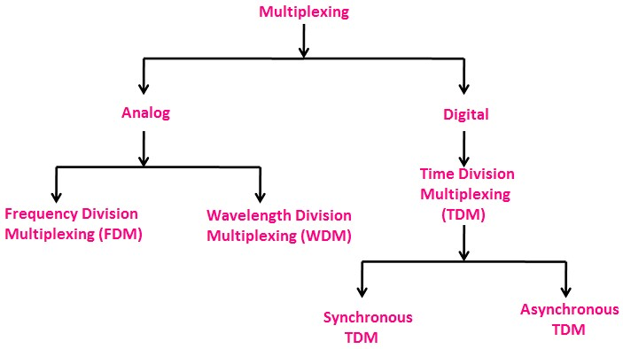

* 1. Frequency Division Multiplexing (FDM): FDM is an analogue technique in which the signals generated by a different carrier; frequencies are combined into a single composite signal that can be transported by the link.

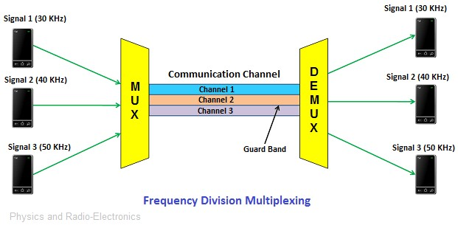

* 1. Time Division Multiplexing (TDM): TDM is a method of transmitting and receiving independent signals over a common signal path by means of synchronized switches at each end of the transmission line so that each signal appears on the line only a fraction of time in an alternating pattern.

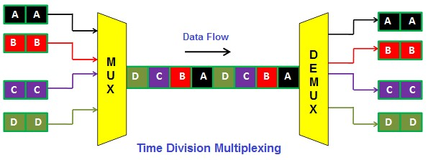

**Types of Time Division Multiplexing:**

* + Synchronous Time Division Multiplexing

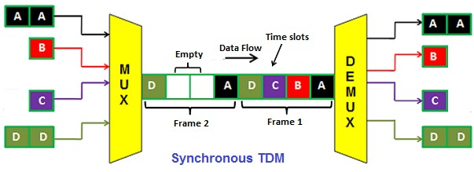

* + Asynchronous Time Division Multiplexing

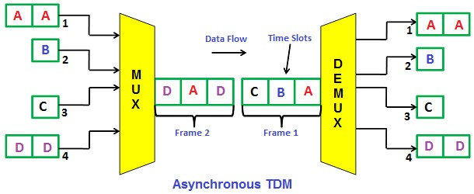

* 1. WDM (Wavelength Division Multiplexing): WDM is a fibre-optic transmission technique that enables the use of multiple light wavelengths (for colours) to send data over the same medium.

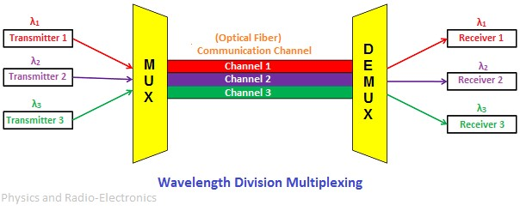

1. **Modem:**

A modem is a device that modulates an analogue carrier signal to encode digital information and demodulates the signal to decode the transmitted information. The goal is to produce a signal that can be transmitted easily and decoded to reproduce the original digital data.

1. **Modulation:**

The process of altering the characteristics of the amplitude, frequency, or phase angle of the high-frequency signal in accordance with the instantaneous value of the modulating wave is called modulation.

Need For Modulation:

* + - Short Operating Range
    - Poor Radiation Efficiency
    - Mutual Interference
    - Huge Antenna Requirement

Types of Modulation:

* + - 1. Analog Modulation: The aim of analog modulation is to transfer an analogue baseband signal, for example, an audio signal or TV signal, over an analogue bandpass channel at a different frequency, for example over a limited radio frequency band or a cable TV network channel. The analogue modulation is also divided into three different types as:
* Amplitude Modulation
* Frequency Modulation
* Phase Modulation
  + - 1. Digital Modulation: Digital modulation is the process of encoding a digital information signal into the amplitude, phase, or frequency of the transmitted signal.

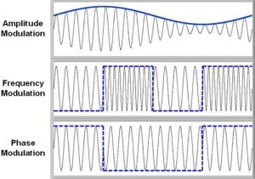

1. **Switching:**

Switching is a technique which is used in a large network, it means those networks that contain a large number of nodes, wires, device etc.

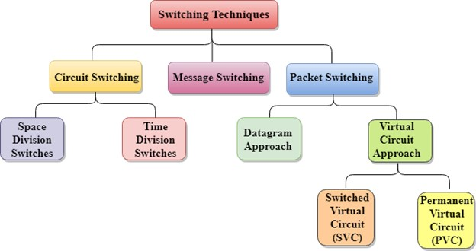

Network Switching can be different types:

* + - 1. Circuit Switching: It is a methodology of implementing a telecommunications network in which two network nodes establish a dedicated communication channel through the network before the nodes may communicate.

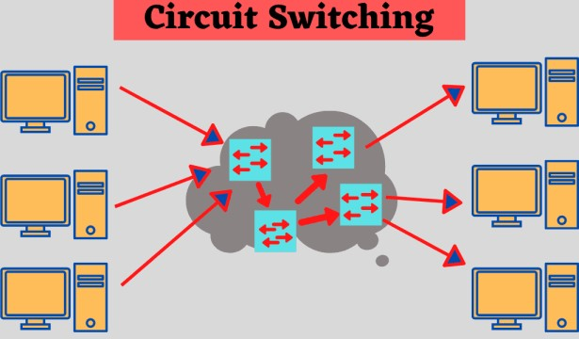

* + - 1. Packet Switching: It is a digital networking communication method that groups all transmitted data regardless of content, type, or structure – into suitably sized blocks, called packets. Two major packets switching modes exist:
* Datagram Switching
* Virtual Circuit Switching

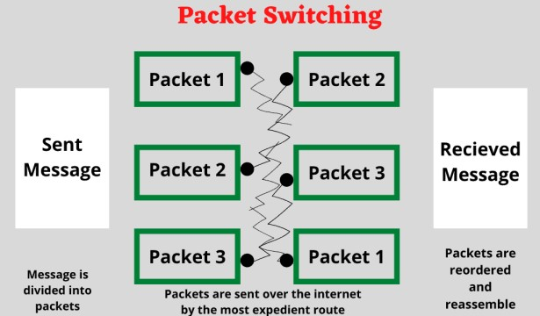

* + - 1. Message Switching: Message switching is a network technique in which data is routed in its entirety from the source node to the destination node, one hope at a time. During message routing, every intermediate switch in the network stores the whole message.

