**11) Write a Python function to find the roots of a quadratic equation.**

a,b,c=map(int,input(**'enter a, b & c :'**).split(**' '**))  
**def** roots(a,b,c):  
 d = (b**2) - (4*a*c)  
 sol1 = (-b-(d**0.5))/(2*a)  
 sol2 = (-b+(d**0.5))/(2*a)  
 print(**'solutions are'**)  
 print(**'sol1 = '**,sol1)  
 print(**'sol2 = '**,sol2)  
roots(a,b,c)

**Output:**

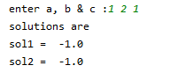

**12) Write a Python function to evaluate factorial function using while loop.**

a=int(input(**'Enter the number : '**))  
**def** facti(a):  
 res=1  
 **while** a>=1:  
 res*=a  
 a=a-1  
 **return** res  
**if** a==0:  
 print(**'Factorial of 0 is 1'**)  
**elif** a<0:  
 print(**"FActorial of negative values isn't possible"**)  
**else**:  
 print(**'Factorial value of '**,a,**' is : '**,facti(a))

**Output:**  Enter the number : 9

Factorial value of 9 is : 362880

**13) Write a Python function to test whether a given number is prime or not.**

a=int(input(**'Enter a : '**))  
**def** prime(a):  
 **if** a>1:  
 **for** i **in** range(2,a//2):  
 **if** a%i==0:  
 print(a,**' is not prime'**)  
 **break  
 else**:  
 print(a,**'is prime'**)  
 **elif** a==1:  
 print(**'1 is unit number'**)  
 **else**:  
 print(**'Please Enter positive number which is greater than 1 '**)  
  
prime(a)

**Output:**

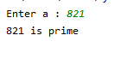

**14) Write a Python function to generate Fibonacci series till given number.**

n=int(input(**'how many numbers you want : '**))  
**def** fibo(n):  
 a=0  
 b=1  
 **if** n ==1:  
 print(0)  
 **elif** n==0 **or** n<0:  
 print(**'please enter right number'**)  
 **else** :  
 print(a);  
 print(b);  
 **for** i **in** range(2,n):  
 c=a+b  
 a=b  
 b=c  
 print(c)  
fibo(n)

**Output:**

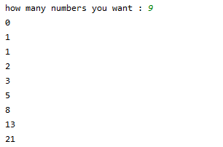

**15) A python program that helps to know the effects of slicing operations on array.**

ash = input(**"Enter the list: "**).split()  
print(ash[::3])  
print(ash[::-1])  
print(ash[0:4:-1])  
print(ash[:-7])  
print(ash[:2])  
print(ash[2:])

**Output:**

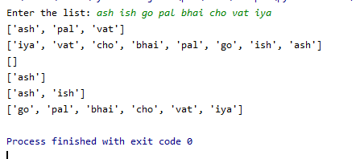

**16) A python program to sort the array elements using bubble sort technique.**

n=int(input(**'enter the total value'**))  
arr=[]  
**for** i **in** range(0,n) :  
 print(**'enter arr['**,i+1,**']'** )  
 k=int(input())  
 arr.append(k)  
  
print(**'array before sorting'**,arr)  
**for** i **in** range(0,n):  
 **for** j **in** range(i,n):  
 **if** arr[i]>arr[j]:  
 temp=arr[i]  
 arr[i]=arr[j]  
 arr[j]=temp  
print(**'array after sorting'**,arr)

**Output:**

enter the total value: 5

enter arr[ 1 ]

5

enter arr[ 2 ]

4

enter arr[ 3 ]

3

enter arr[ 4 ]

2

enter arr[ 5 ]

1

array before sorting [5, 4, 3, 2, 1]

array after sorting [1, 2, 3, 4, 5]

**17) A python program to search for the position of an element in an array using index( ) method.**

n=int(input(**'enter the total value : '**))  
arr=[]  
**for** i **in** range(0,n) :  
 print(**'enter arr['**,i+1,**']'** )  
 k=int(input())  
 arr.append(k)  
  
a=int(input(**'Enter the number of which you want to know the position :'**))  
print(**'Index of '**,a,**'is :'**,arr.index(a))

**Output:**

enter the total value : 6

enter arr[ 1 ]

5

enter arr[ 2 ]

8

enter arr[ 3 ]

1

enter arr[ 4 ]

6

enter arr[ 5 ]

3

enter arr[ 6 ]

99

Enter the number of which you want to know the position :6

Index of 6 is: 3

**18) A python program to accept two matrices and find their product.**

**def** matrix(row, column):  
 p = []  
 print(**'Enter elements row wise'**)  
 **for** i **in** range(row):  
 q = []  
 **for** j **in** range(column):  
 k = int(input())  
 q.append(k)  
 p.append(q.copy())  
 q.clear()  
 **return** p  
print(**"1st matrix:"**)  
i, j = map(int, input(**"enter row and column="**).split(**" "**))  
a = matrix(i, j)  
print(**"2st matrix:"**)  
i, j = map(int, input(**"enter row and column="**).split(**" "**))  
b = matrix(i, j)  
  
**def** product(m, n):  
 r = []  
 **if** len(m[0]) == len(n):  
 **for** i **in** range(len(m)):  
 t = []  
 **for** j **in** range(len(n[i])):  
 sum = 0  
 **for** k **in** range(len(m[i])):  
 sum += m[i][k] * n[k][j]  
 t.append(sum)  
 r.append(t.copy())  
 t.clear()  
 **return** r  
 **else**:  
 print(**"Can't Multiply !!!!"**)  
 print(**'Column of 1st Matrix and Row od 2nd Martix should be same'**)c = product(a, b)  
print(c)

**Output:**

1st matrix:

enter row and column=2 3

Enter elements row wise: 5 6 4 0 2 1

2st matrix:

enter row and column=3 2

Enter elements row wise: 1 2 3 4 5 6

[[43, 58], [11, 14]]

**19) A python program to find the number of words in a string.**

ash=input(**'Enter the String : '**)  
  
print (**"The original string is : "** +ash)  
total = str(len(ash.split(**' '**)))  
print (**"The number of words in string are : "** +total)

**Output:**

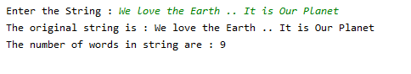

**20) A python program to insert a sub string in a string in a particular position.**

mainstr=input(**'Enter main string : '**)  
sub=input(**'Enter sub string : '**)  
N=int(input(**'Enter the position where you want to insert : '**))  
print(**"The original string : "** +mainstr)  
print(**"The add string : "** +sub)  
  
finalstr = list(mainstr)  
finalstr.insert(N,sub)  
finalstr = **''**.join(finalstr)  
print(**"The final string : "** + str(finalstr))

**Output:**

