EE 610: Image Processing
Assignment 1: Basic Image Editor
Arpan Banerjee
150070011

Abstract—This report captures the features of the basic image editor created for Assignment 1. The image editor supports loading and saving of images, along with some image manipulation algorithms like histogram equalization, gamma correction, log transform, blur, sharpening and emboss.
Keywords—image editor, image manipulation, intensity transforms, spatial transforms.

Introduction
The problem statement involved building a GUI software for a basic image editor which could load, display and save images as well as perform basic image manipulation functions on the image, namely hostogram, equalization, gamma correction, log transform, blurring, sharpening and an extra feature, which I chose to be emboss. The GUI is built in python using the pyqt5 library and OpenCV is used for some basic image loading and saving functionalities.

Background Reading

Python Libraries
Pyqt5 is a python library, commonly used to make GUI’s and is simple to pick up and use. It also provides UI widgets like dialog boxes and menus.
OpenCV is an image processing library which provides a variety of tools. I have only used image loading and saving features to load the image into numpy arrays.

Approach
I developed a simple user interface with software like MS Paint in mind, having menus and sub-menus. There are several features implemented like -
- Open, Save Image: This uses OpenCV library functionalities for loading and saving image data into numpy arrays which are easy to manipulate. Color images are converted to HSV and all the manipulations are done on the V channel.
- Utility functions (Undo, Restore Original)
- Histogram Equalization: The histogram of the intensities in the image is computed and is stretched out over the entire range, further darkening dark pixels and making light pixels lighter.
- Gamma Correction: Gamma is taken as an input from the user and gamma correction is applied, which is basically an exponential intensity transform.
- Log Transform: A logarithmic transfer function is applied on the input image intensities.
- Blur: A variable size (with size as input from the user) Gaussian blur kernel is applied to the image. This is known to give better results than simple average blurring.
- Sharpening: A technique called unsharp masking is used, wherein a blurred (Gaussian blur) image is used to create a mask of the image. This is then combined with the original image, which cancels out the low frequency (blurred) components.
- Emboss: This filter gives the image relief with bumps and hollows, giving it the impression of being a paper or metal embossing.

Discussion
The main challenges faced in this assignment were learning to use the GUI software and storing references to images and previous images efficiently and correctly. It was also found that vectorizing the 2D convolution operation of the kernel made a significant speed up in the computation time.
Given more time, I would try out more transformation kernels and algorithms, as well as try some transformations in the Fourier domain. Making the UI more user friendly would also be another goal.

Test Images

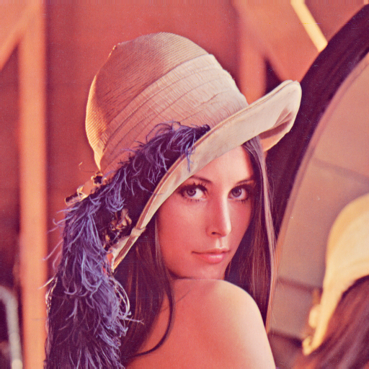
Original Image
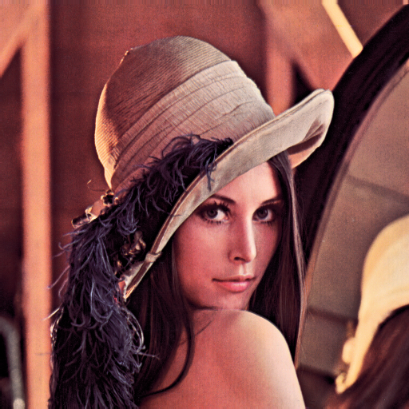
Histogram Equalized Image

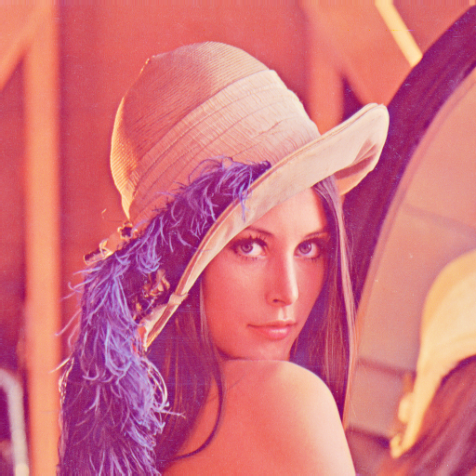
Gamma Corrected Image γ=0.5

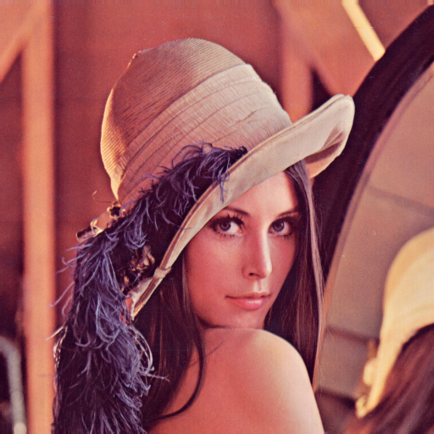
Gamma Corrected Image γ=1.5

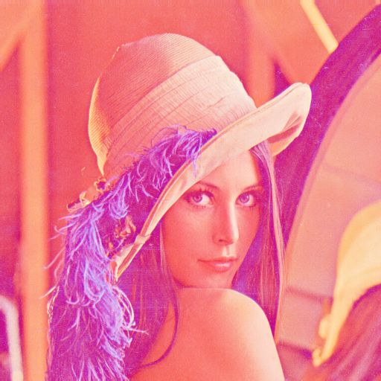
Log transformed image

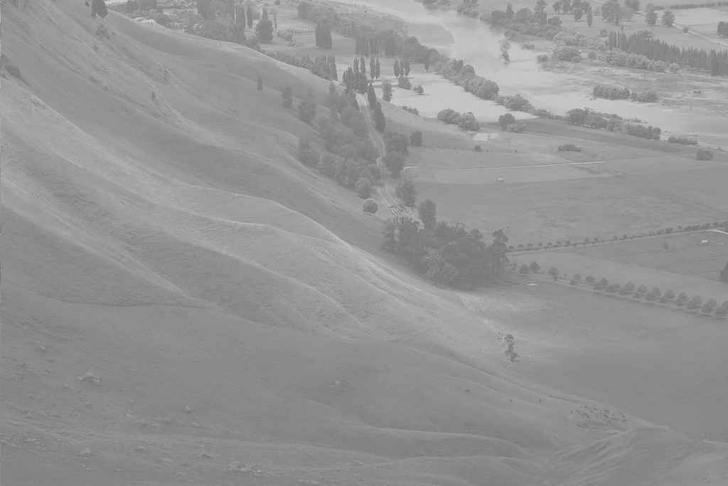
Original Image

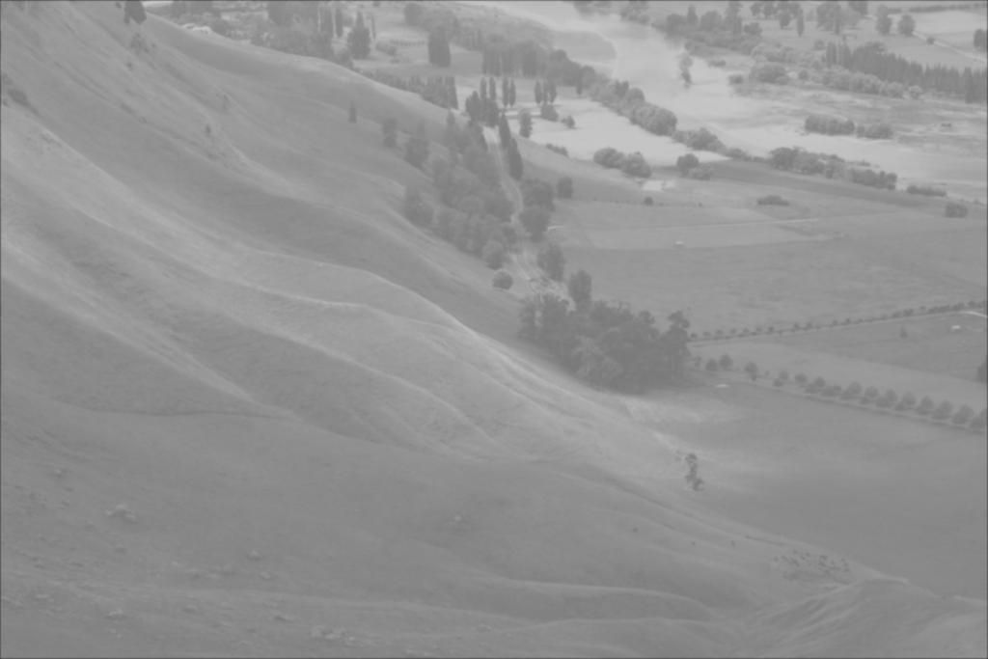
Blurred image with kernel size=15

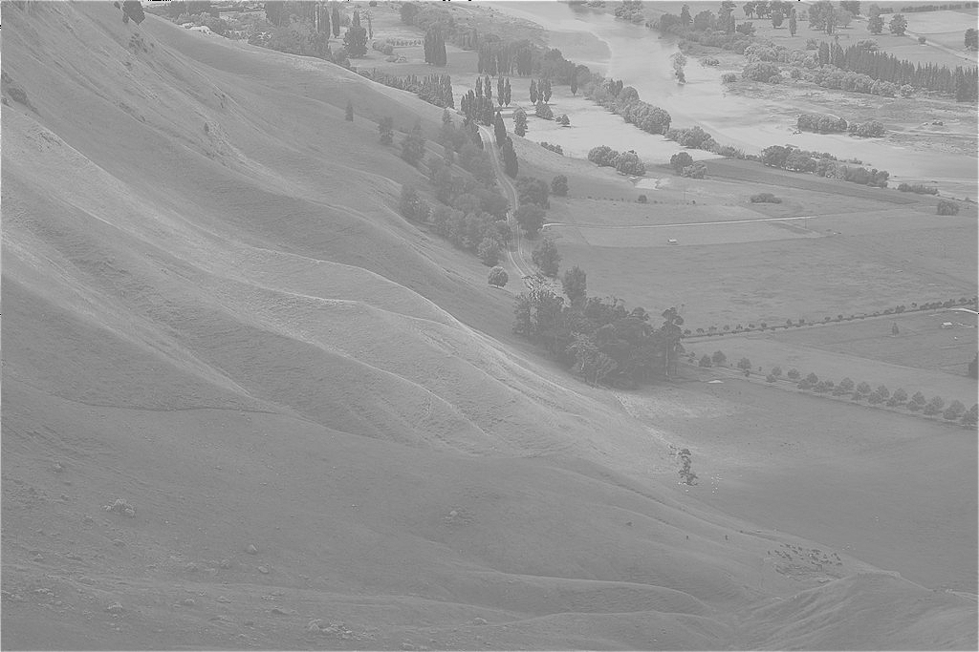
Sharpened image with kernel size=15

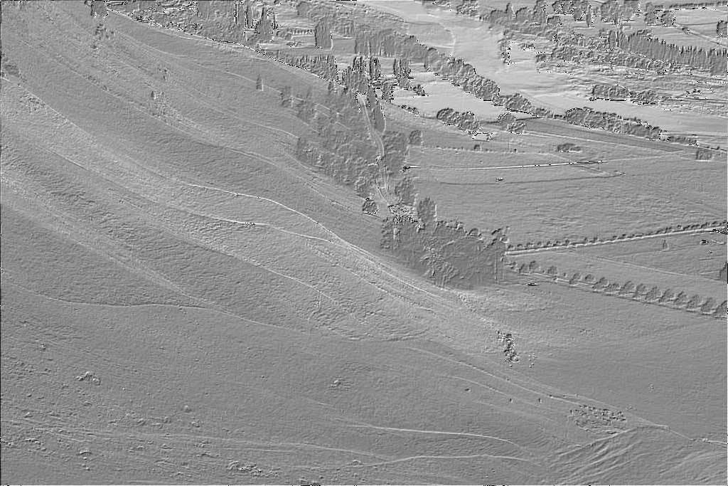
Embossed Image

References

- http://pyqt.sourceforge.net/Docs/PyQt5/
- https://docs.opencv.org/3.0-beta/doc/py_tutorials/py_gui/py_table_of_contents_gui/py_table_of_contents_gui.html#py-table-of-content-gui
- http://setosa.io/ev/image-kernels/
- https://stackoverflow.com/questions/29731726/how-to-calculate-a-gaussian-kernel-matrix-efficiently-in-numpy

Appendix (Code)
# Python Starter Code Author: Devdatta Kathale

# if PY_VERSION_HEX < 0x03070000 && defined(PySlice_GetIndicesEx)
# if !defined(PYPY_VERSION)
# undef PySlice_GetIndicesEx
# endif
# endif

from PyQt5.QtGui import QPixmap, QImage
from PyQt5.QtWidgets import (QMainWindow, QApplication, QWidget, QAction, QLabel, QVBoxLayout, QFileDialog, QInputDialog)

import numpy as np # Import numpy for mathematical operations and functions
import sys # Required for starting and exiting application
import copy # Need the deepcopy function to copy entire arrays
import cv2

# Computes the normalised histogram of an image, returns np array
def normalisedHistogram(img):
m, n = img.shape
h = [0.0] * 256
for i in range(m):
for j in range(n):
h[int(img[i, j])] += 1
return np.array(h)/(m*n)

# Computes the cumulative sums of an array, returns np array
def cumulativeSum(h):
return np.array([sum(h[:i+1]) for i in range(len(h))])

# Loads an image with given filename into an np array
def loadImage(filename):
img = cv2.imread(filename)
return img

# Returns a 2d gaussian kernel of variable size and sigma
def gkern(l=3, sig=1.):
"""
creates gaussian kernel with side length l and a sigma of sig
"""

ax = np.arange(-l // 2 + 1., l // 2 + 1.)
xx, yy = np.meshgrid(ax, ax)

kernel = np.exp(-(xx**2 + yy**2) / (2. * sig**2))

return (kernel / np.sum(kernel))

class GUI(QMainWindow):

def __init__(self):
super().__init__()
self.initUI()
self.central_widget = QWidget()
self.setCentralWidget(self.central_widget)
self.layout = QVBoxLayout(self.central_widget)
self.imageLabel = QLabel(self)

def initUI(self):
# Define menu actions
openImageAction = QAction('Open Image', self)
openImageAction.triggered.connect(self.openImage)

equalizeHistogramAction = QAction('Equalize Histogram', self)
equalizeHistogramAction.triggered.connect(self.equalizeHistogram)

gammaCorrectAction = QAction('Gamma Correct', self)
gammaCorrectAction.triggered.connect(self.gammaCorrect)

logTransformAction = QAction('Log Transform', self)
logTransformAction.triggered.connect(self.logTransform)

blurAction = QAction('Blur', self)
blurAction.triggered.connect(self.blur)

sharpenAction = QAction('Sharpen', self)
sharpenAction.triggered.connect(self.sharpen)

embossAction = QAction('Emboss', self)
embossAction.triggered.connect(self.emboss)

menuBar = self.menuBar()
menuBar.addAction(openImageAction)

# Define GUI menu
manipulationMenu = menuBar.addMenu('Image Manipulation')
manipulationMenu.addAction(equalizeHistogramAction)
manipulationMenu.addAction(gammaCorrectAction)
manipulationMenu.addAction(logTransformAction)
manipulationMenu.addAction(blurAction)
manipulationMenu.addAction(sharpenAction)
manipulationMenu.addAction(embossAction)

undoAction = QAction('Undo', self)
undoAction.triggered.connect(self.undo)
menuBar.addAction(undoAction)

restoreAction = QAction('Restore', self)
restoreAction.triggered.connect(self.restore)
menuBar.addAction(restoreAction)

saveAction = QAction('Save', self)
saveAction.triggered.connect(self.saveImage)
menuBar.addAction(saveAction)

# Define window geometry
self.setGeometry(50, 50, 1280, 720)
self.setWindowTitle('Image Editor')
self.show()

# Opens image using a file selector
def openImage(self):
print("Open image")
filename, _ = QFileDialog.getOpenFileName(self, "Select Image File", "", "Image files (*.jpg *.png *.gif)")
if filename:
print(filename)
pixmap = QPixmap(filename)
self.imageLabel.setPixmap(pixmap)
self.layout.addWidget(self.imageLabel)
self.image = loadImage(filename)
height, width, self.channels = self.image.shape
self.image = cv2.cvtColor(self.image, cv2.COLOR_BGR2HSV)
self.modifiable_channel = self.image[:, :, 2]
self.original_image = copy.deepcopy(self.image)
self.previous_image = copy.deepcopy(self.image)

# Sets the display image to self.image
def showImage(self):
img = cv2.cvtColor(self.image, cv2.COLOR_HSV2RGB)
height, width, channel = img.shape
bytesPerLine = 3 * width
qImg = QImage(img, width, height, bytesPerLine, QImage.Format_RGB888)
self.imageLabel.setPixmap(QPixmap(qImg))

# Sets self.image to given np array
def applyImage(self, Y):
Y = np.clip(Y, 0, 255)
self.image[:, :, 2] = Y
self.modifiable_channel = self.image[:, :, 2]

# Saves image using file selector
def saveImage(self):
filename, _ = QFileDialog.getSaveFileName(self, "Save Image File", "")
if filename:
cv2.imwrite(filename, cv2.cvtColor(self.image, cv2.COLOR_HSV2BGR))

# Histogram equalization algorithm
def equalizeHistogram(self):
self.previous_image = copy.deepcopy(self.image)
h = normalisedHistogram(self.modifiable_channel)
cdf = cumulativeSum(h)
cdf = 255 * cdf
m, n = self.modifiable_channel.shape
Y = np.zeros_like(self.modifiable_channel)
for i in range(m):
for j in range(n):
Y[i, j] = int(cdf[int(self.modifiable_channel[i, j])])
self.applyImage(Y)
self.showImage()

# Copies the previous image into current image
def undo(self):
self.image = copy.deepcopy(self.previous_image)
self.showImage()

# Copies the original image into current image
def restore(self):
self.image = copy.deepcopy(self.original_image)
self.showImage()

# Gamma correction, displays input dialog box for value of gamma
def gammaCorrect(self):
self.previous_image = copy.deepcopy(self.image)
gamma, okPressed = QInputDialog.getDouble(self, "Enter Gamma", "Gamma:", value=1.0, decimals=3)
if okPressed:
m, n = self.modifiable_channel.shape
Y = np.zeros_like(self.modifiable_channel, dtype=np.float32)
for i in range(m):
for j in range(n):
Y[i, j] = (self.modifiable_channel[i, j] / 255.0) ** gamma
Y[i, j] = int(255 * Y[i, j])
self.applyImage(Y)
self.showImage()

# Performs log transform on self.image
def logTransform(self):
self.previous_image = copy.deepcopy(self.image)
c = 255.0 / (np.log(1 + np.max(self.modifiable_channel)))
m, n = self.modifiable_channel.shape
Y = np.zeros_like(self.modifiable_channel, dtype=np.float32)
for i in range(m):
for j in range(n):
Y[i, j] = int(c * np.log(1 + self.modifiable_channel[i, j]))
self.applyImage(Y)
self.showImage()

# Performs 2D convolution on self.image using the kernel passed in argument
def applyKernel(self, kernel):
kernelRows, kernelColumns = kernel.shape
kernelCenter = (int(kernelRows / 2), int(kernelColumns / 2))
m, n = self.modifiable_channel.shape
C = np.zeros([m + 2*kernelCenter[0], n + 2*kernelCenter[1]], dtype=np.float32)
C[kernelCenter[0] : kernelCenter[0] + m, kernelCenter[1] : kernelCenter[1] + n] = self.modifiable_channel
Y = copy.deepcopy(self.modifiable_channel)
for i in range(kernelCenter[0], m + kernelCenter[0]):
for j in range(kernelCenter[1], n + kernelCenter[1]):
imageSlice = C[i - kernelCenter[0] : i + kernelCenter[0] + 1, j - kernelCenter[1] : j + kernelCenter[1] + 1]
imageSlice = imageSlice.flatten()
kernel = kernel.flatten()
Y[i - kernelCenter[0], j - kernelCenter[1]] = np.dot(imageSlice, kernel)
return Y

# Performs gaussian blur using a variable sized gaussian kernel
def blur(self):
# Average (mean) blurring
self.previous_image = copy.deepcopy(self.image)
kSize, okPressed = QInputDialog.getInt(self, "Blur", "Kernel size:", 3, 3, 15, 2)
if okPressed:
kernel = gkern(l=kSize)
Y = self.applyKernel(kernel)
self.applyImage(Y)
self.showImage()

# Performs unsharp masking using gaussian blur
def sharpen(self):
# Get mask by blurring, then subtracting from original image
# Finally add to original image
self.previous_image = copy.deepcopy(self.image)
kSize, okPressed = QInputDialog.getInt(self, "Sharpen", "Kernel size:", 3, 3, 15, 2)
if okPressed:
kernel = gkern(l=kSize)
Y = self.applyKernel(kernel)
mask = self.modifiable_channel - Y
mask = np.clip(mask, 0, 255)
self.modifiable_channel += mask
self.applyImage(self.modifiable_channel)
self.showImage()

# Applies emboss kernel to self.image
def emboss(self):
self.previous_image = copy.deepcopy(self.image)
embossKernel = np.array([[-2, -1, 0], [-1, 1, 1], [0, 1, 2]])
Y = self.applyKernel(embossKernel)
self.applyImage(Y)
self.showImage()

if __name__ == '__main__':
app = QApplication(sys.argv)
gui = GUI()
sys.exit(app.exec_())

