**1. Renaming variables, methods, and classes.**

classEvenOrOdd

{

publicstatic voidmain(Stringargs[])

{

int n=Integer.parseInt(args[0]);

for(inti=0;i<=n;i++)

{

if(i%2==0)

System.out.Println("it is evennumber",+i);

else

System.out.Println("it is oddnumber",+i);

}

}

}

**OUTPUT**

**javac Eclipse.javajavaEvenOrOdd**

it is even number0

it is odd number1

it is even number2

it is odd number3

it is even number4

it is odd number5

it is even number6

it is odd number7

it is even number8

**2. Write a Java program that works as a simple calculator. Use a grid layout to arrangebuttons for the digits and for the +, -,*, % operations.**

**Gedit Calculator.javaimport java.awt.*;importjava.a wt.event.*;**

publicclassCalculatorimplementsActionListener

{

intc,n;

String s1,s2,s3,s4,s5;Framef;

Button b1,b2,b3,b4,b5,b6,b7,b8,b9,b10,b11,b12,b13,b14,b15,b16,b17;Panelp;

TextFieldtf;

GridLayout g;Calculator()

{

f=newFrame("Mycalculator");

p = new Panel();

f.setLayout(new FlowLayout());

b1 = new Button("0");b1.addActionListener(this);

b2 = new Button("1");b2.addActionListener(this);

b3 = new Button("2");b3.addActionListener(this);

b4 = new Button("3");b4.addActionListener(this);

b5 = new Button("4");b5.addActionListener(this);

b6 = new Button("5");b6.addActionListener(this);

b7 = new Button("6");b7.addActionListener(this);

b8 = new Button("7");b8.addActionListener(this);

b9 = new Button("8");b9.addActionListener(this);

b10 = new Button("9");b10.addActionListener(this);b11 = new Button("+");b11.addActionListener(this);b12 = new Button("-");b12.addActionListener(this);b13 = new Button("*");b13.addActionListener(this);b14 = new Button("/");b14.addActionListener(this);b15 = new Button("%");b15.addActionListener(this);b16 = new Button("=");b16.addActionListener(this);b17 = new Button("C");b17.addActionListener(this);

tf = new TextField(20);f.add(tf);

g = new GridLayout(4,4,10,20);p.setLayout(g);

p.add(b1);

p.add(b2);

p.add(b3);

p.add(b4);

p.add(b5);

p.add(b6);

p.add(b7);

p.add(b8);

p.add(b9);

p.add(b10);

p.add(b11);

p.add(b12);

p.add(b13);

p.add(b14);

p.add(b15);

p.add(b16);

p.add(b17);

f.add(p);

f.setSize(300,300);f.setVisible(true);

}

publicvoidactionPerformed(ActionEvente)

{

if(e.getSource()==b1)

{

s3 = tf.getText();

s4= "0";

s5 = s3+s4;tf.setText(s5);

}

if(e.getSource()==b2)

{

s3 = tf.getText();

s4= "1";

s5 = s3+s4;tf.setText(s5);

}

if(e.getSource()==b3)

{

s3 = tf.getText();

s4= "2";

s5 = s3+s4;tf.setText(s5);

}

if(e.getSource()==b4)

{

s3 = tf.getText();

s4= "3";

s5 = s3+s4;tf.setText(s5);

}

if(e.getSource()==b5)

{

s3 = tf.getText();

s4= "4";

s5 =s3+s4;

tf.setText(s5);

}

if(e.getSource()==b6)

{

s3 = tf.getText();

s4= "5";

s5 = s3+s4;tf.setText(s5);

}

if(e.getSource()==b7)

{

s3 = tf.getText();

s4= "6";

s5 = s3+s4;tf.setText(s5);

}

if(e.getSource()==b8)

{

s3 = tf.getText();

s4= "7";

s5 = s3+s4;tf.setText(s5);

}

if(e.getSource()==b9)

{

s3 = tf.getText();

s4= "8";

s5 = s3+s4;tf.setText(s5);

}

if(e.getSource()==b10)

{

s3 = tf.getText();

s4= "9";

s5 = s3+s4;tf.setText(s5);

}

if(e.getSource()==b11)

{

s1=tf.getText();

tf.setText("");

c=1;

}

if(e.getSource()==b12)

{

s1 = tf.getText();tf.setText("");

c=2;

}

if(e.getSource()==b13)

{

s1 = tf.getText();

tf.setText("");

c=3;

}

if(e.getSource()==b14)

{

s1 = tf.getText();tf.setText("");

c=4;

}

if(e.getSource()==b15)

{

s1 = tf.getText();tf.setText("");

c=5;

}

if(e.getSource()==b16)

{

s2 = tf.getText();if(c==1)

{

n = Integer.parseInt(s1)+Integer.parseInt(s2);tf.setText(String.valueOf(n));

}

elseif(c==2)

{

n=Integer.parseInt(s1)-Integer.parseInt(s2);tf.setText(String.valueOf(n));

}

elseif(c==3)

{

n = Integer.parseInt(s1)*Integer.parseInt(s2);tf.setText(String.valueOf(n));

}

if(c==4)

{

try

{

intp=Integer.parseInt(s2);if(p!=0)

{

n = Integer.parseInt(s1)/Integer.parseInt(s2);tf.setText(String.valueOf(n));

}

else

tf.setText("infinite");

}

catch(Exceptioni)

{

}

}

if(c==5)

{

n = Integer.parseInt(s1)%Integer.parseInt(s2);tf.setText(String.valueOf(n));

}

}

if(e.getSource()==b17)

{

tf.setText("");

}

}

publicstaticvoidmain(String[]args)

{

Calculatorv=newCalculator();

}

}

**Output**

**javac** Calculator.javajavaCalculator

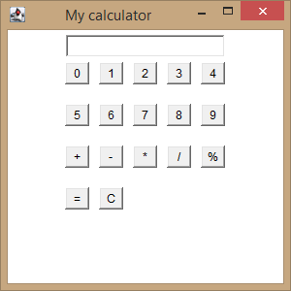

**3.A)Java thatdisplaysasimplemessage.**

**B)Java that receives an integer in one text field, and computes itsfactorial Value and returns it in another text field, when the button named “Compute” isclicked.**

* 1. **Javathatdisplays a simplemessage.**

**Geditsimpleapplet.java**

importjava.applet.*;

importjava.awt.*;

publicclasssimpleappletextendsApplet

{

publicvoidpaint(Graphicsg)

{

g.drawString("hello",50,50);

}

}

**Ouput**

**javac simpleapplet.javageditsimpleapplet.html**

<html>

<appletcode="simpleapplet.class"height=500width=700>

</applet>

</html>

**appletviewersimpleapplet.html**

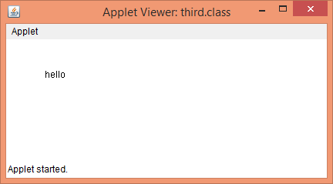

**B)Java that receives an integer in one text field, and computes itsfactorial Value and returns it in another text field, when the button named “Compute” isclicked.**

**GeditIntegerApplet.java**

importjava.awt.*;

importjava.awt.event.*;

publicclassIntegerAppletextendsjava.applet.AppletimplementsActionListener

{

TextFieldt1,t2;

Labell1,l2,l3;

Buttonb1;

intfact=1,n,i;IntegerApplet e;

publicvoidinit()

{

e=this;

t1=new TextField(10);t2=newTextField(10);

l1=new Label("factorial of a number");l2=newLabel("enternumber");

l3=new Label("result");

b1=new Button("compute");add(l1);

add(l2);

add(l3);

add(t1);

add(t2);

add(b1);b1.addActionListener(this);

}

publicvoidactionPerformed(ActionEventae)

{

String str=t1.getText();n=Integer.parseInt(str);for(i=n;i>1;i--)

{

fact=fact*i;

}

Stringmsg=""+fact;

t2.setText(msg);

fact=1;

}

}

**Output**

**javac IntegerApplet.javageditfact.html**

<html>

<applet code="IntegerApplet.class"width=300height=300>

<paramname="t1"value="ram">

<paramname="t2"value="98.55">

</applet>

</html>

**apppletviewerfact.html**

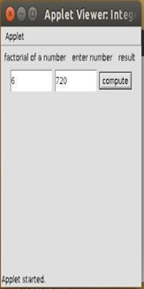

**4.Write a java program that creates a user interface to perform integer divisions. The user enters two numbers in thetext fields, Num1 and Num2. The division of Num1and Num 2 is displayed in the Result fieldwhen the Divide button is clicked. If Num1 or Num2 were not an integer, the program wouldthrowaNumberFormatException.IfNum2wereZero,theprogramwouldthrowanArithmeticException. Display theexceptioninamessagedialog box.**

**Gedit Division.java**

importjava.awt.*;importjavax.swing.*;

import java.applet.Applet;importjava.awt.event.*;

publicclassDivisionextendsAppletimplementsActionListener

{

TextField t1,t2,t3;

Buttonb;

LabelL1,L2,L3,L4;

String s;

Division e;

publicvoidinit()

{

e=this;

t1=new TextField(10);

t2=new TextField(10);

t3=newTextField(10);

L1=new Label("enter num1");

L2=new Label("enter num2");L3=newLabel("Resultis");

L4=new Label("Division of numbers");

b=new Button("Divide");

add(L4);

add(L1);

add(t1);

add(L2);

add(t2);

add(L3);

add(t3);

add(b);b.addActionListener(this);

}

publicvoidactionPerformed(ActionEventae)

{

try

{

int num1=Integer.parseInt(t1.getText());

int num2=Integer.parseInt(t2.getText());

s=""+(num1/num2);

t3.setText(s);

}

catch(ArithmeticExceptiona)

{

JOptionPane.showMessageDialog(null,"Dividebyzero");

}

catch(NumberFormatExceptionb)

{

JOptionPane.showMessageDialog(null,"NumberFormatException");

}

}

}

**output:**

**javac Division.javageditDivision.html**

<html>

<head>

</head>

<body>

<appletcode="Division.class"height=500width=300></applet>

</body>

</html>

**appletviewerDivision.htm**

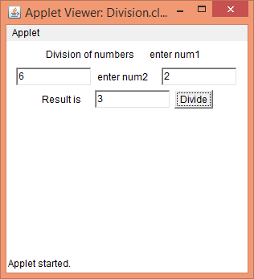

**When we entered mun2 as 0 it will gives**

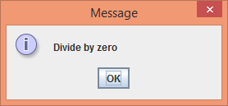

**When we entered non integer values, it throws NumberFormatException**

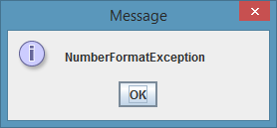

**5.WriteaJavaprogramthatimplements a multi-thread application that has three threads. First thread generates randominteger every 1 second and if the value is even, second thread computes the square of thenumber and prints. If the value is odd, the third thread will print the value of cube of thenumber.**

**Gedit Mthread.java**import java.lang.*;importjava.util.*;

classevenimplementsRunnable

{

publicintx;

publiceven(intx)

{

this.x=x;

}

public voidrun()

{

System.out.println("thread name:even thread and"+x+"is even number and squareof"+x+"is:"+x*x);

}

}

classoddimplementsRunnable

{

publicintx;

public odd(intx)

{

this.x=x;

}

public voidrun()

{

System.out.println("thread name:odd thread and"+x+"is odd number andcubeof"+x+"is:"+x*x*x);

}

}

classAextendsThread

{

public String tname;

public Random r;public Thread t1,t2;

publicA(Strings)

{

tname=s;

}

public voidrun()

{

intnum=10;

r= new Random();

try

{

for(inti=0;i<50;i++)

{

num=r.nextInt(100);

System.out.println("mainthreadandgeneratednumberis"+num);if(num%2==0)

{

t1=newThread(neweven(num));t1.start();

}

else

{

t2 = new Thread(new odd(num));

t2.start();

}

Thread.sleep(1000);

System.out.println(" ");

}

}

catch(Exceptione)

{

System.out.println(e.getMessage());

}

}

}

classMthread

{

publicstatic voidmain(Stringargs[])

{

Aa=newA("one");

a.start();

}

}

**output:**

**javac Mthread.javajavaMthread**

mainthreadandgeneratednumberis2

thread name:eventhreadand2isevennumberandsquareof2is:4

mainthreadandgeneratednumberis85

threadname:oddthread and85isodd numberandcubeof85is:614125

mainthreadandgeneratednumberis92

threadname:eventhreadand92isevennumberandsquareof92is:8464

mainthreadandgeneratednumberis24

threadname:eventhreadand24isevennumberandsquareof24is:576

mainthreadandgeneratednumberis74

threadname:eventhreadand74isevennumberandsquareof74is:5476

mainthreadandgeneratednumberis4

thread name:eventhreadand4isevennumberandsquareof4is:16

mainthreadandgeneratednumberis59

threadname:oddthread and59isodd numberandcubeof59is:205379

mainthreadandgeneratednumberis83

threadname:oddthread and83isodd numberandcubeof83is:571787

mainthreadandgeneratednumberis23

threadname:oddthread and23isodd numberandcubeof23is:12167

mainthreadandgeneratednumberis24

threadname:eventhreadand24isevennumberandsquareof24is:576

mainthreadandgeneratednumberis88

threadname:eventhreadand88isevennumberandsquareof88is:7744

mainthreadandgeneratednumberis62

threadname:eventhreadand62isevennumberandsquareof62is:3844

mainthreadandgeneratednumberis75

threadname:oddthread and75isodd numberandcubeof75is:421875

mainthreadandgeneratednumberis30

threadname:eventhreadand30isevennumberandsquareof30is:900