SELENIUM

Question: What is Selenium?

Answer:

Selenium is a suite of software tools to automate web browsers across many platforms (Different Operation Systems like MS Windows, Linux Macintosh etc.). It was launched in 2004, and it is open source Test Tool suite.

Question: What is Selenium WebDriver?

Answer:

Selenium WebDriver is a tool for writing automated tests of websites. It is an API name and aims to mimic the behavior of a real user, and as such interacts with the HTML of the application. Selenium WebDriver is the successor of Selenium Remote Control which has been officially deprecated.

Question: Explain Selenium Web Driver Architecture?

Answer:

Selenium Web Driver Architecture contains following components as mentioned below:

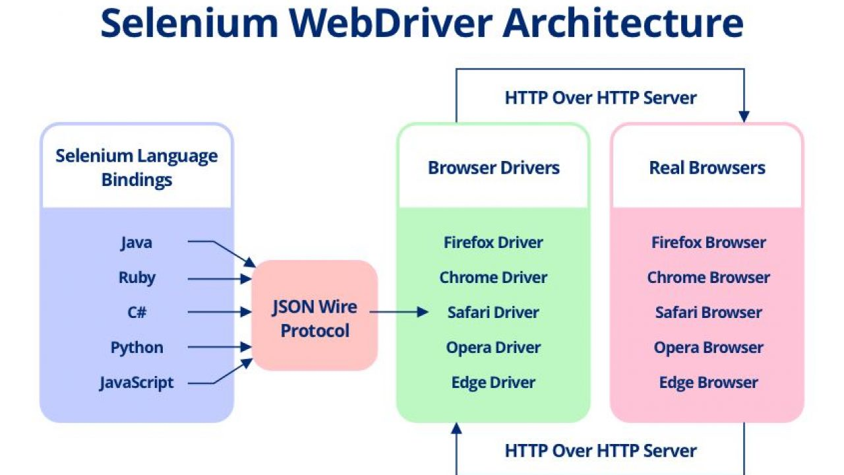

Question: What is cost of WebDriver, is this commercial or open source?

Answer:

Selenium is an open source and free of cost.

Question: How you specify browser configurations with Selenium 3.0?

Answer:

Following driver classes are used for browser configuration

AndroidDriver,

ChromeDriver,

EventFiringWebDriver,

FirefoxDriver,

HtmlUnitDriver,

InternetExplorerDriver,

IPhoneDriver,

IPhoneSimulatorDriver,

RemoteWebDriver

Question: Which web driver implementation is fastest?

Answer:

HTMLUnitDriver. Simple reason is HTMLUnitDriver does not execute tests on browser but plain http request – response which is far quick than launching a browser and executing tests. But then you may like to execute tests on a real browser than something running behind the scenes

Headless browser:

WebDriver driver = new HTMLUnitDriver();

HTMLUNIT driver is not part of se 3.0

Html unit driver is not available in selenium jar file

We need to download to use this concept

Advantages

1.faster execution

2.testing happening behin the scene

3.not suitable for actions class-user actions-mouse actions,doubleclick

Question: What all different element locators are available with Selenium?

Answer:

1. driver.findElement(By.id("HTMLid"));
2. driver.findElement(By.name("HTMLname"));
3. driver.findElement(By.cssSelector("cssLocator"));
4. driver.findElement(By.className("ClassName”));
5. driver.findElement(By.linkText ("LinkText”));
6. driver.findElement(By.partialLinkText ("PartialLink”));
7. driver.findElement(By.tagName ("TagName”));
8. driver.findElement(By.xpath("XPathLocator));

Selenium uses following method to access elements:

Question: How to capture screen shot in Webdriver ?

Answer:

File file= ((**TakesScreenshot**)driver).getScreenshotAs(OutputType.FILE);

FileUtils.copyFile(file, new File("c:\\name.png"));

Question: How do I clear content of a text box in Selenium 3.0 ?

Answer:

WebElement element= driver.findElement(By.id("ElementID"));

element.clear();

Question: How to execute java scripts function ?

Answer:

JavascriptExecutor js = (JavascriptExecutor) driver;

String title = (String) js.executeScript("pass your java scripts");

Question: How to count total number of rows of a table using Selenium 3.0 ?

Answer:

List {WebElement} rows = driver.findElements(By.className("//table[@id='tableID']/tr"));

int totalRow = rows.size();

Question. How to delete Browser Cookies with Selenium Web Driver ?

Answer:

driver.Manage().Cookies.DeleteAllCookies();

Question: How to capture page title using Selenium ?

Answer:

String title = driver.getTitle();

Question: How to store current url using Selenium?

Answer:

String currentURL = driver.getCurrentUrl();

Question: How to store page source using Selenium?

Answer:

String pagesource = driver.getPageSource();

Question: What is the difference between Assert and Verify in Selenium?

Answer:

Assert: In simple words, if the assert condition is true then the program control will execute the next test step but if the condition is false, the execution will stop and further test step will not be executed.

Verify: In simple words, there won’t be any halt in the test execution even though the verify condition is true or false.

Question: What are Soft Assert and Hard Assert in Selenium?

Answer:

Soft Assert: Soft Assert collects errors during @Test Soft Assert does not throw an exception when an assert fails and would continue with the next step after the assert statement.

Hard Assert: Hard Assert throws an AssertException immediately when an assert statement fails and test suite continues with next @Test

Question: What are the verification points available in Selenium?

Answer:

In Selenium WebDriver, there is no built-in features for verification points. It totally depends on our coding style. some of the Verification points are

1. To check for page title
2. To check for certain text with in web page
3. To check for certain element (text box, button, drop down, etc.)
4. To check for click operation
5. To check for submit operation
6. To Check for navigation from 1 link to other link

Question: What are the different exceptions you have faced in Selenium WebDriver?

Answer:

Some of the exceptions I have faced in my current project are:

a) ElementNotVisibleException

b) StaleElementReferenceException

**Element Not visible Exception**:

This exception will be thrown when you are trying to locate a particular element on webpage that is not currently visible eventhough it is present in the DOM. Also sometimes, if you are trying to locate an element with the xpath which associates with two or more element.

**Stale Element Reference Exception:**

A stale element reference exception is thrown in one of two cases, the first being more common than the second.

The two reasons for Stale element reference are

The element has been deleted entirely.

The element is no longer attached to the DOM.

We face this stale element reference exception when the element we are interacting is destroyed and then recreated again. When this happens the reference of the element in the DOM becomes stale. Hence we are not able to get the reference to the element.

Some other exceptions we usually face are as follows:

c) WebDriverException

d) IllegalStateException

e) TimeoutException

f) NoAlertPresentException

g) NoSuchWindowException

h) NoSuchElementException

Question: What are the types of waits available in Selenium WebDriver?

Answer:

In Selenium we could see three types of waits such as Implicit Waits, Explicit Waits and Fluent Waits.

Question: What is Implicit Wait In Selenium WebDriver?

Answer:

Implicit waits tell to the WebDriver to wait for a certain amount of time before it throws an exception. Once we set the time, WebDriver will wait for the element based on the time we set before it throws an exception. The default setting is 0 (zero). We need to set some wait time to make WebDriver to wait for the required time.

Question: What is WebDriver Wait In Selenium WebDriver?

Answer:

WebDriverWait is applied on a certain element with defined expected condition and time. This wait is only applied to the specified element. This wait can also throw an exception when an element is not found.

Question: What is Fluent Wait In Selenium WebDriver?

Answer:

FluentWait can define the maximum amount of time to wait for a specific condition and frequency with which to check the condition before throwing an “ElementNotVisibleException” exception.

Question: How to input text in the text box using Selenium WebDriver?

Answer:

By using sendKeys() method

Question: How to input text in the text box without calling the sendKeys()?

Answer:

Using Java Script Executor

Question: How to clear the text in the text box using Selenium WebDriver?

Answer:

By Using clear method

Question: How to get a text of a web element?

**Answer:** By using getText() method

Question: How to get an attribute value using Selenium WebDriver?

Answer:

By using getAttribute(value) method

It returns the value of the attribute passed as a parameter.

HTML:

<input name="nameSelenium" value="nextGeneration">Next Generation Automation</input>

Selenium Code:

Question: How to assert text of webpage using Selenium ?

Answer:

Selenium Code:

Question: How to click on a hyperlink using Selenium WebDriver?

Answer:

We use click() method in Selenium

Question: How to submit a form using Selenium WebDriver?

Answer:

We use “submit” method on element to submit a form

driver.findElement(By.id("form_1")).submit();

Alternatively, you can use click method on the element which does form submission

Question: How to press ENTER key on text box In Selenium WebDriver?

Answer:

To press ENTER key using Selenium WebDriver, We need to use Selenium Enum Keys with its constant ENTER.

driver.findElement(By.xpath("xpath")).sendKeys(Keys.ENTER);

Question:How to pause a test execution for 5 seconds at a specific point?

Answer:

By using java.lang.Thread.sleep(long milliseconds) method we could pause the execution for a specific time.

To pause 5 seconds, we need to pass parameter as 5000 (5 seconds)

Thread.sleep(5000)

Question: Is Selenium Server needed to run Selenium WebDriver Scripts?

Answer:

When we are distributing our Selenium WebDriver scripts to execute using Selenium Grid, we need to use Selenium Server.

**Question: What happens if I run this command.** driver.get(“www.nextgenerationautomation.com”) ;

Answer:

An exception is thrown. We need to pass HTTP protocol within driver.get() method.

driver.get("https://www.nextgenerationautomation.com");

Question: What is the alternative to driver.get() method to open an URL using Selenium WebDriver?

Answer:

Alternative method to driver.get(“url”) method is driver.navigate.to(“url”)

Question: What is the difference between driver.get() and driver.navigate.to(“url”)?

Answer:

driver.get(): To open an URL and it will wait till the whole page gets loaded

driver.navigate.to(): To navigate to an URL and It will not wait till the whole page gets loaded

Question: Can I navigate back and forth in a browser in Selenium WebDriver?

Answer:

We use Navigate interface to do navigate back and forth in a browser. It has methods to move back, forward as well as to refresh a page.

driver.navigate().forward(); – to navigate to the next web page with reference to the browser’s history

driver.navigate().back(); – takes back to the previous webpage with reference to the browser’s history

driver.navigate().refresh(); – to refresh the current web page thereby reloading all the web elements

driver.navigate().to(“url”); – to launch a new web browser window and navigate to the specified URL

Question: How to fetch the current page URL in Selenium?

Answer:

To fetch the current page URL, we use getCurrentURL()

driver.getCurrentUrl();

Question: How can we maximize browser window in Selenium?

Answer:

To maximize browser window in selenium we use maximize() method. This method maximizes the current window if it is not already maximized

driver.manage().window().maximize();

**Question:** What is the difference between driver.getWindowHandle() and driver.getWindowHandles() in Selenium WebDriver?

Answer:

driver.getWindowHandle() – It returns a handle of the current page (a unique identifier)

driver.getWindowHandles() – It returns a set of handles of the all the pages available.

Question: What are the ways to refresh a browser using Selenium WebDriver?

Answer:

There are multiple ways to refresh a page in selenium

a) Using driver.navigate().refresh()

b) Using driver.get(“URL”) on the current URL or using driver.getCurrentUrl()

c) Using driver.navigate().to(“URL”) on the current URL d)driver.navigate().to(driver.getCurrentUrl());

e) Using sendKeys(Keys.F5) on any textbox on the webpage

Question: What is the difference between driver.close() and driver.quit() methods?

Answer:

Purpose of these two methods (driver.close and driver.quit) is almost same. Both allow us to close a browser but still, there is a difference.

driver.close(): To close current WebDriver instance

driver.quit(): To close all the opened WebDriver instances

Question: What is the difference between driver.findElement() and driver.findElements() commands?

Answer:

The difference between driver.findElement() and driver.findElements() commands is-

findElement() returns a single WebElement (found first) based on the locator passed as parameter. Whereas findElements() returns a list of WebElements, all satisfying the locator value passed.

Syntax of findElement()-

WebElement textbox = driver.findElement(By.id(“textBoxLocator”));

Syntax of findElements()-

List <WebElement> elements = element.findElements(By.id(“value”));

Another difference between the two is- if no element is found then findElement() throws NoSuchElementException whereas findElements() returns a list of 0 elements.

Question: How to find whether an element is displayed on the web page?

Answer:

WebDriver facilitates the user with the following methods to check the visibility of the web elements. These web elements can be buttons, drop boxes, checkboxes, radio buttons, labels etc.

a) isDisplayed()

boolean elePresent = driver.findElement(By.xpath("xpath")).isDisplayed();

b) isSelected()

boolean eleSelected= driver.findElement(By.xpath("xpath")).isSelected();

c) isEnabled()

boolean eleEnabled= driver.findElement(By.xpath("xpath")).isEnabled();

Question: How to Handle Drop Down And Multi Select List Using Selenium WebDriver?

Answer:

To handle drop down and multi select list using Selenium WebDriver, we need to use Select class.

The Select class is a Webdriver class which provides the implementation of the HTML SELECT tag. It exposes several “Select By” and “Deselect By” type methods. We use these methods to select or deselect in the drop down list or multi select object. The Select class is the part of the selenium package.

To Handle Drop Down And Multi Select List in Selenium we use the following types of Select Methods.

Types of Select Methods:

i. selectByVisibleText Method

ii. selectByIndex Method

iii. selectByValue Method

Types of DeSelect Methods:

i. deselectByVisibleText Method

ii. deselectByIndex Method

iii. deselectByValue Method

iv. deselectAll Method

Example:

WebElement mySelectElement = driver.findElement(By.name("dropdown"));

Select dropdown = new Select(mySelectElement);

dropdown.selectByVisibleText(Text);

dropdown.selectByIndex(Index);

dropdown.selectByValue(Value);

**Question:** How to mouse hover on a web element using WebDriver?

Answer:

By using Actions class

WebElement ele = driver.findElement(By.xpath("xpath"));

//Create object 'action' of an Actions class

Actions action = new Actions(driver);

//Mouseover on an element

action.moveToElement(ele).perform();

**Question:** How can we handle web based pop-up?

Answer:

Alerts are basically popup boxes that take your focus away from the current browser and forces you to read the alert message. You need to do some action such as accept or dismiss the alert box to resume your task on the browser.

To handle alerts popups we need to do switch to the alert window and call Selenium WebDriver Alert API methods.

There are two types of alerts.

Windows Based

Web Based/Browser Based

To handle Browser based Alerts (Web based alert popups), we use Alert Interface. The Alert Interface provides some methods to handle the popups.

While running the WebDriver script, the driver control will be on the browser even after the alert generated which means the driver control will be behind the alert pop up. In order to switch the control to alert pop up, we use the following command :

driver.switchTo().alert();

Once we switch the control from browser to the alert window. We can use the Alert Interface methods to do required actions such as accepting the alert, dismissing the alert, get the text from the alert window, writing some text on the alert window etc.,

To get a handle to the open alert:

Alert alert = driver.switchTo().alert();

To Click on OK button:

alert.accept();

To click on Cancel button.

alert.dismiss()

To get the text which is present on the Alert.

alert.getText();

To enter the text into the alert box

alert.sendkeys(String stringToSend);

To Authenticate by passing the credentials

alert.authenticateUsing(Credentials credentials)

For Windows Based, Need to use tools like AutoIT.

Question: How to double click on element using Selenium ?

Answer:

WebElement element = driver.findElement(By.id("ElementID"));

Actions builder = new Actions(driver);

builder.doubleClick(element).build().perform();

Question: How to perform drag and drop in Selenium ?

Answer:

WebElement source = driver.findElement(By.id("Source ElementID"));

WebElement destination = driver.findElement(By.id("Taget ElementID"));

Actions builder = new Actions(driver);

builder.dragAndDrop(source, destination ).perform();

Question: How to handle hidden elements in Selenium WebDriver?

Answer:

It is one of the most important selenium interview questions.

We can handle hidden elements by using javaScript executor

(JavascriptExecutor(driver)).executeScript("document.getElementsByClassName(ElementLocator).click();");

Question: How to Find Broken Links Using Selenium WebDriver?

Answer:

One of the key test case is to find broken links on a webpage. Due to existence of broken links, your website reputation gets damaged and there will be a negative impact on your business. It’s mandatory to find and fix all the broken links before release. If a link is not working, we face a message as 404 Page Not Found.

Let’s see some of the HTTP status codes.

200 – Valid Link

404 – Link not found

400 – Bad request

401 – Unauthorized

500 – Internal Error

Consider a test case to test all the links in the home page of “NextGenerationAutomation.com”

Below code fetches all the links of a given website (i.e.,NextGenerationAutomation.com) using ***WebDriver***commands and reads the status of each *href* link with the help of ***HttpURLConnection*** class.

**Question:** What is JavaScriptExecutor and in which cases JavaScriptExecutor will help in Selenium automation?

Answer:

In general, we click on an element using click() method in Selenium.

For example:

In general, we click on an element using click() method in Selenium.

Sometimes web controls don’t react well against selenium commands and we may face issues with the above statement (click()). To overcome such kind of situation, we use JavaScriptExecutor interface.

It provides a mechanism to execute Javascript through Selenium driver. It provides “executescript” & “executeAsyncScript” methods, to run JavaScript in the context of the currently selected frame or window.

There is no need to write a separate script to execute JavaScript within the browser using Selenium WebDriver script. Just we use predefined interface named ‘Java Script Executor’. We need to import the JavascriptExecutor package in the script.

Package:

import org.openqa.selenium.JavascriptExecutor;

Syntax:

JavascriptExecutor js = (JavascriptExecutor) driver;

js.executeScript(Script,Arguments);

Script – The JavaScript to execute

Arguments – The arguments to the script(Optional). May be empty.

Returns – One of Boolean, Long, String, List, WebElement, or null.

Let’s see some scenarios we could handle using this Interface:

1. To type Text in Selenium WebDriver without using sendKeys() method

2. To click a Button in Selenium WebDriver using JavaScript

3. To handle Checkbox

4. To generate Alert Pop window in selenium

5. To refresh browser window using Javascript

6. To get innertext of the entire webpage in Selenium

7. To get the Title of our webpage

8. To get the domain

9. To get the URL of a webpage

10. To perform Scroll on an application using Selenium

11. To click on a SubMenu which is only visible on mouse hover on Menu

12. To navigate to different page using Javascript

Question: How to verify PDF content using Selenium 3.0?

Answer:

NextGeneration Automation will explain the procedure to verify PDF file content using java WebDriver. As some time we need to verify content of web application PDF file, opened in browser.

Use below code in your test scripts to get PDF file content.

//get current URL PDF file URL

URL url = new URL(driver.getCurrentUrl());

//create buffer reader object

BufferedInputStream fileToParse = new BufferedInputStream(url.openStream());

PDFParserPDFParser = newPDFParser(fileToParse);

PDFParser.parse();

//savePDF text into strong variable

String pdftxt = newPDFTextStripper().getText(pdfParser.getPDDocument());

//closePDFParser object

PDFParser.getPDDocument().close();

After applying above code, you can store all PDF file content into “pdftxt” string variable.

Now you can verify string by giving input. As if you want to verify “Selenium or WebDiver” text. Use below code.

Assert.assertTrue(pdftxt.contains(“Next Generation Automation”));

**Question:** How to handle Ajax calls in Selenium WebDriver?

Answer:

Handling AJAX calls is one of the common issues when using Selenium WebDriver. We wouldn’t know when the AJAX call would get completed and the page has been updated. In this post, we see how to handle AJAX calls using Selenium.

AJAX stands for Asynchronous JavaScript and XML. AJAX allows the web page to retrieve small amounts of data from the server without reloading the entire page. AJAX sends HTTP requests from the client to server and then process the server’s response without reloading the entire page. To handle AJAX controls, wait commands may not work. It’s just because the actual page is not going to refresh.

When you click on a submit button, the required information may appear on the web page without refreshing the browser. Sometimes it may load in a second and sometimes it may take longer. We have no control over loading time. The best approach to handle this kind of situations in selenium is to use dynamic waits (i.e. WebDriverWait in combination with ExpectedCondition)

Some of the methods which are available are as follows:

1. titleIs() – The expected condition waits for a page with a specific title.

wait.until(ExpectedConditions.titleIs(“Deal of the Day”));

2. elementToBeClickable() – The expected condition waits for an element to be clickable i.e. it should be present/displayed/visible on the screen as well as enabled.

wait.until(ExpectedConditions.elementToBeClickable(By.xpath("xpath")));

3. alertIsPresent() – The expected condition waits for an alert box to appear.

wait.until(ExpectedConditions.alertIsPresent()) !=null);

4. textToBePresentInElement() – The expected condition waits for an element having a certain string pattern.

wait.until(ExpectedConditions.textToBePresentInElement(By.id(“title’”), “text to be found”));

**Question:** List some scenarios which we cannot automate using Selenium WebDriver?

Answer:

1. Bitmap comparison is not possible using Selenium WebDriver

2. Automating Captcha is not possible using Selenium WebDriver

3. We can not read bar code using Selenium WebDriver

**Question:** What is Object Repository in Selenium WebDriver?

Answer:

Object Repository is used to store element locator values in a centralized location instead of hard coding them within the scripts. We do create a property file (.properties) to store all the element locators and these property files act as an object repository in Selenium WebDriver.

**Question:** How you build Object Repository in your project?

Answer:

In QTP, there is an Object Repository concept. When a user records a test, the objects and its properties are captured by default in an Object Repository.

QTP uses this Object Repository to play back the scripts.

Coming to Selenium, there is no default Object Repository concept. It doesn’t mean that there is no Object Repository in Selenium. Even though there is no default one still we could create our own.

In Selenium, we call objects as locators (such as ID, Name, Class Name, Tag Name, Link Text, Partial Link Text, XPath, and CSS). Object repository is a collection of objects. One of the ways to create Object Repository is to place all the locators in a separate file (i.e., properties file).

But the best way is to use Page Object Model. In the Page Object Model Design Pattern, each web page is represented as a class. All the objects related to a particular page of a web application are stored in a class.

Question: What is Page Object Model in Selenium?

Answer:

Page Object Model is a Design Pattern which has become popular in Selenium Test Automation. It is widely used design pattern in Selenium for enhancing test maintenance and reducing code duplication.

Page object model (POM) can be used in any kind of framework such as modular, data-driven, keyword driven, hybrid framework etc. A page object is an object-oriented class that serves as an interface to a page of your Application Under Test(AUT).

The tests then use the methods of this page object class whenever they need to interact with the User Interface (UI) of that page. The benefit is that if the UI changes for the page, the tests themselves don’t need to change, only the code within the page object needs to change. Subsequently, all changes to support that new UI is located in one place.

Question: What is Page Factory?

Answer:

We have seen that ‘Page Object Model’ is a way of representing an application in a test framework. For every ‘page’ in the application, we create a Page Object to reference the ‘page’ whereas a ‘Page Factory’ is one way of implementing the ‘Page Object Model’.

Page Object is a class that represents a web page and hold the functionality and members.

Page Factory is a way to initialize the web elements you want to interact with within the page object when you create an instance of it.

Code Snippet:

@FindBy(how=How.XPATH, using="//div[text()='Account Settings']")

WebElement profileDropdown;

@FindBy(how=How.XPATH, using="//text()[.='Log Out']/ancestor::span[1]")

WebElement logoutLink;

@FindBy(how=How.XPATH, using="///div[text()='Good afternoon, SoftwareTesting!']")

loggedInUserNameText;

FbLoginPage loginpage = PageFactory.initElements(driver, FbLoginPage.class);

Question: What are the advantages of Page Object Model Framework?

Answer:

Code reusability – We could achieve code reusability by writing the code once and use it in different tests.

Code maintainability – There is a clean separation between test code and page specific code such as locators and layout which becomes very easy to maintain code. Code changes only on Page Object Classes when a UI change occurs. It enhances test maintenance and reduces code duplication.

Object Repository – Each page will be defined as a java class. All the fields in the page will be defined in an interface as members. The class will then implement the interface.

Readability – Improves readability due to clean separation between test code and page specific code

Question: How can you use the Recovery Scenario in Selenium WebDriver?

Answer:

By using “Try Catch Block” within Selenium WebDriver Java tests.

try {

driver.get("www.SoftwareTestingMaterial.com");

}catch(Exception e){

System.out.println(e.getMessage());

}

Question: How to verify response 200 code using Selenium ?

Answer:

Next Generation Automation will explain you to verify HTTP response code 200 of web application using java webdriver. As webdriver does not support direct any function to verify page response code. But using "WebClient" of HtmlUnit API we can achieve this.

Html unit API is GUI less browser for java developer, using WebClent class we can send request to application server and verify response header status.

Below code, used in my Webdriver script to verify response 200 of web application

String url = "http://www.google.com/";

WebClient webClient = new WebClient();

HtmlPage htmlPage = webClient.getPage(url);

//Verify response

Assert.assertEquals(200,htmlPage.getWebResponse().getStatusCode());

Assert.assertEquals("OK",htmlPage.getWebResponse().getStatusMessage());

If HTTP authentication is required in web application use below code.

String url = "Application Url";

WebClient webClient = new WebClient();

DefaultCredentialsProvider credential = new DefaultCredentialsProvider();

//Set some example credentials credential.addCredentials("UserName", "Passeord"); webClient.setCredentialsProvider(credential);

HtmlPage htmlPage = webClient.getPage(url);

//Verify response

Assert.assertEquals(200,htmlPage.getWebResponse().getStatusCode());

Assert.assertEquals("OK",htmlPage.getWebResponse().getStatusMessage());

Question: Where you have applied OOPS in Automation Framework

Answer:

OOPS concepts contains following:

a) ABSTRACTION

b) INTERFACE

c) INHERITANCE

d) POLYMORPHISM

e) METHOD OVERLOADING

f) METHOD OVERRIDING

g) ENCAPSULATION

ABSTRACTION

In Page Object Model design pattern, we write locators (such as id, name, xpath etc.,) in a Page Class. We utilize these locators in tests but we can’t see these locators in the tests. Literally we hide the locators from the tests.

Abstraction is the methodology of hiding the implementation of internal details and showing the functionality to the users.

INTERFACE

Basic statement we all know in Selenium is

WebDriver driver = new FirefoxDriver();

WebDriver itself is an Interface.

So based on the above statement WebDriver driver = new FirefoxDriver();

We are initializing Firefox browser using Selenium WebDriver. It means we are creating a reference variable (driver) of the interface (WebDriver) and creating an Object.

Here WebDriver is an Interface as mentioned earlier and FirefoxDriver is a class.

An interface in Java looks similar to a class but both the interface and class are two different concepts. An interface can have methods and variables just like the class but the methods declared in interface are by default abstract. We can achieve 100% abstraction and multiple inheritance in Java with Interface.

INHERITANCE

We create a Base Class in the Framework to initialize WebDriver interface, WebDriver waits, Property files, Excels, etc., in the Base Class.We extend the Base Class in other classes such as Tests and Utility Class.

Extending one class into other class is known as Inheritance.

POLYMORPHISM

Combination of overloading and overriding is known as Polymorphism. We will see both overloading and overriding below.

Polymorphism allows us to perform a task in multiple ways.

METHOD OVERLOADING

We use implicit wait in Selenium. Implicit wait is an example of overloading. In Implicit wait we use different time stamps such as SECONDS, MINUTES, HOURS etc.

A class having multiple methods with same name but different parameters is called Method Overloading

METHOD OVERRIDING

We use a method which was already implemented in another class by changing its parameters. To understand this you need to understand Overriding in Java.

Declaring a method in child class which is already present in the parent class is called Method Overriding. Examples are get and navigate methods of different drivers in Selenium

ENCAPSULATION

All the page classes in a framework are an example of Encapsulation. In POM classes, we declare the data members using @FindBy and initialization of data members will be done using Constructor to utilize those in methods.

Encapsulation is a mechanism of binding code and data together in a single unit.

Question: How to handle browser (chrome) notifications in Selenium?

Answer:

In Chrome, we can use ChromeOptions as shown below.

ChromeOptions options = new ChromeOptions();

options.addArguments("disable-infobars");

WebDriver player = new ChromeDriver(options);

Question: How To Highlight Element Using Selenium WebDriver

Answer:

In selenium we need to get the help of JavascriptExecutor interface to achieve this.

Let’s make the above code as a function. So whenever we want to highlight particular element, we could use this method to achieve our goal.

Question: How to achieve Database testing in Selenium?

Answer:

As we all know Selenium WebDriver is a tool to automate User Interface. We could only interact with Browser using Selenium WebDriver.

Sometimes, we may face a situation to get the data from the Database or to modify (update/delete) the data from the Database. If we plan to automate anything outside the vicinity of a browser, then we need to use other tools to achieve our task. To achieve the Database connection and work on it, we need to use JDBC API Driver.

The Java Database Connectivity (JDBC) API provides universal data access from the Java programming language. Using the JDBC API, you can access virtually any data source, from relational databases to spreadsheets and flat files. It lets the user connect and interact with the Database and fetch the data based on the queries we use in the automation script. JDBC is a SQL level API that allows us to execute SQL statements. It creates a connectivity between Java Programming Language and the database.

Using JDBC Driver we could do the following

i. Establish a Database connection

ii. Send SQL Queries to the Database

iii. Process the results

Script to get the data from the Database – Database Testing:

Script to update the data in the Database – Database Testing:

Script to delete the data in the Database – Database Testing:

Question: How To Download File Using AutoIT In Selenium WebDriver

Answer:

Download File Using AutoIT In Selenium WebDriver

Selenium can not handle file downloading because browsers use native dialogs for downloading files. Sometime we need to download file from AUT(Application Under Test). There are several ways to automate download file in Selenium but here we see download file using AutoIT in Selenium WebDriver.

AutoIt Introduction:

AutoIt Tool is an open source tool. It is a freeware BASIC-like scripting language designed for automating the Windows GUI and general scripting. It uses a combination of simulated keystrokes, mouse movement and window/control manipulation in order to automate tasks in a way not possible or reliable with other languages (e.g. VBScript and SendKeys). AutoIt is also very small, self-contained and will run on all versions of Windows out-of-the-box with no annoying “runtimes” required!

Now the question is how we do download file using AutoIT Tool in Selenium WebDriver.

Follow the below steps:

Step 1: Download Autoit tool from <https://www.autoitscript.com/site/autoit/downloads/>

and install it

Step 2: Open SciTE Script editor and add the below mentioned AutoIt script and save it as ‘DownloadFile.au3’ in your system.

AutoIt Script:

Step 3: Once the file is saved, we need to convert the ‘DownloadFile.au3’ to ‘DownloadFile.exe’. To do this we need to compile the ‘DownloadFile.au3’

Right click on the file ‘DownloadFile.au3’ and click on ‘Compile Script’ to generate an executable file ‘DownloadFile.exe’

Step 4: In Eclipse, add the below mentioned Selenium Script and run

In the above Selenium Script, we did call the AutoIt Script after clicking on the browser button which transfers windows popup box and download the required file.

API

Question: What is an API?

Answer:

An API (Application Programming Interface) is a software intermediary that enables two applications to communicate with each other. It comprises a number of subroutine definitions, logs, and tools for creating application software.

In an API testing interview, you could be asked to give some API examples, here are the well-known ones: Google Maps API, Amazon Advertising API, Twitter API, YouTube API, which can be used to perform different CRUD Ope

Question: What are main differences between API and Web Service?

Answer:

All Web services are APIs but not all APIs are Web services.

Web services might not contain all the specifications and cannot perform all the tasks that APIs would perform.

A Web service uses only three styles of use: SOAP, REST and XML-RPC for communication whereas API may be exposed to in multiple ways.

A Web service always needs a network to operate while APIs don’t need a network for operation.rations.

Question: What are some architectural styles for creating a Web API?

Answer:

Below are four common Web API architectural styles:

a) HTTP for client-server communication

b) XML/JSON as formatting language

c) Simple URI as the address for the services

d) Stateless communication

Question: Who can use a Web API?

Answer:

Web API can be consumed by any clients which support HTTP verbs such as GET, PUT, DELETE, POST. Since Web API services do not require configuration, they can be easily used by any client. In fact, even portable devices such as mobile devices can easily use Web API, which is undoubtedly the biggest advantage of this technology.

Question: What is API Testing?

Answer:

API testing is a kind of software testing which determines if the developed APIs meet expectations regarding the functionality, reliability, performance, and security of the application.

Question: What are the advantages of API Testing?

Answer:

a) Test for Core Functionality: API testing provides access to the application without a user interface. The core and code-level of functionalities of the application will be tested and evaluated early before the GUI tests. This will help detect the minor issues which can become bigger during the GUI testing.

b) Time Effective: API testing usually is less time consuming than functional GUI testing. The web elements in GUI testing must be polled, which makes the testing process slower. Particularly, API test automation requires less code so it can provide better and faster test coverage compared to GUI test automation. These will result in the cost saving for the testing project.

c) Language-Independent: In API testing, data is exchanged using XML or JSON. These transfer modes are completely language-independent, allowing users to select any code language when adopting automation testing services for the project.

d) Easy Integration with GUI: API tests enable highly integrable tests, which is particularly useful if you want to perform functional GUI tests after API testing. For instance, simple integration would allow new user accounts to be created within the application before a GUI test started.

Question: Some common protocols used in API testing?

Answer:

JMS, REST, HTTP, UDDI and SOAP.

Question: What are principles of an API test design?

Answer:

The five most important principles of an API test design are:

a) Setup: Create objects, start services, initialize data, etc

b) Execution: Steps to apply API or the scenario, including logging

c) Verification: Oracles to evaluate the result of the execution

d) Reporting: Pass, failed or blocked

e) Clean up: Pre-test state

Question: What is the procedure to perform API testing?

Answer:

a) Choose the Test suite to add the API test case

b) Choose the Test development mode either Manual or Automation

c) Development of test cases for the required API methods

d) Configure the control parameters of the application and then test conditions part of Test Data

e) Configure method validation part of Test Validation

f) Execute the API test

g) Generate test reports for execution

h) Publish Test reports to different stake holders

Question: What must be checked when performing API testing?

Answer:

During the API testing process, a request is raised to the API with the known data. This way you can analyze the validation response. While testing an API, you should consider:

a) Accuracy of data

b) Schema validation

c) HTTP status codes

d) Data type, validations, order and completeness

e) Authorization checks

f) Implementation of response timeout

g) Error codes in case API returns, and

h) Non-functional testing like performance and security testing

Question: What is the best approach method to perform API testing?

Answer:

The following factors should be considered when performing API testing:

a) Defining the correct input parameters

b) Verifying the calls of the mixture of two or more added value parameters

c) Defining the basic functionality and scope of the API program

d) Writing appropriate API test cases and making use of testing techniques such as equivalence class, boundary value, etc. to check the operability

e) Testing case execution

f) Comparing the test result with the expected result

g) Verifying the API behavior under conditions such as Communication between multiple APIS, between API and Database, between real API and mock APIS.

Question: What are tools could be used for API testing?

Answer:

There are good number of different API testing tools available. A few of common tools are Katalon Studio, Postman, SoapUi Pro, Tricentis Tosca, Apigee, etc.

And for Automation most popular framework is Rest Assured and Karate.

Question. What are differences between API Testing and Unit Testing?

Answer:

API Testing

Conducted by QA team

Mostly Black box as you need not require to know the business logic of API under test

Aimed to assess the full functionality of the system for it will be employed by the end user

Often run once build is ready

Unit Testing

Conducted by the development

White Box testing

Used to verify whether each unit in isolation peform as expected or not'

Each of the code modules must be ensured to pass the unit test before being built by developers.

Question: What are differences between API Testing and UI Testing?

Answer:

API enables communication between two separate software systems. A software system implementing an API contains functions or subroutines that can be executed by another software system.

On the other hand, UI ( User Interface) testing refers to testing graphical interface such as how users interact with the applications, testing application elements like fonts, images, layouts etc. UI testing basically focuses on look and feel of an application.

Question: What are major challenges faced in API testing?

Answer:

Some of the challenges faced are:

a) Parameter Selection

b) Parameter Combination

c) Call sequencing

d) Output verification and validation

d) Another important challenge is providing input values, which is very difficult as GUI is not available in this case.

Question: Why is API testing considered as the most suitable form for Automation testing?

Answer:

API testing is now preferred over GUI testing and is considered as most suitable because:

It verifies all the functional paths of the system under test very effectively.

It provides the most stable interface.

It is easier to maintain and provides fast feedback.

Question What are common API errors that often founded?

Answer:

Some of common API errors that founded as below:

a) Missing inter api communication

b) Path Parameter validation errors

c) Query Parameter validation errors

d) Incorrect Authorization as per user roles

e) And some standard error expectations as if the result is not so predicted then the occurrence of errors can be seen

Question: What is API documentation?

Answer:

The API documentation is a complete, accurate technical writing giving instructions on how to effectively use and integrate with an API. It is a compact reference manual that has all the information needed to work with the API, and helps you answer all the API testing questions with details on functions, classes, return types, arguments, and also examples and tutorials.

Question: What are API documentation templates that are commonly used?

Answer:

There are several available API documentation templates help to make the entire process simple and straightforward, these are:

Swagger

Miredot

Slate

FlatDoc

API blueprint

RestDoc

Web service API specification

Question: When writing API document, what must be considered?

Answer:

Source of the content

Document plan or sketch

Delivery layout

Information needed for every function in the document

Automatic document creation programs

Question: How often are the APIs changed and, more importantly, deprecated?

Answer:

APIs, especially modern RESTful APIs, are a nice creation that can certainly simplify and accelerate integration efforts, which makes it more likely you will benefit from them. But APIs can and do change for various reasons, sometimes abruptly, and hence REST APIs do not differ from traditional integration methods in this respect. If an API call is obsolete and disappears, your procedure will interrupt and it is important to understand how often the APIs you depend on change or are deprecated.

Question: What is REST?

Answer:

REST (Representational State Transfer) is an architectural style for developing web services which exploit the ubiquity of HTTP protocol and uses HTTP method to define actions. It revolves around resource where every component being a resource that can be accessed through a shared interface using standard HTTP methods.

In REST architecture, a REST Server provides access to resources and REST client accesses and makes these resources available. Here, each resource is identified by URIs or global IDs, and REST uses multiple ways to represent a resource, such as text, JSON, and XML. XML and JSON are nowadays the most popular representations of resources.

Question: What is a RESTFul Web Services?

Answer:

2 kind of Restful Web Services are:

a) SOAP (Simple Object Access Protocol) – an XML-based method to expose web services.

b) Web services developed in the REST style are referred to as RESTful web services. These web services use HTTP methods to implement the concept of REST architecture. A RESTful web service usually defines a URI, Uniform Resource Identifier a service, provides resource representation like JSON and a set of HTTP methods.

Question: What is a “Resource” in REST?

Answer:

REST architecture treats any content as a resource, which can be either text files, HTML pages, images, videos or dynamic business information.

REST Server gives access to resources and modifies them, where each resource is identified by URIs/ global IDs.

Question: What is the most popular way to represent a resource in REST?

Answer:

REST uses different representations to define a resource like text, JSON, and XML.

XML and JSON are the most popular representations of resources.

Question: Which protocol is used by RESTful Web services?

Answer:

RESTful web services use the HTTP protocol as a medium of communication between the client and the server.

Question: What are some key characteristics of REST?

Answer:

Key characteristics of REST are:

REST is stateless, therefore the SERVER has no status (or session data)

With a well-applied REST API, the server could be restarted between two calls, since all data is transferred to the server

Web service uses POST method primarily to perform operations, while REST uses GET for accessing resources.

Question: What is messaging in RESTful Web services?

Answer:

RESTful web services use the HTTP protocol as a communication tool between the client and the server. The technique that when the client sends a message in the form of an HTTP Request, the server sends back the HTTP reply is called Messaging. These messages comprise message data and metadata, that is, information on the message itself.

Question: What are the core components of an HTTP request?

Answer:

An HTTP request contains five key elements:

1. An action showing HTTP methods like GET, PUT, POST, DELETE.

2. Uniform Resource Identifier (URI), which is the identifier for the resource on the server.

3. HTTP Version, which indicates HTTP version, for example-HTTP v1.1.

4. Request Header, which carries metadata (as key-value pairs) for the HTTP Request message. Metadata could be a client (or browser) type, format supported by the client, format of a message body format, cache settings, and so on.

5. Request Body, which indicates the message content or resource representation.

Question. What are the most commonly used HTTP methods supported by REST?

Answer:

a) GET is only used to request data from a specified resource. Get requests can be cached and bookmarked. It remains in the browser history and haS length restrictions. GET requests should never be used when dealing with sensitive data.

b) POST is used to send data to a server to create/update a resource. POST requests are never cached and bookmarked and do not remain in the browser history.

c) PUT replaces all current representations of the target resource with the request payload.

d) DELETE removes the specified resource.

e) OPTIONS is used to describe the communication options for the target resource.

f) HEAD asks for a response identical to that of a GET request, but without the response body.

Question: Can GET request to be used instead of PUT to create a resource?

Answer:

The PUT or POST method should be used to create a resource. GET is only used to request data from a specified resource.

Question: Is there any difference between PUT and POST operations?

Answer:

Post is used for create new resources and Put is used to update new resources

Scenario: Let’s say we are designing a network application. Let’s list down few URIs and their purpose to get to know when to use POST and when to use PUT operations.

POST /device-management/devices : Create a new device

PUT /device-management/devices/{id} : Update the device information identified by “id”

Question: Which purpose does the OPTIONS method serve for the RESTful Web services?

Answer:

The OPTIONS Method lists down all the operations of a web service supports. It creates read-only requests to the server.

Question: What is URI?

Answer:

URI stands for Uniform Resource Identifier. It is a string of characters designed for unambiguous identification of resources and extensibility via the URI scheme.

The purpose of a URI is to locate a resource(s) on the server hosting of the web service.

The URI generic syntax consists of a hierarchical sequence of five components

URI = scheme:[//authority]path[?query][[#fragment](https://www.nextgenerationautomation.com/blog/search/.hash.fragment)]

where the authority component divides into three subcomponents:

authority = [userinfo@]host[:port]

https://static.wixstatic.com/media/1af9b8_337385a2f80e465980ab0d36c73af41e~mv2.png/v1/fit/w_300,h_300,al_c,q_5/file.png

Examples to describe URI as below:

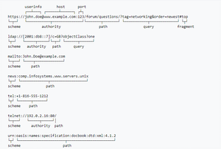

Question: What is payload in RESTFul Web services?

Answer:

The “payload” is the data you are interested in transporting. This is differentiated from the things that wrap the data for transport like the HTTP/S Request/Response headers, authentication, etc.

Question: What is the upper limit for a payload to pass in the POST method?

Answer:

<POST> doesn’t have any such limit.

So, theoretically, a user can pass unlimited data as the payload to POST method. But, if we consider a real use case, then sending POST with large payload will consume more bandwidth. It’ll take more time and present performance challenges to your server. Hence, a user should take action accordingly.

Question: What is the caching mechanism?

Answer:

Caching is just the practice of storing data in temporarily and retrieving data from a high-performance store (usually memory) either explicitly or implicitly.

When a caching mechanism is in place, it helps improve delivery speed by storing a copy of the asset you requested and later accessing the cached copy instead of the original.

Question: What are SOAP Web services?

Answer:

This is one of the fundamental Web services testing questions that you must know the answer. The SOAP (Simple Object Access Protocol) is defined as an XML-based protocol. It is known for designing and developing web services as well as enabling communication between applications developed on different platforms using various programming languages over the Internet. It is both platform and language independent.

Question: How does SOAP work?

Answer:

SOAP is used to provide a user interface that can be accessed by the client object, and the request that it sends goes to the server, which can be accessed using the server object. The user interface creates some files or methods consisting of server object and the name of the interface to the server object. It also contains other information such as the name of the interface and methods. It uses HTTP to send the XML to the server using the POST method, which analyzes the method and sends the result to the client. The server creates more XML consisting of responses to the request of user interface using HTTP. The client can use any approach to send the XML, like the SMTP server or POP3 protocol to pass the messages or reply to queries.

Question: When to use SOAP API?

Answer:

Use the SOAP API to create, retrieve, update or delete records, like accounts, leads, and user-defined objects. With more than 20 different calls, you can also use the SOAP API to manage passwords, perform searches, etc. by using the SOAP API in any language that supports web services.

Question: How users utilize the facilities provided by SOAP?

Answer:

PutAddress(): It is used to enter an address in the webpage and has an address instance on the SOAP call.

PutListing(): It is used to allow the insertion of a complete XML document into the web page. It receives the XML file as an argument and transports the XML file to XML parser liaison, which reads it and inserts it into the SOAP call as a parameter.

GetAddress(): It is used to get a query name and gets the result that best matches a query. The name is sent to the SOAP call in the form of text character string.

GetAllListing(): It is used to return the full list in an XML format.

Question: What is the major obstacle users faced when using SOAP?

Answer:

When using SOAP, users often see the firewall security mechanism as the biggest obstacle. This block all the ports leaving few like HTTP port 80 and the HTTP port used by SOAP that bypasses the firewall. The technical complaint against SOAP is that it mixes the specification for message transport with the specification for message structure.

Question: What are the various approaches available for developing SOAP based web services?

Answer:

There are two different methods available for developing SOAP-based web services, which are explained below:

Contract-first approach: the contract is first defined by XML and WSDL, and then Java classes are derived from the contract.

Contract-last approach: Java classes are first defined, and then the contract is generated, which is normally the WSDL file from the Java class.

“Contract-first” method is the most popular approach.

Question: What are the elements of a SOAP message structure?

Answer:

It is a common XML document that contains the elements as a SOAP message

Envelope: It is an obligatory root element that translates the XML document and defines the beginning and end of the message.

Header: It is an optional item which contains information about the message being sent.

Body: It contains the XML data comprising the message being sent.

Fault: It provides the information on errors that occurred while during message processing.

Question: What are the syntax rules for a SOAP message?

Answer:

a) Must use encoded XML

b) Envelope namespace must be used

c) Encoding namespace must be used

d) Must not consist of a DTD reference

e) Must not have XML processing instruction

Question: What is the transport method in SOAP?

Answer:

Application layer and transport layers of a network are used by SOAP; HTTP and SMTP are the valid protocol of the application layer used as the transport for SOAP. HTTP is more preferable, since it works well with the current Internet infrastructure, in particular with firewalls.

The SOAP requests can be sent using an HTTP GET method while the specification only contains details about HTTP POST.

Question: What are some important characteristics of a SOAP envelope element?

Answer:

a) SOAP message has a root Envelope element

b) Envelope is an obligatory part of the SOAP message.

c) If an envelope includes a header element, it should not contain more than one.

d) Envelope version will change if the SOAP version changes.

e) The SOAP envelope is indicated by the prefix ENV and the envelope element.

f) The optional SOAP encoding is also specified using a namespace and the optional encoding style element.

Question: What are the major functionalities provided by the SOAP protocol class?

Answer:

The SOAP protocol is used to provide simple access methods for all the applications available on the Internet, providing the following functionalities:

Call: A class which provides the main functionality for a remote method for which a call is needed. It is used to create the call() and to specify the encoding style of the registry that will be assigned when if necessary. This call() function is used by the RPC call, which represents the options of the call object.

Deployment Descriptor: A class used to provide the information about the SOAP services. It enables easy deployment without the need for other approaches.

DOM2 Writer: A class that serializes and uses DOM node as XML string to provide more functionalities.

RPC Message: A class used as the base class that calls and replies to the request submitted to the server.

Service Manager: A class that provides, lists and then outputs all SOAP services.

Question: What are the web relation functionalities provided by SOAP protocol?

Answer:

HTTPUtils: This provides the functionality of the POST method to safely meet the requirements.

Parameter: It is an argument for an RPC call used by both the client and the server.

Response: It is an object that represents an RPC reply from both client and server, but the result will not be displayed until after the method call.

TCPTunnel: It is an object that provides the ability to listen on a specific port and to forward all the host and port names.

TypeConverter: It helps to convert an object of one type into another type and this is called using the class in the form object.

Question: How does the message security model allow the creation of SOAP more secure to use?

Answer:

The security model includes the given security tokens. These tokens comprise digital signatures for protection and authentication of SOAP messages. Security tokens can be used to provide the bond between authentication secrets or keys and security identities. Security token uses the authentication protocols and an X.509 certificate to define the relationship between the public key and identity key. The signatures are used to verify the messages and their origin, generate knowledge to confirm the security tokens to bind the identity of a person to the identity of the originator. Security model prevents different attacks and can be used to protect the SOAP architecture.

Question: What is the difference between top down & bottom up approach in SOAP Web services?

Answer:

Top down SOAP Web services include creating WSDL document to create a contract between the web service and the client, with a required code as an option. This is also known as Contract-first approach. The top-down approach is difficult to implement because classes must be written to confirm the contract defined in WSDL. One of the benefits of this method is that both client and server code can be written in parallel.

Bottom up SOAP web services require the code to be written first and then WSDL is generated. It is also known as Contract-last approach. Since WSDL is created based on the code, bottom-up approach is easy to implement and client codes must wait for WSDL from the server side to start working.

Question: What are advantages of SOAP?

Answer:

a) SOAP is both platform and language independent.

b) SOAP separates the encoding and communications protocol from the runtime environment.

c) Web service can retrieve or receive a SOAP user data from a remote service, and the source’s platform information is completely independent of each other.

d) Everything can generate XML, from Perl scripts through C++ code to J2EE app servers.

e) It uses XML to send and receive messages.

f) It uses standard internet HTTP protocol.

g) SOAP runs over HTTP; it eliminates firewall problems. When protocol HTTP is used as the protocol binding, an RPC call will be automatically assigned to an HTTP request, and the RPC response will be assigned to an HTTP reply.

h) Compared to RMI, CORBA and DCOM, SOAP is very easy to use.

i) SOAP acts as a protocol to move information in a distributed and decentralized environment.

j) SOAP is independent of the transport protocol and can be used to coordinate different protocols.

Question: What are disadvantages of SOAP?

Answer:

SOAP is typically significantly slower than other types of middleware standards, including CORBA, because SOAP uses a detailed XML format. A complete understanding of the performance limitations before building applications around SOAP is hence required.

SOAP is usually limited to pooling and not to event notifications when HTTP is used for the transport. In addition, only one client can use the services of one server in typical situations.

If HTTP is used as the transport protocol, firewall latency usually occurs since the firewall analyzes the HTTP transport. This is because HTTP is also leveraged for Web browsing, and so many firewalls do not understand the difference between using HTTP within a web browser and using HTTP within SOAP.

SOAP has different support levels, depending on the supported programming language. For instance, SOAP supported in Python and PHP is not as powerful as it is in Java and .NET

Question: SOAP or Rest APIs, which method to use?

Answer:

SOAP is the heavyweight choice for Web service access. It provides the following advantages when compared to REST:

a) SOAP is not very easy to implement and requires more bandwidth and resources.

b) SOAP message request is processed slower as compared to REST and it does not use web caching mechanism.

c) WS-Security: While SOAP supports SSL (just like REST) it also supports WS-Security which adds some enterprise security features.

d) WS-AtomicTransaction: Need ACID Transactions over a service, you’re going to need SOAP.

e) WS-ReliableMessaging: If your application needs Asynchronous processing and a guaranteed level of reliability and security. Rest doesn’t have a standard messaging system and expects clients to deal with communication failures by retrying.

f) If the security is a major concern and the resources are not limited then we should use SOAP web services. Like if we are creating a web service for payment gateways, financial and telecommunication related work, then we should go with SOAP as here high security is needed.

REST is easier to use for the most part and is more flexible. It has the following advantages when compared to SOAP:

a) Since REST uses standard HTTP, it is much simpler.

b) REST is easier to implement, requires less bandwidth and resources.

c) REST permits many different data formats whereas SOAP only permits XML.

d) REST allows better support for browser clients due to its support for JSON.

e) REST has better performance and scalability. REST reads can be cached, SOAP based reads cannot be cached.

f) If security is not a major concern and we have limited resources. Or we want to create an API that will be easily used by other developers publicly then we should go with REST.

g) If we need Stateless CRUD operations then go with REST.

h) REST is commonly used in social media, web chat, mobile services and Public APIs like Google Maps.

i) RESTful service returns various MediaTypes for the same resource, depending on the request header parameter “Accept” as application/xml or application/json for POST and /user/1234.json or GET /user/1234.xml for GET.

j) REST services are meant to be called by the client-side application and not the end user directly.

k) ST in REST comes from State Transfer. You transfer the state around instead of having the server store it, this makes REST services scalable.

Question: What are the factors that help to decide which style of Web services – SOAP or REST – to use?

Answer:

Generally, REST is preferred due to its simplicity, performance, scalability, and support for multiple data formats.

However, SOAP is favorable to use where service requires an advanced level of security and transactional reliability.

But you can read the following facts before opting for any of the styles.

Does the service expose data or business logic? REST is commonly used for exposing data while SOAP for logic.

The requirement from clients or providers for a formal contract. SOAP can provide contract via WSDL.

Support multiple data formats.

Support for AJAX calls. REST can apply the XMLHttpRequest.

Synchronous and asynchronous calls. SOAP enables both synchronous/ asynchronous operations whereas REST has built-in support for synchronous.

Stateless or Stateful calls. REST is suited for stateless operations.

Security. SOAP provides a high level of security.

Transaction support. SOAP is good at transaction management.

Limited bandwidth. SOAP has a lot of overhead when sending/receiving packets since it’s XML based, requires a SOAP header. However, REST requires less bandwidth to send requests to the server. Its messages are mostly built using JSON.

Ease of use. REST based application is easy to implement, test, and maintain.

JAVA

Question: What is Java?

Answer:

Java is a programming language and computing platform first released by Sun Microsystems in 1995. There are lots of applications and websites that will not work unless you have Java installed, and more are created every day. Java is fast, secure, and reliable. From laptops to datacenters, game consoles to scientific supercomputers, cell phones to the Internet, Java is everywhere!

Question: Mention some features of Java?

Answer:

Some of the features which play important role in the popularity of java are as follows:

a) Simple: Java is easy to learn. Eventhough Java is based on C++ , it was developed by eliminating poor programming practices of C++.

b) Object-Oriented: Java is a object oriented programming language. Everything in Java is an Object.

c) Portable: Java run time environment uses a bytecode verification process to make sure that code loaded over the network doesn’t violate Java security constraints.

d) Platform independent: Java is platform independent. Java is a write once, run anywhere language. Without any modifications, we can use a program in different platforms.

e) Secured: Java is well known for its security. It delivers virus free systems.

High Performance: Java enables high performance with the use of JIT (Just-In-Time) compilers

f) Multithreaded: Java Multithreaded features allows us to write programs that can perform many tasks simulatenously. Multithreading concept of Java shares a common memory area. It doesn’t occupy memory for each thread.

Question: What is the difference between Declaration and Definition in Java?

Answer:

Declaration: If you just declare a class or method/function or variable without mentioning anything about what that class or method/function or variable looks like is called as declaration in Java.

Definition: If you define how a class or method/function or variable is implemented then it is called definition in Java.

When we create an interface or abstract class, we simply declare a method/function but not define it.

Question: What is an Object in Java?

Answer:

An object is an instance of a class. Objects have state (variables) and behavior (methods).

Example: A dog is an object of Animal class. The dog has its states such as color, name, breed known as variables, and behaviors such as barking, eating, wagging her tail.

Syntax:

Question: What is a Class in Java?

Answer:

A class can be defined as a collection of objects. It is the blueprint or template that describes the state and behavior of an object.

Syntax**:**

Question: What is Constructor in Java?

Answer:

Constructor in Java is used in the creation of an Object that is an instance of a Class. Constructor name should be same as class name. It looks like a method but its not a method. It wont return any value. We have seen that methods may return a value. If there is no constructor in a class, then compiler automatically creates a default constructor.

Question: What is Local Variable, Instance Variable & Class variable in Java?

Answer:

Local Variable:

Local variable is a variable which we declare inside a Method. A method will often store its temporary state in local variables.

Instance Variable (Non-static):

Instance variable is a variable which is declared inside a Class but outside a Method. We don’t declare this variable as Static because these variables are non-static variables.

Class Variable (Static):

Class variable is a variable which is declared as Static. Additionally, the keyword final could be added to include that the value will never change.

Example:

Question: What are the OOPs concepts?

Answer:

OOPS Stands for Object Oriented Programming System. It includes Abstraction, Encapsulation, Inheritance, Polymorphism, Interface etc.,

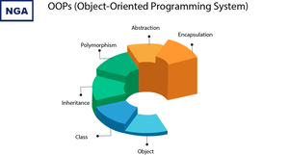

Question: What is Inheritance in Java?

Answer:

Inheritance is a process where one class inherits the properties of another class

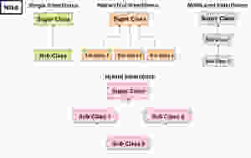

Question: What is Polymorphism?

Answer:

Polymorphism allows us to perform a task in multiple ways. Let’s break the word Polymorphism and see it, ‘Poly’ means ‘Many’ and ‘Morphos’ means ‘Shapes’

In picture below, Same Gentleman can take different roles like Father, Employee, Shopper as per need etc.

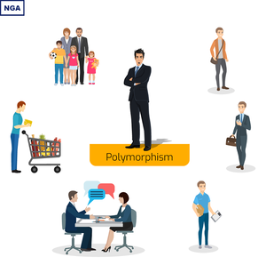

Question: What are the types of Polymorphism?

Answer:

There are two types of Polymorphism in Java

1. Compile time polymorphism (Static binding) – Method overloading

2. Runtime polymorphism (Dynamic binding) – Method overriding

We can perform polymorphism by ‘Method Overloading’ and ‘Method Overriding’

Question: What is Method Overloading?

Answer:

A class having multiple methods with same name but different parameters is called Method Overloading. There are three ways to overload a method.

a) Parameters with different data types

b) Parameters with different sequence of a data types

c) Different number of parameters

Question: What is Method Overriding?

Answer:

Declaring a method in child class which is already present in the parent class is called Method Overriding.

In simple words, overriding means to override the functionality of an existing method.

In this case, if we call the method with child class object, then the child class method is called. To call the parent class method we have to use super keyword.

Question: What is Abstraction in Java?

Answer:

Abstraction is the methodology of hiding the implementation of internal details and showing the functionality to the users.

Abstraction In Java

Example: Mobile Phone.

A layman who is using mobile phone doesn’t know how it works internally but he can make phone calls.

Question. What is Abstract Class in Java?

Answer:

We can easily identify whether a class is an abstract class or not. A class which contains abstract keyword in its declaration then it is an Abstract Class.

Syntax:

abstract class <class-name>{}

Points to remember:

a) Abstract classes may or may not include abstract methods

b) If a class is declared abstract then it cannot be instantiated.

c) If a class has abstract method then we have to declare the class as abstract class

d) When an abstract class is subclassed, the subclass usually provides implementations for all of the abstract methods in its parent class. However, if it does not, then the subclass must also be declared abstract.

Question: What is Abstract Method?

Answer:

An abstract method is a method that is declared without an implementation (without braces, and followed by a semicolon), like this:

abstract void myMethod();

In order to use an abstract method, you need to override that method in sub class.

Question: What is Interface in Java?

Answer:

An interface in Java looks similar to a class but both the interface and class are two different concepts. An interface can have methods and variables just like the class but the methods declared in interface are by default abstract. We can achieve 100% abstraction and multiple inheritance in Java with Interface.

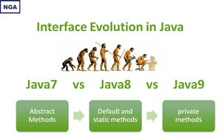

Question: What is Encapsulation in Java?

Answer:

Encapsulation is a mechanism of binding code and data together in a single unit. Let’s take an example of Capsule. Different powdered or liquid medicines are encapsulated inside a capsule. Likewise in encapsulation, all the methods and variables are wrapped together in a single class.

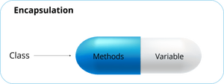

Second View:



Question: Write a program to print the pattern given below

1

1 2

1 2 3

1 2 3 4

1 2 3 4 5

Answer:

Question: Write a program to print Fibonacci Series up to count 10.

Answer:

Question: How to reverse a String in Java?

Answer:

Second Approach:

Question: How To Find The Largest Value From The Given Array.

Answer:

Question: How to display all the prime numbers between 1 and 100

Answer:

The number which is only divisible by 1 and itself is known as a prime number. For example 2, 3, 5, 7, 11… are prime numbers.

Question: How to display all the prime numbers between 1 and n (n is the number, get the input from user)

Answer:

Question: How to find the given number is a prime number or not by getting input from the user ?

Answer:

Question: Write a program to print Fibonacci Series?

Answer:

Method 1:

Method 2:

Question: Difference between Array and ArrayList?

Answer:

Array:

Array is static

Size of the array should be given at the time of array declaration. We cannot change the size of array after creating it

Array can contain both primitive data types as well as objects

Arrays are multidimensional

ArrayList:

ArrayList is dynamic

Size of the array may not be required. It changest the size dynamically. Capacity of ArrayList increases automatically whenever we add elements to an ArrayList

ArrayList cannot contain primitive data types. It contains only objects

ArrayList is always single dimension

Question: Difference between ArrayList and HashSet in Java?

Answer:

ArrayList:

ArrayList implements List interface

ArrayList allows duplicates

ArrayList is an ordered collection and maintains insertion order of elements

ArrayList is backed by an Array

ArrayList is an index based

In ArrayList, we can retrive object by calling get() method or remove object by calling remove() method

HashSet:

HashSet implements Set interface

HashSet doesn’t allow duplicates

HashSet is an unordered collection and doesn’t maintain insertion order

HashSet is backed by an HashMap instance

HashSet is object based

In HashSet, we can’t achieve get() method

Question: What are the different access modifiers available in Java?

Answer:

Access modifiers are subdivided into four types such as Default, Public, Private, Protected

a) default: The scope of default access modifier is limited to the package only. If we do not mention any access modifier, then it acts like a default access modifier.

b) private: The scope of private access modifier is only within the classes.

Note: Class or Interface cannot be declared as private

c) protected: The scope of protected access modifier is within a package and also outside the package through inheritance only.

Note: Class cannot be declared as protected

d) public: The scope of public access modifier is everywhere. It has no restrictions. Data members, methods and classes that declared public can be accessed from anywhere.

Question: Difference between static binding and dynamic binding?

Answer:

1. Static binding is also known as early binding whereas dynamic binding is also known as late binding.

2. Determining the type of an object at compile time is Static binding whereas determining the type of an object at run time is dynamic binding

3. Java uses static binding for overloaded methods and dynamic binding for overridden methods.

Question: Difference between Abstract Class and Interface?

Answer:

ABSTRACT CLASS

To declare Abstract class we have to use abstract keyword

In an Abstract class keyword abstract is mandatory to declare a method as an abstract

An abstract class contains both abstract methods and concrete methods(method with body)

Compiler treats all the methods as abstract by default

An abstract class provides partial abstraction

An abstract class can have public and protected abstract methods

An abstract class can have static, final or static final variables with any access modifiers

An abstract class can extend one class or one abstract class

Abstract class doesn't support multiple inheritance

INTERFACE:

To declare Interface we have to use interface keyword

In an Interface keyword abstract is optional to declare a method as an abstract.

An interface can have only abstract methods

An interface provides fully abstraction

An interface can have only public abstract methods

An interface can have only public static final variables

An interface can extend any number of interfaces

Interface supports multiple inheritance

Question: What is Multiple Inheritance?

Answer:

If a class implements multiple interfaces, or an interface extends multiple interfaces then it is known as multiple inheritance.

Question: How to create singleton class in java?

Answer:

1. Declare a private constructor to prevent others from instantiating the class.

2. Create the instance of the class either during class loading in a static field/block, or on-demand in a static method that first checks whether the instance exists or not and creates a new one only if it doesn’t exist.

Example:

Eagerly Initialized Singleton : Class loading in a static field

Eagerly Initialized Static Block Singleton: Class loading in a static block

**Lazily Initialized Singleton:** On-demand in a static method

Accessibillity

What is Website Accessibility Testing?

Building a more accessible website is more than just a worthy goal. In many places, creating an online experience that meets WCAG accessibility standards is a legal requirement. Even beyond legal obligations, many people would say that offering equal access to users of all abilities is a moral responsibility.

With that in mind, improving your website’s accessibility isn’t something you can just decide to tackle and be done with. Maintaining an accessible website requires not only identifying your key accessibility issues, but also making regular reassessments of your content and best practices to ensure that your standards stay up to date. That requires a consistent, multi-faceted approach to accessibility testing.

Why is website accessibility needed and Why we do accessibility testing

Before you begin addressing accessibility issues on your website, you’ll first need to determine what and where they are. For nearly any public-facing website, that will require a combination of automated and manual accessibility testing. Each approach has its benefits and downsides, so it pays to know the ins and outs of both methods.

Automated Accessibility Testing on a website

Even for people well-versed in online accessibility, locating and identifying every potential problem on a website is too big a task to take on manually. Even if you manage to catch a good percentage of issues the first time around, a website is not a stationary thing. Pages get updated, information gets deleted, designs get revamped. Every time your website undergoes a change, the door is opened for new accessibility issues to work their way into your system.

This is where an automated tool like Siteimprove Content & Accessibility can save a lot of time and effort. An automated scan provides you with a page-by-page inventory of all site content and makes it much easier to pinpoint areas that fail to meet WCAG compliance standards. Automated accessibility testing can alert you to issues such as:

Improper page structure

Missing page titles

Unclear text content

Non-accessible links

Poor readability

Images without alternative text

Video and audio without captions or transcripts

While the ultimate aim with automated accessibility testing is building a more accessible website for everyone, it’s also important to keep legal requirements in mind. Be sure to look for a tool or software solution that scans for compliance with WCAG guidelines as well as any national or local accessibility regulations that apply in your area. A good tool can go a long way toward keeping your organization on the right side of equal access laws.

Manual Accessibility Testing

As helpful as automated testing is, it’s not enough on its own. A number of accessibility issues require manual testing by an actual human to ensure that all functionality is actually usable and efficient for users with specific disabilities. For instance, an automated tool can’t accurately assess how easily a human can navigate a site using only a keyboard, or recognize how fluidly a website interacts with screen readers and other assistive techs. Accessibility issues that should be tested for by a trained expert include:

Keyboard-only navigation, including the ability to move between sections of a web page, access all menus, and access links and form fields

Compatibility with screen readers and other assistive techs

Customizable color adjustments

Useful page titles

Proper coding

[Manual accessibility testing](https://siteimprove.com/en/accessibility/manual-accessibility-testing/) requires an experienced professional who is familiar with common accessibility issues. Your accessibility tester should be well-versed in all of the above-mentioned topics and able to offer insights and solutions for these issues. As with automated testing, it’s important that a manual accessibility tester be familiar with WCAG Level AA guidelines and any accessibility laws that apply in your area of operation. A tester who can help bring your website up to date with the latest international accessibility standards is vital to your efforts.

Building a website that offers equal access for users of all abilities is a challenging and ongoing task, requiring close attention and maintenance for the lifespan of your site. By putting together a well-coordinated combination of automated and manual accessibility testing, as well as a clear plan for addressing the issues that arise, site owners can make a major difference in creating a more usable internet for every user.

Tips for Creating Accessible Websites

Web accessibility is the practice of removing barriers and creating equal access to information and websites for people with disabilities. It is aimed to address barriers relating to visual, motor, auditory, and cognitive disabilities. For example, individuals who are blind use screen reading software that reads content using a synthesized voice. Someone who has a physical disability that affects their use of hands or are unable to use a mouse may rely exclusively on a keyboard. How a website or application is designed can significantly impact a user's experience, therefore how we design or structure a website is important.

# Heading structure

HTML headings do not only act as visual cues, but also as an outline as to how a page is structured and how sections relate to one another. Proper heading structure can be especially useful for people who use screen readers, as they can be used as a navigational aids to jump from heading to heading.

Make sure headings (H1, H2, H3...) are structured in a logical order that conveys hierarchy, ensuring that all headings have a proper parent/child relationship.

It’s best practice to start each page with a single Heading 1 in the main content area. Heading 1 is the most important heading in terms of rank or hierarchy.

Different levels of subheadings should be underneath main headings, for example a H3 would be nested under a H2. Skipping heading ranks can be confusing and should be avoided.

## Self-describing page links

Ensure hyperlinks are self-describing. “Click here” or "learn more" does not provide any useful information to someone using a screen reader, and does not make sense out of context. For best practice, hyperlinks should be descriptive, link to nouns that are specific in context, and try to be placed towards the end of a sentence.

## How to use colour

Some people perceive colour differently, therefore colour should never be the only way of conveying information. Use a combination of shapes, colours & text.

Graphs and charts can be difficult to understand, as meaning is often conveyed exclusively through colour. Textures, patterns or shapes along with high-contrast colours can help communicate distinct information.

Try printing a chart in black and white. Are you able to perceive the information easily?

Hyperlinks should be underlined in addition to colour, so it can be easily distinguished from surrounding text.

## Contrast

Some people have difficulty perceiving or distinguishing text that has little contrast between the foreground and background. The WCAG 2.0 requires colour combinations to meet the following contrast ratios:

Level AA requires a contrast ratio of at least 4.5:1 for normal text and 3:1 for large text.

Level AAA requires a contrast ratio of at least 7:1 for normal text and 4.5:1 for large text.

Large text is defined as 19 pixels (1.2 em) and bold or larger, or 24 pixels (2 em) or larger.

**There are many tools available to check contrast ratios.**

[WebAIM Colour Contrast Checker, external link](https://webaim.org/resources/contrastchecker/) - Easily check two colour combinations.

[Tanaguru Contrast Finder, external link](http://contrast-finder.tanaguru.com/) - Finds and recommends multiple colour combinations.

[Color Safe, external link](http://colorsafe.co/) - Find accessible colour palettes.

[Colour Contrast Analyser, external link](https://developer.paciellogroup.com/resources/contrastanalyser/) - Contrast analyzer with an eyedropper tool available on Windows and Mac.

## Alternative text for images

Alternative (alt) text is used to convey meaning and provide context in place of an image, graph and other media. Blind and low vision users rely on the alt text attribute to understand the equivalent meaning of images, figures or other graphics in textual form. Alt text should provide a concise description conveying essential information about the image.

Alternative text should be concise and meaningful.

Usually, around one hundred characters or less.

Use punctuation, as it can help make information easier to understand.

Avoid phrases such as "image of…" or "graphic of…"

Consider the context of the surrounding information when writing.

**Example code:** <img src="/images/eggy-the-ram.jpg" alt="Eggy the Ram posing for a picture with students" />

For more guidance on alternative text concepts and how to use correctly, please visit [W3C's Images Tutorial., external link](https://www.w3.org/WAI/tutorials/images/)

## Forms and labels

All form fields should have accurate labels that programmatically correspond with each other using the input’s **id**attribute and label’s **for** attribute. The keyboard focus order should also match the visual order of the form.

**Example code:**<label for="searchbox">Search Site and People:</label>  
<input id="searchbox" name="searchbox" type="text" />

Ζ For more guidance on creating accessible forms, visit [W3C’s Forms Concepts., external link](https://www.w3.org/WAI/tutorials/forms/)

## Tables

Tables should be used to present data in tabular form. Accessible tables should include proper HTML markup.

Use table headers (<th> element) to markup all column or row headers.

Define the scope of each header, indicating whether it’s a column or row header. The value of the scope attribute can either be “col” or “row”.

Avoid merged cells and empty table headers if possible.

|  |  |  |
| --- | --- | --- |
| Event Name | Time | Location |
| Keynote | 9:00 AM | Auditorium |
| Lunch | 12:00 PM | Skyline Room |
| Closing Dinner | 5:00 PM | Metropolitan Room |

[Code example for table](https://www.ryerson.ca/accessibility/guides-resources/web-accessibility/#accordion-content-1520633973589-code-example-for-table)

Ζ For more guidance on creating accessible tables, visit [W3C’s Tables Concepts., external link](https://www.w3.org/WAI/tutorials/tables/)



## Test the accessibility of a website

Here are some basic tests you can do evaluate the accessibility of a website.

### Manual testing

Try to navigate a website using only a keyboard. Use a combination of the “Tab” and “Enter” keys.

Are you able to access all links, menus, or interactive components such as accordion panels, pop-up navigation menus or carousels?

Are you able to pause an image carousel?

Can you see where your cursor is located on the page?

Does the cursor follow a logical path from top to bottom, left to right?

#### Screen reader testing

Trying navigating a website using a screen reader with your monitor turned off. If you are using an Apple Mac, you can try the built-in screen reader utility called [VoiceOver,, external link](http://webaim.org/articles/voiceover/) found in the accessibility settings. If you are using Windows, you can download a free screen reader like [NVDA., external link](http://www.nvaccess.org/download/)

Alternatively, another great tool for content editors and developers is [ChromeVox., external link](https://chrome.google.com/webstore/detail/chromevox/kgejglhpjiefppelpmljglcjbhoiplfn?hl=en-US) ChromeVox is a light weight Google Chrome extension that's easy to install and learn, making it great for testing purposes. View [ChromeVox Keyboard Shorcuts., external link](http://www.chromevox.com/keyboard_shortcuts.html)

### Automated testing

There are many free tools, plugins, book-marklets and applications available to test the accessibility of a website. Please note that automated tools should never be used to validate conformance with accessibility guidelines - only a human can determine true accessibility. Here are a few tools you can add to your testing toolkit.

[WAVE Web Accessibility Evaluation Tool, external link](https://wave.webaim.org/) - Highlights accessibility issues visually on your website.

[Tota11y by Khan Academy, external link](http://khan.github.io/tota11y/) - An accessibility visualization book-marklet.

[Accessibility Developer Tools for Google Chrome, external link](https://chrome.google.com/webstore/detail/accessibility-developer-t/fpkknkljclfencbdbgkenhalefipecmb?hl=en) - A Chrome extension for developers to audit the accessibility of a website within the Developer Tools tab.

[Tenon.io, external link](https://tenon.io/) - An accessibility tool for developers.

## Who must comply

By law, you must make new and significantly refreshed public websites accessible if you are:

a private or non-profit organization with 50+ employees; or

a public sector organization

The organization that controls the website must meet the accessibility requirements.

## Compliance deadline

**Beginning January 1, 2014**: new public websites, significantly refreshed websites and any web content posted after January 1, 2012 must meet Web Content Accessibility Guidelines (WCAG) 2.0 Level A

**Beginning January 1, 2021:** all public websites and web content posted after January 1, 2012 must meet WCAG 2.0 Level AA other than criteria 1.2.4 (live captions) and 1.2.5 (pre-recorded audio descriptions)

### WCAG 2.0 Guidelines

WCAG 2.0 is an internationally accepted standard for web accessibility developed by the World Wide Web Consortium (W3C), an international team of experts.

Following these guidelines should make it easier for everyone to access your website and content.

### Levels of web accessibility

Each guideline has three levels of accessibility: A, AA and AAA. Newly created or refreshed websites must meet level A. Later, your website will need to meet Level AA. Meeting Level AAA is not required at this time.

In most cases you must meet the Level A criteria before you can meet the Level AA criteria.

You don’t have to make your internal website (intranet) accessible. You don’t have to modify content posted before 2012. If asked, you will need to work with individuals to make the content available to them in an alternate format such as large print or braille.

### Level A

#### [Guideline 1.1: Provide text alternatives for non-text content](http://www.w3.org/TR/UNDERSTANDING-WCAG20/text-equiv.html)

[Success Criterion 1.1.1 Non-text content](http://www.w3.org/TR/UNDERSTANDING-WCAG20/text-equiv-all.html)

#### [Guideline 1.2: Provide alternatives for time-based media](http://www.w3.org/TR/UNDERSTANDING-WCAG20/media-equiv.html)

[Success Criterion 1.2.1 Audio-only and video-only (Prerecorded)](http://www.w3.org/TR/UNDERSTANDING-WCAG20/media-equiv-av-only-alt.html)

[Success Criterion 1.2.2 Captions (Prerecorded)](http://www.w3.org/TR/UNDERSTANDING-WCAG20/media-equiv-captions.html)

[Success Criterion 1.2.3 Audio Description or Media Alternative (Prerecorded)](http://www.w3.org/TR/UNDERSTANDING-WCAG20/media-equiv-audio-desc.html)

#### [Guideline 1.3: Adaptable content](http://www.w3.org/TR/UNDERSTANDING-WCAG20/content-structure-separation.html)

[Success Criterion 1.3.1 Info and relationships](http://www.w3.org/TR/UNDERSTANDING-WCAG20/content-structure-separation-programmatic.html)

[Success Criterion 1.3.2 Meaningful sequence](http://www.w3.org/TR/UNDERSTANDING-WCAG20/content-structure-separation-sequence.html)

[Success Criterion 1.3.3 Sensory characteristics](http://www.w3.org/TR/UNDERSTANDING-WCAG20/content-structure-separation-understanding.html)

#### [Guideline 1.4: Distinguishable content](http://www.w3.org/TR/UNDERSTANDING-WCAG20/visual-audio-contrast.html)

[Success Criterion 1.4.1 Use of color](http://www.w3.org/TR/UNDERSTANDING-WCAG20/visual-audio-contrast-without-color.html)

[Success Criterion 1.4.2 Audio control](http://www.w3.org/TR/UNDERSTANDING-WCAG20/visual-audio-contrast-dis-audio.html)

#### [Guideline 2.1: Keyboard accessible](http://www.w3.org/TR/UNDERSTANDING-WCAG20/keyboard-operation.html)

[Success Criterion 2.1.1 Keyboard](http://www.w3.org/TR/UNDERSTANDING-WCAG20/keyboard-operation-keyboard-operable.html)

[Success Criterion 2.1.2 No keyboard trap](http://www.w3.org/TR/UNDERSTANDING-WCAG20/keyboard-operation-trapping.html)

#### [Guideline 2.2: Provide users enough time to read and use content](http://www.w3.org/TR/UNDERSTANDING-WCAG20/time-limits.html)

[Success Criterion 2.2.1 Timing adjustable](http://www.w3.org/TR/UNDERSTANDING-WCAG20/time-limits-required-behaviors.html)

[Success Criterion 2.2.2 Pause, stop, hide](http://www.w3.org/TR/UNDERSTANDING-WCAG20/time-limits-pause.html)

#### [Guideline 2.3: Don’t design content in a way that is known to cause seizures](http://www.w3.org/TR/UNDERSTANDING-WCAG20/seizure.html)

[Success Criterion 2.3.1 Three flashes or below threshold](http://www.w3.org/TR/UNDERSTANDING-WCAG20/seizure-does-not-violate.html)

### [Guideline 2.4: Navigable content](http://www.w3.org/TR/UNDERSTANDING-WCAG20/navigation-mechanisms.html)

[Success Criterion 2.4.1 Bypass blocks](http://www.w3.org/TR/UNDERSTANDING-WCAG20/navigation-mechanisms-skip.html)

[Success Criterion 2.4.2 Page titled](http://www.w3.org/TR/UNDERSTANDING-WCAG20/navigation-mechanisms-title.html)

[Success Criterion 2.4.3 Focus order](http://www.w3.org/TR/UNDERSTANDING-WCAG20/navigation-mechanisms-focus-order.html)

[Success Criterion 2.4.4 Link purpose (in context)](http://www.w3.org/TR/UNDERSTANDING-WCAG20/navigation-mechanisms-refs.html)

#### [Guideline 3.1: Readable text content](http://www.w3.org/TR/UNDERSTANDING-WCAG20/meaning.html)

[Success Criterion 3.1.1 Language of page](http://www.w3.org/TR/UNDERSTANDING-WCAG20/meaning-doc-lang-id.html)

#### [Guideline 3.2: Predictable web pages](http://www.w3.org/TR/UNDERSTANDING-WCAG20/consistent-behavior.html)

[Success Criterion 3.2.1 On focus](http://www.w3.org/TR/UNDERSTANDING-WCAG20/consistent-behavior-receive-focus.html)

[Success Criterion 3.2.2 On input](http://www.w3.org/TR/UNDERSTANDING-WCAG20/consistent-behavior-unpredictable-change.html)

#### [Guideline 3.3: Input assistance](http://www.w3.org/TR/UNDERSTANDING-WCAG20/minimize-error.html)

[Success Criterion 3.3.1 Error identification](http://www.w3.org/TR/UNDERSTANDING-WCAG20/minimize-error-identified.html)

[Success Criterion 3.3.2 Labels or instructions](http://www.w3.org/TR/UNDERSTANDING-WCAG20/minimize-error-cues.html)

#### [Guideline 4.1: Compatible](http://www.w3.org/TR/UNDERSTANDING-WCAG20/ensure-compat.html)

[Success Criterion 4.1.1 Parsing](http://www.w3.org/TR/UNDERSTANDING-WCAG20/ensure-compat-parses.html)

[Success Criterion 4.1.2 Name, role, value](http://www.w3.org/TR/UNDERSTANDING-WCAG20/ensure-compat-rsv.html)

### Level AA

#### [Guideline 1.4: Distinguishable content](http://www.w3.org/TR/UNDERSTANDING-WCAG20/visual-audio-contrast.html)

[Success Criterion 1.4.3 Contrast (Minimum)](http://www.w3.org/TR/UNDERSTANDING-WCAG20/visual-audio-contrast-contrast.html)

[Success Criterion 1.4.4 Resize text](http://www.w3.org/TR/UNDERSTANDING-WCAG20/visual-audio-contrast-scale.html)

[Success Criterion 1.4.5 Images of text](http://www.w3.org/TR/UNDERSTANDING-WCAG20/visual-audio-contrast-text-presentation.html)

#### [Guideline 2.4: Navigable content](http://www.w3.org/TR/UNDERSTANDING-WCAG20/navigation-mechanisms.html)

[Success Criterion 2.4.5 Multiple ways](http://www.w3.org/TR/UNDERSTANDING-WCAG20/navigation-mechanisms-mult-loc.html)

[Success Criterion 2.4.6 Headings and labels](http://www.w3.org/TR/UNDERSTANDING-WCAG20/navigation-mechanisms-descriptive.html)

[Success Criterion 2.4.7 Focus visible](http://www.w3.org/TR/UNDERSTANDING-WCAG20/navigation-mechanisms-focus-visible.html)

#### [Guideline 3.1: Readable text content](http://www.w3.org/TR/UNDERSTANDING-WCAG20/meaning.html)

[Success Criterion 3.1.2 Language of parts](http://www.w3.org/TR/UNDERSTANDING-WCAG20/meaning-other-lang-id.html)

#### [Guideline 3.2: Predictable web pages](http://www.w3.org/TR/UNDERSTANDING-WCAG20/consistent-behavior.html)

[Success Criterion 3.2.4 Consistent identification](http://www.w3.org/TR/UNDERSTANDING-WCAG20/consistent-behavior-consistent-functionality.html)

#### [Guideline 3.3: Input assistance](http://www.w3.org/TR/UNDERSTANDING-WCAG20/minimize-error.html)

[Success Criterion 3.3.3 Error suggestion](http://www.w3.org/TR/UNDERSTANDING-WCAG20/minimize-error-suggestions.html)

[Success Criterion 3.3.4 Error prevention (Legal, financial, data)](http://www.w3.org/TR/UNDERSTANDING-WCAG20/minimize-error-reversible.html)

## If you can’t comply

Sometimes it may not be possible to meet the WCAG 2.0 requirements. For example, you may have used software and other tools that predate WCAG 2.0 to develop your website.

You may be able to update or repair the products you used to support accessibility. If this is not possible, make sure you use software that supports accessibility the next time you refresh your site.

It may not be possible to post some content in a way that complies with WCAG 2.0. For example, it may be impossible to make some online maps and complex diagrams accessible to people with visual disabilities. In such cases you may still post the content, but you must provide it in an accessible format upon request.

## Tips for testing websites for accessibility

There are a number of ways to know if your new or refreshed website is accessible:

### 1. Automatic assessment and assistive technology

Do a final evaluation of your site using an automatic assessment to flag any issues that may not have been resolved. For example, you can review your site using assistive technology such as a screen reader to make sure the design and technical aspects of the site are accessible.

### 2. User testing and feedback

If possible, ask people with disabilities to test your new or refreshed site before you launch. Get feedback from customers and other site users to find out if there are any improvements needed.

### 3. Review key milestones and changes

Keep a record of the accessibility issues that have been repaired, or ask your web developer to maintain such a record. This will show you the completed work and the new level of accessibility. It will also be helpful if your organization is asked to show that your website is WCAG 2.0 compliant.

### 4. Online accessibility checker

You can use an online tool to check if your website is accessible. Using an online accessibility checker does not guarantee that you will find all accessibility issues with your website. It is important to have a person review the site as well.

This is an example of an online accessibility checker that can help you find accessibility issues with your new or refreshed website:

[AChecker](http://achecker.ca/checker/index.php)

## Tips for working with web developers

If you don’t manage your website or don’t have web development experience, the following steps may help you work with a web developer to make your website more accessible.

### Determine your web developer’s level of expertise

Make sure your in-house developer or the developer you plan to hire has the expertise needed to make your website more accessible.

Here are some questions you may want to ask:

Are you familiar with WCAG 2.0, Level A and AA?

Have you developed/refreshed an accessible website (WCAG 2.0, Level A or higher)? Do you have links or references for these sites?

Do you code manually or with the assistance of a program? If you use a program, does it support accessibility?

Do you test the website for accessibility using automated and manual assessments and assistive technology?

### Communicate your expectations

Think about accessibility from the start. When working on the website design, let your web developer know your expectations for:

making the website and web content accessible (WCAG 2.0)

the level of accessibility (Level A or AA), and

timelines for completing the website

### Ask for a project plan

Your developer should provide you with a project plan for completing the website. The plan should include the following steps:

identifies techniques or software used: developers should tell you if they are using accessible coding techniques or software that supports accessible websites

outlines how your website will be tested: the plan should include automated and manual tests, as well as testing using assistive technology, such as screen readers

identifies how the site will be maintained: this could include training you or your staff on how to make changes to the website, how to create accessible content, or an agreement to maintain the website

outlines key deliverables and timelines: whether the developer is fixing accessibility issues or creating an entirely new website, they should be able to clearly tell you when and how the project will be delivered

**Conformance Level:** One of the following levels of conformance is met in full.

**Level A:**For Level A conformance (the minimum level of conformance), the [Web page](https://www.w3.org/TR/UNDERSTANDING-WCAG20/conformance.html#webpagedef) [satisfies](https://www.w3.org/TR/UNDERSTANDING-WCAG20/conformance.html#satisfiesdef) all the Level A Success Criteria, or a [conforming alternate version](https://www.w3.org/TR/UNDERSTANDING-WCAG20/conformance.html#conforming-alternate-versiondef) is provided.

**Level AA:**For Level AA conformance, the Web page satisfies all the Level A and Level AA Success Criteria, or a Level AA conforming alternate version is provided.

**Level AAA:**For Level AAA conformance, the Web page satisfies all the Level A, Level AA and Level AAA Success Criteria, or a Level AAA conforming alternate version is provided.

Note 1: Although conformance can only be achieved at the stated levels, authors are encouraged to report (in their claim) any progress toward meeting success criteria from all levels beyond the achieved level of conformance.

Note 2: It is not recommended that Level AAA conformance be required as a general policy for entire sites because it is not possible to satisfy all Level AAA Success Criteria for some content.

JIRA

In this blog, we will be covering the most frequently asked JIRA interview questions with detailed answer for your reference. JIRA is a bug tracking and defect management tool that is that has been used by software testing team from years. The tool was developed by Atlassian that is necessary for issue tracking and project management too.

The tool can be directly integrated into the code development environment for agile project management, recording, reporting, or any other convenient-related feature. Once you know what is Atlassian JIRA tool, let us focus on a list of 15 interview questions and answer to help you in your next interview.

## ****JIRA Interview Questions****

[What is the purpose of JIRA for software testing projects?](https://www.janbasktraining.com/blog/jira-interview-questions/#1)

[Explain the workflow of JIRA in detail.](https://www.janbasktraining.com/blog/jira-interview-questions/#2)

[How are reports generated in JIRA?](https://www.janbasktraining.com/blog/jira-interview-questions/#3)

[Name a few reports generated by Kanban projects in JIRA.](https://www.janbasktraining.com/blog/jira-interview-questions/#4)

[Name a few reports generated by Scrum projects in JIRA.](https://www.janbasktraining.com/blog/jira-interview-questions/#5)

[Name a few reports that are needed for the issues tracking and analysis.](https://www.janbasktraining.com/blog/jira-interview-questions/#6)

[Explain the issue creation process in JIRA step-by-step.](https://www.janbasktraining.com/blog/jira-interview-questions/#7)

[Do you know about the color indicators and their significance in JIRA?](https://www.janbasktraining.com/blog/jira-interview-questions/#8)

[What the total information available under the change history section in JIRA?](https://www.janbasktraining.com/blog/jira-interview-questions/#9)

[How an issue can be shared in JIRA with other users?](https://www.janbasktraining.com/blog/jira-interview-questions/#10)

[Why an issue is labeled in JIRA?](https://www.janbasktraining.com/blog/jira-interview-questions/#11)

[Define the process for linking an issue in JIRA.](https://www.janbasktraining.com/blog/jira-interview-questions/#12)

[What is the significance of a dashboard in JIRA? How can you create your own dashboard or customize the existing one?](https://www.janbasktraining.com/blog/jira-interview-questions/#13)

[How to schedule an issue in JIRA?](https://www.janbasktraining.com/blog/jira-interview-questions/#14)

[How the details for a particular project can be listed in JIRA?](https://www.janbasktraining.com/blog/jira-interview-questions/#15)

### ****JIRA Interview Questions and Answers****

#### ****Q1). What is the purpose of JIRA for software testing projects?****

JIRA is a popular defect management or issue tracking tools that are quite beneficial when used along with a proper workflow. Here are a few reasons why should you use JIRA.

It helps you in tracking the progress of a project on time.

The use-cases in JIRA deliver multiple features like implementation, project management, or bug tracking etc.

This is easy to customize workflows in JIRA as needed.

Along with bug tracking, you can also check the history of an issue like when it was created and why?

The best part is that JIRA is a platform independent tool that could run anywhere.

### ****Q2). Explain the workflow of JIRA in detail.****

Workflows in JIRA define the steps or stages that are followed by an issue during its entire lifecycle. The process starts with issue creation then a number of steps are followed to fix the issue and, in the end, the issue is closed finally after verification. Refer the diagram below for a better understanding of the concept.Explain the workflow of JIRA in detail.

[**Read: Automation Testing Interview Questions & Answers**](https://www.janbasktraining.com/blog/automation-testing-interview-questions-answers/)

### ****Q3). How are reports generated in JIRA?****

To generate reports for a project in JIRA, you need to follow the given steps –

First of all, navigate to the given dashboard.

On the left-hand side, under the reports tab, you can see the different type of reports there.

Now click on switch report option to view a different report.

#### ****Q4). Name a few reports generated by Kanban projects in JIRA.****

The reports generated by any Kanban project in JIRA include cumulative flow diagram and the Flow Chart.

#### ****Q5). Name a few reports generated by Scrum projects in JIRA.****

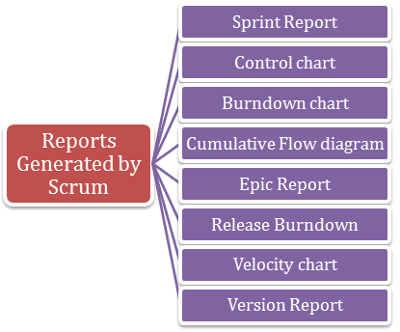

#### ****Q6). Name a few reports that are needed for the issues tracking and analysis.****

Reports Generated For Issue Analysis

Average Age Report

Created vs Resolved issue Report

Pie Chart Report

Recently created Issue Report

Resolution Time Report

Time Tracking Report

User Work load Report

Version Work load Report

Workload Pie chart Report

### ****Q7). Explain the issue creation process in JIRA step-by-step.****

Every time an issue is tracked by the testing team, it needs to be reported quickly to the development team so that it can be addressed as needed. Here, we will see how to create an issue in JIRA.

First of all, Login to your JIRA account and you will be directed to default dashboard quickly.

Once you are on the dashboard, you can see a CREATE button there. As soon as you click on the button, it will redirect you to the issue creation page.

Here, you need to enter the necessary details as required like Project ID, type of the issue, summary, reporter field, description field, Priority, fix version, attachment, or environment etc.

Once you have added all details carefully, now click on the CREATE option to generate a new issue.

Here, one issue ID will be generated that can be used later to check the progress of a project.

#### ****Q8). Do you know about the color indicators and their significance in JIRA?****

For every issue in JIRA, there are three indicators in total. These are Blue, Green, and the Orange. These colors will show the total time spent to fix an issue. All the information is given under “Time Tracking” section.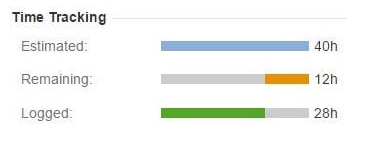Let us see the significance of each color and refer to the image below for a better understanding of the concept.

**Blue**– This color will show the total time given to fix an issue. This is called the Estimated field too.

**Orange**– This color shows the total time left to fix an issue. It is label as remaining.

**Green** – This color shows the total time invested to fix an issue so far. It is label as the Logged.

#### ****Q9). What the total information available under the change history section in JIRA?****

Under the change history section, you can check the details when changes were made to an issue. It will include the previous changes too so that they can be resumed back when required. Here, the information is given under the change history section –

Creation or deletion of a comment or issue link.

Deleting a work log.

How to make changes in the file log.

Changes in the issue fields etc.

#### ****Q10). How an issue can be shared in JIRA with other users?****

On the issue description page, there is one share option that can be used to share the issue in JIRA with other users. As soon as you will click on the Share option, it will ask you the username and email ID that has to be filled.

### ****Q11). Why an issue is labeled in JIRA?****

Labeling an issue is important in JIRA to find which category it actually belongs to. If you wanted to search any issue later then it can be quickly found with the help of labels only. Labels should be added at the time of issue creation and they can be modified if required. To check the labels for an issue, you should go under Details section for complete information.

[**Read: Load Testing Tutorial Guide for Beginner**](https://www.janbasktraining.com/blog/load-testing-tutorial/)

#### ****Q12). Define the process for linking an issue in JIRA.****

Linking means establishing the relationship between the two. Here are the possible ways how an issue can be linked in JIRA by the following ways –

It can be connected to another issue.

It can be the copy of an existing issue.

It can be used to block any other issue.

Linking can be done on the same servers or different JIRA servers too.

[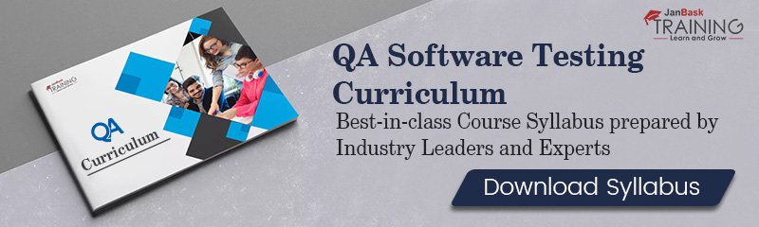](https://www.janbasktraining.com/online-qa-training?utm_source=Blog&utm_medium=InLineBanner&utm_campaign=QA_Broucher)

#### ****Q13). What is the significance of a dashboard in JIRA? How can you create your own dashboard or customize the existing one?****

The first page whatever you see when you logged in to the JIRA application is the Dashboard. There is one default dashboard that is common for all user but you may create your own as per the requirement. It may be designed with the help of different gadgets and customized the same based on preferences. The customized dashboard could give you more detailed information about an issue that you wanted to check for a project. To create a dashboard in JIRA, you need to follow the below-given steps –

First of all, login to the JIRA dashboard with valid credentials.

Now on the left-hand side, choose the option, Create a Dashboard. Here, you can see multiple options. You can choose copy dashboard option if there are limited changes only otherwise customize the dashboard as per the requirements.

As soon as, you will click pm the required option, a new dashboard page will open in front of you.

Here, you should enter all necessary details and click on the Create button in the end.

Now navigate to the page where you will find multiple options to add gadgets to your dashboard.

There are a plenty of options to edit or manage the layout of the dashboard in JIRA.

Keep in mind that any particular Dashboard can be edited, copied, shared, delete from the Manage dashboard section.

#### ****Q14). How to schedule an issue in JIRA?****

Scheduling an issue in JIRA is easy where you can add a due date and set the scheduling permission as well. Under the details section, you can check the due date and other important information too.

#### ****Q15). How the details for a particular project can be listed in JIRA?****

Every project has a list of certain attributes that are displayed under the project summary section. The list of attributes majorly involves –

Nature of the project,

Keys for the project,

Components and version for the project

That’s all for the day. We have listed top 15 JIRA interview questions here with detailed answers for your reference. We make sure that a depth understanding of these questions will surely help you in getting selected by top MNCs quickly.

How to Invoke PayPal Authorization REST API using Java Client?

Used PayPal Java Developer APIs

Add maven dependency :

<dependency>

<groupId>com.paypal.sdk</groupId>

<artifactId>rest-api-sdk</artifactId>

<version>LATEST</version>

</dependency>

You need PayPal Account. Follow below steps:

Create official PayPal account

Login to PayPal’s developer portal using this link: https://developer.paypal.com/developer/applications

Create new App using this link: https://developer.paypal.com/developer/applications/create

Get ClientID and ClientSecret which we need in our program to generate paypalContext.

Refer: <https://crunchify.com/paypal-java-sdk-tutorial-authorization-call/>

**1. What is an API?**

An API (Application Programming Interface) is a software intermediary that enables two applications to communicate with each other. It comprises a number of subroutine definitions, logs, and tools for creating application software.

In an API testing interview, you could be asked to give some API examples, here are the well-known ones: Google Maps API, Amazon Advertising API, Twitter API, YouTube API, etc.

**2. What are main differences between API and Web Service?**

* All Web services are APIs but not all APIs are Web services.
* Web services might not contain all the specifications and cannot perform all the tasks that APIs would perform.
* A Web service uses only three styles of use: SOAP, REST and XML-RPC for communication whereas API may be exposed to in multiple ways.
* A Web service always needs a network to operate while APIs don’t need a network for operation.

**3. What are the Limits of API Usage?**

Many APIs have a certain limit set up by the provider. Thus, try to estimate your usage and understand how that will impact the overall cost of the offering. Whether this will be a problem depends in large part on how data is leveraged. Getting caught by a quota and effectively cut-off because of budget limitations will render the service (and any system or process depending on it) virtually useless.

**Creating an API (Common Web API Testing interview questions)**

**4. What are some architectural styles for creating a Web API?**

This is one of the fundamental Web API interview questions. Bellows are four common Web API architectural styles:

* HTTP for client-server communication
* XML/JSON as formatting language
* Simple URI as the address for the services
* Stateless communication

**5. Who can use a Web API?**

Web API can be consumed by any clients which support HTTP verbs such as GET, PUT, DELETE, POST. Since Web API services do not require configuration, they can be easily used by any client. In fact, even portable devices such as mobile devices can easily use Web API, which is undoubtedly the biggest advantage of this technology.

**Testing an API – Top Web API Testing interview questions & answers**

**6. What is API Testing?**

[API testing](https://www.katalon.com/resources-center/tutorials/introduction-api-testing/) is a kind of software testing which determines if the developed APIs meet expectations regarding the functionality, reliability, performance, and security of the application.

**7. What are the advantages of API Testing?**

In an API interview, they are likely to ask about the advantages of API testing. So be prepared with the significant ones such as:

* ***Test for Core Functionality:***API testing provides access to the application without a user interface. The core and code-level of functionalities of the application will be tested and evaluated early before the GUI tests. This will help detect the minor issues which can become bigger during the GUI testing.
* ***Time Effective:***API testing usually is less time consuming than functional GUI testing. The web elements in GUI testing must be polled, which makes the testing process slower. Particularly, API test automation requires less code so it can provide better and faster test coverage compared to GUI test automation. These will result in the cost saving for the testing project.
* ***Language-Independent:*** In API testing, data is exchanged using XML or JSON. These transfer modes are completely language-independent, allowing users to select any code language when adopting automation testing services for the project.
* ***Easy Integration with GUI:*** API tests enable highly integrable tests, which is particularly useful if you want to perform functional GUI tests after API testing. For instance, simple integration would allow new user accounts to be created within the application before a GUI test started.

**8. Some common protocols used in API testing?**

Many protocols are now available to be used in API testing, such as JMS, REST, HTTP, UDDI and SOAP.

**9. What is the test environment of API?**

Setting up the API’s test environment is not an easy task, so you should have a ready answer if your API testing interview is coming. The test environment of API is a bit complete and requires the configuration of the database and server, depending on the software requirements. No GUI (Graphical User Interface) is available in this test form.

When the installation process is complete, API is verified for the proper operation. Throughout the process, the API called from the original environment is set up with different parameters to study the test results.

**10. What are principles of an API test design?**

The five most important principles of an API test design are:

* Setup: Create objects, start services, initialize data, etc
* Execution: Steps to apply API or the scenario, including logging
* Verification: Oracles to evaluate the result of the execution
* Reporting: Pass, failed or blocked
* Clean up: Pre-test state

**11. What are the common API testing types?**

While there are certainly specialty tests, and no list can be asked to be comprehensive in this realm, most tests fit broadly into these following nine categories that you should remember before attending in an API testing interview.

1. Validation Testing
2. Functional Testing
3. UI testing
4. Load testing
5. Runtime/ Error Detection
6. Security testing
7. Penetration testing
8. Fuzz testing
9. Interoperability and WS Compliance testing

**12. What is the procedure to perform API testing?**

1. Choose the suite to add the API test case
2. Choose the test development mode
3. Demand the development of test cases for the required API methods
4. Configure the control parameters of the application and then test conditions
5. Configure method validation
6. Execute the API test
7. Check test reports and filter API test cases
8. Arrange all API test cases

**13. What must be checked when performing API testing?**

During the API testing process, a request is raised to the API with the known data. This way you can analyze the validation response. While testing an API, you should consider:

* Accuracy of data
* Schema validation
* HTTP status codes
* Data type, validations, order and completeness
* Authorization checks
* Implementation of response timeout
* Error codes in case API returns, and
* Non-functional testing like performance and security testing

**14. What is the best approach method to perform API testing?**

The following factors should be considered when performing API testing:

* Defining the correct input parameters
* Verifying the calls of the mixture of two or more added value parameters
* Defining the basic functionality and scope of the API program
* Writing appropriate API test cases and making use of testing techniques such as equivalence class, boundary value, etc. to check the operability
* Testing case execution
* Comparing the test result with the expected result
* Verifying the API behavior under conditions such as connection to files and so on.

**15. What are tools could be used for API testing?**

There are myriad of different [**API testing tools**](https://www.katalon.com/resources-center/blog/top-5-free-api-testing-tools/) available. A few of common tools are Katalon Studio, Postman, SoapUi Pro, Tricentis Tosca, Apigee, etc.  While doing Unit and API testing, both targets source code. If an API method uses code based in .NET then another supporting tool must have .NET.

Learn more: **[SoapUI vs Postman, Katalon Studio: A Review of Top 3 API Tools](https://www.katalon.com/resources-center/blog/soapui-vs-postman-katalon-api-tools/)**

**[](https://www.katalon.com/)**

**16. What are differences between API Testing and Unit Testing?**

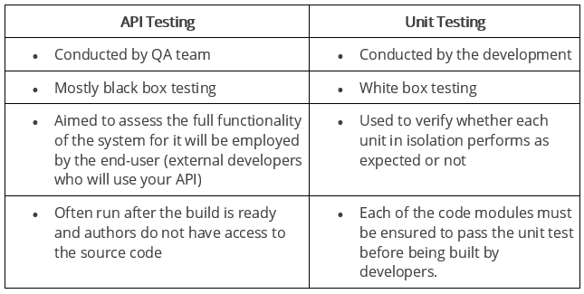

**17. What are differences between API Testing and UI Testing?**

* API enables communication between two separate software systems. A software system implementing an API contains functions or subroutines that can be executed by another software system.
* On the other hand, UI ( User Interface) testing refers to testing graphical interface such as how users interact with the applications, testing application elements like fonts, images, layouts etc. UI testing basically focuses on look and feel of an application.

**18. What are major challenges faced in API testing?**

If you can overcome the challenges in API Testing, you can be confident in the API testing interview too. They are:

* Parameter Selection
* Parameter Combination
* Call sequencing
* Output verification and validation
* Another important challenge is providing input values, which is very difficult as GUI is not available in this case.

**19. What are the testing methods that come under API testing?**

One of the most common Web API testing interview questions is about the testing methods. They are:

* Unit testing and Functional testing
* Load testing to test the performance under load
* Discovery testing to list, create and delete the number of calls documented in API
* Usability and Reliability testing to get consistent results
* Security and Penetration testing to validate all types of authentication
* Automation testing to create and run scripts that require regular API calls
* End to end Integration and Web UI testing
* API documentation testing to determine its efficiency and effectiveness

**20. Why is API testing considered as the most suitable form for Automation testing?**

API testing is now preferred over GUI testing and is considered as most suitable because:

* It verifies all the functional paths of the system under test very effectively.
* It provides the most stable interface.
* It is easier to maintain and provides fast feedback.

**21. What are common API errors that often founded?**

Not only API fundamental questions, the interviewer also determine your knowledge and experience by asking about the API errors in a Web API testing interview. So the most common ones are:

* Missing module errors
* Documentation errors
* Parameter validation errors
* And some standard error expectations as if the result is not so predicted then the occurrence of errors can be seen and for the same warnings are specified in the form of a message. There can be one or more warnings within an individual module.

**22. What kinds of bugs that API testing would often find?**

* Missing or duplicate functionality
* Fails to handle error conditions gracefully
* Stress
* Reliability
* Security
* Unused flags
* Not implemented errors
* Inconsistent error handling
* Performance
* Multi-threading issues
* Improper errors

**Documenting the API (Common Web API Testing interview questions)**

**23. What is API documentation?**

The API documentation is a complete, accurate technical writing giving instructions on how to effectively use and integrate with an API. It is a compact reference manual that has all the information needed to work with the API, and helps you answer all the API testing questions with details on functions, classes, return types, arguments, and also examples and tutorials.

**24. What are API documentation templates that are commonly used?**

There are several available API documentation templates help to make the entire process simple and straightforward, which could be  answered in your API testing interview, such as:

* Swagger
* Miredot
* Slate
* FlatDoc
* API blueprint
* RestDoc
* Web service API specification

**25. When writing API document, what must be considered?**

* Source of the content
* Document plan or sketch
* Delivery layout
* Information needed for every function in the document
* Automatic document creation programs

**26. How often are the APIs changed and, more importantly, deprecated?**

APIs, especially modern RESTful APIs, are a nice creation that can certainly simplify and accelerate integration efforts, which makes it more likely you will benefit from them. But APIs can and do change for various reasons, sometimes abruptly, and hence REST APIs do not differ from traditional integration methods in this respect. If an API call is obsolete and disappears, your procedure will interrupt and it is important to understand how often the APIs you depend on change or are deprecated.

**REST (Common Web API Testing interview questions)**

**27. What is REST?**

REST (Representational State Transfer) is an architectural style for developing web services which exploit the ubiquity of HTTP protocol and uses HTTP method to define actions. It revolves around resource where every component being a resource that can be accessed through a shared interface using standard HTTP methods.  
  
In REST architecture, a REST Server provides access to resources and REST client accesses and makes these resources available. Here, each resource is identified by URIs or global IDs, and REST uses multiple ways to represent a resource, such as text, JSON, and XML. XML and JSON are nowadays the most popular representations of resources.

**28. What is a RESTFul Web Services?**

Mostly, there are two kinds of Web Services which should be remembered in your next API testing interview:

1. SOAP (Simple Object Access Protocol) – an XML-based method to expose web services.
2. Web services developed in the REST style are referred to as RESTful web services. These web services use HTTP methods to implement the concept of REST architecture. A RESTful web service usually defines a URI, Uniform Resource Identifier a service, provides resource representation like JSON and a set of HTTP methods.

**29. What is a “Resource” in REST?**

REST architecture treats any content as a resource, which can be either text files, HTML pages, images, videos or dynamic business information.  
REST Server gives access to resources and modifies them, where each resource is identified by URIs/ global IDs.

**30. What is the most popular way to represent a resource in REST?**

REST uses different representations to define a resource like text, JSON, and XML.  
XML and JSON are the most popular representations of resources.

**31. Which protocol is used by RESTful Web services?**

RESTful web services use the HTTP protocol as a medium of communication between the client and the server.

**32. What are some key characteristics of REST?**

Key characteristics of REST are likely asked in a Web API Testing interview. So please get the answer ready in your mind with these 2 ones:

* REST is stateless, therefore the SERVER has no status (or session data)  
  With a well-applied REST API, the server could be restarted between two calls, since all data is transferred to the server
* Web service uses POST method primarily to perform operations, while REST uses GET for accessing resources.

**33. What is messaging in RESTful Web services?**

RESTful web services use the HTTP protocol as a communication tool between the client and the server. The technique that when the client sends a message in the form of an HTTP Request, the server sends back the HTTP reply is called Messaging. These messages comprise message data and metadata, that is, information on the message itself.

**34. What are the core components of an HTTP request?**

An HTTP request contains five key elements:

1. An action showing HTTP methods like GET, PUT, POST, DELETE.
2. Uniform Resource Identifier (URI), which is the identifier for the resource on the server.
3. HTTP Version, which indicates HTTP version, for example-HTTP v1.1.
4. Request Header, which carries metadata (as key-value pairs) for the HTTP Request message. Metadata could be a client (or browser) type, format supported by the client, format of a message body format, cache settings, and so on.
5. Request Body, which indicates the message content or resource representation.

**35. What are the most commonly used HTTP methods supported by REST?**

* GET is only used to request data from a specified resource. Get requests can be cached and bookmarked. It remains in the browser history and haS length restrictions. GET requests should never be used when dealing with sensitive data.
* POST is used to send data to a server to create/update a resource. POST requests are never cached and bookmarked and do not remain in the browser history.
* PUT replaces all current representations of the target resource with the request payload.
* DELETE removes the specified resource.
* OPTIONS is used to describe the communication options for the target resource.
* HEAD asks for a response identical to that of a GET request, but without the response body.

**36. Can GET request to be used instead of PUT to create a resource?**

The PUT or POST method should be used to create a resource. GET is only used to request data from a specified resource.

**37. Is there any difference between PUT and POST operations?**

PUT and POST operation are quite similar, except the terms of the result generated by them.

PUT operation is idempotent, so you can cache the response while the responses to POST operation are not cacheable, and if you retry the request N times, you will end up having N resources with N different URIs created on server.

In a Web API Testing interview, you should give a specific example for PUT and POST operations to make crystal clear to the interviewer. Below is an example:

*Scenario:* *Let’s say we are designing a network application. Let’s list down few URIs and their purpose to get to know when to use POST and when to use PUT operations.*  
  
GET /device-management/devices : Get all devices  
POST /device-management/devices : Create a new device  
  
GET /device-management/devices/{id} : Get the device information identified by “id”  
PUT /device-management/devices/{id} : Update the device information identified by “id”  
DELETE /device-management/devices/{id} : Delete device by “id”

**38. Which purpose does the OPTIONS method serve for the RESTful Web services?**

The OPTIONS Method lists down all the operations of a web service supports. It creates read-only requests to the server.

**39. What is URI? What is the main purpose of REST-based web services and what is its format?**

URI stands for Uniform Resource Identifier. It is a string of characters designed for unambiguous identification of resources and extensibility via the URI scheme.

The purpose of a URI is to locate a resource(s) on the server hosting of the web service.

A URI’s format is <protocol>://<service-name>/<ResourceType>/<ResourceID>.

**40. What is payload in RESTFul Web services?**

The “payload” is the data you are interested in transporting. This is differentiated from the things that wrap the data for transport like the HTTP/S Request/Response headers, authentication, etc.

**41. What is the upper limit for a payload to pass in the POST method?**

<GET> appends data to the service URL. But, its size shouldn’t exceed the maximum URL length. However, <POST> doesn’t have any such limit.

So, theoretically, a user can pass unlimited data as the payload to POST method. But, if we consider a real use case, then sending POST with large payload will consume more bandwidth. It’ll take more time and present performance challenges to your server. Hence, a user should take action accordingly.

**42. What is the caching mechanism?**

Caching is just the practice of storing data in temporarily and retrieving data from a high-performance store (usually memory) either explicitly or implicitly.

When a caching mechanism is in place, it helps improve delivery speed by storing a copy of the asset you requested and later accessing the cached copy instead of the original.

**SOAP (Common Web API Testing interview questions)**

**43. What are SOAP Web services?**

This is one of the fundamental Web services testing questions that you must know the answer. The SOAP (Simple Object Access Protocol) is defined as an XML-based protocol. It is known for designing and developing web services as well as enabling communication between applications developed on different platforms using various programming languages over the Internet. It is both platform and language independent.

**44. How does SOAP work?**

SOAP is used to provide a user interface that can be accessed by the client object, and the request that it sends goes to the server, which can be accessed using the server object. The user interface creates some files or methods consisting of server object and the name of the interface to the server object. It also contains other information such as the name of the interface and methods. It uses HTTP to send the XML to the server using the POST method, which analyzes the method and sends the result to the client. The server creates more XML consisting of responses to the request of user interface using HTTP. The client can use any approach to send the XML, like the SMTP server or POP3 protocol to pass the messages or reply to queries.

**45. When to use SOAP API?**

Use the SOAP API to create, retrieve, update or delete records, like accounts, leads, and user-defined objects. With more than 20 different calls, you can also use the SOAP API to manage passwords, perform searches, etc. by using the SOAP API in any language that supports web services.

**46. How users utilize the facilities provided by SOAP?**

* PutAddress(): It is used to enter an address in the webpage and has an address instance on the SOAP call.
* PutListing(): It is used to allow the insertion of a complete XML document into the web page. It receives the XML file as an argument and transports the XML file to XML parser liaison, which reads it and inserts it into the SOAP call as a parameter.
* GetAddress(): It is used to get a query name and gets the result that best matches a query. The name is sent to the SOAP call in the form of text character string.
* GetAllListing(): It is used to return the full list in an XML format.

**47. What is the major obstacle users faced when using SOAP?**

When using SOAP, users often see the firewall security mechanism as the biggest obstacle. This block all the ports leaving few like HTTP port 80 and the HTTP port used by SOAP that bypasses the firewall. The technical complaint against SOAP is that it mixes the specification for message transport with the specification for message structure.

**48. What are the various approaches available for developing SOAP based web services?**

There are two different methods available for developing SOAP-based web services, which are explained below:

* Contract-first approach: the contract is first defined by XML and WSDL, and then Java classes are derived from the contract.
* Contract-last approach: Java classes are first defined, and then the contract is generated, which is normally the WSDL file from the Java class.

“Contract-first” method is the most popular approach.

**49. What are the elements of a SOAP message structure?**

It is a common XML document that contains the elements as a SOAP message

Envelope: It is an obligatory root element that translates the XML document and defines the beginning and end of the message.

Header: It is an optional item which contains information about the message being sent.

Body: It contains the XML data comprising the message being sent.

Fault: It provides the information on errors that occurred while during message processing.

**50. What are the syntax rules for a SOAP message?**

* Must use encoded XML
* Envelope namespace must be used
* Encoding namespace must be used
* Must not consist of a DTD reference
* Must not have XML processing instruction

**51. What is the transport method in SOAP?**

Application layer and transport layers of a network are used by SOAP; HTTP and SMTP are the valid protocol of the application layer used as the transport for SOAP. HTTP is more preferable, since it works well with the current Internet infrastructure, in particular with firewalls.  
The SOAP requests can be sent using an HTTP GET method while the specification only contains details about HTTP POST.

**52. What are some important characteristics of a SOAP envelope element?**

* SOAP message has a root Envelope element
* Envelope is an obligatory part of the SOAP message.
* If an envelope includes a header element, it should not contain more than one.
* Envelope version will change if the SOAP version changes.
* The SOAP envelope is indicated by the prefix ENV and the envelope element.
* The optional SOAP encoding is also specified using a namespace and the optional encoding style element.

**53. What are the major functionalities provided by the SOAP protocol class?**

The SOAP protocol is used to provide simple access methods for all the applications available on the Internet, providing the following functionalities:

* ***Call***: A class which provides the main functionality for a remote method for which a call is needed. It is used to create the call() and to specify the encoding style of the registry that will be assigned when if necessary. This call() function is used by the RPC call, which represents the options of the call object.
* ***Deployment Descriptor***: A class used to provide the information about the SOAP services. It enables easy deployment without the need for other approaches.
* ***DOM2 Writer***: A class that serializes and uses DOM node as XML string to provide more functionalities.
* ***RPC Message***: A class used as the base class that calls and replies to the request submitted to the server.
* ***Service Manager***: A class that provides, lists and then outputs all SOAP services.

**54. What are the web relation functionalities provided by SOAP protocol?**

* ***HTTPUtils***: This provides the functionality of the POST method to safely meet the requirements.
* ***Parameter***: It is an argument for an RPC call used by both the client and the server.
* ***Response***: It is an object that represents an RPC reply from both client and server, but the result will not be displayed until after the method call.
* ***TCPTunnel***: It is an object that provides the ability to listen on a specific port and to forward all the host and port names.
* ***TypeConverter***: It helps to convert an object of one type into another type and this is called using the class in the form object.

**55. How does the message security model allow the creation of SOAP more secure to use?**

The security model includes the given security tokens. These tokens comprise digital signatures for protection and authentication of SOAP messages. Security tokens can be used to provide the bond between authentication secrets or keys and security identities. Security token uses the authentication protocols and an X.509 certificate to define the relationship between the public key and identity key. The signatures are used to verify the messages and their origin, generate knowledge to confirm the security tokens to bind the identity of a person to the identity of the originator. Security model prevents different attacks and can be used to protect the SOAP architecture.

**56. What is the difference between top down & bottom up approach in SOAP Web services?**

* Top down SOAP Web services include creating WSDL document to create a contract between the web service and the client, with a required code as an option. This is also known as Contract-first approach. The top-down approach is difficult to implement because classes must be written to confirm the contract defined in WSDL. One of the benefits of this method is that both client and server code can be written in parallel.
* Bottom up SOAP web services require the code to be written first and then WSDL is generated. It is also known as Contract-last approach. Since WSDL is created based on the code, bottom-up approach is easy to implement and client codes must wait for WSDL from the server side to start working.

**57. What are advantages of SOAP?**

* SOAP is both platform and language independent.
* SOAP separates the encoding and communications protocol from the runtime environment.
* Web service can retrieve or receive a SOAP user data from a remote service, and the source’s platform information is completely independent of each other.
* Everything can generate XML, from Perl scripts through C++ code to J2EE app servers.
* It uses XML to send and receive messages.
* It uses standard internet HTTP protocol.
* SOAP runs over HTTP; it eliminates firewall problems. When protocol HTTP is used as the protocol binding, an RPC call will be automatically assigned to an HTTP request, and the RPC response will be assigned to an HTTP reply.
* Compared to RMI, CORBA and DCOM, SOAP is very easy to use.
* SOAP acts as a protocol to move information in a distributed and decentralized environment.
* SOAP is independent of the transport protocol and can be used to coordinate different protocols.

**58. What are disadvantages of SOAP?**

SOAP is typically significantly slower than other types of [**middleware**](https://searchmicroservices.techtarget.com/definition/middleware) standards, including CORBA, because SOAP uses a detailed XML format. A complete understanding of the performance limitations before building applications around SOAP is hence required.

SOAP is usually limited to pooling and not to event notifications when HTTP is used for the transport. In addition, only one client can use the services of one server in typical situations.

If HTTP is used as the transport protocol, firewall latency usually occurs since the firewall analyzes the HTTP transport. This is because HTTP is also leveraged for Web browsing, and so many firewalls do not understand the difference between using HTTP within a web browser and using HTTP within SOAP.

SOAP has different support levels, depending on the supported programming language. For instance, SOAP supported in [**Python**](https://whatis.techtarget.com/definition/Python) and PHP is not as powerful as it is in Java and .NET

**59. What are the differences between SOAP and REST?**

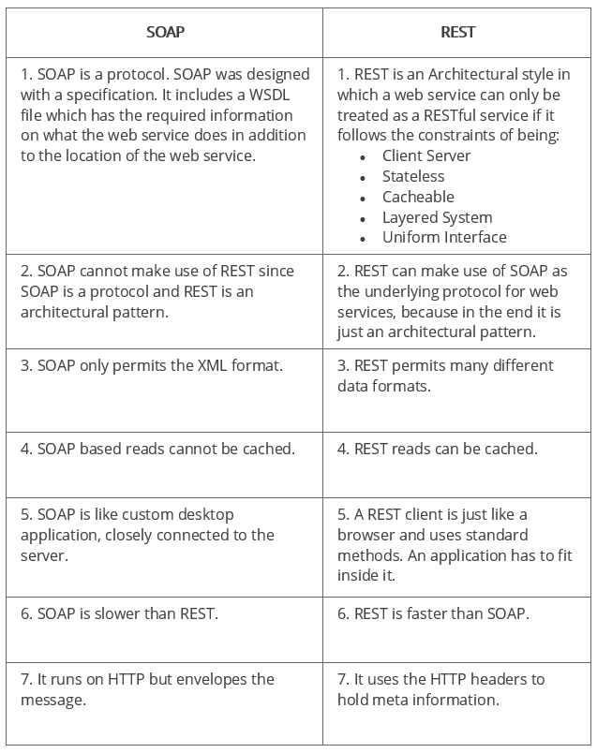

**60. SOAP or Rest APIs, which method to use?**

SOAP is the heavyweight choice for Web service access. It provides the following advantages when compared to REST:

* SOAP is not very easy to implement and requires more bandwidth and resources.
* SOAP message request is processed slower as compared to REST and it does not use web caching mechanism.
* WS-Security: While SOAP supports SSL (just like REST) it also supports WS-Security which adds some enterprise security features.
* WS-AtomicTransaction: Need ACID Transactions over a service, you’re going to need SOAP.
* WS-ReliableMessaging: If your application needs Asynchronous processing and a guaranteed level of reliability and security. Rest doesn’t have a standard messaging system and expects clients to deal with communication failures by retrying.
* If the security is a major concern and the resources are not limited then we should use SOAP web services. Like if we are creating a web service for payment gateways, financial and telecommunication related work, then we should go with SOAP as here high security is needed.

REST is easier to use for the most part and is more flexible. It has the following advantages when compared to SOAP:

* Since REST uses standard HTTP, it is much simpler.
* REST is easier to implement, requires less bandwidth and resources.
* REST permits many different data formats whereas SOAP only permits XML.
* REST allows better support for browser clients due to its support for JSON.
* REST has better performance and scalability. REST reads can be cached, SOAP based reads cannot be cached.
* If security is not a major concern and we have limited resources. Or we want to create an API that will be easily used by other developers publicly then we should go with REST.
* If we need Stateless CRUD operations then go with REST.
* REST is commonly used in social media, web chat, mobile services and Public APIs like Google Maps.
* RESTful service returns various MediaTypes for the same resource, depending on the request header parameter “Accept” as application/xml or application/json for POST and /user/1234.json or GET /user/1234.xml for GET.
* REST services are meant to be called by the client-side application and not the end user directly.
* ST in REST comes from State Transfer. You transfer the state around instead of having the server store it, this makes REST services scalable.

**61. What are the factors that help to decide which style of Web services – SOAP or REST – to use?**

Generally, REST is preferred due to its simplicity, performance, scalability, and support for multiple data formats.

However, SOAP is favorable to use where service requires an advanced level of security and transactional reliability.

But you can read the following facts before opting for any of the styles.

* ***Does the service expose data or business logic?*** REST is commonly used for exposing data while SOAP for logic.
* ***The requirement from clients or providers for a formal contract****.* SOAP can provide contract via WSDL.
* ***Support multiple data formats****.*
* ***Support for AJAX calls.*** REST can apply the XMLHttpRequest.
* ***Synchronous and asynchronous calls.***SOAP enables both synchronous/ asynchronous operations whereas REST has built-in support for synchronous.
* ***Stateless or Stateful calls.*** REST is suited for stateless operations.
* ***Security.*** SOAP provides a high level of security.
* ***Transaction support.*** SOAP is good at transaction management.
* ***Limited bandwidth****.* SOAP has a lot of overhead when sending/receiving packets since it’s XML based, requires a SOAP header. However, REST requires less bandwidth to send requests to the server. Its messages are mostly built using JSON.
* ***Ease of use****.* REST based application is easy to implement, test, and maintain.

**Ready to succeed in your next Web API Testing interview**

API testing interview questions can be unlimited regarding of the number of questions and area covered. Although the above answers might not fully be used in your interview, we do hope it somehow provides the solid understanding on Web API testing and gets you ready for the upcoming job and project related to API testing.

Wish you confidence and luck in your testing career! If you have any suggestions on this topic, please do not hesitate to add to here. We look forward to a better and more adequate list to all testers.

**Q #1. What are web services?**

**Ans.** Web services are web components that transfer data between client and server. The client sends a web request to the server and the server then responds to the client. The response and request are related and different requests evoke the corresponding response.

Web Service is a web component or software program that can be accessed on the Internet. It is mainly used to communicate with the web-based applications through XML messaging concepts. For example, if we want to access a particular location using Google Maps, we can use the corresponding web service URL. For that, we have to pass the appropriate inputs.

**Q #2. What is the primary challenge when testing web services?**

**Ans.** Majority of the functional testing is carried out via the GUI; the biggest challenge of web services is that they do not have a UI.

**Q #3. What are the communication channels available for a web service?**

In general, web service is combined with the following protocols. They are,

* HTTP / POST
* HTTP / GET
* SOAP

While exposing the web services, these channels will be used for communication with the clients. Here HTTP / POST protocol transfers the information between the clients with a secure mode. HTTP / GET protocol allows the clients to view transferred data partially at the browser’s address bar. SOAP is used for transferring the confidential data safely.

**Q #4. What are the different components can be used in the web services?**

There are four components are used in web services. They are,

1. WSDL – Web Service Description Language
2. SOAP – Simple Access Object Protocol
3. UDDI – Universal Description, Discovery and Integration
4. RDF – Resource Description Framework
5. XML – eXtensible Markup Language

**Q #5. What are the tools used for testing Web services?**

To perform functional testing for web services, we can use the following tools.

* SoapUI
* RESTClient – This is a Firefox plug-in
* JMeter – Specially made it for performance testing tool and also we can do functional testing the web services.

**Q #6. What is WSDL?**

**Ans.** WSDL stands for Web Service Description Language and is a document written in XML. It uses XML to define the service layer document which consists of origin of the web service, headers, port types, request and response data. This one can provide the information about web methods and web service.

It describes:

* Origin of the web service
* Header information
* Port type
* Input and output messages

For more info and examples, check out this article <https://www.softwaretestinghelp.com/web-services-api-testing-tool-soapui-tutorial-1/>

**Q #7. What is the role of WSDL document in web service testing?**

**Ans.** Validating web services in only possible with WSDL document because to configure web services in SoapUI, WSDL document is mandatory. If the WSDL document is not valid, SoapUI will throw an exception immediately.

**Q #8. What is UDDI?**

**Ans.** Universal Description, Discovery and Integration- a directory or global repository where all the web services can be found. A new Webservice can also be registered through this. This is also the place where WSDL detailed definitions are found.

It uses the discovery layer which is used in the web services. UDDI has all the information about the web services in detail. Global web services can be deployed at <http://uddi.xml.org/>

**Q #9. What is SOAP?**

**Ans.** Simple Object access protocol that uses XML to interact with web applications. It uses XML based content to communicate between two client machines across any network

**Q #10. What would be the message format of SOAP protocol?**

Generally, all the SOAP-based web services are written by using XML language which uses standard message format that is accepted across the universe. In this format, it is easy to read, identify the errors, avoids interoperability problems etc.

Here’s the sample SOAP message format.

*POST /InStock HTTP/1.1*  
*Host: localhost*  
*Content-Type: application/soap+xml; charset=utf-8*  
*Content-Length: 399*  
*SOAPAction: “http://www.example.com/soap-envelope”*

*<?xml version=”1.0??>*  
*<soap:Envelope xmlns:soap=”http://www.example.com/soap-envelope”>*  
*<soap:Header>*  
*</soap:Header>*  
*<soap:Body>*  
*<m:TutorialName>SoapUI</m:TutorialName>*  
*</soap:Body>*  
*</soap:Envelope>*

**Q #11. What are the advantages of SOAP?**

**Ans.** Since its XML based, it is platform and programming language independent. RPC (Remote procedure calls) are sometimes blocked by firewalls and proxy servers- Soap overcomes that.

**Q #12. What does a soap document contain**?

**Ans.** Envelope element is the topmost tag which identifies the XML document as a SOAP message. Followed by Envelope element, you see the header element that has header information. The Body element specifies the call and response information. Finally, you have a Fault element which contains errors and status information.

**Q #13. What is meant by Protocols and what are the major types are used in web services?**

A protocol is a set of standard rules that help to communicate the hardware devices through the software applications. There are different types of protocols used in the Internet and Intranet applications. They are

TCP which stands for Transmission Control Protocol. It has the rules to exchange the messages between two different Internet applications.

Internet Protocol uses the rules for sending and receiving the information between two different Internet addresses.

Similarly, HTTP, FTP and DHCP protocols have used the set of rules to transfer the data other than Internet applications.

**Q #14. What is XML?**

**Ans.** XML (eXtensible Markup Language) is a mark-up language that is used for storing, sharing and formatting data. In general, an XML document is built by the tags. For more info and examples, check out this article <https://www.softwaretestinghelp.com/web-services-api-testing-tool-soapui-tutorial-1/>

**Q #15. SoapUI and SoapUI Pro?**

**Ans.** SoapUI is a web service testing tool and SoapUI Pro is its commercial version. SoapUI can help create functional, security and load testing test suites. SoapUI Pro does all that with advanced drag and drop, Data Driven testing, advanced reporting and coverage analysis. Check out this article for more information: <https://www.softwaretestinghelp.com/soapui-tutorial-12-soapui-pro-features/>

**Q #16.** **What we can do with the help of SoapUI?**

* SoapUI offers us to perform automation testing which includes functional testing, load testing and Data Driven testing.
* It also provides in build reporting tool and export test results log provision
* We assert our services using various types of assertions

**Q #17. What hierarchy does SoapUI follow to build a proper testing project?**

In a SoapUI project, the following order should be maintained.

* TestSuite – This is combination of functional tests and logical blocks
* Testcase – It's a group that contains several test steps for the specific aspects of the service.
* Teststep – it contains the set of functional tests

**Q #18. What is the basic method to automate web services in SoapUI?**

**Ans.**

* Create a project and add the WSDL file
* Add test suites, Test cases and Test cases- in that order
* Include custom programming/validation using by adding Groovy steps
* Call external data sources if using
* Add assertions if necessary
* Then RUN.

**Q #19. What are SoapUI assertions?**

**Ans.** Assertions compare the parts/all of the response message to the expected outcome.

**Q #20. What are the major types of assertions available in SoapUI?**

Assertions are one of the major features in SoapUI. It offers the following types of assertions.

* Simple contains
* Schema compliance
* Simple not contain
* Soap Faults
* Response SLA
* XPath Match
* XQuery Match
* WS security status
* Script Assertion
* WS- Addressing Request or Response Assertion

Additionally, **Equals** assertion is introduced in SoapUI NG Pro version.

**Q #21. Explain about XPath Assertion in SoapUI**

In SoapUI, XPath assertion is used for asserting the web service response value by specifying the absolute path. If the absolute path is matched with the response value, then the test case or test suite will be considered as PASS otherwise it will be notified as FAILED. We can see the results of assertion at bottom of the screen where the Assertion tab will have resultant information.

**Q #22. What is Data Driven testing?**

Data Driven testing means to store our test data which includes input and expected output in an external data source called Excel / Database / XML file. Later, we need to iterate the data source using respective component. In SoapUI, Datasource and Datasource Loop test steps are used for performing data driven testing.

**Q #23. What are the different types of assertions used in SoapUI?**

**Ans.** The following are the different types of assertions:

* Contains & Not Contains
* XPath match
* XQuery match
* Schema compliance
* Soap Faults
* Response SLA
* WS security Status
* Script Assertion
* WS- Addressing Request or Response Assertion

**Q #24. How can assertions be added in SoapUI?**

**Ans.** Receive a response to a request as you normally would follow the below steps:

* Create a project, add WSDL
* Add Test suite, Test case and Test steps
* Run the request

To add assertions:  
– Click on the Add Assertions at the top of log tabs.  
– Configure the assertions as per the type and data required.

For more info and examples, check out this article: <https://www.softwaretestinghelp.com/soapui-tutorial-5-soapui-assertions/>

**Q #25. What is Groovy script and where can it be used?**

**Ans.** Groovy is a scripting language which internally includes all the Java libraries – it helps us to customize and add custom validations to SoapUI tests

**Q #26. Can the custom code be added to SoapUI? If yes, what can be added?**

**Ans.** Yes -Groovy steps and Javascript steps.

**Q #27. How to group tests?**

**Ans.** The basic Test suite is a way for us to group tests in SoapUI. When you need a different set of tests, you just have to create a new test suite and create tests as required under it as test cases.

**Q #28. How to save the responses received?**

**Ans.** The response values can be saved by clicking on the required request and choosing the “Dump file” location in its properties.

**Q #29. What are the properties available in SoapUI?**

In SoapUI, there are three levels of properties available. They are,

**Custom Properties or Project Level Properties:**

These properties are added several times based on our needs and they can be utilized at any test suites, test cases or test steps that belong to the current project.

**Test Suite Level Properties:**

The tester can add his own properties with relevant information under the test suites. These properties are available for the corresponding test suite only.

**Test case Level Properties:** If the tester needs to store their test data within the test cases they can create their own properties inside the test case. So these properties can be accessed within the respective test cases.

**Q #30. Explain the procedure to parameterize the endpoint in SoapUI?**

The parameterizing feature is most important when we automate the test cases and also this is the beginning of the test step creation process. Let us have a look into this.

1. Create project which has the endpoint information
2. If necessary, change the endpoint and assign to the property through the property expansion test step
3. Make sure the request information available in the given endpoint address
4. During the execution time, a property will hold the test value. Providing different input value to the property it is easy to do it through the IDE.

**Q #31. What are the major places that Groovy Script Teststep used?**

In SoapUI, we can use Groovy Script in the following two places.

* Groovy Script Teststep under the test case
* Script Assertion Test Step

**Q #32. Soap vs REST?**

**Ans.**

* SOAP is a protocol and REST is architecture. It allows us to send SOAP envelops to REST-based applications.
* REST supports different message formats but SOAP permits XML only.
* REST services are faster and easy to handle.
* SOAP is tied with SMTP and HTTP protocols whereas REST relies on HTTP only.
* SOAP is more secure and structured format.
* REST does not depend on any specific standards as it supports various messaging formats like JSON, CSV and XML.
* SOAP web services allow us to build the client with RESTful services.
* SOAP was introduced for distributed computing.
* After REST’s entry, it accommodated the web by its performance and scalability as it is a lightweight component.
* REST is stateless whereas SOAP is a stateful specification.
* REST uses Uniform Resource Identifier (URI) and it has the methods like GET, PUT, POST and DELETE to expose their resources.
* SOAP uses named operations and interfaces to achieve its business logic.

Check out this article for more information: <https://www.softwaretestinghelp.com/soapui-tutorial-13-soap-vs-rest-services/>

**Q #33. What is RDF?**

**Ans.** Resource Description Framework- RDF contains the description of the web resources such as title, author, content, and copyright information. It is written using XML. For more info and examples, check out this article <https://www.softwaretestinghelp.com/web-services-api-testing-tool-soapui-tutorial-1/>

**Q #34. What can data sources be used in SoapUI?**

**Ans.**

* Excel Files
* CSV Files
* ODBC Sources
* SQL / ADO Objects

### *****What are some tools used for API Testing?*****

There are many API testing tools. The following six are the top most according to the users/downloads. These are not the rankings though.

* ***Postman***
* ***SoapUI***
* ***Katalon Studio***
* ***Tricentis Tosca***
* ***Apigee***
* ***Jmeter***

## 

### *****In which type of encoding does postman accept authorization credentials? Why?*****

Postman accept authorization in Base64 encoding only. This is provided inbuilt in Postman or else you can also refer third party websites to convert the credentials in base64. We use base64 particularly because it transmits the data into textual form and send it in easier form such as HTML form data**.** We use Base64 particularly because we can rely on the same 64 characters in any encoding language that we use. (Refer [***tutorial***](http://toolsqa.com/postman/basic-authentication-in-postman/))

### *****What is meant by the term Environment with respect to Postman?*****

An environment in Postman is a set of key-value pairs. You can create multiple env in postman which can be switched quickly with a press of a button. There are two types of environment, global and local. They define the scope of the variable to use it in the requests. Most commonly the variable is defined inside the environment for the same purpose. The most common variable we use is url because url is used in every requests and changing it can be very time consuming.  When we create an environment inside Postman, we can change the value of the key value pairs and the changes are reflected in our requests. An environment just provides boundaries to variables. (Refer [***tutorial***](http://toolsqa.com/postman/environment-variables-in-postman/))

### *****Can we have two global scope variables with the same name in Postman?*****

Since global variables are global i.e. without any environment, they cannot have duplicate names as it creates confusion for the software. Local variables can have same name but in different environments. (Refer [***tutorial***](http://toolsqa.com/postman/environment-variables-in-postman/))

### Which one has the higher priority in Postman? A global variable or a local variable?

In Postman, if two variables have same name (one being local and one being global) then the higher priority is of the local variable. It will overwrite the global variable. (Refer [***tutorial***](http://toolsqa.com/postman/environment-variables-in-postman/))

### *****Define Team workspace in Postman*****

A workspace is a collaborative environment for a group of users to develop and test APIs. A team workspace is a workspace which is shared by the whole team working on same collections of requests. Since it is very time consuming and hard to share the collections through external drives or other sharing means, team workspace synchronises and collaborates all the team’s work at one place. (Refer [***tutorial***](http://toolsqa.com/postman/collections-in-postman/))

### *****Explain the following piece of test code in Postman*****

***tests[“Status Code is 200”] = responseCode.code === 200***

* ***tests*** – variable on one of type array
* ***Status code is 200*** – A string or the test name which will be represented in the test result box so that we can know what test was it. It is important as we use many tests on one request.
* ***responseCode.code*** = responseCode is used to save all the response that we get from the server. Since we do not need complete response, we need to create one object to extract our required info. code object is then called to output the status code (like 200) from the entire response which we have saved. (Refer [***tutorial***](http://toolsqa.com/postman/test-and-collection-runner-in-postman/))

### *****What is the difference between Postman Monitors and Postman Collection Runner?*****

The postman Monitor is an automated way of running collections. Collections are triggered automatically as per specified parameters whereas Postman Collections require some manual effort to start and monitor the execution. A postman collection runner runs the collection for the iterations you want to. It will be stopped when you stop the software and is not automated. A postman monitor will run your collection at regular user defined intervals till the time you have specified. Your collection will be run even if your system has shut down as it is connected through postman cloud.  (Refer [***tutorial***](http://toolsqa.com/postman/monitor-collections-in-postman/))

### *****Can we import local variables in Postman Monitors?*****

Yes. Postman monitors allows to import local variables but it does not allow to import global variables. I believe it can be imported in json, if yes, pls mention.(Refer [***tutorial***](http://toolsqa.com/postman/monitor-collections-in-postman/))

### *****Describe any four response things you receive from a response (Correct or Incorrect)*****

* ***Status Code***
* ***Response Status***
* ***Response time***
* ***Response Size***
* ***Response Headers***
* ***Response Cookies***
* ***Response Date and Time***
* ***Response Session limit***
* ***Response Cookies***
* ***Response Server***
* ***Response type***

(Refer [***Tutorial***](http://toolsqa.com/postman/response-in-postman/))

### *****What is a collection in Postman?*****

A collection in Postman can be imagined similar to a folder in your system. A collection is the grouping of requests, preferably of the similar types. It can be compared similar to the folder inside your system which has one type of files. It is one of the most vital feature of Postman and it also provides nice features such as running a whole group of request together with just one click. A collection is also important for sharing many requests at once and contains many more features which can be referred by the given link. (Refer [***tutorial***](http://toolsqa.com/postman/collections-in-postman/))

### *****Should we save our work in Postman cloud if we are working in a company? Why?*****

A Postman cloud is Postman company’s repository like Microsoft has One Drive etc. In Postman cloud you can save your work instantly after logging in and also retrieve it from anywhere you want. It is not preferred to save your work in Postman cloud as company’s work is often confidential and should not be leaked out. Postman cloud needs signing in and hence security can be compromised, therefore team workspace is preferred instead of saving the work in Postman Cloud. (Refer [***tutorial***](http://toolsqa.com/postman/collections-in-postman/))

### *****State any 5 types of Request Method types*****.

* ***Get***
* ***Post***
* ***Put***
* ***Delete***
* ***Patch***
* ***Head***
* ***Delete***

(Refer [***Tutorial***](http://toolsqa.com/postman/get-request-in-postman/))

### *****Please define status code 401. Also, a situation in which we can incur such status code.*****

Status code 401 is referred for an unauthorized request. An unauthorized request is a request for which you are not authorized. We can incur such a status code when you are not authorized to access the server or you have entered wrong credentials.

Other status codes which are seen commonly are

* ***200 (OK)*** : Defines that the request was correct.
* ***201 (Created)*** : The value wrapped with the request has been created in the database. It is needless to say that the request was correct.
* ***204(No Content)*** : This status code means that the request was correct and received but there is no response to send to the client by the server.
* ***400 (Bad Request)*** : A bad request means that the syntax of the request was incorrect. It can happen if you have sent wrong parameters along with the request url or in the body of the request.
* ***404 (Not Found)*** : A response code 404 means that the server was connected but it could not find what was requested. You can normally see this status code when you request a web page which is not available.

(Refer [***tutorial***](http://toolsqa.com/postman/response-in-postman/))

### *****What are different types by which we can see response body in Postman. Explain.*****

In Postman, a response body can be seen by three different types

* ***Pretty***
* ***Raw***
* ***Preview***

Although all the three have their own importance and value in Postman, the most commonly used is Pretty as it shows the response code in different format and colours which is easy to read and analyse the response. It is just like any good text editor used for coding. (Refer [***tutorial***](http://toolsqa.com/postman/response-in-postman/))

### *****What is “Bulk Edit” feature of Postman used for?*****

Bulk Edit feature of Postman is used for the convenience of adding parameters to a new request from the previous request. Since a request can have many parameters and it is very difficult to copy and paste one by one, bulk edit feature helps us copy all the keys and their respective values at once and paste them. (Refer [***tutorial***](http://toolsqa.com/postman/request-parameters-in-postman/))

### *****What is “x-www-urlencoded” in Post method in Postman?*****

Form data and x-www-form-urlencodedare very similar. They both are used for almost the same purposes. But the difference between the form data and x-www-form-urlencoded is that the url will be encoded when sent through x-www-form-urlencoded. Encoded means the data which is sent will be encoded to different characters so that it is unrecognizable even if it is under attack. (Refer [***tutorial***](http://toolsqa.com/postman/post-request-in-postman/))

### *****What is binary in Post method in Postman?*****

Binary form in Postman is designed to send the information in a format that cannot be entered manually. Since everything in a computer is converted to binary, we use these options which cannot be written manually such as an image, a file etc. (Refer [***tutorial***](http://toolsqa.com/postman/post-request-in-postman/))

### *****What is Pre-Request Script in Postman?*****

A pre request script is a script that runs before the execution of a request. (Refer [***tutorial***](http://toolsqa.com/postman/pre-request-script-in-postman/))

### *****What is the difference between authorization and authentication?*****

Authentication is a process of presenting your credentials to the system and the system validating your credentials. These credentials tell the system about who you are. Authorization is a process of allowing or denying someone from accessing something, once authenticationis done. (Refer [***tutorial***](http://toolsqa.com/postman/basic-authentication-in-postman/))

### *****What are the different scopes of an environment variable in Postman?*****

A scope of a variable is defined as the boundaries through which it can accessed. They are

* ***Local Scope*** : Can be accessed only in the environment in which it was created
* ***Global Scope***: Can be accessed globally in any environment or no environment.

(Refer [***tutorial***](http://toolsqa.com/postman/environment-variables-in-postman/))

### *****Why do we group requests under collections when collection is already a grouping of requests?*****

A collection may have hundreds of requests under it. We need to sub categorize the requests according to a more specific category so that it is easier for us to find them, edit them or modify them. For this we use folders in collections. A collection may have many folders inside it and a folder may have many requests. This way we can generalise the types of requests to a deeper level than the collections which is already generalised. For easiness, a collection can be considered a folder “Movies” in your system which has all the movies. A folder can be considered as different folders inside “Movies” like Hollywood, Bollywood etc which have respective types of movies.

(Refer [***tutorial***](http://toolsqa.com/postman/collections-in-postman/))

### *****What are the two ways in which tests can be written in Postman?*****

In postman we can write tests in either Javascript method or Functional method. Although functional method also uses javascript but the syntax is different. Functional method is officially recommended and used method in Postman. It can also be noticed that all the snippets inside Postman are in functional methods only. It also has an inbuilt library which is Chai. Chai also uses functional method in a very beautiful way to make it more readable and shorter.(Refer [***tutorial***](http://toolsqa.com/postman/test-and-collection-runner-in-postman/))

### *****Which method should you prefer? Javascript or Functional to write the tests?*****

It is advised and recommended to use the functional method while writing tests in Postman. Although there have been no notice of ending the support for JS method. (Refer [***tutorial***](http://toolsqa.com/postman/test-and-collection-runner-in-postman/))

### *****Write a test code to check whether the response status is 200 or not.*****

A test code to check whether the response status is 200 or not is as follows

tests[“Status Code is 200”] = responseCode.code === 200;

### *****What is the need to Monitor the collections in Postman?*****

It is very important that your API’s responses and performance remain up to the mark throughout the day. Monitors can help you schedule a collectionof test runs to monitor the performance and response of your APIs een if you are not available or not handling them. (Refer [***tutorial***](http://toolsqa.com/postman/monitor-collections-in-postman/))

### *****Can we run monitors in Postman without Signing in?*****

No, monitors cannot be run without signing in because monitors run your collection even if your system is shut down. So, you need a place to store the collection and let it run automatically. You also need a place to store the reports so that you can look at them when you are free. This all needs to be saved into your postman account and hence you need to sign in. (Refer [***tutorial***](http://toolsqa.com/postman/monitor-collections-in-postman/))

### *****What is the importance of setNextRequest in Postman?*****

setNextRequest in Postman is used to define the workflow. setNextRequest is needed to change the order of the requests being executed. (Refer [***tutorial***](http://toolsqa.com/postman/workflows-in-postman/))

### *****What are the two types of scripts in Postman?*****

We can write two types of script in Postman

* ***Tests script***
* ***Pre-request script***

(Refer [***tutorial***](http://toolsqa.com/postman/pre-request-script-in-postman/))

### *****What is Chai Assertion Library?*****

Chai assertion library is an assertion library which is installed beforehand to use in Postman. This is used to write assertions in Postman which are very beneficial. Chai assertion helps us write many lines of test code in a few lines which is both understandable and readable. Chai uses BDD approach which means that chai library has codes that are more user friendly.

A simple code written in chai library which tests if number 3 is already in array or not.

pm.test(“Number included”, function(){  
pm.expect([1,2,3]).to.include(3);  
});

(Refer [***tutorial***](http://toolsqa.com/postman/assertions-in-postman-with-chai-assertion-library/))

### *****What command line interface is used with Postman normally to serve continuous integration.*****

Newman is used with Postman normally as a command line interface to serve continuous integration. (Refer [***tutorial***](http://toolsqa.com/postman/what-is-newman-in-postman/))

### *****Write the command for running a folder in Newman.*****

In Newman it is not necessary to run the complete collection to check just a bunch of request. This is obviously time consuming and not recommended. We can also run just a folder located inside a collection in the Newman. For running a folder in Newman, the following command is used

newman run <collection_name> –folder <folder name>

(Refer [***tutorial***](http://toolsqa.com/postman/newman-optional-parameters-configurations/))

### *****What is Jenkins?*****

Jenkins is used to build and test your project continuously and hence making the work of a developer and a tester easy for the software. Jenkins uses continuous integration and continuous development for the development and deployment of the software. (Refer [**tutorial**](http://toolsqa.com/postman/postman-with-newman-jenkins/))

### *****In what language is Jenkins written?*****

Jenkins is an open source automation server written in Java. (Refer [***tutorial***](http://toolsqa.com/postman/postman-with-newman-jenkins/))

### *****What do you understand by continuous delivery?*****

Continuous delivery works as a next step of continuous integration. Continuous delivery is a DevOps software development practice where code changes are automatically built, tested (Unit Tests), and prepared for a release to an environment. (Refer [***tutorial***](http://toolsqa.com/postman/postman-with-newman-jenkins/))

### *****What is the main difference between continuous delivery and continuous deployment?*****

The main difference between ***continuous delivery*** and ***continuous deployment*** is the presence of a manual approval to update to production. With continuous deployment, production deployment happens automatically without explicit approval. (Refer [***tutorial***](http://toolsqa.com/postman/postman-with-newman-jenkins/))

### *****State any 2 advantages of Jenkins*****.

* It has huge plugin support.
* It is built in Java and hence, platform independent.
* It is an open source tool with great community support
* It is easy to install.
* It is free of cost.

(Refer [***tutorial***](http://toolsqa.com/postman/postman-with-newman-jenkins/))

### *****Why is freestyle job the most preferred job for developers in Jenkins?*****

A freestyle project is a project in which you can run any types of build. This enables the developers to develop huge number of plugins for this type of projects as it gives flexibility. Also, it let us develop any type of build so it becomes a primitive choice. (Refer [***tutorial***](http://toolsqa.com/postman/sconfigure-jenkins-job-to-run-batch-command/))

### *****Why does plugins not come pre installed in Jenkins?*****

Plugins are used for extending the features of a software. Since these plugins can be of considerable sizes, it increases the overall size of the software. Moreover, it is quite obvious no one developer will be using all the features in his software. Therefore, plugins do not come pre installed and the developers install themselves whichever plugin they need.

### *****What is the difference in Post-Build and Build with respect to Jenkins?*****

Build in Jenkins accepts the batch commands that are needed to be executed. For example ***newman run <link>*** is a batch command needed to run a collection through Newman and hence is written in build section.

Post-Build section is used to tell jenkins if there is anything that is needed to be done after the batch commands have been executed. These can include publishing the reports as we publish the report after the commands have executed and tests are run etc. (Refer [***tutorial***](http://toolsqa.com/postman/sconfigure-jenkins-job-to-run-batch-command/))

### *****What flag is used to remove unicode from the Jenkins console output?*****

A flag is used in Jenkins to make some changes in the output console. A flag also provide option so that the complete response can be filtered out. For removing the unicode we use ***–disable-unicode*** flag. (Refer [***tutorial***](http://toolsqa.com/postman/run-postman-collection-on-jenkins/))

### *****Why do we require Reports in Jenkins?*****

A report in Jenkins is a structured and graphical way where we can see the execution results or test output. Reports also work easier when we have to communicate the results with our team members or with other stakeholders. It is always convenient to see the complete track of your APIs through a report than comparing the console outputs. (Refer [***tutorial***](http://toolsqa.com/postman/generate-newman-reports-on-jenkins/))

### *****What is the command to generate an junit xml report in Jenkins?*****

To generate a junit xml report we use***–reporters junit*** command. (Refer [***tutorial***](http://toolsqa.com/postman/generate-newman-reports-on-jenkins/))

### *****What is the difference between –reporters and –reporter flags in Jenkins?*****

–reporters is used to tell jenkins that we need to publish a report. We then need to specify what type of report we want.

–reporter is used to as an option for additional operations on reports. This is defined by the flags we use after this. For example –reporter-export will export the report to the given location. (Refer [***tutorial***](http://toolsqa.com/postman/generate-newman-reports-on-jenkins/))

System.get(webdriver.chrome.driver,"path");

driver.get("url");

classname can be same for different elements(not recommended)

best one

id

xpath-not hierarchy based

name

for links-linktext

css selector:

inspect element:<input id="abc"/>

driver.findElememt(By.cssSelector("#abc"))

if id is there,#abc

if class is there,.class

Dropdown

Select select= new Select(driver.find element);

select.selectByvisibletext();

Javascript alert

Alert alert=driver.switchTo.alert();

alert.accept();

alert.dismiss();

Browse Button(opened window is part of os,not part of browser)doesnot support windows operation

sendkeys("location of file");

Mouse Over

Actions action=new Actions(driver);

action.moveToElement(webelement).build.perform();

driver.findElemtnt(elemt in list).click();

dragandgrop

action.clickAndHold(element1).moveToElement(element2).release.build.perform

wait

driver.manage.timeout.pageload()

driver.manage.timeout.implicitywait()

Xpath:

//tag[@attribute='']

//tag[contains(@attribute,'')

dynamis ids: contains and starts-with and ends-with

id=test_123

id=test_435

id=test_780

handled using contains

driver.findElemtnt(By.xpath("//input[starts-with(@id,'test_').sendkeys()

Links

linktext

xpath :driver.findElememt(By.xpath("//a[contains(text(),'')").click();

find all links in page

List<WebElement> list=driver.findElememt(By.tagname("a");

for(int i=0; i<list.size();i++)

list.get(i).getText();

handle popup

set object doesnot store objects in the form of indexes.

so cannot use for loop,use iterator

iterator point to top of set.

to point to first item,use it.next();

Set<String>handle=driver.getWindowHandles();

Iterator<String>it=handle.iterator();

String parenhandle=it.next();

String ChildHAndle=it.next();

driver.switchTo.window(childhandle);

driver.close();

driver.switchTo.window(parentwindowid);

Object repository in Selenium

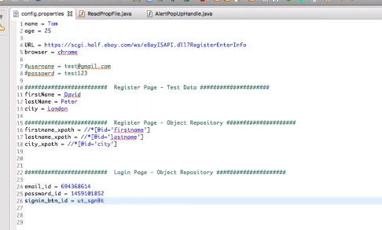

TestNG

Used in test driven development

Install testing in eclipse

Add library in eclipse:testNG, to add testNG to lib folder

TestNg will automatical execute class-no need to main

Features in the form of annotations:@

@BeforeSuite

@BeforeTest

@BeforeClass

@BeforeMethod

@Test

@AfterMethod

@BeforeMethod

@Test2

@AfterMethod

@AfterClass

@AfterTest

@AfterSuite

Usually we write

@BeforeMethod

@Test

@AfterMethod

Test-output-output of test results

Index.html

@test(priority=,groups=)

Groups to get groupwise reporting in index.html output

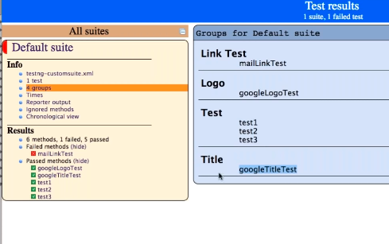

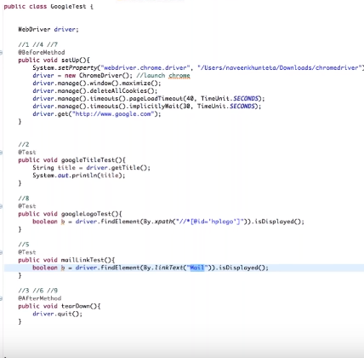

@test(priority=,groups=,ependsOnMethods=””)

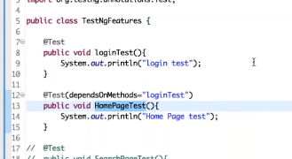

Homepagetest will execute only or else it will get skipped if logintest is passed

Same test repeat multliple times

@test(innovationCount=10)

@test(Timeout=2000)

@Test(innvocationTimeout=2000)

Assert.assert

If we have many test classes, we need to execute each one by one manually

We can use xml template file,testNG.xml

New-other-file>TestNg.xml

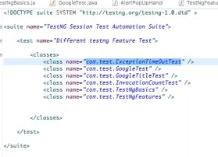

@PARAMETER PASSING THROUGH TESTnG XML

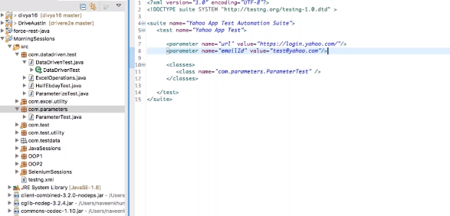

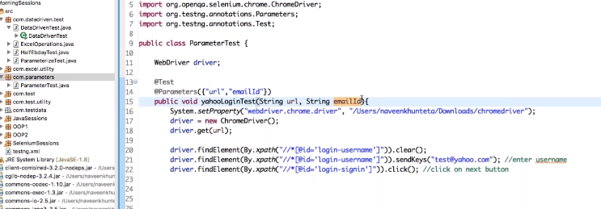

Data driven

1.excel file

2.testng file

Properties file

Frame:

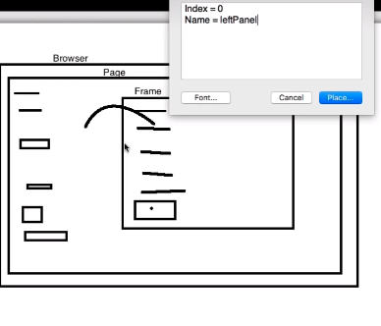

Headless browser:

WebDriver driver = new HTMLUnitDriver();

HTMLUNIT driver is not part of se 3.0

Html unit driver is not available in selenium jar file

We need to download to use this concept

Advantages

1.faster execution

2.testing happening behin the scene

3.not suitable for actions class-user actions-mouse actions,doubleclick

JIRA

Pom xml-jiraclient dependency

Create new [interface-@interface//@retention(retentioppolicy.runtime)](mailto:interface-@interface//@retention(retentioppolicy.runtime))

Javascript executor:

Highlight element utility:

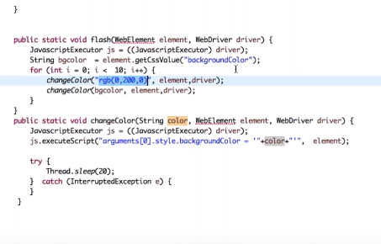

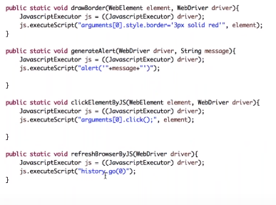

isDispalyed: applicable for all elements

isEnabled:checkbox like I agree,mainly with buttons

isSelected-applicable fro checkboxes,radio button,dropdown

Bootstrap button:dropdown with no select,dropdown will be in button tag

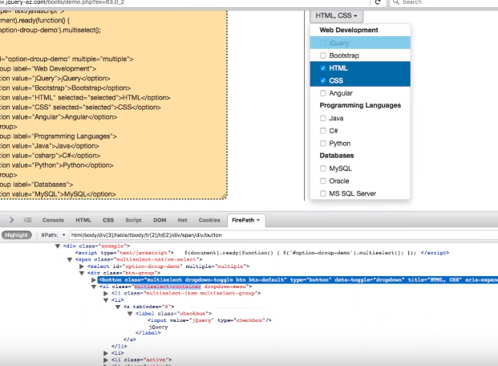

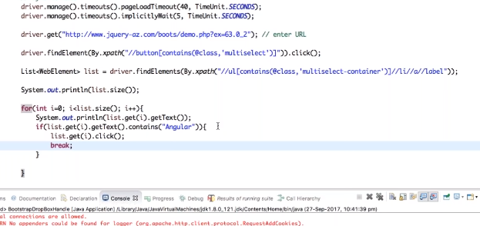

DOM-API interface provided by browser.

When a web page is loaded,browser creates a DOM of the page.

Following chrome options are required for Chrome HeadLess Browser:

Chrome version should be greater than 59on mac and 60 for windows

ChromeOptions options = new ChromeOptions();

options.addArguments("window-size=1400,800");

options.addArguments("headless");

Webdriver driver =new Chromedriver(options)

Extent Reports

Pom.xml add extent report jar-gives amaing dashboard,reports

Class in reporting folder og pom project

Copy paste the utiolity

Add listener in testng.xml

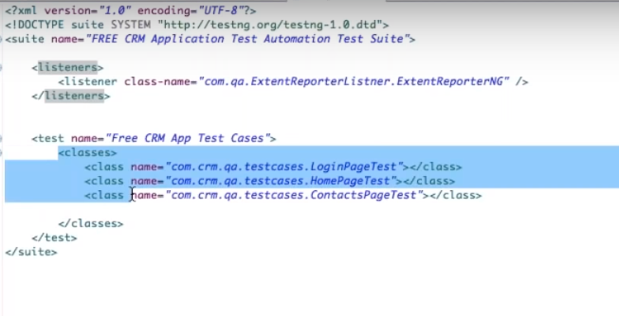

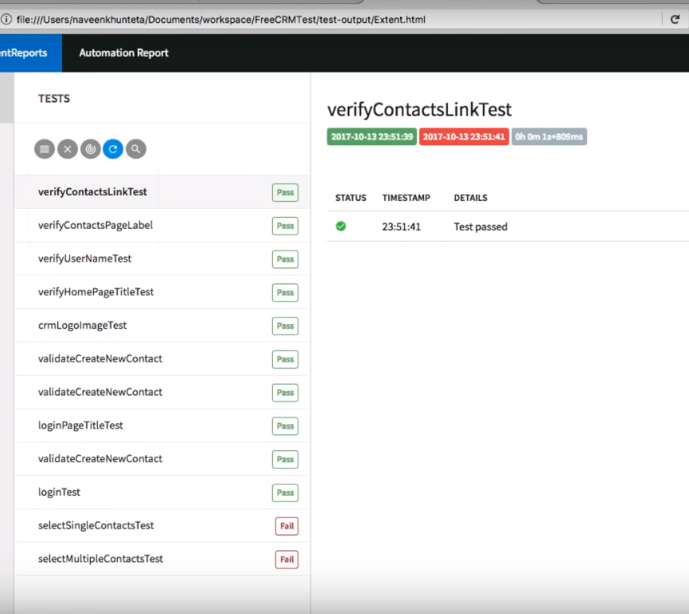

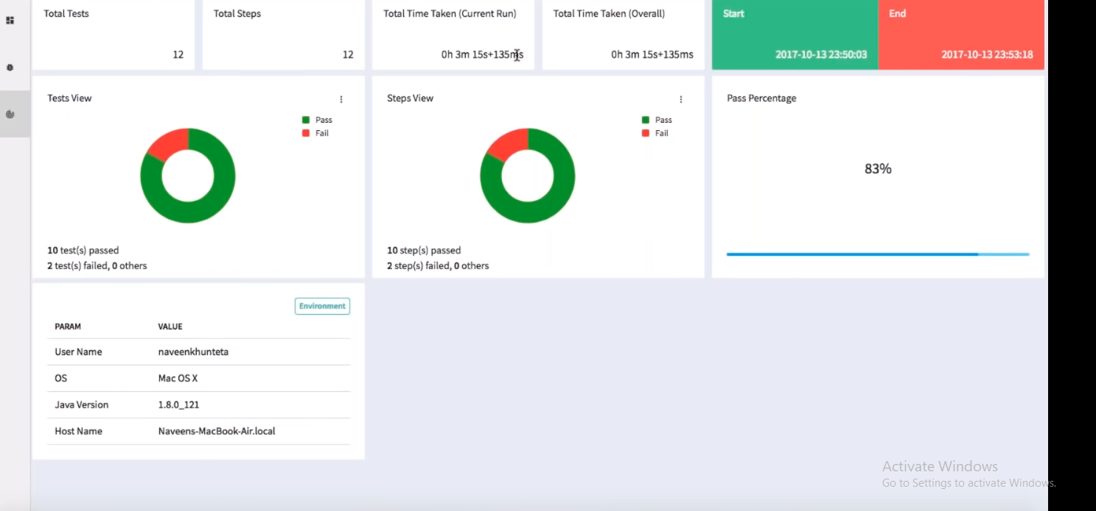

Run testcaases from github using Jenkins

Github

If production issue, who wrote the buggy code /developer is first prob

Second prob-reviewer

Master branch-conatins stable working code

Agile

Create branch for each userstory