**Objective:**

To implement and simulate the fulfillment business flow for a leading travel company,Sabre, by orchestrating get-reservation,payment,fraud-check, miscellaneous fee collection and update reservation business functionalities via REST API’s in Mule.

**Application Design Architecture:**

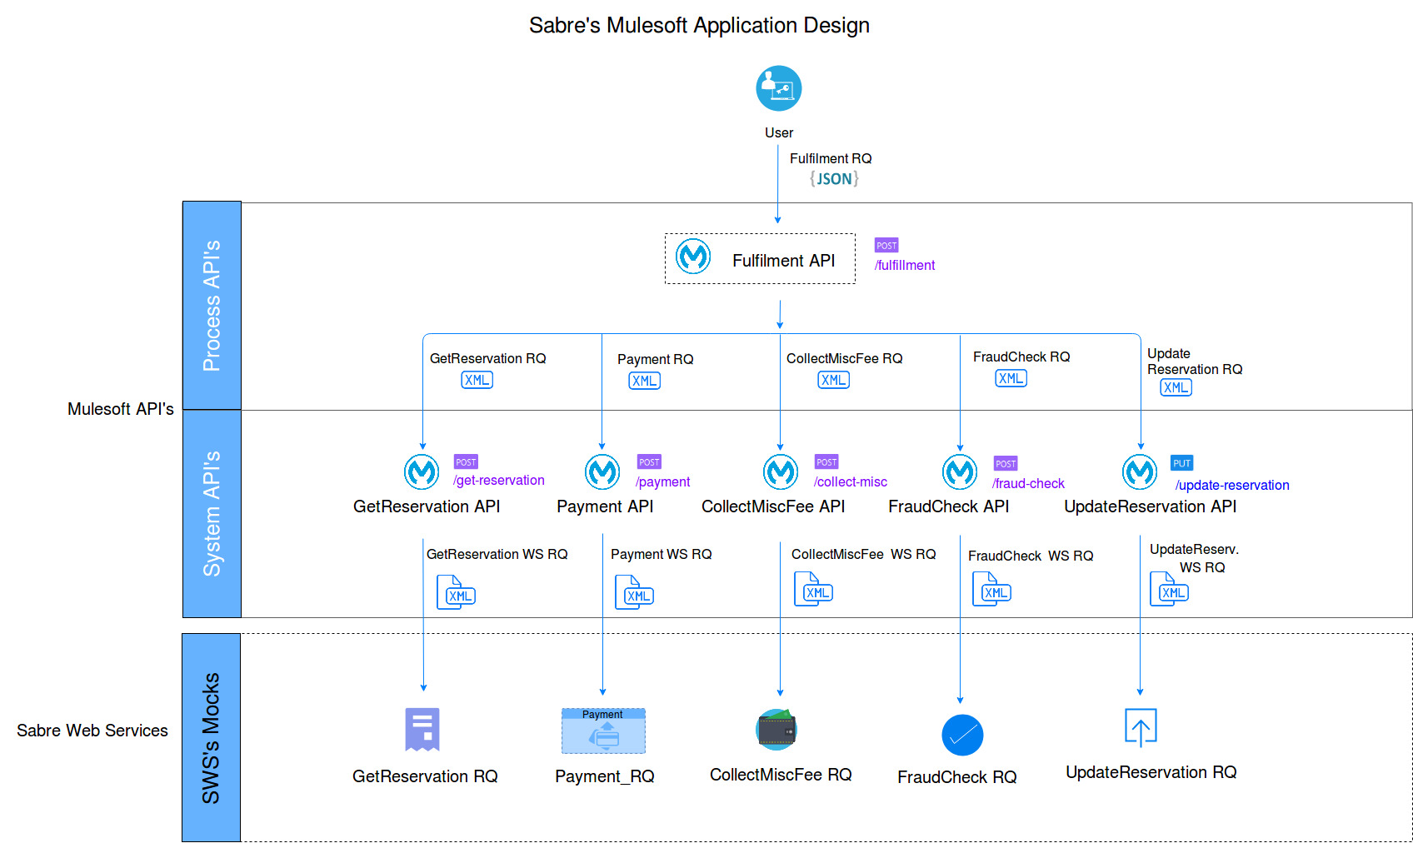

**Requirements Overview:**

GetReservationRQ service returns the Itinerary details. PaymentRQ service authorizes the funds, FraudCheckRQ implements fraud check and avoid fraud transactions, CollectMiscFeeRQ collects the funds and issues EMD(Electronic Miscellaneous Document). If any webservice call fails during this orchestration, it needs to be added in the PNR(Passenger Name Record) via updateReservationRQ service.

**Process API’s Layer:**

**Fulfillment API:**

1. Should expose resource **“fulfillment”** with POST HTTP method.

2. Client will pass JSON body in payload of request. Fulfillment Request and Response JSON files are available in Resources folder.

3. Final response returned to client will have JSON body as per Fulfillment response JSON format.

4. Transformation from JSON to XML format and vice-versa needs to be taken care during request-response processing.

**System API’s Layer:**

1. getReservation,payment,collect-misc,fraud-check API’s need to expose POST method, while update-reservation API needs to expose PUT method.

2. Transformations are required to be implemented in system API’s using Dataweave expressions as per DML files *Resources/MuleDMLTransformations* folder.

**Additional Business Requirements:**

1. Fraud check system api should only be called when fraud-check is enabled in fulfillment request.

2. If one system API fails or SOAP UI mock service is not running, then update reservation API should be called to update remarks in response and gracefully degrade.

3. Error and exception handling should be correctly implemented

**Resources Provided:**

**JSON Service contracts:**

These files are available in **Resources** folder.

***Fullfillment_request.json***

***Fullfillment_response.json***

**SabreWebservice:**

GetReservation/Payment/FraudCheck/CollectMiscFee/UpdateReservation WSDL files and samples are present in **Resources/SWS** folder

***Wsdl/common***

***Wsdl/fraudCheck***

***Wsdl/getReservation***

***Wsdl/payment***

***Wsdl/updateReservation***

***Wsdl/collectmiscfee***

**Samples:**

These files are available in **Resources/SWS/Samples** folder

***getReservationRQ.xml***

***getReservationRS.xml***

***paymentRQ.xml***

***paymentRS.xml***

***fraudCheckRQ.xml***

***fraudCheckRS.xml***

***collectMiscFeeRQ.xml***

***collectMiscFeeRS.xml***

***updateReservationRQ.xml***

***updateReservationRS.xml***

**SOAP UI Mock API Response Project:**

This file as available as XML file and needs to be imported in SOAP UI and run to simulate the response from APIs, response returned is in XML format, its is available in path **Resources/Sabre_PoC_Soap_Project.zip**

**XML Design Schemas:**

XSD files are included for parsing XML body in **Resources/SWS/wsdl** path

**Use Case Expectations:**

Sabre is looking to validate below scenario as part of this use-case implementation.

• Service design

• Request validation

• Expected request/response

• Error handling

• Connectors