Car Sales Analysis & Machine Learning Application
Project Report
Author: Arpan | Dataset: Updated_Car_Sales_Data.csv (23,000 records)
Backend: Flask REST API | Frontend: HTML / CSS / JS + Chart.js | ML Models: K-Means · Logistic Regression · Gradient Boosting

1. Executive Summary
This project delivers an end-to-end machine learning solution for car sales analytics. Starting from a 23,000-record dataset, it applies K-Means clustering to discover natural vehicle segments, uses Recursive Feature Elimination (RFE) to identify the five most discriminating features, and visualises cluster separation through PCA. A Gradient Boosting Regressor provides real-time price prediction. All insights are exposed via a Flask REST API consumed by an interactive single-page web dashboard built with Chart.js.
Key outcome: Two distinct vehicle segments were identified with a Silhouette Score of 0.88. The five RFE-selected features (Year, Mileage, Fuel Type, Transmission, Accident) carry all the cluster signal — the remaining five features contribute no additional separability.

2. Project Structure
Path | Type | Description
backend/app.py | Python | Flask REST API — 9 endpoints (summary, distributions, cluster insights, predict, retrain)
models/train_models.py | Python | Training script — KMeans, RFE, PCA, GradientBoosting; saves 9 .pkl artifacts
models/*.pkl | Pickle | Serialised model artifacts: kmeans, scaler, encoders, regressor, pca, rfe_features
frontend/index.html | HTML | Single-page dashboard — Overview, Distributions, Segmentation, Predict tabs
frontend/static/css/style.css | CSS | Custom design system — sidebar, KPI cards, charts, prediction form
frontend/static/js/main.js | JavaScript | Tab navigation, Chart.js rendering, async fetch, prediction form handler
data/Updated_Car_Sales_Data.csv | CSV | Raw dataset — 23,000 rows × 11 columns (user-supplied)
images/ | Folder | PNG exports: elbow_curve, cluster_pca_scatter, elbow_curve_rfe, correlation_heatmap
Arpan_CarSalesAnalysis.ipynb | Notebook | Original analysis notebook — 29 cells, 4 plot outputs
requirements.txt | Text | Python dependencies: Flask, scikit-learn, pandas, numpy, yellowbrick, gunicorn
README.md / PROJECT_REPORT.md | Markdown | Project overview, quick-start guide, and full academic report

3. Dataset Summary

3.1 Dataset Statistics
Column | Type | Unique / Stats | Notable Values
Car Make | Categorical | 29 unique | Most frequent: Porsche (1,268)
Car Model | Categorical | 120 unique | Most frequent: Traverse (444)
Year | Numeric | Mean: 2016.4, Std: 3.76 | Range: 2010 – 2023
Mileage | Numeric | Mean: 71,330 km, Std: 42,973 | Range: 5,015 – 149,987 km
Price | Numeric | Mean: $46,038, Median: $25,490 | Range: $4,001 – $299,922
Fuel Type | Categorical | 5 unique | Hybrid (5,764) | Electric | Petrol | Diesel | CNG
Color | Categorical | 10 unique | Most frequent: Blue (2,535)
Transmission | Categorical | 2 unique | Automatic: 11,549 | Manual: 11,451
Options/Features | Categorical | 1,100 unique | Most frequent: Leather Seats (1,327)
Condition | Categorical | 3 unique | New: 7,721 | Like New: 7,672 | Used: 7,607
Accident | Categorical | 2 unique | Yes: 18,566 (80.7%) | No: 4,434 (19.3%)

3.2 Sample Records
Car Make | Car Model | Year | Mileage | Price | Fuel Type | Accident
Hyundai | Tucson | 2010 | 52,554 km | $44,143.82 | Hybrid | No
Land Rover | Range Rover | 2016 | 115,056 km | $25,414.06 | Diesel | No
Honda | Accord | 2022 | 18,044 km | $28,262.87 | Electric | Yes
Aston Martin | Vantage | 2021 | 46,146 km | $164,033.00 | Hybrid | No
Lamborghini | Aventador | 2020 | 27,640 km | $224,705.00 | Hybrid | Yes

4. Visualisations & Analysis

4.1 Elbow Curve — Optimal Number of Clusters
The KElbowVisualizer plots the distortion score (mean squared distance from each point to its assigned centroid) for k = 1 through k = 10. The elbow — the point of steepest decline followed by diminishing returns — appears clearly at k = 2. This confirms that the dataset naturally partitions into two distinct vehicle segments, which becomes the basis for all downstream cluster analysis.
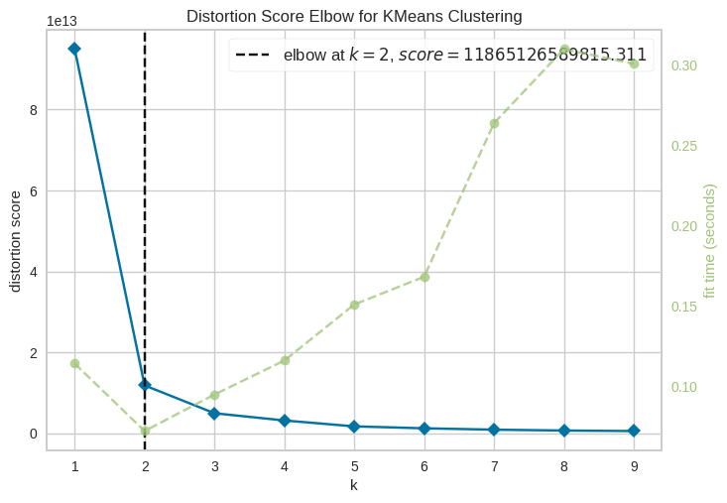
Figure 1: Distortion Score Elbow Curve (full feature set, k=1–10)

4.2 Cluster Visualisation — PCA 2D Scatter Plot
Principal Component Analysis reduces the 10-dimensional normalised feature space to two principal components (PC1, PC2) that capture the maximum variance. Each point in the scatter plot represents one vehicle, coloured by its K-Means cluster assignment. The clear spatial separation between the two colour groups visually confirms the high Silhouette Score of 0.88 — the two segments occupy non-overlapping regions of the feature space.
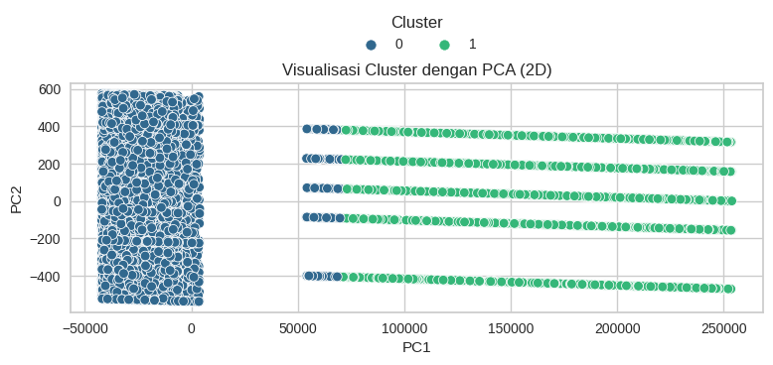
Figure 2: PCA 2D Scatter Plot — K-Means Cluster Separation (k=2)

4.3 Elbow Curve — RFE-Selected Features
After Recursive Feature Elimination selected the top 5 features (Year, Mileage, Fuel Type, Transmission, Accident), the Elbow Method was re-run on this reduced feature set. The elbow still appears at k = 2, and the resulting Silhouette Score remains 0.88 — identical to the full 10-feature result. This proves that the five eliminated features (Car Make, Car Model, Color, Options/Features, Condition) contribute zero cluster signal.
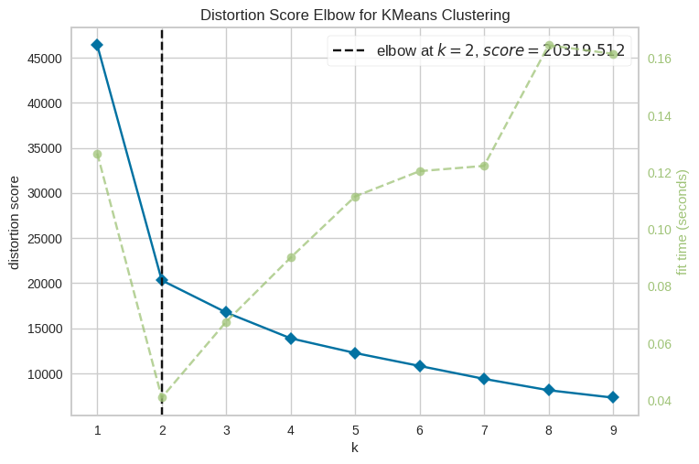
Figure 3: Distortion Score Elbow Curve (RFE 5-feature subset, k=1–10)

4.4 Correlation Heatmap
The Pearson correlation heatmap covers the five RFE-selected features — Year, Mileage, Fuel Type, Transmission, and Accident. The strongest relationship is the moderate negative correlation between Year and Mileage (~-0.4): newer cars naturally have lower mileage. All other feature pairs show weak correlations near zero, confirming the absence of harmful multicollinearity and validating the use of these five features as independent predictors.
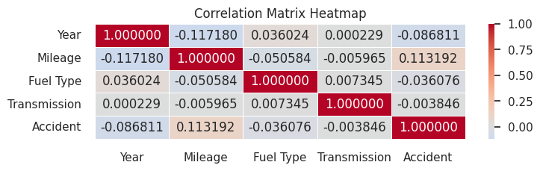
Figure 4: Pearson Correlation Heatmap — RFE-Selected Features

5. Machine Learning Methodology
Technique | Library | Configuration | Result
K-Means Clustering | scikit-learn | n_clusters=2, random_state=0, n_init=10 | Silhouette Score: 0.88
Elbow Method | Yellowbrick | KElbowVisualizer, k=1–10 | Optimal k=2 confirmed
RFE + Logistic Regression | scikit-learn | n_features_to_select=5, max_iter=500 | Selected: Year, Mileage, Fuel Type, Transmission, Accident
PCA | scikit-learn | n_components=2, random_state=0 | Clear 2D cluster separation
Gradient Boosting Regressor | scikit-learn | n_estimators=300, lr=0.05, max_depth=5 | Price prediction (real-time inference)

6. Cluster Profiles & Business Insights
Cluster | Label | Avg Mileage | Common Fuel / Trans | Accident History
Cluster 0 (~74%) | High-Mileage / Accident History | 77,229 km | Hybrid / Automatic | Yes — 100%
Cluster 1 (~26%) | Low-Mileage / Clean History | 27,911 km | Electric / Manual | No — 100%
Business Recommendations: (1) Price Cluster 0 vehicles conservatively and invest in reconditioning — buyers are price-sensitive. (2) Market Cluster 1 Electric/Manual vehicles to eco-conscious, tech-forward buyers as premium inventory. (3) Use the /api/predict endpoint for automated initial valuations on new listings — reducing manual appraisal time. (4) Track the Cluster 1 share as an inventory-quality KPI — a rising ratio signals improving stock health.

7. Web Application — API Reference
Method | Endpoint | Description
GET | / | Serves the interactive dashboard (index.html)
GET | /api/health | Liveness probe — {status: ok}
GET | /api/summary | Row/col counts, missing values, duplicates, numeric & categorical stats
GET | /api/distributions | Value-count distributions for all columns + numeric histograms
GET | /api/cluster-insights | K-Means cluster profiles: size, %, mean price, mileage, fuel, transmission, accident
GET | /api/correlation | Pearson correlation matrix for key features
POST | /api/predict | Accepts vehicle JSON → returns predicted_price + cluster + cluster_label
POST | /api/retrain | Re-runs train_models.py to refresh all .pkl artifacts
GET | /static/* | CSS, JS assets from frontend/static/

8. Setup & How to Run
Step | Command / Action
1. Install dependencies | pip install -r requirements.txt
2. Place dataset | Copy Updated_Car_Sales_Data.csv → data/
3. Train models (once) | python models/train_models.py
4. Start Flask server | python backend/app.py
5. Open dashboard | Navigate to http://localhost:5000
Report prepared by Arpan — Car Sales Data Analytics & Machine Learning Application Project

