ChatGPT: An Adversary or Someone You Trust?

**1. Introduction**

As intelligent software and hardware, also known as intelligent agents, are developed and analyzed, artificial intelligence (AI) becomes more and more integrated into our daily lives. One of the most simplest and well-known forms of intelligent Human-Computer Interaction (HCI), a chatbot is a typical example of an AI system[1]. A chatbot is defined as a dialogue-capable piece of software that can converse with people and interpret their natural language input. When communicating with a chatbot via text or speech, the computer software acts intelligently and uses Natural Language Processing (NLP) to understand one or more human languages[2].

Chatbots are often referred to as intelligent bots, conversational agents, dynamic assistants, or digital personal assistants. They are beneficial in applications like online commerce, the business department, education, and data searching[1].

**1.1 Brief History**

Chatbots have a long history that dates all the way back to Alan Turing in the 1950s. Professor Joseph Weizenbaum of MIT created the first chatbot ever in the 1960s, named ELIZA following the introduction of the Turing Test[2]. It employed a straightforward template-based response system and matching of patterns. Their conversational skills were poor, but they were effective to confuse humans during a period when they were not accustomed to talking with machines, which inspired them to begin creating more chatbots[4]. A chatbot designated as PARRY that was created in 1972 was an upgrade over ELIZA. It is a program that uses natural language and simulates human thought processes. After that, in 1995, Richard Wallace was a forerunner in the development of ALICE which was the first program to run on a computer called Alice, it was once known as Alicebot. In 2000, 2001, and 2004, Alice earned the Loebner Prize, which is awarded for passing the Turing Test. The term "almost human computer" was initially used for this machine[6].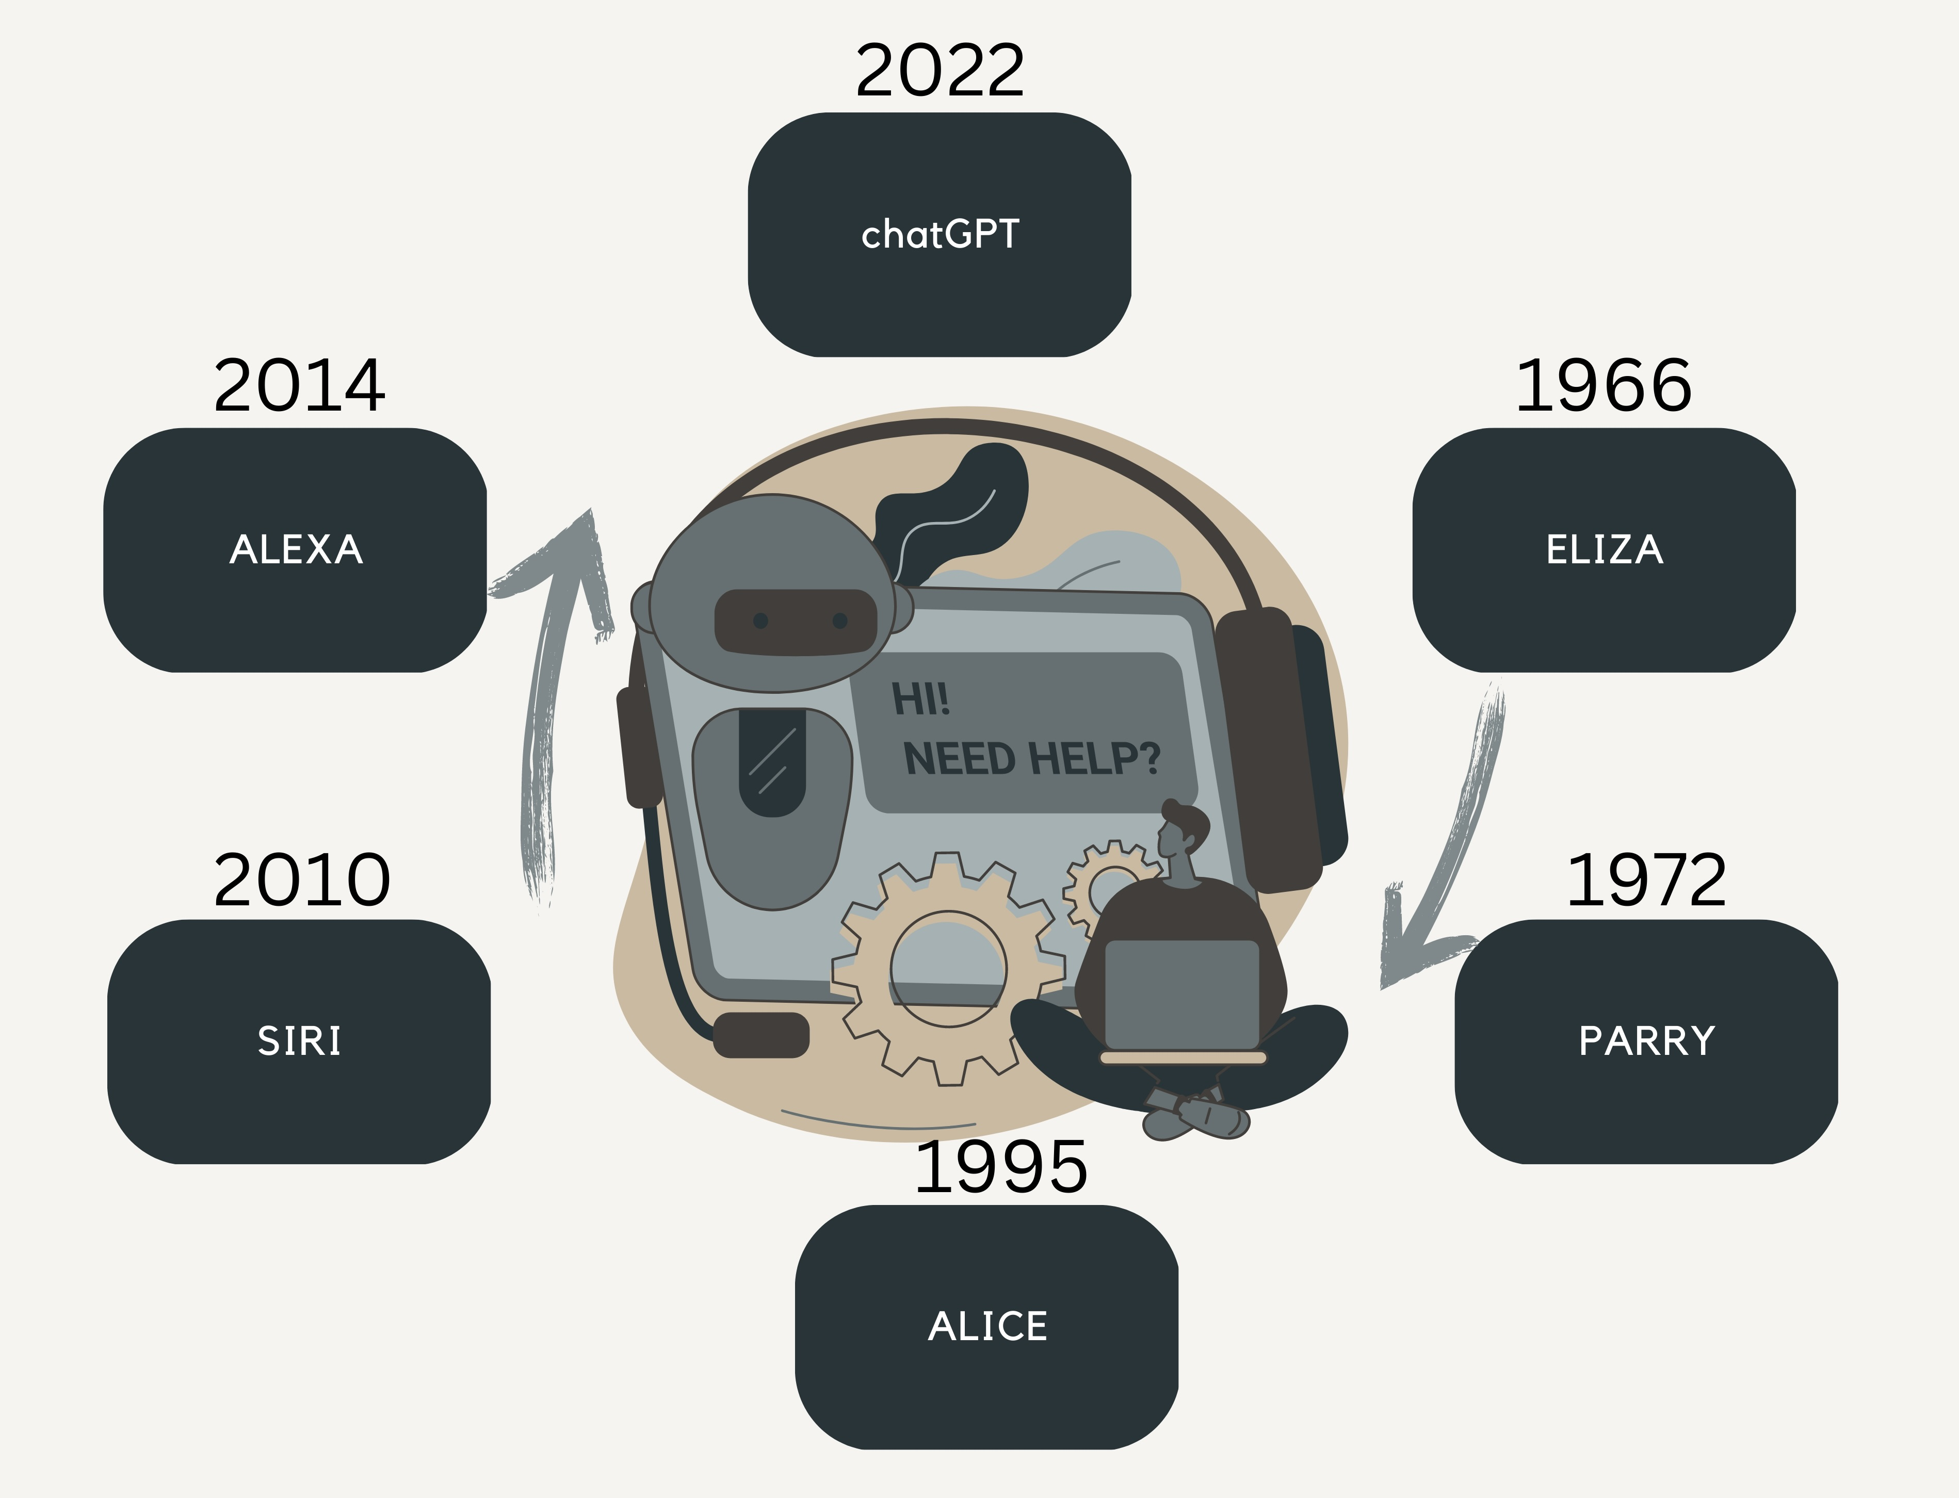

Figure 1: Evolution of Chatbots

Likewise, in 2001, the invention of the SmartChild served as a forerunner to Siri with the ability to have engaging discussions while having easy access to other services' data. Later, the account suits a certain discourse. In 2010, Apple created Siri for iOS. A few instances of a dialogue between Siri and a user in Messages during which the user asks inquiries are shown in the patent. Amazon created Alexa, a highly intelligent virtual assistant in 2014[2]. The Alexa Skills Kit (ASK) from Amazon enables developers to create and publish skills for Alexa that can be added to any Alexa-enabled device to increase its functionality. Between 1960s-now, many more chatbots were introduced and some got highly appreciated when other bots stopped. Currently, the large-scale language model ChatGPT was developed by OpenAI. It is intended to help users create writing that appears human-like from the input[1].

**1.2 Relevance of Chatbots**

In the current digital world, chatbots are growing more and more significant for a number of objectives because they can connect with people quickly, effectively, and individually[4]. Here are some significances of them:

* Customers may start a chatbot discussion at any moment and get an immediate answer if they have any queries or concerns about a product or service. This has improved accessibility and efficiency for the customer service experience.
* A huge amount of simultaneous enquiries may be handled by chatbots, eliminating the need for human customer care agents. Businesses may be able to devote resources to other areas and save money as a result[3].
* In the healthcare sector, chatbots can offer medical advice and assistance, bridging the gap between the patient and the healthcare professional, particularly in rural and distant places where access to healthcare may be constrained[5].

**1.3 Variations of Chatbots**

Chatbots may be categorized using a variety of factors. At the moment, different sectors are using various forms of chatbots. Let’s talk about widely used chatbot types[1].

Voice chatbots: A vocal bot is an AI- and NLU-powered communication channel that can convert voice to text and text to speech. The entire speech understanding and response process is carried out by these bots in a manner that closely resembles that of a person.

Hybrid chatbots: The greatest features of both chatbots and live chat are harmoniously combined in a hybrid chatbot. Any client questions that may be too complicated or nuanced for automation alone can be addressed by a customer support agent during live chat[3].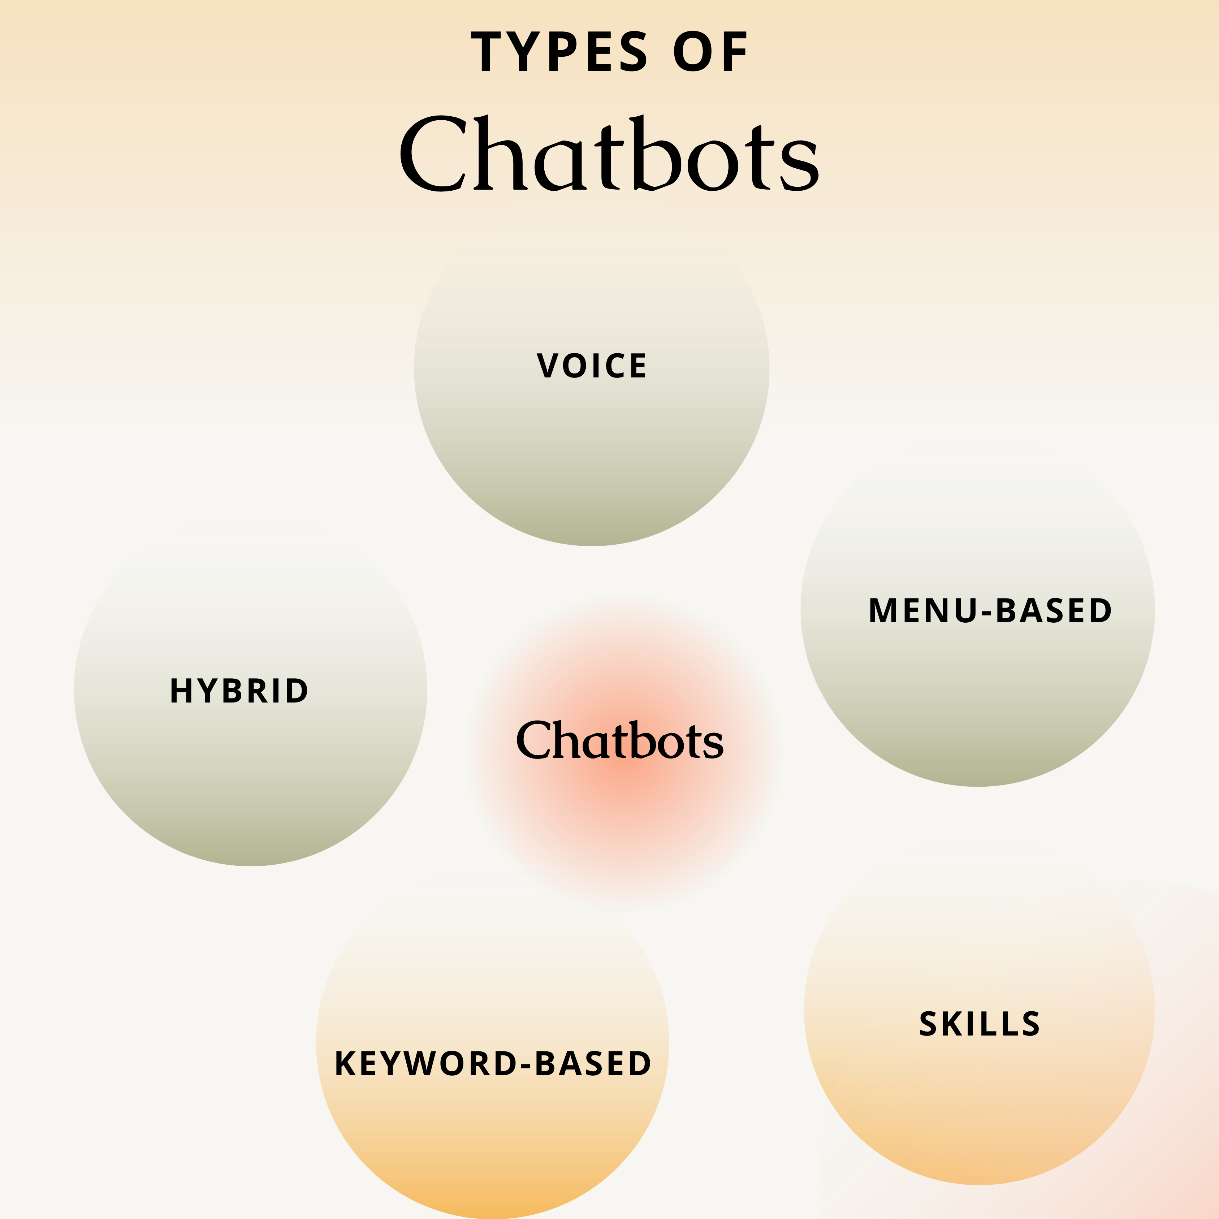

Figure 2: Types of Chatbots

Key-based chatbots: Keyword-based chatbots can hear what users put in and reply correctly, in contrast to those that rely on menus. These chatbots utilize natural language processing (NLP) and programmable keywords to recognize activity triggering in the conversation and decide how to respond to the audience[6].

Skills chatbots: A skills chatbot can carry out a certain set of activities after its capabilities have been expanded using pre-defined skills software. For instance, when linked to a smart home appliance, the chatbot may be able to switch down your room's lights, deliver weather information, shop for groceries online, and perform other functions[3].

**1.4 ChatGPT**

As a natural language processing model, ChatGPT from OpenAI can respond to queries and carry out activities that need text-based input using deep learning. ChatGPT is far more generalizable since it interprets the query or task using its linguistic knowledge to get the best possible answer[6].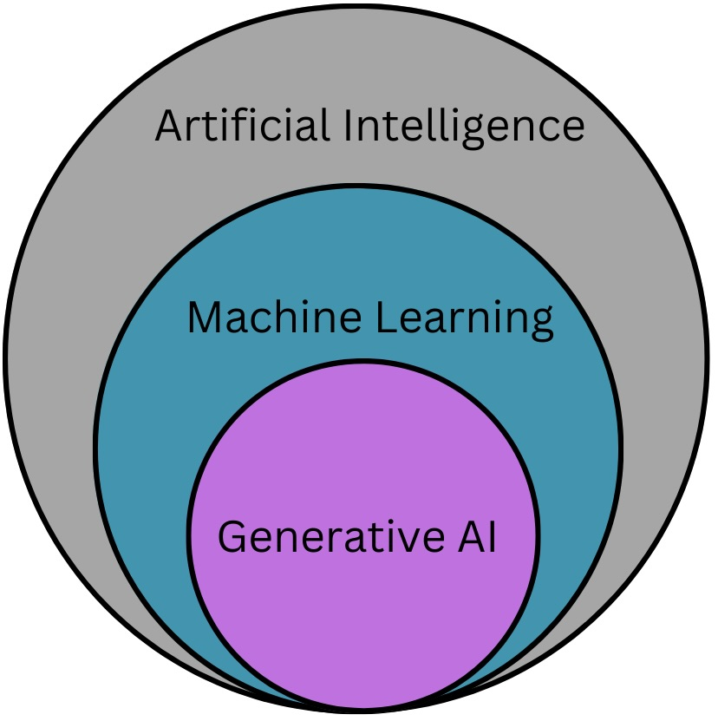

Figure 3: Generative AI is subset of AI and ML

With a history dating back to the introduction of GPT-1 in 2018, ChatGPT has grown to become one of the most prominent technological debuts in recent years. GPT-2, released in 2019, has 1.5 billion parameters and is considerably more potent. Conversely, ChatGPT has a bigger model with 175 billion parameters, enabling it to produce replies to user inquiries that are more precise and human-like. Although both ChatGPT and chatbots are interactive AI tools, they serve different functions. While ChatGPT employs a large language model trained on a ton of data, chatbots often use a rule-based or decision tree-based technique to create replies to user input. Compared to conventional chatbots, ChatGPT is more versatile and produces replies that sound more natural[1].

**1.5 Working Mechanism of ChatGPT**

A good example of a generative AI model is ChatGPT. A model may produce new material using generative AI, a subset of artificial intelligence and machine learning, by drawing on patterns in data that it has already seen[2].

Figure 4: Simple Working Mechanism of ChatGPT

A generative language model called ChatGPT is built on the "transformer" architecture. GPT requires a lot of text to be "trained" on in order for it to function. Conversations between the user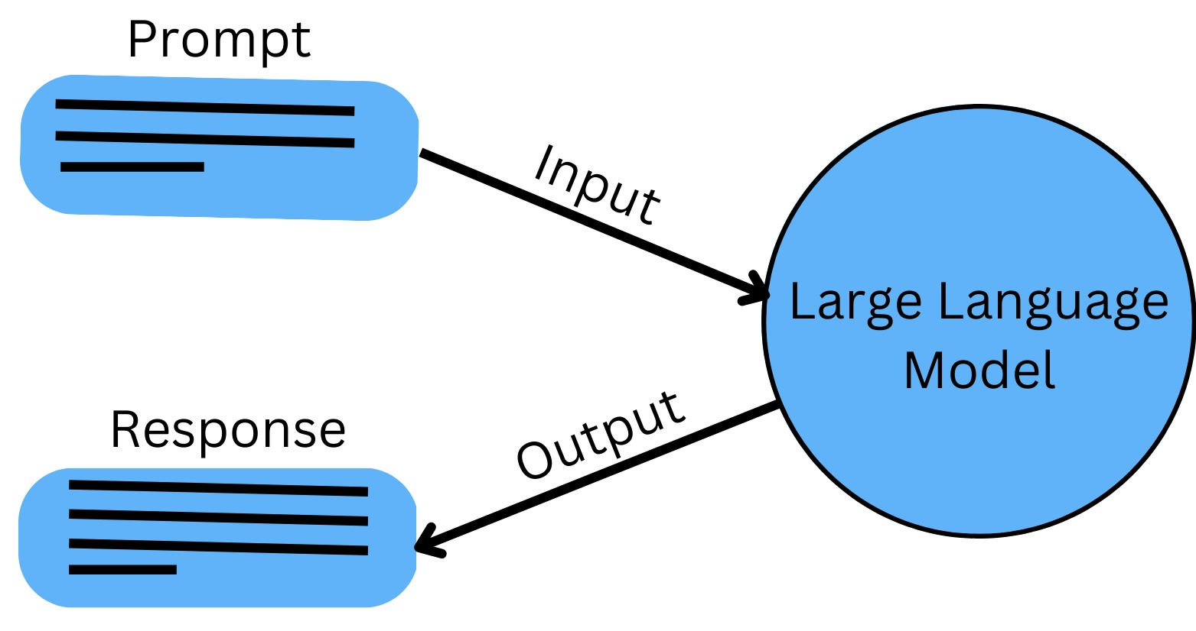 and the AI assistant were given by human AI trainers. It generates a response based on its linguistic expertise and comprehension of the situation.  It accomplishes this by dissecting the text input into its component words before processing and producing a response using a multi-layer neural network[4].

Figure 5: Work Method of ChatGPT[5]

Because of the GPT design, ChatGPT may gradually produce more insightful replies by taking into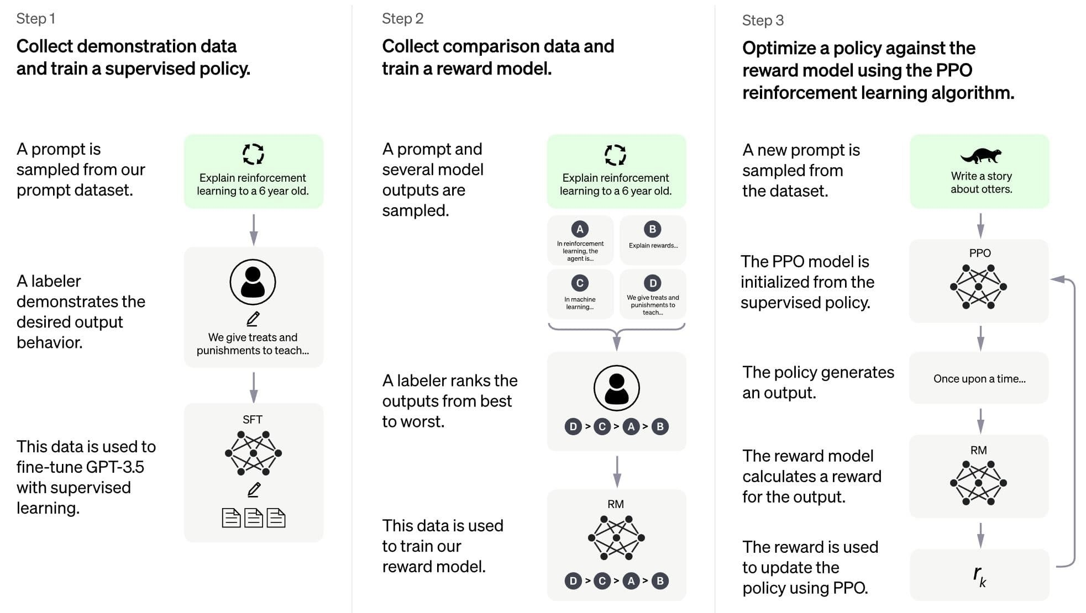 account the conversation's context. It can comprehend and produce natural language, which enhances its ability to interact with people. The stimulus is then interpreted using these patterns, and fresh, pertinent text is produced in response. Finally, the user receives the created text or answer. Let's look at some instances of ChatGPT in use[4].

Figure 6: Response of ChatGPT

**References**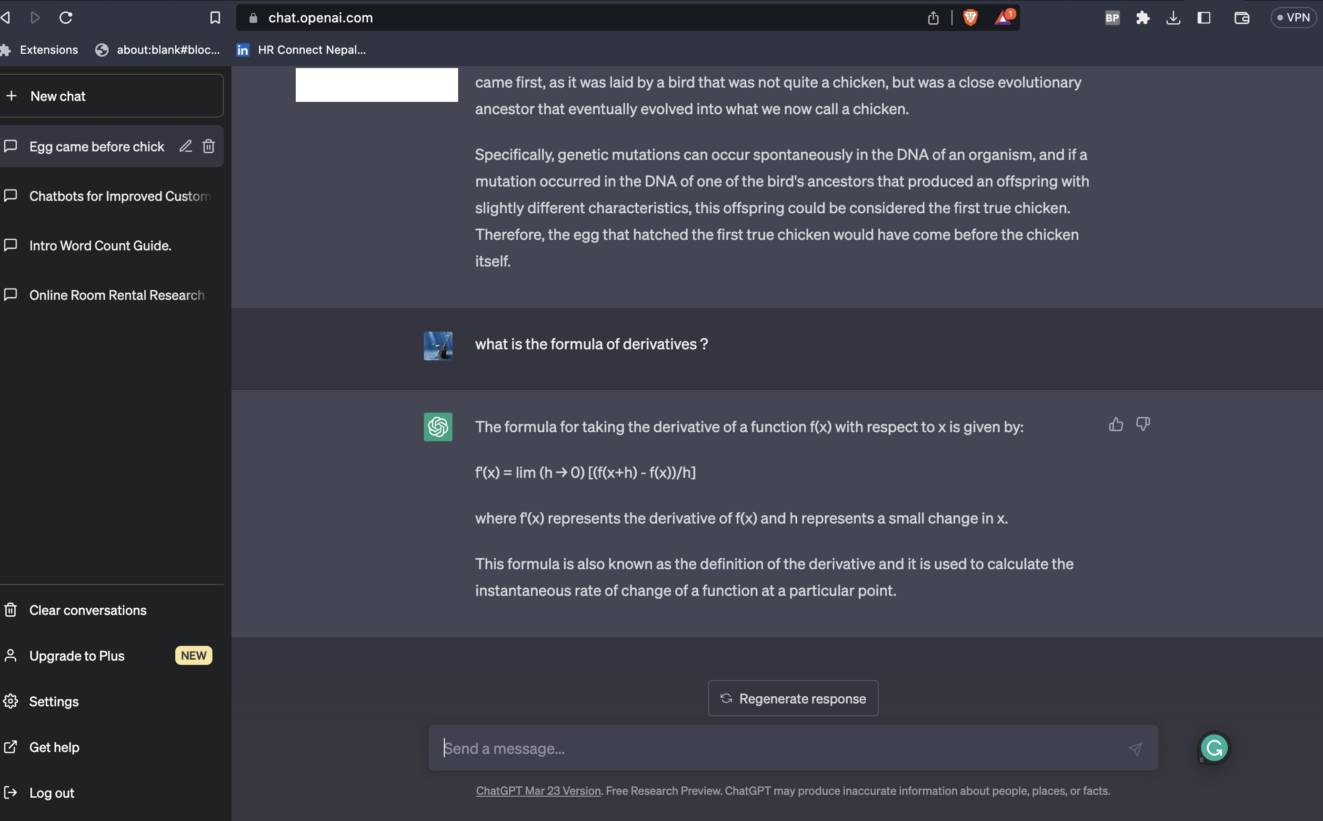

1. Huang, W., Fryer, L. K., & Hew, K. F. (2021). *Chatbots for Language Learning—Are They Really Useful? A Systematic Review of Chatbot‐Supported Language Learning*, 237–257. [https://doi.org/doi/epdf/10.1111/jcal.12610](https://onlinelibrary.wiley.com/doi/epdf/10.1111/jcal.12610)

2. (2020). *An Overview of Chatbot Technology*, *584*. [https://doi.org/chapter/10.1007/978-3-030-49186-4_31](https://link.springer.com/chapter/10.1007/978-3-030-49186-4_31)

3. Liu, D., Huang, W., & Lv, Y. (2023). How Do Consumers React to Chatbots' Humorous Emojis in Service Failures, 73. [https://doi.org/chapter/10.1007/978-3-030-49186-4_31](https://www.sciencedirect.com/science/article/abs/pii/S0160791X23000490?via=ihub)

4. Luo, B., Li, C., Lau, R. Y. K., & Si, Y.-W. (2021). A Critical Review of State-of-the-Art Chatbot Designs and Applications . [https://doi.org/chapter/10.1007/978-3-030-49186-4_31](https://www.citationmachine.net/bibliographies/9e7e4ff5-c4a0-4a37-b262-063d7057ee16)

5. Fedewa, J. (2023). *What Is ChatGPT, and Why Is It Important?* <https://howtogeek.com/871071/what-is-chatgpt/>

*6.* Lee, J. Y. (2023). Can an Artificial Intelligence Chatbot Be the Author of a Scholarly Article? [https://doi.org/chapter/10.1007/978-3-030-49186-4_31](https://synapse.koreamed.org/articles/1516081874)