**2 Literature Review**

According to recent research, ChatGPT is a formidable chatbot powered by AI that has the capacity to revolutionize a number of areas, including education, health, medicine, business, and research[1].

This paper is presented from a research journal(Puranjay Savar Mattas 2023) that attempted to better understand the advantages and difficulties of AI language processing and its potential influence on many businesses via a thorough assessment of the literature and case studies[1]. Similarly, Lund and Ting(2023) observed that the advantages of ChatGPT, such as enhanced search and discovery, reference and information services, production of catalogs and metadata, and material creation, as well as the moral issues that must be taken into consideration, such as prejudice and security[2].  Both journals[1-2] were conducted in the rush to produce new scholarly knowledge and train the next generation of professionals, it is crucial to think about how to use this technology responsibly and ethically and to discover how we, as professionals, can work alongside it to improve our work rather than abusing it or allowing it to abuse us.

**2.1 Industry Applications**

When it comes to education, in order to produce instructional content and improve student interactive learning, ChatGPT has attracted attention. According to the research by Lund and Ting(2023), high-quality instructional material that is tailored to the requirements of specific pupils may be produced using ChatGPT. In the medical sector, advanced analytics techniques like machine learning, and predictive modeling may be combined with digital health data to find patterns, trends, and insights that might enhance patient outcomes and lower costs. A study by Mijwil et al.(2023)  found that patients with anxiety and depression can benefit from effective assistance through ChatGPT. Within the scientific field, researchers have utilized ChatGPT to generate academic papers and support their studies. By researchers, Tiwary et al.(2023) conducted that researchers can benefit from using ChatGPT to develop hypotheses and plan studies. In the field of organizations, it may be used in business to enhance relations with clients, automate processes, and spark innovation. A study by Lund and Ting(2023) found that we may utilize ChatGPT to come up with fresh concepts for products or marketing plans.

**2.2 Industry Applications**

Numerous NLP applications, including content creation, text summarization, machine translation, and question-answering, have made use of ChatGPT[4]. When it comes to creating content, high-quality material has been produced with ChatGPT for a variety of uses, including social media, news stories, and blog entries. ChatGPT can provide engaging social media postings that effectively engage people which was conducted by Paul et al.(2023). Text summarization is a discipline in which long papers have been summarized accurately and succinctly using ChatGPT. Summaries produced by ChatGPT can be as good as those produced by humans, as studied by Lund and Ting(2023). Additionally, it has been demonstrated that ChatGPT's machine translation feature performs better than conventional machine translation techniques. They observed(Tiwary et al. 2023) observed that modern machine translation performance is possible using ChatGPT. in the area of query resolution, chatGPT has been used to generate natural language answers to inquiries. Both (Tiwary et al.2023; Paul et al.2023) had done research on chatGPT that can answer questions with a high degree of accuracy. But the researchers Mijwil et al.(2023) didn’t elaborate on it.

**2.3 Benefits, drawbacks, and Limitations of ChatGPT**

The advantages of ChatGPT include its capacity to produce language that is human-like, flexibility in many areas, and potential to increase worker productivity and effectiveness, 24/7 availability,  personalization, and cost-effectiveness[8]. Researchers Ding and Lin(2023) observed that it provides a number of advantages, including higher efficiency, more accuracy, and cost savings. Nevertheless, there are also issues with ChatGPT's limitations, including its need for a lot of training data, inability to comprehend context or reason, and potential for prejudice. It's critical to establish strategies to address these possible ChatGPT ethical and societal problems. According to the research by Paul et al.(2023) said that a lack of emotional intelligence, biased answers, a lack of subject expertise, a susceptibility to adversarial attacks, and a lack of explainability, among others.

**2.4 Technical Implementation of ChatGPT**

In order to build ChatGPT technically, a transformer-based architecture with self-attention techniques was used. The model's use of the transformer architecture's several layers enables efficient processing of lengthy sequences[4]. For language processing tasks like interpreting and producing natural language, the transformer model is a sort of neural network design. Deng and Lind(2023) introduced it is now a widely used technique for language modeling.

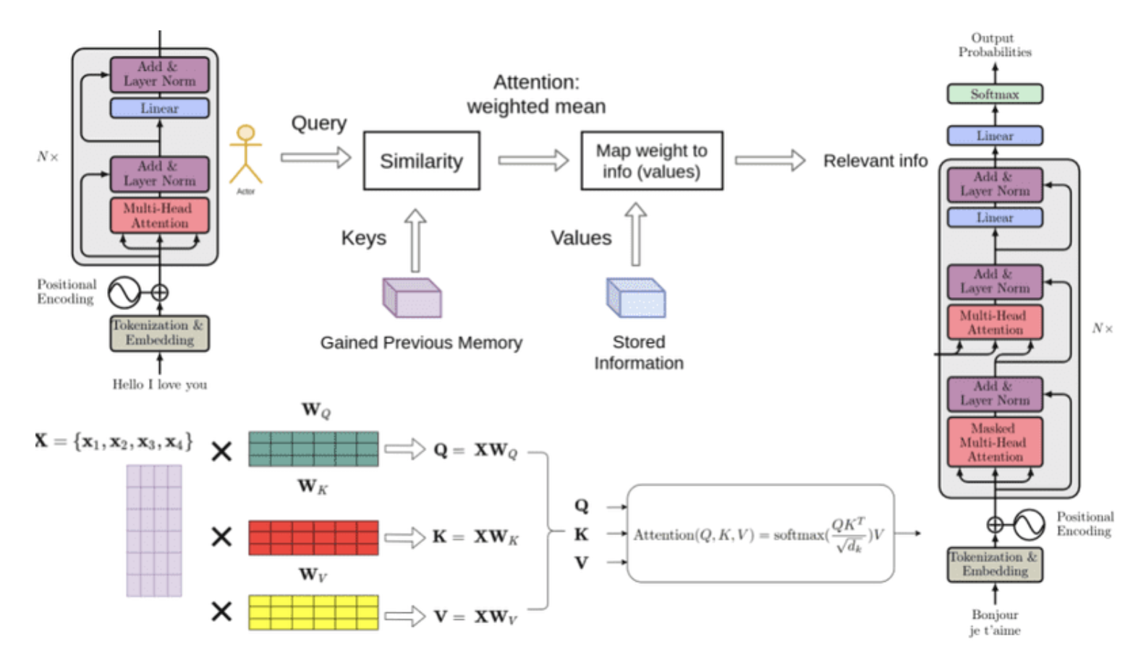

Figure n: Working Mechanism of ChatGPT[7]

In the transformer architecture, an embedding layer places the input token sequence (words or subwords) into a high-dimensional space. The embedded sequence is processed by encoder and decoder layers. Each word in the input sequence is ranked by the transformer model encoder layer using a multi-head self-attention method. The output of the self-attention mechanism is converted into encoder output by a feedforward neural network. The decoder layer of the transformer model may attend to the output of the encoder thanks to multi-head self-attention and an attention mechanism. The output of the decoder is routed via a feedforward neural network to create the final output sequence. The model is trained unsupervised on a sizable corpus of text using the GPT (Generative Pre-trained Transformer) architecture[8]. During training, the model develops the ability to predict the next words based on previous words. The model gains a broad understanding of language from this pre-training, which may then be honed for particular language tasks like question-answering or summarizing[10].

**2.5 Comparison between chatGPT and other AI-based chatbots**

We will evaluate ChatGPT's performance, accuracy, and efficiency against those of other AI-based chatbots[11]. Aljanabi and M. (2023) compared several natural language processing (NLP) tasks including text categorization, question answering, and language production, ChatGPT competes with other cutting-edge language models, such as BERT and XLNet. According to the study, BERT and XLNet beat other models on classification and question-answering tasks whereas ChatGPT did better on language production tasks. According to research by Lee and H.(2023) differentiated on a healthcare application, ChatGPT was tested with a number of other chatbots to determine their efficacy and accuracy in giving patients medical advice. According to the study, ChatGPT is a potential tool for healthcare applications since it performs more accurately and with a faster reaction time than other chatbots[9].

**2.6 Performance Issues**

ChatGPT has received accolades for its capacity to make coherent replies in a variety of circumstances and generate natural-sounding English. It also has a number of performance problems, though, that must be resolved.

The computational demands of ChatGPT are one of the key performance challenges. ChatGPT demands a huge amount of computing resources to train and execute since it is a massive model with millions of parameters[3]. ChatGPT may be difficult for firms without access to high-performance computing resources, making it less available to people and smaller companies. A study by Deng and Lin(2023) showed a huge carbon footprint might result from training big models like ChatGPT, which can be problematic for the environment. ChatGPT's propensity to create biased or abusive language is another performance flaw. Large volumes of text data may have biases that ChatGPT picks up as it learns, which might result in the development of prejudiced or objectionable language. A study by Paul et al.(2023) found that ChatGPT's propensity to create biased or abusive language is another performance flaw. Large volumes of text data may have biases that ChatGPT picks up as it learns, which might result in the development of prejudiced or objectionable language[6].

**References**

1. Mattas, P. S. (2023). CHATGPT: A study of ai language processing and its implications. *International Journal of Research Publication and Reviews*, *04*(02), 435–440. [https://doi.org/10.55248/gengpi.2023.4218](https://ijrpr.com/uploads/V4ISSUE2/IJRPR9921.pdf)

2. Lund, B., & Ting, W. (2023). Chatting about chatgpt: How may AI and GPT Impact Academia and libraries? *SSRN Electronic Journal*. [https://doi.org/10.2139/ssrn.4333415](https://papers.ssrn.com/sol3/papers.cfm?abstract_id=4333415)

3. Mijwil, M., Aljanabi, M., & Ali, A. H. (2023). Chatgpt: Exploring the role of cybersecurity in the Protection of Medical Information. *Mesopotamian Journal of Cyber Security*, 18–21. <https://doi.org/10.58496/mjcs/2023/004>

4. Huang, W., Fryer, L. K., & Hew, K. F. (2021). *Chatbots for Language Learning—Are They Really Useful? A Systematic Review of Chatbot‐Supported Language Learning*, 237–257. [https://doi.org/doi/epdf/10.1111/jcal.12610](https://onlinelibrary.wiley.com/doi/epdf/10.1111/jcal.12610)

5. A, S., A, V., & Tiwary, N. (2023, February 1). Netizens, academicians, and information professionals' opinions about AI with special reference to chatgpt. arXiv.org. Retrieved April 25, 2023, from <https://arxiv.org/abs/2302.07136>

6. Paul, J., Ueno, A., & Dennis, C. (2023). chatgpt and consumers: Benefits, Pitfalls and Future Research Agenda. *International Journal of Consumer Studies*. <https://doi.org/10.1111/ijcs.12928>

7. Kumar, S. (2023, April 4). *All about chat gpt(version, datasizes, working) explained*. Curious Steve. Retrieved April 25, 2023, from <https://curioussteve.com/tech/explained/chat-gpt-explained/>

8. Deng, J., & Lin, Y. (2023). The benefits and challenges of chatgpt: An overview. *Frontiers in Computing and Intelligent Systems*, *2*(2), 81–83. <https://doi.org/10.54097/fcis.v2i2.4465>

9. Lee, H. (2023). The rise of chatgpt : Exploring its potential in medical education. *Anatomical Sciences Education*. https://doi.org/10.1002/ase.2270

10. Omar, R., Mangukiya, O., Kalnis, P., & Mansour, E. (2023, February 8). Chatgpt versus traditional question answering for knowledge graphs: Current status and future directions towards knowledge graph Chatbots. arXiv.org. Retrieved April 25, 2023, from <https://arxiv.org/abs/2302.06466>

11. Aljanabi, M. (2023). Chatgpt: Future directions and open possibilities. *Mesopotamian Journal of Cyber Security*, 16–17. <https://doi.org/10.58496/mjcs/2023/003>