

**Introduction:**

Goat Walk is a two-player board game based off a Nepali game called Bagh-chal. It is a two-player game with one player controlling the tigers and another player controlling the goats. Players take turns moving or placing tiles, with the goats starting.

Tigers start with four tiles on the board and can move in all directions. They can also leap over adjacent goat tiles provided there is an empty tile to land directly on the other side, which will “kill” the goat. No additional tiger tiles can be placed.

Goats have no tiles starting on the board and can only place each of their stock pile of 20 tiles one tile at a time until they have no more tiles in their stockpile. At this point, they can then move one tile at a time. They cannot leap tigers.

To win, tigers need to kill 6 of the goats. Goats need to trap all the tigers so they have no legal moves they can make.

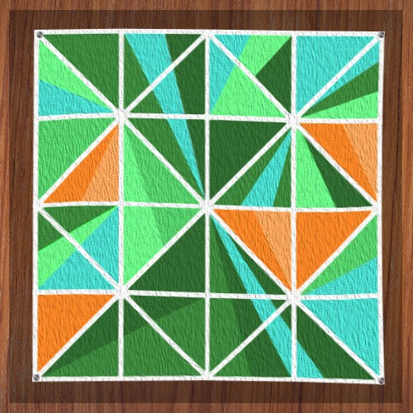

**Features:**

* Two-player game
* Background music and sound effects, including error warnings.
* Menu allowing players to play, read the rules and credits or quit.
* Rules are enforced on the playing board ensuring players cannot break the game.
* Customs graphics designed by the team.
* Unique win scenes for each player

**Design Decisions:**

The art style was inspired to pay homage to the Nepali heritage of the game while also reflecting an artistic style for the game that would be user friendly for players and comfortable enough for our designer to implement given our timeframe and resources. The colours are bright comfortable on the eyes as this is designed to be a relaxing board game.

The use of wooden aesthetics for the various menu items and the board is kept consistent across the game, again hinting at the more traditional background of the original board game.

The music and sound effects with chosen to be significantly more modern with the electronic chillwave choice of background music reflecting the light-hearted and relaxing nature of the game with the slightly higher tempo still adding a degree of energy to the environment. The sound effects for movement of tiles is simple and reflecting the movement of a physical tile on a wooden board while the error beep is more abrupt.

**Contributions:**

Arpan: Arpan had a simple skeleton of the game finish within the first few days of the team working together which gave Michael and Daniel something to work off. He then reworked the original code into a tidier system that is what the game is currently using. Arpan got the original placement of the boxes and tiles working within the few couple days.

Michael: Michael was the primary programmer once Arpan had the skeleton of the board down and was instrumental in writing in a few of the core rules the game had to follow as well as tidying the code into more an efficient and human-readable format. The majority of commits in the were from Michael, finalising the core logic.

Daniel: Daniel worked on the edges of the code, filling in smaller gaps left between the big features implemented by Arpan and Michael, such as adding the main menu, the background music and the switching between turns. Daniel also carried out much of the QA work and fed back information to Michael and Arpan on the state of the game.

**Credits:**

Background music – Just a dream wake up *(Kim Lightyear)*

