Backpropagation in single Neuron
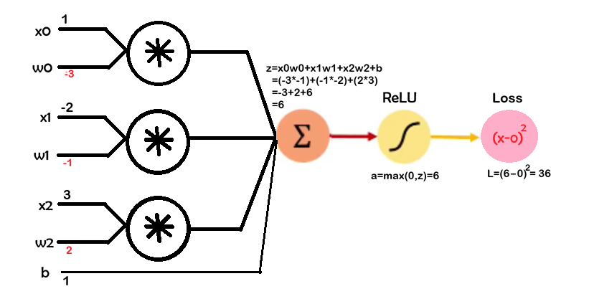
z=(−3)(1)+(−1)(−2)+(2)(3)+1
= z=−3+2+6+1 = 6

$$\frac{∂z}{∂w_{1}}=1,\frac{∂z}{∂w_{2}}=-2,\frac{∂z}{∂w_{3}}=3$$

ReLU activation:
a=max(0,z)=6
ReLU′(z)=1 Since $z=6>0$

Loss:
$$L=(a-y)^{2}=(6-0)^{2}=36$$$\frac{∂L}{∂a}=2(a-y)$ = 2(6-0) = 12
Weights: $w=[-3,-1, 2]$
Inputs: $x=[1,-2,3]$
Bias: $b=1$
Target: $y=0$
Learning rate: $η=0.001$
  - Linear combination: $z=w_{1}x_{1}+w_{2}x_{2}+w_{3}x_{3}+b$
$$\frac{∂z}{∂w_{1}}=x_{1},\frac{∂z}{∂w_{2}}=x_{2},\frac{∂z}{∂w_{3}}=x_{3}$$
1.2. Activation (ReLU): $a=\max\left(0,z\right) \frac{∂a}{∂z}=\left\{\begin{matrix}1 & \text{if }z>0 \\ 0 & \text{if }z≤0\end{matrix}\right.$
1.3. Loss (assume simple squared error):
$L=(a-y)^{2}$ $\frac{∂L}{∂a}=2(a-y)$ = 2(6-0) = 12
We need to find: $\frac{∂L}{∂w_{0}},\frac{∂L}{∂w_{1}},\frac{∂L}{∂w_{2}}$
Chain Rule Breakdown
$\frac{∂L}{∂w_{0}}=12⋅1=12$
$\frac{∂L}{∂w_{1}}=12⋅\left(-2\right)=-24$
$\frac{∂L}{∂w_{2}}=12⋅3=36$

4. Weight Updates
$$w_{i}^{new}=w_{i}-η⋅\frac{∂L}{∂w_{i}}$$Updated values
- $w_{1}=-3-0.001(12)=-3.012$
- $w_{2}=-1-0.001(-24)=-0.976$
- $w_{3}=2-0.001(36)=1.964$
- b = $2-0.001(12)=0.988$
Earlier Loss = 36
New Loss: 33.8724
New Z = 1(-3.012)-2(-0.976)+3(1.964) + 0.988
= 5.82
LossNew = (5.82)² = 33.8724

$$\frac{∂L}{∂w_{i}}=\frac{∂L}{∂a}⋅\frac{∂a}{∂z}⋅\frac{∂z}{∂w_{i}}$$
$$\frac{∂L}{∂w_{i}}=2(a-y)⋅{\text{ReLU}}^{'}(z)⋅x_{i}$$
= 2(6-0) $⋅{\text{ReLU}}^{'}(z)⋅x_{i}$
=$12⋅1⋅x_{i}$ [since ReLU′(z)=1 Since $z=6>0]$
$$\frac{∂L}{∂w_{i}}=2\left(a-y\right)⋅{\text{ReLU}}^{'}\left(z\right)⋅x_{i}$$
- If $z≤0$→ ReLU gradient = 0
→ ALL weight gradients = 0 ❌ (dead neuron problem)
- If $z>0$→ behaves like linear neuron:
$$\frac{∂L}{∂w_{i}}=(a-y)⋅x_{i}$$

Backpropagation with Multiple Neuron
(Layer of Neuron)

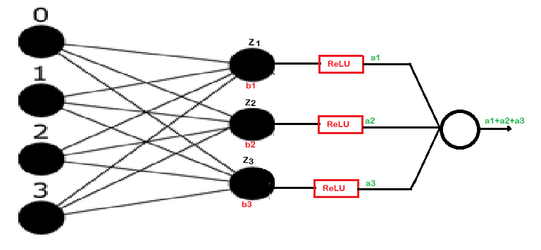
$$z_{1}= w_{11}x_{1}+w_{12}x_{2}+w_{13}x_{3}+w_{14}x_{4}+b_{1}$$
$$z_{2}= w_{21}x_{1}+w_{22}x_{2}+w_{23}x_{3}+w_{24}x_{4}+b_{2}$$
$$z_{3}= w_{31}x_{1}+w_{32}x_{2}+w_{33}x_{3}+w_{34}x_{4}+b_{3}$$

$$Y=a_{1}+a_{2}+a_{3}$$
$$Loss={(a}_{1}+a_{2}+a_{3}-0)^{2}$$
$$L=(y)^{2}$$

$$a_{1}= ReLU(z_{1})$$
$$a_{2}= ReLU(z_{2})$$
$$a_{3}= ReLU(z_{3})$$

$$\frac{∂L}{∂w_{11}}=\frac{∂L}{∂y}⋅\frac{∂y}{∂a_{1}}⋅\frac{∂a_{1}}{∂z_{1}}⋅\frac{∂z_{1}}{∂wz_{11}}$$$=2y . 1 . 1 . x_{1 } [ \frac{∂a_{1}}{∂z_{1}}=1 as z_{1}>0]$
2* 21.6 *1 = 43.2
$\frac{∂L}{∂w_{12}}=2y . 1 . 1 . x_{2 }$ 2 * 21.6 * 2 = 86.4
$\frac{∂L}{∂w_{13}}=2y . 1 . 1 . x_{3 }$ 2 * 21.6 * 3 = 129.6
$\frac{∂L}{∂w_{14}}=2y . 1 . 1 . x_{4 }$ 2 * 21.6 * 4 = 172.8
$\frac{∂L}{∂b_{1}}=2y . 1$ 43.2
$\frac{∂L}{∂b_{2}}=2y . 1$ 43.2
$\frac{∂L}{∂b_{3}}=2y . 1$ 43.2
$$w_{1}=[0.1, 0.2, 0.3, 0.4]$$
$$w_{2}=[0.5, 0.6, 0.7, 0.8]$$
$$w_{3}=[0.9, 1, 1.1, 1.2]$$
$$b_{1}=0.1, b_{2}=0.2, b_{3}=0.3$$
$$X=1, 2, 3, 4$$
$$Z_{1}=3, Z_{2}=7.2, Z_{3}=11.4$$
$$a_{1}=3, a_{2}=7.2, a_{3}=11.4$$
$$y=a_{1}+ a_{2}+ a_{3}=21.6$$
$$L=(21.6)^{2}= 466.56$$

$$w_{i}^{new}=w_{i}-η⋅\frac{∂L}{∂w_{i}}$$

$$\frac{∂L}{∂b_{1}}=\frac{∂L}{∂y}⋅\frac{∂y}{∂a_{1}}⋅\frac{∂a_{1}}{∂z_{1}}⋅\frac{∂z_{1}}{∂b_{11}}=2y . 1 . 1 . x_{1 } [ \frac{∂a_{1}}{∂z_{1}}=1 as z_{1}>0]$$

