Transformer
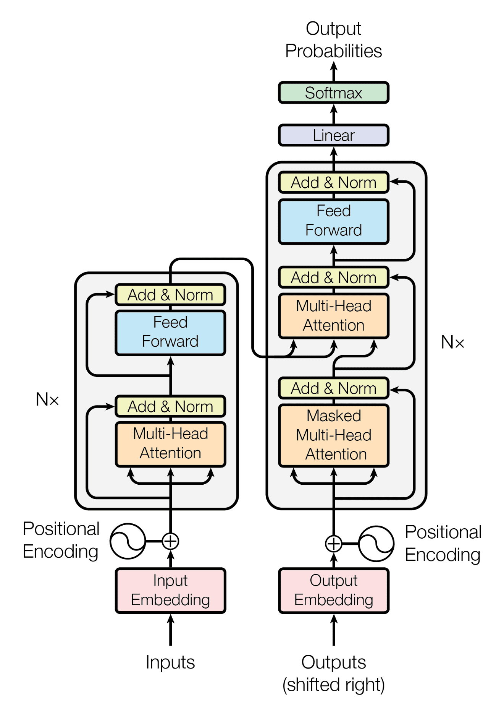
GPT_CONFIG_124M = {
"vocab_size": 50257, # total unique tokens in tokenizer vocabulary
"ctx_length": 1024, # maximum number of input tokens the model can process
"emb_dim": 768, # size of token embedding / hidden representation
"n_heads": 12, # number of attention heads in multi-head attention
"n_layers": 12, # number of transformer blocks (layers)
"drop_rate": 0.1, # dropout probability used for regularization
"qkv_bias": False # whether Query/Key/Value projections use bias terms
}

DummyGPTModel
class DummyGPTModel(nn.Module):
def __init__(self, cfg):
super().__init__()
self.tok_emb = nn.Embedding(cfg["vocab_size"], cfg["emb_dim"])
self.pos_emb = nn.Embedding(cfg["context_length"], cfg["emb_dim"])
self.drop_emb = nn.Dropout(cfg["drop_rate"])

# Use a placeholder for TransformerBlock
self.trf_blocks = nn.Sequential(
*[DummyTransformerBlock(cfg) for _ in range(cfg["n_layers"])]
)

# Use a placeholder for LayerNorm
self.final_norm = DummyLayerNorm(cfg["emb_dim"])
self.out_head = nn.Linear(
cfg["emb_dim"], cfg["vocab_size"], bias=False
)

def forward(self, in_idx):
batch_size, seq_len = in_idx.shape
tok_embeds = self.tok_emb(in_idx)
pos_embeds = self.pos_emb(torch.arange(seq_len, device=in_idx.device))
x = tok_embeds + pos_embeds
x = self.drop_emb(x)
x = self.trf_blocks(x)
x = self.final_norm(x)
logits = self.out_head(x)
return logits

class DummyTransformerBlock(nn.Module):
def __init__(self, cfg):
super().__init__()
# A simple placeholder

def forward(self, x):
# This block does nothing and just returns its input.
return x

class DummyLayerNorm(nn.Module):
def __init__(self, normalized_shape, eps=1e-5):
super().__init__()
# The parameters here are just to mimic the LayerNorm interface.

def forward(self, x):
# This layer does nothing and just returns its input.
return x

Token Embedding
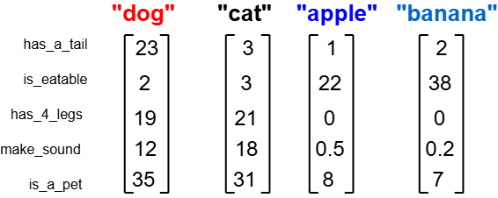
How are these vectors created?
We can train a neural network to turn words into vector embeddings. By looking at sentences in a document, the model learns which words often appear together and which have similar meanings.
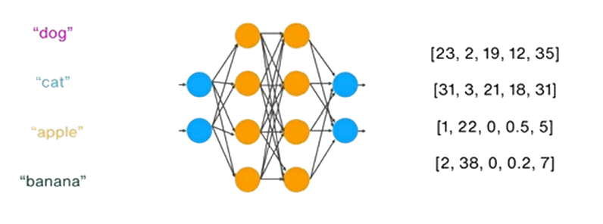
But this isn’t easy. For example, a model like GPT-2 has a vocabulary of about 50,000 words. That means it needs to learn a vector for each word and understand how they relate to one another. Doing this requires a lot of computation and data

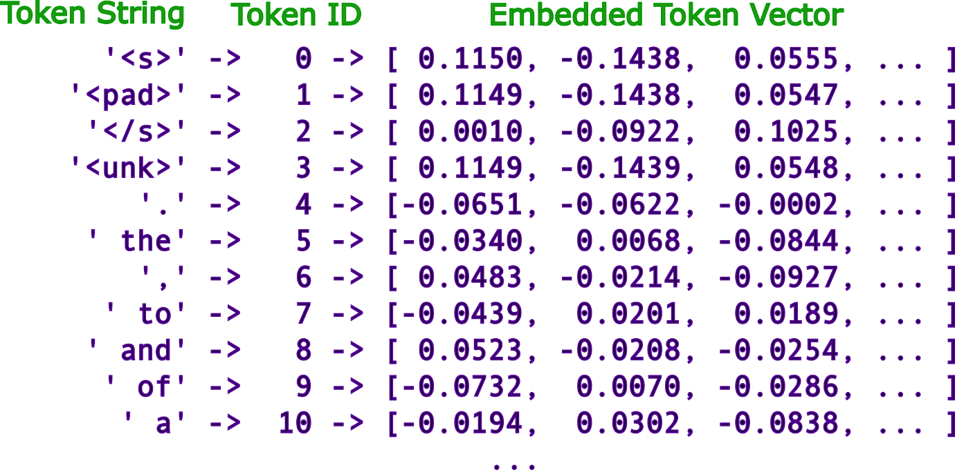

Embedding Model Comparison:
Model | Type | Embedding size  (dim) | Vocabulary size | Notes
Word2Vec | Static | 300 | ~3M (Google News) | One vector per word
ELMo | Context-aware (LSTM) | 256–1024 | No fixed vocab  (char-based) | Infinite word handling
DeepSeek | Transformer | ~4K–8K | ~100K–200K | Efficient scaling
GPT-2 (small) | Transformer | 768 | 50,257 | Subword BPE
GPT-3 (Davinci) | Transformer | 12,288 | ~100K | Much larger latent space
Modern LLMs (e.g. GPT-4 class) | Transformer | 3K–12K+ | 100K–200K+ | Larger vocab trend

How are these vectors created?
Step1: Start with a tiny dataset:

Imagine we have this small corpus:
From this, our vocabulary is:
["the", "cat", "dog", "sits", "on", "mat", "log"]

"the cat sits on the mat"
"the dog sits on the log"

Step2: Create training pairs
(context learning):
If we choose a window size of 1, training pairs look like:
- (“the” → “cat”), (“the” → “sits”),
- ("cat" → "the"), ("cat" → "sits"), ("cat" → "on")
- (“sits” → “the”), ("sits" → "cat"), ("sits" → "on")
- (on, cat), (on, sits), (on, the), (on, mat),
- (the, sits), (the, on), (the, mat),
- (mat, on), (mat, the)
So the model learns: words appearing in similar contexts should have similar vectors.

One simple method is Word2Vec (Skip-gram).
The idea: given a word, predict its
surrounding words.

"the cat sits on the mat"

Step 4: Neural network structure:

A very simple network:
Input (one-hot) → Hidden layer → Output layer
- Input size = vocabulary size (7)
- Hidden layer = embedding size (say 3)
- Output = probability of context words

What happens during training
When the model processes:
Case 1: ("cat" → "sits")
- It adjusts weights so cat’s vector helps predict "sits"
Case 2: ("dog" → "sits")
- It adjusts weights so dog’s vector helps predict "sits"
Since both:
- need to predict the same outputs
- receive similar gradient updates

Step3: Convert words to numbers:
We encode each word as a one-hot vector:
Example (7 words total):
- “the” → [1,0,0,0,0,0,0]
- "cat" → [0,1,0,0,0,0,0]
- "dog" → [0,0,1,0,0,0,0]
These are sparse and not meaningful yet.

Step 5: Training process
For each pair like ("cat" → "sits"):
- Input: one-hot("cat")
- Predict: probability distribution over all words
- Compare with actual ("sits")
- Compute loss (cross-entropy)
- Update weights using backpropagation
Repeat this thousands/millions of times.

Step 6: Final result (embeddings)
cat ≈ [0.2, 0.8, 0.1]
dog ≈ [0.25, 0.75, 0.15]
mat = [0.9, 0.1, 0.2]
log = [0.85, 0.15, 0.25]

# Step 1: Toy dataset  sentences = [  ["the", "cat", "sits", "on", "the", "mat"],  ["the", "dog", "sits", "on", "the", "log"]  ]  Step 2: Build vocabulary  import numpy as np  words = list(set(w for s in sentences for w in s))  word_to_idx = {w:i for i,w in enumerate(words)}  idx_to_word = {i:w for w,i in word_to_idx.items()}  vocab_size = len(words)  embedding_dim = 2 | Step 3: Generate training pairs (window=1)  pairs = []  window = 1  for sent in sentences:  for i, word in enumerate(sent):  for j in range(max(0, i-window), min(len(sent), i+window+1)):  if i != j:  pairs.append((word, sent[j]))  # Step 4: Initialize weights  W1 = np.random.randn(vocab_size, embedding_dim) # embeddings  W2 = np.random.randn(embedding_dim, vocab_size) # output
# Step 5: Helper functions  def softmax(x):  e_x = np.exp(x - np.max(x))  return e_x / e_x.sum()  def one_hot(idx, size):  vec = np.zeros(size)  vec[idx] = 1  return vec  # Step 6: Helper functions  lr = 0.05  for epoch in range(5000):  loss = 0  for target, context in pairs:  x = one_hot(word_to_idx[target], vocab_size)  y_true = one_hot(word_to_idx[context], vocab_size)  # Forward pass  h = np.dot(x, W1) # embedding  u = np.dot(h, W2) # scores  y_pred = softmax(u)  # Loss (cross-entropy)  loss -= np.log(y_pred[np.argmax(y_true)] + 1e-9)  # Backprop  error = y_pred - y_true  dW2 = np.outer(h, error)  dW1 = np.outer(x, np.dot(W2, error))  # Update  W1 -= lr * dW1  W2 -= lr * dW2  if epoch % 1000 == 0:  print(f"Epoch {epoch}, Loss: {loss:.4f}")  # Step 7: Inspect embeddings  for word in words:  print(word, W1[word_to_idx[word]]) | PyTorch Implementation (Skip-gram)  Step 1: Dataset : Same as Step1- Toy dataset  Step 2: Training pairs: Same as Step3 - Generate training pairs  Step 3: Model  # nn.Embedding is just a lookup table (no explicit one-hot needed)  class SkipGram(nn.Module):  def __init__(self, vocab_size, embedding_dim):  super().__init__()  self.embeddings = nn.Embedding(vocab_size, embedding_dim)  self.output = nn.Linear(embedding_dim, vocab_size)  def forward(self, x):  x = self.embeddings(x) # this replaces one-hot + matrix multiply  x = self.output(x)  return x  Step 4: Training  for epoch in range(1000):  total_loss = 0  for target, context in pairs:  target = torch.tensor([target])  context = torch.tensor([context])  output = model(target)  loss = loss_fn(output, context)  optimizer.zero_grad()  loss.backward()  optimizer.step()  total_loss += loss.item()  if epoch % 200 == 0:  print(f"Epoch {epoch}, Loss: {total_loss:.4f}")  Step 5: Training  embeddings = model.embeddings.weight.data  for word, idx in word_to_idx.items():  print(word, embeddings[idx])

The Attention Mechanism
(Self Attention without Trainable weights)
Self Attention
with trainable weights
Context matters
Multi-Head Attention
(only consider pervious & current input in a sequence)
Causal Attention
(only consider pervious & current input in a sequence)
Word | Example Context
see | I will see you soon  I will see this project to its end  I see what you mean
bank | I went to the bank to apply for a loan  I am banking on the job offer coming through  I am standing on the left bank
it | The animal didn’t cross the street because it was too tired  The animal didn’t cross the street because it was too wide
station | The train left the station on the time  The radio station was playing 60s hit  I was stationed on a remote island in Polynesia
Input Vector
(token embedding)
“your” “journey” “starts” ……. “step”
x⁽¹⁾ x⁽²⁾ x⁽³⁾ ……. x^{(T)}
[0.4,0.1,0.8] [0. 5,0.8,0.6] [0.5,0.8,0.6] …… [0.0, 0.8,0.5]
Same logic for all words
Here we just showed only for one word “journey”

a_{2,1}

a_{2,2}

a_{2,3}

a_{2,T}

The context vector z⁽²⁾ is computed as a combination of all input vector weighted with respect to input element x⁽²⁾

[0.4,0.6,0.5]
z⁽²⁾
Attention weight to weigh the importance on input x^{(i)}

z⁽²⁾ = $a_{1,6}x_{1}+a_{2,6}x_{2}+a_{3,6}x_{3}+…+a_{T,6}x_{T}$

Attention weights
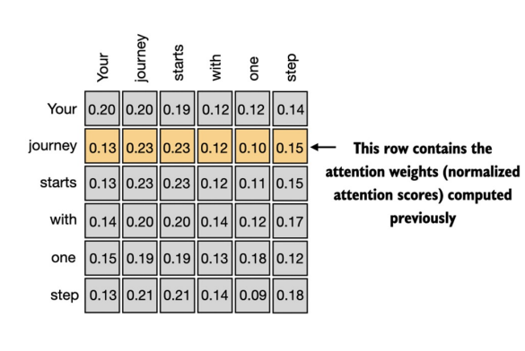
How should we achieve this?
- Dot Product Similarity:
$$⟨\text{journey},\text{step}⟩=∥\text{journey}∥ ∥\text{step}∥cos⁡(θ)$$
- However, since $cos⁡(θ)$can be negative,
these similarity scores cannot be used
directly as weights. We need weights that are:
  - Non-negative
  - Sum to 1
Solution: Softmax Normalization
$$s_{1,6}=\frac{\exp\left(⟨x_{1},x_{6}⟩\right)}{\sum_{k}{exp⁡}\left(⟨x_{k},x_{6}⟩\right)}$$

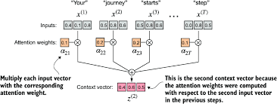
Implement Simple Attention mechanism
#Step1: Convert Words into Vectors  inputs = torch.tensor([  [0.43, 0.15, 0.89], # your (x^1)  [0.55, 0.87, 0.66], # journey (x^2)  [0.57, 0.85, 0.64], # starts (x^3)  [0.22, 0.58, 0.33], # with (x^4)  [0.77, 0.25, 0.10], # one (x^5)  [0.05, 0.80, 0.55] # step (x^6)  ]) | #Step2: Compute Similarity  # Lets take the 2nd token “journey”  # The attention scores are calculated between the  # query token and each input tokens  query = inputs[1] # 2nd input token is the query  attn_scores_2 = torch.empty(inputs.shape[0])  for i, x_i in enumerate(inputs):  attn_scores_2[i] = torch.dot(x_i, query)  print(attn_scores_2) # [0.9, 1.4, 1.4, 0.8, 0.7, 1.0]
#Step3: Softmax Normalization  # Normalize each of the attention scores  # to obtain attention weights that sum up to 1  attn_weights_2 = torch.softmax(attn_scores_2, dim=0)  print("Attention Weights: ", attn_weights_2)  print("Sum: ", attn_weights_2.sum()) #1 | # [0.1385, 0.2379, 0.2333, 0.1240, 0.1082, 0.1581]  your journey starts with one step  13% 23% 23% 12% 10% 15%  i.e., High attention is paid to journey(23%) and starts(23%)
# Step4: Weighted Sum (Context Vector)  # Calculate Context Z(2) Vector as  # weighted sum of all input vectors  # This involves multiplying each input vector by its corresponding attention weight  0.1385[0.43, 0.15, 0.89] + 0.2379[0.55, 0.87, 0.66] +  0.2333[0.57, 0.85, 0.64] + 0.1240[0.22, 0.58, 0.33] +  0.1082[0.77, 0.25, 0.10] + 0.1581[0.05, 0.80, 0.55]  query = inputs[1] # 2nd input token is the query  context_vec_2 = torch.zeros(query.shape)  for i, x_i in enumerate(inputs):  context_vec_2 += attn_weights_2[i] * x_i  print(context_vec_2) # [0.4419, 0.6515, 0.5683] | # Step5: Now we can extend this computation to calculate attention weights and context vectors for all inputs  First, we add an additional for-loop to compute the dot products for all pairs of inputs  attn_scores = torch.empty(6,6)  for i, x_i in enumerate(inputs):  for j, x_j in enumerate(inputs):  attn_scores[i,j] = torch.dot(x_i, x_j)  print(attn_scores)  # Optimization:Avoid nested for loop  attn_scores = inputs @ inputs.T  print(attn_scores)
# Step6: Normalize each row, so that the values in each row sums to 1  attn_weights = torch.softmax(attn_scores, dim=-1)  print(attn_weights) | # Step7: we now use these attention weights to compute all context vectors  all_context_vecs = attn_weights @ inputs  print(all_context_vecs)

Why do Transformers need trainable weight (Q,K,V) matrices in self-attention? Why can’t we directly compute attention using only raw embedding dot products?
Problem With This Simple Method (Dot Product)
"The bank was flooded after heavy rain."
“The cat sat on the mat because it was warm”
If we use raw embedding similarity:
- "bank" may strongly match "money", because embedding contains financial meaning
- Without Trainable weights: if we only use dot product between the query “warm” with each word’s embedding, we might find that ” warm” is most similar to itself, and may be somewhat related to “mat” (if our embeddings capture that mats can be warm). Words like “the”, “cat” and “sat” might have low similarity scores because they are not semantically related to “warm”
But in this sentence:
- river-bank meaning is correct

Self attention with learned weights
Intuition
Example:
"The bank approved the loan because it trusted the customer"

For word "it":
- Query asks: “Who can trust someone?”
- Keys from other words respond:
  - bank → strong match
  - loan → weak match
  - customer → medium
Thus "it" attends strongly to "bank".

- Query: What am I searching for?
- Key: What information do I contain?
- Value: What information should I send?
Why Weights Matter?
Without weights:
- similarity only depends on raw embeddings
With learned weights model learns:
- subject-object relations
- tense
- semantic roles
$$Q=XW_{q}=\left[\begin{matrix}0.2309 & 1.0966 \\ 0.4307 & 1.4551 \\ 0.4301 & 1.4343 \\ 0.2355 & 0.7990 \\ 0.2983 & 0.6566 \\ 0.2569 & 1.0533\end{matrix}\right]$$
$$K=XW_{k}=\left[\begin{matrix}0.3670 & 0.7646 \\ 0.4434 & 1.1418 \\ 0.4361 & 1.1156 \\ 0.2409 & 0.6706 \\ 0.1827 & 0.3292 \\ 0.3275 & 0.9642\end{matrix}\right]$$

$$V=XW_{v}=\left[\begin{matrix}0.1855 & 0.8812 \\ 0.3951 & 1.0037 \\ 0.3879 & 0.9830 \\ 0.2393 & 0.5493 \\ 0.1492 & 0.3345 \\ 0.3221 & 0.7863\end{matrix}\right]$$

- long-distance dependencies
$$W_{q}=\left[\begin{matrix}0.2961 & 0.5166 \\ 0.2517 & 0.6886 \\ 0.0740 & 0.8665\end{matrix}\right]$$

$$W_{k}=\left[\begin{matrix}0.1366 & 0.1025 \\ 0.1841 & 0.7264 \\ 0.3153 & 0.6871\end{matrix}\right]$$

$$W_{v}=\left[\begin{matrix}0.0756 & 0.1966 \\ 0.3164 & 0.4017 \\ 0.1186 & 0.8274\end{matrix}\right]$$

$$\left[\begin{matrix}0.43 & 0.15 & 0.89 \\ 0.55 & 0.87 & 0.66 \\ 0.57 & 0.85 & 0.64 \\ 0.22 & 0.58 & 0.33 \\ 0.77 & 0.25 & 0.10 \\ 0.05 & 0.80 & 0.55\end{matrix}\right]$$

Full Transformer Formula:
$$Attention(Q,K,V)=softmax\left(\frac{QK^{T}}{\sqrt{d_{k}}}\right)V$$
Why divide by $\sqrt{d_{k}}$?
- Dot products become very large in high dimensions.
- Large values make softmax unstable.
- Scaling keeps gradients stable.
Example2
"Jaguar runs fast"
Problem:
Dot products:
$$Jaguar⋅fast=20$$
But this similarity is vague.
Embedding contains BOTH:
- animal meaning
- car meaning
No specialization.

Without Trainable Weights
Suppose embeddings:
Word | Vector
Jaguar | [5,5]
runs | [1,1]
fast | [2,2]

- Jaguar = animal?
- Jaguar = car?

With Trainable Weights:
The model learned:
in this context, “Jaguar” behaves more like an animal.

$$Jaguar=[animal=5, vehicle=5]$$
$W_{Q}=\left[\begin{matrix}2 & 0 \\ 0 & 0.2\end{matrix}\right] ==>$Transformed: $\left[5,5]\left[\begin{matrix}2 & 0 \\ 0 & 0.2\end{matrix}\right]=[10,1\right]$
Now:
- animal feature dominates
- vehicle feature suppressed

Another Important Reason
Different Relationships Need Different Spaces
Example 1 — Pronoun Resolution
"John gave food to the dog because it was hungry."
Question: Who is “it”?
- John?
- dog?
- food?
Humans know:
- dogs become hungry
- food is not hungry
Transformer learns this statistically.

Relationship | Example
subject-verb | dog runs
pronoun reference | John lost his bag
tense | ate vs eating
location | lives in Paris
sentiment | great movie
Step 1 — Initial Embeddings
Word | Initial Meaning
John | person
dog | animal
hungry | biological state
Initially these are just vectors. The model does NOT yet know grammar.
Why does "dog" get high score?
Because during training, model repeatedly saw patterns like:
"dog was hungry"
"cat was hungry"
"child was hungry"

So weights evolve to associate:
- hungry ↔ living things

Step 2 — Self-Attention Comparison
When processing "it"
Transformer computes attention
scores with all words.
Compared Word | Attention Score
John | medium
dog | HIGH
hungry | low

Example 2 — Grammar Learning
"The cats are sleeping"
During training the model repeatedly sees:
- cats are
- dog is
- boys are
- girl is
Eventually attention heads learn agreement patterns.

- One Attention Head May Learn: plural noun ↔ plural verb
- Another Head May Learn: subject ↔ action
Example Attention Pattern
"The cats are sleeping"
The word "eats" may strongly attend to:
Training Process Behind It
Transformer training objective:
Predict missing/next words.
Example:
"The dogs ___ barking"
Correct answer: are, Wrong: is
If model predicts wrong:
- gradients update weights
- attention patterns improve
Over billions of examples:
grammar structures emerge naturally.

- cat
because verbs depend on subjects.

How This Emerges Mathematically
- Suppose: $Q_{eats}$ learns to ask:
“Who is performing this action?”
- And keys: $K_{cat}$ learn to advertise:
“I am a noun that can perform actions.”

What is QKV in Transformer Architecture
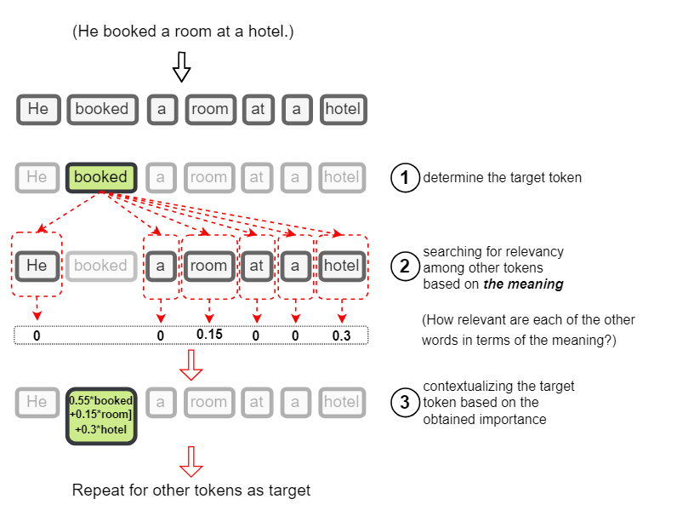
To make more sense, think of when you search for something on YouTube, for example. Assume YouTube stores all its videos as a pair of “video title” and the “video file” itself. Which we call a Key-Value pair, with the Key being the video title and the Value being the video itself.

The text you put in the search box is called a Query in search terms. So in a sense, when you search for something, YouTube compares your search Query with the Keys of all its videos, then measures the similarity between them, and ranks their Values from the highest similarity down.
A cute cat

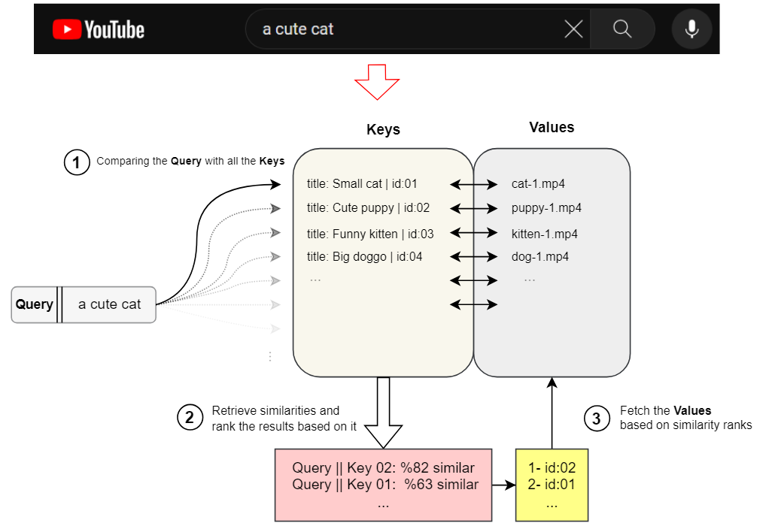
In our problem, we have a sequence of token vectors, and we want to search for the weights to re-weight and contextualize each token (word) embedding of the sequence, we can think in terms of:
- What you want to look for is the Query.
- What you are searching among is Key-Value pairs.
- The query is compared to all the Keys to measure the relevance/importance/similarity.
- The Values are utilized based on the assigned similarity measure.
Another helpful relevant analogy is a dictionary (or hashmap) data structure. A dictionary stores data in key-value pairs and it maps keys to their respective value pairs. When you try to get a specific value from the dictionary, you have to provide a query to match its corresponding key, then it searches among those keys, compares them with the query, and if matched, the desired value will be returned.
However, the difference here is that this is a “hard-matching” case, where the Query either exactly matches the Key or it doesn’t and an in-between similarity is not measured between them.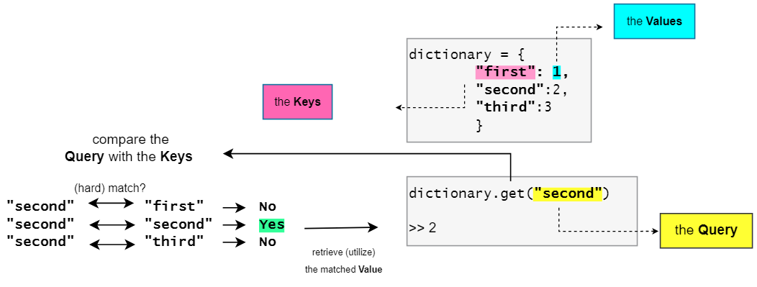
We earlier mentioned that we are only working with real-valued vectors (token embeddings). So the Query, Key, and Value also need to be vectors. However, so far we only have one vector for each token which is its embedding vector. So, how should we obtain the Query, Key, and Value vectors?
We Construct them using linear projections (linear transformations aka single dense layer with separate sets of weights: Wq, Wₖ, Wᵥ) of the embedding vector of each token. This means we use a learnable vector of weights for each of the Query, Key, and Value to do a linear transformation on the word embedding to obtain the corresponding Query, Key, and Value vectors.
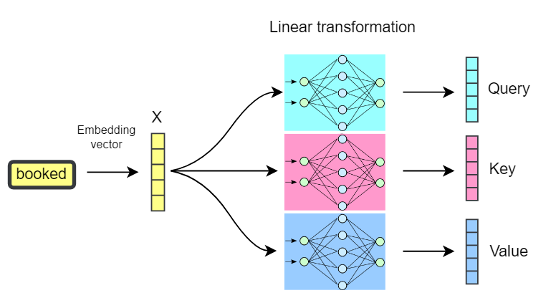
An embedding of a token may represent different contextual, structural, and syntactical aspects of that token. By using learnable linear transformation layers to construct these vectors from the token’s embedding, we allow the network to:
network to:
- Extract and pass a limited specific part of that information into the Q, K, and V vectors.
- Determine a narrower context in which the search and match is going to be done.
- Learn what information in an embedding is more important to attend to.

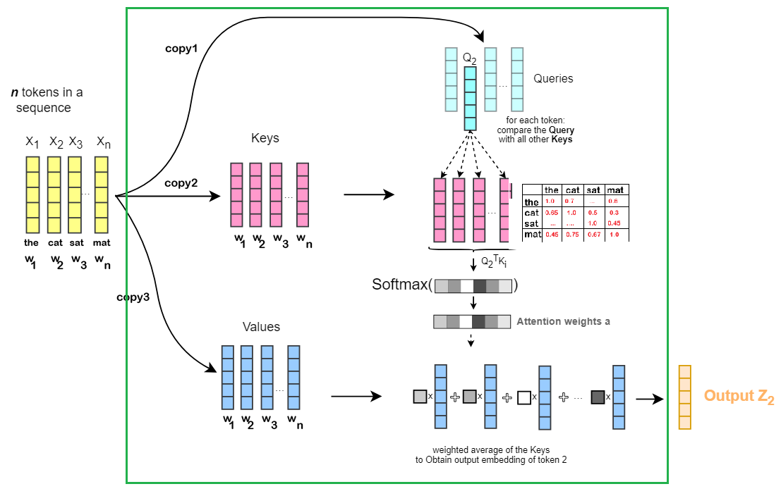
the
cat
sat
mat
0.1w1​+0.7w2​+0.2w3​+⋯
0.1w1​+0.7w2​+0.2w3​+⋯
0.1w1​+0.7w2​+0.2w3​+⋯
0.1w1​+0.7w2​+0.2w3​+⋯
$${\hat{W}}_{1}$$

$${\hat{W}}_{2}$$

$${\hat{W}}_{3}$$

$${\hat{W}}_{n}$$

$$Attention(Q,K,V)=softmax\left(\frac{QK^{⊤}}{\sqrt{d_{k}}}\right)V$$

So the whole notion of the Q, K, and V vectors is like a soft dictionary to mimic a search-and-match procedure from which we learn how much two tokens in a sequence are relevant (the weights), and what should be added as the context (the values). Also, note that this process does not have to happen sequentially (one token at a time). This all happens in parallel by using matrix operations.
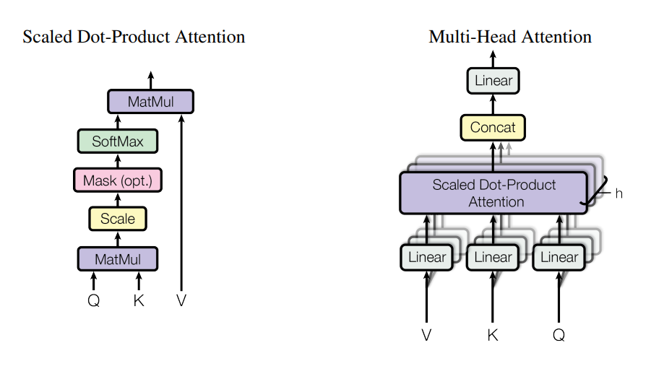

Contextual Embedding in Transformer
Input sentence:
What’s different in transformers?
Word2Vec:
- Static embeddings (same vector always)
Transformers:
- Contextual embeddings
Example:
"bank" in:
- "river bank"
- "bank account"
Different vectors!
"the cat sits on the mat"

Step 1: Tokenization
["the", "cat", "sits"] → [5, 12, 33]

Step 2: Embedding lookup
[5, 12, 33] →
[
[0.1, 0.8, ...], # "the"
[0.2, 0.7, ...], # "cat"
[0.3, 0.6, ...] # "sits"
]
👉 Same idea as your model.
Token IDs
↓
Embedding Layer ← (what you implemented)
↓
+ Positional Encoding
↓
Transformer Blocks (attention)
↓
Output probabilities

How transformers achieve Self-attention?
Instead of:
word → fixed vector
They do:
word → embedding → attention → context-aware vector

Why positional encoding? (why order matter?)

1. The core problem:
Attention has no sense of order
3. Why self-attention alone is not enough
If we remove positional encoding, the model sees a bag of words:
I, deposited, money, in, the, bank

Self-attention computes relationships like:
“Which words are relevant to each other?”
But without positional encoding, it does NOT know:
“What is the order of those words?”
So “money → bank” and “bank → money” would look identical in a bag-of-words sense.

1. “I deposited money in the bank”
2. “bank the in money deposited I”
Even though both contain the same words, But
meaning depends heavily on order

2. Why position matters
(your example: “bank”)
Consider the sentence:
“I deposited money in the bank”
Here, “bank” = financial institution
Note: Why not just use numbers like 1, 2, 3, 4…?
We could assign:
- “I” → 1 , “deposited” → 2 , “money” → 3
This causes problems:
- The model might think position 10 is “10× bigger” than position 1 (which is not meaningful in language)
- It doesn’t generalize well to longer sequences than it saw during training
So instead, Transformers use a smooth mathematical pattern: sine and cosine waves.
position | sin(pos) | cos(pos)
1 | 0.84 | 0.54
2 | 0.91 | -0.42
3 | 0.14 | -0.99

“bank at position 6” ≠ bank at position 2”
even if the word is identical
But compare:
“I sat on the river bank”
Here, “bank” = river edge.

The word “bank” is ambiguous. The meaning
is resolved by context and position:
Even dimensions:
$$PE(pos,2i)=sin⁡\left(\frac{pos}{{10000}^{2i/d}}\right)$$Odd dimensions: $$PE(pos,2i+1)=cos⁡\left(\frac{pos}{{10000}^{2i/d}}\right)$$
- pos = word position in sentence
- d = embedding dimension (e.g., 512 or 768)
- i = dimension index

Why Self-attention? (Why Attention matter?)
Embeddings alone don’t understand order.
Step 3: Self-attention idea
We compute:
- Query (Q): what I’m looking for
- Key (K): what I represent
- Value (V): what I contain
For simplicity, assume:
Q = K = V = embeddings

Case A: “bank” in financial context
Sentence:
I deposited money in the bank

We compute similarity of bank with other words.
Dot products (simplified):
bank · money = HIGH (0.5·0.9 + ...)
bank · deposited = HIGH
bank · river = LOW
bank · sat = LOW

Softmax result (attention weights):
money → 0.45
deposited → 0.35
others → 0.20

New representation of “bank”:
bank_finance =
0.45·money + 0.35·deposited + 0.20·others

Case B: “bank” in river context
Sentence:
I sat on the river bank

Now attention changes:
bank · river = HIGH
bank · sat = MEDIUM
bank · money = LOW

Softmax result (attention weights):
river → 0.50
sat → 0.30
others → 0.20

New representation:
bank_river =
0.50·river + 0.30·sat + 0.20·others

“I deposited money in the bank”
“I sat on the river bank”
The word bank has two meanings:
- 💰 financial institution
- 🌊 river edge

Step1: Token embeddings
Let’s simplify embeddings to 3D vectors:
bank = [0.5, 0.5, 0.5]
money = [0.9, 0.1, 0.2]
river = [0.2, 0.9, 0.3]
deposited = [0.8, 0.2, 0.4]
sat = [0.3, 0.7, 0.6]

Step2: Add positional encoding
Sentence 1:
I deposited money in the bank
Sentence 2:
I sat on the river bank

Even after positional encoding, bank is still ambiguous.
So we need attention.

------------------------------------------------------

Full attention matrix view
For every word, transformer builds a grid like this:
 | I | deposited | money | river | bank
I | 0 | 0.1 | 0.1 | 0.0 | 0.1
deposited | 0 | 0.1 | 0.3 | 0.0 | 0.2
money | 0 | 0.2 | 0.2 | 0.0 | 0.1
river | 0 | 0.0 | 0.0 | 0.2 | 0.4
bank | 0 | 0.3 | 0.4 | 0.5 | 0.1
This is usually visualized as a heatmap where:
- bright = strong attention
- dark = weak attention

Multi-head Attention
- grammar (who did what)
- Semantic meaning (financial vs river bank)
- relationships (verb-object links)

Concatenation of Multiple Attention Heads
┌──────────────┐
│ Head 1 │ → meaning (money)
├──────────────┤
BANK ──────────▶│ Head 2 │ → grammar (verb/object)
├──────────────┤
│ Head 3 │ → context (location)
└──────────────┘
↓
Concatenate + Linear layer
↓
FINAL CONTEXTUAL BANK VECTOR

Head 1 → [0.8, 0.1] (meaning)
Head 2 → [0.3, 0.9] (grammar)
Head 3 → [0.6, 0.4] (context)
We combine them:
BANK_final = concat(H1, H2, H3)

Full transformer forward pass walk through
We’ll use a simple sentence:
“I deposited money in the bank”

And we’ll pretend the model is trying to predict the next word after “bank”.

OVERVIEW:
Tokens → Embeddings (meaning) → Positional Encoding (order) → Multi-Head Self-Attention (relationships)
→ Feed Forward Network (feature refinement)
→ Final Linear Layer (map to vocabulary)
→ Softmax (probabilities) → Prediction / NEXT WORD

STEP 1: Tokenization  We convert text into token IDs: | STEP 2: Token Embeddings  Each token becomes a vector (say 4D for simplicity):
"I deposited money in the bank"  → [I, deposited, money, in, the, bank]  → [10, 532, 98, 44, 21, 77] | I → [0.2, 0.1, 0.7, 0.0]  deposited → [0.6, 0.2, 0.1, 0.9]  money → [0.9, 0.1, 0.3, 0.4]  in → [0.3, 0.8, 0.2, 0.1]  the → [0.5, 0.4, 0.6, 0.2]  bank → [0.7, 0.3, 0.8, 0.5]
Now we have a matrix: X = (6 tokens × 4 dims)

STEP 3: Positional Encoding (adds order  We add position vectors: | Example:
P0 = [0.0, 0.1, 0.0, 0.1]  P1 = [0.1, 0.0, 0.1, 0.0]  P2 = ...  Final input: X' = embedding + position | bank = [0.7, 0.3, 0.8, 0.5]  P5 = [0.1, 0.0, 0.1, 0.0]  → bank' = [0.8, 0.3, 0.9, 0.5]

STEP 4: Self-Attention  We compute for each token:  Q (Query), K (Key), V (Value)  Q = XWq  K = XWk  V = XWv | Focus on ONE token: “bank”  We compute how “bank” attends to all tokens:  Step 4.1: similarity scores  bank · I = 0.2  bank · money = 0.9 ← strong  bank · deposited = 0.85 ← strong  bank · in = 0.3  bank · the = 0.4  bank · bank = 0.6 | Step 4.2: softmax  (attention weights)  I → 0.05  deposited→ 0.30  money → 0.35  in → 0.05  the → 0.05  bank → 0.20

Step 4.3: weighted sum (new representation)
bank_context = 0.05·I + 0.30·deposited + 0.35·money + 0.20·bank + ...
👉 Now “bank” becomes financial-context-aware

STEP 5: Multi-head attention (parallel views)  concat(head1, head2, head3) → linear transform  STEP 7: Final Linear Layer (vocabulary projection)  We now predict next word:  logits = hidden_state(bank) · W_vocab | STEP 6: Feed Forward Network (MLP per token)  Each token independently passes through:  FFN(x) = W2(ReLU(W1x))  STEP 8: Softmax  Convert logits into probabilities:  P("loan") = 0.30  P("account")= 0.25  P("river") = 0.01
Model outputs: "I deposited money in the bank → loan"

Causal Self Attention
(self-attention + masking constraint)

Self-attention with Q, K, and V tells the model how tokens interact.
Causal attention tells the model which tokens are allowed to interact.
Why causal attention is needed?
For text generation, the model must predict the next token without cheating.
What causal attention does?
Causal attention adds a mask to self-attention.
Token at position $i$can only attend to
positions $≤i$.
Token | Can attend to
The | The
Cat | The, cat
Sat | The, cat, sat
on | The, cat, sat, on
Future tokens are masked with $-∞$before softmax.
Regular self-attention:
In self-attention, every token can attend to every
other token.
For a sequence:
"I love deep learning"

each word can look at all words,
including future ones.
$$\text{Attention}(Q,K,V)=\text{softmax}\left(\frac{QK^{T}}{\sqrt{d_{k}}}\right)V$$
Nothing here prevents token 1 from seeing token 4.
So during training:
- "I" can see "learning"
- "love" can see "deep"
- etc.
This is fine for tasks where the whole sentence is available:
- translation encoder
- BERT
- sentiment classification

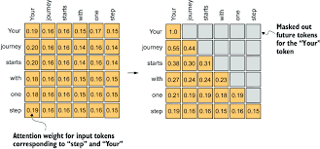
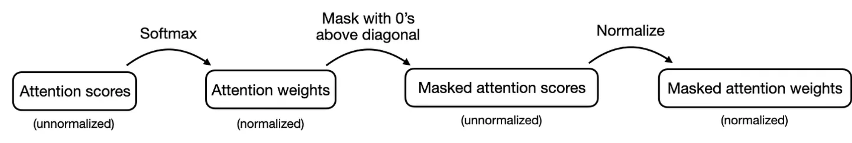
Alternatively, there is a more efficient way to achieve the same results.
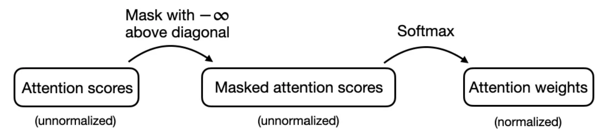

Implement Self Attention
import torch.nn as nn  class SelfAttentionV1(nn.Module):  def __init__(self, d_in, d_out, qkv_bias=False):  super().__init__()  self.W_query = nn.Linear(d_in, d_out, bias=qkv_bias)  self.W_key = nn.Linear(d_in, d_out, bias=qkv_bias)  self.W_value = nn.Linear(d_in, d_out, bias=qkv_bias)  def forward(self, x):  keys = x @ self.W_key(x)  queries = x @ self.W_query(x)  values = x @ self.W_value(x)  attn_scores = queries @ keys.T # omega  attn_weights = torch.softmax(  attn_scores / keys.shape[-1] ** 0.5, dim=-1  )  context_vec = attn_weights @ values  return context_vec | More Efficient ways  Attention Scores --> Upper Triangular Infinity Mask -->Softmax  torch.triu(torch.ones(ctx_length, ctx_length))  ([[1., 1., 1., 1., 1., 1.],  [0., 1., 1., 1., 1., 1.],  [0., 0., 1., 1., 1., 1.],  [0., 0., 0., 1., 1., 1.],  [0., 0., 0., 0., 1., 1.],  [0., 0., 0., 0., 0., 1.]])  mask = torch.triu(torch.ones(ctx_length,  ctx_length), diagonal=1)  masked = attn_scores.masked_fill(mask.bool(),  -torch.inf)  print(masked)
torch.manual_seed(123)  sa_v1 = SelfAttentionV1(d_in, d_out)  print(sa_v1(inputs)) | Apply softmax  attn_weights = torch.softmax(  masked / keys.shape[-1] ** 0.5, dim=1  )

class CausalAttention(nn.Module):
def __init__(self, d_in, d_out, ctx_length, dropout, qkv_bias=False):
super().__init__()
self.d_out = d_out
self.W_query = nn.Linear(d_in, d_out, bias=qkv_bias)
self.W_key = nn.Linear(d_in, d_out, bias=qkv_bias)
self.W_value = nn.Linear(d_in, d_out, bias=qkv_bias)
self.dropout = nn.Dropout(dropout)
self.register_buffer('mask', torch.triu(torch.ones(ctx_length, ctx_length), diagonal=1))

def forward(self, x):
b, num_tokens, d_in = x.shape # new batch dimension b
keys = self.W_key(x)
queries = self.W_query(x)
values = self.W_value(x)

attn_scores = queries @ keys.transpose(-2, -1) # omega
attn_scores.masked_fill(
self.mask.bool()[:num_tokens, :num_tokens], -torch.inf
)
attn_weights = torch.softmax(attn_scores / keys.shape[-1] ** 0.5, dim=1)
attn_weights = self.dropout(attn_weights)

context_vec = attn_weights @ values
return context_vec

Why dropout is applied after attention scores?
The attention mechanism computes: $\text{Attention}(Q,K,V)=\text{softmax}\left(\frac{QK^{T}}{\sqrt{d_{k}}}\right)V$
The important part is: $A=\text{softmax}\left(\frac{QK^{T}}{\sqrt{d_{k}}}\right)$
where $A$is the attention weight matrix.
Dropout is typically applied like this: $\text{Dropout}(A)V$

Why dropout is needed here
Without dropout:
- the model may always focus on the same tokens,
- attention heads can become overly confident,
- the model overfits training data,
- some heads become redundant.
Applying dropout forces the model to distribute attention more robustly.

Intuition
Think of attention like students copying answers.
If one student always copies from the same topper, they fail when that topper is absent.
Dropout randomly blocks some “copy connections” during training so the student learns from multiple sources.
Example:
"The cat sat on the mat"
After softmax, attention weights may become:
Here the model heavily depends on "cat".
Without dropout The output becomes:
$$0.70⋅V_{\text{cat}}+0.10⋅V_{\text{sat}}+...$$The model learns:
“Whenever predicting sat, just look at cat.”
This can overfit.

Token | Attention weight
The | 0.05
cat | 0.70
sat | 0.10
on | 0.05
the | 0.05
mat | 0.05
With dropout (say p=0.5)
During training, some attention weights are randomly zeroed.
Now "sat" cannot rely only on "cat".
Why dropout is applied AFTER softmax?
Before softmax, scores are raw logits: $QK^{T}$
These are unnormalized and unstable.

After softmax:
- values become probabilities,
- easier to interpret,
- dropout removes actual attention links.
So the model randomly removes connections between tokens.

Token | Original | After dropout
The | 0.05 | 0
cat | 0.70 | 0
sat | 0.10 | 0.20
on | 0.05 | 0.10
the | 0.05 | 0
mat | 0.05 | 0.10
(remaining weights are rescaled)

What exactly is being dropped?
Not tokens.
Not values $V$.
The model drops attention probabilities.
So certain token-to-token interactions disappear
temporarily during training.

In PyTorch
attn = softmax(scores, dim=-1)
attn = dropout(attn)
output = attn @ V

Multi-Head Attention

Model | Parameters | Transformer Layers | Attention Heads
GPT-3 (175B version) | 175 billion | 96 | 96 heads
GPT-4 | Not officially disclosed | Not officially disclosed | Unknown / not publicly released
DeepSeek-V3 | 671B total (37B active) | 128 Multi-head Latent Attention (MLA) | 128 heads
For the largest GPT-3 model (175B), OpenAI publicly reported:
- 96 transformer layers
GPT-3 uses standard: $\text{softmax}(QK^{T})V$
But DeepSeek-V2/V3 introduced: MLA

MLA — Multi-head Latent Attention:
Instead of storing full Keys/Values for every head, DeepSeek compresses them into a smaller latent representation.

his reduces:
- KV cache memory,
- inference cost,
- bandwidth usage.
So even though DeepSeek has 128 heads, the memory cost is much lower than traditional MHA.

- 96 attention heads
- hidden size $d_{model}=12,288$
- head dimension $=128$
So: $96×128=12288$
which matches the model embedding dimension.

GPT-3 architecture summary
Component | Value
Parameters | 175B
Layers | 96
Attention heads | 96
Head dimension | 128
Hidden size | 12,288
Context window | 2048 tokens

class MultiHeadAttentionWrapper(nn.Module):
def __inot__(self, d_in, d_out, ctx_length, dropout, num_heads, qkv_bias=False):
super().__init__()
self.num_heads = nn.ModuleList([
CausalAttention(d_in, d_out, ctx_length, dropout, qkv_bias=qkv_bias)
for _ in range(num_heads)
])

def forward(self, x):
return torch.cat([head(x) for head in self.heads], dim=-1)

Multi-Head Attention with Weight Split — Intuition

Instead of using one large attention operation, the model splits the representation into multiple smaller parts (heads), and each head learns different attention patterns using different weights.

Step 1 — Single-head attention problem
Suppose a word embedding has dimension: $d_{model}=512$
If we use only one attention mechanism:
- one Query matrix $W_{Q}$
- one Key matrix $W_{K}$
- one Value matrix $W_{V}$
then the model learns only one type of relationship.

Step 2 — Split into multiple heads
Instead of one big attention:
Transformer splits the 512-dimensional vector into smaller chunks.
Example:
$h=8\text{ heads}$
What “weight split” means
Each head has its own learned weight matrices:
$$W_{Q}^{i}, W_{K}^{i}, W_{V}^{i}$$for head $i$.
So the model learns different projections for each head.

Visualization
Instead of:
512-dim vector
↓
One attention block

we do:
512-dim vector
↓ split
[64][64][64][64][64][64][64][64]
↓
8 independent attention heads
Each head learns something different.
Then each head gets: $d_{k}=\frac{512}{8}=64$
So:
Head | Vector size
Head 1 | 64
Head 2 | 64
Head 3 | 64
...
Head 8 | 64
ss

Layer Normalization in Transformers
Without it:
For a token vector:
[2.1, -0.5, 8.7, 15.2, ...]
LayerNorm transforms it into something like:
[-0.2, -1.1, 0.5, 1.3, ...]
So the values stay centered and scaled.

- values can grow too large,
- gradients can explode or vanish,
- training becomes unstable,
- deep Transformers become hard to optimize.

What LayerNorm does mathematically
Given a token representation: $x=[x_{1},x_{2},...,x_{d}]$
Then apply learnable scale and shift:
$$y_{i}=γ{\hat{x}}_{i}+β$$
where:
- $γ$= learnable scale
- $β$= learnable shift

LayerNorm computes:
Mean $μ=\frac{1}{d}∑x_{i}$
Variance $σ^{2}=\frac{1}{d}∑(x_{i}-μ)^{2}$
Normalize ${\hat{x}}_{i}=\frac{x_{i}-μ}{\sqrt{σ^{2}+ϵ}}$
Why not BatchNorm?
BatchNorm | LayerNorm
depends on batch statistics | independent of batch
bad for variable sequence lengths | works well for NLP
problematic for autoregressive generation | perfect for token-wise processing
Transformers process sequences token-by-token, so LayerNorm is more suitable.
Important intuition
LayerNorm does NOT add knowledge.
It helps the network maintain:
- stable numerical behavior,
- smooth optimization,
- trainability at large scale.
It is mainly an optimization/stability tool.

Analogy
Imagine students taking exa
Without normalization:
- one exam may be out of 10,
- another out of 1000,
- another out of 50.
Comparisons become unstable.
LayerNorm rescales everything consistently.

Ex: x=[1.1, 0.8, 2.3, 4.4]
Mean $μ=\frac{1.1+0.8+2.3+4.4}{4}$ $=\frac{8.6}{4} =2.15$
Variance $σ^{2}=\frac{1}{d}\sum_{i=1}^{d}{(}x_{i}-μ)^{2}$
= $\frac{1}{4} [{\left(x_{1}-μ\right)}^{2}+ {\left(x_{2}-μ\right)}^{2}+ {\left(x_{3}-μ\right)}^{2}+ {\left(x_{4}-μ\right)}^{2})]$ = 2.0025
Standard Deviation $σ=\sqrt{σ^{2}}$ $=\sqrt{2.0025}$ $≈1.415$
Normalized =$[\frac{x_{1}-μ}{σ}, \frac{x_{2}-μ}{σ}, \frac{x_{3}-μ}{σ}, \frac{x_{4}-μ}{σ}]$
=$\left[\frac{1.1-2.15}{1.415}, \frac{0.8-2.15}{1.415}, \frac{2.3-2.15}{1.415}, \frac{4.4-2.15}{1.415}\right]$
$$=\boxed{\left[-0.742, -0.954, 0.106, 1.590\right]}$$
Note about real Transformers
Actual LayerNorm uses: ${\hat{x}}_{i}=\frac{x_{i}-μ}{\sqrt{σ^{2}+ϵ}}$
Then Transformers apply learnable parameters:
$$y_{i}=γ{\hat{x}}_{i}+β$$
where:
- $ϵ$is a tiny number like ${10}^{-5}$
- added for numerical stability.

Coding Layer Normalization:
class LayerNorm(nn.Module):
def __init__(self, emb_dim):
super().__init__()
self.eps = 1e-5
self.scale = nn.Parameter(torch.ones(emb_dim))
self.shift = nn.Parameter(torch.zeros(emb_dim))

def forward(self, x):
mean = x.mean(dim=-1, keepdim=True)
var = x.var(dim=-1, keepdim=True, unbiased=False)
norm_x = (x - mean) / torch.sqrt(var + self.eps)
return self.scale * norm_x + self.shift

GELU Activation Function
(Gaussian Error Linear Unit)
GELU decides:
“How much of the input should pass through?”
But unlike ReLU, it does this smoothly and probabilistically.
$$\text{GELU}(x)=x⋅Φ(x)$$where: $Φ(x)$: is the cumulative distribution function (CDF) of a standard Gaussian distribution.

$$\text{GELU}(x)=0.5x\left(1+tanh⁡\left(\sqrt{ \frac{2}{π}}(x+0.044715x^{3})\right)\right)$$Intuition:
small negative values → partially suppressed
large negative values → near zero
positive values → mostly preserved
Unlike ReLU, it does NOT sharply cut values at zero.
Why "Gaussian"?
Because GELU uses Gaussian probability: $Φ(x)$
Interpretation: $P(X≤x)$
You can think of GELU as: “Randomly keep neurons depending on their importance.”
- Large positive values highly preserved.
- Small negative values: softly reduced.
- Very negative values: nearly removed.
For: $x=-1$ $Φ(-1)≈0.159$
Then: $\text{GELU}(-1)=-1×0.159=-0.159$
Notice:
- negative values are not fully zeroed,
- unlike ReLU.

Example Calculation:
Suppose: $x=1$
Approximate: $Φ(1)≈0.841$
Then: $\text{GELU}(1)=1×0.841=0.841$

Why Feed Forward Neural Network?
(Why attention alone is insufficient)
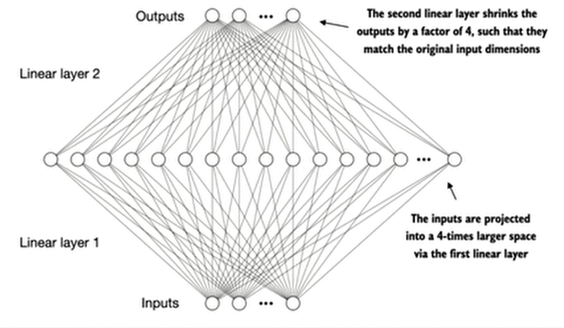
Attention computes relationships:
$$\text{softmax}(QK^{T})V$$
This tells the model:
- which words matter,
- how strongly they interact.
But attention is mostly a weighted averaging mechanism.
Weighted averaging alone cannot learn very complex transformations.
Example:
"The movie was surprisingly good"
Attention may learn:
Main purpose of FFN
- Adds nonlinearity
- Feature transformation
- Expands representational capacity
- "good" relates to "movie"
- "surprisingly" modifies "good"
But attention itself cannot strongly transform:
- sentiment,
- abstraction,
- semantic composition.

1. Adds nonlinearity:
- Without FFN: Transformer becomes mostly linear operations.
- Stacking linear layers without nonlinearity collapses into another linear transformation.
- GELU introduces nonlinear learning capability.
Why nonlinearity matters? Language is highly nonlinear.
Example: "not bad" ≠ negative Meaning changes contextually.

2. Feature transformation
After attention:
[cat-related info,
grammar info,
position info]
FFN converts it into:
- higher-level semantic features,
- abstract concepts,
- prediction-friendly representations.

3. Expands representational capacity
Transformer FFNs usually expand dimensions:
Example GPT/BERT style:
$$768→(4*768) 3072→768$$Example:
Input embedding: 768 dimensions
First linear layer: 768 → 3072
Now the network has more room to:
- combine features,
- detect patterns,
- build abstractions.
Second linear layer compresses back:
3072 → 768

Why Shortcut (Residual) Connections
are Needed in Transformers

Residual Connections or Skip Connections — are critical for training deep Transformers.
Why is this needed?
Deep networks have a major problem:
Problem: information degradation
As layers increase:
Layer 1 → good signal
Layer 10 → weaker
Layer 50 → distorted
Layer 100 → almost lost
Important information can vanish.
Residual connections preserve the original signal.

They help:
- preserve information,
- stabilize gradients,
- prevent degradation in deep networks,
- make training much easier.

What is a shortcut connection?
Instead of using only: $\text{Output}=F(x)$
Transformer uses: $\text{Output}=x+F(x)$
where:
- $x$= original input,
- $F(x)$= transformed output (attention or FFN).
So the input is directly added back.

1. Prevent vanishing gradients
During backpropagation gradients must travel through many layers.
Without residuals:
Example
Suppose token embedding:
x = [cat, animal, pet]
Attention learns contextual info:
F(x) = [sits on mat]
Residual output:
x + F(x) = [cat, animal, pet, sits on mat]
Original semantics are preserved.

gradient × small numbers × small numbers × ...
Eventually gradients become tiny $≈0$
Training stops learning.
With shortcut connection
Gradient gets a direct path: $\frac{∂}{∂x}(x+F(x))=1+F^{'}(x)$
Notice the important part:

2. Preserve original information:
Attention/FFN may distort useful features.
Residual keeps the original representation available.
Example:
Output = Original Meaning + Learned Modification
instead of completely overwriting it.

3. Makes deep Transformers trainable
Without residuals:
- deep models fail,
- optimization becomes unstable.

