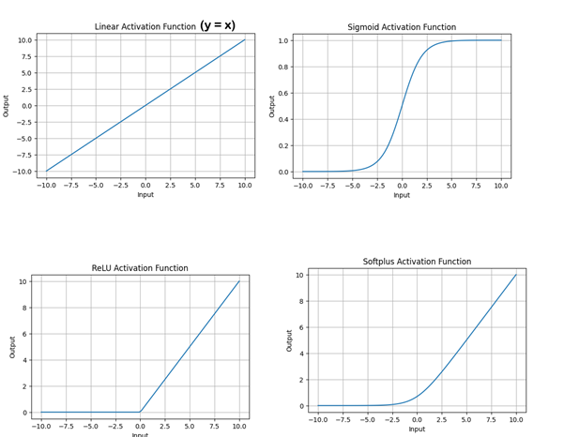
Activation Function
Linear Activation Function:
- Linear Activation Function or Identity Function returns the input as the output
- $\text{y = x}$
- Range of the output spans from (−∞ to +∞)

ReLU (Non-Linear):
- $f\left(x\right)=\max\left(0,x\right)$
- Outputs 0 for negative inputs, and x for positive inputs
- Range: [0, ∞)
Leaky ReLU:
$$f(x)=\left\{\begin{matrix}x & \text{if }x>0 \\ αx & \text{if }x≤0\end{matrix}\right.$$

Sigmoid (Non-Linear):
- $σ(x)=\frac{1}{1+e^{-x}}$
- Outputs a single probability (independent of others)
- Used for binary classification (e.g., yes/no, spam/not spam)
- Each neuron’s output is treated independently
- Can be used in multi-label classification (multiple classes can be “on” at once)
- Example: If you’re predicting whether an email is spam:
  - Output: 0.85 → high probability of spam

Softmax Activation Function (Non-Linear):
- $\text{softmax}(x_{i})=\frac{e^{x_{i}}}{\sum_{j}{e^{x_{j}}}}$
- Outputs multiple probabilities that sum to 1
- Used for multi-class classification (one correct class out of many)
- Outputs are dependent (increase one → others decrease)
- Emphasizes the largest values (makes the top class stand out)
- Exapmple: If classifying an image into cat/dog/bird:
  - Output: [0.7, 0.2, 0.1] → “cat” is most likely
Feature | ReLU | Sigmoid | Softmax
Output range | [0, ∞) | (0, 1) | (0, 1), sum = 1
Use | Hidden layers | Binary output | Multi-class output
Gradient issue | Mostly avoids vanishing | Suffers from it | Depends on context
Interpretation | Feature activation | Probability | Probability distribution
Downsides | Dying ReLU problem: neurons can get stuck outputting 0 if weights push inputs negative | A frequent mistake is using sigmoid for multi-class classification where classes are mutually exclusive. This can lead to inconsistent predictions (e.g., multiple classes with high probability). In such cases, softmax is the correct choice. | Overconfidence in Predictions

Simple intuition
- ReLU → “Is this feature present strongly enough?”
- Sigmoid → “What’s the probability of this one thing?”
- Softmax → “Which option is most likely among all choices?”

