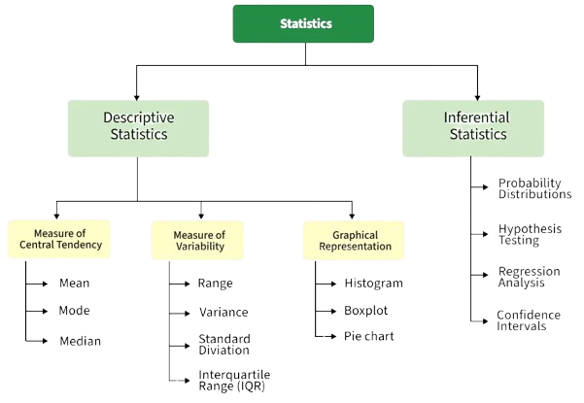
Population: Whole group
Sample = Part of group
Variable: What you measure
👉 Here, what are we measuring? Height of students = Variable
(Other examples of variables: marks, age, weight, etc.)
Parameter: numerical value that describes the population.
👉 The true average height of all students in the school = Parameter
⚠️ Important: We usually don’t know the parameter exactly because measuring everyone is hard.

Putting it all together
Business / Shop Example
A supermarket wants customer feedback:
- Population → All customers visiting the store
- Sample → 200 customers surveyed
- Variable → Satisfaction rating (1–5)
- Parameter → True average satisfaction of all customers

- Population → All students
- Sample → 50 selected students
- Variable → Height
- Parameter → True average height of all students
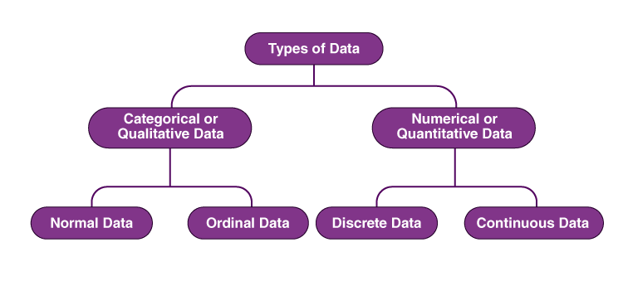
Cricket Example
Imagine analyzing a player’s performance:
- Population → All matches played by Virat Kohli
- Sample → Last 10 matches he played
- Variable → Runs scored in each match
- Parameter → His true batting average across all matches
👉 Why sample?
Because checking every match every time is time-consuming.
Quantitative (Numerical) Data
- Data that consists of numbers and can be measured or counted.
- Age: 21, 35, 50
- Height: 150 cm, 172 cm
- Income: ₹25,000, ₹50,000
Discrete Data (a type of numerical data)
- Countable values (usually whole numbers).
- Number of students in a class: 30
- Number of cars: 5
- Number of books: 12
Continuous Data
- Measurable values that can take any value within a range
- Weight: 55.5 kg, Temperature: 36.7°C, Time: 2.35 hours
Categorical Data:
- Data that represents categories or labels
- Gender: Male, Female
- Colors: Red, Blue, Green
- Types of fruits: Apple, Banana, Mango
- Blood group: A, B, AB, O
Nominal Data (categorical data with no order)
- Gender: Male, Female
- Religion: Hindu, Muslim, Christian
Ordinal Data (categorical with order)
- Education level: Primary, Secondary, Graduate
- Customer satisfaction: Poor, Average, Good, Excellent
- Class ranks: 1st, 2nd, 3rd

Type | Meaning | Example
Categorical (= names) | Labels or groups | Colors
Nominal (=no order) | No order | Blood group
Ordinal (=order) | Ordered categories | Rankings
Quantitative (= numbers) | Numerical values | Height
Discrete (=count / Digit) | Countable numbers | Number of students
Continuous (=measure) | Measurable values | Weight

Measure of Central Tendency
(Mean, Median, Mode)
Example - Income in a company
- Mean → average salary (can be misleading)
- Median → typical employee salary (more accurate)
- Mode → most common salary band

  - Mean (Average):
    - Sum of all values / number of values
    - $\text{Mean}=\frac{∑x}{n}$
    - Suppose 5 people earn: ₹20k, ₹25k, ₹30k, ₹35k, ₹90k
    - Mean = (20 + 25 + 30 + 35 + 90) / 5 = ₹40k
⚠️ Problem: One high salary (₹90k) increased the average a lot.
  - Median (Middle value after sorting):
    - Middle number after sorting
    - $\text{Median}=x_{\left(\frac{n+1}{2}\right)}$ If n is odd: $\frac{\left(n + 1\right)}{2}$
    - $\text{Median}=\frac{x_{\left(\frac{n}{2}\right)}+x_{\left(\frac{n}{2} + 1\right)}}{2}$ If n is even: [(n/2)^{th} term + {(n/2 )+ 1}^{th} term]/2
    - Median = in above example ₹30k (middle value)
✔️ More realistic when there are extreme values.
  - Mode (Most frequent value):
    - Value that appears most often
    - Example (Daily expenses): ₹100, ₹200, ₹200, ₹300, ₹400
    - Mode = ₹200 (appears most)
✔️ Useful to find “most common behavior”

For Grouped Data (Important for exams)
- $f$= frequency
- $x$= class midpoint
- $L$= lower class boundary
- $f$= frequency of median class
- $cf$= cumulative frequency before median class
- $h$= class width
- $f_{1}$= frequency of modal class
- $f_{0}$, $f_{2}$= frequencies before and after

Mean: $\overset{ˉ}{x}=\frac{∑fx}{∑f}$
Median: $L+\left(\frac{\frac{n}{2}-cf}{f}\right)×h$
Mode: $L+\left(\frac{f_{1}-f_{0}}{2f_{1}-f_{0}-f_{2}}\right)×h$

Measure of Variability / Spread / Dispersion
(Range, Variance, Std Deviation, Interquartile Range)
Imagine 5 students scored these marks in a test: 40, 50, 60, 70, 80
- Range = Max−Min
  - Range = Max – Min = 80 – 40 = 40
  - Meaning: Your returns vary from 2% to 20% → very wide spread
Value | Difference from Mean | Squared
40 | (40-60) = -20 | 400
50 | (50-60) = -10 | 100
60 | (60-60) = 0 | 0
70 | (70-60) = 10 | 100
80 | (80-60) = 20 | 400
Why we used Squared? Why not mod?
We can Mean Absolute Deviation (MAD)
$$MAD=\frac{∑∣x_{i}-μ∣}{N}$$⚠️Absolute values $∣x_{i}-μ∣$are harder to work with mathematically.
- They are not smooth (they have a “sharp corner” at 0)
- Difficult in calculus (derivatives, optimization)

⚠️ Problem: Only uses 2 values & affected by outliers (ignores rest)

- Variance (How spread out data is)
  - Measures how far each value is from the average (mean)
  - $σ^{2}=\frac{∑(x_{i}-μ)^{2}}{N}$
  - Steps:
    - Mean ≈ (40 + 50 + 60 + 70 + 80) / 5 = 60
    - Measure how far each value is from mean
    - Square them (to avoid negatives)
    - Average of squared differences
Variance = (400 + 100 + 0 + 100 + 400) / 5 = 200
👉 Meaning: On average, values are about 200 unit
away from the mean

- Standard Deviation (Real-world spread)
  - The standard deviation is just the square root of variance.
  - $σ=\sqrt{σ^{2}}$
  - = √200 ≈ 14.14
👉 Meaning: Scores typically vary about 14 marks from the mean.

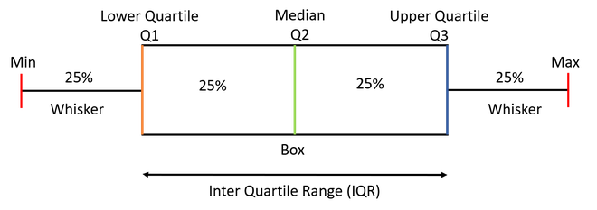
- Interquartile Range (IQR) — Middle spread
  - The IQR shows the spread of the middle 50% of data.
  - It covers the middle 50% of the data, making it a strong measure of spread that is resistant to extreme values.
  - Percentile: Divide the data into 100 equal parts. P1(first percentile), P2 (2nd percentile) …P99 (99th percentile)
$$P_{k}=\text{value at position }\left(\frac{k}{100}×(N+1)\right)$$
  - Step 1: Find quartiles
Data: 40, 50, 60, 70, 80
    - Q1 (lower quartile): The value below which 25% of the data lies = 50
    - Q2 (median) : The middle value that splits the data into two equal halves = 60
    - Q3 (upper quartile) : The value below which 75% of the data lies = 70
  - Step 2: Calculate IQR
IQR = Q3 − Q1 = 70 − 50 = 20
👉 Meaning: The middle half of scores lie within a 20-mark range.
Percentile rank (percentage below a value):
$$\text{Percentile Rank}=\frac{\text{Number of values below }x}{N}×100$$
Ex: Find percentile rank of 60:
- Values below 30 → 10, 20 (2 values)
- $\frac{2}{5}×100=40$
- So, 30 is at the 40th percentile
Percentile (position in a dataset)
Data: 40, 50, 60, 70, 80
Find 25th percentile: $\text{Position}=\frac{25}{100}×(5+1)=1.5$
- $P_{25}=45$

Q. Why take the square root? Why Std Deviance Exist?
Although we have Deviation

Because variance has a problem:
  - Units are squared: If data is in meters → variance is in meters² ❌ (hard to interpret)

Example: Suppose you have heights (in cm):
Step 2: Deviations $150-160=-10,$$$160-160=0,$$
$$170-160=10$$

Step 3: Square them $\left(-10)^{2}=100\right.$
$${ 0}^{2}=0 \\ { 10}^{2}=10$$

Data: 150, 160, 170

Step 1: Mean $μ=\frac{150+160+170}{3}=160$
Step 4: Variance $σ^{2}=\frac{100+0+100}{3}=66.67$
Problem with variance
66.67 cm² That’s not easy to interpret.
What does “cm²” even mean for height?

Step 5: Take square root
(Standard Deviation)
Now the unit is back to
cm (same as original data)
$$σ=\sqrt{66.67}≈8.16$$

Example1: Cricket Scores
Score | Difference | Squared
10 | -41.43 | 1716
20 | -31.43 | 987
30 | -21.43 | 459
40 | -11.43 | 131
50 | -1.43 | 2
60 | 8.57 | 73
150 | 98.57 | 9716

Suppose a player scored runs in 7 matches: 10, 20, 30, 40, 50, 60, 150
(Notice that 150 is unusually high — this is called an outlier)

- Mean = (10 + 20 + 30 + 40 + 50 + 60 + 150) / 7= 360 / 7 ≈ 51.43
- Range = Max – Min = 150 − 10 = 140
👉 Huge range because of that one big score (150)
- Variance = (sum of squared differences) / 7 ≈ 13084 / 7 ≈ 1869
👉 Very large because of the 150 score
Key Insight (VERY IMPORTANT)
- Range, variance, SD → heavily affected by outliers
- IQR → ignores extreme values
- If you're a coach, using:
  - Range/SD → you’ll think player is inconsistent (because of 150)
  - IQR → you’ll see most scores are between 20 and 60 → more realistic
- Standard Deviation = SD = √1869 ≈ 43.2
👉 Scores typically vary by ~43 runs from the average
— again inflated by the outlier
- Interquartile Range (IQR)
Sorted data: 10, 20, 30, 40, 50, 60, 150
- Q1 = 20
- Median = 40
- Q3 = 60
IQR = 60 − 20 = 40
👉 Notice: IQR is much smaller than range (140)

Example2: Two Realistic Fund Types
(why small-cap has high std deviation)
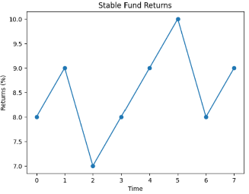  Stable Fund  (Large-cap / Index)  Returns (%):  8, 9, 7, 8, 9, 10, 8, 9 | 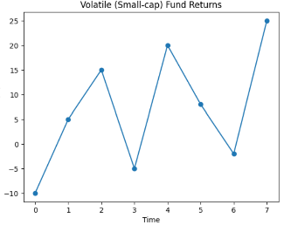  Volatile Fund  (Small-cap)  Returns (%):  -10, 5, 15, -5, 20, 8, -2, 25
Range (Best vs Worst)  - Stable → 10 − 7 = 3  - Small-cap → 25 − (-10) = 35  👉 Small-cap has huge swings → risky  Standard Deviation (Actual Risk Measure)  - Stable → ~1%  - Small-cap → ~12–15%  👉 Meaning:  - Stable fund → returns stay close to average  - Small-cap → returns fluctuate wildly  ✔️ This is why apps show “high risk / very high risk” | Interquartile Range (IQR) — Stability Zone  - Stable → IQR ≈ 1–2%  - Small-cap → IQR ≈ 10%+  👉 Meaning:  - Stable → consistent performance  - Small-cap → unpredictable even in normal cases
Interpretation  Stable Fund  - Low range  - Low std deviation  - Low IQR  👉 ✔️ Predictable  👉 ✔️ Good for long-term core investment | Interpretation  Small-cap Fund  - High range  - High std deviation  - High IQR  - 👉 ⚠️ High risk  👉 ⚠️ Big gains + big losses

How to check risk (Std Deviation, etc.) in real Apps
Standard Deviation (MOST IMPORTANT)
- 5–10 → 🟢 Low risk
- 10–15 → 🟡 Moderate
- 15+ → 🔴 High risk
👉 This is exactly what we visualized in the graph.

Beta (Market sensitivity)
- ≈ 1 → moves like market
- 1 → more volatile than market
- < 1 → more stable

Sharpe Ratio (Return per risk)
- Higher = better
👉 Good fund = high return + low risk
In Groww:
      - Open any mutual fund
      - Scroll to “Fund Details”
      - Look for:
        - Standard Deviation
        - Beta
        - Sharpe Ratio

In Zerodha (Coin):
      - Open fund in Coin
      - Go to “Fund Overview”
      - Look for:
        - Risk level (Low / Moderate / High)
        - Beta
        - Sharpe Ratio

Understanding:
- Large Cap Fund  - Std Dev: ~8  - Beta: ~1  👉 Stable, predictable | - Small Cap Fund  - Std Dev: ~18–25  - Beta: >1  👉 High risk, big swings

💡 Simple Decision Rule (Use This)
- If Std Dev high + returns not great → ❌ Avoid
- If Std Dev moderate + good returns → ✅ Best choice
- If Std Dev high + very high returns → ⚠️ Invest small %

Covariance
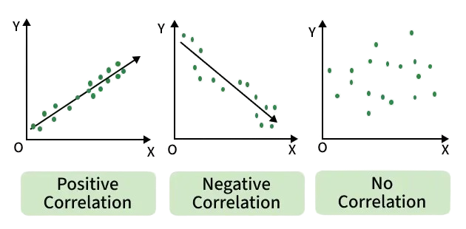
1. What is Covariance?
Covariance tells you how two variables move together.
- If both increase/decrease together → positive covariance
- If one increases while the other decreases → negative covariance
- If there’s no consistent pattern → covariance ≈ 0
Positive Correlation:
Positive correlation indicates that two variables have a direct relationship. As one variable increases, the other variable also increases.
Eg: there is a positive correlation between height and weight. As people get taller, they also tend to weigh more.

$$\text{Cov}(X,Y)=\frac{1}{n}∑(X_{i}-\overset{ˉ}{X})(Y_{i}-\overset{ˉ}{Y})$$
Negative Correlation: Negative correlation indicates
that two variables have an inverse relationship. As
one variable increases, the other variable decreases.
Eg: there is a negative correlation between price and
demand. As the price of a product increases,
the demand for that product decreases.
3. Disadvantages of covariance
- Hard to interpret magnitude:
A covariance of 500 vs 5 — which is strong?
- Unit-dependent
If you measure height in cm vs meters, covariance changes
- Not standardized
No fixed range (can be very large or small)

2. Why do we need covariance?
- Tells us direction of relationship between variables
- Is a building block for more advanced concepts like:
  - Correlation
  - Linear Regression
  - Principal Component Analysis
Example1:
Experience(X) = [2,5,8,12,13] $\overset{ˉ}{X}$ = 8
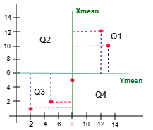
Salary(Y) = [1,2,5,12,10] $\overset{ˉ}{Y}$ = 6
Exp(X) | Salary(Y) | X-X_{mean} | Y-Y_{mean} | Product
2 | 1 | -6 | -5 | 30
5 | 2 | -3 | -4 | 12
8 | 5 | 0 | -1 | -1
12 | 12 | 4 | 6 | 24
13 | 10 | 5 | 4 | 20
Cov = (30+12-1+24+20)/5 = 85/5 = 17 ==> +ve
Observation:
- We can see most of the values are present
in quadrant-1 and quadrant-3
- in Q3 : Multiplication of (X-Xmean)*(Y-Ymean) = +ve
- in Q1 : Multiplication of (X-Xmean)*(Y-Ymean) = +ve
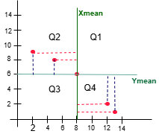
- +ve trend
Example2:
Baclogs(X) = [2,5,8,12,13] $\overset{ˉ}{X}$ = 8
Packages(Y) = [9,8,6,3,1] $\overset{ˉ}{Y}$ = 6
BacklogX) | Package(Y) | X-X_{mean} | Y-Y_{mean} | Product
2 | 9 | -6 | 3.6 | -21.6
5 | 8 | -3 | 2.6 | -7.8
8 | 6 | 0 | 0.6 | 0
12 | 3 | 4 | -2.4 | -9.6
13 | 1 | 5 | -4.4 | -22.0
Cov = (-21.6-7.8+0-9.6-22)/5 = -61/5 = -12.2 ==> -ve

Q1. Why subtract the mean? (centering)
$\left(X_{i} − \overset{ˉ}{X}\right)$and $\left(Y_{i} − \overset{ˉ}{Y}\right)$measure:
How far is each value from its average?
- If a student studies above average and scores above average → meaningful relationship
- If both are below average → also meaningful
We care about deviations from the mean, not raw numbers.

Q2. Why do we multiply the deviations?
The product: $\left(X_{i}-\overset{ˉ}{X})(Y_{i}-\overset{ˉ}{Y}\right)$ captures joint behavior.
X deviation | Y deviation | Product | Meaning
+ | + | + | Move together ↑
- | - | + | Move together ↓
+ | - | - | Move opposite
- | + | - | Move Oposite

Q3. Why not just add deviations? $∑\left(X_{i}-\overset{ˉ}{X}\right)+\left(Y_{i}-\overset{ˉ}{Y}\right)$
It wouldn’t work because:
Multiplication avoids this by:
- Reinforcing agreement (positive × positive)
Penalizing disagreement (positive × negative)
- Positive and negative deviations cancel out
- You lose relationship information

Q4. Why average (divide by n)?
- Get an average relationship
- Make it independent of dataset size

Q5. Why Covariance is hard to interpret
magnitude
x = [12,25,68,42,113]
y = [11,29,58,121,100]
ax1.scatter(x, x)
ax2.scatter(x, y)
ax3.scatter(x*2, y*2)

fig, (ax1, ax2, ax3) = plt.subplots(1, 3, figsize=(15,3))

ax1.set_title(f"Cov - {np.cov(x, x)[0,1]}")
ax2.set_title(f"Cov - {np.cov(x, y)[0,1]}")
ax3.set_title(f"Cov - {np.cov(x*2, y*2)[0,1]}")
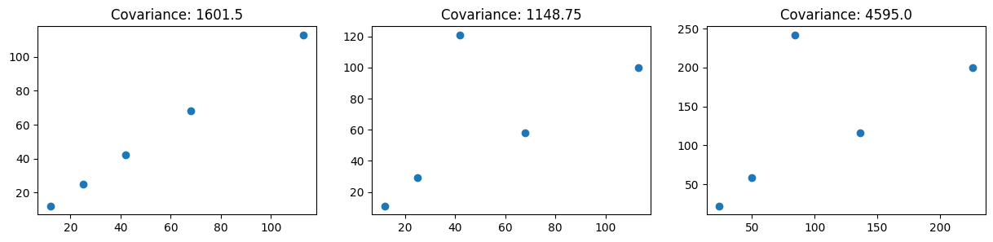
Note1 (Fig2 & Fig3): Original: $x,y$ Scaled version: 2x,2y
- Even though the pattern (relationship) between x and y is exactly the same in both plots:
But covariance values will be different in fact $\text{Cov}(2X,2Y)=4⋅\text{Cov}(X,Y)$
Note2 (Fig1): Covariance with itself $\text{Cov}(X,X)=\text{Var}(X)$
- In Fig 1, this value is 1601, which appears smaller than the covariance values observed with other variables (e.g., 1148 in Fig 2 or 4595 in Fig 3).
$$\text{Cov}(X,Y)=\frac{1}{n}∑(X_{i}-\overset{ˉ}{X})(Y_{i}-\overset{ˉ}{Y})$$put $Y=X$ $\text{Cov}(X,X)=\frac{1}{n}∑(X_{i}-\overset{ˉ}{X})(X_{i}-\overset{ˉ}{X})$ $=\frac{1}{n}∑(X_{i}-\overset{ˉ}{X})^{2}$ $==> \text{Var}(X)$
Correlation
Correlation in statistics measures the strength and direction of a relationship between two variables
Pearson correlation coefficient:
$$r=\frac{\text{Cov}(X,Y)}{σ_{X}σ_{Y}}$$
- +1 → perfect positive relationship (both increase together)
- -1 → perfect negative relationship (one increases, the other decreases)
- 0 → no linear relationship
fig, (ax1, ax2, ax3) = plt.subplots(1, 3, figsize=(15,3))  ax1.set_title(f"Correlation: {np.corrcoef(x, x)[0,1]}")  ax2.set_title(f"Correlation: {np.corrcoef(x, y)[0,1]}")  ax3.set_title(f"Correlation: {np.corrcoef(x*2, y*2)[0,1]}") | x = np.array([12,25,68,42,113])  y = np.array([11,29,58,121,100])  ax1.scatter(x, x)  ax2.scatter(x, y)  ax3.scatter(x*2, y*2)

