Histogram(identify distribution)
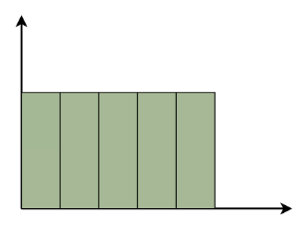
A histogram helps us understand the shape of the data, such as peaks, spread, and whether the data is symmetric or skewed.
Uniform Histogram:
A uniform histogram is a histogram in which all the bars are nearly equal in height, showing that the data is evenly distributed among all class intervals.
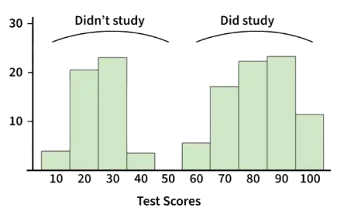
Bimodal Histogram:
A histogram is called bimodal if it has two distinct peaks. This shows that the data consists of observations from two different groups or categories, and each group has its own centre or pattern of values.
N=400
mu_1, sigma_1 = 80, 10
mu_2, sigma_2 = 20, 10
# Generate two normal distributions of given mean sdand concatenate
X_1 = np.random.normal(mu_1, sigma_1, N)
X_2 = np.random.normal(mu_2, sigma_2, N)
X = np.concatenate([X_1, X_2])
sns.displot(X,bins=10,kde=True , color='green')
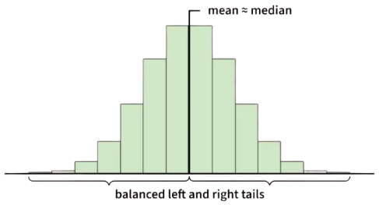
Symmetric Histogram
A symmetric histogram is also called a bell-shaped histogram. It is said to be symmetric when a vertical line drawn through the centre divides the histogram into two identical halves. The left and right sides are equal in size and shape, showing a balanced distribution of data.
data = np.random.normal(10.0, 3, 500)
sns.displot(data, kde= True, bins=10, color='black')
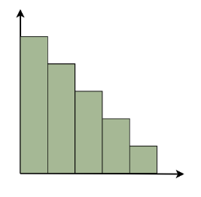
Right-Skewed Histogram
A right-skewed histogram is a histogram in which the bars extend more towards the right side. This means that most of the data values are on the left side, while a few very large values lie on the right.
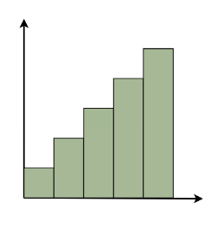
For example: In a histogram showing family incomes, most families may have lower incomes, but a few very rich families stretch the data towards the right.
Left-Skewed Histogram
A left-skewed histogram shows bars that extend towards the left side. This means that most of the data values are on the right side, while a few very low values lie on the left.
For example: In a histogram showing test scores, most students may score high marks, but a few students with very low scores stretch the distribution towards the left.
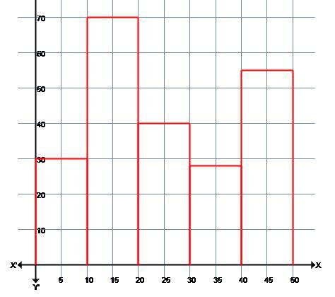
Example:
Marks | 0-10 | 10-20 | 20-30 | 30-40 | 40-50
No. of students | 30 | 70 | 40 | 28 | 55
We take the Marks on the graph's horizontal axis and, based on the first column of the data, set the scale to 1 unit = 10. We pick number of students on the vertical axis of the graph and use the second column of the table to determine the scale: 1 unit = 10. Now we'll create the relevant histogram.

Box Plot (identify Outlier)
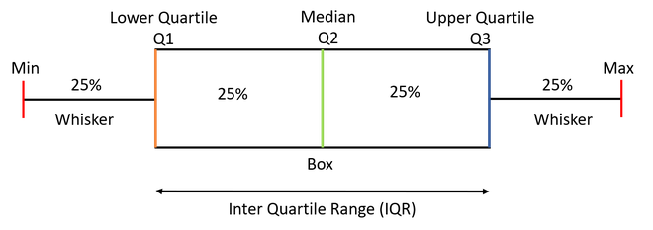
A Box Plot is also known as a Box and Whisker Plot and it is a graphical tool used to understand the distribution of numerical data. It shows the median, quartiles and possible outliers in a simple visual form. It helps compare distributions between groups with ease.
The box in a box plot represents the
Interquartile Range (IQR)
$$IQR=Q_{3}-Q_{1}$$
It covers the middle 50% of the data, making it a strong measure of spread that is resistant to extreme values.
- Minimum: The smallest non-outlier value shown at the lower whisker end.
- First Quartile (Q1): The value below which 25% of the data lies.
- Median (Q2): The middle value that splits the data into two equal halves.
- Third Quartile (Q3): The value below which 75% of the data lies.
- Maximum: The largest non-outlier value shown at the upper whisker end.

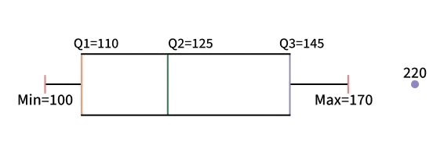
Example:
Consider the runs scored by a cricket team in 12 matches:
100, 120, 110, 150, 110, 140, 130, 170, 120, 220, 140, 110

Step 1: Arrange Data in Ascending Order
- 100, 110, 110, 110, 120, 120, 130, 140, 140, 150, 170, 220
Step 4: Calculate Limits
- $\text{Lower Limit}=110-1.5×35=57.5$
- $\text{Upper Limit}=145+1.5×35=197.5$
Step 5: Identify Min, Max and Outliers
- Minimum (within limit) = 100
- Maximum (within limit) = 170
- Outlier = 220

Step 2: Find Quartiles and Median
- $\text{Median }(Q_{2})=\frac{120+130}{2}=125$
- $Q_{1}=\text{Median of first 6 values}=\frac{110+110}{2}=110$
- $Q_{3}=\text{Median of last 6 values}=\frac{140+150}{2}=145$
Step 3: Compute IQR
- $\text{IQR}=145-110=35$
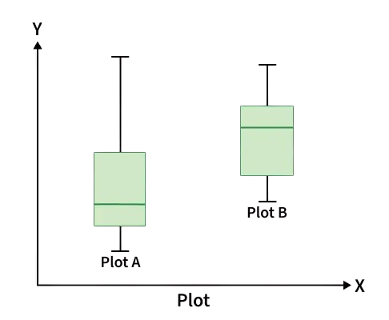
Compare Box Plots
1. Compare the Medians
- Check if the median line of one plot lies outside the box of another.
- A median placed higher usually indicates larger overall values.
- If Group B’s median falls outside Group A’s box, the groups differ notably.

2. Compare the Dispersion (Spread)
- IQR represents the height of the box, showing spread of middle 50 percent data.
- A longer box means higher variability.
- Longer whiskers indicate greater overall spread of values.
- Plot A with a bigger box and whiskers has more variable data.

3. Compare Outliers
- Outliers appear as points beyond whiskers.
- More outliers indicate irregular or inconsistent data.
- Fewer outliers suggest more stable and predictable values.

4. Compare Skewness
- Skewness shows asymmetry in data distribution.
- Median closer to the bottom with a longer upper whisker indicates right skew.
- Median near the top with a longer lower whisker indicates left skew.
- Plot A is left-skewed and Plot B is right-skewed, showing clear distribution differences.

Scatter Plot
(Bivariate Analysis)
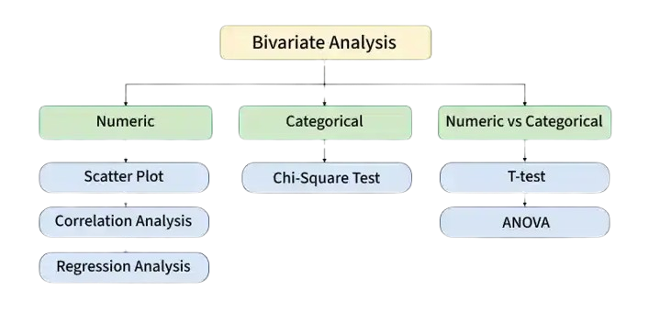
Scatter Plots:
Visually display the relationship between two variables.
Each dot on the plot represents a single
observation, (x_{i}, y_{i})
- Positive Trend: Points slope upward
(e.g., height vs. weight).
- Negative Trend: Points slope downward
(e.g., TV time vs. grades).
- No Pattern: Random cloud (e.g., shoe size vs. IQ).
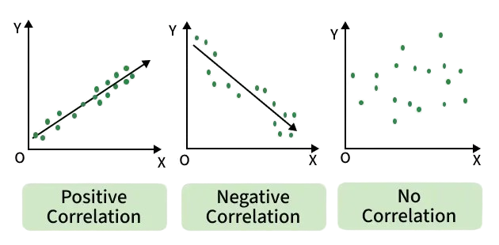
Types of Scatter Plot
- Scatter Plot For Positive Correlation
- Scatter Plot For Negative Correlation
- Scatter Plot For No Correlation

1. Correlation Analysis:
Understanding the relationships between different variables
- The Pearson correlation coefficient is the
most often used metric of correlation.
Positive Correlation:
Positive correlation indicates that two variables have a direct relationship. As one variable increases, the other variable also increases.
Eg: there is a positive correlation between height and weight. As people get taller, they also tend to weigh more.

$$r=\frac{∑(x_{i}-μ_{x})(y_{i}-μ_{y})}{\sqrt{∑(x_{i}-μ_{x})^{2} ∑(y_{i}-μ_{y})^{2}}}$$
r = -1 : a perfect negative correlation.
r = 0 : no linear correlation between the variables.
r = 1 : a perfect positive correlation.
Negative Correlation: Negative correlation indicates that two variables have an inverse relationship. As one variable increases, the other variable decreases.
Eg: there is a negative correlation between price and demand. As the price of a product increases, the demand for that product decreases.
#Using NumPy  x = np.array([1, 2, 3, 4, 5])  y = np.array([5, 7, 3, 9, 1])  # Calculate correlation coefficient  corr = np.corrcoef(x, y)  print(corr) # [[ 1. -0.3] [-0.3 1.]]  r = corr [0, 1] # r = -0.3 | #Using pandas  # Create a DataFrame with sample data  data = pd.DataFrame({'X': [1, 2, 3, 4, 5], 'Y': [5, 7, 3, 9, 1]})  # Calculate correlation coefficient  correlation_coefficient = data['X'].corr(data['Y'])  print(correlation_coefficient) #-0.3
# Create scatter plot  # points: (1,5), (2,7), (3,3), (4,9), (5,1)  plt.scatter(x, y, color='blue')  # Add labels and title  plt.xlabel("X values")  plt.ylabel("Y values")  plt.title(f"Scatter Plot (r = {r:.2f})")  plt.show() | # Correlation matrix  corr = np.corrcoef(x, y)  # Heatmap  sns.heatmap(corr, annot=True, cmap="coolwarm")  plt.title("Correlation Heatmap")  plt.show()
** Value greater than 0.7 is considered a strong correlation between variables.

Linear Regression
$$Y=β_{0}+β_{1}X+ϵ$$

from sklearn.linear_model import LinearRegression

X = [[1], [2], [3], [4], [5]]
y = [50, 55, 65, 70, 80]

model = LinearRegression()
model.fit(X, y)

print("Predicted score for 6 hours:", model.predict([[6]])[0])
print("Coefficient:", model.coef_)
print("Intercept:", model.intercept_)

Multiple Regression
$$Y=β_{0}+β_{1}X_{1}+β_{2}X_{2}+…+β_{n}X_{n}+ϵ$$

from sklearn.linear_model import LinearRegression

X = [[2, 70], [3, 80], [4, 85], [5, 90]]
y = [60, 65, 70, 78]

model = LinearRegression()
model.fit(X, y)

print("Prediction:", model.predict([[6, 95]])[0]) # 84.0
print("Coefficients:", model.coef_) # [ 8.5 -0.4]
print("Intercept:", model.intercept_) # 71.000

Polynomial Regression
$$y=β_{0}+β_{1}x+β_{2}x^{2}+β_{3}x^{3}+⋯+β_{n}x^{n}+ϵ$$

from sklearn.linear_model import LinearRegression
from sklearn.preprocessing import PolynomialFeatures

X = [[1], [2], [3], [4], [5]]
y = [2, 6, 14, 28, 45]

poly = PolynomialFeatures(degree=2)
X_poly = poly.fit_transform(X)

model = LinearRegression()
model.fit(X_poly, y)

print("Prediction:", model.predict(poly.transform([[6]]))[0]) # 67.40

