# ANSWER

1. **Location of the institute**

* Following table shows the number of students in a particular state

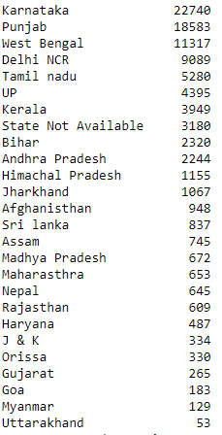

* We can further classify these states into four parts based on similar location and similar culture

|  |  |
| --- | --- |
| **Northern States**  Punjab, Delhi NCR, UP, Himachal Pradesh, Madhya Pradesh, Nepal, Rajasthan, Haryana, J&k, Uttarakhand, Bihar, Afghanistan | 18583 + 9089 + 4395 + 2320 + 1155 + 672 + 645 + 609 + 487 + 334 + 53 + 948 = **38342** |
| **Southern States**  Karnataka, Kerala, Tamil Nadu, Andhra Pradesh, Sri Lanka, Myanmar | 22740 + 3949 + 5280 + 2244 + 837 + 129 = **35179** |
| **Eastern States**  West Bengal, Bihar, Jharkhand, Assam, Nepal, Orissa | 11317 + 2320 + 948 + 745 + 645 + 330 = **16305** |
| **Western States**  Madhya Pradesh, Rajasthan, Gujarat, Goa, Maharashtra, Delhi NCR | 672 + 653 + 609 + 265 + 183 = **2382** |

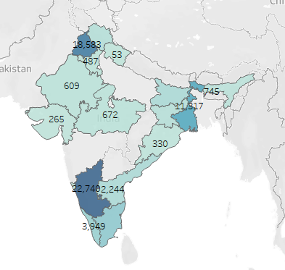

From the data and from the above map**, it can be concluded that the university should be situated in either Northern region or Southern region**, thus to further narrow down our observation, we will conduct an A-B test.

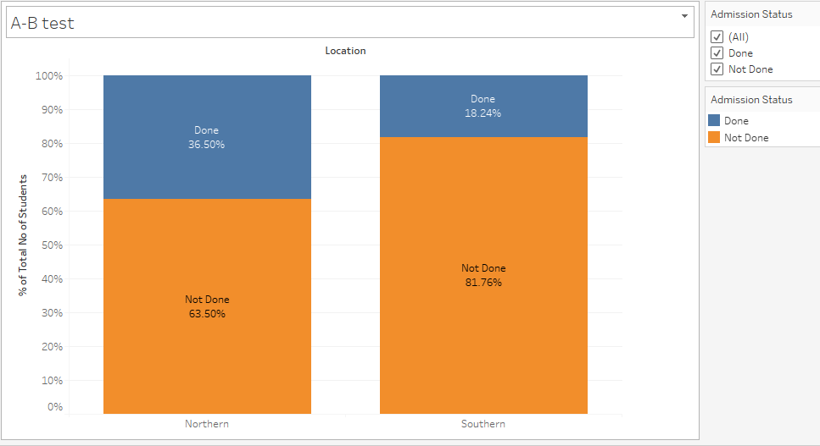

From AB test, it can be seen that more percentage of students in Northern region has taken admission in colleges thus the **university should be located in Northern region and that too in Delhi NCR**.

**REASONS**

1. Delhi is situated in Northern region where the density of students is maximum.
2. Delhi is connected to almost every part of India.
3. It would also be easy for foreign students to travel to Delhi.
4. Students from other states would also find it easy to adjust in Delhi.

Certain Assumptions

*Certain states like Delhi, Madhya Pradesh and Rajasthan are included in more than one part as they share their boundaries and culture with these parts.

*There can be other students whose data is not available to us. Thus any conclusion can be made only on the basis of available data.

*As no data regarding cost of setting university and jobs around university is given, thus these factors have not been considered while selecting the location of university.

1. **In-depth Market Research**

* Personal Interviews

One to one interviews with students who will be involved in taking admissions in the university.

Interviews should also involve other stakeholders like parents and school teachers as they have a large influence on students.

Face to face interviews are best, though talking over the telephone may be a practical alternative.

Use a semi-structured format, where you have both questions to ask and also space for free exploration.

Ask them what would persuade them to take admissions.

Capture their thoughts to be used in marketing campaigns.

* Focus Groups

Engage more people to have social interaction.

Seek people who will be open and honest yet not dominate the group in a way that would sway the views of other people.

Show the group trial material including prospectus, marketing messages, advertisement formats etc.

Look for their reactions

Give them alternatives to see which they choose.

Stay open to their ideas while neither going blindly with their suggestions nor ignoring what they say.

Use their responses to help narrow possible messages and campaigns.

* Survey

1. Wide survey to verify the research.

These methods will help in identifying the thought process of potential students regarding their choice of colleges. Students’ choices will also help in identifying the competitors, benchmarking the performance of the university, monitoring results and developing an action plan.

**MARKETING STRATEGY**

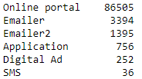

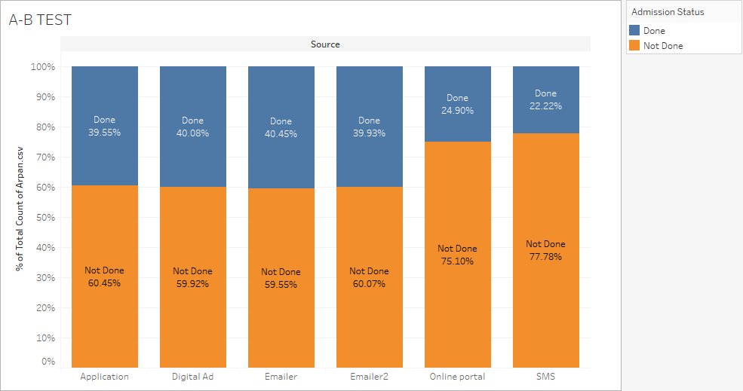

* **As we can see that the more number of students use online portal to view universities thus we can use online portals like College Duniya to advertise about our university**.
* **From A-B test, it is clear that more percentage of students took admission using Emails, Digital Ads and Application.**
* **Thus we should not totally ignore these platforms to advertise. We can first use other platform to obtain a large dataset of students using these platforms and only then we can appropriately conclude on our advertising technique.**

Some other techniques to achieve admissions targets can be:

* Building micro sites on online portals to attract students.
* Using data of students from these portals and directly contacting them.
* Conducting seminars in schools and coaching centers.
* Recruiting faculty with good academic background.
* Initially scholarships can be given to attract meritorious students.

1. **NUMBER OF COURSES**

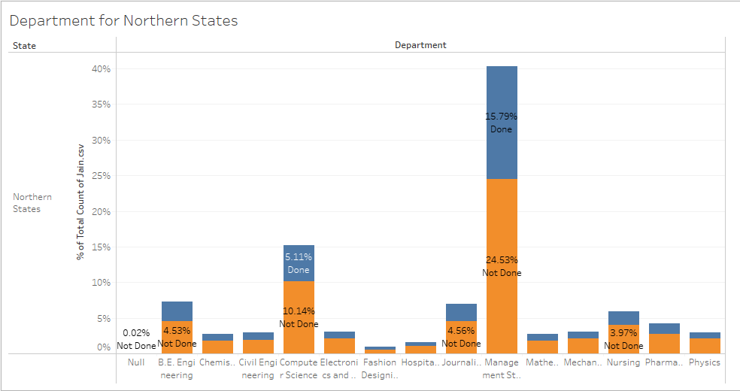

Thus we can see that the maximum students are taking admissions in **Management and Engineering** Courses. Thus initially, we should focus on Management and Engineering (especially Computer Engineering) courses and later on, we can add other courses like Nursing and Pharmacy.

ASSUMPTIONS

*As we have no data regarding cost of infrastructure and faculty for each course, thus we have not taken this into account while deciding number of courses.

**Number of Seats**

* While deciding number of seats, we can assume that the target percentage of students in Northern States will be 15% and target percentage of students in Other States will be 5%.
* We have bifurcated 75% of seats for bachelor courses, 20% for masters and 5% for other higher courses.
* Students who have not mentioned their choices of engineering courses separately will be bifurcated on the ratio of engineering courses.

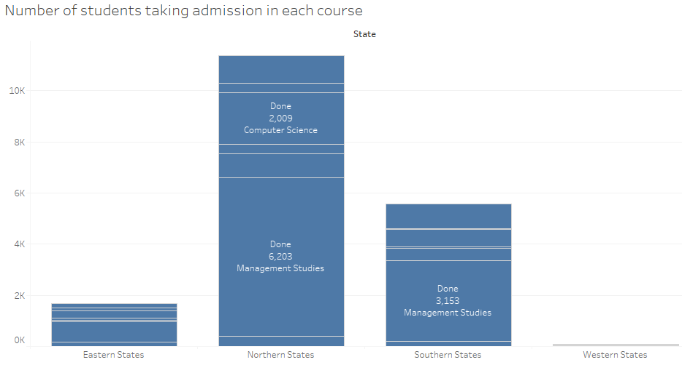

|  |  |
| --- | --- |
| **Courses** | **Number of Seats (1856)** |
| **Management Studies** | **1131** |
| **Management Studies - Bachelors** | **848** |
| **Management Studies - Masters** | **226** |
| **Management Student – Other higher courses** | **57** |
| **Computer Science** | **485** |
| **Computer Science - Bachelors** | **364** |
| **Computer Science - Masters** | **97** |
| **Computer Science - Phd** | **24** |
| **Civil** | **75** |
| **Civil - Bachelors** | **56** |
| **Civil - Masters** | **15** |
| **Civil - Phd** | **4** |
| **Mechanical** | **75** |
| **Mechanical - Bachelors** | **56** |
| **Mechanical - Masters** | **15** |
| **Mechanical - Phd** | **4** |
| **Electronics** | **90** |
| **Electronics - Bachelors** | **67** |
| **Electronics - Masters** | **18** |
| **Electronics - Phd** | **5** |

**Fees**

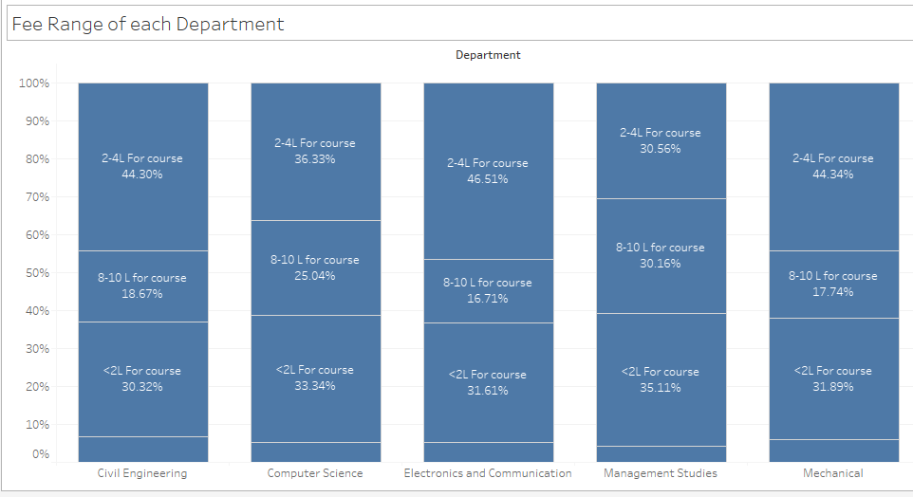

Based on the above graph, fees for each department will be

|  |  |
| --- | --- |
| **Department** | **Fees** |
| **Management** | **3*0.31 + 9*0.3 + 1*0.35 = 4 lakhs** |
| **Computer Science** | **3*0.36 + 9*0.25+1*0.33 = 3.7 lakhs** |
| **Electronics and Communication** | **3*0.47 + 9*0.17 +1*0.32 = 3.3 lakhs** |
| **Civil Engineering** | **3*0.44 + 9*0.19 + 1*0.3 = 3.3 lakhs** |
| **Mechanical** | **3*0.44 + 9*0.18 + 1*0.32 = 3.3 lakhs** |

Assumptions

*Infrastructure and faculty cost for each department not considered as the data is not available.

*Fees of other competitors not considered as the data is not available.

1. **Top 3 most influential factors for admissions** (Logistic Regression : Training and Test Data is divided in the ratio of 85:15)

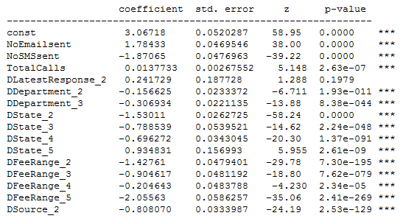

As observed from above statistics, the lowest p-values are for Department, Fee Range and Total Calls. Thus we can say that **the 3 most influential factors for admissions are**

**Department**

**Fee Range**

**Total Calls**

*As there were a lot of null values (64,657) in Last Exam Taken column, thus we have dropped that column.

*One other method can also be chi-square test to check the dependability of these variables on admissions.