

**BI Test: Task 1**

**SQL**

A metro company

1. How many restaurants in master, how many restaurants have reservations and what percentage do they account for? How many reservations were made in total?
2. Total No of Restaurants in Master

select count(restaurant_id) as total_no_of_restaurant

from Hospitality_Digital.dbo.[Restaurant Master]

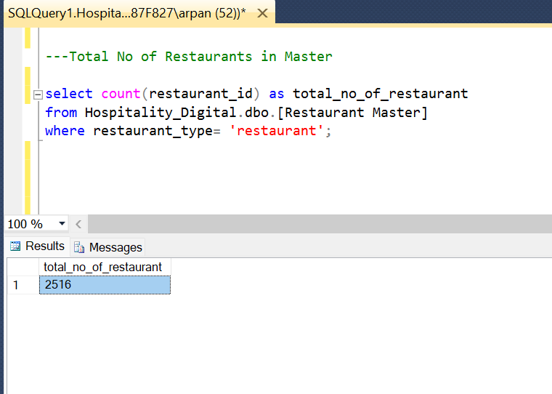 where restaurant_type= 'restaurant';

1. No of Reserved Restaurant in Master

select count(distinct R1.restaurant_id) as No_of_reserved_restaurant

from Hospitality_Digital.dbo.[Restaurant Master] as R1

inner join Hospitality_Digital.dbo.[Restaurant Reservation] as R2

on R1.restaurant_id = R2.restaurant_id

where R1.restaurant_type= 'restaurant';

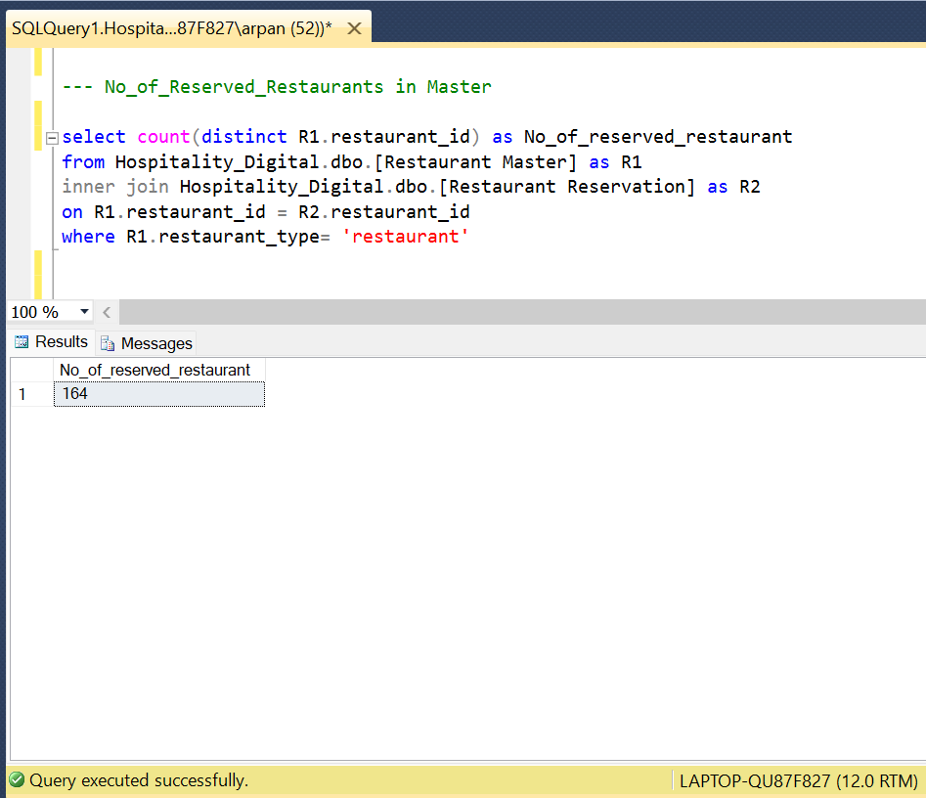

1. Percentage of Restaurants which are reserved out of Total_restaurants in Master

with t1 as (select count(restaurant_id) as total_no_of_restaurant

from Hospitality_Digital.dbo.[Restaurant Master]

where restaurant_type= 'restaurant'),

t2 as (select count(distinct R1.restaurant_id) as No_of_reserved_restaurant

from Hospitality_Digital.dbo.[Restaurant Master] as R1

inner join Hospitality_Digital.dbo.[Restaurant Reservation] as R2

on R1.restaurant_id = R2.restaurant_id

where R1.restaurant_type= 'restaurant')

select cast (round(cast(No_of_reserved_restaurant as float) / cast(total_no_of_restaurant as

float) * 100,2) as varchar) + '%' from t1, t2;

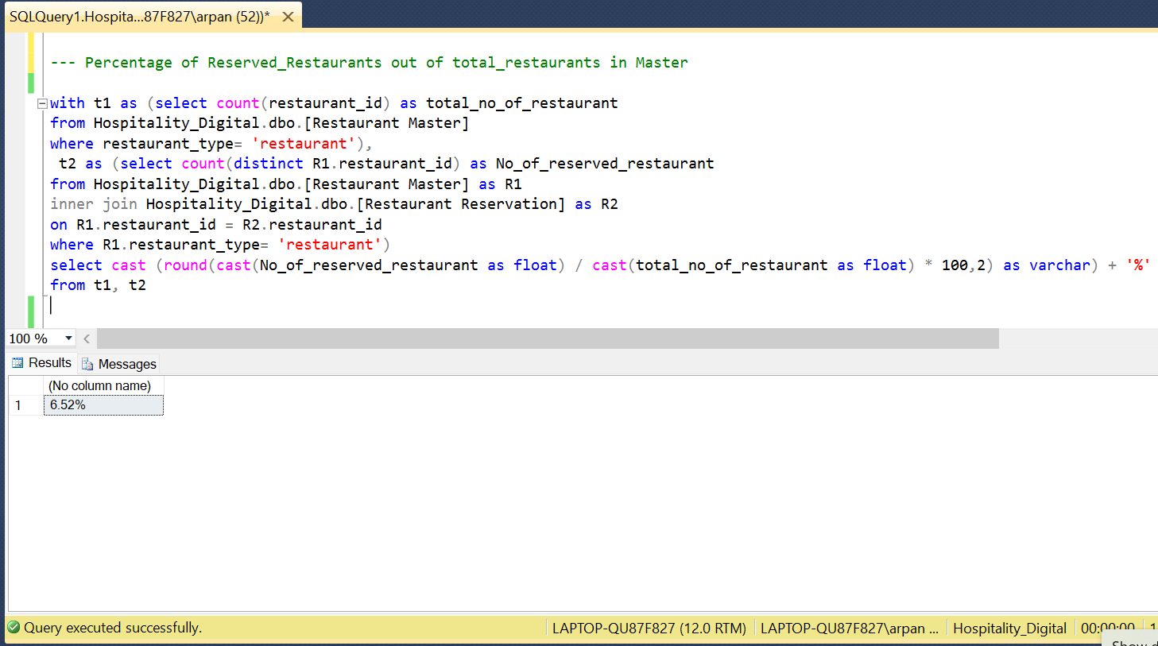

1. Total No. of Reservations made in Restaurants from Master

select count(R2.reservation_id) as Total_no_of_reservation

from Hospitality_Digital.dbo.[Restaurant Master] as R1

inner join Hospitality_Digital.dbo.[Restaurant Reservation] as R2

on R1.restaurant_id = R2.restaurant_id

where R1.restaurant_type= 'restaurant';

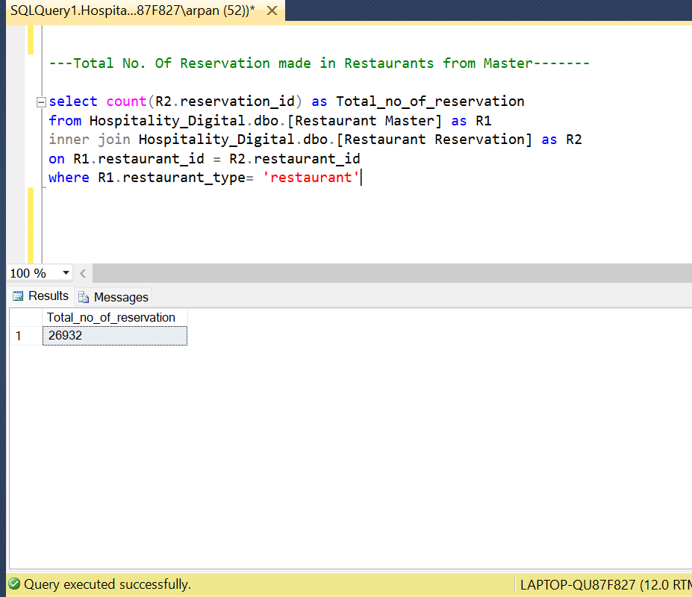

1. Developments in Reservations over time at Monthly level:-

select year(reservation_created_date) as year, month(reservation_created_date) as month,

count(reservation_id) as current_month_reservation,

LAG(count(reservation_id)) over (order by year(reservation_created_date),

month(reservation_created_date)) as previous_month_reservation,

count(reservation_id)- LAG(count(reservation_id)) over (order by year(reservation_created_date),

month(reservation_created_date)) as change

from Hospitality_Digital.dbo.[Restaurant Reservation]

group by year(reservation_created_date), month(reservation_created_date);

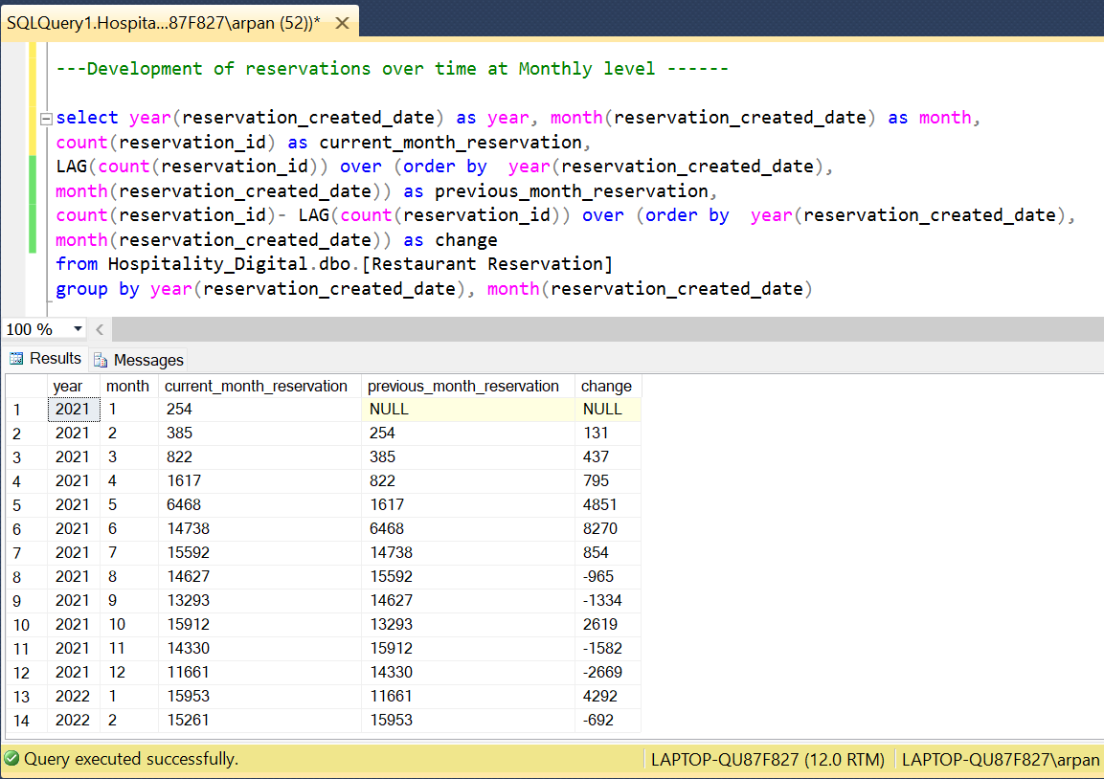

1. Year/Month with Highest No. of Reservations:-

select top 1 year(reservation_created_date) as year,

month(reservation_created_date) as month, count(reservation_id) as no_of_reservations

from Hospitality_Digital.dbo.[Restaurant Reservation]

group by year(reservation_created_date), month(reservation_created_date)

order by count(reservation_id) desc

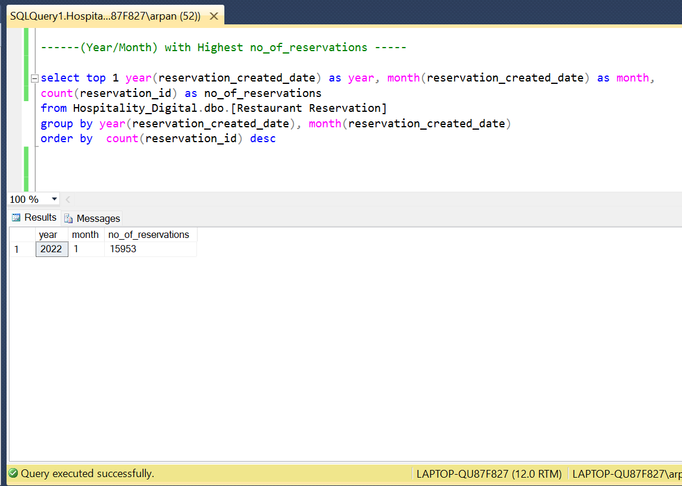

1. Year/Month with Lowest No. of Reservations:-

select top 1 year(reservation_created_date) as year, month(reservation_created_date) as month, count(reservation_id)

from Hospitality_Digital.dbo.[Restaurant Reservation]

where month(reservation_created_date) in (1,2,3)

group by year(reservation_created_date), month(reservation_created_date)

order by count(reservation_id)

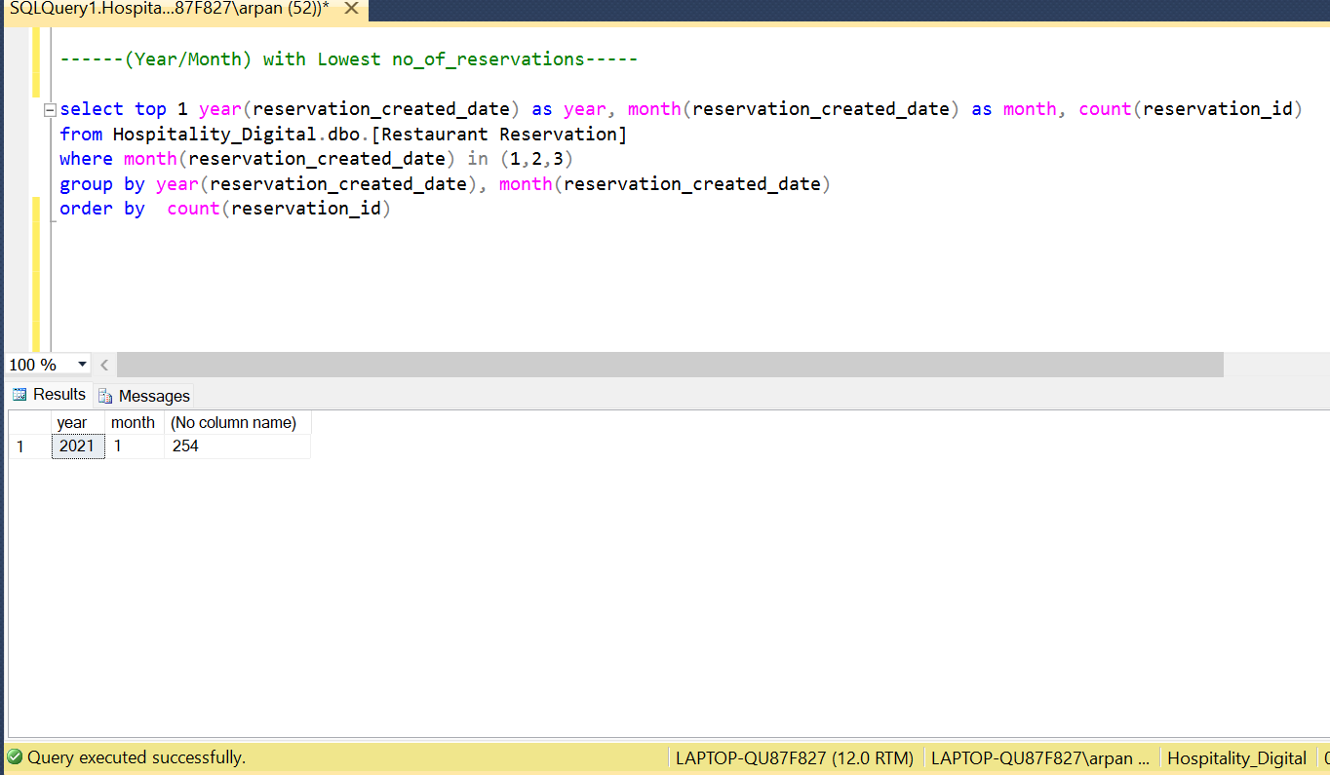

1. Average Reservations per Month:-

with t1 as (select month(reservation_created_date) as month, count(reservation_id) as no_of_reservations

from Hospitality_Digital.dbo.[Restaurant Reservation]

group by year(reservation_created_date), month(reservation_created_date))

select month, avg(no_of_reservations) as monthly_avg

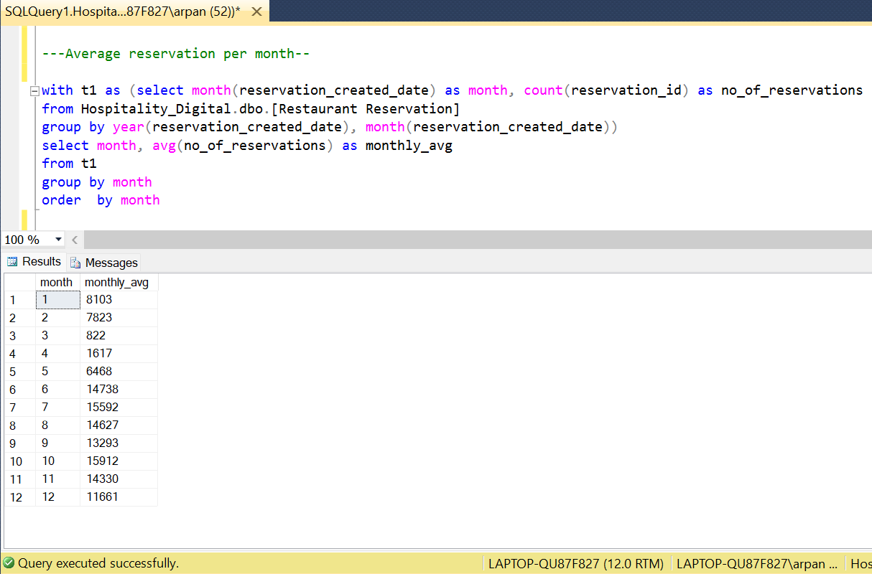from t1 group by month order by month

1. Third Reservation per Restaurant:-

with t1 as (select *,

ROW_NUMBER () over (partition by restaurant_id order by reservation_created_date, reservation_id) as rank

from Hospitality_Digital.dbo.[Restaurant Reservation])

select restaurant_id, reservation_id, reservation_created_date

from t1

where rank = 3

