**Chart-1:**

**BI Test: Task 2**

**Data Visualization**

A metro company

Bar graph: To illustrate number of different restaurant types among the countries.

Geographical Map: To compare the number of restaurants in different countries.

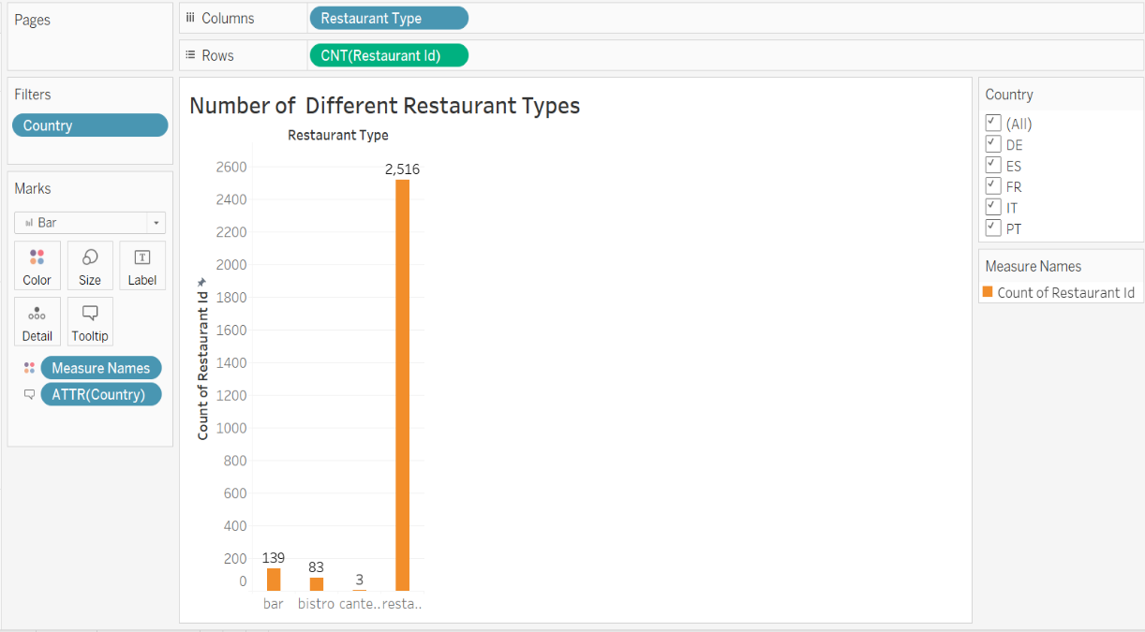 [note: User has been provided with the access to use the Filter-Country in order to compare the number of restaurants among different countries.]

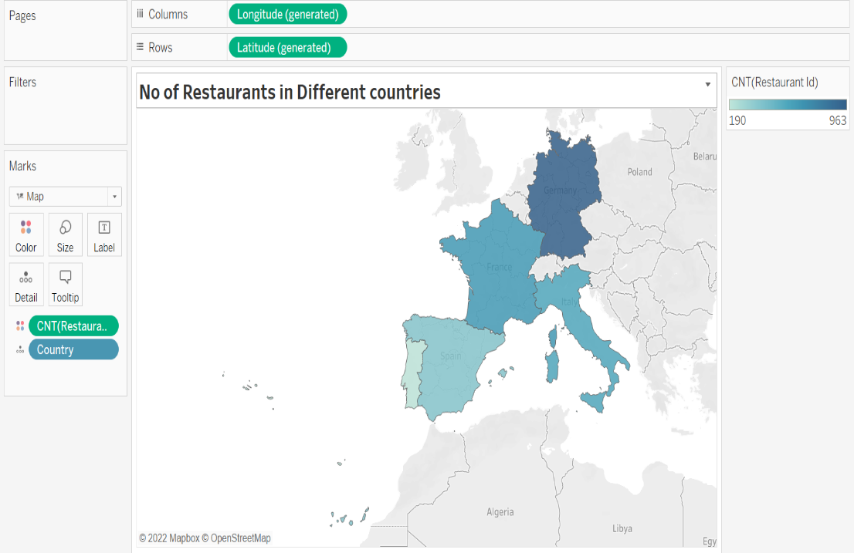

**Key Data Points/ Insights:**

* **Restaurants are of the highest in numbers in all the countries.**
* **Germany (DE) has the highest no of restaurants (i.e 963) whereas Spain (ES) and Portugal (PT) have the least of the same,**

**Chart-2:**

Line Chart (Dual-Axis Chart): To illustrate Month Over Month Development of Reservations with percentage of Difference compared to previous month.

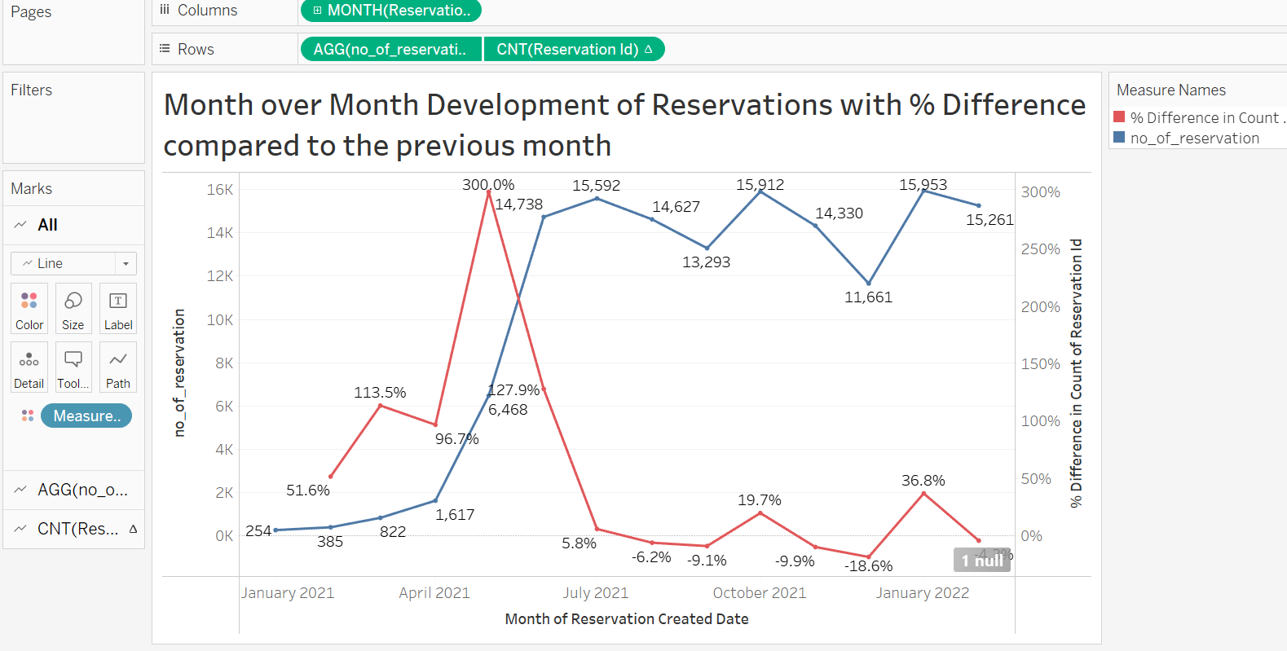

**Key Data Points/ Insights:**

* **The month, which has the highest number of reservations, is Jan,2022.**
* **Reservation rate has made a humongous growth between April,2021 to May,2021 (i.e 300%)**
* **Highest number of reservations has been made in the 3rd Quarter of 2021 with a mere 15-20% deviation in the graph.**

**Chart-3:**

Bar Graph: To illustrate the Top Restaurants based on the Number of Reservations.

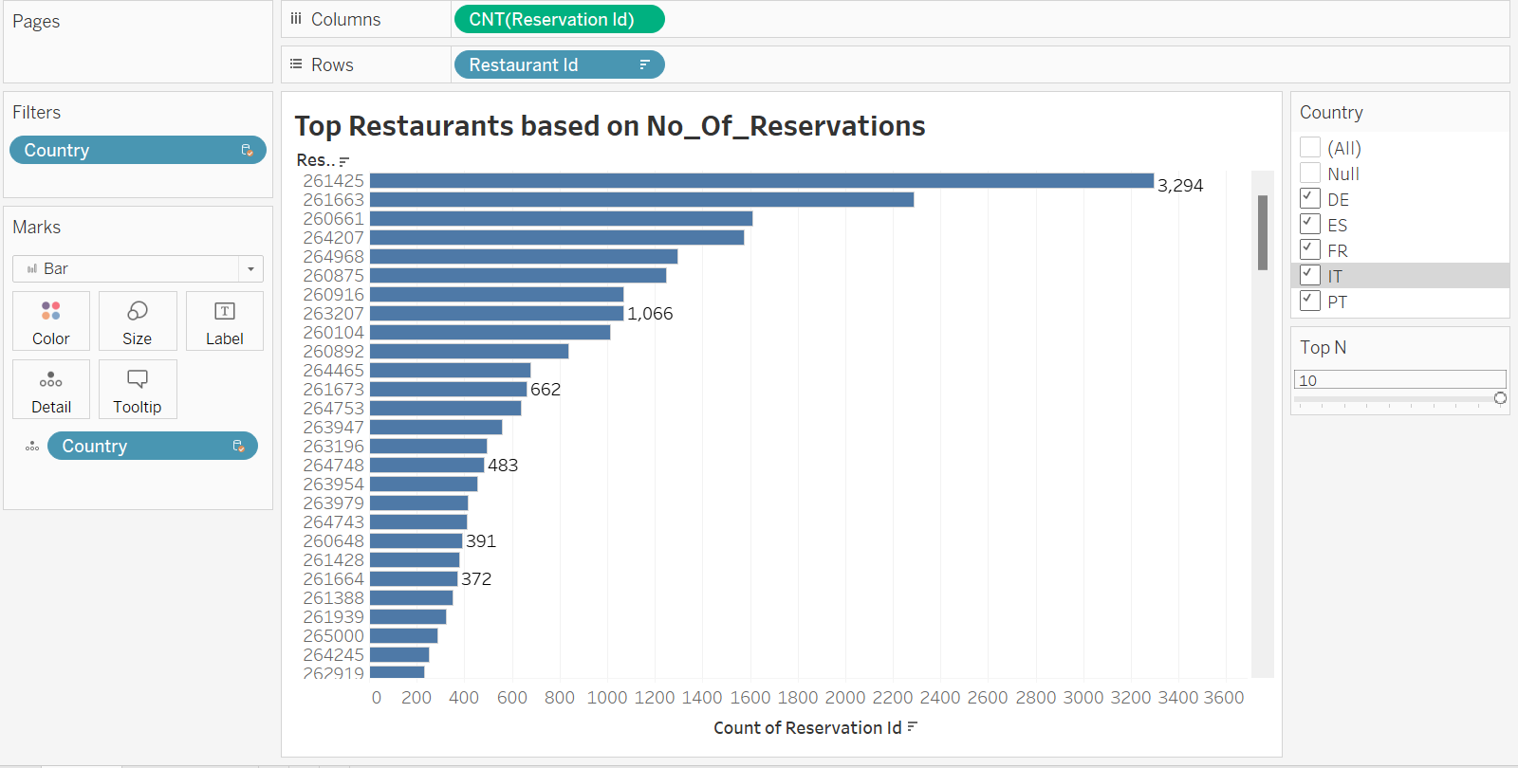[note: User has been provided with the access to use the Filter-Country in order to observe top n and bottom n Restaurants from different countries

**Key Data Points/ Insights:**

* **Among the Top 10 restaurants, majority are from Germany(DE) which means Restaurants from Germany has done the highest business over the period of 1 year compared to other countries.**
* **Restaurants from FR, IT and PT haven’t done that well as they are at the bottom ends based on the no of reservation.**

**Conclusions for Decision Making:**

* **From the above charts, we have noticed that least number of reservations are done during 1st & 2nd Quarter of the year 2021. Hence, in order to increase the reservation rate during these periods of the year, we can have multiple campaigns and provide discounts (like seasonals offers or weekly specials) based on certain parameters of the restaurants which in turn will help us attract more and more customers.**
* **Additionally, we can target the restaurants with prime native cuisines and cultural interior designs as per their respective locations of the restaurants, especially for the countries like ES, PT, IT.**
* **We can also focus upon the key factors (like cuisines, interiors, etc) of the bestselling restaurants country wise and look for more number restaurants with similar aspects in the respective regions.**