|  |  |
| --- | --- |
| **Topic :** | **Book Recommendation System** |
| **Document Type:** | **Wireframe** |
| **Author :** | **Arpan Kumar Sasmal** |
| **Date: 10/09/2024** | **PW Skills: Full Stack Data Science Pro** |

**1. Initial Page: The web page opens with a clean interface showing an empty box with a dropdown list of books. A "Get Recommendation" button is located at the bottom.**

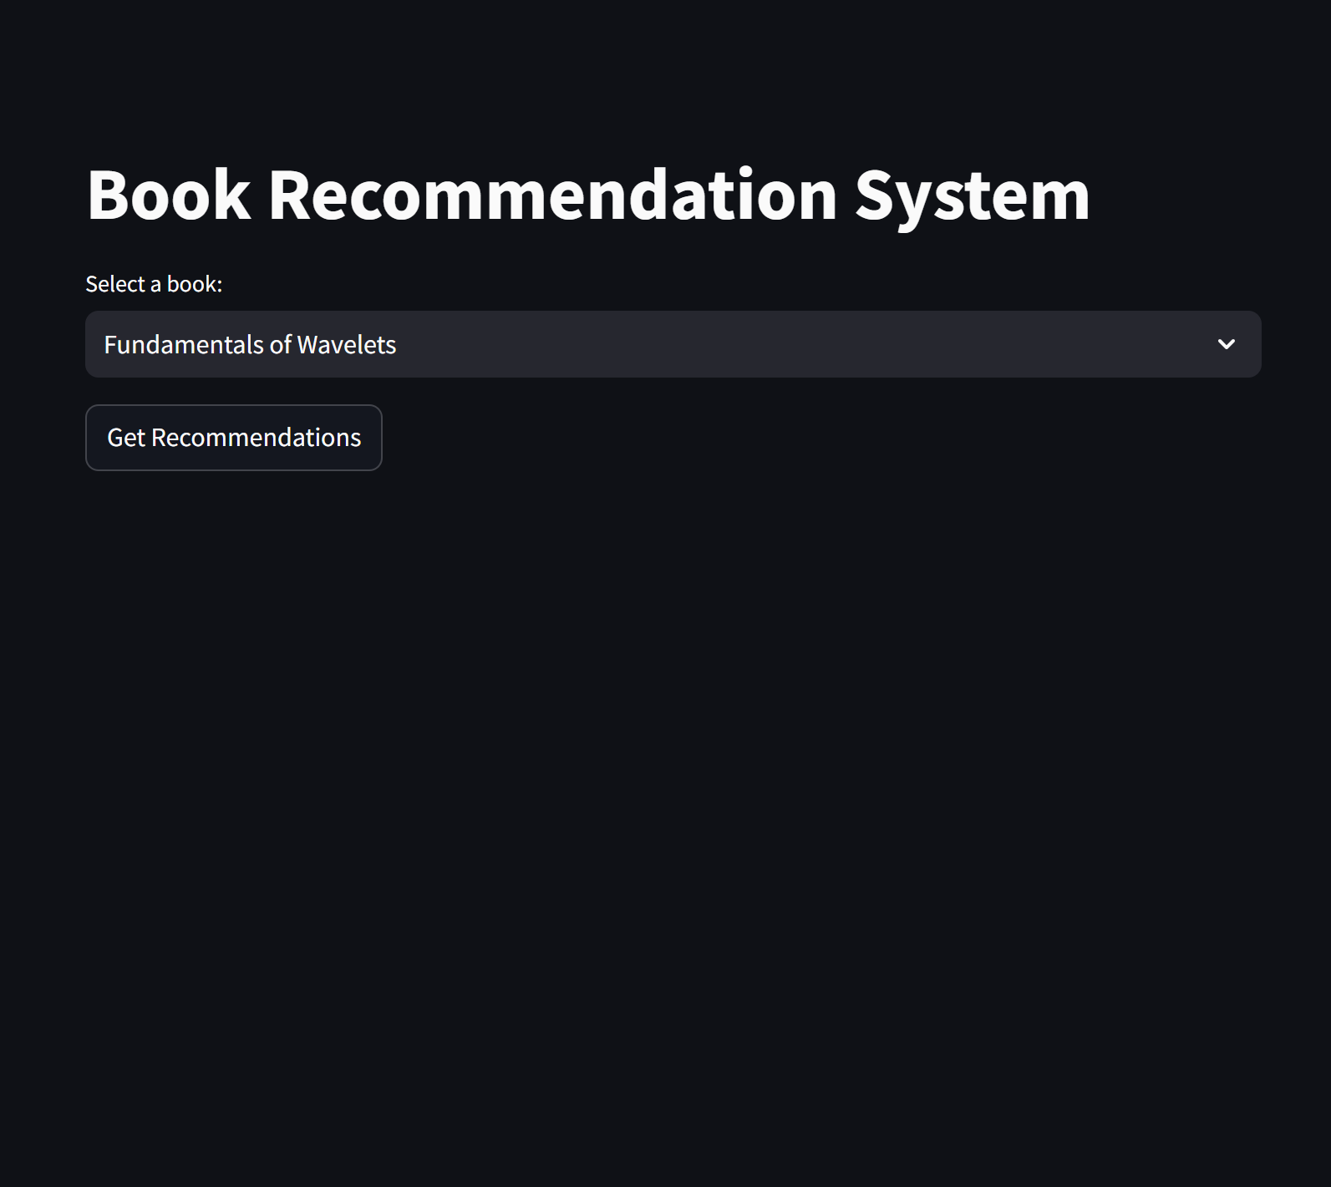

**2. Book Selection: When the user clicks the arrow next to the box, a window appears, listing all the available books. The user can scroll through and select a book.**

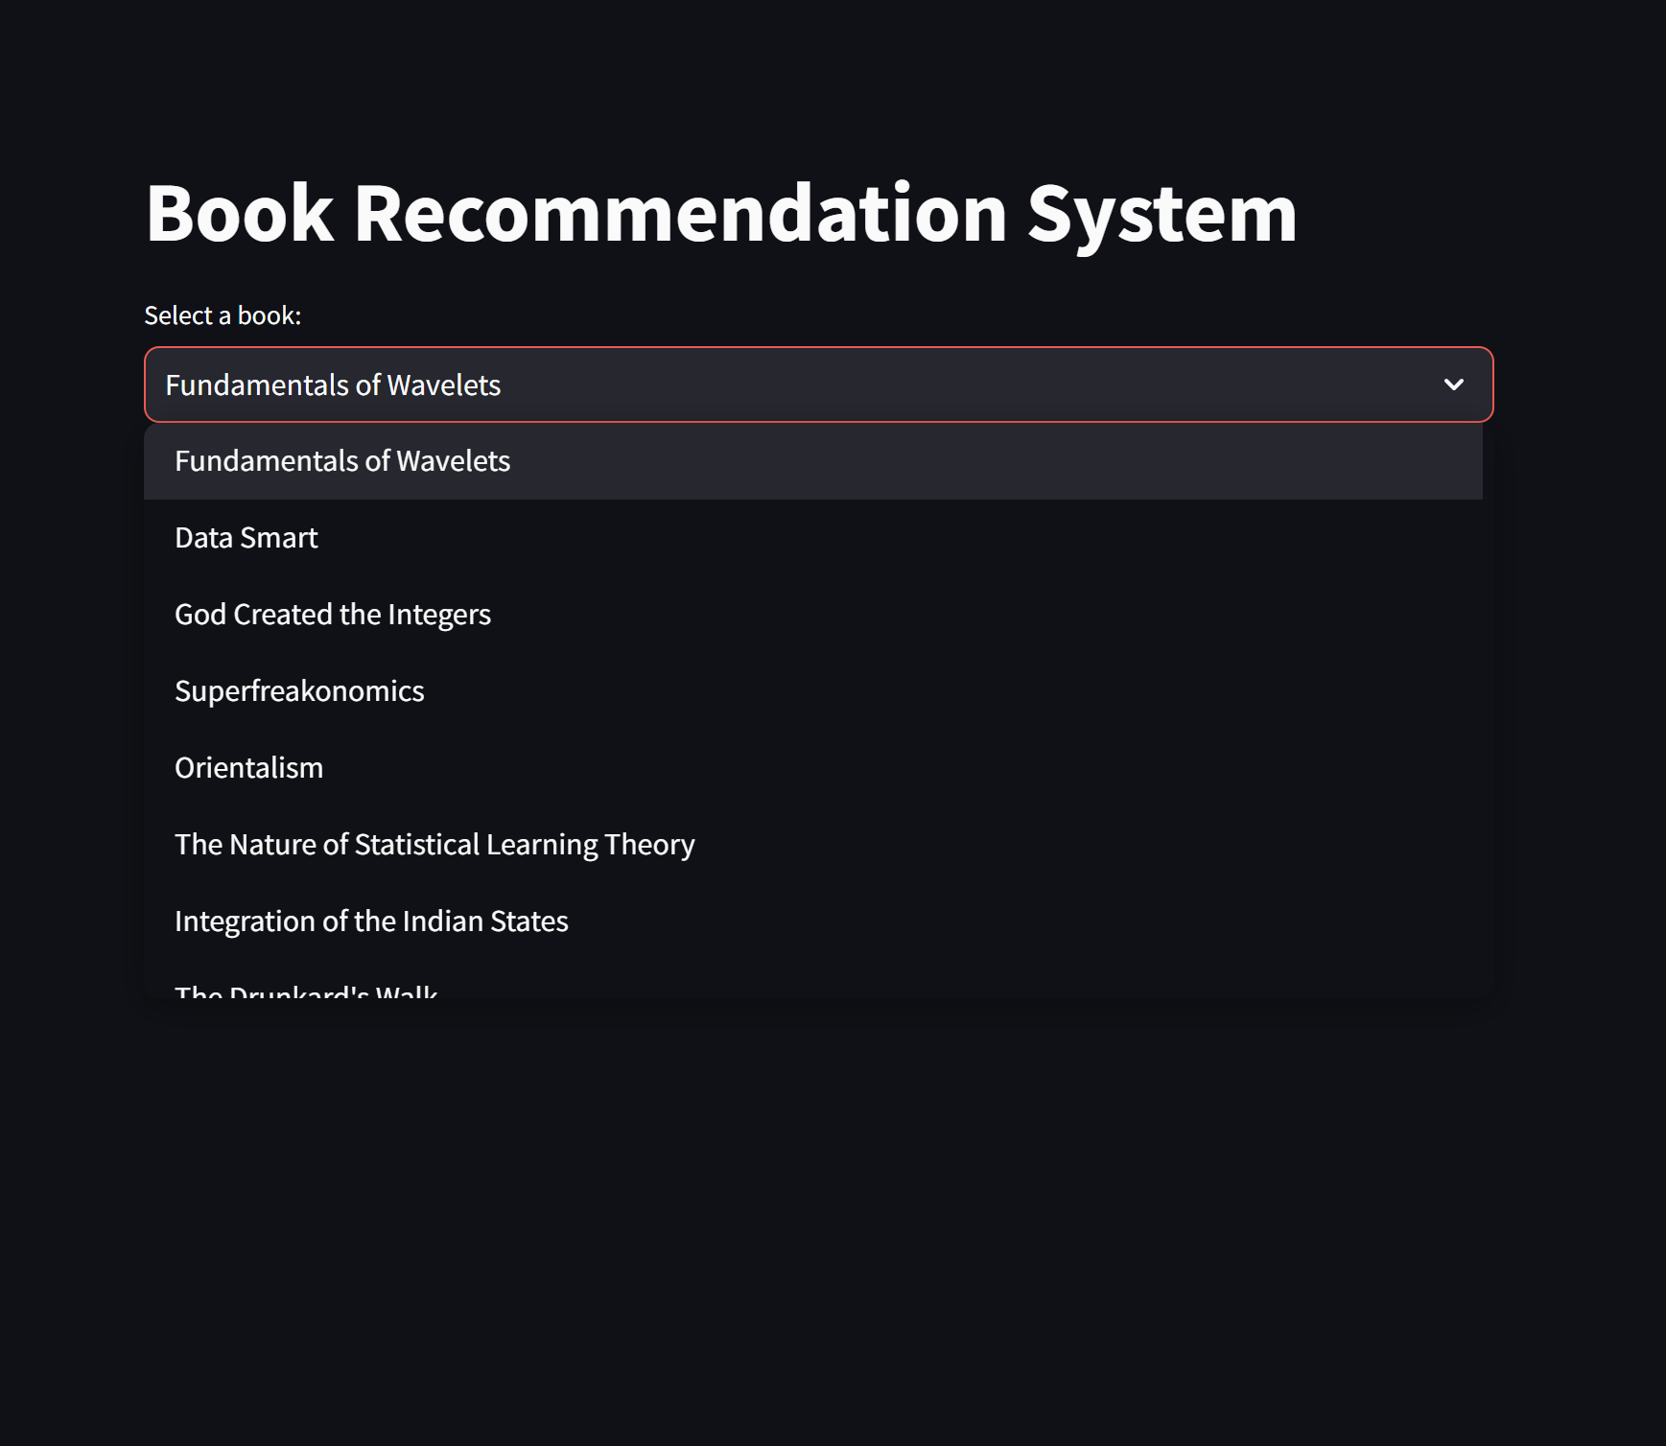

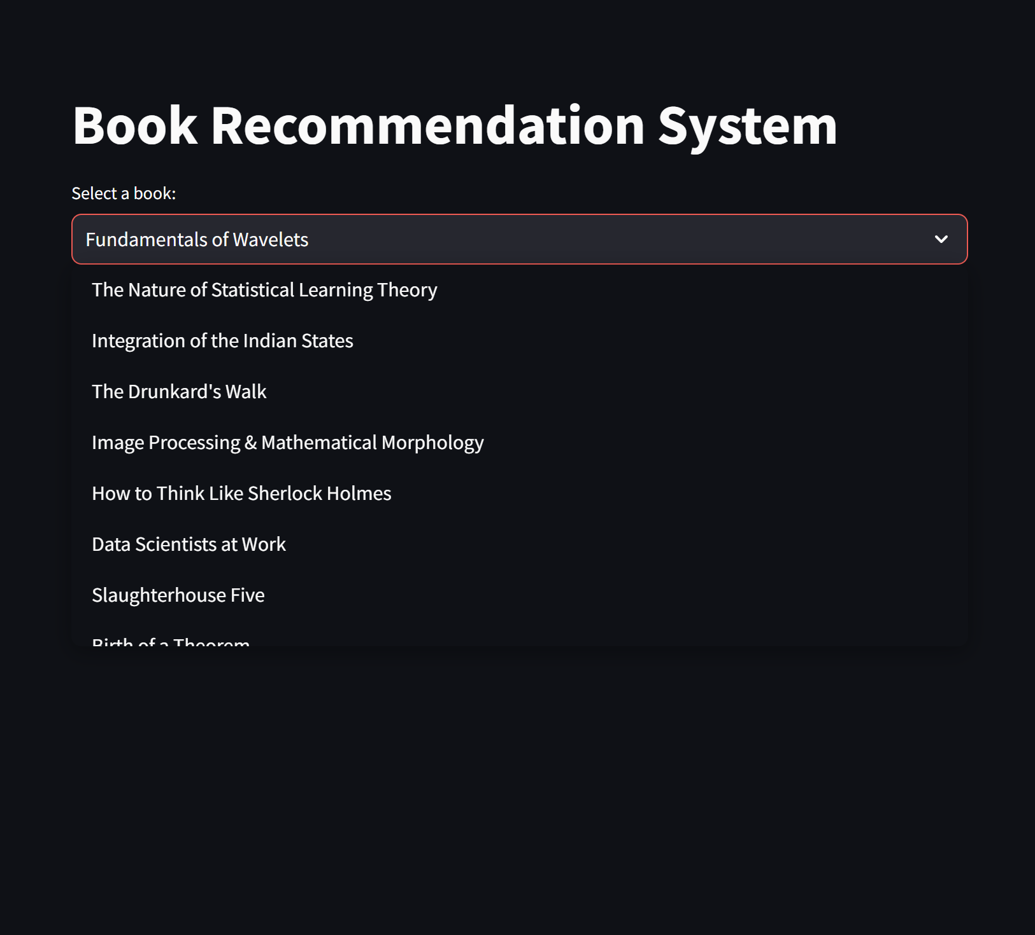

**3. Recommendations: After selecting a book and clicking the "Get Recommendation" button, the system predicts and displays the top 5 recommended books.**

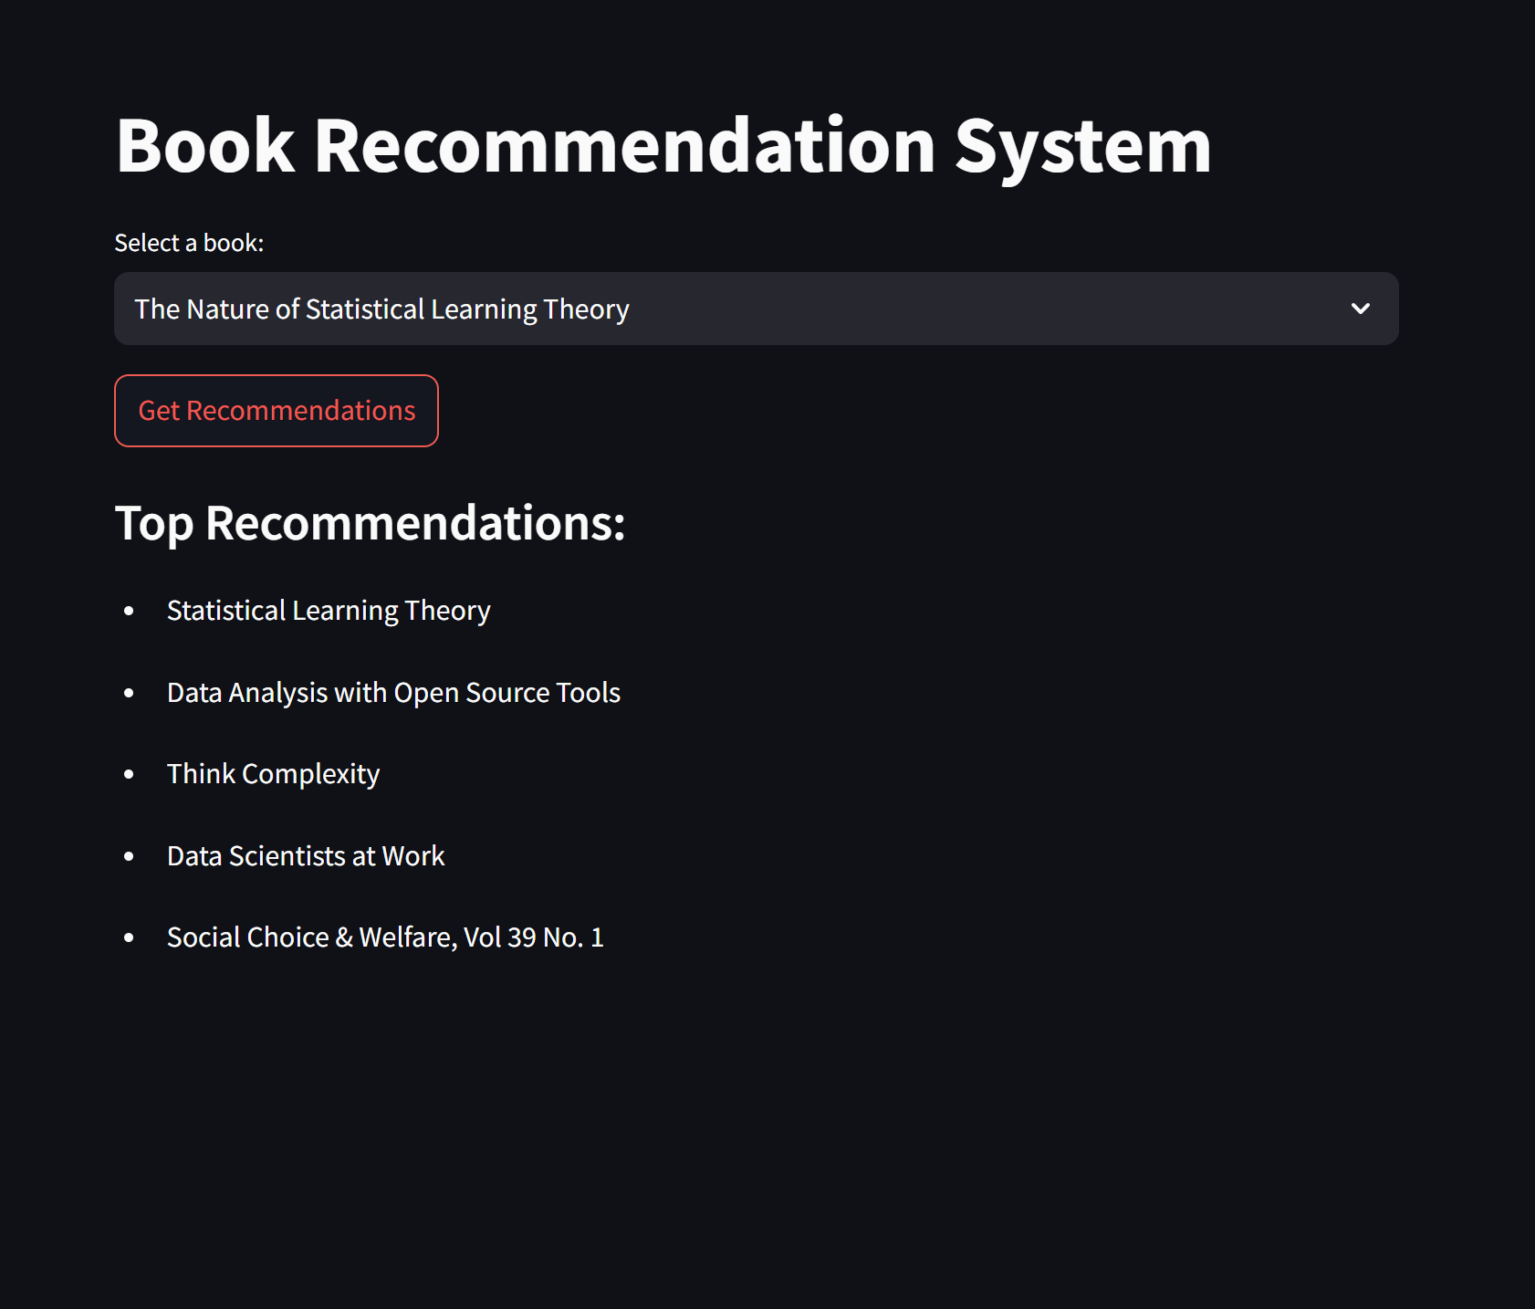

**4. Re-selection Option: The user can again click the arrow to reopen the book list, choose a different book, and repeat the recommendation process.**

