ACADEMIC RESULT MANAGEMENT SYSTEM

Report­I

03/09/2015

Ayushi Jain (04)

Ayushi Kumari (06)

# Table of Contents

1. INTRODUCTION 1
   1. PURPOSE 1
   2. SCOPE 1
   3. DEFINITIONS, ACRONYMS, AND ABBREVIATIONS 1
   4. REFERENCES 1
   5. OVERVIEW
2. GENERAL DESCRIPTION 2
   1. PRODUCT PERSPECTIVE 2
   2. PRODUCT FUNCTIONS 2
   3. USER CHARACTERISTICS 2
   4. GENERAL CONSTRAINTS 2
   5. ASSUMPTIONS AND DEPENDENCIES 3
3. SPECIFIC REQUIREMENTS 2
   1. EXTERNAL INTERFACE REQUIREMENTS 3
      1. *User Interfaces 3*
      2. *Hardware Interfaces 4*
      3. *Software Interfaces 4*
      4. *Communications Interfaces 4*
   2. FUNCTIONAL REQUIREMENTS 4
   3. OTHER REQUIREMENTS 4
4. ANALYSIS MODELS 5
   1. FLOW CHART 5
   2. MODULE DESCRIPTION 5

# Introduction

This document aims at defining overall software requirement for ACADEMIC RESULT MANAGEMENT SYSTEM .Efforts have been made to define the requirements exhaustively and accurately. The final product will be having only features/functionalities mentioned in this document and assumptions for any additional functionality/feature should not be made by any of the parties involved in developing/testing/implementing /using this product .

## Purpose

This specification document describes the capabilities that will be provided by the software application STUDENT RESULT MANAGEMENT SYSTEM .It also states the various constraints by which the system will abide. The intended audience for this document are the development team, testing team and end users of the product.

## Scope

The application will manage the information about various students enrolled in this course in different years, the subjects offered during different semesters of the course, the marks obtained by the various students in various subjects in different semesters.

The application will greatly simplify and speed up the result preparation and management process.

## Definitions, Acronyms, and Abbreviations

* SRS­Software Requirement Specification
* IEEE­The Institute of Electrical and Electronics Engineers
* DFD­ Data Flow Diagram
* DB­Database
* OS­ Operating System

## References

* IEEE 830­1998 standard for writing SRS document.
* Wikipedia
* Software engineering by KK Agrawal
* Software engineering by Roger S. Pressman

## Overview

Student’s information is stored in mysql the authority is given to Administrator; he gives the permission to instructor to enter the department data and student information. The security is providing by giving password to each instructor..

# General Description

This section of the SRS should describe the general factors that affect 'the product and its requirements. It should be made clear that this section does not state specific requirements; it only makes those requirements easier to understand.

## Product Perspective

The application will be windows based, self­contained and independent software product.



**Backend**

**DB**

Front end client Application (with data/entry/update/delete/view and reporting facility)

## Product Functions

1. Information about the various Users
2. Information about subjects offered in various semesters
3. Marks obtain by Students in different semesters
4. Generation of Reports

## User Characteristics

This subsection of the SRS should describe those general characteristics of the eventual users of the product that will affect the specific requirements. (See the IEEE Guide to SRS for more details).

## General Constraints

* + - * + Users at university will have to implement a security policy to safeguard the marks related information being modified by unauthorized users (by means of gaining access to the backend database)

## Assumptions and Dependencies

1. The number of subjects to be taken by the student in each semester does not change.
2. The subject types do not change.
3. The number of semester do not change.
4. The users have sufficient knowledge of computers.
5. The users know the English language, as the user interface will be provided in English.

# Specific Requirements

This section contains the software requirements to a level of detail sufficient to enable designers to design the system and testers to test that system.

## External Interface Requirements

### User Interfaces

The following screens will be provided:

Login screen: This will be the first screen that will be displayed. It allows user to access different screens based upon the user role. Various fields available on this screen will be User id: alphanumeric of length up to 10char.

Password: alphanumeric of length up to 10char Role: Will have the following

Values: Administrator, Data entry Operator , student , teacher

1. Subject info Parameter Screen:

This screen will be accessible only to the Administrator. It will allow the user to enter the semester number for which the user wants to access the subject information.

1. Student info Parameter Screen:

This screen will be accessible only to the Administrator. It will allow the user to enter the Batch Year for which the user wants to access the student information.

1. Student Information Screen: This screen will be accessible only to the Administrator. It will allow the user to modify the information about new/existing student for particular batch year. Various fields available on these screen are:

Student Enrollment No: of the format B.E/YYYY where YYYY represents the batch year Student Name: only alphabetic letters and length up to 40 chars.

Batch Year: of the format YYYY

1. Marks Entry Parameter Screen: This screen will be accessible only to the Teacher. It will allow the user to enter the Batch Year, the semester number and the subject for which the user wants to access the marks information.
2. Marks entry screen: Screen: This screen will be accessible only to the Teacher. It will

allow the user to add/modify/delete information about the marks obtained in the selected subject by different students. It includes Student enrollment no, student name, internal marks, external marks, total marks.

### Hardware Interfaces

1. Intel p4 processor with minimum 2GHz speed.
2. RAM: Minimum 1GB
3. Hard Disk: min 20GB

### Software Interfaces

1. Turbo C++
2. DB Server: SQL SERVER 2008
3. OS: Window Vista/XP/7/8/10

## Functional Requirements

Depending upon the user role he/she will be able to access only the specific modules of the system.

1. Login facility for enabling only authorized access to the system
2. User (with role Data Entry operator) will be able to modify /add/delete information about different students that are enrolled for the course in different years .

## Other Requirements

### NON­ FUNCTIONAL REQUIREMENT

1 **.Safety Requirements**

The database may get crashed at any certain time due to virus or operating system failure. Therefore, it is required to take the database backup

### Security Requirements

We are going to develop a secured database for the university .Depending upon the category of user the access rights are decided. It means if the user is an administrator then he can be able to modify the data, delete, append etc. All other users other than staff only have the rights to retrieve the information about database.

### Hardware Constraints

The system requires a database in order to store persistent data. The database should

have backup capabilities

### DB Requirement

The following information will be placed in DB:

1. Subject info: Subject Name, Code, Semester
2. Student Info: Student Enrolment Number, Student name, enrollment year.
3. Marks info: Student Enrolment , Semester, internal marks in each subject, external marks in each subject
4. User Account Info: UserName, User Id, password, role

# Analysis Models

## Flow Chart

Context diagram­

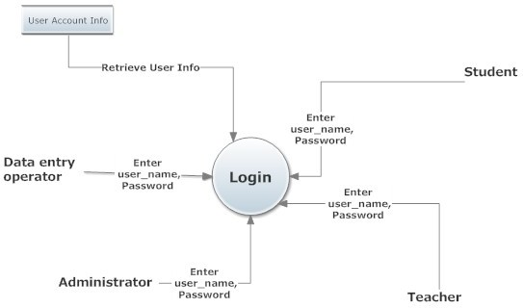

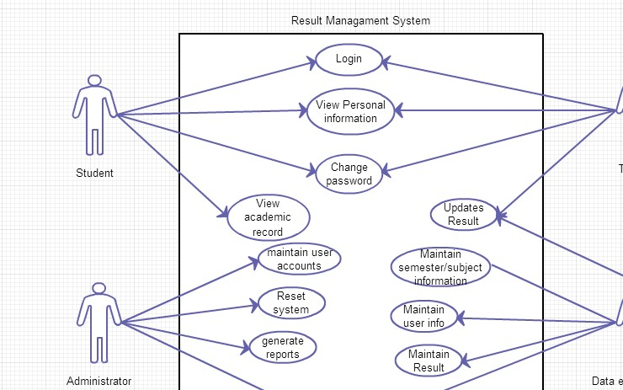

## LEVEL­1 DFD

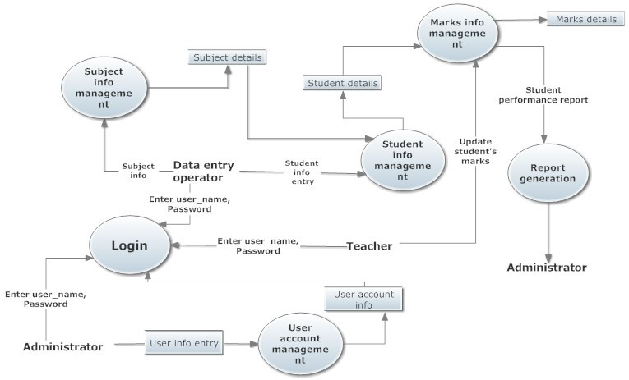

**LEVEL ­2 DFD**



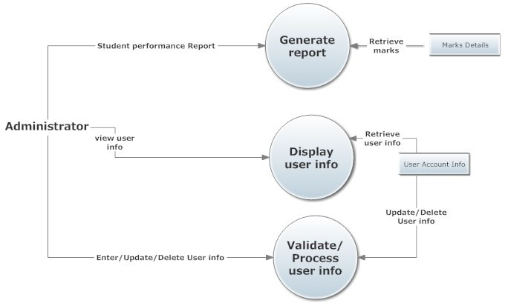

## USE CASE DIAGRAM

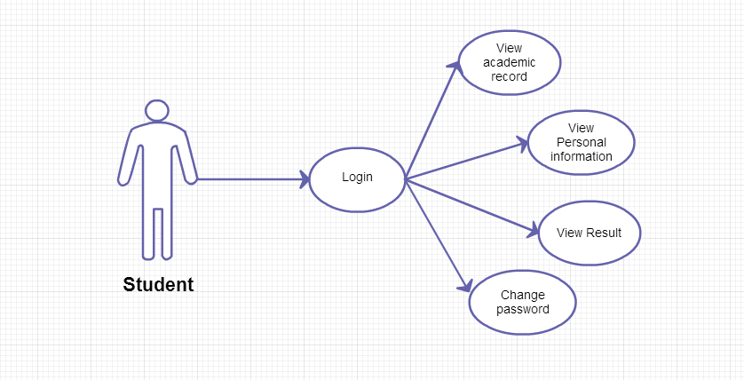

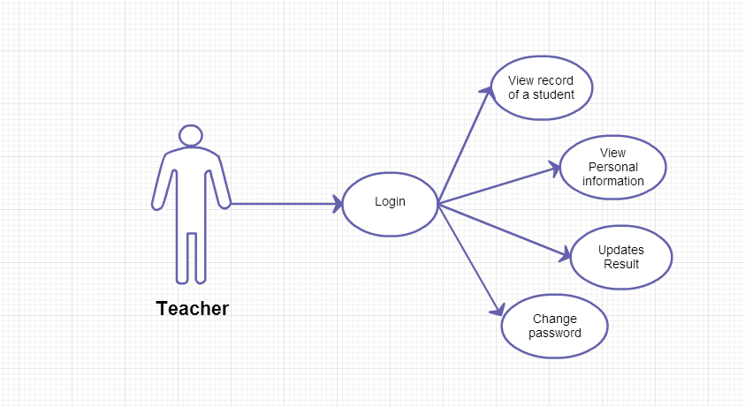

USE CASE DIAGRAM

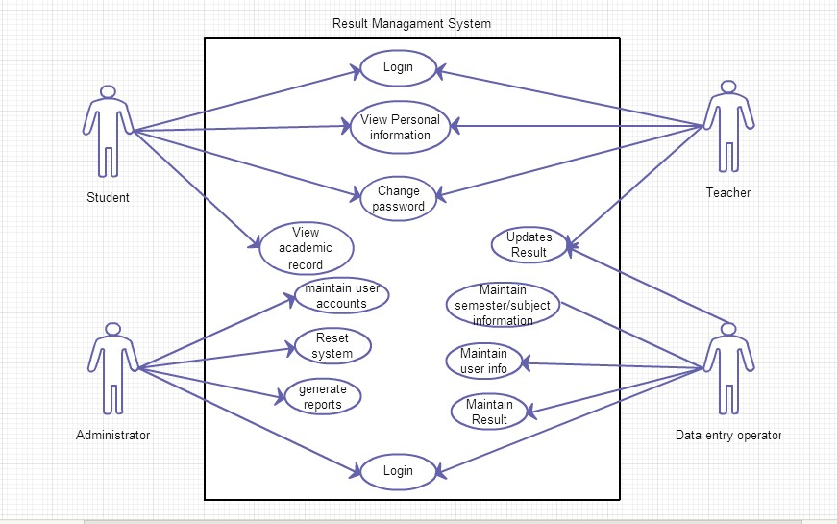

ER DIAGRAM

