**REPORT OF MINI PROJECT**

**18CSC304J -COMPILER DESIGN**

***Submitted by***

**APEKSHA SEHRAWAT(RA1911028010073)**

**SHIVANSH(RA1911028010076)**

**ARPAN MISHRA(RA1911028010082)**

**I2-SECTION**

**FACULTY : DR.VIJAY VASANTH**

***In partial fulfillment for the award of the degree of***

**BACHELOR OF TECHNOLOGY**

in

**COMPUTER SCIENCE & ENGINEERING**

of

**FACULTY OF ENGINEERING AND TECHNOLOGY**



S.R.M. Nagar, Kattankulathur, Kancheepuram District

**MAY 2022**

**SRM INSTITUTE OF SCIENCE AND TECHNOLOGY**

(Under Section 3 of UGC Act, 1956)

**BONAFIDE CERTIFICATE**

Certified that the Mini project of COMPILER DESIGN report titled ‘PYTHON IDE (OWN COMPILER )’ is the bonafide work of “APEKSHA SEHRAWAT **[RA1911028010073] ,** SHIVANSH**[RA1911028010076],** ARPAN MISHRA **[RA1911028010082]**” submitted for the course 18CSC304J COMPILER DESIGN. This report is a record of successful completion of the specified course evaluated based on literature reviews and the supervisor. No part of the COMPILER DESIGN has been submitted for any degree, diploma, title, or recognition before.

**SIGNATURE**

DR.V.VASANTH Assistant Professor

Dept. of Computer Science & Engineering

**SIGNATURE**

APEKSHA SEHRAWAT

SHIVANSH

ARPAN MISHRA

Academic Advisor/HOD

Dept. of Computer Science & Engineering

# ACKNOWLEDGEMENT

A person thrives when they are inspired and motivated. It plays a key role in the success of any venture.

I would like to express my sincere thanks to **VIJAY VASANTH SIR**  for encouraging me to the highest point and always helping me whenever I got stuck. Due to her guidance I was able to complete my project.

I would like to thank **my parents** for their support, care and inspira- tion.

# ABSTRACT

* Python is one of the most famous programming languages. Python is an interpreted programming language and has different execution environments. It has a wide range of compilers to execute the python programs eg. PyCharm, PyDev, Jupyter Notebook, Visual Studio Code, and many more.
* The compiler is a special program that is written in a specific programming language to convert the human-readable language i.e. high-level language to machine-readable language i.e. low-level language

It can be really difficult and tedious task to sit for hours and trying to understand how a sorting algorithm works or how the linked is traversed.

Our application aims that the user get a firm hold on the basics of data structure and algorithms.

# INTRODUCTION

A compiler is a translator that converts the high-level language into the machine language. High-level language is written by a developer and machine language can be understood by the processor. Compiler is used to show errors to the programmer.

compiler, computer software that translates (compiles) source code written in a high-level language (e.g., C++) into a set of machine-language instructions that can be understood by a digital computer's CPU. Compilers are very large programs, with error-checking and other abilities. The first Autocode and compiler in the modern sense were developed by Alick Glennie in 1952 at the University of Manchester for the Mark 1 computer. The FORTRAN team led by John W. Backus at IBM introduced the first commercially available compiler, in 1957, which took 18 person-years to create.

**4.Specific Requirements**

* Any Operating System preferably Window 10/Ubuntu 18.04.
* Node version 14.0.
* Node Package Manager version 6.8
* VS Code.
* Pycharm IDE
* Google Chrome / Firefox / Microsoft Edge.

**5.MODULE DESCRIPTION**

* Pycharm (Python IDE)
* Tkinter (Library)
* Subprocess (python dictionary)
* Pandas (Library)

**6. CODING WORK & COMPILER(OUTPUT)**

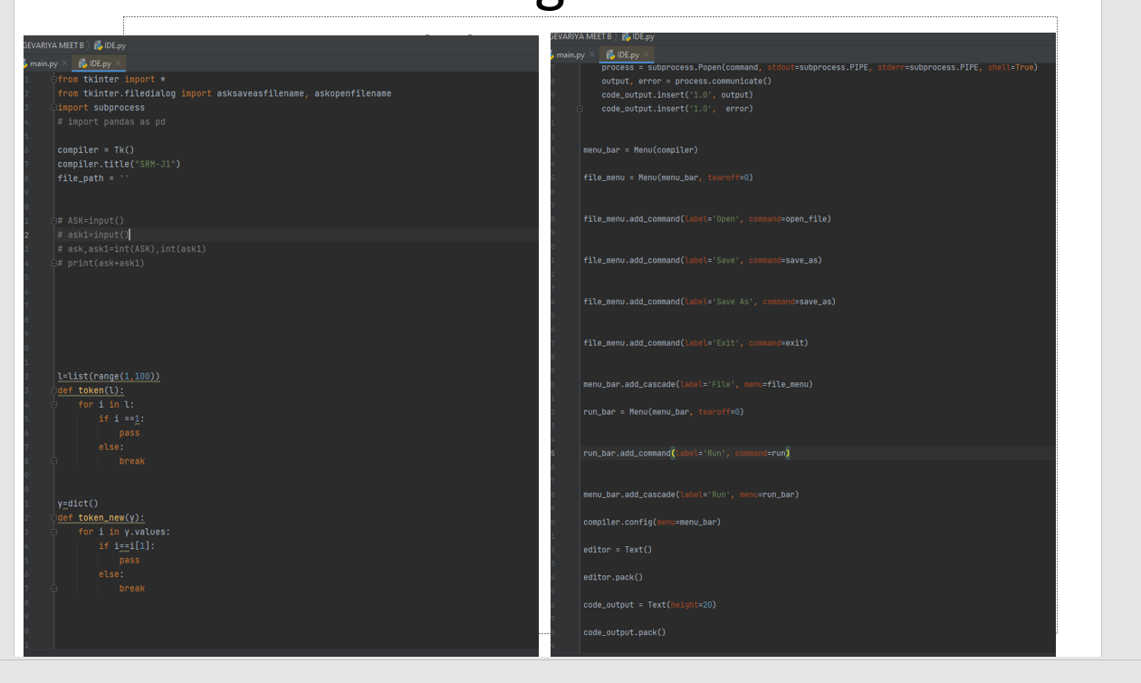

**,** 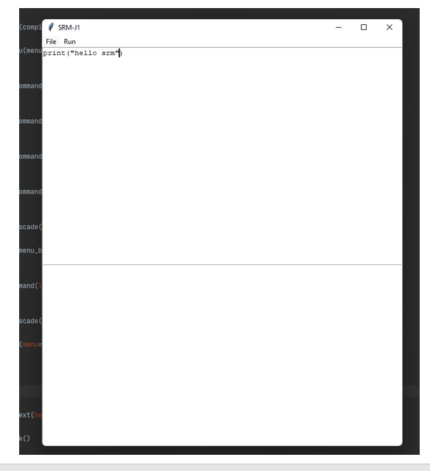

**7.Conclusion and Future work**

* Over the course of this semester our group was able to create a compiler for the PYTHON language from beginning to end. Testing was performed at four critical junctions, after implementing the scanner, after creating the parser, after creating a parse tree generator, and finally after the code generation step.
* In the future, we plan to expand on the foundation created in this course. Expansion will focus on the ability to add more functionality to the compiler as well as memory management. Currently the compiler is capable of running the 15 3AC codes. Future utilization of this project should allow for the functionality of shifting statements as well as logical operations.

**THANK YOU**