Analises_

2024-01-22

### Carregando bibliotecas

library(tidyverse)  
library(geobr)  
source("R/gafico.R")  
source("R/my-function.R")  
#> | | | 0% | |=== | 4% | |===== | 7% | |======== | 11% | |========== | 15% | |============= | 19% | |================ | 22% | |================== | 26% | |===================== | 30% | |======================= | 33% | |========================== | 37% | |============================= | 41% | |=============================== | 44% | |================================== | 48% | |==================================== | 52% | |======================================= | 56% | |========================================= | 59% | |============================================ | 63% | |=============================================== | 67% | |================================================= | 70% | |==================================================== | 74% | |====================================================== | 78% | |========================================================= | 81% | |============================================================ | 85% | |============================================================== | 89% | |================================================================= | 93% | |=================================================================== | 96% | |======================================================================| 100%  
#> Downloading: 9.9 kB Downloading: 9.9 kB Downloading: 26 kB Downloading: 26 kB Downloading: 42 kB Downloading: 42 kB Downloading: 58 kB Downloading: 58 kB Downloading: 58 kB Downloading: 58 kB Downloading: 58 kB Downloading: 58 kB Downloading: 67 kB Downloading: 67 kB Downloading: 83 kB Downloading: 83 kB Downloading: 83 kB Downloading: 83 kB Downloading: 99 kB Downloading: 99 kB Downloading: 110 kB Downloading: 110 kB Downloading: 110 kB Downloading: 110 kB Downloading: 120 kB Downloading: 120 kB Downloading: 120 kB Downloading: 120 kB Downloading: 120 kB Downloading: 120 kB Downloading: 120 kB Downloading: 120 kB Downloading: 130 kB Downloading: 130 kB Downloading: 130 kB Downloading: 130 kB Downloading: 130 kB Downloading: 130 kB Downloading: 140 kB Downloading: 140 kB Downloading: 160 kB Downloading: 160 kB Downloading: 160 kB Downloading: 160 kB Downloading: 160 kB Downloading: 160 kB Downloading: 170 kB Downloading: 170 kB Downloading: 180 kB Downloading: 180 kB Downloading: 190 kB Downloading: 190 kB Downloading: 190 kB Downloading: 190 kB Downloading: 200 kB Downloading: 200 kB Downloading: 200 kB Downloading: 200 kB Downloading: 200 kB Downloading: 200 kB Downloading: 210 kB Downloading: 210 kB Downloading: 230 kB Downloading: 230 kB Downloading: 240 kB Downloading: 240 kB Downloading: 250 kB Downloading: 250 kB Downloading: 250 kB Downloading: 250 kB Downloading: 250 kB Downloading: 250 kB Downloading: 270 kB Downloading: 270 kB Downloading: 290 kB Downloading: 290 kB Downloading: 300 kB Downloading: 300 kB Downloading: 320 kB Downloading: 320 kB Downloading: 320 kB Downloading: 320 kB Downloading: 320 kB Downloading: 320 kB Downloading: 320 kB Downloading: 320 kB Downloading: 330 kB Downloading: 330 kB Downloading: 340 kB Downloading: 340 kB Downloading: 360 kB Downloading: 360 kB Downloading: 370 kB Downloading: 370 kB Downloading: 380 kB Downloading: 380 kB Downloading: 380 kB Downloading: 380 kB Downloading: 380 kB Downloading: 380 kB Downloading: 390 kB Downloading: 390 kB Downloading: 390 kB Downloading: 390 kB Downloading: 410 kB Downloading: 410 kB Downloading: 410 kB Downloading: 410 kB Downloading: 410 kB Downloading: 410 kB Downloading: 430 kB Downloading: 430 kB Downloading: 440 kB Downloading: 440 kB Downloading: 450 kB Downloading: 450 kB Downloading: 450 kB Downloading: 450 kB Downloading: 450 kB Downloading: 450 kB Downloading: 460 kB Downloading: 460 kB Downloading: 460 kB Downloading: 460 kB Downloading: 460 kB Downloading: 460 kB Downloading: 470 kB Downloading: 470 kB Downloading: 480 kB Downloading: 480 kB Downloading: 490 kB Downloading: 490 kB Downloading: 490 kB Downloading: 490 kB Downloading: 500 kB Downloading: 500 kB Downloading: 500 kB Downloading: 500 kB Downloading: 510 kB Downloading: 510 kB Downloading: 510 kB Downloading: 510 kB Downloading: 510 kB Downloading: 510 kB Downloading: 520 kB Downloading: 520 kB Downloading: 520 kB Downloading: 520 kB Downloading: 530 kB Downloading: 530 kB Downloading: 540 kB Downloading: 540 kB Downloading: 540 kB Downloading: 540 kB Downloading: 540 kB Downloading: 540 kB Downloading: 550 kB Downloading: 550 kB Downloading: 560 kB Downloading: 560 kB Downloading: 570 kB Downloading: 570 kB Downloading: 580 kB Downloading: 580 kB Downloading: 580 kB Downloading: 580 kB Downloading: 580 kB Downloading: 580 kB Downloading: 580 kB Downloading: 580 kB Downloading: 580 kB Downloading: 580 kB Downloading: 590 kB Downloading: 590 kB Downloading: 600 kB Downloading: 600 kB Downloading: 610 kB Downloading: 610 kB Downloading: 620 kB Downloading: 620 kB Downloading: 630 kB Downloading: 630 kB Downloading: 630 kB Downloading: 630 kB Downloading: 640 kB Downloading: 640 kB Downloading: 650 kB Downloading: 650 kB Downloading: 650 kB Downloading: 650 kB Downloading: 660 kB Downloading: 660 kB Downloading: 670 kB Downloading: 670 kB Downloading: 670 kB Downloading: 670 kB Downloading: 670 kB Downloading: 670 kB Downloading: 680 kB Downloading: 680 kB Downloading: 680 kB Downloading: 680 kB Downloading: 690 kB Downloading: 690 kB Downloading: 690 kB Downloading: 690 kB Downloading: 700 kB Downloading: 700 kB Downloading: 710 kB Downloading: 710 kB Downloading: 720 kB Downloading: 720 kB Downloading: 720 kB Downloading: 720 kB Downloading: 740 kB Downloading: 740 kB Downloading: 750 kB Downloading: 750 kB Downloading: 750 kB Downloading: 750 kB Downloading: 750 kB Downloading: 750 kB Downloading: 760 kB Downloading: 760 kB Downloading: 770 kB Downloading: 770 kB Downloading: 790 kB Downloading: 790 kB Downloading: 800 kB Downloading: 800 kB Downloading: 810 kB Downloading: 810 kB Downloading: 810 kB Downloading: 810 kB Downloading: 830 kB Downloading: 830 kB Downloading: 830 kB Downloading: 830 kB Downloading: 830 kB Downloading: 830 kB Downloading: 840 kB Downloading: 840 kB Downloading: 840 kB Downloading: 840 kB Downloading: 860 kB Downloading: 860 kB Downloading: 870 kB Downloading: 870 kB Downloading: 880 kB Downloading: 880 kB Downloading: 880 kB Downloading: 880 kB Downloading: 880 kB Downloading: 880 kB Downloading: 890 kB Downloading: 890 kB Downloading: 890 kB Downloading: 890 kB Downloading: 910 kB Downloading: 910 kB Downloading: 910 kB Downloading: 910 kB Downloading: 910 kB Downloading: 910 kB Downloading: 920 kB Downloading: 920 kB Downloading: 930 kB Downloading: 930 kB Downloading: 930 kB Downloading: 930 kB Downloading: 930 kB Downloading: 930 kB Downloading: 940 kB Downloading: 940 kB Downloading: 940 kB Downloading: 940 kB Downloading: 960 kB Downloading: 960 kB Downloading: 970 kB Downloading: 970 kB Downloading: 980 kB Downloading: 980 kB Downloading: 1,000 kB Downloading: 1,000 kB Downloading: 1 MB Downloading: 1 MB Downloading: 1 MB Downloading: 1 MB Downloading: 1 MB Downloading: 1 MB Downloading: 1 MB Downloading: 1 MB Downloading: 1 MB Downloading: 1 MB Downloading: 1 MB Downloading: 1 MB Downloading: 1 MB Downloading: 1 MB Downloading: 1.1 MB Downloading: 1.1 MB Downloading: 1.1 MB Downloading: 1.1 MB Downloading: 1.1 MB Downloading: 1.1 MB Downloading: 1.1 MB Downloading: 1.1 MB Downloading: 1.1 MB Downloading: 1.1 MB Downloading: 1.1 MB Downloading: 1.1 MB Downloading: 1.1 MB Downloading: 1.1 MB Downloading: 1.1 MB Downloading: 1.1 MB Downloading: 1.1 MB Downloading: 1.1 MB Downloading: 1.1 MB Downloading: 1.1 MB Downloading: 1.1 MB Downloading: 1.1 MB Downloading: 1.1 MB Downloading: 1.1 MB Downloading: 1.2 MB Downloading: 1.2 MB Downloading: 1.2 MB Downloading: 1.2 MB Downloading: 1.2 MB Downloading: 1.2 MB Downloading: 1.2 MB Downloading: 1.2 MB Downloading: 1.2 MB Downloading: 1.2 MB Downloading: 1.2 MB Downloading: 1.2 MB Downloading: 1.2 MB Downloading: 1.2 MB Downloading: 1.2 MB Downloading: 1.2 MB Downloading: 1.2 MB Downloading: 1.2 MB Downloading: 1.2 MB Downloading: 1.2 MB Downloading: 1.2 MB Downloading: 1.2 MB Downloading: 1.2 MB Downloading: 1.2 MB Downloading: 1.2 MB Downloading: 1.2 MB Downloading: 1.2 MB Downloading: 1.2 MB Downloading: 1.3 MB Downloading: 1.3 MB Downloading: 1.3 MB Downloading: 1.3 MB Downloading: 1.3 MB Downloading: 1.3 MB Downloading: 1.3 MB Downloading: 1.3 MB Downloading: 1.3 MB Downloading: 1.3 MB Downloading: 1.3 MB Downloading: 1.3 MB Downloading: 1.3 MB Downloading: 1.3 MB Downloading: 1.3 MB Downloading: 1.3 MB Downloading: 1.3 MB Downloading: 1.3 MB Downloading: 1.3 MB Downloading: 1.3 MB Downloading: 1.3 MB Downloading: 1.3 MB Downloading: 1.3 MB Downloading: 1.3 MB Downloading: 1.3 MB Downloading: 1.3 MB Downloading: 1.3 MB Downloading: 1.3 MB Downloading: 1.4 MB Downloading: 1.4 MB Downloading: 1.4 MB Downloading: 1.4 MB Downloading: 1.4 MB Downloading: 1.4 MB Downloading: 1.4 MB Downloading: 1.4 MB Downloading: 1.4 MB Downloading: 1.4 MB Downloading: 1.4 MB Downloading: 1.4 MB Downloading: 1.4 MB Downloading: 1.4 MB Downloading: 1.4 MB Downloading: 1.4 MB Downloading: 1.4 MB Downloading: 1.4 MB Downloading: 1.4 MB Downloading: 1.4 MB Downloading: 1.4 MB Downloading: 1.4 MB Downloading: 1.4 MB Downloading: 1.4 MB Downloading: 1.4 MB Downloading: 1.4 MB Downloading: 1.4 MB Downloading: 1.4 MB Downloading: 1.4 MB Downloading: 1.4 MB Downloading: 1.5 MB Downloading: 1.5 MB Downloading: 1.5 MB Downloading: 1.5 MB Downloading: 1.5 MB Downloading: 1.5 MB Downloading: 1.5 MB Downloading: 1.5 MB Downloading: 1.5 MB Downloading: 1.5 MB Downloading: 1.5 MB Downloading: 1.5 MB Downloading: 1.5 MB Downloading: 1.5 MB Downloading: 1.5 MB Downloading: 1.5 MB Downloading: 1.5 MB Downloading: 1.5 MB Downloading: 1.5 MB Downloading: 1.5 MB Downloading: 1.5 MB Downloading: 1.5 MB Downloading: 1.5 MB Downloading: 1.5 MB Downloading: 1.5 MB Downloading: 1.5 MB Downloading: 1.5 MB Downloading: 1.5 MB Downloading: 1.5 MB Downloading: 1.5 MB Downloading: 1.5 MB Downloading: 1.5 MB Downloading: 1.5 MB Downloading: 1.5 MB Downloading: 1.5 MB Downloading: 1.5 MB Downloading: 1.6 MB Downloading: 1.6 MB Downloading: 1.6 MB Downloading: 1.6 MB Downloading: 1.6 MB Downloading: 1.6 MB Downloading: 1.6 MB Downloading: 1.6 MB Downloading: 1.6 MB Downloading: 1.6 MB Downloading: 1.6 MB Downloading: 1.6 MB Downloading: 1.6 MB Downloading: 1.6 MB Downloading: 1.6 MB Downloading: 1.6 MB Downloading: 1.6 MB Downloading: 1.6 MB Downloading: 1.7 MB Downloading: 1.7 MB Downloading: 1.7 MB Downloading: 1.7 MB Downloading: 1.7 MB Downloading: 1.7 MB Downloading: 1.7 MB Downloading: 1.7 MB Downloading: 1.7 MB Downloading: 1.7 MB Downloading: 1.7 MB Downloading: 1.7 MB Downloading: 1.7 MB Downloading: 1.7 MB Downloading: 1.7 MB Downloading: 1.7 MB Downloading: 1.7 MB Downloading: 1.7 MB Downloading: 1.7 MB Downloading: 1.7 MB Downloading: 1.7 MB Downloading: 1.7 MB Downloading: 1.7 MB Downloading: 1.7 MB Downloading: 1.7 MB Downloading: 1.7 MB Downloading: 1.7 MB Downloading: 1.7 MB Downloading: 1.8 MB Downloading: 1.8 MB Downloading: 1.8 MB Downloading: 1.8 MB Downloading: 1.8 MB Downloading: 1.8 MB Downloading: 1.8 MB Downloading: 1.8 MB Downloading: 1.8 MB Downloading: 1.8 MB Downloading: 1.8 MB Downloading: 1.8 MB Downloading: 1.8 MB Downloading: 1.8 MB Downloading: 1.8 MB Downloading: 1.8 MB Downloading: 1.8 MB Downloading: 1.8 MB Downloading: 1.8 MB Downloading: 1.8 MB Downloading: 1.8 MB Downloading: 1.8 MB Downloading: 1.8 MB Downloading: 1.8 MB Downloading: 1.8 MB Downloading: 1.8 MB Downloading: 1.8 MB Downloading: 1.8 MB Downloading: 1.8 MB Downloading: 1.8 MB Downloading: 1.8 MB Downloading: 1.8 MB Downloading: 1.8 MB Downloading: 1.8 MB Downloading: 1.8 MB Downloading: 1.8 MB Downloading: 1.8 MB Downloading: 1.8 MB Downloading: 1.8 MB Downloading: 1.8 MB Downloading: 1.8 MB Downloading: 1.8 MB Downloading: 1.8 MB Downloading: 1.8 MB Downloading: 1.9 MB Downloading: 1.9 MB Downloading: 1.9 MB Downloading: 1.9 MB Downloading: 1.9 MB Downloading: 1.9 MB Downloading: 1.9 MB Downloading: 1.9 MB Downloading: 1.9 MB Downloading: 1.9 MB Downloading: 1.9 MB Downloading: 1.9 MB Downloading: 1.9 MB Downloading: 1.9 MB Downloading: 1.9 MB Downloading: 1.9 MB Downloading: 1.9 MB Downloading: 1.9 MB Downloading: 1.9 MB Downloading: 1.9 MB Downloading: 1.9 MB Downloading: 1.9 MB Downloading: 1.9 MB Downloading: 1.9 MB Downloading: 1.9 MB Downloading: 1.9 MB Downloading: 1.9 MB Downloading: 1.9 MB Downloading: 2 MB Downloading: 2 MB Downloading: 2 MB Downloading: 2 MB Downloading: 2 MB Downloading: 2 MB Downloading: 2 MB Downloading: 2 MB Downloading: 2 MB Downloading: 2 MB Downloading: 2 MB Downloading: 2 MB Downloading: 2 MB Downloading: 2 MB Downloading: 2 MB Downloading: 2 MB Downloading: 2 MB Downloading: 2 MB Downloading: 2 MB Downloading: 2 MB Downloading: 2 MB Downloading: 2 MB Downloading: 2 MB Downloading: 2 MB Downloading: 2 MB Downloading: 2 MB Downloading: 2 MB Downloading: 2 MB Downloading: 2 MB Downloading: 2 MB Downloading: 2 MB Downloading: 2 MB Downloading: 2 MB Downloading: 2 MB Downloading: 2 MB Downloading: 2 MB Downloading: 2 MB Downloading: 2 MB Downloading: 2 MB Downloading: 2 MB Downloading: 2 MB Downloading: 2 MB Downloading: 2.1 MB Downloading: 2.1 MB Downloading: 2.1 MB Downloading: 2.1 MB Downloading: 2.1 MB Downloading: 2.1 MB Downloading: 2.1 MB Downloading: 2.1 MB Downloading: 2.1 MB Downloading: 2.1 MB Downloading: 2.1 MB Downloading: 2.1 MB Downloading: 2.1 MB Downloading: 2.1 MB Downloading: 2.1 MB Downloading: 2.1 MB Downloading: 2.1 MB Downloading: 2.1 MB Downloading: 2.1 MB Downloading: 2.1 MB Downloading: 2.1 MB Downloading: 2.1 MB Downloading: 2.1 MB Downloading: 2.1 MB Downloading: 2.2 MB Downloading: 2.2 MB Downloading: 2.2 MB Downloading: 2.2 MB Downloading: 2.2 MB Downloading: 2.2 MB Downloading: 2.2 MB Downloading: 2.2 MB Downloading: 2.2 MB Downloading: 2.2 MB Downloading: 2.2 MB Downloading: 2.2 MB Downloading: 2.2 MB Downloading: 2.2 MB Downloading: 2.2 MB Downloading: 2.2 MB Downloading: 2.2 MB Downloading: 2.2 MB Downloading: 2.3 MB Downloading: 2.3 MB Downloading: 2.3 MB Downloading: 2.3 MB Downloading: 2.3 MB Downloading: 2.3 MB Downloading: 2.3 MB Downloading: 2.3 MB Downloading: 2.3 MB Downloading: 2.3 MB Downloading: 2.3 MB Downloading: 2.3 MB Downloading: 2.3 MB Downloading: 2.3 MB Downloading: 2.3 MB Downloading: 2.3 MB Downloading: 2.3 MB Downloading: 2.3 MB Downloading: 2.3 MB Downloading: 2.3 MB Downloading: 2.3 MB Downloading: 2.3 MB Downloading: 2.3 MB Downloading: 2.3 MB Downloading: 2.4 MB Downloading: 2.4 MB Downloading: 2.4 MB Downloading: 2.4 MB Downloading: 2.4 MB Downloading: 2.4 MB Downloading: 2.4 MB Downloading: 2.4 MB Downloading: 2.4 MB Downloading: 2.4 MB Downloading: 2.4 MB Downloading: 2.4 MB Downloading: 2.4 MB Downloading: 2.4 MB Downloading: 2.4 MB Downloading: 2.4 MB Downloading: 2.4 MB Downloading: 2.4 MB Downloading: 2.4 MB Downloading: 2.4 MB Downloading: 2.4 MB Downloading: 2.4 MB Downloading: 2.4 MB Downloading: 2.4 MB Downloading: 2.4 MB Downloading: 2.4 MB Downloading: 2.4 MB Downloading: 2.4 MB Downloading: 2.4 MB Downloading: 2.4 MB Downloading: 2.4 MB Downloading: 2.4 MB Downloading: 2.4 MB Downloading: 2.4 MB Downloading: 2.4 MB Downloading: 2.4 MB Downloading: 2.5 MB Downloading: 2.5 MB Downloading: 2.5 MB Downloading: 2.5 MB Downloading: 2.5 MB Downloading: 2.5 MB Downloading: 2.5 MB Downloading: 2.5 MB Downloading: 2.5 MB Downloading: 2.5 MB Downloading: 2.5 MB Downloading: 2.5 MB Downloading: 2.5 MB Downloading: 2.5 MB Downloading: 2.5 MB Downloading: 2.5 MB Downloading: 2.5 MB Downloading: 2.5 MB Downloading: 2.5 MB Downloading: 2.5 MB Downloading: 2.5 MB Downloading: 2.5 MB Downloading: 2.5 MB Downloading: 2.5 MB Downloading: 2.5 MB Downloading: 2.5 MB Downloading: 2.5 MB Downloading: 2.5 MB Downloading: 2.5 MB Downloading: 2.5 MB Downloading: 2.6 MB Downloading: 2.6 MB Downloading: 2.6 MB Downloading: 2.6 MB Downloading: 2.6 MB Downloading: 2.6 MB Downloading: 2.6 MB Downloading: 2.6 MB Downloading: 2.6 MB Downloading: 2.6 MB Downloading: 2.6 MB Downloading: 2.6 MB Downloading: 2.6 MB Downloading: 2.6 MB Downloading: 2.6 MB Downloading: 2.6 MB Downloading: 2.6 MB Downloading: 2.6 MB Downloading: 2.6 MB Downloading: 2.6 MB Downloading: 2.6 MB Downloading: 2.6 MB Downloading: 2.6 MB Downloading: 2.6 MB Downloading: 2.7 MB Downloading: 2.7 MB Downloading: 2.7 MB Downloading: 2.7 MB Downloading: 2.7 MB Downloading: 2.7 MB Downloading: 2.7 MB Downloading: 2.7 MB Downloading: 2.7 MB Downloading: 2.7 MB Downloading: 410 B Downloading: 410 B Downloading: 1.7 kB Downloading: 1.7 kB Downloading: 1.9 kB Downloading: 1.9 kB Downloading: 2.4 kB Downloading: 2.4 kB Downloading: 2.4 kB Downloading: 2.4 kB Downloading: 11 kB Downloading: 11 kB Downloading: 27 kB Downloading: 27 kB Downloading: 27 kB Downloading: 27 kB Downloading: 35 kB Downloading: 35 kB Downloading: 35 kB Downloading: 35 kB Downloading: 51 kB Downloading: 51 kB Downloading: 59 kB Downloading: 59 kB Downloading: 59 kB Downloading: 59 kB Downloading: 59 kB Downloading: 59 kB Downloading: 67 kB Downloading: 67 kB Downloading: 67 kB Downloading: 67 kB Downloading: 83 kB Downloading: 83 kB Downloading: 83 kB Downloading: 83 kB Downloading: 91 kB Downloading: 91 kB Downloading: 91 kB Downloading: 91 kB Downloading: 100 kB Downloading: 100 kB Downloading: 100 kB Downloading: 100 kB Downloading: 120 kB Downloading: 120 kB Downloading: 120 kB Downloading: 120 kB Downloading: 120 kB Downloading: 120 kB Downloading: 120 kB Downloading: 120 kB Downloading: 130 kB Downloading: 130 kB Downloading: 130 kB Downloading: 130 kB Downloading: 130 kB Downloading: 130 kB Downloading: 150 kB Downloading: 150 kB Downloading: 160 kB Downloading: 160 kB Downloading: 170 kB Downloading: 170 kB Downloading: 180 kB Downloading: 180 kB Downloading: 180 kB Downloading: 180 kB Downloading: 190 kB Downloading: 190 kB Downloading: 190 kB Downloading: 190 kB Downloading: 190 kB Downloading: 190 kB Downloading: 190 kB Downloading: 190 kB Downloading: 190 kB Downloading: 190 kB Downloading: 200 kB Downloading: 200 kB Downloading: 200 kB Downloading: 200 kB Downloading: 210 kB Downloading: 210 kB Downloading: 210 kB Downloading: 210 kB Downloading: 220 kB Downloading: 220 kB Downloading: 220 kB Downloading: 220 kB Downloading: 240 kB Downloading: 240 kB Downloading: 250 kB Downloading: 250 kB Downloading: 250 kB Downloading: 250 kB Downloading: 250 kB Downloading: 250 kB Downloading: 250 kB Downloading: 250 kB Downloading: 250 kB Downloading: 250 kB Downloading: 250 kB Downloading: 250 kB Downloading: 260 kB Downloading: 260 kB Downloading: 260 kB Downloading: 260 kB Downloading: 270 kB Downloading: 270 kB Downloading: 270 kB Downloading: 270 kB Downloading: 280 kB Downloading: 280 kB Downloading: 280 kB Downloading: 280 kB Downloading: 280 kB Downloading: 280 kB Downloading: 290 kB Downloading: 290 kB Downloading: 290 kB Downloading: 290 kB Downloading: 290 kB Downloading: 290 kB Downloading: 290 kB Downloading: 290 kB Downloading: 300 kB Downloading: 300 kB Downloading: 310 kB Downloading: 310 kB Downloading: 310 kB Downloading: 310 kB Downloading: 320 kB Downloading: 320 kB Downloading: 320 kB Downloading: 320 kB Downloading: 320 kB Downloading: 320 kB Downloading: 330 kB Downloading: 330 kB Downloading: 330 kB Downloading: 330 kB Downloading: 330 kB Downloading: 330 kB Downloading: 330 kB Downloading: 330 kB Downloading: 340 kB Downloading: 340 kB Downloading: 340 kB Downloading: 340 kB Downloading: 350 kB Downloading: 350 kB Downloading: 360 kB Downloading: 360 kB Downloading: 370 kB Downloading: 370 kB Downloading: 370 kB Downloading: 370 kB Downloading: 380 kB Downloading: 380 kB Downloading: 380 kB Downloading: 380 kB Downloading: 380 kB Downloading: 380 kB Downloading: 390 kB Downloading: 390 kB Downloading: 390 kB Downloading: 390 kB Downloading: 400 kB Downloading: 400 kB Downloading: 400 kB Downloading: 400 kB Downloading: 400 kB Downloading: 400 kB Downloading: 420 kB Downloading: 420 kB Downloading: 430 kB Downloading: 430 kB Downloading: 430 kB Downloading: 430 kB Downloading: 430 kB Downloading: 430 kB Downloading: 440 kB Downloading: 440 kB Downloading: 450 kB Downloading: 450 kB Downloading: 450 kB Downloading: 450 kB Downloading: 450 kB Downloading: 450 kB Downloading: 460 kB Downloading: 460 kB Downloading: 460 kB Downloading: 460 kB Downloading: 460 kB Downloading: 460 kB Downloading: 460 kB Downloading: 460 kB Downloading: 480 kB Downloading: 480 kB Downloading: 490 kB Downloading: 490 kB Downloading: 500 kB Downloading: 500 kB Downloading: 500 kB Downloading: 500 kB Downloading: 510 kB Downloading: 510 kB Downloading: 520 kB Downloading: 520 kB Downloading: 520 kB Downloading: 520 kB Downloading: 520 kB Downloading: 520 kB Downloading: 530 kB Downloading: 530 kB Downloading: 530 kB Downloading: 530 kB Downloading: 540 kB Downloading: 540 kB Downloading: 540 kB Downloading: 540 kB Downloading: 560 kB Downloading: 560 kB Downloading: 560 kB Downloading: 560 kB Downloading: 560 kB Downloading: 560 kB Downloading: 570 kB Downloading: 570 kB Downloading: 570 kB Downloading: 570 kB Downloading: 580 kB Downloading: 580 kB Downloading: 580 kB Downloading: 580 kB Downloading: 590 kB Downloading: 590 kB Downloading: 590 kB Downloading: 590 kB Downloading: 590 kB Downloading: 590 kB Downloading: 600 kB Downloading: 600 kB Downloading: 600 kB Downloading: 600 kB Downloading: 610 kB Downloading: 610 kB Downloading: 630 kB Downloading: 630 kB Downloading: 630 kB Downloading: 630 kB Downloading: 630 kB Downloading: 630 kB Downloading: 630 kB Downloading: 630 kB Downloading: 630 kB Downloading: 630 kB Downloading: 630 kB Downloading: 630 kB Downloading: 640 kB Downloading: 640 kB Downloading: 640 kB Downloading: 640 kB Downloading: 640 kB Downloading: 640 kB Downloading: 650 kB Downloading: 650 kB Downloading: 650 kB Downloading: 650 kB Downloading: 660 kB Downloading: 660 kB Downloading: 670 kB Downloading: 670 kB Downloading: 670 kB Downloading: 670 kB Downloading: 680 kB Downloading: 680 kB Downloading: 690 kB Downloading: 690 kB Downloading: 700 kB Downloading: 700 kB Downloading: 700 kB Downloading: 700 kB Downloading: 710 kB Downloading: 710 kB Downloading: 710 kB Downloading: 710 kB Downloading: 710 kB Downloading: 710 kB Downloading: 710 kB Downloading: 710 kB Downloading: 720 kB Downloading: 720 kB Downloading: 720 kB Downloading: 720 kB Downloading: 740 kB Downloading: 740 kB Downloading: 750 kB Downloading: 750 kB Downloading: 760 kB Downloading: 760 kB Downloading: 760 kB Downloading: 760 kB Downloading: 760 kB Downloading: 760 kB Downloading: 760 kB Downloading: 760 kB Downloading: 760 kB Downloading: 760 kB Downloading: 760 kB Downloading: 760 kB Downloading: 770 kB Downloading: 770 kB Downloading: 770 kB Downloading: 770 kB Downloading: 770 kB Downloading: 770 kB Downloading: 790 kB Downloading: 790 kB Downloading: 790 kB Downloading: 790 kB Downloading: 790 kB Downloading: 790 kB Downloading: 800 kB Downloading: 800 kB Downloading: 820 kB Downloading: 820 kB Downloading: 820 kB Downloading: 820 kB Downloading: 820 kB Downloading: 820 kB Downloading: 830 kB Downloading: 830 kB Downloading: 830 kB Downloading: 830 kB Downloading: 840 kB Downloading: 840 kB Downloading: 840 kB Downloading: 840 kB Downloading: 840 kB Downloading: 840 kB Downloading: 850 kB Downloading: 850 kB Downloading: 860 kB Downloading: 860 kB Downloading: 880 kB Downloading: 880 kB Downloading: 880 kB Downloading: 880 kB Downloading: 880 kB Downloading: 880 kB Downloading: 880 kB Downloading: 880 kB Downloading: 890 kB Downloading: 890 kB Downloading: 890 kB Downloading: 890 kB Downloading: 900 kB Downloading: 900 kB Downloading: 900 kB Downloading: 900 kB Downloading: 910 kB Downloading: 910 kB Downloading: 920 kB Downloading: 920 kB Downloading: 930 kB Downloading: 930 kB Downloading: 930 kB Downloading: 930 kB Downloading: 950 kB Downloading: 950 kB Downloading: 960 kB Downloading: 960 kB Downloading: 960 kB Downloading: 960 kB Downloading: 960 kB Downloading: 960 kB Downloading: 970 kB Downloading: 970 kB Downloading: 970 kB Downloading: 970 kB Downloading: 970 kB Downloading: 970 kB Downloading: 980 kB Downloading: 980 kB Downloading: 980 kB Downloading: 980 kB Downloading: 990 kB Downloading: 990 kB Downloading: 990 kB Downloading: 990 kB Downloading: 990 kB Downloading: 990 kB Downloading: 1,000 kB Downloading: 1,000 kB Downloading: 1,000 kB Downloading: 1,000 kB Downloading: 1 MB Downloading: 1 MB Downloading: 1 MB Downloading: 1 MB Downloading: 1 MB Downloading: 1 MB Downloading: 1 MB Downloading: 1 MB Downloading: 1 MB Downloading: 1 MB Downloading: 1.1 MB Downloading: 1.1 MB Downloading: 1.1 MB Downloading: 1.1 MB Downloading: 1.1 MB Downloading: 1.1 MB Downloading: 1.1 MB Downloading: 1.1 MB Downloading: 1.1 MB Downloading: 1.1 MB Downloading: 1.1 MB Downloading: 1.1 MB Downloading: 1.1 MB Downloading: 1.1 MB Downloading: 1.1 MB Downloading: 1.1 MB Downloading: 1.1 MB Downloading: 1.1 MB Downloading: 1.1 MB Downloading: 1.1 MB Downloading: 1.1 MB Downloading: 1.1 MB Downloading: 1.1 MB Downloading: 1.1 MB Downloading: 1.1 MB Downloading: 1.1 MB Downloading: 1.1 MB Downloading: 1.1 MB Downloading: 1.1 MB Downloading: 1.1 MB Downloading: 1.1 MB Downloading: 1.1 MB Downloading: 1.2 MB Downloading: 1.2 MB Downloading: 1.2 MB Downloading: 1.2 MB Downloading: 1.2 MB Downloading: 1.2 MB Downloading: 1.2 MB Downloading: 1.2 MB Downloading: 1.2 MB Downloading: 1.2 MB Downloading: 1.2 MB Downloading: 1.2 MB Downloading: 1.2 MB Downloading: 1.2 MB Downloading: 1.2 MB Downloading: 1.2 MB Downloading: 1.2 MB Downloading: 1.2 MB Downloading: 1.2 MB Downloading: 1.2 MB Downloading: 1.2 MB Downloading: 1.2 MB Downloading: 1.2 MB Downloading: 1.2 MB Downloading: 1.2 MB Downloading: 1.2 MB Downloading: 1.2 MB Downloading: 1.2 MB Downloading: 1.2 MB Downloading: 1.2 MB Downloading: 1.2 MB Downloading: 1.2 MB Downloading: 1.2 MB Downloading: 1.2 MB Downloading: 1.2 MB Downloading: 1.2 MB Downloading: 1.3 MB Downloading: 1.3 MB Downloading: 1.3 MB Downloading: 1.3 MB Downloading: 1.3 MB Downloading: 1.3 MB Downloading: 1.3 MB Downloading: 1.3 MB Downloading: 1.3 MB Downloading: 1.3 MB Downloading: 1.3 MB Downloading: 1.3 MB Downloading: 1.3 MB Downloading: 1.3 MB Downloading: 1.3 MB Downloading: 1.3 MB Downloading: 1.3 MB Downloading: 1.3 MB Downloading: 1.3 MB Downloading: 1.3 MB Downloading: 1.3 MB Downloading: 1.3 MB Downloading: 1.3 MB Downloading: 1.3 MB Downloading: 1.3 MB Downloading: 1.3 MB Downloading: 1.3 MB Downloading: 1.3 MB Downloading: 1.3 MB Downloading: 1.3 MB Downloading: 1.3 MB Downloading: 1.3 MB Downloading: 1.4 MB Downloading: 1.4 MB Downloading: 1.4 MB Downloading: 1.4 MB Downloading: 1.4 MB Downloading: 1.4 MB Downloading: 1.4 MB Downloading: 1.4 MB Downloading: 1.4 MB Downloading: 1.4 MB Downloading: 1.4 MB Downloading: 1.4 MB Downloading: 1.4 MB Downloading: 1.4 MB Downloading: 1.4 MB Downloading: 1.4 MB Downloading: 1.4 MB Downloading: 1.4 MB Downloading: 1.4 MB Downloading: 1.4 MB Downloading: 1.4 MB Downloading: 1.4 MB Downloading: 1.4 MB Downloading: 1.4 MB Downloading: 1.4 MB Downloading: 1.4 MB Downloading: 1.4 MB Downloading: 1.4 MB Downloading: 1.4 MB Downloading: 1.4 MB Downloading: 1.4 MB Downloading: 1.4 MB Downloading: 1.5 MB Downloading: 1.5 MB Downloading: 1.5 MB Downloading: 1.5 MB Downloading: 1.5 MB Downloading: 1.5 MB Downloading: 1.5 MB Downloading: 1.5 MB Downloading: 1.5 MB Downloading: 1.5 MB Downloading: 1.5 MB Downloading: 1.5 MB Downloading: 1.5 MB Downloading: 1.5 MB Downloading: 1.5 MB Downloading: 1.5 MB Downloading: 1.5 MB Downloading: 1.5 MB Downloading: 1.5 MB Downloading: 1.5 MB Downloading: 1.5 MB Downloading: 1.5 MB Downloading: 1.5 MB Downloading: 1.5 MB Downloading: 1.5 MB Downloading: 1.5 MB Downloading: 1.5 MB Downloading: 1.5 MB Downloading: 1.6 MB Downloading: 1.6 MB Downloading: 1.6 MB Downloading: 1.6 MB Downloading: 1.6 MB Downloading: 1.6 MB Downloading: 1.6 MB Downloading: 1.6 MB Downloading: 1.6 MB Downloading: 1.6 MB Downloading: 1.6 MB Downloading: 1.6 MB Downloading: 1.6 MB Downloading: 1.6 MB Downloading: 1.6 MB Downloading: 1.6 MB Downloading: 1.6 MB Downloading: 1.6 MB Downloading: 1.6 MB Downloading: 1.6 MB Downloading: 1.6 MB Downloading: 1.6 MB Downloading: 1.6 MB Downloading: 1.6 MB Downloading: 1.6 MB Downloading: 1.6 MB Downloading: 1.6 MB Downloading: 1.6 MB Downloading: 1.6 MB Downloading: 1.6 MB Downloading: 1.6 MB Downloading: 1.6 MB Downloading: 1.6 MB Downloading: 1.6 MB Downloading: 1.6 MB Downloading: 1.6 MB Downloading: 1.7 MB Downloading: 1.7 MB Downloading: 1.7 MB Downloading: 1.7 MB Downloading: 1.7 MB Downloading: 1.7 MB Downloading: 1.7 MB Downloading: 1.7 MB Downloading: 1.7 MB Downloading: 1.7 MB Downloading: 1.7 MB Downloading: 1.7 MB Downloading: 1.7 MB Downloading: 1.7 MB Downloading: 1.7 MB Downloading: 1.7 MB Downloading: 1.7 MB Downloading: 1.7 MB Downloading: 1.7 MB Downloading: 1.7 MB Downloading: 1.7 MB Downloading: 1.7 MB Downloading: 1.7 MB Downloading: 1.7 MB Downloading: 1.7 MB Downloading: 1.7 MB Downloading: 1.7 MB Downloading: 1.7 MB Downloading: 1.7 MB Downloading: 1.7 MB Downloading: 1.7 MB Downloading: 1.7 MB Downloading: 1.7 MB Downloading: 1.7 MB Downloading: 1.7 MB Downloading: 1.7 MB Downloading: 1.7 MB Downloading: 1.7 MB Downloading: 1.7 MB Downloading: 1.7 MB Downloading: 1.7 MB Downloading: 1.7 MB Downloading: 1.7 MB Downloading: 1.7 MB Downloading: 1.7 MB Downloading: 1.7 MB Downloading: 1.8 MB Downloading: 1.8 MB Downloading: 1.8 MB Downloading: 1.8 MB Downloading: 1.8 MB Downloading: 1.8 MB Downloading: 1.8 MB Downloading: 1.8 MB Downloading: 1.8 MB Downloading: 1.8 MB Downloading: 1.8 MB Downloading: 1.8 MB Downloading: 1.8 MB Downloading: 1.8 MB Downloading: 1.8 MB Downloading: 1.8 MB Downloading: 1.8 MB Downloading: 1.8 MB Downloading: 1.8 MB Downloading: 1.8 MB Downloading: 1.8 MB Downloading: 1.8 MB Downloading: 1.8 MB Downloading: 1.8 MB Downloading: 1.9 MB Downloading: 1.9 MB Downloading: 1.9 MB Downloading: 1.9 MB Downloading: 1.9 MB Downloading: 1.9 MB Downloading: 1.9 MB Downloading: 1.9 MB Downloading: 1.9 MB Downloading: 1.9 MB Downloading: 1.9 MB Downloading: 1.9 MB Downloading: 1.9 MB Downloading: 1.9 MB Downloading: 1.9 MB Downloading: 1.9 MB Downloading: 1.9 MB Downloading: 1.9 MB Downloading: 1.9 MB Downloading: 1.9 MB Downloading: 1.9 MB Downloading: 1.9 MB Downloading: 1.9 MB Downloading: 1.9 MB Downloading: 1.9 MB Downloading: 1.9 MB Downloading: 1.9 MB Downloading: 1.9 MB Downloading: 2 MB Downloading: 2 MB Downloading: 2 MB Downloading: 2 MB Downloading: 2 MB Downloading: 2 MB Downloading: 2 MB Downloading: 2 MB Downloading: 2 MB Downloading: 2 MB Downloading: 2 MB Downloading: 2 MB Downloading: 2 MB Downloading: 2 MB Downloading: 2 MB Downloading: 2 MB Downloading: 2 MB Downloading: 2 MB Downloading: 2 MB Downloading: 2 MB Downloading: 2 MB Downloading: 2 MB Downloading: 2 MB Downloading: 2 MB Downloading: 2 MB Downloading: 2 MB Downloading: 2 MB Downloading: 2 MB Downloading: 2 MB Downloading: 2 MB Downloading: 2 MB Downloading: 2 MB Downloading: 2.1 MB Downloading: 2.1 MB Downloading: 2.1 MB Downloading: 2.1 MB Downloading: 2.1 MB Downloading: 2.1 MB Downloading: 2.1 MB Downloading: 2.1 MB Downloading: 2.1 MB Downloading: 2.1 MB Downloading: 2.1 MB Downloading: 2.1 MB Downloading: 2.1 MB Downloading: 2.1 MB Downloading: 2.1 MB Downloading: 2.1 MB Downloading: 2.1 MB Downloading: 2.1 MB Downloading: 2.1 MB Downloading: 2.1 MB Downloading: 2.1 MB Downloading: 2.1 MB Downloading: 2.1 MB Downloading: 2.1 MB Downloading: 2.2 MB Downloading: 2.2 MB Downloading: 2.2 MB Downloading: 2.2 MB Downloading: 2.2 MB Downloading: 2.2 MB Downloading: 2.2 MB Downloading: 2.2 MB Downloading: 2.2 MB Downloading: 2.2 MB Downloading: 2.2 MB Downloading: 2.2 MB Downloading: 2.2 MB Downloading: 2.2 MB Downloading: 2.2 MB Downloading: 2.2 MB Downloading: 2.2 MB Downloading: 2.2 MB Downloading: 2.2 MB Downloading: 2.2 MB Downloading: 2.2 MB Downloading: 2.2 MB Downloading: 2.2 MB Downloading: 2.2 MB Downloading: 2.2 MB Downloading: 2.2 MB Downloading: 2.3 MB Downloading: 2.3 MB Downloading: 2.3 MB Downloading: 2.3 MB Downloading: 2.3 MB Downloading: 2.3 MB Downloading: 2.3 MB Downloading: 2.3 MB Downloading: 2.3 MB Downloading: 2.3 MB Downloading: 2.3 MB Downloading: 2.3 MB Downloading: 2.3 MB Downloading: 2.3 MB Downloading: 2.3 MB Downloading: 2.3 MB Downloading: 2.3 MB Downloading: 2.3 MB Downloading: 2.3 MB Downloading: 2.3 MB Downloading: 2.3 MB Downloading: 2.3 MB Downloading: 2.3 MB Downloading: 2.3 MB Downloading: 2.4 MB Downloading: 2.4 MB Downloading: 2.4 MB Downloading: 2.4 MB Downloading: 2.4 MB Downloading: 2.4 MB Downloading: 2.4 MB Downloading: 2.4 MB Downloading: 2.4 MB Downloading: 2.4 MB Downloading: 2.4 MB Downloading: 2.4 MB Downloading: 2.4 MB Downloading: 2.4 MB Downloading: 2.4 MB Downloading: 2.4 MB Downloading: 2.4 MB Downloading: 2.4 MB Downloading: 2.4 MB Downloading: 2.4 MB Downloading: 2.4 MB Downloading: 2.4 MB Downloading: 2.4 MB Downloading: 2.4 MB Downloading: 2.5 MB Downloading: 2.5 MB Downloading: 2.5 MB Downloading: 2.5 MB Downloading: 2.5 MB Downloading: 2.5 MB Downloading: 2.5 MB Downloading: 2.5 MB Downloading: 2.5 MB Downloading: 2.5 MB Downloading: 2.5 MB Downloading: 2.5 MB Downloading: 2.5 MB Downloading: 2.5 MB Downloading: 2.5 MB Downloading: 2.5 MB Downloading: 2.5 MB Downloading: 2.5 MB Downloading: 2.5 MB Downloading: 2.5 MB Downloading: 2.5 MB Downloading: 2.5 MB Downloading: 2.5 MB Downloading: 2.5 MB Downloading: 2.5 MB Downloading: 2.5 MB Downloading: 2.5 MB Downloading: 2.5 MB Downloading: 2.5 MB Downloading: 2.5 MB Downloading: 2.5 MB Downloading: 2.5 MB Downloading: 2.6 MB Downloading: 2.6 MB Downloading: 2.6 MB Downloading: 2.6 MB Downloading: 2.6 MB Downloading: 2.6 MB Downloading: 2.6 MB Downloading: 2.6 MB Downloading: 2.6 MB Downloading: 2.6 MB Downloading: 2.6 MB Downloading: 2.6 MB Downloading: 2.6 MB Downloading: 2.6 MB Downloading: 2.6 MB Downloading: 2.6 MB Downloading: 2.6 MB Downloading: 2.6 MB Downloading: 2.6 MB Downloading: 2.6 MB Downloading: 2.6 MB Downloading: 2.6 MB Downloading: 2.6 MB Downloading: 2.6 MB Downloading: 2.7 MB Downloading: 2.7 MB Downloading: 2.7 MB Downloading: 2.7 MB Downloading: 2.7 MB Downloading: 2.7 MB Downloading: 2.7 MB Downloading: 2.7 MB Downloading: 2.7 MB Downloading: 2.7 MB Downloading: 2.7 MB Downloading: 2.7 MB Downloading: 2.7 MB Downloading: 2.7 MB Downloading: 2.7 MB Downloading: 2.7 MB Downloading: 2.8 MB Downloading: 2.8 MB Downloading: 2.8 MB Downloading: 2.8 MB Downloading: 2.8 MB Downloading: 2.8 MB Downloading: 2.8 MB Downloading: 2.8 MB Downloading: 2.8 MB Downloading: 2.8 MB Downloading: 2.8 MB Downloading: 2.8 MB Downloading: 2.8 MB Downloading: 2.8 MB Downloading: 2.8 MB Downloading: 2.8 MB Downloading: 2.8 MB Downloading: 2.8 MB Downloading: 2.8 MB Downloading: 2.8 MB Downloading: 2.8 MB Downloading: 2.8 MB Downloading: 2.8 MB Downloading: 2.8 MB Downloading: 2.9 MB Downloading: 2.9 MB Downloading: 2.9 MB Downloading: 2.9 MB Downloading: 2.9 MB Downloading: 2.9 MB Downloading: 2.9 MB Downloading: 2.9 MB Downloading: 2.9 MB Downloading: 2.9 MB Downloading: 2.9 MB Downloading: 2.9 MB Downloading: 2.9 MB Downloading: 2.9 MB Downloading: 2.9 MB Downloading: 2.9 MB Downloading: 2.9 MB Downloading: 2.9 MB Downloading: 2.9 MB Downloading: 2.9 MB Downloading: 2.9 MB Downloading: 2.9 MB Downloading: 3 MB Downloading: 3 MB Downloading: 3 MB Downloading: 3 MB Downloading: 3 MB Downloading: 3 MB Downloading: 3 MB Downloading: 3 MB Downloading: 3 MB Downloading: 3 MB Downloading: 3 MB Downloading: 3 MB Downloading: 3 MB Downloading: 3 MB Downloading: 3 MB Downloading: 3 MB Downloading: 3 MB Downloading: 3 MB Downloading: 3 MB Downloading: 3 MB Downloading: 3 MB Downloading: 3 MB Downloading: 3 MB Downloading: 3 MB Downloading: 3 MB Downloading: 3 MB Downloading: 3 MB Downloading: 3 MB Downloading: 3 MB Downloading: 3 MB Downloading: 3.1 MB Downloading: 3.1 MB Downloading: 3.1 MB Downloading: 3.1 MB Downloading: 3.1 MB Downloading: 3.1 MB Downloading: 3.1 MB Downloading: 3.1 MB Downloading: 3.1 MB Downloading: 3.1 MB Downloading: 3.1 MB Downloading: 3.1 MB Downloading: 3.1 MB Downloading: 3.1 MB Downloading: 3.1 MB Downloading: 3.1 MB Downloading: 3.1 MB Downloading: 3.1 MB Downloading: 3.1 MB Downloading: 3.1 MB Downloading: 3.1 MB Downloading: 3.1 MB Downloading: 3.1 MB Downloading: 3.1 MB Downloading: 3.1 MB Downloading: 3.1 MB Downloading: 3.1 MB Downloading: 3.1 MB Downloading: 3.2 MB Downloading: 3.2 MB Downloading: 3.2 MB Downloading: 3.2 MB Downloading: 3.2 MB Downloading: 3.2 MB Downloading: 3.2 MB Downloading: 3.2 MB Downloading: 3.2 MB Downloading: 3.2 MB Downloading: 3.2 MB Downloading: 3.2 MB Downloading: 3.2 MB Downloading: 3.2 MB Downloading: 3.2 MB Downloading: 3.2 MB Downloading: 3.2 MB Downloading: 3.2 MB Downloading: 3.2 MB Downloading: 3.2 MB Downloading: 3.2 MB Downloading: 3.2 MB Downloading: 3.2 MB Downloading: 3.2 MB Downloading: 3.2 MB Downloading: 3.2 MB Downloading: 3.2 MB Downloading: 3.2 MB Downloading: 3.3 MB Downloading: 3.3 MB Downloading: 3.3 MB Downloading: 3.3 MB Downloading: 3.3 MB Downloading: 3.3 MB Downloading: 3.3 MB Downloading: 3.3 MB Downloading: 3.3 MB Downloading: 3.3 MB Downloading: 3.3 MB Downloading: 3.3 MB Downloading: 3.3 MB Downloading: 3.3 MB Downloading: 3.3 MB Downloading: 3.3 MB Downloading: 3.3 MB Downloading: 3.3 MB Downloading: 3.3 MB Downloading: 3.3 MB Downloading: 3.3 MB Downloading: 3.3 MB Downloading: 3.3 MB Downloading: 3.3 MB Downloading: 3.4 MB Downloading: 3.4 MB Downloading: 3.4 MB Downloading: 3.4 MB Downloading: 3.4 MB Downloading: 3.4 MB Downloading: 3.4 MB Downloading: 3.4 MB Downloading: 3.4 MB Downloading: 3.4 MB Downloading: 3.4 MB Downloading: 3.4 MB Downloading: 3.4 MB Downloading: 3.4 MB Downloading: 3.4 MB Downloading: 3.4 MB Downloading: 3.4 MB Downloading: 3.4 MB Downloading: 3.4 MB Downloading: 3.4 MB Downloading: 3.4 MB Downloading: 3.4 MB Downloading: 3.4 MB Downloading: 3.4 MB Downloading: 3.4 MB Downloading: 3.4 MB Downloading: 3.4 MB Downloading: 3.4 MB Downloading: 3.4 MB Downloading: 3.4 MB Downloading: 3.4 MB Downloading: 3.4 MB Downloading: 3.5 MB Downloading: 3.5 MB Downloading: 3.5 MB Downloading: 3.5 MB Downloading: 3.5 MB Downloading: 3.5 MB Downloading: 3.5 MB Downloading: 3.5 MB Downloading: 3.5 MB Downloading: 3.5 MB Downloading: 3.5 MB Downloading: 3.5 MB Downloading: 3.5 MB Downloading: 3.5 MB Downloading: 3.5 MB Downloading: 3.5 MB Downloading: 3.5 MB Downloading: 3.5 MB Downloading: 3.5 MB Downloading: 3.5 MB Downloading: 3.5 MB Downloading: 3.5 MB Downloading: 3.5 MB Downloading: 3.5 MB Downloading: 3.5 MB Downloading: 3.5 MB Downloading: 3.5 MB Downloading: 3.5 MB Downloading: 3.5 MB Downloading: 3.5 MB Downloading: 3.5 MB Downloading: 3.5 MB Downloading: 3.5 MB Downloading: 3.5 MB Downloading: 3.5 MB Downloading: 3.5 MB Downloading: 3.5 MB Downloading: 3.5 MB Downloading: 3.6 MB Downloading: 3.6 MB Downloading: 3.6 MB Downloading: 3.6 MB Downloading: 3.6 MB Downloading: 3.6 MB Downloading: 3.6 MB Downloading: 3.6 MB Downloading: 3.6 MB Downloading: 3.6 MB Downloading: 3.6 MB Downloading: 3.6 MB Downloading: 3.6 MB Downloading: 3.6 MB Downloading: 3.6 MB Downloading: 3.6 MB Downloading: 3.6 MB Downloading: 3.6 MB Downloading: 3.6 MB Downloading: 3.6 MB Downloading: 3.6 MB Downloading: 3.6 MB Downloading: 3.7 MB Downloading: 3.7 MB Downloading: 3.7 MB Downloading: 3.7 MB Downloading: 3.7 MB Downloading: 3.7 MB Downloading: 3.7 MB Downloading: 3.7 MB Downloading: 3.7 MB Downloading: 3.7 MB Downloading: 3.7 MB Downloading: 3.7 MB Downloading: 3.7 MB Downloading: 3.7 MB Downloading: 3.7 MB Downloading: 3.7 MB Downloading: 3.7 MB Downloading: 3.7 MB Downloading: 3.7 MB Downloading: 3.7 MB Downloading: 3.8 MB Downloading: 3.8 MB Downloading: 3.8 MB Downloading: 3.8 MB Downloading: 3.8 MB Downloading: 3.8 MB Downloading: 3.8 MB Downloading: 3.8 MB Downloading: 3.8 MB Downloading: 3.8 MB Downloading: 3.8 MB Downloading: 3.8 MB Downloading: 3.8 MB Downloading: 3.8 MB Downloading: 3.8 MB Downloading: 3.8 MB Downloading: 3.8 MB Downloading: 3.8 MB Downloading: 3.8 MB Downloading: 3.8 MB Downloading: 3.8 MB Downloading: 3.8 MB Downloading: 3.9 MB Downloading: 3.9 MB Downloading: 3.9 MB Downloading: 3.9 MB Downloading: 3.9 MB Downloading: 3.9 MB Downloading: 3.9 MB Downloading: 3.9 MB Downloading: 1.9 kB Downloading: 1.9 kB Downloading: 10 kB Downloading: 10 kB Downloading: 26 kB Downloading: 26 kB Downloading: 26 kB Downloading: 26 kB Downloading: 42 kB Downloading: 42 kB Downloading: 59 kB Downloading: 59 kB Downloading: 59 kB Downloading: 59 kB Downloading: 59 kB Downloading: 59 kB Downloading: 59 kB Downloading: 59 kB Downloading: 75 kB Downloading: 75 kB Downloading: 91 kB Downloading: 91 kB Downloading: 110 kB Downloading: 110 kB Downloading: 120 kB Downloading: 120 kB Downloading: 120 kB Downloading: 120 kB Downloading: 120 kB Downloading: 120 kB Downloading: 130 kB Downloading: 130 kB Downloading: 150 kB Downloading: 150 kB Downloading: 160 kB Downloading: 160 kB Downloading: 180 kB Downloading: 180 kB Downloading: 190 kB Downloading: 190 kB Downloading: 190 kB Downloading: 190 kB Downloading: 200 kB Downloading: 200 kB Downloading: 200 kB Downloading: 200 kB Downloading: 210 kB Downloading: 210 kB Downloading: 220 kB Downloading: 220 kB Downloading: 240 kB Downloading: 240 kB Downloading: 250 kB Downloading: 250 kB Downloading: 250 kB Downloading: 250 kB Downloading: 260 kB Downloading: 260 kB Downloading: 260 kB Downloading: 260 kB Downloading: 270 kB Downloading: 270 kB Downloading: 290 kB Downloading: 290 kB Downloading: 300 kB Downloading: 300 kB Downloading: 310 kB Downloading: 310 kB Downloading: 320 kB Downloading: 320 kB Downloading: 330 kB Downloading: 330 kB Downloading: 330 kB Downloading: 330 kB Downloading: 330 kB Downloading: 330 kB Downloading: 350 kB Downloading: 350 kB Downloading: 360 kB Downloading: 360 kB Downloading: 370 kB Downloading: 370 kB Downloading: 370 kB Downloading: 370 kB Downloading: 370 kB Downloading: 370 kB Downloading: 380 kB Downloading: 380 kB Downloading: 390 kB Downloading: 390 kB Downloading: 390 kB Downloading: 390 kB Downloading: 410 kB Downloading: 410 kB Downloading: 410 kB Downloading: 410 kB Downloading: 420 kB Downloading: 420 kB Downloading: 420 kB Downloading: 420 kB Downloading: 430 kB Downloading: 430 kB Downloading: 430 kB Downloading: 430 kB Downloading: 440 kB Downloading: 440 kB Downloading: 450 kB Downloading: 450 kB Downloading: 460 kB Downloading: 460 kB Downloading: 460 kB Downloading: 460 kB Downloading: 470 kB Downloading: 470 kB Downloading: 490 kB Downloading: 490 kB Downloading: 490 kB Downloading: 490 kB Downloading: 500 kB Downloading: 500 kB Downloading: 500 kB Downloading: 500 kB Downloading: 510 kB Downloading: 510 kB Downloading: 510 kB Downloading: 510 kB Downloading: 520 kB Downloading: 520 kB Downloading: 540 kB Downloading: 540 kB Downloading: 540 kB Downloading: 540 kB Downloading: 550 kB Downloading: 550 kB Downloading: 560 kB Downloading: 560 kB Downloading: 570 kB Downloading: 570 kB Downloading: 580 kB Downloading: 580 kB Downloading: 580 kB Downloading: 580 kB Downloading: 580 kB Downloading: 580 kB Downloading: 580 kB Downloading: 580 kB Downloading: 590 kB Downloading: 590 kB Downloading: 610 kB Downloading: 610 kB Downloading: 630 kB Downloading: 630 kB Downloading: 630 kB Downloading: 630 kB Downloading: 640 kB Downloading: 640 kB Downloading: 640 kB Downloading: 640 kB Downloading: 650 kB Downloading: 650 kB Downloading: 660 kB Downloading: 660 kB Downloading: 660 kB Downloading: 660 kB Downloading: 670 kB Downloading: 670 kB Downloading: 670 kB Downloading: 670 kB Downloading: 680 kB Downloading: 680 kB Downloading: 690 kB Downloading: 690 kB Downloading: 700 kB Downloading: 700 kB Downloading: 710 kB Downloading: 710 kB Downloading: 710 kB Downloading: 710 kB Downloading: 710 kB Downloading: 710 kB Downloading: 710 kB Downloading: 710 kB Downloading: 710 kB Downloading: 710 kB Downloading: 710 kB Downloading: 710 kB Downloading: 730 kB Downloading: 730 kB Downloading: 740 kB Downloading: 740 kB Downloading: 750 kB Downloading: 750 kB Downloading: 750 kB Downloading: 750 kB Downloading: 760 kB Downloading: 760 kB Downloading: 760 kB Downloading: 760 kB Downloading: 770 kB Downloading: 770 kB Downloading: 770 kB Downloading: 770 kB Downloading: 780 kB Downloading: 780 kB Downloading: 780 kB Downloading: 780 kB Downloading: 780 kB Downloading: 780 kB Downloading: 790 kB Downloading: 790 kB Downloading: 800 kB Downloading: 800 kB Downloading: 820 kB Downloading: 820 kB Downloading: 820 kB Downloading: 820 kB Downloading: 830 kB Downloading: 830 kB Downloading: 830 kB Downloading: 830 kB Downloading: 840 kB Downloading: 840 kB Downloading: 840 kB Downloading: 840 kB Downloading: 840 kB Downloading: 840 kB Downloading: 850 kB Downloading: 850 kB Downloading: 860 kB Downloading: 860 kB Downloading: 860 kB Downloading: 860 kB Downloading: 860 kB Downloading: 860 kB Downloading: 870 kB Downloading: 870 kB Downloading: 880 kB Downloading: 880 kB Downloading: 880 kB Downloading: 880 kB Downloading: 880 kB Downloading: 880 kB Downloading: 880 kB Downloading: 880 kB Downloading: 880 kB Downloading: 880 kB Downloading: 890 kB Downloading: 890 kB Downloading: 890 kB Downloading: 890 kB Downloading: 900 kB Downloading: 900 kB Downloading: 900 kB Downloading: 900 kB Downloading: 920 kB Downloading: 920 kB Downloading: 930 kB Downloading: 930 kB Downloading: 940 kB Downloading: 940 kB Downloading: 940 kB Downloading: 940 kB Downloading: 950 kB Downloading: 950 kB Downloading: 950 kB Downloading: 950 kB Downloading: 960 kB Downloading: 960 kB Downloading: 960 kB Downloading: 960 kB Downloading: 960 kB Downloading: 960 kB Downloading: 970 kB Downloading: 970 kB Downloading: 980 kB Downloading: 980 kB Downloading: 1,000 kB Downloading: 1,000 kB Downloading: 1 MB Downloading: 1 MB Downloading: 1 MB Downloading: 1 MB Downloading: 1 MB Downloading: 1 MB Downloading: 1 MB Downloading: 1 MB Downloading: 1 MB Downloading: 1 MB Downloading: 1 MB Downloading: 1 MB Downloading: 1 MB Downloading: 1 MB Downloading: 1 MB Downloading: 1 MB Downloading: 1 MB Downloading: 1 MB Downloading: 1.1 MB Downloading: 1.1 MB Downloading: 1.1 MB Downloading: 1.1 MB Downloading: 1.1 MB Downloading: 1.1 MB Downloading: 1.1 MB Downloading: 1.1 MB Downloading: 1.1 MB Downloading: 1.1 MB Downloading: 1.1 MB Downloading: 1.1 MB Downloading: 1.1 MB Downloading: 1.1 MB Downloading: 1.1 MB Downloading: 1.1 MB Downloading: 1.1 MB Downloading: 1.1 MB Downloading: 1.1 MB Downloading: 1.1 MB Downloading: 1.1 MB Downloading: 1.1 MB Downloading: 1.1 MB Downloading: 1.1 MB Downloading: 1.1 MB Downloading: 1.1 MB Downloading: 1.2 MB Downloading: 1.2 MB Downloading: 1.2 MB Downloading: 1.2 MB Downloading: 1.2 MB Downloading: 1.2 MB Downloading: 1.2 MB Downloading: 1.2 MB Downloading: 1.2 MB Downloading: 1.2 MB Downloading: 1.2 MB Downloading: 1.2 MB Downloading: 1.2 MB Downloading: 1.2 MB Downloading: 1.2 MB Downloading: 1.2 MB Downloading: 1.2 MB Downloading: 1.2 MB Downloading: 1.2 MB Downloading: 1.2 MB Downloading: 1.2 MB Downloading: 1.2 MB Downloading: 1.2 MB Downloading: 1.2 MB Downloading: 1.2 MB Downloading: 1.2 MB Downloading: 1.2 MB Downloading: 1.2 MB Downloading: 1.2 MB Downloading: 1.2 MB Downloading: 1.2 MB Downloading: 1.2 MB Downloading: 1.2 MB Downloading: 1.2 MB Downloading: 1.2 MB Downloading: 1.2 MB Downloading: 1.3 MB Downloading: 1.3 MB Downloading: 1.3 MB Downloading: 1.3 MB Downloading: 1.3 MB Downloading: 1.3 MB Downloading: 1.3 MB Downloading: 1.3 MB Downloading: 1.3 MB Downloading: 1.3 MB Downloading: 1.3 MB Downloading: 1.3 MB Downloading: 1.3 MB Downloading: 1.3 MB Downloading: 1.3 MB Downloading: 1.3 MB Downloading: 1.3 MB Downloading: 1.3 MB Downloading: 1.3 MB Downloading: 1.3 MB Downloading: 1.3 MB Downloading: 1.3 MB Downloading: 1.4 MB Downloading: 1.4 MB Downloading: 1.4 MB Downloading: 1.4 MB Downloading: 1.4 MB Downloading: 1.4 MB Downloading: 1.4 MB Downloading: 1.4 MB Downloading: 1.4 MB Downloading: 1.4 MB Downloading: 1.4 MB Downloading: 1.4 MB Downloading: 1.4 MB Downloading: 1.4 MB Downloading: 1.4 MB Downloading: 1.4 MB Downloading: 1.4 MB Downloading: 1.4 MB Downloading: 1.5 MB Downloading: 1.5 MB Downloading: 1.5 MB Downloading: 1.5 MB Downloading: 1.5 MB Downloading: 1.5 MB Downloading: 1.5 MB Downloading: 1.5 MB Downloading: 1.5 MB Downloading: 1.5 MB Downloading: 1.5 MB Downloading: 1.5 MB Downloading: 1.5 MB Downloading: 1.5 MB Downloading: 1.5 MB Downloading: 1.5 MB Downloading: 1.5 MB Downloading: 1.5 MB Downloading: 1.5 MB Downloading: 1.5 MB Downloading: 1.5 MB Downloading: 1.5 MB Downloading: 1.5 MB Downloading: 1.5 MB Downloading: 1.5 MB Downloading: 1.5 MB Downloading: 1.6 MB Downloading: 1.6 MB Downloading: 1.6 MB Downloading: 1.6 MB Downloading: 1.6 MB Downloading: 1.6 MB Downloading: 1.6 MB Downloading: 1.6 MB Downloading: 1.6 MB Downloading: 1.6 MB Downloading: 1.6 MB Downloading: 1.6 MB Downloading: 1.6 MB Downloading: 1.6 MB Downloading: 1.6 MB Downloading: 1.6 MB Downloading: 1.6 MB Downloading: 1.6 MB Downloading: 1.6 MB Downloading: 1.6 MB Downloading: 1.6 MB Downloading: 1.6 MB Downloading: 1.6 MB Downloading: 1.6 MB Downloading: 1.7 MB Downloading: 1.7 MB Downloading: 1.7 MB Downloading: 1.7 MB Downloading: 1.7 MB Downloading: 1.7 MB Downloading: 1.7 MB Downloading: 1.7 MB Downloading: 1.7 MB Downloading: 1.7 MB Downloading: 1.7 MB Downloading: 1.7 MB Downloading: 1.7 MB Downloading: 1.7 MB Downloading: 1.7 MB Downloading: 1.7 MB Downloading: 1.7 MB Downloading: 1.7 MB Downloading: 1.7 MB Downloading: 1.7 MB Downloading: 1.7 MB Downloading: 1.7 MB Downloading: 1.7 MB Downloading: 1.7 MB Downloading: 1.7 MB Downloading: 1.7 MB Downloading: 1.8 MB Downloading: 1.8 MB Downloading: 1.8 MB Downloading: 1.8 MB Downloading: 1.8 MB Downloading: 1.8 MB Downloading: 1.8 MB Downloading: 1.8 MB Downloading: 1.8 MB Downloading: 1.8 MB Downloading: 1.8 MB Downloading: 1.8 MB Downloading: 1.8 MB Downloading: 1.8 MB Downloading: 1.8 MB Downloading: 1.8 MB Downloading: 1.8 MB Downloading: 1.8 MB Downloading: 1.8 MB Downloading: 1.8 MB Downloading: 1.8 MB Downloading: 1.8 MB Downloading: 1.8 MB Downloading: 1.8 MB Downloading: 1.8 MB Downloading: 1.8 MB Downloading: 1.8 MB Downloading: 1.8 MB Downloading: 1.8 MB Downloading: 1.8 MB Downloading: 1.8 MB Downloading: 1.8 MB Downloading: 1.8 MB Downloading: 1.8 MB Downloading: 1.9 MB Downloading: 1.9 MB Downloading: 1.9 MB Downloading: 1.9 MB Downloading: 1.9 MB Downloading: 1.9 MB Downloading: 1.9 MB Downloading: 1.9 MB Downloading: 1.9 MB Downloading: 1.9 MB Downloading: 1.9 MB Downloading: 1.9 MB Downloading: 1.9 MB Downloading: 1.9 MB Downloading: 1.9 MB Downloading: 1.9 MB Downloading: 1.9 MB Downloading: 1.9 MB Downloading: 1.9 MB Downloading: 1.9 MB Downloading: 1.9 MB Downloading: 1.9 MB Downloading: 1.9 MB Downloading: 1.9 MB Downloading: 1.9 MB Downloading: 1.9 MB Downloading: 1.9 MB Downloading: 1.9 MB Downloading: 1.9 MB Downloading: 1.9 MB Downloading: 1.9 MB Downloading: 1.9 MB Downloading: 1.9 MB Downloading: 1.9 MB Downloading: 1.9 MB Downloading: 1.9 MB Downloading: 1.9 MB Downloading: 1.9 MB Downloading: 1.9 MB Downloading: 1.9 MB Downloading: 1.9 MB Downloading: 1.9 MB Downloading: 2 MB Downloading: 2 MB Downloading: 2 MB Downloading: 2 MB Downloading: 2 MB Downloading: 2 MB Downloading: 2 MB Downloading: 2 MB Downloading: 2 MB Downloading: 2 MB Downloading: 2 MB Downloading: 2 MB Downloading: 2 MB Downloading: 2 MB Downloading: 2 MB Downloading: 2 MB Downloading: 2 MB Downloading: 2 MB Downloading: 2 MB Downloading: 2 MB Downloading: 2 MB Downloading: 2 MB Downloading: 2 MB Downloading: 2 MB Downloading: 2 MB Downloading: 2 MB Downloading: 2 MB Downloading: 2 MB Downloading: 2.1 MB Downloading: 2.1 MB Downloading: 2.1 MB Downloading: 2.1 MB Downloading: 2.1 MB Downloading: 2.1 MB Downloading: 2.1 MB Downloading: 2.1 MB Downloading: 2.1 MB Downloading: 2.1 MB Downloading: 2.1 MB Downloading: 2.1 MB Downloading: 2.1 MB Downloading: 2.1 MB Downloading: 2.1 MB Downloading: 2.1 MB Downloading: 2.1 MB Downloading: 2.1 MB Downloading: 2.1 MB Downloading: 2.1 MB Downloading: 2.1 MB Downloading: 2.1 MB Downloading: 2.1 MB Downloading: 2.1 MB Downloading: 2.1 MB Downloading: 2.1 MB Downloading: 2.1 MB Downloading: 2.1 MB Downloading: 2.1 MB Downloading: 2.1 MB Downloading: 2.1 MB Downloading: 2.1 MB Downloading: 2.1 MB Downloading: 2.1 MB Downloading: 2.1 MB Downloading: 2.1 MB Downloading: 2.1 MB Downloading: 2.1 MB Downloading: 2.1 MB Downloading: 2.1 MB Downloading: 2.1 MB Downloading: 2.1 MB Downloading: 2.2 MB Downloading: 2.2 MB Downloading: 2.2 MB Downloading: 2.2 MB Downloading: 2.2 MB Downloading: 2.2 MB Downloading: 2.2 MB Downloading: 2.2 MB Downloading: 2.2 MB Downloading: 2.2 MB Downloading: 2.2 MB Downloading: 2.2 MB Downloading: 2.2 MB Downloading: 2.2 MB Downloading: 2.2 MB Downloading: 2.2 MB Downloading: 2.2 MB Downloading: 2.2 MB Downloading: 2.2 MB Downloading: 2.2 MB Downloading: 2.2 MB Downloading: 2.2 MB Downloading: 2.2 MB Downloading: 2.2 MB Downloading: 2.2 MB Downloading: 2.2 MB Downloading: 2.2 MB Downloading: 2.2 MB Downloading: 2.2 MB Downloading: 2.2 MB Downloading: 2.2 MB Downloading: 2.2 MB Downloading: 2.2 MB Downloading: 2.2 MB Downloading: 2.2 MB Downloading: 2.2 MB Downloading: 2.2 MB Downloading: 2.2 MB Downloading: 2.2 MB Downloading: 2.2 MB Downloading: 2.2 MB Downloading: 2.2 MB Downloading: 2.3 MB Downloading: 2.3 MB Downloading: 2.3 MB Downloading: 2.3 MB Downloading: 2.3 MB Downloading: 2.3 MB Downloading: 2.3 MB Downloading: 2.3 MB Downloading: 2.3 MB Downloading: 2.3 MB Downloading: 2.3 MB Downloading: 2.3 MB Downloading: 2.3 MB Downloading: 2.3 MB Downloading: 2.3 MB Downloading: 2.3 MB Downloading: 2.3 MB Downloading: 2.3 MB Downloading: 2.3 MB Downloading: 2.3 MB Downloading: 2.3 MB Downloading: 2.3 MB Downloading: 2.3 MB Downloading: 2.3 MB Downloading: 2.3 MB Downloading: 2.3 MB Downloading: 2.3 MB Downloading: 2.3 MB Downloading: 2.3 MB Downloading: 2.3 MB Downloading: 2.3 MB Downloading: 2.3 MB Downloading: 2.4 MB Downloading: 2.4 MB Downloading: 2.4 MB Downloading: 2.4 MB Downloading: 2.4 MB Downloading: 2.4 MB Downloading: 2.4 MB Downloading: 2.4 MB Downloading: 2.4 MB Downloading: 2.4 MB Downloading: 2.4 MB Downloading: 2.4 MB Downloading: 2.4 MB Downloading: 2.4 MB Downloading: 2.4 MB Downloading: 2.4 MB Downloading: 2.4 MB Downloading: 2.4 MB Downloading: 2.4 MB Downloading: 2.4 MB Downloading: 2.4 MB Downloading: 2.4 MB Downloading: 2.4 MB Downloading: 2.4 MB Downloading: 2.4 MB Downloading: 2.4 MB Downloading: 2.4 MB Downloading: 2.4 MB Downloading: 2.4 MB Downloading: 2.4 MB Downloading: 2.5 MB Downloading: 2.5 MB Downloading: 2.5 MB Downloading: 2.5 MB Downloading: 2.5 MB Downloading: 2.5 MB Downloading: 2.5 MB Downloading: 2.5 MB Downloading: 2.5 MB Downloading: 2.5 MB Downloading: 2.5 MB Downloading: 2.5 MB Downloading: 2.5 MB Downloading: 2.5 MB Downloading: 2.5 MB Downloading: 2.5 MB Downloading: 2.5 MB Downloading: 2.5 MB Downloading: 2.5 MB Downloading: 2.5 MB Downloading: 2.5 MB Downloading: 2.5 MB Downloading: 2.5 MB Downloading: 2.5 MB Downloading: 2.5 MB Downloading: 2.5 MB Downloading: 2.6 MB Downloading: 2.6 MB Downloading: 2.6 MB Downloading: 2.6 MB Downloading: 2.6 MB Downloading: 2.6 MB Downloading: 2.6 MB Downloading: 2.6 MB Downloading: 2.6 MB Downloading: 2.6 MB Downloading: 2.6 MB Downloading: 2.6 MB Downloading: 2.6 MB Downloading: 2.6 MB Downloading: 2.6 MB Downloading: 2.6 MB Downloading: 2.6 MB Downloading: 2.6 MB Downloading: 2.6 MB Downloading: 2.6 MB Downloading: 2.6 MB Downloading: 2.6 MB Downloading: 2.6 MB Downloading: 2.6 MB Downloading: 2.6 MB Downloading: 2.6 MB Downloading: 2.7 MB Downloading: 2.7 MB Downloading: 2.7 MB Downloading: 2.7 MB Downloading: 2.7 MB Downloading: 2.7 MB Downloading: 2.7 MB Downloading: 2.7 MB Downloading: 2.7 MB Downloading: 2.7 MB Downloading: 2.7 MB Downloading: 2.7 MB Downloading: 2.7 MB Downloading: 2.7 MB Downloading: 2.7 MB Downloading: 2.7 MB Downloading: 2.7 MB Downloading: 2.7 MB Downloading: 2.7 MB Downloading: 2.7 MB Downloading: 2.7 MB Downloading: 2.7 MB Downloading: 2.7 MB Downloading: 2.7 MB Downloading: 2.7 MB Downloading: 2.7 MB Downloading: 2.7 MB Downloading: 2.7 MB Downloading: 2.7 MB Downloading: 2.7 MB Downloading: 2.7 MB Downloading: 2.7 MB Downloading: 2.8 MB Downloading: 2.8 MB Downloading: 2.8 MB Downloading: 2.8 MB Downloading: 2.8 MB Downloading: 2.8 MB Downloading: 2.8 MB Downloading: 2.8 MB Downloading: 2.8 MB Downloading: 2.8 MB Downloading: 2.8 MB Downloading: 2.8 MB Downloading: 2.8 MB Downloading: 2.8 MB Downloading: 2.8 MB Downloading: 2.8 MB Downloading: 2.8 MB Downloading: 2.8 MB Downloading: 2.8 MB Downloading: 2.8 MB Downloading: 2.8 MB Downloading: 2.8 MB Downloading: 2.8 MB Downloading: 2.8 MB Downloading: 2.8 MB Downloading: 2.8 MB Downloading: 2.8 MB Downloading: 2.8 MB Downloading: 2.8 MB Downloading: 2.8 MB Downloading: 2.8 MB Downloading: 2.8 MB Downloading: 2.9 MB Downloading: 2.9 MB Downloading: 2.9 MB Downloading: 2.9 MB Downloading: 2.9 MB Downloading: 2.9 MB Downloading: 2.9 MB Downloading: 2.9 MB Downloading: 2.9 MB Downloading: 2.9 MB Downloading: 2.9 MB Downloading: 2.9 MB Downloading: 2.9 MB Downloading: 2.9 MB Downloading: 2.9 MB Downloading: 2.9 MB Downloading: 2.9 MB Downloading: 2.9 MB Downloading: 2.9 MB Downloading: 2.9 MB Downloading: 2.9 MB Downloading: 2.9 MB Downloading: 2.9 MB Downloading: 2.9 MB Downloading: 2.9 MB Downloading: 2.9 MB Downloading: 2.9 MB Downloading: 2.9 MB Downloading: 2.9 MB Downloading: 2.9 MB Downloading: 2.9 MB Downloading: 2.9 MB Downloading: 2.9 MB Downloading: 2.9 MB Downloading: 2.9 MB Downloading: 2.9 MB Downloading: 2.9 MB Downloading: 2.9 MB Downloading: 2.9 MB Downloading: 2.9 MB Downloading: 3 MB Downloading: 3 MB Downloading: 3 MB Downloading: 3 MB Downloading: 3 MB Downloading: 3 MB Downloading: 3 MB Downloading: 3 MB Downloading: 3 MB Downloading: 3 MB Downloading: 3 MB Downloading: 3 MB Downloading: 3 MB Downloading: 3 MB Downloading: 3 MB Downloading: 3 MB Downloading: 3 MB Downloading: 3 MB Downloading: 3 MB Downloading: 3 MB Downloading: 3 MB Downloading: 3 MB Downloading: 3 MB Downloading: 3 MB Downloading: 3 MB Downloading: 3 MB

### Carregando as bases de dados

emissions_sources <- read_rds("data/emissions_sources.rds") %>%   
 mutate(source_name_1 = str_to_title(source_name))  
states <- read_rds("data/states.rds") %>%   
 mutate(name_region = ifelse(name_region == "Centro Oeste","Centro-Oeste",name_region))  
  
brazil_ids <- read_rds("data/df_nome.rds")  
glimpse(emissions_sources)  
#> Rows: 2,853,440  
#> Columns: 31  
#> $ source_id <int> 10805081, 10722332, 10722332, 10722332, 1072…  
#> $ iso3_country <chr> "BRA", "BRA", "BRA", "BRA", "BRA", "BRA", "B…  
#> $ original_inventory_sector <chr> "cropland-fires", "cropland-fires", "croplan…  
#> $ start_time <date> 2022-01-01, 2022-01-01, 2022-01-01, 2022-01…  
#> $ end_time <date> 2022-12-31, 2022-12-31, 2022-12-31, 2022-12…  
#> $ temporal_granularity <chr> "annual", "annual", "annual", "annual", "ann…  
#> $ gas <chr> "co2", "co2", "ch4", "n2o", "co2e_100yr", "c…  
#> $ emissions_quantity <dbl> 11058.3448, 7718135.9166, 13755.0934, 356.61…  
#> $ created_date <date> 2023-11-03, 2023-11-03, 2023-11-03, 2023-11…  
#> $ modified_date <date> 2023-11-03, 2023-11-03, 2023-11-03, 2023-11…  
#> $ source_name <chr> "Coqueiro Seco", "Pernambuco", "Pernambuco",…  
#> $ source_type <chr> NA, NA, NA, NA, NA, NA, NA, NA, NA, NA, NA, …  
#> $ lat <dbl> -9.642262, -8.325216, -8.325216, -8.325216, …  
#> $ lon <dbl> -35.80874, -37.99768, -37.99768, -37.99768, …  
#> $ geometry_ref <chr> "gadm_BRA.2.23_2", "gadm_BRA.17_1", "gadm_BR…  
#> $ directory <chr> "data-raw/BRA/agriculture/cropland-fires_emi…  
#> $ emissions_factor <dbl> NA, NA, NA, NA, NA, NA, NA, NA, NA, NA, NA, …  
#> $ emissions_factor_units <chr> NA, NA, NA, NA, NA, NA, NA, NA, NA, NA, NA, …  
#> $ capacity <dbl> NA, NA, NA, NA, NA, NA, NA, NA, NA, NA, NA, …  
#> $ capacity_units <chr> NA, NA, NA, NA, NA, NA, NA, NA, NA, NA, NA, …  
#> $ capacity_factor <dbl> NA, NA, NA, NA, NA, NA, NA, NA, NA, NA, NA, …  
#> $ activity <dbl> NA, NA, NA, NA, NA, NA, NA, NA, NA, NA, NA, …  
#> $ activity_units <chr> NA, NA, NA, NA, NA, NA, NA, NA, NA, NA, NA, …  
#> $ year <dbl> 2022, 2022, 2022, 2022, 2022, 2022, 2017, 20…  
#> $ sector_name <chr> "agriculture", "agriculture", "agriculture",…  
#> $ sub_sector <chr> "cropland-fires", "cropland-fires", "croplan…  
#> $ sigla_uf <chr> "AL", "PE", "PE", "PE", "PE", "PE", "PE", "P…  
#> $ nome_regiao <chr> "Nordeste", "Nordeste", "Nordeste", "Nordest…  
#> $ biome <chr> "AF", "CAAT", "CAAT", "CAAT", "CAAT", "CAAT"…  
#> $ city_ref <chr> "Coqueiro Seco", "Betânia", "Betânia", "Betâ…  
#> $ source_name_1 <chr> "Coqueiro Seco", "Pernambuco", "Pernambuco",…  
nomes_uf <- c(brazil_ids$nome_uf %>% unique(),"Brazil")  
abbrev_states <- brazil_ids$sigla_uf %>% unique()  
region_names <- brazil_ids$nome_regiao %>% unique()

### Mapeando Fontes e Sumidouros

anos <- 2015:2022  
  
for(i in seq_along(anos)){  
 plot_source_sink <- biomes |>  
 filter(name_biome!='Sistema Costeiro') |>   
 ggplot() +  
 geom_sf(fill="white", color="black",  
 size=.15, show.legend = FALSE) +  
 geom_point(  
 data = emissions_sources |>   
 filter(year == anos[i],  
 gas == "co2e_100yr",  
 !source_name %in% nomes_uf,  
 !sub_sector %in% c("forest-land-clearing",  
 "forest-land-degradation",  
 "shrubgrass-fires",  
 "forest-land-fires",  
 "wetland-fires",  
 "removals")  
 ) %>%   
 group_by(lon,lat,city_ref) %>%   
 summarise(  
 emission = sum(emissions_quantity, na.rm=TRUE)  
 ) %>%   
 mutate(  
 fonte_sumidouro = ifelse(emission <=0, "Sink","Source")  
 ),  
 aes(lon,lat,color=fonte_sumidouro),  
 alpha=.25) +  
 scale_color_manual(values = c("green","darkred"))+  
 tema_mapa()+  
 labs(x='Longitude',y='Latitude',col=expression('CO'[2]~'eq'))  
   
   
 ggplot2::ggsave(paste0('img/source_sink_',anos[i],'.png'),  
 units="in", width=8, height=6,  
 dpi=1000)  
 print(plot_source_sink)  
}

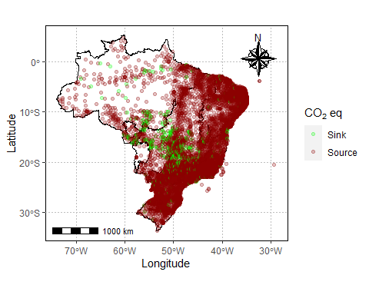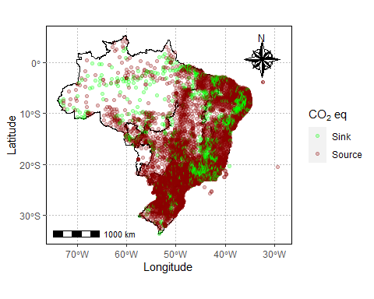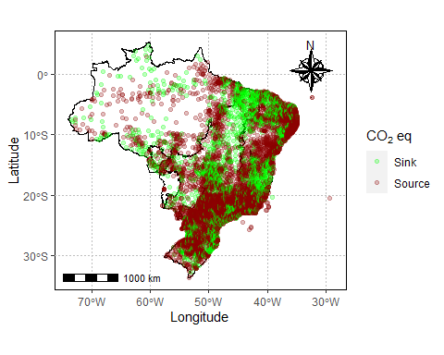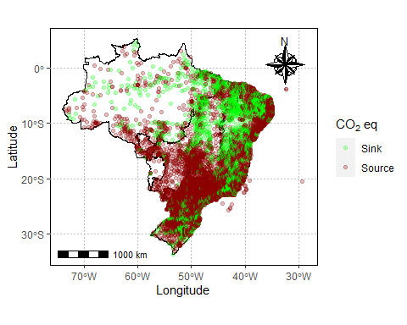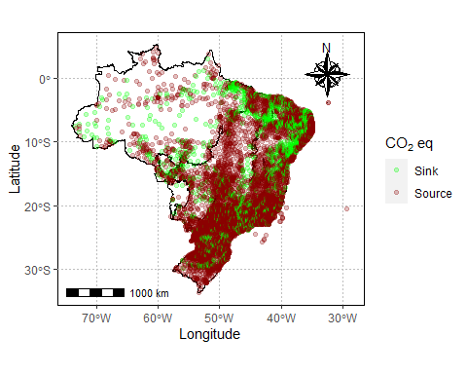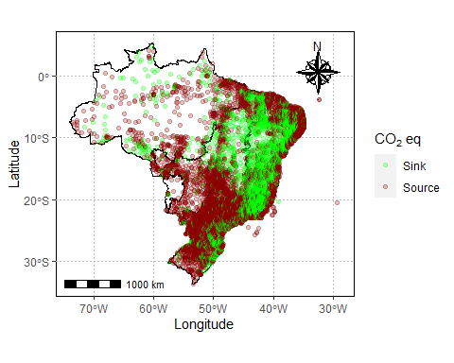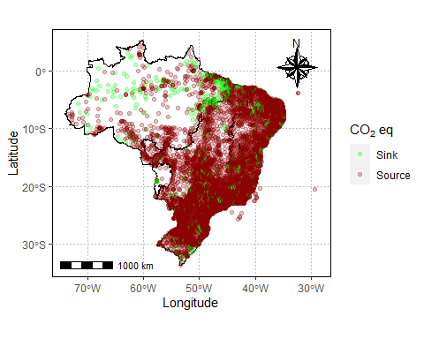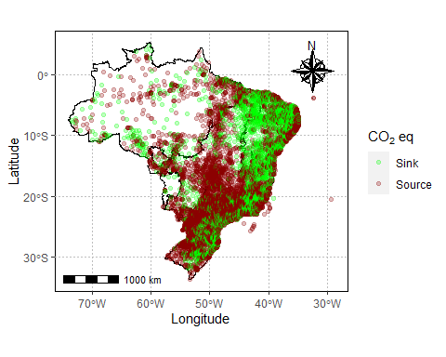

emissions_sources |>  
 filter(year > 2018 & year < 2023,  
 gas == "co2e_100yr",  
 !source_name %in% nomes_uf,  
 !sub_sector %in% c("forest-land-clearing",  
 "forest-land-degradation",  
 "shrubgrass-fires",  
 "forest-land-fires",  
 "wetland-fires",  
 "removals")  
 ) |>   
 mutate(  
 region = case_when(  
 nome_regiao=='Norte'~'North',  
 nome_regiao=='Nordeste'~'Northeast',  
 nome_regiao=='Sul'~'South',  
 nome_regiao=='Sudeste'~'Southeast',  
 nome_regiao=='Centro-Oeste'~'Midweast',  
 .default = 'Other'  
 )  
 ) |>   
 group_by(region,year) |>  
 filter(year!=2019) |>   
 summarise(  
 ghg_balance = sum(emissions_quantity, na.rm=TRUE)  
 ) |>   
 ggplot(aes(x=year,y=ghg_balance/1e6,fill=region))+  
 geom_col(position = 'dodge')+  
 scale_fill_viridis_d()+  
 labs(x='Year',y=expression('CO'[2]~'eq Balance (M ton CO'[2]~'eq '~year^-1~')'),fill='Region')

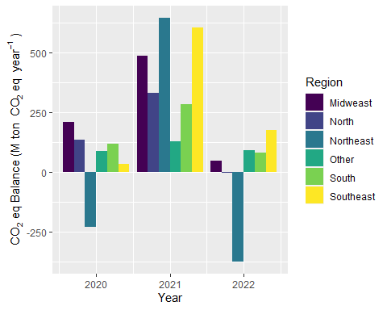

emissions_sources |>  
 filter(year > 2018 & year < 2023,  
 gas == "co2e_100yr",  
 !source_name %in% nomes_uf,  
 !sub_sector %in% c("forest-land-clearing",  
 "forest-land-degradation",  
 "shrubgrass-fires",  
 "forest-land-fires",  
 "wetland-fires",  
 "removals")  
 ) |>   
 mutate(  
 region = case_when(  
 nome_regiao=='Norte'~'North',  
 nome_regiao=='Nordeste'~'Northeast',  
 nome_regiao=='Sul'~'South',  
 nome_regiao=='Sudeste'~'Southeast',  
 nome_regiao=='Centro-Oeste'~'Midweast',  
 .default = 'Other'  
 )  
 ) |>   
 group_by(region,sub_sector,year) |>   
 filter(year!=2019) |>   
 summarise(  
 ghg_balance = sum(emissions_quantity, na.rm=TRUE)  
 ) |>   
 ggplot(aes(x=year,y=ghg_balance/1e6,fill=sub_sector))+  
 geom_col(position = 'dodge')+  
 scale_fill_viridis_d()+  
 facet_wrap(~region,scales='free')+  
 labs(x='Year',y=expression('CO'[2]~'eq Balance (M ton CO'[2]~'eq '~ year^-1~')'),fill='Sector')

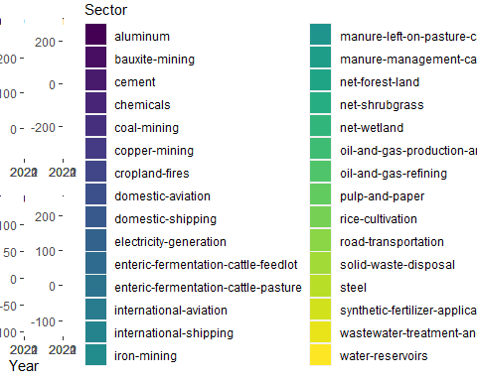

ggplot2::ggsave('img/co2_balance_sector.png',  
 units="in",width=10,heigh=6,dpi=1000)

emissions_sources |>  
 filter(year > 2018 & year < 2023,  
 gas == "co2e_100yr",  
 !source_name %in% nomes_uf,  
 !sub_sector %in% c("forest-land-clearing",  
 "forest-land-degradation",  
 "shrubgrass-fires",  
 "forest-land-fires",  
 "wetland-fires",  
 "removals")  
 ) |>   
 mutate(  
 region = case_when(  
 nome_regiao=='Norte'~'North',  
 nome_regiao=='Nordeste'~'Northeast',  
 nome_regiao=='Sul'~'South',  
 nome_regiao=='Sudeste'~'Southeast',  
 nome_regiao=='Centro-Oeste'~'Midweast',  
 .default = 'Other'  
 )  
 ) |>   
 group_by(year) |>   
 filter(year!=2019) |>   
 summarise(  
 ghg_balance = sum(emissions_quantity, na.rm=TRUE)  
 ) |>   
 ggplot(aes(x=year,y=ghg_balance/1e6))+  
 geom_col(position = 'dodge')+  
 scale_fill_viridis_d()+  
 labs(x='Year',y=expression('CO'[2]~'eq Balance (M ton CO'[2]~'eq '~ year^-1~')'),fill='Sector')

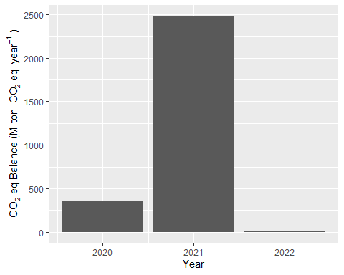

emissions_sources |>  
 filter(year > 2018 & year < 2023,  
 gas == "co2e_100yr",  
 !source_name %in% nomes_uf,  
 !sub_sector %in% c("forest-land-clearing",  
 "forest-land-degradation",  
 "shrubgrass-fires",  
 "forest-land-fires",  
 "wetland-fires",  
 "removals")  
 ) |>   
 mutate(  
 region = case_when(  
 nome_regiao=='Norte'~'North',  
 nome_regiao=='Nordeste'~'Northeast',  
 nome_regiao=='Sul'~'South',  
 nome_regiao=='Sudeste'~'Southeast',  
 nome_regiao=='Centro-Oeste'~'Midweast',  
 .default = 'Other'  
 )  
 ) |>   
 group_by(year,sub_sector) |>   
 filter(year!=2019) |>   
 summarise(  
 ghg_balance = sum(emissions_quantity, na.rm=TRUE)  
 ) |>   
 #filter(sub_sector=='agriculture') |>   
 mutate(ghg_balance=ghg_balance/1e6) |>   
 ggplot(aes(x=year,y=ghg_balance,fill=sub_sector))+  
 geom_col(position = 'dodge')+  
 scale_fill_viridis_d()+  
 labs(x='Year',  
 y=expression('CO'[2]~'eq Balance (M ton CO'[2]~'eq '~year^-1~')'),  
 fill='Sector')

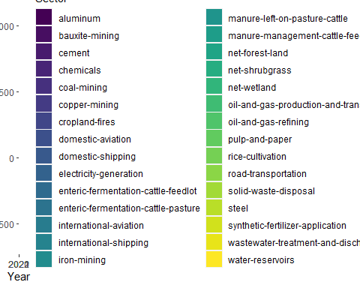

ggplot2::ggsave('img/co2_brazil_balance_sector.png',  
 units="in",width=8,heigh=6,dpi=1000)

## Análise por bioma

biomes <- geobr::read_biomes()  
biomes |>   
 filter(name_biome!='Sistema Costeiro') |>   
 ggplot(aes(fill=name_biome))+  
 geom_sf()+  
 tema_mapa()

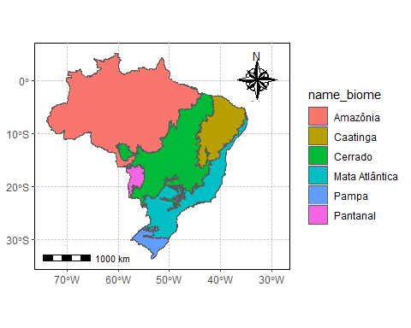

emissions_sources |>   
 ggplot(aes(x=lon,y=lat,color=biome))+  
 geom_point()

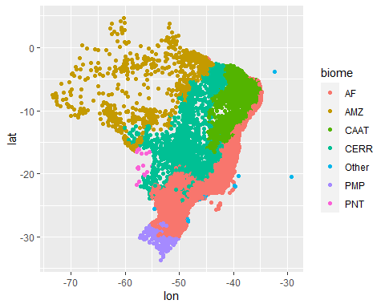

emissions_sources |>   
 filter(year > 2018 & year < 2023,  
 gas == "co2e_100yr",  
 !source_name %in% nomes_uf,  
 !sub_sector %in% c("forest-land-clearing",  
 "forest-land-degradation",  
 "shrubgrass-fires",  
 "forest-land-fires",  
 "wetland-fires",  
 "removals")  
 ) |>   
 ggplot(aes(x=lon,y=lat,col=biome))+  
 geom_point()

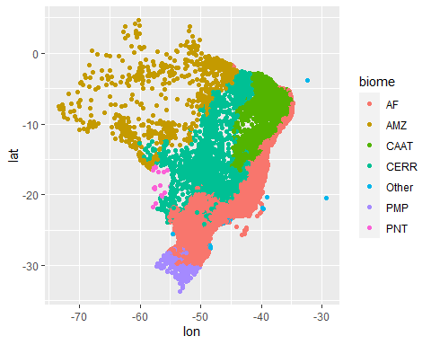

emissions_sources |>  
 filter(year > 2018 & year < 2023,  
 gas == "co2e_100yr",  
 !source_name %in% nomes_uf,  
 !sub_sector %in% c("forest-land-clearing",  
 "forest-land-degradation",  
 "shrubgrass-fires",  
 "forest-land-fires",  
 "wetland-fires",  
 "removals")  
 ) |>   
 group_by(biome,year) |>   
 filter(year!=2019) |>   
 summarise(  
 ghg_balance = sum(emissions_quantity, na.rm=TRUE)  
 ) |>   
 ggplot(aes(x=year,y=ghg_balance/1e6,fill=biome))+  
 geom_col(position = 'dodge')+  
 scale_fill_viridis_d()+  
 labs(x='Year',y=expression('CO'[2]~'eq Balance (M ton CO'[2]~'eq '~year^-1~')'),fill='Biome')

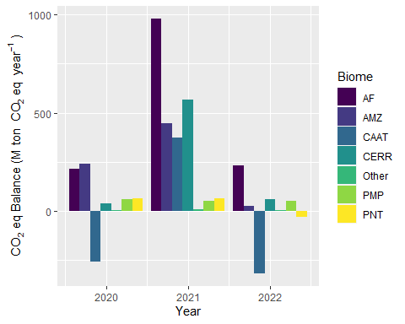

emissions_sources |>  
 filter(year > 2018 & year < 2023,  
 gas == "co2e_100yr",  
 !source_name %in% nomes_uf,  
 !sub_sector %in% c("forest-land-clearing",  
 "forest-land-degradation",  
 "shrubgrass-fires",  
 "forest-land-fires",  
 "wetland-fires",  
 "removals")  
 ) |>   
 group_by(biome,sub_sector,year) |>   
 filter(year!=2019) |>   
 summarise(  
 ghg_balance = sum(emissions_quantity, na.rm=TRUE)  
 ) |>   
 ggplot(aes(x=year,y=ghg_balance/1e6,fill=sub_sector))+  
 geom_col(position = 'dodge')+  
 scale_fill_viridis_d()+  
 facet_wrap(~biome,scales='free')+  
 labs(x='Year',  
 y=expression('CO'[2]~'eq Balance (M ton '[2]~'eq'~year^-1~')'),  
 fill='Biome')

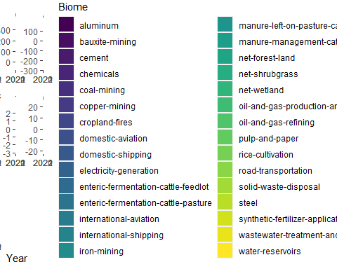

ggplot2::ggsave('img/co2_balance_sector_biomes.png',  
 units="in",width=10,heigh=6,dpi=1000)

emissions_sources |>  
 filter(year > 2018 & year < 2023,  
 gas == "co2e_100yr",  
 !source_name %in% nomes_uf,  
 !sub_sector %in% c("forest-land-clearing",  
 "forest-land-degradation",  
 "shrubgrass-fires",  
 "forest-land-fires",  
 "wetland-fires",  
 "removals")  
 ) |>   
 #group_by(biomes,year) |>  
 filter(year!=2019) |>   
 ggplot(aes(x=emissions_quantity/1e6,  
 y=as.factor(year),  
 fill=as.factor(year)  
 ))+  
 ggridges::geom_density_ridges(alpha=.4)+  
 facet_wrap(~biome,scales = 'free_x')

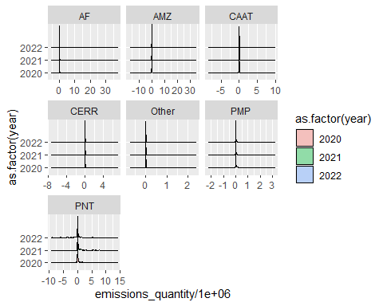

#xlim(-2.5,2.5)