SIF analise

2024-01-24

### Carregando bibliotecas

library(tidyverse)  
library(geobr)  
source("R/gafico.R")  
source("R/my-function.R")  
#> | | | 0% | |=== | 4% | |===== | 7% | |======== | 11% | |========== | 15% | |============= | 19% | |================ | 22% | |================== | 26% | |===================== | 30% | |======================= | 33% | |========================== | 37% | |============================= | 41% | |=============================== | 44% | |================================== | 48% | |==================================== | 52% | |======================================= | 56% | |========================================= | 59% | |============================================ | 63% | |=============================================== | 67% | |================================================= | 70% | |==================================================== | 74% | |====================================================== | 78% | |========================================================= | 81% | |============================================================ | 85% | |============================================================== | 89% | |================================================================= | 93% | |=================================================================== | 96% | |======================================================================| 100%  
#> Downloading: 2 kB Downloading: 2 kB Downloading: 18 kB Downloading: 18 kB Downloading: 34 kB Downloading: 34 kB Downloading: 51 kB Downloading: 51 kB Downloading: 67 kB Downloading: 67 kB Downloading: 83 kB Downloading: 83 kB Downloading: 99 kB Downloading: 99 kB Downloading: 120 kB Downloading: 120 kB Downloading: 120 kB Downloading: 120 kB Downloading: 140 kB Downloading: 140 kB Downloading: 140 kB Downloading: 140 kB Downloading: 150 kB Downloading: 150 kB Downloading: 160 kB Downloading: 160 kB Downloading: 170 kB Downloading: 170 kB Downloading: 170 kB Downloading: 170 kB Downloading: 180 kB Downloading: 180 kB Downloading: 180 kB Downloading: 180 kB Downloading: 200 kB Downloading: 200 kB Downloading: 200 kB Downloading: 200 kB Downloading: 210 kB Downloading: 210 kB Downloading: 210 kB Downloading: 210 kB Downloading: 230 kB Downloading: 230 kB Downloading: 230 kB Downloading: 230 kB Downloading: 240 kB Downloading: 240 kB Downloading: 240 kB Downloading: 240 kB Downloading: 260 kB Downloading: 260 kB Downloading: 260 kB Downloading: 260 kB Downloading: 270 kB Downloading: 270 kB Downloading: 280 kB Downloading: 280 kB Downloading: 290 kB Downloading: 290 kB Downloading: 290 kB Downloading: 290 kB Downloading: 310 kB Downloading: 310 kB Downloading: 310 kB Downloading: 310 kB Downloading: 330 kB Downloading: 330 kB Downloading: 330 kB Downloading: 330 kB Downloading: 340 kB Downloading: 340 kB Downloading: 340 kB Downloading: 340 kB Downloading: 350 kB Downloading: 350 kB Downloading: 360 kB Downloading: 360 kB Downloading: 370 kB Downloading: 370 kB Downloading: 380 kB Downloading: 380 kB Downloading: 400 kB Downloading: 400 kB Downloading: 410 kB Downloading: 410 kB Downloading: 430 kB Downloading: 430 kB Downloading: 450 kB Downloading: 450 kB Downloading: 460 kB Downloading: 460 kB Downloading: 480 kB Downloading: 480 kB Downloading: 490 kB Downloading: 490 kB Downloading: 500 kB Downloading: 500 kB Downloading: 500 kB Downloading: 500 kB Downloading: 510 kB Downloading: 510 kB Downloading: 530 kB Downloading: 530 kB Downloading: 540 kB Downloading: 540 kB Downloading: 560 kB Downloading: 560 kB Downloading: 570 kB Downloading: 570 kB Downloading: 580 kB Downloading: 580 kB Downloading: 580 kB Downloading: 580 kB Downloading: 600 kB Downloading: 600 kB Downloading: 600 kB Downloading: 600 kB Downloading: 620 kB Downloading: 620 kB Downloading: 620 kB Downloading: 620 kB Downloading: 630 kB Downloading: 630 kB Downloading: 630 kB Downloading: 630 kB Downloading: 650 kB Downloading: 650 kB Downloading: 650 kB Downloading: 650 kB Downloading: 670 kB Downloading: 670 kB Downloading: 670 kB Downloading: 670 kB Downloading: 680 kB Downloading: 680 kB Downloading: 680 kB Downloading: 680 kB Downloading: 700 kB Downloading: 700 kB Downloading: 700 kB Downloading: 700 kB Downloading: 710 kB Downloading: 710 kB Downloading: 710 kB Downloading: 710 kB Downloading: 710 kB Downloading: 710 kB Downloading: 730 kB Downloading: 730 kB Downloading: 750 kB Downloading: 750 kB Downloading: 750 kB Downloading: 750 kB Downloading: 760 kB Downloading: 760 kB Downloading: 780 kB Downloading: 780 kB Downloading: 800 kB Downloading: 800 kB Downloading: 800 kB Downloading: 800 kB Downloading: 820 kB Downloading: 820 kB Downloading: 840 kB Downloading: 840 kB Downloading: 840 kB Downloading: 840 kB Downloading: 840 kB Downloading: 840 kB Downloading: 840 kB Downloading: 840 kB Downloading: 860 kB Downloading: 860 kB Downloading: 880 kB Downloading: 880 kB Downloading: 880 kB Downloading: 880 kB Downloading: 890 kB Downloading: 890 kB Downloading: 910 kB Downloading: 910 kB Downloading: 920 kB Downloading: 920 kB Downloading: 940 kB Downloading: 940 kB Downloading: 960 kB Downloading: 960 kB Downloading: 970 kB Downloading: 970 kB Downloading: 980 kB Downloading: 980 kB Downloading: 990 kB Downloading: 990 kB Downloading: 1 MB Downloading: 1 MB Downloading: 1 MB Downloading: 1 MB Downloading: 1 MB Downloading: 1 MB Downloading: 1 MB Downloading: 1 MB Downloading: 1 MB Downloading: 1 MB Downloading: 1.1 MB Downloading: 1.1 MB Downloading: 1.1 MB Downloading: 1.1 MB Downloading: 1.1 MB Downloading: 1.1 MB Downloading: 1.1 MB Downloading: 1.1 MB Downloading: 1.1 MB Downloading: 1.1 MB Downloading: 1.1 MB Downloading: 1.1 MB Downloading: 1.1 MB Downloading: 1.1 MB Downloading: 1.1 MB Downloading: 1.1 MB Downloading: 1.1 MB Downloading: 1.1 MB Downloading: 1.1 MB Downloading: 1.1 MB Downloading: 1.1 MB Downloading: 1.1 MB Downloading: 1.1 MB Downloading: 1.1 MB Downloading: 1.1 MB Downloading: 1.1 MB Downloading: 1.1 MB Downloading: 1.1 MB Downloading: 1.2 MB Downloading: 1.2 MB Downloading: 1.2 MB Downloading: 1.2 MB Downloading: 1.2 MB Downloading: 1.2 MB Downloading: 1.2 MB Downloading: 1.2 MB Downloading: 1.2 MB Downloading: 1.2 MB Downloading: 1.2 MB Downloading: 1.2 MB Downloading: 1.2 MB Downloading: 1.2 MB Downloading: 1.2 MB Downloading: 1.2 MB Downloading: 1.2 MB Downloading: 1.2 MB Downloading: 1.2 MB Downloading: 1.2 MB Downloading: 1.2 MB Downloading: 1.2 MB Downloading: 1.2 MB Downloading: 1.2 MB Downloading: 1.2 MB Downloading: 1.2 MB Downloading: 1.2 MB Downloading: 1.2 MB Downloading: 1.2 MB Downloading: 1.2 MB Downloading: 1.3 MB Downloading: 1.3 MB Downloading: 1.3 MB Downloading: 1.3 MB Downloading: 1.3 MB Downloading: 1.3 MB Downloading: 1.3 MB Downloading: 1.3 MB Downloading: 1.3 MB Downloading: 1.3 MB Downloading: 1.3 MB Downloading: 1.3 MB Downloading: 1.3 MB Downloading: 1.3 MB Downloading: 1.3 MB Downloading: 1.3 MB Downloading: 1.3 MB Downloading: 1.3 MB Downloading: 1.3 MB Downloading: 1.3 MB Downloading: 1.3 MB Downloading: 1.3 MB Downloading: 1.4 MB Downloading: 1.4 MB Downloading: 1.4 MB Downloading: 1.4 MB Downloading: 1.4 MB Downloading: 1.4 MB Downloading: 1.4 MB Downloading: 1.4 MB Downloading: 1.4 MB Downloading: 1.4 MB Downloading: 1.4 MB Downloading: 1.4 MB Downloading: 1.4 MB Downloading: 1.4 MB Downloading: 1.4 MB Downloading: 1.4 MB Downloading: 1.4 MB Downloading: 1.4 MB Downloading: 1.4 MB Downloading: 1.4 MB Downloading: 1.4 MB Downloading: 1.4 MB Downloading: 1.4 MB Downloading: 1.4 MB Downloading: 1.4 MB Downloading: 1.4 MB Downloading: 1.5 MB Downloading: 1.5 MB Downloading: 1.5 MB Downloading: 1.5 MB Downloading: 1.5 MB Downloading: 1.5 MB Downloading: 1.5 MB Downloading: 1.5 MB Downloading: 1.5 MB Downloading: 1.5 MB Downloading: 1.5 MB Downloading: 1.5 MB Downloading: 1.5 MB Downloading: 1.5 MB Downloading: 1.5 MB Downloading: 1.5 MB Downloading: 1.5 MB Downloading: 1.5 MB Downloading: 1.5 MB Downloading: 1.5 MB Downloading: 1.5 MB Downloading: 1.5 MB Downloading: 1.5 MB Downloading: 1.5 MB Downloading: 1.5 MB Downloading: 1.5 MB Downloading: 1.5 MB Downloading: 1.5 MB Downloading: 1.6 MB Downloading: 1.6 MB Downloading: 1.6 MB Downloading: 1.6 MB Downloading: 1.6 MB Downloading: 1.6 MB Downloading: 1.6 MB Downloading: 1.6 MB Downloading: 1.6 MB Downloading: 1.6 MB Downloading: 1.6 MB Downloading: 1.6 MB Downloading: 1.6 MB Downloading: 1.6 MB Downloading: 1.6 MB Downloading: 1.6 MB Downloading: 1.6 MB Downloading: 1.6 MB Downloading: 1.6 MB Downloading: 1.6 MB Downloading: 1.6 MB Downloading: 1.6 MB Downloading: 1.6 MB Downloading: 1.6 MB Downloading: 1.6 MB Downloading: 1.6 MB Downloading: 1.6 MB Downloading: 1.6 MB Downloading: 1.6 MB Downloading: 1.6 MB Downloading: 1.6 MB Downloading: 1.6 MB Downloading: 1.6 MB Downloading: 1.6 MB Downloading: 1.7 MB Downloading: 1.7 MB Downloading: 1.7 MB Downloading: 1.7 MB Downloading: 1.7 MB Downloading: 1.7 MB Downloading: 1.7 MB Downloading: 1.7 MB Downloading: 1.7 MB Downloading: 1.7 MB Downloading: 1.7 MB Downloading: 1.7 MB Downloading: 1.7 MB Downloading: 1.7 MB Downloading: 1.7 MB Downloading: 1.7 MB Downloading: 1.7 MB Downloading: 1.7 MB Downloading: 1.7 MB Downloading: 1.7 MB Downloading: 1.7 MB Downloading: 1.7 MB Downloading: 1.7 MB Downloading: 1.7 MB Downloading: 1.8 MB Downloading: 1.8 MB Downloading: 1.8 MB Downloading: 1.8 MB Downloading: 1.8 MB Downloading: 1.8 MB Downloading: 1.8 MB Downloading: 1.8 MB Downloading: 1.8 MB Downloading: 1.8 MB Downloading: 1.8 MB Downloading: 1.8 MB Downloading: 1.8 MB Downloading: 1.8 MB Downloading: 1.8 MB Downloading: 1.8 MB Downloading: 1.8 MB Downloading: 1.8 MB Downloading: 1.8 MB Downloading: 1.8 MB Downloading: 1.8 MB Downloading: 1.8 MB Downloading: 1.9 MB Downloading: 1.9 MB Downloading: 1.9 MB Downloading: 1.9 MB Downloading: 1.9 MB Downloading: 1.9 MB Downloading: 1.9 MB Downloading: 1.9 MB Downloading: 1.9 MB Downloading: 1.9 MB Downloading: 1.9 MB Downloading: 1.9 MB Downloading: 1.9 MB Downloading: 1.9 MB Downloading: 1.9 MB Downloading: 1.9 MB Downloading: 1.9 MB Downloading: 1.9 MB Downloading: 1.9 MB Downloading: 1.9 MB Downloading: 1.9 MB Downloading: 1.9 MB Downloading: 2 MB Downloading: 2 MB Downloading: 2 MB Downloading: 2 MB Downloading: 2 MB Downloading: 2 MB Downloading: 2 MB Downloading: 2 MB Downloading: 2 MB Downloading: 2 MB Downloading: 2 MB Downloading: 2 MB Downloading: 2 MB Downloading: 2 MB Downloading: 2 MB Downloading: 2 MB Downloading: 2 MB Downloading: 2 MB Downloading: 2 MB Downloading: 2 MB Downloading: 2 MB Downloading: 2 MB Downloading: 2.1 MB Downloading: 2.1 MB Downloading: 2.1 MB Downloading: 2.1 MB Downloading: 2.1 MB Downloading: 2.1 MB Downloading: 2.1 MB Downloading: 2.1 MB Downloading: 2.1 MB Downloading: 2.1 MB Downloading: 2.1 MB Downloading: 2.1 MB Downloading: 2.1 MB Downloading: 2.1 MB Downloading: 2.1 MB Downloading: 2.1 MB Downloading: 2.1 MB Downloading: 2.1 MB Downloading: 2.1 MB Downloading: 2.1 MB Downloading: 2.1 MB Downloading: 2.1 MB Downloading: 2.1 MB Downloading: 2.1 MB Downloading: 2.1 MB Downloading: 2.1 MB Downloading: 2.1 MB Downloading: 2.1 MB Downloading: 2.2 MB Downloading: 2.2 MB Downloading: 2.2 MB Downloading: 2.2 MB Downloading: 2.2 MB Downloading: 2.2 MB Downloading: 2.2 MB Downloading: 2.2 MB Downloading: 2.2 MB Downloading: 2.2 MB Downloading: 2.2 MB Downloading: 2.2 MB Downloading: 2.2 MB Downloading: 2.2 MB Downloading: 2.2 MB Downloading: 2.2 MB Downloading: 2.2 MB Downloading: 2.2 MB Downloading: 2.2 MB Downloading: 2.2 MB Downloading: 2.2 MB Downloading: 2.2 MB Downloading: 2.2 MB Downloading: 2.2 MB Downloading: 2.2 MB Downloading: 2.2 MB Downloading: 2.2 MB Downloading: 2.2 MB Downloading: 2.3 MB Downloading: 2.3 MB Downloading: 2.3 MB Downloading: 2.3 MB Downloading: 2.3 MB Downloading: 2.3 MB Downloading: 2.3 MB Downloading: 2.3 MB Downloading: 2.3 MB Downloading: 2.3 MB Downloading: 2.3 MB Downloading: 2.3 MB Downloading: 2.3 MB Downloading: 2.3 MB Downloading: 2.3 MB Downloading: 2.3 MB Downloading: 2.3 MB Downloading: 2.3 MB Downloading: 2.3 MB Downloading: 2.3 MB Downloading: 2.3 MB Downloading: 2.3 MB Downloading: 2.3 MB Downloading: 2.3 MB Downloading: 2.3 MB Downloading: 2.3 MB Downloading: 2.4 MB Downloading: 2.4 MB Downloading: 2.4 MB Downloading: 2.4 MB Downloading: 2.4 MB Downloading: 2.4 MB Downloading: 2.4 MB Downloading: 2.4 MB Downloading: 2.4 MB Downloading: 2.4 MB Downloading: 2.4 MB Downloading: 2.4 MB Downloading: 2.4 MB Downloading: 2.4 MB Downloading: 2.4 MB Downloading: 2.4 MB Downloading: 2.4 MB Downloading: 2.4 MB Downloading: 2.4 MB Downloading: 2.4 MB Downloading: 2.5 MB Downloading: 2.5 MB Downloading: 2.5 MB Downloading: 2.5 MB Downloading: 2.5 MB Downloading: 2.5 MB Downloading: 2.5 MB Downloading: 2.5 MB Downloading: 2.5 MB Downloading: 2.5 MB Downloading: 2.5 MB Downloading: 2.5 MB Downloading: 2.5 MB Downloading: 2.5 MB Downloading: 2.6 MB Downloading: 2.6 MB Downloading: 2.6 MB Downloading: 2.6 MB Downloading: 2.6 MB Downloading: 2.6 MB Downloading: 2.6 MB Downloading: 2.6 MB Downloading: 2.6 MB Downloading: 2.6 MB Downloading: 2.6 MB Downloading: 2.6 MB Downloading: 2.6 MB Downloading: 2.6 MB Downloading: 2.6 MB Downloading: 2.6 MB Downloading: 2.6 MB Downloading: 2.6 MB Downloading: 2.6 MB Downloading: 2.6 MB Downloading: 2.6 MB Downloading: 2.6 MB Downloading: 2.6 MB Downloading: 2.6 MB Downloading: 2.6 MB Downloading: 2.6 MB Downloading: 2.6 MB Downloading: 2.6 MB Downloading: 2.7 MB Downloading: 2.7 MB Downloading: 2.7 MB Downloading: 2.7 MB Downloading: 2.7 MB Downloading: 2.7 MB Downloading: 2.7 MB Downloading: 2.7 MB

### Carregando dados

sif_file <- list.files('SIF/data/',full.names = T)  
sif_df <- read_rds(sif_file) |> filter(year>2018 & year <2023) |>   
 filter(sif_757> -0.1)  
   
  
states <- read_rds("data/states.rds") |>   
 mutate(name_region = ifelse(name_region == "Centro Oeste","Centro-Oeste",name_region))

anos <- 2019:2022  
for(i in seq_along(anos)){  
 plot_sif <- biomes |>   
 filter(name_biome!='Sistema Costeiro') |>   
 ggplot() +  
 geom_sf(fill="white", color="black",  
 size=.15, show.legend = FALSE) +  
 geom_tile(data= sif_df |>   
 filter(dist_sif<0.25) |>   
 filter(year==anos[i]) |>   
 #mutate(sif_757=cut(sif_757,5)) |>   
 group_by(lon_grid,lat_grid) |>   
 summarise(  
 sif = mean(sif_757)  
 ) |>   
 mutate(  
 sifn=case_when(  
 sif <=.1 ~ '<= 0.1',  
 sif <=.2 ~ '<= 0.2',  
 sif <=.3 ~ '<= 0.3',  
 sif<= .4 ~ '<= 0.4',  
 sif >.4 ~ '> 0.4'  
 )  
 )  
 ,  
 aes(lon_grid,lat_grid,fill=sifn))+  
 scale_fill_manual(values=c('red','orange','yellow','green','blue'))+  
 tema_mapa()+  
 labs(x='Longitude',y='Latitude',  
 fill=expression('SIF 757nm (Wm'^-2~'sr'^-1~mu~'m'^-1~')')  
 )  
 ggplot2::ggsave(paste0('img/sif_media_',anos[i],'.png'),  
 units="in", width=8, height=6,  
 dpi=1000)  
 print(plot_sif)  
}

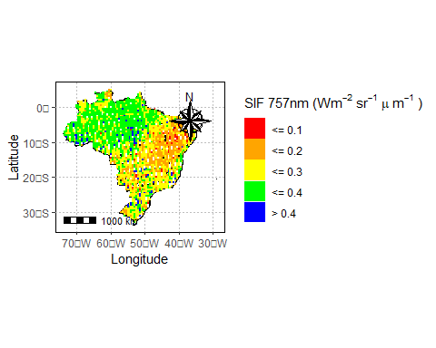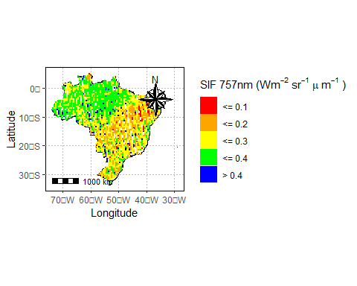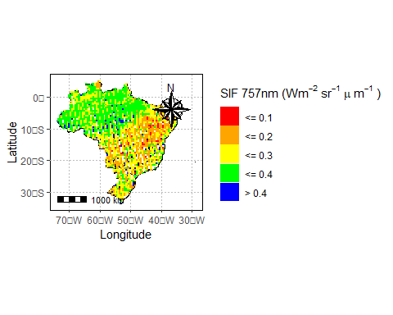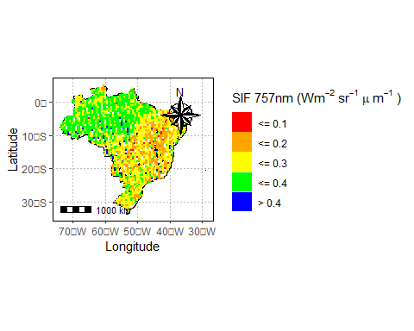

sif_df |>   
 filter(dist_sif<0.25) |>   
 group_by(lon_grid,lat_grid,year) |>   
 summarise(sif = mean(sif_757)) |>   
 mutate(  
 biomes = get_geobr_biomes(lon_grid,lat_grid)  
 ) |>  
 mutate(  
 biomes_n =  
 case_when(  
 biomes=='Other'& lon_grid>=-45 & lat_grid <0~'AF',  
 biomes=='Amazônia'~'AMZ',  
 biomes=='Other'& lon_grid< -45 & lat_grid >=-10 ~'AMZ',  
 biomes == 'Mata Atlântica' ~ 'AF',  
 biomes=='Cerrado'~'CERR',  
 biomes =='Pampa'~'PMP',  
 biomes == 'Pantanal' ~ 'PNT',  
 biomes=='Caatinga'~'CAAT',  
 .default = 'Other'  
 )  
 ) |>  
 ggplot(aes(x=lon_grid,y=lat_grid,col=biomes_n))+  
 geom_point()

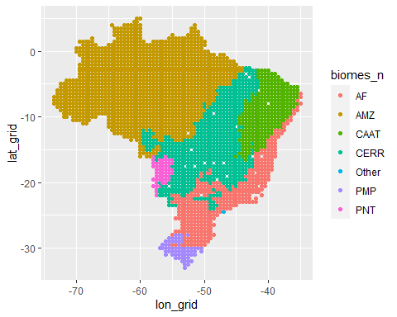

sif_df |>   
 filter(dist_sif<0.25) |>   
 group_by(lon_grid,lat_grid,year) |>   
 summarise(sif = mean(sif_757)) |>   
 mutate(  
 biomes = get_geobr_biomes(lon_grid,lat_grid)  
 ) |>  
 mutate(  
 biomes_n =  
 case_when(  
 biomes=='Other'& lon_grid>=-45 & lat_grid <0~'AF',  
 biomes=='Amazônia'~'AMZ',  
 biomes=='Other'& lon_grid< -45 & lat_grid >=-10 ~'AMZ',  
 biomes == 'Mata Atlântica' ~ 'AF',  
 biomes=='Cerrado'~'CERR',  
 biomes =='Pampa'~'PMP',  
 biomes == 'Pantanal' ~ 'PNT',  
 biomes=='Caatinga'~'CAAT',  
 .default = 'Other'  
 )  
 ) |>  
 filter(biomes_n!='Other',  
 year>2019) |>   
 ggplot(aes(x=sif,y=as.factor(year),fill=as.factor(year)))+  
 ggridges::geom_density_ridges(alpha=.4)+  
 facet_wrap(~biomes_n,scales='free_x')+  
 labs(x=expression('SIF 757nm (Wm'^-2~'sr'^-1~mu~'m'^-1~')'),  
 y='year',  
 fill=''  
 )+  
 scale_fill_viridis_d()+  
 theme_bw()

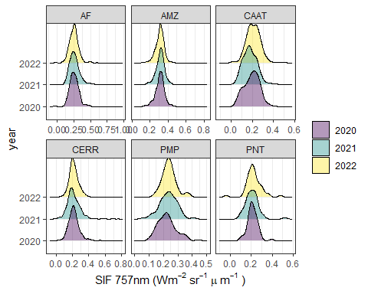

ggplot2::ggsave('img/sif_distribution.png',  
 units="in", width=8, height=6,  
 dpi=1000)