Modelagem 04

Panosso AR & Oliveira JA

2023-06-12

### Análise de modelagem 01

sim_municipio <- read_rds("../data/sim_municipio.rds") %>%   
 mutate(across(c(ano, idade, numero_obitos),as.numeric))  
glimpse(sim_municipio)

## Rows: 4,881,149  
## Columns: 11  
## $ ano <dbl> 1996, 1996, 1996, 1996, 1996, 1996, 1996, 19~  
## $ sigla_uf <chr> "SP", "SP", "SP", "SP", "SP", "SP", "SP", "S~  
## $ id_municipio <chr> "3500000", "3500000", "3500000", "3500000", ~  
## $ causa_basica <chr> "B206", "I10", "K275", "R98", "R98", "V959",~  
## $ idade <dbl> 34, 66, 36, 21, 32, 41, 29, 40, 52, 66, 67, ~  
## $ sexo <chr> "1", "2", "1", "1", "1", "1", "1", "2", "1",~  
## $ raca_cor <chr> NA, NA, NA, NA, NA, NA, NA, NA, NA, NA, NA, ~  
## $ numero_obitos <dbl> 1, 1, 1, 1, 1, 1, 1, 1, 1, 1, 1, 1, 1, 1, 1,~  
## $ nome_regiao_imediata <chr> NA, NA, NA, NA, NA, NA, NA, NA, "Adamantina ~  
## $ nome_regiao_intermediaria <chr> NA, NA, NA, NA, NA, NA, NA, NA, "Presidente ~  
## $ nome <chr> NA, NA, NA, NA, NA, NA, NA, NA, "Adamantina"~

sim_municipio %>%   
 group_by(ano, id_municipio) %>%   
 summarise( count= sum(numero_obitos)) %>%   
 filter(id_municipio == "3500105")

## # A tibble: 24 x 3  
## # Groups: ano [24]  
## ano id_municipio count  
## <dbl> <chr> <dbl>  
## 1 1996 3500105 232  
## 2 1997 3500105 221  
## 3 1998 3500105 240  
## 4 1999 3500105 248  
## 5 2000 3500105 209  
## 6 2001 3500105 268  
## 7 2002 3500105 250  
## 8 2003 3500105 256  
## 9 2004 3500105 264  
## 10 2005 3500105 268  
## # i 14 more rows

sim_municipio %>%   
 group_by(ano, sexo, raca_cor) %>%   
 summarise( n_obitos = sum(numero_obitos)) %>%   
 ggplot(aes(x=ano, y=n_obitos, color=sexo)) +  
 # geom_col(color="black",  
 # position = "dodge") +  
 facet_wrap(~raca_cor) +  
 geom_point() +  
 geom_line() +  
 theme_bw()

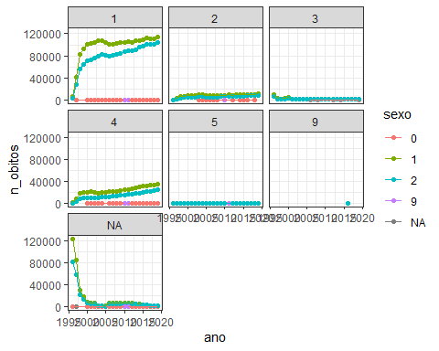

### Mapeando

soma <- sim_municipio %>%   
 group_by(ano, nome, id_municipio) %>%  
 summarise(  
 n_obitos = sum(numero_obitos, na.rm=TRUE)  
) %>%   
 arrange(desc(n_obitos)) %>%   
 filter(!is.na(nome)) %>%   
 mutate(categoria = as.factor(case_when(  
 n_obitos <= 50 ~ "[0-50]",  
 n_obitos <= 100 ~ "[50-100]",  
 n_obitos <= 300 ~ "[100-300]",  
 n_obitos <= 500 ~ "[300-500]",  
 n_obitos <= 700 ~ "[500-700]",  
 n_obitos > 700 ~ "[>500]",  
 )))  
soma <- soma %>% mutate(categoria = as.factor(categoria),  
 categoria = fct_relevel(categoria,  
 "[0-50]","[50-100]",  
 "[100-300]","[300-500]",  
 "[500-700]","[>700]"))  
  
glimpse(soma)

## Rows: 15,459  
## Columns: 5  
## Groups: ano, nome [15,459]  
## $ ano <dbl> 2019, 2018, 2016, 2017, 2015, 2014, 2013, 1996, 2011, 201~  
## $ nome <chr> "São Paulo", "São Paulo", "São Paulo", "São Paulo", "São ~  
## $ id_municipio <chr> "3550308", "3550308", "3550308", "3550308", "3550308", "3~  
## $ n_obitos <dbl> 78581, 77474, 77466, 76271, 75368, 74266, 73313, 72170, 7~  
## $ categoria <fct> [>500], [>500], [>500], [>500], [>500], [>500], [>500], [~

## Mapeando

soma %>%  
 ggplot(aes(x=n_obitos)) +  
 geom_histogram(color="black",  
 fill="lightgray") +  
 theme_bw()

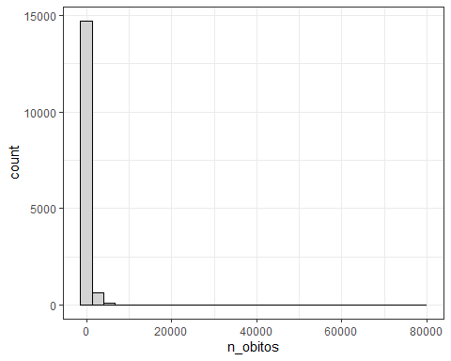

soma %>% pull(n_obitos) %>% summary()

## Min. 1st Qu. Median Mean 3rd Qu. Max.   
## 2.0 34.0 86.0 400.5 243.0 78581.0

### Juntando as bases de dados

d_sf_municipio <- st_read("../shp/35MUE250GC_SIR.shp", quiet = TRUE)  
d_sf_municipio <- d_sf_municipio %>%  
 rename(id_municipio = CD_GEOCMU) %>%  
 inner_join(soma %>%  
 relocate(id_municipio),   
 "id_municipio")

anos <- soma$ano %>% unique() %>% sort()  
map(anos, ~{  
 ggplot(d_sf_municipio %>% filter(ano == .x)) +  
 geom_sf(aes(fill = as.factor(categoria)))+  
 theme_minimal() +  
 scale_fill_viridis_d()+  
 labs(title = .x, fill="# obitos")  
})

## [[1]]

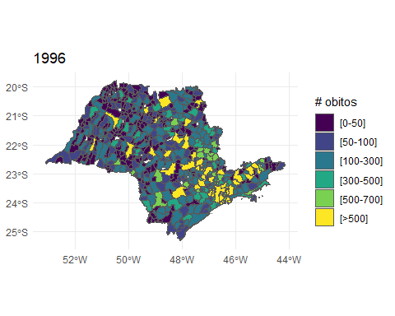

##   
## [[2]]

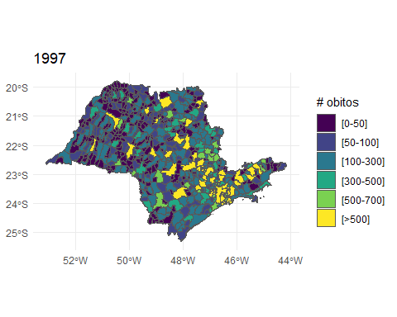

##   
## [[3]]

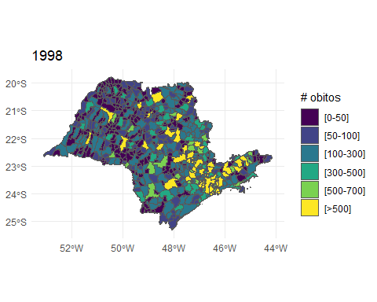

##   
## [[4]]

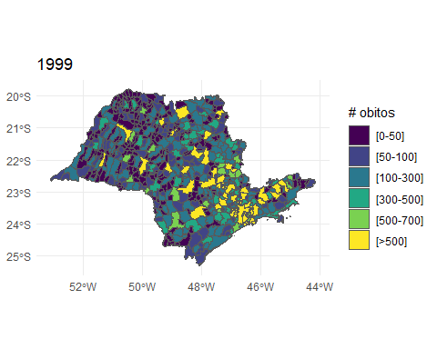

##   
## [[5]]

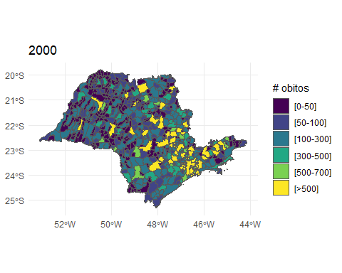

##   
## [[6]]

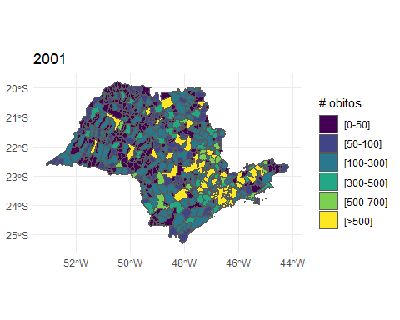

##   
## [[7]]

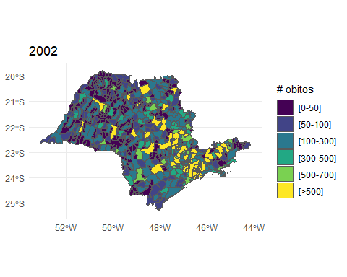

##   
## [[8]]

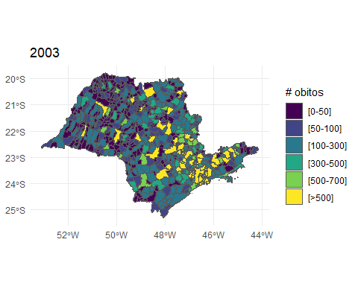

##   
## [[9]]

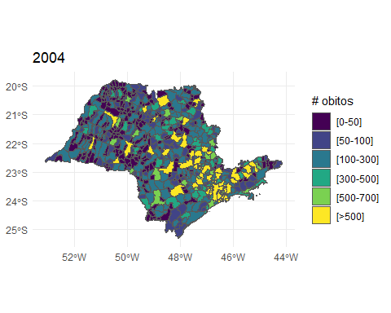

##   
## [[10]]

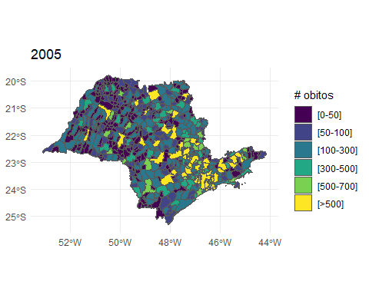

##   
## [[11]]

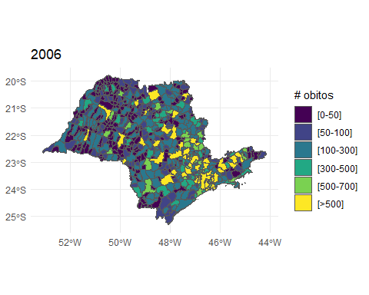

##   
## [[12]]

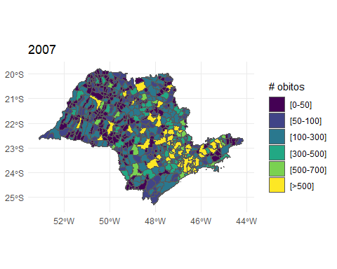

##   
## [[13]]

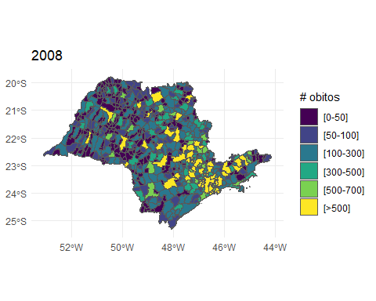

##   
## [[14]]

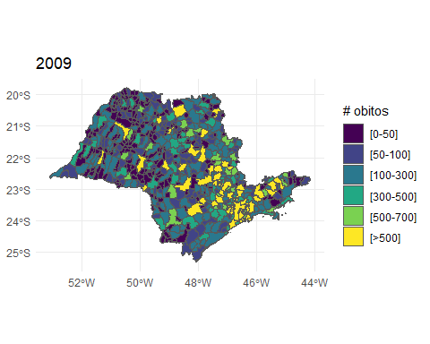

##   
## [[15]]

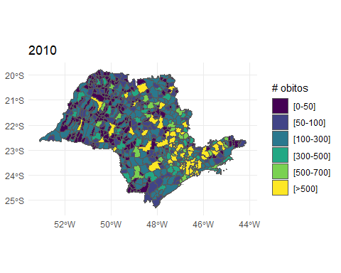

##   
## [[16]]

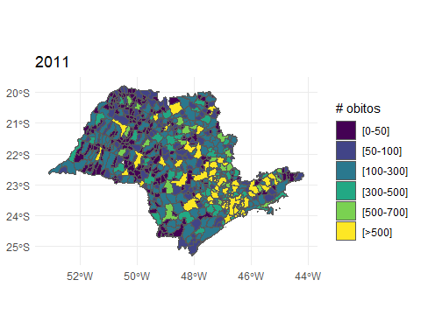

##   
## [[17]]

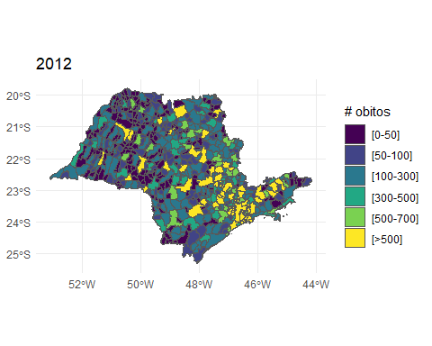

##   
## [[18]]

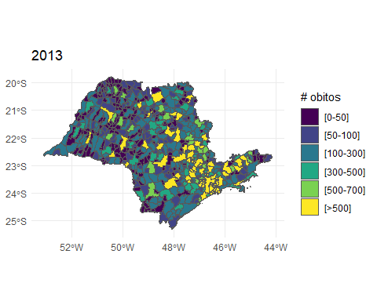

##   
## [[19]]

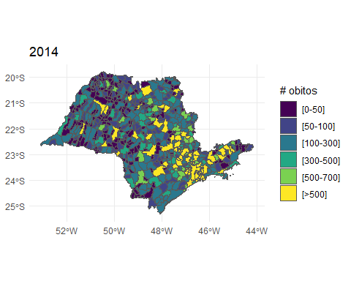

##   
## [[20]]

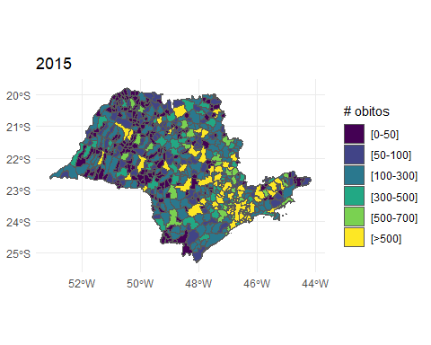

##   
## [[21]]

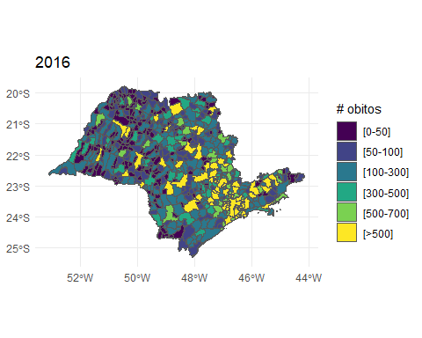

##   
## [[22]]

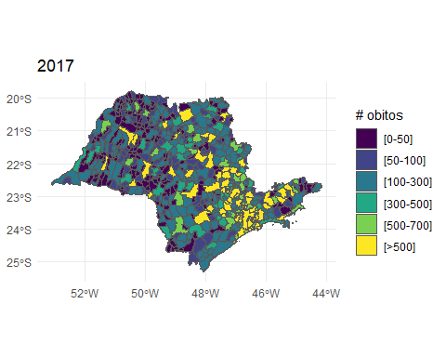

##   
## [[23]]

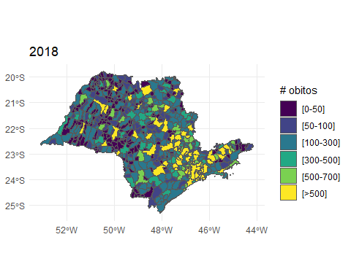

##   
## [[24]]

