Modelagem Saude-Sisvan

Panosso AR & Oliveira JA

2023-05-03

### Carregando pacotes

library(tidyverse)

### Saude estado nutricional

df_final <- read_rds("../data/df_final.rds") %>%   
 select(-indice_cri,-indice_ado)  
  
saude_consumo <- read_rds("../data/consumo/consumo.rds") %>%   
 rename(id_municipio = codigo_ibge) %>%   
 mutate(id_municipio = as.character(id_municipio))  
glimpse(saude_consumo)

## Rows: 63,004  
## Columns: 10  
## $ faixa_etaria <chr> "2-anos-ou-mais", "2-anos-ou-mais", "2-anos-ou-mais", "~  
## $ fase_da_vida <chr> "adolecentes", "adolecentes", "adolecentes", "adolecent~  
## $ tipo_relatorio <chr> "CONS_3REFEICOES", "CONS_3REFEICOES", "CONS_3REFEICOES"~  
## $ ano <int> 2015, 2015, 2015, 2015, 2015, 2015, 2015, 2015, 2015, 2~  
## $ uf <chr> "SP", "SP", "SP", "SP", "SP", "SP", "SP", "SP", "SP", "~  
## $ id_municipio <chr> "350010", "350030", "350055", "350080", "350100", "3501~  
## $ municipio <chr> "ADAMANTINA", "AGUAÍ", "ÁGUAS DE SANTA BÁRBARA", "ALFRE~  
## $ total <dbl> 5, 3, 0, 21, 4, 1, 0, 33, 10, 0, 1, 133, 92, 38, 1, 1, ~  
## $ percent <dbl> 0.8333333, 0.7500000, 0.0000000, 0.6000000, 0.8000000, ~  
## $ monitorados <dbl> 6, 4, 1, 35, 5, 1, 46, 47, 46, 11, 1, 161, 145, 48, 1, ~

df_nome <- read_rds("../data/df_nome.rds") %>%   
 mutate(id_municipio = id_municipio_6) %>% select(nome, id_municipio)  
  
saude_consumo <- left_join(saude_consumo, df_nome, "id_municipio") %>%   
 mutate(municipio = nome) %>%   
 select(-nome)

## Três Refeições

saude_consumo %>% pull(var = tipo_relatorio) %>% unique()

## [1] "CONS_3REFEICOES" "CONS_ASSISTETV" "CONS_BEBIDAS"   
## [4] "CONS_EMBUT" "CONS_FEIJAO" "CONS_FRUTA"   
## [7] "CONS_GULOSEIMA" "CONS_SALGADINHO" "CONS_ULTRA"   
## [10] "CONS_VERD" "AMC" "BEBIDA"   
## [13] "DAM" "DOCES" "EMBUT"   
## [16] "FERRO" "FMCA" "SALGAD"   
## [19] "VITAA" "IntruducaoAlimentos" "AME"   
## [22] "ULTRA"

saude_consumo %>% filter(tipo_relatorio == "CONS_3REFEICOES") %>%   
 group_by(ano, fase_da_vida) %>%   
 summarise(  
 valor = sum(total),  
 total = sum(monitorados),  
 perc = valor/total *100  
 ) %>%   
 ggplot(aes(x=ano, y=perc, fill= fase_da_vida)) +  
 geom_col(position = "dodge", color="black") +  
 theme_bw()

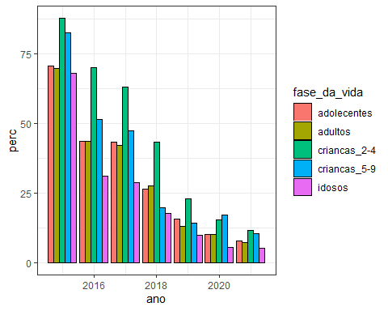

## grando todos

relatorio <- saude_consumo %>% pull(var = tipo_relatorio) %>% unique()  
  
for( i in seq_along(relatorio)){  
 rl <- relatorio[i]  
   
 plt_i <- saude_consumo %>% filter(tipo_relatorio == rl) %>%   
 group_by(ano, fase_da_vida) %>%   
 summarise(  
 valor = sum(total),  
 total = sum(monitorados),  
 perc = valor/total *100  
 ) %>%   
 ggplot(aes(x=ano, y=perc, fill= fase_da_vida)) +  
 geom_col(position = "dodge", color="black") +  
 labs(title = rl) +  
 theme_bw()  
 print(plt_i)  
}

