Multivariada

Montanari e Nilton

2024-08-17

## Carregando pacotes

library(readxl)  
library(tidyverse)  
library(janitor)  
library(skimr)  
library(vegan)  
library(corrplot)  
source("R/my-functions.R")  
theme_set(theme_bw())

## Carregando os Bancos de dados

data_set <- readr::read_rds("data/data_set.rds")

### Estatística descritiva

skim(data_set)

Data summary

|  |  |
| --- | --- |
| Name | data_set |
| Number of rows | 150 |
| Number of columns | 51 |
| _______________________ |  |
| Column type frequency: |  |
| character | 1 |
| numeric | 50 |
| ________________________ |  |
| Group variables | None |

**Variable type: character**

| skim_variable | n_missing | complete_rate | min | max | empty | n_unique | whitespace |
| --- | --- | --- | --- | --- | --- | --- | --- |
| tratamento | 0 | 1 | 8 | 11 | 0 | 3 | 0 |

**Variable type: numeric**

| skim_variable | n_missing | complete_rate | mean | sd | p0 | p25 | p50 | p75 | p100 | hist |
| --- | --- | --- | --- | --- | --- | --- | --- | --- | --- | --- |
| pontos | 0 | 1 | 25.50 | 14.48 | 1.00 | 13.00 | 25.50 | 38.00 | 50.00 | ▇▇▇▇▇ |
| s_em_graus | 0 | 1 | 339953.31 | 35674.45 | 34397.00 | 343915.00 | 343944.50 | 343974.75 | 363439.00 | ▁▁▁▁▇ |
| w_em_graus | 0 | 1 | 7737049.51 | 59.55 | 7736705.00 | 7737006.25 | 7737036.00 | 7737112.00 | 7737145.00 | ▁▁▁▇▅ |
| altitude | 0 | 1 | 393.09 | 2.80 | 387.00 | 391.00 | 393.00 | 395.00 | 400.00 | ▂▇▆▅▂ |
| alt_m | 0 | 1 | 3.38 | 0.77 | 0.90 | 3.00 | 3.40 | 4.00 | 4.70 | ▁▂▃▇▆ |
| dap_m | 0 | 1 | 0.02 | 0.01 | 0.00 | 0.00 | 0.02 | 0.03 | 0.04 | ▇▂▃▆▂ |
| vol_m3 | 0 | 1 | 0.00 | 0.00 | 0.00 | 0.00 | 0.00 | 0.00 | 0.01 | ▆▇▇▃▃ |
| rp1 | 0 | 1 | 0.82 | 0.43 | 0.55 | 0.55 | 0.65 | 0.89 | 2.64 | ▇▁▁▁▁ |
| rp2 | 0 | 1 | 3.42 | 1.22 | 1.06 | 2.67 | 3.25 | 3.92 | 10.47 | ▆▇▁▁▁ |
| ug1 | 0 | 1 | 0.03 | 0.01 | 0.01 | 0.02 | 0.03 | 0.03 | 0.05 | ▃▆▇▅▁ |
| ug2 | 0 | 1 | 0.04 | 0.01 | 0.02 | 0.03 | 0.04 | 0.04 | 0.07 | ▃▇▇▁▁ |
| uv2 | 0 | 1 | 0.06 | 0.01 | 0.03 | 0.05 | 0.05 | 0.06 | 0.09 | ▃▇▇▂▁ |
| ds2 | 0 | 1 | 1.44 | 0.11 | 1.06 | 1.36 | 1.44 | 1.51 | 1.79 | ▁▃▇▃▁ |
| dp1 | 0 | 1 | 2.69 | 0.04 | 2.53 | 2.67 | 2.70 | 2.70 | 2.78 | ▁▁▇▇▃ |
| dp2 | 0 | 1 | 2.70 | 0.04 | 2.60 | 2.67 | 2.70 | 2.74 | 2.90 | ▁▇▃▁▁ |
| pt2 | 0 | 1 | 0.47 | 0.04 | 0.34 | 0.44 | 0.47 | 0.50 | 0.60 | ▁▃▇▃▁ |
| areia1 | 0 | 1 | 895.82 | 10.59 | 871.00 | 887.50 | 894.75 | 903.37 | 927.50 | ▂▇▆▃▁ |
| areia2 | 0 | 1 | 890.28 | 11.39 | 871.00 | 881.63 | 888.00 | 896.87 | 921.00 | ▅▇▅▂▂ |
| arg1 | 0 | 1 | 72.75 | 6.99 | 58.60 | 68.33 | 72.40 | 77.20 | 97.60 | ▃▇▆▂▁ |
| arg2 | 0 | 1 | 79.16 | 7.82 | 57.30 | 73.27 | 81.05 | 84.80 | 93.50 | ▁▂▅▇▃ |
| silte1 | 0 | 1 | 31.44 | 7.20 | 10.30 | 26.40 | 32.60 | 36.65 | 53.70 | ▁▅▇▅▁ |
| silte2 | 0 | 1 | 30.56 | 6.72 | 12.30 | 26.20 | 31.65 | 35.55 | 49.20 | ▁▃▇▆▁ |
| p1 | 0 | 1 | 2.81 | 1.36 | 1.00 | 2.00 | 3.00 | 3.00 | 14.00 | ▇▁▁▁▁ |
| p2 | 0 | 1 | 1.89 | 0.79 | 1.00 | 1.00 | 2.00 | 2.00 | 7.00 | ▇▁▁▁▁ |
| mo1 | 0 | 1 | 11.39 | 1.52 | 8.00 | 10.00 | 11.00 | 12.00 | 18.00 | ▃▇▂▁▁ |
| mo2 | 0 | 1 | 9.81 | 1.01 | 8.00 | 9.00 | 10.00 | 10.00 | 13.00 | ▇▆▂▁▁ |
| p_h1 | 0 | 1 | 4.38 | 0.63 | 2.90 | 3.92 | 4.20 | 4.70 | 7.30 | ▁▇▂▁▁ |
| ph2 | 0 | 1 | 4.17 | 0.38 | 2.80 | 3.90 | 4.00 | 4.30 | 5.60 | ▁▃▇▂▁ |
| k1 | 0 | 1 | 0.76 | 0.40 | 0.10 | 0.50 | 0.70 | 0.88 | 2.40 | ▅▇▂▁▁ |
| k2 | 0 | 1 | 0.61 | 0.32 | 0.20 | 0.40 | 0.50 | 0.70 | 2.80 | ▇▂▁▁▁ |
| ca1 | 0 | 1 | 8.22 | 10.28 | 1.00 | 1.00 | 3.50 | 11.75 | 60.00 | ▇▂▁▁▁ |
| ca2 | 0 | 1 | 4.27 | 5.86 | 1.00 | 1.00 | 2.00 | 5.00 | 45.00 | ▇▁▁▁▁ |
| mg1 | 0 | 1 | 6.51 | 6.31 | 1.00 | 2.00 | 4.00 | 9.00 | 30.00 | ▇▂▁▁▁ |
| mg2 | 0 | 1 | 3.63 | 3.80 | 1.00 | 1.00 | 2.00 | 4.00 | 26.00 | ▇▁▁▁▁ |
| h_al1 | 0 | 1 | 24.05 | 5.94 | 8.00 | 19.00 | 25.00 | 29.00 | 36.00 | ▁▆▅▇▅ |
| h_al2 | 0 | 1 | 23.19 | 4.20 | 15.00 | 20.00 | 24.00 | 26.00 | 38.00 | ▅▆▇▂▁ |
| al1 | 0 | 1 | 8.90 | 5.27 | 0.00 | 4.25 | 10.00 | 14.00 | 17.00 | ▆▅▅▆▇ |
| al2 | 0 | 1 | 10.97 | 4.59 | 0.00 | 8.00 | 12.00 | 15.00 | 16.00 | ▁▂▂▃▇ |
| sb1 | 0 | 1 | 15.49 | 16.50 | 2.20 | 3.73 | 8.70 | 21.70 | 90.50 | ▇▂▁▁▁ |
| sb2 | 0 | 1 | 8.51 | 9.58 | 2.20 | 2.62 | 4.80 | 10.25 | 71.50 | ▇▁▁▁▁ |
| ctc1 | 0 | 1 | 39.55 | 12.57 | 24.50 | 32.55 | 36.05 | 42.70 | 98.50 | ▇▂▁▁▁ |
| ctc2 | 0 | 1 | 31.70 | 7.97 | 23.40 | 28.30 | 29.85 | 32.65 | 86.50 | ▇▁▁▁▁ |
| v1 | 0 | 1 | 33.14 | 23.65 | 6.25 | 11.75 | 24.89 | 52.02 | 91.88 | ▇▃▂▂▁ |
| v2 | 0 | 1 | 23.84 | 17.34 | 7.28 | 10.10 | 17.20 | 34.50 | 82.66 | ▇▂▂▁▁ |
| ca1_t1 | 0 | 1 | 16.88 | 15.01 | 2.58 | 3.52 | 10.29 | 27.99 | 60.91 | ▇▂▂▂▁ |
| ca1_t2 | 0 | 1 | 11.61 | 10.70 | 2.91 | 3.51 | 6.39 | 17.59 | 52.02 | ▇▂▂▁▁ |
| mg1_t1 | 0 | 1 | 14.22 | 9.15 | 2.59 | 6.54 | 11.42 | 22.07 | 34.65 | ▇▅▂▃▂ |
| mg1_t2 | 0 | 1 | 10.28 | 7.16 | 2.98 | 3.88 | 7.38 | 14.37 | 34.30 | ▇▃▂▁▁ |
| m1 | 0 | 1 | 47.23 | 31.18 | 0.00 | 16.25 | 53.00 | 78.00 | 88.00 | ▆▃▂▃▇ |
| m2 | 0 | 1 | 61.41 | 26.54 | 0.00 | 43.50 | 72.00 | 84.00 | 88.00 | ▂▂▂▂▇ |

# Análise Multivariada - Por tratamento e por profundidade

data_set <- data_set %>%   
 pivot_longer(cols = rp1:m2) %>%   
 mutate(  
 variavel = str_remove(name,".$"),  
 prof = str_sub(name,-1,-1)  
 )

tratamentos <- data_set %>% pull(tratamento) %>% unique()  
for(i in seq_along(tratamentos)){  
 for(j in 1:2){  
 my_trat <- tratamentos[i]  
 da <- data_set %>%   
 select(-name) %>%   
 filter(  
 tratamento == my_trat,  
 prof == j  
 ) %>%   
 pivot_wider(values_from = value, names_from = variavel)  
  
 nomes <- da %>%   
 pull(pontos)  
 da <- da %>% select(alt_m:m, -prof)  
 mc <- da %>% cor()  
   
 print("##########################################")  
 print(paste0(" Tratamento: ",tratamentos[i]))  
 print(paste0(" Profundidade: ",j))  
 print("##########################################")  
 print("======== Análise de correlação linear ========== ")  
 corrplot::corrplot(mc)  
   
 print("======== Análise de Agrupamento Hierárquico ========== ")  
 da_pad<-decostand(da,   
 method = "standardize",  
 na.rm=TRUE)  
 da_pad_euc<-vegdist(da_pad,"euclidean")   
 da_pad_euc_ward<-hclust(da_pad_euc, method="ward.D")  
 plot(da_pad_euc_ward,   
 ylab="Distância Euclidiana",  
 xlab="Acessos", hang=-1,  
 col="blue", las=1,  
 cex=.6,lwd=1.5);box()  
 grupo<-cutree(da_pad_euc_ward,3)  
   
   
 print("======== Análise de Componentes Principais ========== ")  
 pca <- prcomp(da_pad,scale.=T)  
 # Autovalores  
 eig<-pca$sdev^2  
 print("==== Autovalores ====")  
 print(round(eig,3))  
 print("==== % da variância explicada ====")  
 ve<-eig/sum(eig)  
 print(round(ve,4))  
 print("==== % da variância explicada acumulada ====")  
 print(round(cumsum(ve),4)*100)  
 print("==== Poder Discriminante ====")  
 mcor<-cor(da_pad,pca$x)  
 corrplot(mcor)  
 print("==== screeplot ====")  
 screeplot(pca)  
 abline(h=1)  
 print("==== Gráfico Biplot ====")  
 pc1V<-cor(da_pad,pca$x)[,1]/sd(cor(da_pad,pca$x)[,1])  
 pc2V<-cor(da_pad,pca$x)[,2]/sd(cor(da_pad,pca$x)[,2])  
 pc3V<-cor(da_pad,pca$x)[,3]/sd(cor(da_pad,pca$x)[,3])  
 pc1c<-pca$x[,1]/sd(pca$x[,1])  
 pc2c<-pca$x[,2]/sd(pca$x[,2])  
 pc3c<-pca$x[,3]/sd(pca$x[,3])  
 nv<-ncol(da)   
   
 bip<-data.frame(pc1c,pc2c,pc3c,nomes,grupo)  
 texto <- data.frame(  
 x = pc1V,  
 y = pc2V,  
 z = pc3V,  
 label = names(da)  
 )  
 graf <- bip %>%   
 ggplot(aes(x=pc1c,y=pc2c,color=grupo))+  
 geom_point(aes(shape = as_factor(grupo), color = as_factor(grupo)), size = 3) +  
 theme_minimal() +   
 scale_shape_manual(values=16:18)+  
 scale_color_manual(values=c("#009E73", "#999999","#D55E00"))+  
 geom_vline(aes(xintercept=0),  
 color="black", size=1)+  
 geom_hline(aes(yintercept=0),  
 color="black", size=1)+  
 annotate(geom="segment",  
 x=rep(0,length(da)),  
 xend=texto$x,  
 y=rep(0,length(da)),  
 yend=texto$y,color="black",lwd=.5)+  
 geom_label(data=texto,aes(x=x,y=y,label=label),  
 color="black",angle=0,fontface="bold",size=4,fill="white")+  
 labs(x=paste("CP1 (",round(100*ve[1],2),"%)",sep=""),  
 y=paste("CP2 (",round(100*ve[2],2),"%)",sep=""),  
 color="",shape="")+  
 theme(legend.position = "top")+  
 annotate(geom="text",  
 x=pc1c+.1,  
 y=pc2c+.1,  
 color="black",  
 label = nomes,  
 size = 2  
 )  
 print(graf)  
   
 print("==== Tabela da correlação dos atributos com cada PC ====")  
 ck<-sum(pca$sdev^2>=0.98)  
 tabelapca<-vector()  
 for( l in 1:ck) tabelapca<-cbind(tabelapca,mcor[,l])  
 colnames(tabelapca)<-paste(rep(c("PC"),ck),1:ck,sep="")  
 pcat<-round(tabelapca,3)  
 tabelapca<-tabelapca[order(abs(tabelapca[,1])),]  
 print(tabelapca)  
 }  
}  
#> [1] "##########################################"  
#> [1] " Tratamento: Testemunha"  
#> [1] " Profundidade: 1"  
#> [1] "##########################################"  
#> [1] "======== Análise de correlação linear ========== "

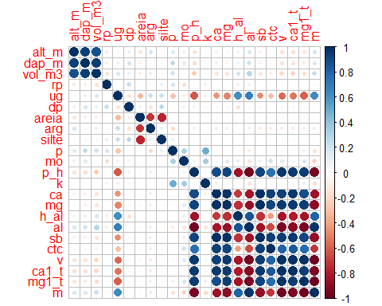

#> [1] "======== Análise de Agrupamento Hierárquico ========== "

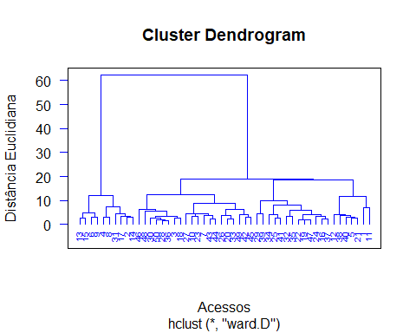

#> [1] "======== Análise de Componentes Principais ========== "  
#> [1] "==== Autovalores ===="  
#> [1] 10.369 3.004 2.223 1.771 1.514 1.089 0.846 0.674 0.541 0.408  
#> [11] 0.224 0.138 0.093 0.042 0.026 0.020 0.017 0.001 0.000 0.000  
#> [21] 0.000 0.000 0.000  
#> [1] "==== % da variância explicada ===="  
#> [1] 0.4508 0.1306 0.0967 0.0770 0.0658 0.0473 0.0368 0.0293 0.0235 0.0177  
#> [11] 0.0098 0.0060 0.0040 0.0018 0.0011 0.0009 0.0007 0.0001 0.0000 0.0000  
#> [21] 0.0000 0.0000 0.0000  
#> [1] "==== % da variância explicada acumulada ===="  
#> [1] 45.08 58.14 67.81 75.51 82.09 86.82 90.50 93.43 95.78 97.56  
#> [11] 98.53 99.13 99.54 99.72 99.83 99.92 99.99 100.00 100.00 100.00  
#> [21] 100.00 100.00 100.00  
#> [1] "==== Poder Discriminante ===="

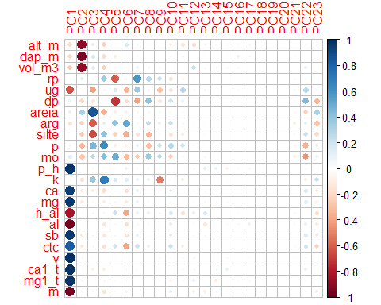

#> [1] "==== screeplot ===="  
#> [1] "==== Gráfico Biplot ===="  
#> Warning: Using `size` aesthetic for lines was deprecated in ggplot2 3.4.0.  
#> ℹ Please use `linewidth` instead.  
#> This warning is displayed once every 8 hours.  
#> Call `lifecycle::last_lifecycle_warnings()` to see where this warning was  
#> generated.

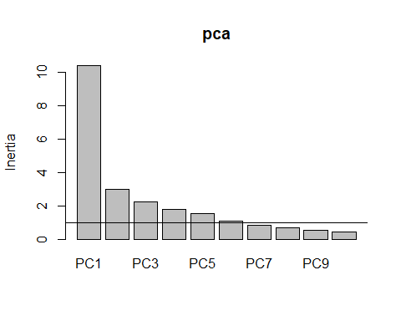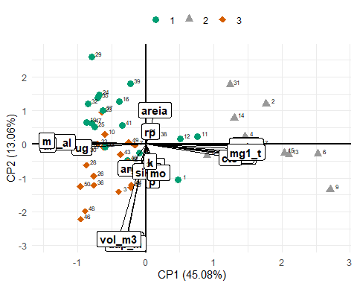

#> [1] "==== Tabela da correlação dos atributos com cada PC ===="  
#> PC1 PC2 PC3 PC4 PC5  
#> silte 0.01357842 -0.254913995 -0.6566712526 0.403552138 -0.23227877  
#> k 0.04657065 -0.161443621 0.3837275660 0.690957889 0.16054886  
#> rp 0.04918077 0.122274094 -0.0634107952 0.355300549 -0.60177729  
#> p 0.06856542 -0.337595774 0.4559664031 0.624524190 -0.10500757  
#> dp 0.08464479 -0.200839078 -0.1347750306 0.010002696 -0.71704040  
#> areia 0.08971671 0.323922627 0.8536000571 -0.359371166 -0.09428718  
#> mo 0.12734612 -0.265968651 0.2546080237 0.428660970 0.49054687  
#> arg -0.15281707 -0.224059666 -0.6066969558 0.118403999 0.39564474  
#> alt_m -0.18772818 -0.897588147 0.1071792154 -0.230996813 -0.01874335  
#> dap_m -0.19588532 -0.930060169 0.1607967288 -0.192340979 -0.10006408  
#> vol_m3 -0.26129826 -0.888634102 0.1278107846 -0.226620068 -0.05138266  
#> ug -0.62193164 -0.027833602 -0.4022303829 -0.074500032 0.17354135  
#> ctc 0.82269800 -0.124053212 -0.0613201324 -0.152401042 0.19300804  
#> h_al -0.82486093 0.022259247 0.0610784656 0.031335508 0.21643307  
#> ca 0.94252516 -0.085510830 -0.1026636534 -0.188485653 0.04641853  
#> al -0.95294083 -0.001131505 -0.0240355892 -0.129594656 0.03485298  
#> sb 0.95884526 -0.103310716 -0.0713050991 -0.128531055 0.05926774  
#> m -0.96373633 0.036996194 -0.0463111867 -0.153057366 -0.03529313  
#> mg 0.96466432 -0.114258042 -0.0570095674 -0.097497814 0.06346670  
#> p_h 0.97313817 -0.004454775 -0.0334320471 0.012979559 -0.01805438  
#> mg1_t 0.97601612 -0.073467415 0.0002549059 0.061794491 0.02017517  
#> ca1_t 0.98010805 -0.015386831 -0.0834834584 -0.098617032 0.00822123  
#> v 0.99155810 -0.048935168 -0.0252381705 0.009319047 0.01811214  
#> PC6  
#> silte -0.36101308  
#> k 0.12672935  
#> rp 0.06956230  
#> p -0.07668102  
#> dp -0.16917362  
#> areia -0.08113410  
#> mo -0.31547432  
#> arg 0.51417988  
#> alt_m 0.14149181  
#> dap_m 0.01340721  
#> vol_m3 0.02696943  
#> ug -0.33030540  
#> ctc -0.38340899  
#> h_al -0.39392957  
#> ca -0.15154340  
#> al -0.17079099  
#> sb -0.13228961  
#> m -0.07792322  
#> mg -0.11240450  
#> p_h 0.09051425  
#> mg1_t 0.04663862  
#> ca1_t -0.04180414  
#> v 0.01020194  
#> [1] "##########################################"  
#> [1] " Tratamento: Testemunha"  
#> [1] " Profundidade: 2"  
#> [1] "##########################################"  
#> [1] "======== Análise de correlação linear ========== "

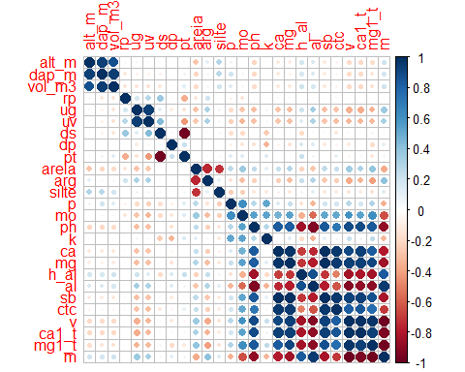

#> [1] "======== Análise de Agrupamento Hierárquico ========== "

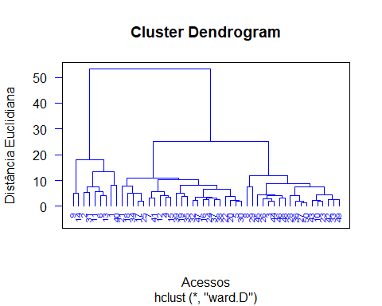

#> [1] "======== Análise de Componentes Principais ========== "  
#> [1] "==== Autovalores ===="  
#> [1] 10.847 3.440 2.615 1.988 1.791 1.134 0.975 0.878 0.726 0.559  
#> [11] 0.358 0.236 0.154 0.111 0.096 0.033 0.028 0.027 0.002 0.001  
#> [21] 0.000 0.000 0.000 0.000 0.000 0.000  
#> [1] "==== % da variância explicada ===="  
#> [1] 0.4172 0.1323 0.1006 0.0765 0.0689 0.0436 0.0375 0.0338 0.0279 0.0215  
#> [11] 0.0138 0.0091 0.0059 0.0043 0.0037 0.0013 0.0011 0.0010 0.0001 0.0000  
#> [21] 0.0000 0.0000 0.0000 0.0000 0.0000 0.0000  
#> [1] "==== % da variância explicada acumulada ===="  
#> [1] 41.72 54.95 65.01 72.65 79.54 83.91 87.66 91.03 93.83 95.98  
#> [11] 97.35 98.26 98.85 99.28 99.65 99.78 99.88 99.99 100.00 100.00  
#> [21] 100.00 100.00 100.00 100.00 100.00 100.00  
#> [1] "==== Poder Discriminante ===="

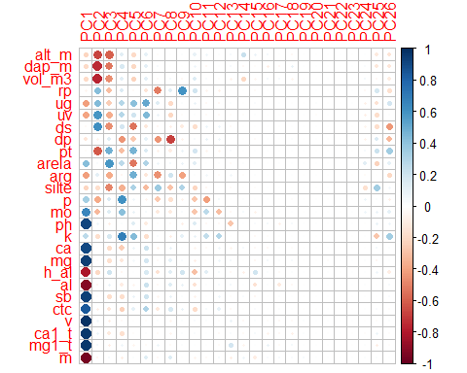

#> [1] "==== screeplot ===="

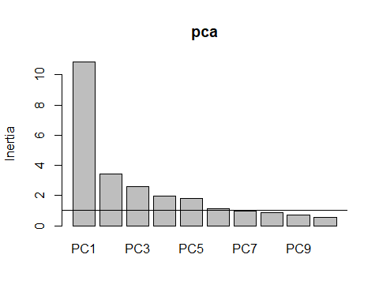

#> [1] "==== Gráfico Biplot ===="

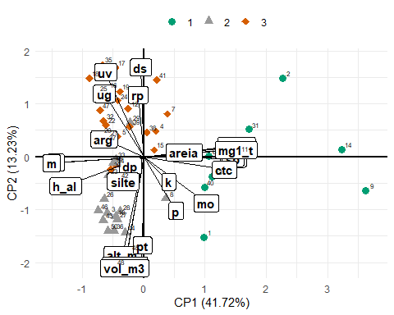

#> [1] "==== Tabela da correlação dos atributos com cada PC ===="  
#> PC1 PC2 PC3 PC4 PC5  
#> pt -0.01234686 -0.610085959 0.48558668 -0.30261670 0.4625901786  
#> ds -0.02818053 0.612255493 -0.46566543 0.18861759 -0.5415629921  
#> rp -0.05750385 0.423995476 -0.30444429 0.15781024 -0.0256438743  
#> dp -0.13994114 -0.064503927 0.13077112 -0.44135721 -0.2610501887  
#> dap_m -0.19392044 -0.748227859 -0.53951513 0.16582226 -0.2053998919  
#> vol_m3 -0.19893303 -0.764891273 -0.46833884 0.12182499 -0.2221343275  
#> silte -0.21310905 -0.171506320 -0.49262615 -0.35256441 0.3112521873  
#> alt_m -0.21550372 -0.675745880 -0.59539877 0.12446858 -0.1995593754  
#> k 0.26119316 -0.172849018 0.17001065 0.68956693 0.4377602976  
#> p 0.33838816 -0.373236527 0.15804567 0.60091626 0.0616093174  
#> uv -0.39657076 0.580566619 -0.36811218 0.28698396 0.1989833811  
#> ug -0.41043170 0.431614767 -0.24147556 0.28072797 0.4166555621  
#> arg -0.41111279 0.119060393 -0.37461127 -0.04950484 0.4815591951  
#> areia 0.42388634 0.029837181 0.58151707 0.26493324 -0.5368428897  
#> mo 0.65209846 -0.320665915 0.13158681 0.41613987 0.0939761186  
#> h_al -0.81248377 -0.202509845 0.20459441 -0.04553181 0.0004910887  
#> ctc 0.84323380 -0.089991676 -0.13543429 -0.23445766 0.1031394631  
#> ca 0.90759214 -0.000788793 -0.18454040 -0.24337621 0.0785659066  
#> ph 0.91499872 0.062442464 -0.09497196 0.01281957 0.1300773978  
#> al -0.91608746 -0.040883179 0.09392084 -0.09877180 -0.0524740196  
#> sb 0.93100609 -0.011828217 -0.17195729 -0.17671277 0.0836503687  
#> mg 0.94064111 -0.013832487 -0.16608004 -0.12906712 0.0495509997  
#> m -0.95740960 -0.044903250 0.03674532 -0.09470529 0.0104276170  
#> mg1_t 0.96263527 0.046631939 -0.09208233 0.06390505 -0.0544644590  
#> ca1_t 0.96600934 0.074761427 -0.11632259 -0.16732626 -0.0165931234  
#> v 0.98587054 0.052011367 -0.09468218 -0.02709711 -0.0002865446  
#> PC6  
#> pt 0.15451219  
#> ds -0.12650548  
#> rp -0.14544108  
#> dp 0.10467317  
#> dap_m 0.11551465  
#> vol_m3 0.11094798  
#> silte -0.31562620  
#> alt_m 0.10069306  
#> k -0.17407823  
#> p -0.06193921  
#> uv 0.44179373  
#> ug 0.51511021  
#> arg -0.13719325  
#> areia 0.30143673  
#> mo 0.03503659  
#> h_al 0.16388446  
#> ctc 0.30882280  
#> ca 0.21726053  
#> ph -0.10968889  
#> al 0.21008801  
#> sb 0.20131439  
#> mg 0.18995676  
#> m 0.13441028  
#> mg1_t -0.02471491  
#> ca1_t 0.01889769  
#> v -0.01414053  
#> [1] "##########################################"  
#> [1] " Tratamento: Calcário"  
#> [1] " Profundidade: 1"  
#> [1] "##########################################"  
#> [1] "======== Análise de correlação linear ========== "

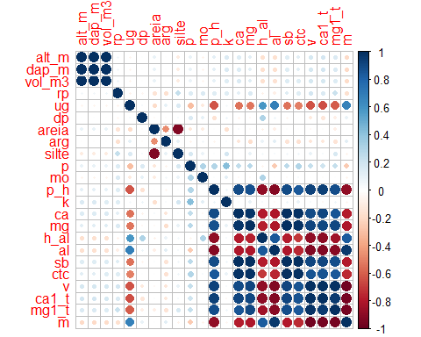

#> [1] "======== Análise de Agrupamento Hierárquico ========== "

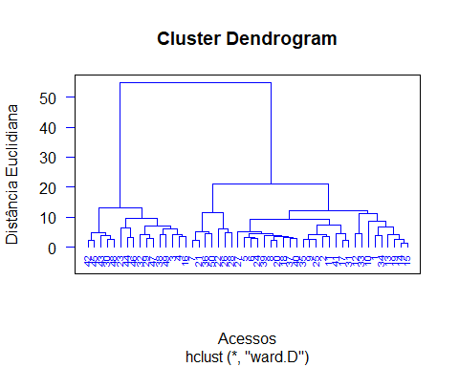

#> [1] "======== Análise de Componentes Principais ========== "  
#> [1] "==== Autovalores ===="  
#> [1] 10.538 2.988 2.358 1.604 1.144 1.023 0.922 0.699 0.637 0.514  
#> [11] 0.321 0.115 0.074 0.037 0.022 0.004 0.002 0.001 0.000 0.000  
#> [21] 0.000 0.000 0.000  
#> [1] "==== % da variância explicada ===="  
#> [1] 0.4582 0.1299 0.1025 0.0697 0.0497 0.0445 0.0401 0.0304 0.0277 0.0224  
#> [11] 0.0140 0.0050 0.0032 0.0016 0.0009 0.0002 0.0001 0.0000 0.0000 0.0000  
#> [21] 0.0000 0.0000 0.0000  
#> [1] "==== % da variância explicada acumulada ===="  
#> [1] 45.82 58.81 69.06 76.03 81.00 85.45 89.46 92.50 95.27 97.50  
#> [11] 98.90 99.40 99.72 99.88 99.97 99.99 100.00 100.00 100.00 100.00  
#> [21] 100.00 100.00 100.00  
#> [1] "==== Poder Discriminante ===="

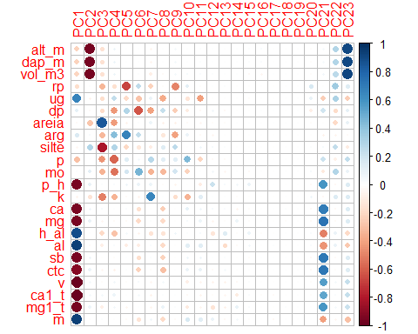

#> [1] "==== screeplot ===="

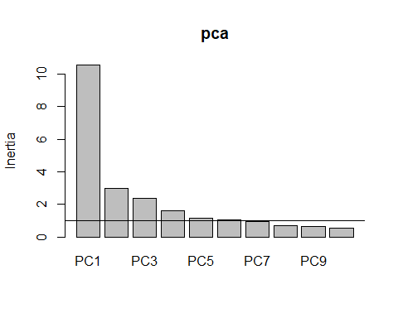

#> [1] "==== Gráfico Biplot ===="

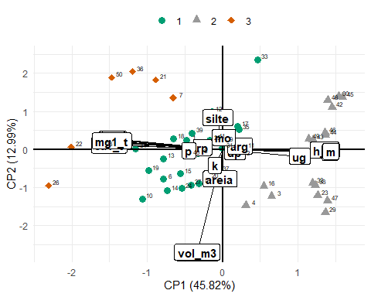

#> [1] "==== Tabela da correlação dos atributos com cada PC ===="  
#> PC1 PC2 PC3 PC4 PC5  
#> mo 0.01151278 0.111195889 -0.342835452 -0.5495416207 0.184541493  
#> areia -0.02159560 -0.273661508 0.846587756 -0.4268002068 -0.069190210  
#> silte -0.04113417 0.294180029 -0.812677826 0.2981276409 -0.209579083  
#> k -0.06546399 -0.147749679 -0.505191950 -0.3440013999 -0.026282774  
#> dp 0.10618767 -0.021708765 -0.180382298 -0.4315510728 0.290223802  
#> arg 0.15103016 0.031992725 -0.323718316 0.4206993644 0.663409090  
#> rp -0.17282910 0.018801297 -0.334121295 -0.1685530672 -0.677838125  
#> vol_m3 -0.21998878 -0.952968611 -0.153948674 0.0713701459 -0.002151635  
#> alt_m -0.22114526 -0.957112228 -0.152052887 0.0736081212 0.001267338  
#> dap_m -0.22114526 -0.957112228 -0.152052887 0.0736081212 0.001267338  
#> p -0.29219370 -0.009701190 -0.446324328 -0.5844142849 0.134278537  
#> ug 0.66756165 -0.063791775 -0.171662154 0.2451157533 -0.191372872  
#> h_al 0.88301989 -0.007294184 -0.196333170 -0.2890860214 0.043538738  
#> ctc -0.91186486 0.083362339 -0.045711103 -0.0756268026 0.015843231  
#> al 0.93044114 -0.027490183 -0.084489384 0.0218080311 -0.093137081  
#> m 0.93695199 -0.017841496 0.015484117 -0.0000632516 -0.029763886  
#> ca -0.94129268 0.064759037 0.037894209 0.0054531398 0.026674573  
#> mg -0.94639534 0.092485629 -0.041609305 -0.0208546027 -0.025987998  
#> sb -0.94922988 0.073153171 -0.002941455 -0.0114975791 0.005567168  
#> p_h -0.94924868 0.097051877 0.012434244 0.0218996382 0.071578744  
#> mg1_t -0.95840262 0.078467266 -0.080439570 0.0519178407 -0.055496839  
#> ca1_t -0.98165825 0.040126608 0.045552019 0.0779867072 0.002318904  
#> v -0.98479729 0.048596009 -0.018079867 0.0593676753 -0.018614861  
#> PC6  
#> mo 0.464480034  
#> areia 0.018771272  
#> silte -0.128450683  
#> k -0.063192613  
#> dp -0.624171694  
#> arg 0.247677251  
#> rp 0.250251471  
#> vol_m3 0.011111244  
#> alt_m 0.004642936  
#> dap_m 0.004642936  
#> p 0.049832919  
#> ug -0.288194517  
#> h_al -0.069089008  
#> ctc -0.220282268  
#> al -0.097048793  
#> m -0.141559293  
#> ca -0.163172535  
#> mg -0.192918111  
#> sb -0.176909101  
#> p_h 0.081794278  
#> mg1_t 0.003337712  
#> ca1_t 0.042132725  
#> v 0.030073789  
#> [1] "##########################################"  
#> [1] " Tratamento: Calcário"  
#> [1] " Profundidade: 2"  
#> [1] "##########################################"  
#> [1] "======== Análise de correlação linear ========== "

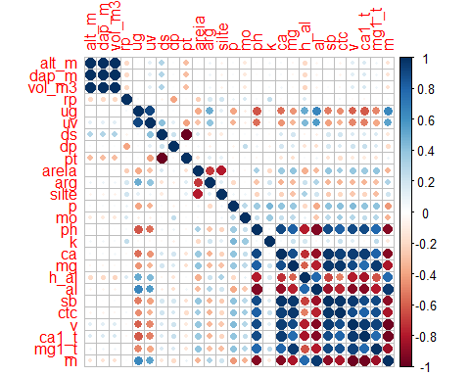

#> [1] "======== Análise de Agrupamento Hierárquico ========== "

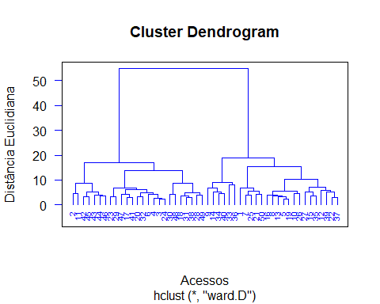

#> [1] "======== Análise de Componentes Principais ========== "  
#> [1] "==== Autovalores ===="  
#> [1] 11.015 3.619 2.367 2.123 1.465 1.271 1.195 0.745 0.595 0.475  
#> [11] 0.416 0.265 0.199 0.114 0.090 0.035 0.006 0.003 0.001 0.001  
#> [21] 0.000 0.000 0.000 0.000 0.000 0.000  
#> [1] "==== % da variância explicada ===="  
#> [1] 0.4237 0.1392 0.0910 0.0817 0.0563 0.0489 0.0460 0.0286 0.0229 0.0183  
#> [11] 0.0160 0.0102 0.0077 0.0044 0.0034 0.0013 0.0002 0.0001 0.0000 0.0000  
#> [21] 0.0000 0.0000 0.0000 0.0000 0.0000 0.0000  
#> [1] "==== % da variância explicada acumulada ===="  
#> [1] 42.37 56.29 65.39 73.55 79.19 84.08 88.68 91.54 93.83 95.66  
#> [11] 97.26 98.28 99.04 99.48 99.83 99.96 99.98 99.99 100.00 100.00  
#> [21] 100.00 100.00 100.00 100.00 100.00 100.00  
#> [1] "==== Poder Discriminante ===="

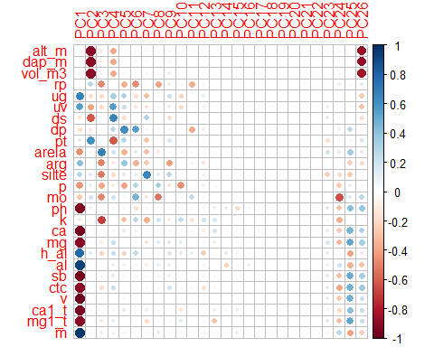

#> [1] "==== screeplot ===="

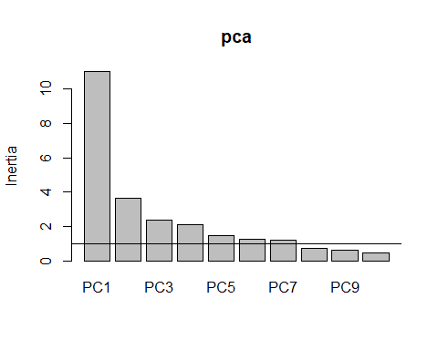

#> [1] "==== Gráfico Biplot ===="

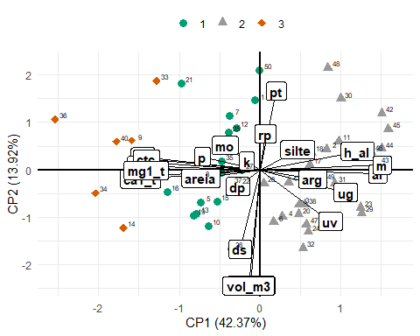

#> [1] "==== Tabela da correlação dos atributos com cada PC ===="  
#> PC1 PC2 PC3 PC4 PC5  
#> rp 0.04240489 0.279215254 -0.486210494 0.04843271 -0.353980070  
#> alt_m -0.07397615 -0.901122447 -0.109476803 -0.38429139 -0.039925631  
#> dap_m -0.07397615 -0.901122447 -0.109476803 -0.38429139 -0.039925631  
#> vol_m3 -0.09099166 -0.903362644 -0.087947967 -0.37190886 -0.035875298  
#> k -0.10543070 0.066832757 -0.691918912 -0.02053900 -0.310101108  
#> pt 0.12840390 0.609899562 0.069041356 -0.61347943 0.299262161  
#> ds -0.15703620 -0.618924890 -0.055036301 0.65103790 -0.174148557  
#> dp -0.17566509 -0.131307419 0.071107988 0.27597954 0.624585022  
#> mo -0.27614774 0.188040305 -0.480479225 0.19385278 0.055565484  
#> silte 0.29777458 0.154283584 -0.535968861 -0.18641250 0.145527735  
#> arg 0.41654606 -0.072896782 -0.500662921 -0.12477226 0.388778801  
#> p -0.45498571 0.101246117 -0.385041137 -0.12479137 -0.400056220  
#> areia -0.46698243 -0.066681863 0.689317108 0.20978241 -0.340655037  
#> uv 0.55650276 -0.402882619 -0.194205591 0.56652999 0.230604326  
#> ug 0.67674267 -0.176779554 -0.194979483 0.33765964 0.322240085  
#> h_al 0.77195209 0.142843936 -0.229462333 0.23198095 -0.221176662  
#> ctc -0.89901756 0.083242776 -0.176998717 0.23828779 0.014054435  
#> mg1_t -0.90135108 -0.006431312 -0.123697389 0.10914345 0.004768597  
#> mg -0.90195152 0.054845301 -0.111236498 0.22711060 0.022398254  
#> ph -0.92710909 0.099761126 -0.026662030 -0.06508844 0.091180418  
#> al 0.92897080 -0.033586895 0.030505061 0.09721754 -0.105915127  
#> ca1_t -0.94721506 -0.071974808 0.003123671 -0.08520287 0.141019768  
#> ca -0.95414242 0.011858481 -0.040767851 0.06769134 0.115050158  
#> sb -0.95921376 0.033012378 -0.089531163 0.14056553 0.069442380  
#> m 0.96570283 0.036391228 0.100708763 0.09250733 -0.084790530  
#> v -0.98328157 -0.048631760 -0.075976863 -0.01025014 0.079030087  
#> PC6 PC7  
#> rp -0.4787414831 0.04612311  
#> alt_m 0.0528015572 -0.06842664  
#> dap_m 0.0528015572 -0.06842664  
#> vol_m3 0.0480862031 -0.06791289  
#> k 0.2642542959 -0.36858040  
#> pt 0.1120056669 -0.30238316  
#> ds -0.0081515141 0.31266019  
#> dp 0.5545970615 0.08514751  
#> mo 0.4655435906 -0.14104334  
#> silte 0.1083654064 0.65512485  
#> arg -0.3594751393 -0.26074575  
#> p 0.2958718845 0.02344085  
#> areia 0.1403077319 -0.31276680  
#> uv -0.1494554446 -0.15908671  
#> ug -0.1686895066 -0.31511864  
#> h_al 0.2580230197 -0.05159810  
#> ctc -0.0176404070 -0.07590481  
#> mg1_t -0.0188096166 -0.19614358  
#> mg -0.0770536974 -0.15909627  
#> ph -0.1716609213 0.05821826  
#> al 0.0817187805 -0.10729047  
#> ca1_t -0.0527108198 0.10728542  
#> ca -0.0926591206 0.05066518  
#> sb -0.0820606364 -0.05058190  
#> m 0.0003336357 -0.04247564  
#> v -0.0322174084 -0.03473342  
#> [1] "##########################################"  
#> [1] " Tratamento: Lama de Cal"  
#> [1] " Profundidade: 1"  
#> [1] "##########################################"  
#> [1] "======== Análise de correlação linear ========== "

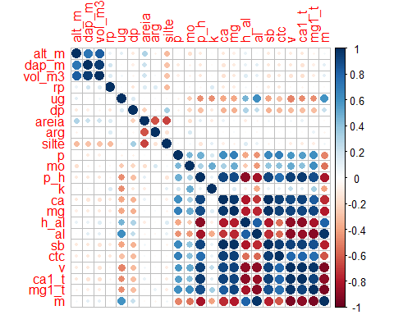

#> [1] "======== Análise de Agrupamento Hierárquico ========== "

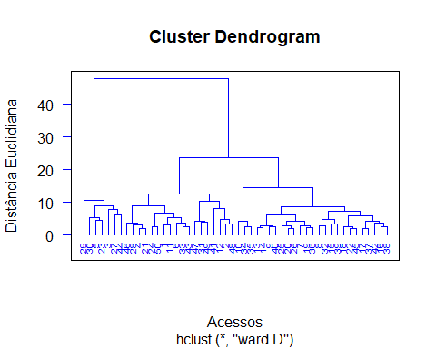

#> [1] "======== Análise de Componentes Principais ========== "  
#> [1] "==== Autovalores ===="  
#> [1] 10.732 3.127 1.911 1.514 1.356 1.143 0.862 0.672 0.507 0.432  
#> [11] 0.256 0.219 0.097 0.066 0.042 0.038 0.025 0.003 0.001 0.000  
#> [21] 0.000 0.000 0.000  
#> [1] "==== % da variância explicada ===="  
#> [1] 0.4666 0.1359 0.0831 0.0658 0.0589 0.0497 0.0375 0.0292 0.0221 0.0188  
#> [11] 0.0111 0.0095 0.0042 0.0029 0.0018 0.0016 0.0011 0.0001 0.0000 0.0000  
#> [21] 0.0000 0.0000 0.0000  
#> [1] "==== % da variância explicada acumulada ===="  
#> [1] 46.66 60.25 68.56 75.15 81.04 86.01 89.76 92.68 94.88 96.76  
#> [11] 97.87 98.82 99.25 99.53 99.71 99.88 99.98 100.00 100.00 100.00  
#> [21] 100.00 100.00 100.00  
#> [1] "==== Poder Discriminante ===="

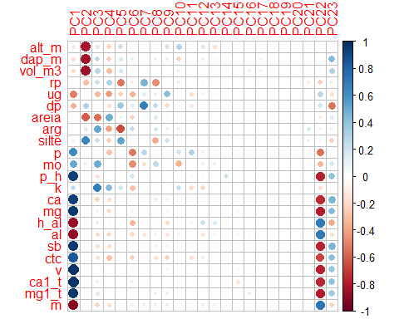

#> [1] "==== screeplot ===="

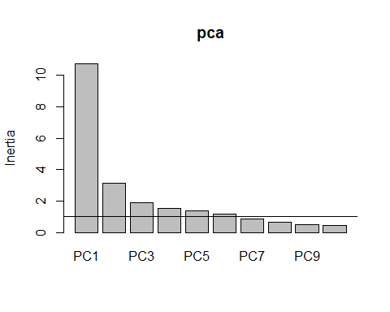

#> [1] "==== Gráfico Biplot ===="

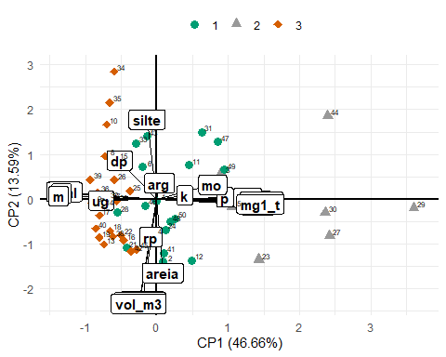

#> [1] "==== Tabela da correlação dos atributos com cada PC ===="  
#> PC1 PC2 PC3 PC4 PC5  
#> arg 0.02354122 0.12787047 0.511259092 -0.402800294 -0.6574758269  
#> areia 0.05393278 -0.60006236 -0.552338631 0.493297404 0.0842920033  
#> rp -0.05470665 -0.30878417 0.221133258 0.309776028 -0.5337592529  
#> silte -0.09161258 0.64673418 0.219141621 -0.247146394 0.5203891162  
#> alt_m -0.12928656 -0.82954618 0.142921821 -0.216299644 0.2255019449  
#> dap_m -0.15712591 -0.83568081 0.261591507 -0.243153998 0.1747360411  
#> vol_m3 -0.17123855 -0.85089969 0.273504421 -0.313270874 0.1871024557  
#> k 0.25826715 0.02989732 0.681265756 0.445039154 0.1958227751  
#> dp -0.34760345 0.31428381 0.051944998 -0.159983180 0.3745489964  
#> mo 0.51914562 0.11757718 0.493201693 0.008481982 -0.0040837558  
#> ug -0.51921494 -0.01085908 -0.328161677 -0.431452954 -0.2362282960  
#> p 0.63265454 0.01360241 -0.012926276 -0.285698182 0.0221575546  
#> ctc 0.84438371 0.01043179 -0.166803663 -0.283548446 0.0217823065  
#> h_al -0.86178020 0.05780876 0.114021080 -0.069612915 0.0416448050  
#> al -0.88772870 0.04706148 -0.184160938 -0.207578456 -0.0527303808  
#> m -0.91579775 0.02480525 -0.219250898 -0.166416255 -0.0609299974  
#> ca 0.93519270 -0.01252429 -0.231893520 -0.176265590 -0.0039881973  
#> p_h 0.93626960 -0.04956319 -0.152772807 -0.007453282 -0.0205004049  
#> sb 0.95455840 -0.01596452 -0.165772261 -0.174976446 -0.0012760545  
#> mg 0.96092732 -0.02391668 -0.077201866 -0.195195037 -0.0073443732  
#> mg1_t 0.96372241 -0.04094921 0.145808643 -0.004817962 0.0022652898  
#> ca1_t 0.97328779 -0.01962242 -0.104909646 -0.002991553 -0.0007075584  
#> v 0.98743565 -0.02623763 0.009059248 0.016072965 0.0078124641  
#> PC6  
#> arg 0.24973484  
#> areia -0.22109410  
#> rp -0.12437777  
#> silte 0.04462867  
#> alt_m 0.01286372  
#> dap_m 0.10995749  
#> vol_m3 0.07077747  
#> k -0.29431414  
#> dp 0.13016735  
#> mo -0.47254829  
#> ug -0.34758360  
#> p -0.52769531  
#> ctc -0.23131537  
#> h_al -0.33020712  
#> al -0.18782058  
#> m -0.10115941  
#> ca 0.01107238  
#> p_h 0.18995278  
#> sb -0.03187775  
#> mg -0.09564109  
#> mg1_t -0.02591929  
#> ca1_t 0.11093723  
#> v 0.05758527  
#> [1] "##########################################"  
#> [1] " Tratamento: Lama de Cal"  
#> [1] " Profundidade: 2"  
#> [1] "##########################################"  
#> [1] "======== Análise de correlação linear ========== "

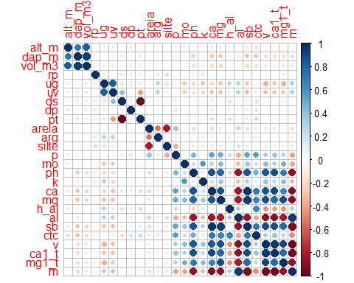

#> [1] "======== Análise de Agrupamento Hierárquico ========== "

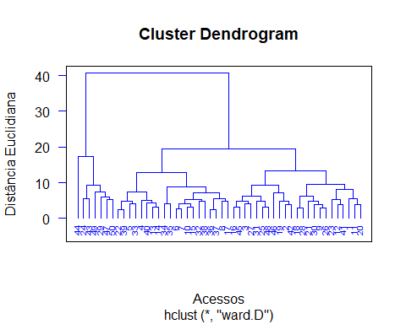

#> [1] "======== Análise de Componentes Principais ========== "  
#> [1] "==== Autovalores ===="  
#> [1] 9.345 3.028 2.587 2.201 1.806 1.633 1.395 0.968 0.870 0.627 0.488 0.315  
#> [13] 0.260 0.196 0.125 0.093 0.032 0.028 0.002 0.001 0.000 0.000 0.000 0.000  
#> [25] 0.000 0.000  
#> [1] "==== % da variância explicada ===="  
#> [1] 0.3594 0.1164 0.0995 0.0846 0.0695 0.0628 0.0537 0.0372 0.0335 0.0241  
#> [11] 0.0188 0.0121 0.0100 0.0075 0.0048 0.0036 0.0012 0.0011 0.0001 0.0000  
#> [21] 0.0000 0.0000 0.0000 0.0000 0.0000 0.0000  
#> [1] "==== % da variância explicada acumulada ===="  
#> [1] 35.94 47.58 57.53 66.00 72.95 79.23 84.59 88.32 91.66 94.07  
#> [11] 95.95 97.16 98.16 98.92 99.40 99.75 99.88 99.99 99.99 100.00  
#> [21] 100.00 100.00 100.00 100.00 100.00 100.00  
#> [1] "==== Poder Discriminante ===="

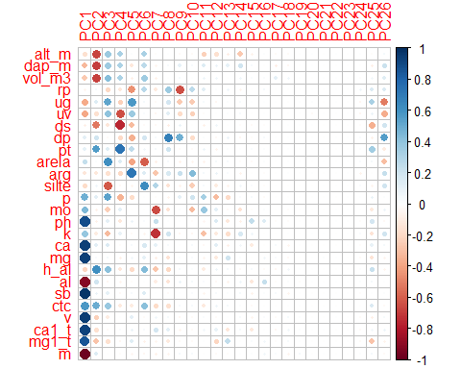

#> [1] "==== screeplot ===="

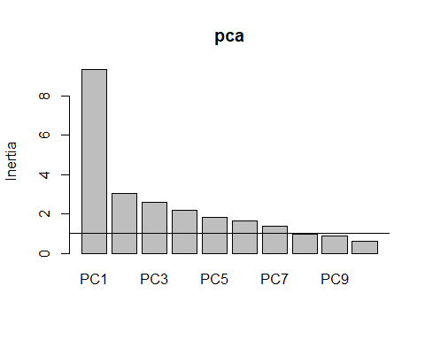

#> [1] "==== Gráfico Biplot ===="

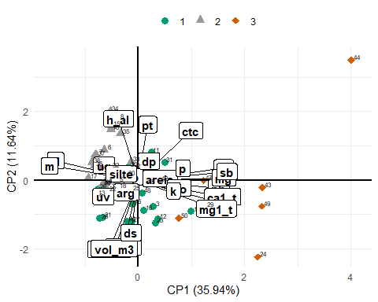

#> [1] "==== Tabela da correlação dos atributos com cada PC ===="  
#> PC1 PC2 PC3 PC4 PC5  
#> rp -0.05430742 0.03580940 -0.205958850 -0.122835741 -0.456706812  
#> ds -0.08444316 -0.52843073 -0.137199692 -0.753459826 -0.312650214  
#> pt 0.10215447 0.56059223 0.131873179 0.730582464 0.257406667  
#> dp 0.11581549 0.19570081 -0.022689262 -0.196877553 -0.355592520  
#> arg -0.13381608 -0.12032414 -0.165152110 -0.202802167 0.725954198  
#> alt_m -0.16497210 -0.67123359 0.367661848 0.328136668 0.018791578  
#> silte -0.18947869 0.06581809 -0.610099276 -0.031136138 -0.050932121  
#> h_al -0.21799788 0.61990609 0.418671750 -0.130197842 -0.195656393  
#> areia 0.23922883 0.01637875 0.611822202 0.147142185 -0.390081604  
#> vol_m3 -0.26702572 -0.68740426 0.428161817 0.318761196 -0.081388668  
#> dap_m -0.32139821 -0.69564900 0.351429466 0.314360784 -0.129061054  
#> ug -0.37954907 0.14936119 0.526368630 -0.230327478 0.573593555  
#> k 0.38464440 -0.10547988 -0.315616303 0.099396698 -0.025244114  
#> uv -0.38573161 -0.16391331 0.402749044 -0.646030925 0.365730540  
#> mo 0.44412818 -0.07709286 -0.245975373 0.114365479 -0.002065267  
#> p 0.48572055 0.12145462 0.536969921 -0.349364142 -0.181981805  
#> ctc 0.57559746 0.49771535 0.371180547 -0.115688092 -0.108670324  
#> mg1_t 0.85601052 -0.28667454 -0.166636465 -0.043589034 0.134349278  
#> ph 0.88177357 -0.07756675 0.111726601 -0.122811642 0.080794215  
#> al -0.91040735 0.19788374 -0.048411449 -0.057357776 -0.015776062  
#> ca1_t 0.92436953 -0.16607340 -0.020645528 0.020402078 0.096206739  
#> ca 0.93539528 0.12455504 0.155661169 -0.014592342 0.030583418  
#> mg 0.93893311 0.02536829 0.044763601 -0.073941005 0.050233305  
#> v 0.94889555 -0.23600690 -0.105082984 0.005163657 0.117947769  
#> sb 0.97005915 0.08580445 0.104634385 -0.032884133 0.037439312  
#> m -0.97641239 0.14568425 -0.002607298 -0.017188162 -0.049702680  
#> PC6 PC7  
#> rp 0.273093414 -0.115562141  
#> ds -0.026301040 -0.039369917  
#> pt 0.056224060 0.045455988  
#> dp 0.185258016 0.035855306  
#> arg 0.141035960 -0.274016275  
#> alt_m 0.329658224 -0.012724585  
#> silte 0.622282954 0.297214086  
#> h_al 0.437940973 -0.272979357  
#> areia -0.607691333 -0.086658352  
#> vol_m3 0.352432253 -0.073135741  
#> dap_m 0.261400657 -0.056547804  
#> ug 0.048784702 -0.025901531  
#> k -0.050988521 -0.723502909  
#> uv 0.026596397 -0.049220559  
#> mo -0.004623709 -0.652886038  
#> p 0.009610321 -0.010798540  
#> ctc 0.416383285 -0.186199041  
#> mg1_t -0.079318314 -0.058962571  
#> ph 0.022796284 0.237341910  
#> al 0.004120074 -0.097178544  
#> ca1_t 0.034371705 0.189420464  
#> ca 0.167673185 0.108668145  
#> mg 0.108791404 -0.093941585  
#> v -0.021077821 0.060898784  
#> sb 0.146920026 0.006152974  
#> m -0.040881433 -0.076768181

# Análise Multivariada - por profundidade (considerando todos os tratamentos juntos)

for(j in 1:2){  
 da <- data_set %>%   
 select(-name) %>%   
 filter(  
 prof == j  
 ) %>%   
 pivot_wider(values_from = value, names_from = variavel)  
   
 nomes <- da %>% mutate(nome = str_sub(tratamento, 1,1)) %>%   
 pull(nome)  
 da <- da %>% select(alt_m:m, -prof)  
 mc <- da %>% cor()  
  
 print("##########################################")  
 print(paste0(" Profundidade: ",j))  
 print("##########################################")  
 print("======== Análise de correlação linear ========== ")  
 corrplot::corrplot(mc)  
   
 print("======== Análise de Agrupamento Hierárquico ========== ")  
 da_pad<-decostand(da,   
 method = "standardize",  
 na.rm=TRUE)  
 da_pad_euc<-vegdist(da_pad,"euclidean")   
 da_pad_euc_ward<-hclust(da_pad_euc, method="ward.D")  
 plot(da_pad_euc_ward,   
 ylab="Distância Euclidiana",  
 xlab="Acessos", hang=-1,  
 col="blue", las=1,  
 cex=.6,lwd=1.5);box()  
 grupo<-cutree(da_pad_euc_ward,3)  
   
   
 print("======== Análise de Componentes Principais ========== ")  
 pca <- prcomp(da_pad,scale.=T)  
 # Autovalores  
 eig<-pca$sdev^2  
 print("==== Autovalores ====")  
 print(round(eig,3))  
 print("==== % da variância explicada ====")  
 ve<-eig/sum(eig)  
 print(round(ve,4))  
 print("==== % da variância explicada acumulada ====")  
 print(round(cumsum(ve),4)*100)  
 print("==== Poder Discriminante ====")  
 mcor<-cor(da_pad,pca$x)  
 corrplot(mcor)  
 print("==== screeplot ====")  
 screeplot(pca)  
 abline(h=1)  
 print("==== Gráfico Biplot ====")  
 pc1V<-cor(da_pad,pca$x)[,1]/sd(cor(da_pad,pca$x)[,1])  
 pc2V<-cor(da_pad,pca$x)[,2]/sd(cor(da_pad,pca$x)[,2])  
 pc3V<-cor(da_pad,pca$x)[,3]/sd(cor(da_pad,pca$x)[,3])  
 pc1c<-pca$x[,1]/sd(pca$x[,1])  
 pc2c<-pca$x[,2]/sd(pca$x[,2])  
 pc3c<-pca$x[,3]/sd(pca$x[,3])  
 nv<-ncol(da)   
   
 bip<-data.frame(pc1c,pc2c,pc3c,nomes,grupo)  
 texto <- data.frame(  
 x = pc1V,  
 y = pc2V,  
 z = pc3V,  
 label = names(da)  
 )  
 graf <- bip %>%   
 ggplot(aes(x=pc1c,y=pc2c,color=grupo))+  
 geom_point(aes(shape = as_factor(grupo), color = as_factor(grupo)), size = 3) +  
 theme_minimal() +   
 scale_shape_manual(values=16:18)+  
 scale_color_manual(values=c("#009E73", "#999999","#D55E00"))+  
 geom_vline(aes(xintercept=0),  
 color="black", size=1)+  
 geom_hline(aes(yintercept=0),  
 color="black", size=1)+  
 annotate(geom="segment",  
 x=rep(0,length(da)),  
 xend=texto$x,  
 y=rep(0,length(da)),  
 yend=texto$y,color="black",lwd=.5)+  
 geom_label(data=texto,aes(x=x,y=y,label=label),  
 color="black",angle=0,fontface="bold",size=4,fill="white")+  
 labs(x=paste("CP1 (",round(100*ve[1],2),"%)",sep=""),  
 y=paste("CP2 (",round(100*ve[2],2),"%)",sep=""),  
 color="",shape="")+  
 theme(legend.position = "top")+  
 annotate(geom="text",  
 x=pc1c+.1,  
 y=pc2c+.1,  
 color="black",  
 label = nomes,  
 size = 2  
 )  
 print(graf)  
   
 print("==== Tabela da correlação dos atributos com cada PC ====")  
 ck<-sum(pca$sdev^2>=0.98)  
 tabelapca<-vector()  
 for( l in 1:ck) tabelapca<-cbind(tabelapca,mcor[,l])  
 colnames(tabelapca)<-paste(rep(c("PC"),ck),1:ck,sep="")  
 pcat<-round(tabelapca,3)  
 tabelapca<-tabelapca[order(abs(tabelapca[,1])),]  
 print(tabelapca)  
}  
#> [1] "##########################################"  
#> [1] " Profundidade: 1"  
#> [1] "##########################################"  
#> [1] "======== Análise de correlação linear ========== "

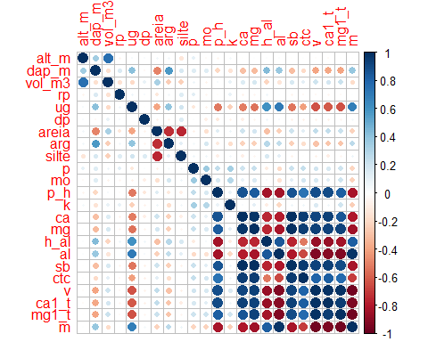

#> [1] "======== Análise de Agrupamento Hierárquico ========== "

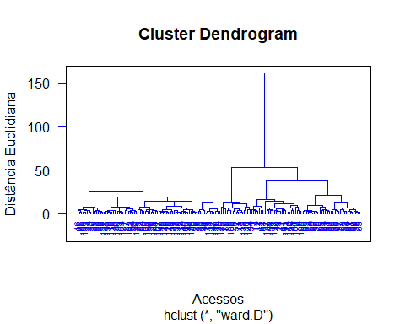

#> [1] "======== Análise de Componentes Principais ========== "  
#> [1] "==== Autovalores ===="  
#> [1] 10.580 2.655 1.868 1.540 1.246 1.015 0.862 0.829 0.585 0.495  
#> [11] 0.474 0.371 0.204 0.106 0.090 0.040 0.038 0.004 0.001 0.000  
#> [21] 0.000 0.000 0.000  
#> [1] "==== % da variância explicada ===="  
#> [1] 0.4600 0.1154 0.0812 0.0669 0.0542 0.0441 0.0375 0.0360 0.0254 0.0215  
#> [11] 0.0206 0.0161 0.0089 0.0046 0.0039 0.0017 0.0016 0.0002 0.0001 0.0000  
#> [21] 0.0000 0.0000 0.0000  
#> [1] "==== % da variância explicada acumulada ===="  
#> [1] 46.00 57.54 65.66 72.36 77.77 82.19 85.93 89.53 92.08 94.23  
#> [11] 96.29 97.90 98.79 99.25 99.64 99.81 99.98 99.99 100.00 100.00  
#> [21] 100.00 100.00 100.00  
#> [1] "==== Poder Discriminante ===="

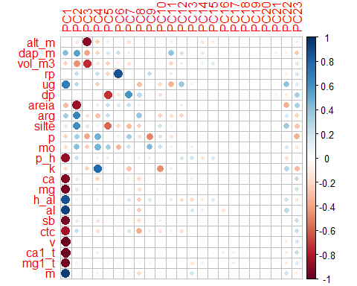

#> [1] "==== screeplot ===="

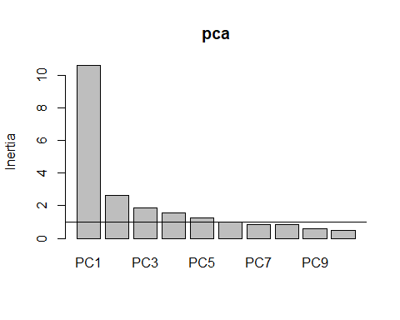

#> [1] "==== Gráfico Biplot ===="

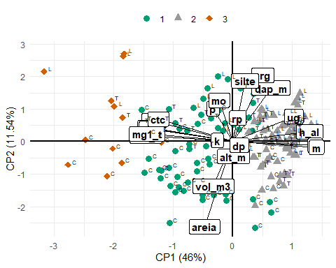

#> [1] "==== Tabela da correlação dos atributos com cada PC ===="  
#> PC1 PC2 PC3 PC4 PC5  
#> alt_m 0.008218097 -0.14968123 -0.906474976 -0.247163675 -0.115429508  
#> rp 0.056982352 0.23835341 0.059594990 0.228923677 -0.212508661  
#> dp 0.073011534 -0.03697153 -0.034425579 0.009146045 -0.724265629  
#> silte 0.138485041 0.61188884 0.151929628 0.086877082 -0.570884435  
#> mo -0.153602066 0.41648208 -0.242205550 0.467269081 0.334947514  
#> k -0.173946852 0.01062837 -0.225932294 0.781898532 -0.033260755  
#> vol_m3 -0.218061213 -0.45049053 -0.740300527 -0.133680986 -0.233143695  
#> p -0.224708434 0.33149059 -0.398250730 0.482890554 0.057781697  
#> areia -0.318232024 -0.85649539 0.001200952 0.120590493 0.233278602  
#> arg 0.339856720 0.66832996 -0.158323531 -0.272333872 0.234365813  
#> dap_m 0.429587869 0.53977953 -0.405109507 -0.218246391 0.168984748  
#> ug 0.685731218 0.25241334 -0.039272255 -0.236706362 0.055449944  
#> ctc -0.837471887 0.22528681 -0.038879001 -0.154392785 0.040058246  
#> h_al 0.865063679 0.09862107 -0.065721062 0.086331606 0.043773019  
#> p_h -0.888141089 0.21021225 0.042359931 -0.095989684 0.110699944  
#> al 0.927123638 -0.03818762 -0.018560664 -0.072578908 0.030981190  
#> ca -0.934738690 0.13163872 0.012199387 -0.201086078 0.033222609  
#> m 0.943624871 -0.05798730 0.012902447 -0.107632448 0.039498390  
#> sb -0.949578046 0.13610118 -0.005945773 -0.148712792 0.014749672  
#> mg -0.950183849 0.14090126 -0.021072696 -0.111109245 -0.013423944  
#> mg1_t -0.964330487 0.07689408 -0.018133280 0.031636850 -0.062955968  
#> ca1_t -0.978527685 0.05671701 0.042198405 -0.108562359 -0.007215868  
#> v -0.987178654 0.06177971 0.010393359 -0.019831852 -0.029690298  
#> PC6  
#> alt_m 0.0722689494  
#> rp 0.8682447060  
#> dp -0.1378873723  
#> silte -0.1916509202  
#> mo -0.3334353921  
#> k -0.0238229233  
#> vol_m3 -0.0791800224  
#> p 0.0829903347  
#> areia 0.1411185325  
#> arg -0.0165473805  
#> dap_m 0.2100306090  
#> ug 0.0188048311  
#> ctc -0.0207368929  
#> h_al -0.0544317581  
#> p_h 0.0706688683  
#> al -0.0347990115  
#> ca 0.0145021595  
#> m 0.0031984416  
#> sb 0.0038085791  
#> mg -0.0121479103  
#> mg1_t -0.0217835842  
#> ca1_t 0.0141191268  
#> v -0.0001422633  
#> [1] "##########################################"  
#> [1] " Profundidade: 2"  
#> [1] "##########################################"  
#> [1] "======== Análise de correlação linear ========== "

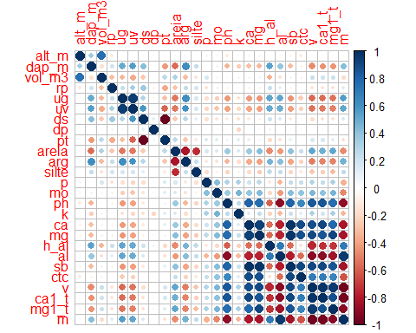

#> [1] "======== Análise de Agrupamento Hierárquico ========== "

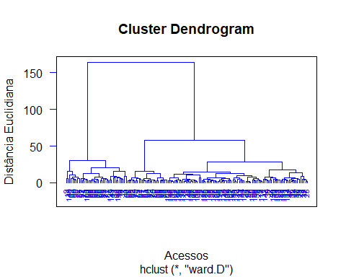

#> [1] "======== Análise de Componentes Principais ========== "  
#> [1] "==== Autovalores ===="  
#> [1] 11.315 3.333 1.817 1.687 1.403 1.196 1.021 0.848 0.718 0.660  
#> [11] 0.539 0.405 0.359 0.270 0.181 0.099 0.083 0.057 0.005 0.003  
#> [21] 0.002 0.000 0.000 0.000 0.000 0.000  
#> [1] "==== % da variância explicada ===="  
#> [1] 0.4352 0.1282 0.0699 0.0649 0.0540 0.0460 0.0393 0.0326 0.0276 0.0254  
#> [11] 0.0207 0.0156 0.0138 0.0104 0.0070 0.0038 0.0032 0.0022 0.0002 0.0001  
#> [21] 0.0001 0.0000 0.0000 0.0000 0.0000 0.0000  
#> [1] "==== % da variância explicada acumulada ===="  
#> [1] 43.52 56.34 63.33 69.82 75.21 79.81 83.74 87.00 89.76 92.30  
#> [11] 94.37 95.93 97.31 98.35 99.05 99.43 99.75 99.97 99.98 99.99  
#> [21] 100.00 100.00 100.00 100.00 100.00 100.00  
#> [1] "==== Poder Discriminante ===="

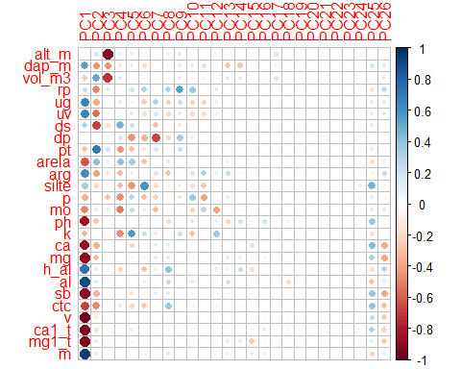

#> [1] "==== screeplot ===="

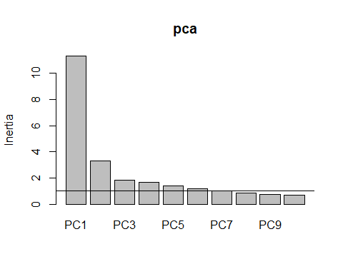

#> [1] "==== Gráfico Biplot ===="

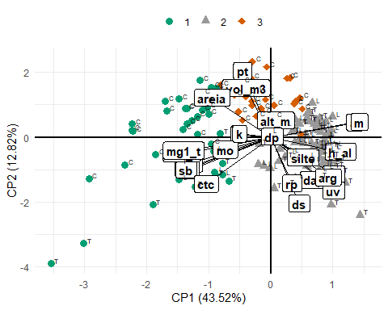

#> [1] "==== Tabela da correlação dos atributos com cada PC ===="  
#> PC1 PC2 PC3 PC4 PC5  
#> dp 0.01602118 0.006013995 0.073612939 0.187062474 -0.45094551  
#> alt_m 0.05173745 0.174624173 -0.926335447 0.105782896 -0.11638133  
#> rp 0.22814341 -0.480293641 0.137602146 0.035124290 0.19197877  
#> vol_m3 -0.26268559 0.513117270 -0.723979871 0.154220369 -0.04900473  
#> pt -0.29844674 0.692327613 0.180193643 -0.441607971 -0.31057829  
#> ds 0.30250174 -0.689745038 -0.166345121 0.474733252 0.22853945  
#> k -0.33151703 0.037797167 -0.045449340 -0.476211411 0.56806632  
#> silte 0.34346331 -0.211853801 -0.026156192 -0.326479374 -0.44854529  
#> p -0.34629805 0.032497210 -0.280075373 -0.461448133 0.28496756  
#> mo -0.48210366 -0.128904889 -0.125145366 -0.521909489 0.23475732  
#> dap_m 0.54897491 -0.441721380 -0.443889755 -0.134054615 -0.12155813  
#> arg 0.61137698 -0.417921417 -0.143154911 -0.310568562 -0.12198439  
#> areia -0.62269794 0.412130816 0.113785464 0.406011877 0.34847478  
#> uv 0.66770333 -0.555344593 -0.065151739 0.074827797 0.14962178  
#> ug 0.66966610 -0.384842378 -0.022481199 -0.124055431 0.09069219  
#> ctc -0.68759326 -0.486808629 0.038098765 -0.126722054 -0.22095059  
#> h_al 0.73995715 -0.150653878 0.067534217 -0.217028495 -0.07454789  
#> ph -0.84109072 -0.273234983 0.015645929 -0.034746740 -0.02134114  
#> ca -0.87045573 -0.347126449 0.009003874 0.010786198 -0.22249238  
#> mg -0.89019112 -0.322263373 -0.004844781 -0.002420033 -0.08555830  
#> al 0.89606415 0.155997511 0.058566053 0.021416333 -0.02163999  
#> sb -0.89690471 -0.339021253 0.002072959 -0.010229824 -0.15116628  
#> mg1_t -0.92634869 -0.137677333 -0.055841192 0.036394685 0.07053738  
#> m 0.94187191 0.159274027 0.057324692 0.024872903 -0.02161693  
#> ca1_t -0.94647917 -0.168586731 -0.024203109 0.087510169 -0.12447909  
#> v -0.97295198 -0.149025840 -0.041259369 0.044101470 -0.01419628  
#> PC6 PC7  
#> dp -0.34419001 -0.671880244  
#> alt_m 0.04212867 0.073957612  
#> rp 0.32481585 -0.036216940  
#> vol_m3 0.07368664 0.048276821  
#> pt -0.13138593 0.178496157  
#> ds 0.07152481 -0.295926197  
#> k 0.22225052 -0.121043490  
#> silte 0.59278494 -0.200687910  
#> p -0.31720557 -0.241752390  
#> mo -0.11027146 -0.311613141  
#> dap_m -0.19371606 0.003049835  
#> arg -0.06389173 0.168440894  
#> areia -0.30588199 0.002693495  
#> uv -0.17513607 0.170116943  
#> ug -0.24161569 0.314925090  
#> ctc -0.25425069 0.096830774  
#> h_al -0.30797359 -0.098369418  
#> ph 0.04827912 0.048464599  
#> ca -0.07758415 0.130079032  
#> mg -0.09170462 0.121434331  
#> al -0.09947090 0.031692601  
#> sb -0.07645469 0.123746638  
#> mg1_t 0.03015463 0.020780769  
#> m -0.07180253 0.063954079  
#> ca1_t 0.05336044 0.011053040  
#> v 0.06206246 0.008643521