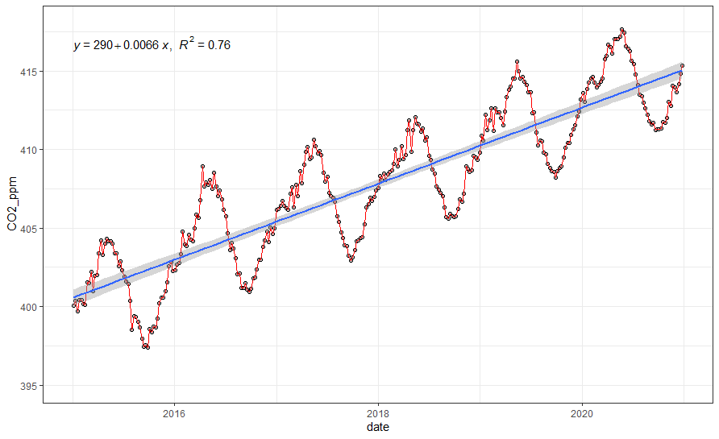

year

CO2\_ppm = 290 + 14.454 years

β20 = 1.61

β19 = 1.20

β18 = 1.57

β17 = 0.84

β16 = 1.10

β15 = 2.01

NOOA

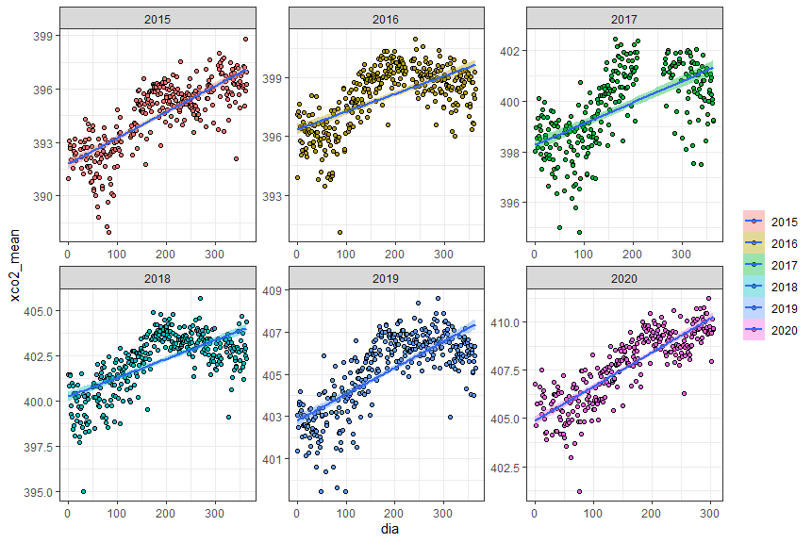

day

β = 5.33

β = 3.78

β = 4.56

β = 6.46

β = 3.04

β = 3.31

|  |  |
| --- | --- |
| 2015 | |
| Beta | Anomaly |
| histograma_beta_2015 | histograma_anomaly_2015 |
| variograma_anomalia_2015 | C:\Users\Usuario\AppData\Local\Microsoft\Windows\INetCache\Content.Word\variograma_beta_2015.png |
| C:\GitHub\regressaolinear202107\imagens\krigagem_beta_2015.png | C:\GitHub\regressaolinear202107\imagens\krigagem_anomalia_2015.png |

|  |  |
| --- | --- |
| 2016 | |
| Beta | Anomaly |
| C:\Users\Usuario\AppData\Local\Microsoft\Windows\INetCache\Content.Word\histograma_beta_2016.png | C:\Users\Usuario\AppData\Local\Microsoft\Windows\INetCache\Content.Word\histograma_anomaly_2016.png |
| C:\GitHub\regressaolinear202107\imagens\variograma_beta_2016.png |  |
| C:\GitHub\regressaolinear202107\imagens\krigagem_beta_2016.png | C:\GitHub\regressaolinear202107\imagens\krigagem_anomalia_2016.png |

|  |  |
| --- | --- |
| 2017 | |
| Beta | Anomaly |
| C:\GitHub\regressaolinear202107\imagens\histograma_beta_2017.png | C:\GitHub\regressaolinear202107\imagens\histograma_anomaly_2017.png |
| C:\GitHub\regressaolinear202107\imagens\variograma_beta_2017.png | C:\GitHub\regressaolinear202107\imagens\variograma_anomalia_2017.png |
| C:\GitHub\regressaolinear202107\imagens\krigagem_beta_2017.png | C:\GitHub\regressaolinear202107\imagens\krigagem_anomalia_2017.png |

|  |  |
| --- | --- |
| 2018 | |
| Beta | Anomaly |
| C:\GitHub\regressaolinear202107\imagens\histograma_beta_2018.png | C:\GitHub\regressaolinear202107\imagens\histograma_anomaly_2018.png |
| C:\GitHub\regressaolinear202107\imagens\variograma_beta_2018.png | C:\GitHub\regressaolinear202107\imagens\variograma_anomalia_2018.png |
| C:\GitHub\regressaolinear202107\imagens\krigagem_beta_2018.png | C:\GitHub\regressaolinear202107\imagens\krigagem_anomalia_2018.png |

|  |  |
| --- | --- |
| 2019 | |
| Beta (MULTIPLICAR POR 365)  MODELO e parâmetros do SEMIVARIOGRAMA | Anomaly |
| C:\GitHub\regressaolinear202107\imagens\histograma_beta_2019.png | C:\GitHub\regressaolinear202107\imagens\histograma_anomaly_2019.png |
| C:\GitHub\regressaolinear202107\imagens\variograma_beta_2019.png | C:\GitHub\regressaolinear202107\imagens\variograma_anomalia_2019.png |
| C:\GitHub\regressaolinear202107\imagens\krigagem_beta_2019.png | C:\GitHub\regressaolinear202107\imagens\krigagem_anomalia_2019.png |

|  |  |
| --- | --- |
| 2020 | |
| Beta | Anomaly |
| C:\GitHub\regressaolinear202107\imagens\histograma_beta_2020.png | C:\GitHub\regressaolinear202107\imagens\histograma_anomaly_2020.png |
| C:\GitHub\regressaolinear202107\imagens\variograma_beta_2020.png | C:\GitHub\regressaolinear202107\imagens\variograma_anomalia_2020.png |
| C:\GitHub\regressaolinear202107\imagens\krigagem_beta_2020.png | C:\GitHub\regressaolinear202107\imagens\krigagem_anomalia_2020.png |