# TCC Neucy - Dados Climáticos

## Carregando pacotes

library(tidyverse)  
library(trend)  
library(ggpubr)  
library(corrplot)  
library(vegan)

## Carregando dados

dados_climatico <- read_rds("data/dados-climaticos.rds")  
glimpse(dados_climatico)  
#> Rows: 1,974  
#> Columns: 10  
#> $ data <dttm> 2020-01-01, 2020-01-02, 2020-01-03, 2020-01-04, 2020-…  
#> $ ano <dbl> 2020, 2020, 2020, 2020, 2020, 2020, 2020, 2020, 2020, …  
#> $ mes <dbl> 1, 1, 1, 1, 1, 1, 1, 1, 1, 1, 1, 1, 1, 1, 1, 1, 1, 1, …  
#> $ dia <int> 1, 2, 3, 4, 5, 6, 7, 8, 9, 10, 11, 12, 13, 14, 15, 16,…  
#> $ dia_juliano <dbl> 1, 2, 3, 4, 5, 6, 7, 8, 9, 10, 11, 12, 13, 14, 15, 16,…  
#> $ temp_max <dbl> 31.7, 29.3, 27.9, 25.1, 29.6, 28.9, 30.8, 26.5, 28.3, …  
#> $ temp_min <dbl> 21.8, 22.6, 22.7, 22.7, 22.6, 22.7, 21.2, 22.5, 22.1, …  
#> $ temp_media <dbl> 25.6, 25.1, 24.0, 23.5, 24.9, 24.8, 25.0, 23.8, 24.8, …  
#> $ precipitacao <dbl> 0.2, 1.2, 8.0, 7.6, 0.0, 5.4, 10.6, 34.2, 0.2, 11.2, 0…  
#> $ preci_acumulada <dbl> 0.2, 1.4, 9.4, 17.0, 17.0, 22.4, 33.0, 67.2, 67.4, 78.…

## Gráfico

plot_climograma <- dados_climatico |>   
 select(data, temp_max, temp_min, temp_media, precipitacao) |>   
 pivot_longer(cols = temp_max:temp_media,  
 names_to = "variavel",  
 values_to = "valores") |>   
 mutate(  
 variavel = case_when(  
 variavel == "temp_max" ~ "Maxima",  
 variavel == "temp_media" ~ "Media",  
 variavel == "temp_min" ~ "Minima"  
 )  
 ) |>   
 ggplot(aes(x = data)) +  
 # barras de precipitação (em escala secundária)  
 geom_line(aes(y = valores, color = variavel), size = .25) +  
 geom_col(aes(y = precipitacao * 0.2), # ajuste o fator (0.2) conforme a escala  
 fill = "skyblue4") +  
 # linhas de temperatura  
 theme_bw() +  
 scale_color_manual(values = c("gray", "black", "darkgray")) +  
 scale_y_continuous(  
 name = "Temperatura (oC)",  
 limits = c(0, 40),   
 sec.axis = sec_axis(~./0.3, name = "Precipitacao (mm)") # inverso do fator usado  
 ) +  
 labs(  
 color = "",  
 x = "Data"  
 ) +  
 theme(  
 legend.position = "top"  
 )   
print(plot_climograma)

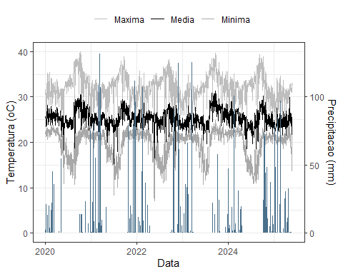

## Estatísticas descritivas gerais

resumo_geral <- dados_climatico |>  
 summarise(  
 temp_min_media = mean(temp_min, na.rm = TRUE),  
 temp_med_media = mean(temp_media, na.rm = TRUE),  
 temp_max_media = mean(temp_max, na.rm = TRUE),  
 prec_media = mean(precipitacao, na.rm = TRUE),  
 temp_min_sd = sd(temp_min, na.rm = TRUE),  
 temp_med_sd = sd(temp_media, na.rm = TRUE),  
 temp_max_sd = sd(temp_max, na.rm = TRUE),  
 prec_sd = sd(precipitacao, na.rm = TRUE),  
 n_dias = n()  
 )  
resumo_geral  
#> # A tibble: 1 × 9  
#> temp_min_media temp_med_media temp_max_media prec_media temp_min_sd  
#> <dbl> <dbl> <dbl> <dbl> <dbl>  
#> 1 19.8 25.2 32.1 5.33 3.03  
#> # ℹ 4 more variables: temp_med_sd <dbl>, temp_max_sd <dbl>, prec_sd <dbl>,  
#> # n_dias <int>

## Estatísticas mensais

resumo_mensal <- dados_climatico |>  
 group_by(ano, mes) |>  
 summarise(  
 temp_min = mean(temp_min, na.rm = TRUE),  
 temp_med = mean(temp_media, na.rm = TRUE),  
 temp_max = mean(temp_max, na.rm = TRUE),  
 prec_total = sum(precipitacao, na.rm = TRUE),  
 .groups = "drop"  
 )  
resumo_mensal  
#> # A tibble: 65 × 6  
#> ano mes temp_min temp_med temp_max prec_total  
#> <dbl> <dbl> <dbl> <dbl> <dbl> <dbl>  
#> 1 2020 1 22.2 25.6 31.2 376.   
#> 2 2020 2 22.5 25.7 31.1 360.   
#> 3 2020 3 22.5 26.0 31.3 171.   
#> 4 2020 4 21.6 25.7 30.9 103.   
#> 5 2020 5 17.9 23.5 29.9 71.4  
#> 6 2020 6 17.4 24.6 32.6 0   
#> 7 2020 7 15.6 24.4 33.4 0   
#> 8 2020 8 16.1 25.5 34.7 0   
#> 9 2020 9 19.4 28.1 37.0 0   
#> 10 2020 10 21.8 27.3 34.8 86.8  
#> # ℹ 55 more rows

## Gráficos de tendência temporal

### Temperatura média diária

dados_climatico |>  
 ggplot(aes(x = data, y = temp_media)) +  
 geom_line(color = "darkred", alpha = 0.6) +  
 geom_smooth(method = "loess", se = FALSE, color = "black") +  
 labs(title = "Temperatura media diaria", x = "Data", y = "oC") +  
 theme_minimal()

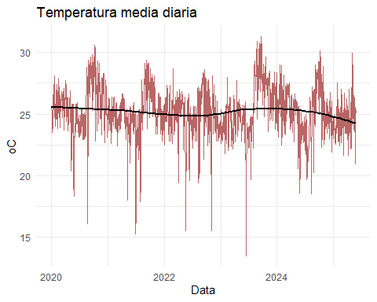

## Precipitação diária

dados_climatico |>  
 ggplot(aes(x = data, y = precipitacao)) +  
 geom_col(fill = "steelblue4") +  
 labs(title = "Precipitacao diaria", x = "Data", y = "mm") +  
 theme_minimal() +  
 facet_wrap(~ano,scale="free") +  
 theme(  
 axis.text.x = element_text(angle = 45)  
 )

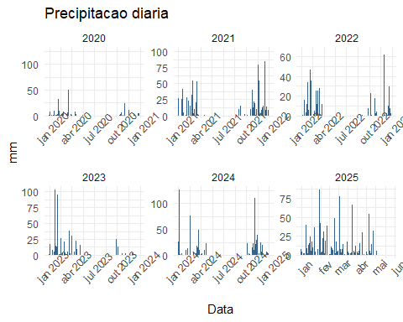

## Boxplots mensais (sazonalidade)

dados_climatico |>  
 ggplot(aes(x = as_factor(mes), y = temp_media)) +  
 geom_boxplot(fill = "orange4", alpha = 0.7) +  
 labs(title = "Distribuicao mensal da temperatura media",  
 x = "Mes", y = "oC") +  
 theme_minimal()

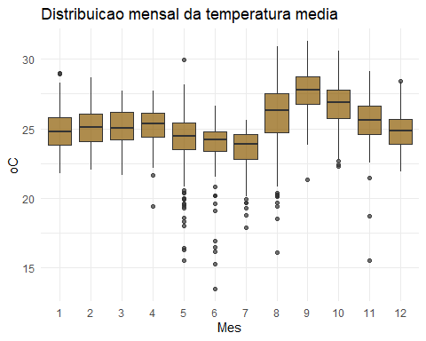

dados_climatico |>  
 ggplot(aes(x = as_factor(mes), y = precipitacao)) +  
 geom_boxplot(fill = "skyblue3", alpha = 0.7) +  
 labs(title = "Distribuicao mensal da precipitacao diaria",  
 x = "Mes", y = "mm") +  
 theme_minimal()

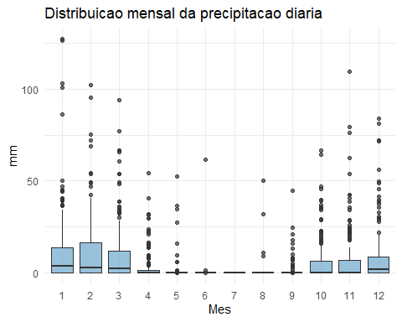

## Correlação entre variáveis

cor_matriz <- dados_climatico %>%  
 select(temp_min, temp_media, temp_max, precipitacao) %>%  
 cor(use = "pairwise.complete.obs")  
  
corrplot(cor_matriz, method = "color", addCoef.col = "grey6")

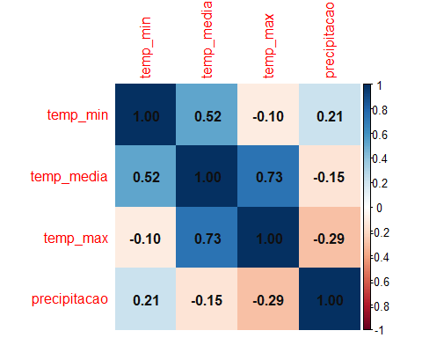

## Análises de extremos

# Dias de chuva  
dias_chuva <- sum(dados_climatico$precipitacao > 1, na.rm = TRUE)  
  
# Dias secos consecutivos  
dias_secos <- rle(dados_climatico$precipitacao == 0)$lengths  
max_dias_secos <- max(dias_secos)  
  
# Ondas de calor (dias com T > p90)  
limite_calor <- quantile(dados_climatico$temp_max, 0.9, na.rm = TRUE)  
ondas_calor <- sum(dados_climatico$temp_max > limite_calor, na.rm = TRUE)  
dias_chuva  
#> [1] 609  
max_dias_secos  
#> [1] 141  
ondas_calor  
#> [1] 198

# Gráfico tipo climograma  
climograma <- resumo_mensal %>%  
 ggplot(aes(x = mes)) +  
 geom_col(aes(y = prec_total), fill = "steelblue4", alpha = 0.6) +  
 geom_line(aes(y = temp_med * 50, group = 1), color = "red", size = 1.1) +  
 scale_y_continuous(  
 name = "Precipitacao (mm)",  
 sec.axis = sec_axis(~./50, name = "Temperatura media (oC)")  
 ) +  
 labs(title = "Climograma - Precipitacao e Temperatura Media Mensal") +  
 theme_minimal()  
  
print(climograma)

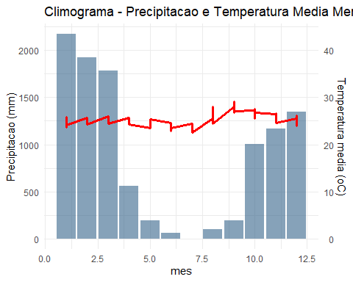

## Tendência temporal (Mann-Kendall)

teste_temp <- mk.test(dados_climatico$temp_media)  
print(teste_temp)  
#>   
#> Mann-Kendall trend test  
#>   
#> data: dados_climatico$temp_media  
#> z = -4.1334, n = 1974, p-value = 3.575e-05  
#> alternative hypothesis: true S is not equal to 0  
#> sample estimates:  
#> S varS tau   
#> -1.208800e+05 8.552482e+08 -6.225825e-02

ggplot(dados_climatico, aes(x = data, y = temp_media)) +  
 geom_line(alpha = 0.6, color = "red4") +  
 geom_smooth(method = "lm", se = TRUE, color = "black") +  
 labs(title = "Tendencia temporal da temperatura media (2020–2025)",  
 x = "Data", y = "Temperatura media (oC)") +  
 theme_minimal()

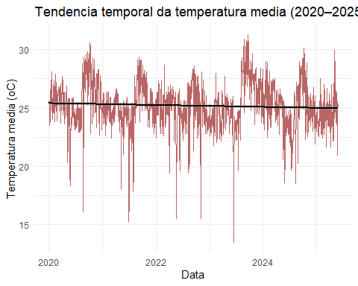

# TCC Neucy - Dados Fenotípicos

## Carregando dados

dados_fenotipicos <- read_rds("data/dados-tcc-neucy.rds")  
skimr::skim(dados_fenotipicos)

Data summary

|  |  |
| --- | --- |
| Name | dados_fenotipicos |
| Number of rows | 3396 |
| Number of columns | 17 |
| _______________________ |  |
| Column type frequency: |  |
| character | 5 |
| factor | 1 |
| numeric | 8 |
| POSIXct | 3 |
| ________________________ |  |
| Group variables | None |

**Variable type: character**

| skim_variable | n_missing | complete_rate | min | max | empty | n_unique | whitespace |
| --- | --- | --- | --- | --- | --- | --- | --- |
| safra | 0 | 1.00 | 9 | 9 | 0 | 5 | 0 |
| cultivar | 0 | 1.00 | 6 | 22 | 0 | 212 | 0 |
| marca | 0 | 1.00 | 3 | 17 | 0 | 28 | 0 |
| g_m_r | 0 | 1.00 | 3 | 3 | 0 | 22 | 0 |
| biotec | 76 | 0.98 | 1 | 4 | 0 | 7 | 0 |

**Variable type: factor**

| skim_variable | n_missing | complete_rate | ordered | n_unique | top_counts |
| --- | --- | --- | --- | --- | --- |
| epoca | 0 | 1 | FALSE | 4 | 2: 1096, 3: 1068, 4: 644, 1: 588 |

**Variable type: numeric**

| skim_variable | n_missing | complete_rate | mean | sd | p0 | p25 | p50 | p75 | p100 | hist |
| --- | --- | --- | --- | --- | --- | --- | --- | --- | --- | --- |
| no | 0 | 1 | 1698.50 | 980.49 | 1.0 | 849.75 | 1698.50 | 2547.25 | 3396.0 | ▇▇▇▇▇ |
| rep | 0 | 1 | 3.60 | 5.99 | 1.0 | 2.00 | 3.00 | 4.00 | 51.0 | ▇▁▁▁▁ |
| ap | 0 | 1 | 81.21 | 14.28 | 32.5 | 71.95 | 81.30 | 91.00 | 131.7 | ▁▃▇▃▁ |
| aiv | 0 | 1 | 15.75 | 3.80 | 6.5 | 13.00 | 15.30 | 18.00 | 37.3 | ▃▇▂▁▁ |
| pop | 0 | 1 | 250874.17 | 75535.71 | 47500.0 | 200000.00 | 245000.00 | 297500.00 | 535000.0 | ▂▇▇▂▁ |
| mmg | 0 | 1 | 170.02 | 21.65 | 109.3 | 154.50 | 170.40 | 183.90 | 251.9 | ▁▆▇▂▁ |
| kg | 0 | 1 | 4485.99 | 833.68 | 2190.6 | 3837.80 | 4527.95 | 5111.58 | 6899.0 | ▁▆▇▆▁ |
| sc | 0 | 1 | 74.77 | 13.89 | 36.5 | 64.00 | 75.50 | 85.20 | 115.0 | ▁▆▇▆▁ |

**Variable type: POSIXct**

| skim_variable | n_missing | complete_rate | min | max | median | n_unique |
| --- | --- | --- | --- | --- | --- | --- |
| data_sem | 0 | 1 | 2020-10-13 | 2024-10-31 | 2023-10-23 | 16 |
| data_floresc | 0 | 1 | 2020-11-12 | 2024-12-16 | 2023-11-26 | 183 |
| data_ciclo | 0 | 1 | 2021-01-25 | 2025-03-03 | 2024-02-01 | 189 |

## Função para criar chuva acumulada e média de temperatura

get_climate_features <- function(data_ref,   
 janela = 15,  
 df_ref,  
 feature = "chuva_acumulada"){  
 data_ref = lubridate::as_date(data_ref)   
 data_l = lubridate::as_date(data_ref) - days(janela)  
 df_aux = df_ref |>   
 filter(data >= data_l & data <= data_ref)  
   
 sum_prec = sum(df_aux$precipitacao)  
 dias_chuva = sum(df_aux$precipitacao>=1)  
 dias_secos = sum(df_aux$precipitacao == 0)  
 seco = df_aux$precipitacao < 1  
 rle_seco = rle(seco)  
 max_dry = ifelse(any(rle_seco$values), max(rle_seco$lengths[rle_seco$values]), 0)  
 temp_media = mean(df_aux$temp_media)   
 if(feature == "chuva_acumulada" ) return(sum_prec)  
 if(feature == "dias_chuva" ) return(dias_chuva)  
 if(feature == "dias_secos" ) return(dias_secos)  
 if(feature == "max_dias_secos" ) return(max_dry)  
 if(feature == "temp_media" ) return(temp_media)  
}  
get_climate_features(lubridate::as_date("2020-11-18"),15,dados_climatico,"chuva_acumulada")  
#> [1] 29.6  
get_climate_features(lubridate::as_date("2020-11-18"),30,dados_climatico,"chuva_acumulada")  
#> [1] 95

# dados <- dados_fenotipicos |>   
# # slice(1:10) |>   
# rowwise() |>  
# mutate(  
# duracao_floresc = as.numeric(data_floresc - data_sem),  
# duracao_ciclo = as.numeric(data_ciclo - data_sem),  
# chuva_total_floresc = get_climate_features(data_floresc,duracao_floresc,  
# dados_climatico,"chuva_acumulada"),  
# chuva_total_ciclo = get_climate_features(data_ciclo,duracao_ciclo,  
# dados_climatico,"chuva_acumulada"),  
# chuva_15d_sem = get_climate_features(data_sem,15,dados_climatico,"chuva_acumulada"),  
# chuva_30d_sem = get_climate_features(data_sem,45,dados_climatico,"chuva_acumulada"),  
# chuva_15d_floresc = get_climate_features(data_floresc,janela = 15,df_ref = dados_climatico,"chuva_acumulada"),  
# chuva_30d_floresc = get_climate_features(data_floresc,45,dados_climatico,"chuva_acumulada"),  
# dias_chuva_30d = get_climate_features(data_ciclo,30,  
# dados_climatico,"dias_chuva"),  
# dias_secos_30d = get_climate_features(data_ciclo,30,  
# dados_climatico,"dias_secos"),  
# max_dias_secos_30d = get_climate_features(data_ciclo,30,  
# dados_climatico,"max_dias_secos"),  
# temp_media_15d_sem = get_climate_features(data_sem,15,  
# dados_climatico,"temp_media"),  
# temp_media_30d_sem = get_climate_features(data_sem,30,  
# dados_climatico,"temp_media"),  
# temp_media_15d_floresc = get_climate_features(data_floresc,15,  
# dados_climatico,"temp_media"),  
# temp_media_30d_floresc = get_climate_features(data_floresc,30,  
# dados_climatico,"temp_media"),  
# temp_media_floresc = get_climate_features(data_floresc,duracao_floresc,  
# dados_climatico,"temp_media"),  
# temp_media_ciclo = get_climate_features(data_floresc,duracao_ciclo,  
# dados_climatico,"temp_media"),  
# )   
# write_rds(dados,"data/dados-agregados.rds")

# DADOS AGREGADOS

dados <- read_rds("data/dados-agregados.rds")  
glimpse(dados)   
#> Rows: 3,396  
#> Columns: 34  
#> Rowwise:   
#> $ no <dbl> 1, 2, 3, 4, 5, 6, 7, 8, 9, 10, 11, 12, 13, 14, …  
#> $ safra <chr> "2020/2021", "2020/2021", "2020/2021", "2020/20…  
#> $ epoca <fct> 1, 1, 1, 1, 1, 1, 1, 1, 1, 1, 1, 1, 1, 1, 1, 1,…  
#> $ cultivar <chr> "HO Cristalino IPRO", "HO Cristalino IPRO", "HO…  
#> $ marca <chr> "HO Genética", "HO Genética", "HO Genética", "H…  
#> $ g_m_r <chr> "8.3", "8.3", "8.3", "8.3", "8.3", "8.3", "8.3"…  
#> $ biotec <chr> "IPRO", "IPRO", "IPRO", "IPRO", "IPRO", "IPRO",…  
#> $ rep <dbl> 1, 2, 3, 4, 1, 2, 3, 4, 1, 2, 3, 4, 1, 2, 3, 4,…  
#> $ data_sem <dttm> 2020-10-13, 2020-10-13, 2020-10-13, 2020-10-13…  
#> $ data_floresc <dttm> 2020-11-27, 2020-11-27, 2020-11-27, 2020-11-27…  
#> $ data_ciclo <dttm> 2021-02-20, 2021-02-20, 2021-02-20, 2021-02-20…  
#> $ ap <dbl> 69.0, 71.5, 66.5, 73.5, 59.0, 54.5, 52.0, 60.5,…  
#> $ aiv <dbl> 14.0, 14.5, 16.0, 15.5, 13.5, 13.0, 16.0, 14.5,…  
#> $ pop <dbl> 180000, 180000, 160000, 160000, 210000, 230000,…  
#> $ mmg <dbl> 152.1, 159.3, 163.8, 151.6, 178.4, 171.2, 168.5…  
#> $ kg <dbl> 3966.7, 4192.1, 3678.0, 4274.1, 3823.6, 4423.0,…  
#> $ sc <dbl> 66.1, 69.9, 61.3, 71.2, 63.7, 73.7, 72.0, 64.8,…  
#> $ duracao_floresc <dbl> 45, 45, 45, 45, 43, 43, 43, 43, 36, 34, 34, 36,…  
#> $ duracao_ciclo <dbl> 130, 130, 130, 130, 119, 119, 119, 123, 130, 13…  
#> $ chuva_total_floresc <dbl> 133.8, 133.8, 133.8, 133.8, 121.4, 121.4, 121.4…  
#> $ chuva_total_ciclo <dbl> 882.4, 882.4, 882.4, 882.4, 781.8, 781.8, 781.8…  
#> $ chuva_15d_sem <dbl> 34.6, 34.6, 34.6, 34.6, 34.6, 34.6, 34.6, 34.6,…  
#> $ chuva_30d_sem <dbl> 34.6, 34.6, 34.6, 34.6, 34.6, 34.6, 34.6, 34.6,…  
#> $ chuva_15d_floresc <dbl> 47.2, 47.2, 47.2, 47.2, 34.8, 34.8, 34.8, 34.8,…  
#> $ chuva_30d_floresc <dbl> 133.8, 133.8, 133.8, 133.8, 122.0, 122.0, 122.0…  
#> $ dias_chuva_30d <int> 19, 19, 19, 19, 19, 19, 19, 20, 19, 19, 19, 19,…  
#> $ dias_secos_30d <int> 10, 10, 10, 10, 11, 11, 11, 9, 10, 10, 10, 10, …  
#> $ max_dias_secos_30d <int> 4, 4, 4, 4, 3, 3, 3, 4, 4, 4, 4, 4, 3, 4, 3, 3,…  
#> $ temp_media_15d_sem <dbl> 28.55625, 28.55625, 28.55625, 28.55625, 28.5562…  
#> $ temp_media_30d_sem <dbl> 28.25806, 28.25806, 28.25806, 28.25806, 28.2580…  
#> $ temp_media_15d_floresc <dbl> 26.05625, 26.05625, 26.05625, 26.05625, 26.1062…  
#> $ temp_media_30d_floresc <dbl> 26.33548, 26.33548, 26.33548, 26.33548, 26.5193…  
#> $ temp_media_floresc <dbl> 26.48696, 26.48696, 26.48696, 26.48696, 26.5159…  
#> $ temp_media_ciclo <dbl> 26.60000, 26.60000, 26.60000, 26.60000, 26.7983…

## Análise de grupamento

safras <- unique(dados$safra)  
epocas <- unique(dados$epoca)  
for(i in seq_along(safras)){  
 # for(j in seq_along(epocas)){  
 df_aux <- dados |>   
 filter(  
 safra == safras[i],  
 # epoca == epocas[j]  
 ) |>   
 group_by(cultivar,epoca) |>   
 summarise(across(.cols = ap:temp_media_ciclo,  
 .fns = mean,  
 .names = "{.col}"   
   
 )) |> ungroup()  
 dados_aux <- df_aux |> select(-cultivar,-epoca,-duracao_floresc,  
 -duracao_ciclo)  
 cultivar <- df_aux$cultivar  
 if(nrow(dados_aux) > 10){  
 mc <- cor(dados_aux)  
 fc <- !is.na(mc[1,])  
 fl <- !is.na(mc[,1])  
 mc <- mc[fc,fl]  
 print("=================================================================")  
 print(paste0("ANALISE PARA SAFRA: ",safras[i]))#,"; EPOCA: ",epocas[j]))  
 print("=================================================================")  
   
 corrplot(mc[1:6,-(1:6)],method = "color",  
 outline = TRUE,  
 addgrid.col = "darkgray",cl.pos = "r", tl.col = "black",  
 tl.cex = 1, cl.cex = 1, bg="azure2",  
 # diag = FALSE,  
 addCoef.col = "black",  
 cl.ratio = 0.2,  
 cl.length = 5,  
 number.cex = 0.8  
 )   
 nomes <- colnames(mc)  
 da_pad<-decostand(dados_aux |>   
 select(nomes),   
 method = "standardize",  
 na.rm=TRUE)  
 da_pad_euc<-vegdist(da_pad,"euclidean")   
 da_pad_euc_ward<-hclust(da_pad_euc, method="ward.D")  
 da_pad_euc_ward$labels <- cultivar  
 grupo<-cutree(da_pad_euc_ward,2)  
 d <- da_pad_euc_ward$height  
 d_corte <- d[which(d |> diff() == max(diff(d)))]  
 plot(da_pad_euc_ward,   
 ylab="Distância Euclidiana",  
 xlab="Acessos", hang=-1,  
 col="blue", las=1,  
 cex=.6,lwd=1.5);box();abline(h=d_corte*1.15)  
   
 print("======== Análise de Componentes Principais ========== ")  
 pca <- prcomp(da_pad,scale.=TRUE)  
 # Autovalores  
 eig<-pca$sdev^2  
 print("==== Autovalores ====")  
 print(round(eig,3))  
 print("==== % da variância explicada ====")  
 ve<-eig/sum(eig)  
 print(round(ve,4))  
 print("==== % da variância explicada acumulada ====")  
 print(round(cumsum(ve),4)*100)  
 print("==== Poder Discriminante ====")  
 mcor<-cor(da_pad,pca$x)  
 corrplot(mcor)  
 print("==== screeplot ====")  
 # screeplot(pca);abline(h=1)  
   
 pc1V<-cor(da_pad,pca$x)[,1]/sd(cor(da_pad,pca$x)[,1])  
 pc2V<-cor(da_pad,pca$x)[,2]/sd(cor(da_pad,pca$x)[,2])  
 pc3V<-cor(da_pad,pca$x)[,3]/sd(cor(da_pad,pca$x)[,3])  
 pc1c<-pca$x[,1]/sd(pca$x[,1])  
 pc2c<-pca$x[,2]/sd(pca$x[,2])  
 pc3c<-pca$x[,3]/sd(pca$x[,3])  
 nv<-ncol(mc) # número de variáveis utilizadas na análise  
   
 # gráfico biplot  
 bip<-data.frame(pc1c,pc2c,pc3c,grupo)  
 texto <- data.frame(  
 x = pc1V,  
 y = pc2V,  
 z = pc3V,  
 label = rownames(mc)  
 )  
 cat("[Grupo 1]:", paste(cultivar[grupo==1],collapse = "\n"))  
 cat("\n\n")  
 cat("[Grupo 2]:", paste(cultivar[grupo==2],collapse = "\n"))  
 cat("\n\n")  
 # cat("[Grupo 3]:", paste(cultivar[grupo==3],collapse = "\n"))  
 # cat("\n\n")  
  
 bi_plot <- bip |>   
 ggplot(aes(x=pc1c,y=pc2c,colour = as_factor(grupo))) +  
 geom_point(size = 3) +  
 theme_minimal() +  
 # scale_shape_manual(values=16:18)+  
 scale_color_manual(values=c("#009E73", "#D55E00")) + #"#999999",  
 # annotate(geom="text", x=pc1c, y=pc2c, label=cultivar,  
 # color="black",size=.25)+  
 geom_vline(aes(xintercept=0),  
 color="black", size=1)+  
 geom_hline(aes(yintercept=0),  
 color="black", size=1)+  
 annotate(geom="segment",  
 x=rep(0,nv),  
 xend=texto$x,  
 y=rep(0,nv),  
 yend=texto$y,color="black",lwd=.5)+  
 geom_label(data=texto,aes(x=x,y=y,label=label),  
 color="black",angle=0,fontface="bold",size=4,fill="white")+  
 labs(x=paste("CP1 (",round(100*ve[1],2),"%)",sep=""),  
 y=paste("CP2 (",round(100*ve[2],2),"%)",sep=""),  
 color="",shape="")+  
 theme(legend.position = "top")  
 print(bi_plot)  
   
 print("==== Tabela da correlação dos atributos com cada PC ====")  
 ck<-sum(pca$sdev^2>=0.98)  
 tabelapca<-vector()  
 for( l in 1:ck) tabelapca<-cbind(tabelapca,mcor[,l])  
 colnames(tabelapca)<-paste(rep(c("PC"),ck),1:ck,sep="")  
 pcat<-round(tabelapca,3)  
 tabelapca<-tabelapca[order(abs(tabelapca[,1])),]  
 print(tabelapca)  
 }  
 # }  
}  
#> [1] "================================================================="  
#> [1] "ANALISE PARA SAFRA: 2020/2021"  
#> [1] "================================================================="

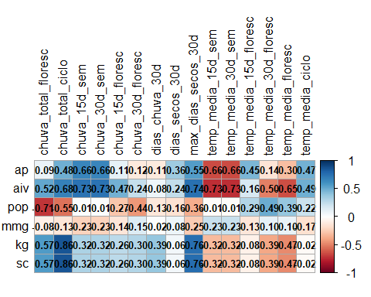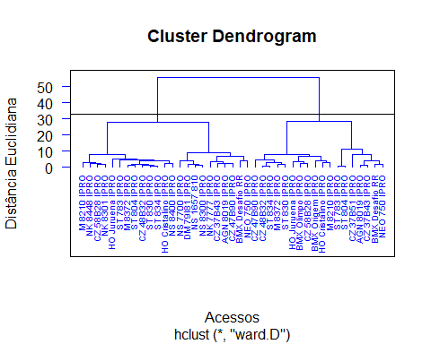

#> [1] "======== Análise de Componentes Principais ========== "  
#> [1] "==== Autovalores ===="  
#> [1] 8.946 4.468 2.688 1.423 1.009 0.531 0.510 0.418 0.261 0.217 0.189 0.149  
#> [13] 0.110 0.056 0.014 0.007 0.005 0.000 0.000 0.000 0.000  
#> [1] "==== % da variância explicada ===="  
#> [1] 0.4260 0.2128 0.1280 0.0678 0.0480 0.0253 0.0243 0.0199 0.0124 0.0103  
#> [11] 0.0090 0.0071 0.0052 0.0027 0.0007 0.0003 0.0002 0.0000 0.0000 0.0000  
#> [21] 0.0000  
#> [1] "==== % da variância explicada acumulada ===="  
#> [1] 42.60 63.88 76.68 83.45 88.26 90.79 93.22 95.21 96.45 97.48  
#> [11] 98.38 99.09 99.61 99.88 99.95 99.98 100.00 100.00 100.00 100.00  
#> [21] 100.00  
#> [1] "==== Poder Discriminante ===="

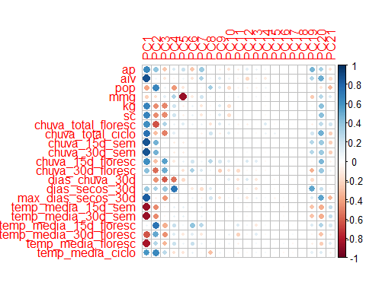

#> [1] "==== screeplot ===="  
#> [Grupo 1]: AGN 8019 IPRO  
#> BMX Desafio RR  
#> BMX Olimpo IPRO  
#> BMX Origem IPRO  
#> CZ 37B43 IPRO  
#> CZ 37B51 IPRO  
#> CZ 47B90 IPRO  
#> CZ 48B32 IPRO  
#> CZ 58B28 IPRO  
#> HO Cristalino IPRO  
#> HO Juruena IPRO  
#> M 8210 IPRO  
#> M 8372 IPRO  
#> NEO 750 IPRO  
#> ST 783 IPRO  
#> ST 804 IPRO  
#> ST 830 IPRO  
#> ST 834 IPRO  
#>   
#> [Grupo 2]: AGN 8019 IPRO  
#> BMX Desafio RR  
#> CZ 37B43 IPRO  
#> CZ 47B90 IPRO  
#> CZ 48B32 IPRO  
#> CZ 58B28 IPRO  
#> DM 79I81 IPRO  
#> HO Cristalino IPRO  
#> HO Juruena IPRO  
#> M 8210 IPRO  
#> M 8372 IPRO  
#> NEO 750 IPRO  
#> NK 7777 IPRO  
#> NK 8301 IPRO  
#> NK 8448 IPRO  
#> NS 1657 810  
#> NS 7700 IPRO  
#> NS 8300 IPRO  
#> NS 8400 IPRO  
#> ST 783 IPRO  
#> ST 804 IPRO  
#> ST 830 IPRO  
#> ST 834 IPRO

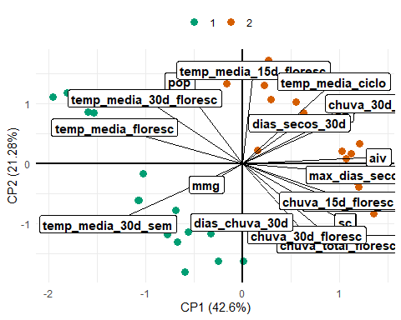

#> [1] "==== Tabela da correlação dos atributos com cada PC ===="  
#> PC1 PC2 PC3 PC4  
#> dias_chuva_30d -0.003262663 -0.45924597 -0.61279410 -0.54014190  
#> temp_media_15d_floresc 0.071191256 0.73807792 -0.35999372 0.22370057  
#> mmg -0.229338602 -0.16324291 0.11760112 0.30324708  
#> dias_secos_30d 0.366342737 0.32116865 0.36386243 0.72297997  
#> pop -0.398947601 0.65085818 0.09333041 -0.43626316  
#> chuva_30d_floresc 0.412443417 -0.56194280 0.49122077 -0.02972249  
#> temp_media_ciclo 0.588357723 0.64625921 0.26709234 -0.15965829  
#> chuva_total_floresc 0.618012467 -0.63426267 0.30212932 0.08177434  
#> chuva_15d_floresc 0.619341107 -0.29222177 0.54994716 -0.11650207  
#> temp_media_30d_floresc -0.626450625 0.51505651 -0.45020561 0.13743234  
#> ap 0.643269549 0.39820348 -0.27166698 0.16588721  
#> kg 0.660285002 -0.46104181 -0.48000503 0.19222671  
#> sc 0.660542388 -0.46117578 -0.47998378 0.19193521  
#> chuva_total_ciclo 0.743315626 -0.30497371 -0.50580730 0.11546556  
#> temp_media_floresc -0.820244966 0.28612238 -0.33700135 0.21827706  
#> max_dias_secos_30d 0.828463906 -0.08470653 -0.43529740 -0.06169801  
#> chuva_15d_sem 0.860116300 0.47537636 0.04789068 -0.10406562  
#> chuva_30d_sem 0.860116300 0.47537636 0.04789068 -0.10406562  
#> temp_media_15d_sem -0.860116300 -0.47537636 -0.04789068 0.10406562  
#> temp_media_30d_sem -0.860116300 -0.47537636 -0.04789068 0.10406562  
#> aiv 0.874150314 0.05332933 -0.12630555 -0.03568441  
#> PC5  
#> dias_chuva_30d -0.197708610  
#> temp_media_15d_floresc 0.044404281  
#> mmg -0.867764521  
#> dias_secos_30d 0.016864942  
#> pop -0.137474881  
#> chuva_30d_floresc -0.155670586  
#> temp_media_ciclo -0.137051095  
#> chuva_total_floresc 0.130875857  
#> chuva_15d_floresc 0.103496115  
#> temp_media_30d_floresc -0.114668954  
#> ap 0.222690805  
#> kg -0.070867100  
#> sc -0.071214867  
#> chuva_total_ciclo -0.022261852  
#> temp_media_floresc 0.077427311  
#> max_dias_secos_30d -0.006670158  
#> chuva_15d_sem -0.102374773  
#> chuva_30d_sem -0.102374773  
#> temp_media_15d_sem 0.102374773  
#> temp_media_30d_sem 0.102374773  
#> aiv 0.060131916  
#> [1] "================================================================="  
#> [1] "ANALISE PARA SAFRA: 2021/2022"  
#> [1] "================================================================="

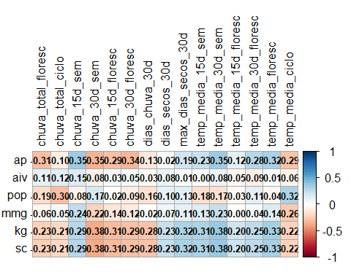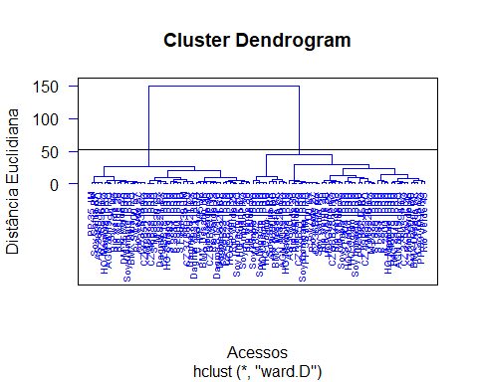

#> [1] "======== Análise de Componentes Principais ========== "  
#> [1] "==== Autovalores ===="  
#> [1] 10.516 2.559 2.251 1.523 1.081 0.802 0.696 0.504 0.359 0.274  
#> [11] 0.220 0.109 0.044 0.033 0.020 0.007 0.001 0.000 0.000 0.000  
#> [21] 0.000  
#> [1] "==== % da variância explicada ===="  
#> [1] 0.5008 0.1219 0.1072 0.0725 0.0515 0.0382 0.0332 0.0240 0.0171 0.0130  
#> [11] 0.0105 0.0052 0.0021 0.0016 0.0010 0.0003 0.0000 0.0000 0.0000 0.0000  
#> [21] 0.0000  
#> [1] "==== % da variância explicada acumulada ===="  
#> [1] 50.08 62.27 72.99 80.24 85.39 89.20 92.52 94.92 96.63 97.93  
#> [11] 98.98 99.50 99.71 99.87 99.96 99.99 100.00 100.00 100.00 100.00  
#> [21] 100.00  
#> [1] "==== Poder Discriminante ===="

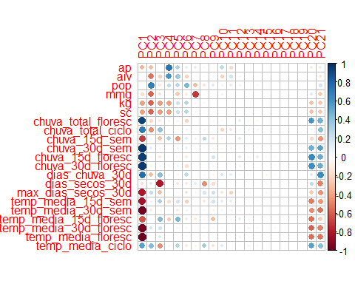

#> [1] "==== screeplot ===="  
#> [Grupo 1]: AGN 8019 IPRO  
#> AGN 8019 IPRO  
#> AS 3680 IPRO  
#> AS 3680 IPRO  
#> BMX Desafio RR  
#> BMX Desafio RR  
#> C 2800 IPRO  
#> C 2811 IPRO  
#> C 2834 IPRO  
#> CZ 36B96 i2x  
#> CZ 37B39 i2x  
#> CZ 37B43 IPRO  
#> CZ 37B51 IPRO  
#> CZ 37B60 IPRO  
#> CZ 48B18 IPRO  
#> CZ 48B32 IPRO  
#> CZ 58B28 IPRO  
#> HO Caiapó IPRO  
#> HO Caiapó IPRO  
#> HO Coxim IPRO  
#> HO Coxim IPRO  
#> HO Guapó i2x  
#> HO Mamoré IPRO  
#> HO Mamoré IPRO  
#> M 8220 i2x  
#> M 8220 i2x  
#> M 8372 IPRO  
#> M 8372 IPRO  
#> PP 195 JZ RR  
#> PP 35 JM IPRO  
#> PP 39 JM IPRO  
#> Rio Verde 13  
#> Rio Verde 26  
#> Rio Verde 27  
#> Rio Verde 28  
#> Rio Verde 29  
#> Rio Verde 30  
#> Rio Verde 32  
#> Rio Verde 45  
#> Rio Verde 46  
#> ST 700 i2x  
#> ST 783 IPRO  
#> ST 794 i2x  
#> ST 804 IPRO  
#> ST 830 IPRO  
#> Soy Ampla IPRO  
#> Soy Ampla IPRO  
#> Soy Combate IPRO  
#> Soy Impacto IPRO  
#> Soy Impacto IPRO  
#> Soy Safira RR  
#> Soy Safira RR  
#> TMG 2379 IPRO  
#>   
#> [Grupo 2]: AGN 8019 IPRO  
#> AS 3680 IPRO  
#> BMX Desafio RR  
#> BMX Ultra IPRO  
#> C 2800 IPRO  
#> C 2811 IPRO  
#> C 2834 IPRO  
#> CZ 36B96 i2x  
#> CZ 37B39 i2x  
#> CZ 37B43 IPRO  
#> CZ 37B51 IPRO  
#> CZ 37B60 IPRO  
#> CZ 48B18 IPRO  
#> CZ 48B32 IPRO  
#> CZ 58B23 IPRO  
#> CZ 58B28 IPRO  
#> DM 75I74 IPRO  
#> Dagma 7621 i2x  
#> Dagma 7921 IPRO  
#> Dagma 8121 IPRO  
#> Dagma 8221 i2x  
#> Dagma 8321 CE  
#> HO Caiapó IPRO  
#> HO Coxim IPRO  
#> HO Guapó i2x  
#> HO Mamoré IPRO  
#> M 8220 i2x  
#> M 8372 IPRO  
#> PP 195 JZ  
#> PP 35 JM  
#> PP 39 JM  
#> Rio Verde 13  
#> Rio Verde 26  
#> Rio Verde 27  
#> Rio Verde 28  
#> Rio Verde 29  
#> Rio Verde 30  
#> Rio Verde 32  
#> Rio Verde 45  
#> Rio Verde 46  
#> ST 700 i2x  
#> ST 783 IPRO  
#> ST 794 i2x  
#> ST 804 IPRO  
#> ST 830 IPRO  
#> Soy Ampla IPRO  
#> Soy Combate IPRO  
#> Soy Impacto IPRO  
#> Soy Safira RR

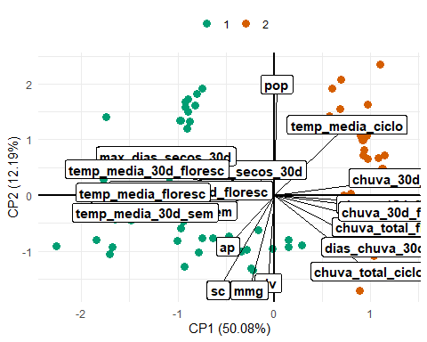

#> [1] "==== Tabela da correlação dos atributos com cada PC ===="  
#> PC1 PC2 PC3 PC4  
#> pop 0.02005968 0.68074291 -0.12448879 0.2403136799  
#> aiv -0.04302253 -0.53737534 -0.24989543 0.5992910906  
#> dias_secos_30d -0.16097175 0.15493941 -0.80068349 0.0048611672  
#> mmg -0.18399176 -0.58037962 -0.16971904 0.0187807019  
#> ap -0.34693075 -0.31180864 -0.03666490 0.7348812108  
#> sc -0.41815060 -0.58084944 -0.42642767 -0.4139419954  
#> kg -0.41841185 -0.58095320 -0.42628166 -0.4136145383  
#> temp_media_ciclo 0.54675045 0.43268669 -0.46413970 -0.0764337050  
#> temp_media_15d_floresc -0.62278093 0.02995090 0.43526878 -0.2519581604  
#> chuva_15d_sem -0.69284627 -0.06992058 -0.29279702 0.3090151630  
#> chuva_total_ciclo 0.71552108 -0.46478329 0.40041226 0.0560443630  
#> dias_chuva_30d 0.76247365 -0.31663766 0.42003890 0.0601362623  
#> max_dias_secos_30d -0.80925111 0.24020540 -0.30808868 -0.0377508193  
#> temp_media_15d_sem -0.82474567 -0.09480597 0.31519364 -0.1785480158  
#> chuva_total_floresc 0.92642542 -0.19319405 -0.11637838 -0.0879795135  
#> chuva_15d_floresc 0.94328069 -0.05472779 -0.13310996 -0.0182943902  
#> temp_media_30d_floresc -0.95116562 0.16001425 0.20679773 -0.0181406713  
#> chuva_30d_floresc 0.95447205 -0.09783222 -0.09995056 -0.0873074286  
#> chuva_30d_sem 0.96472043 0.10596222 -0.08574239 -0.0240730816  
#> temp_media_30d_sem -0.96512425 -0.10558869 0.06181478 0.0438101913  
#> temp_media_floresc -0.98130782 0.01720236 0.14680986 0.0004437253  
#> PC5  
#> pop 0.27961043  
#> aiv 0.37094099  
#> dias_secos_30d -0.14749332  
#> mmg -0.26520117  
#> ap 0.31822982  
#> sc 0.21068369  
#> kg 0.21092448  
#> temp_media_ciclo 0.28421160  
#> temp_media_15d_floresc 0.45472159  
#> chuva_15d_sem -0.44852270  
#> chuva_total_ciclo -0.05120739  
#> dias_chuva_30d -0.08680799  
#> max_dias_secos_30d 0.05682048  
#> temp_media_15d_sem 0.18077541  
#> chuva_total_floresc 0.08291853  
#> chuva_15d_floresc 0.05279444  
#> temp_media_30d_floresc 0.07669841  
#> chuva_30d_floresc 0.09958710  
#> chuva_30d_sem 0.09321034  
#> temp_media_30d_sem -0.11905249  
#> temp_media_floresc 0.01429384  
#> [1] "================================================================="  
#> [1] "ANALISE PARA SAFRA: 2022/2023"  
#> [1] "================================================================="

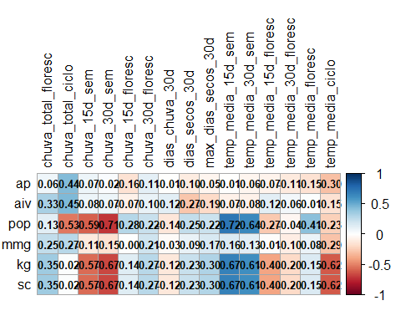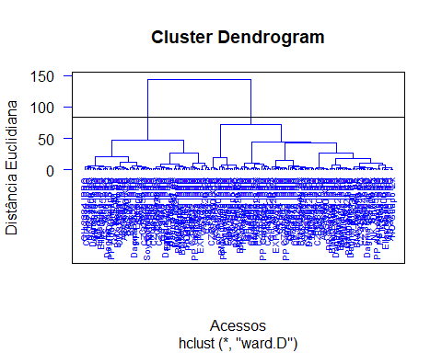

#> [1] "======== Análise de Componentes Principais ========== "  
#> [1] "==== Autovalores ===="  
#> [1] 7.167 3.400 2.828 1.571 1.258 0.974 0.915 0.686 0.632 0.414 0.355 0.265  
#> [13] 0.196 0.161 0.085 0.040 0.028 0.023 0.000 0.000 0.000  
#> [1] "==== % da variância explicada ===="  
#> [1] 0.3413 0.1619 0.1347 0.0748 0.0599 0.0464 0.0436 0.0327 0.0301 0.0197  
#> [11] 0.0169 0.0126 0.0094 0.0077 0.0041 0.0019 0.0013 0.0011 0.0000 0.0000  
#> [21] 0.0000  
#> [1] "==== % da variância explicada acumulada ===="  
#> [1] 34.13 50.32 63.79 71.27 77.26 81.90 86.25 89.52 92.53 94.50  
#> [11] 96.19 97.46 98.39 99.16 99.57 99.75 99.89 100.00 100.00 100.00  
#> [21] 100.00  
#> [1] "==== Poder Discriminante ===="

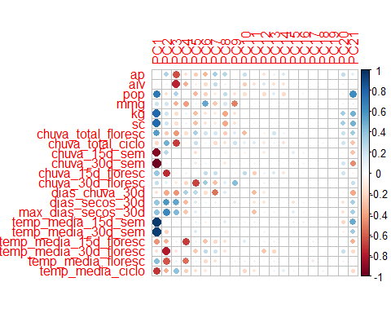

#> [1] "==== screeplot ===="  
#> [Grupo 1]: AS 3680 IPRO  
#> AS 3680 IPRO  
#> AS 3700 XTD  
#> AS 3700 XTD  
#> AS 3707 i2x  
#> AS 3707 i2x  
#> AS 3790 IPRO  
#> AS 3800 i2x  
#> B 5710 CE  
#> B 5830 CE  
#> BMX Ataque i2x  
#> BMX Ataque i2x  
#> BMX Bônus IPRO  
#> BMX Bônus IPRO  
#> BMX Desafio RR  
#> BMX Desafio RR  
#> BMX Olimpo IPRO  
#> BMX Olimpo IPRO  
#> Bela 35 IPRO  
#> Bela 39 IPRO  
#> Bela 46 IPRO  
#> Bela 47 i2x  
#> Bela 64 CE  
#> C 2732 IPRO  
#> C 2811 IPRO  
#> CZ 37B39 i2x  
#> CZ 37B39 i2x  
#> CZ 37B43 IPRO  
#> CZ 37B43 IPRO  
#> CZ 37B51 IPRO  
#> CZ 37B51 IPRO  
#> CZ 37B60 IPRO  
#> CZ 37B60 IPRO  
#> CZ 48B01 IPRO  
#> CZ 48B01 IPRO  
#> CZ 48B18 IPRO  
#> CZ 48B18 IPRO  
#> CZ 48B32 IPRO  
#> CZ 48B32 IPRO  
#> CZ 58B23 i2x  
#> CZ 58B23 i2x  
#> CZ 58B28 IPRO  
#> CZ 58B28 IPRO  
#> Dagma 6822 IPRO  
#> Dagma 7621 i2x  
#> Dagma 7921 IPRO  
#> Dagma 8121 IPRO  
#> Dagma 8221 i2x  
#> Dagma 8321 CE  
#> EXP WS 29 IPRO  
#> Ellas Elisa IPRO  
#> Ellas Elisa IPRO  
#> Ellas Manu IPRO  
#> Ellas Paula IPRO  
#> FT 3282 IPRO  
#> FT 3771 IPRO  
#> GH 2282 IPRO  
#> GH 2282 IPRO  
#> GH 2376 IPRO  
#> GH 2376 IPRO  
#> GH 2384 IPRO  
#> GH 2384 IPRO  
#> GH 2478 IPRO  
#> GH 2478 IPRO  
#> HO Coari i2x  
#> HO Guapó i2x  
#> HO Guapó i2x  
#> HO Itiquira IPRO  
#> M 8220 i2x  
#> M 8220 i2x  
#> NK 7010 IPRO  
#> NK 7777 IPRO  
#> NK 8100 IPRO  
#> PP Aguerrida IPRO  
#> PP Aguerrida IPRO  
#> PP Avanço IPRO  
#> PP Avanço IPRO  
#> PP Grandeza IPRO  
#> PP Grandeza IPRO  
#> PP Peleia IPRO  
#> PP Peleia IPRO  
#> ST 700 i2x  
#> ST 752 i2x  
#> ST 783 IPRO  
#> VA 79A IPRO  
#> VA 79A IPRO  
#> VA 84A IPRO  
#> VA 84A IPRO  
#>   
#> [Grupo 2]: AS 3680 IPRO  
#> AS 3700 XTD  
#> AS 3707 i2x  
#> AS 3790 IPRO  
#> AS 3800 i2x  
#> B 5710 CE  
#> B 5830 CE  
#> BMX Ataque i2x  
#> BMX Bônus IPRO  
#> BMX Desafio RR  
#> BMX Olimpo IPRO  
#> Bela 35 IPRO  
#> Bela 39 IPRO  
#> Bela 45 IPRO  
#> Bela 46 IPRO  
#> Bela 47 i2x  
#> Bela 64 CE  
#> C 2732 IPRO  
#> C 2811 IPRO  
#> CZ 37B39 i2x  
#> CZ 37B43 IPRO  
#> CZ 37B51 IPRO  
#> CZ 37B60 IPRO  
#> CZ 48B01 IPRO  
#> CZ 48B18 IPRO  
#> CZ 48B32 IPRO  
#> CZ 58B23 i2x  
#> CZ 58B28 IPRO  
#> Dagma 6822 IPRO  
#> Dagma 7621 i2x  
#> Dagma 7921 IPRO  
#> Dagma 8121 IPRO  
#> Dagma 8221 i2x  
#> Dagma 8321 CE  
#> EXP WS 29 IPRO  
#> Ellas Elisa IPRO  
#> Ellas Manu IPRO  
#> Ellas Paula IPRO  
#> FT 3282 IPRO  
#> FT 3771 IPRO  
#> GH 2282 IPRO  
#> GH 2376 IPRO  
#> GH 2384 IPRO  
#> GH 2478 IPRO  
#> HO Coari i2x  
#> HO Guapó i2x  
#> HO Itiquira IPRO  
#> M 8220 i2x  
#> NK 7010 IPRO  
#> NK 7777 IPRO  
#> NK 8100 IPRO  
#> PP Aguerrida IPRO  
#> PP Avanço IPRO  
#> PP Grandeza IPRO  
#> PP Peleia IPRO  
#> ST 700 i2x  
#> ST 752 i2x  
#> ST 783 IPRO  
#> Soy Combate IPRO  
#> VA 79A IPRO  
#> VA 84A IPRO

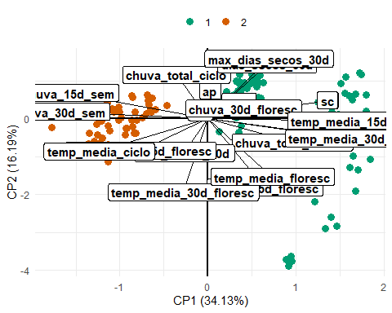

#> [1] "==== Tabela da correlação dos atributos com cada PC ===="  
#> PC1 PC2 PC3 PC4  
#> ap 0.01425838 0.30360332 -0.642384864 -0.168070336  
#> aiv -0.05266986 0.07277953 -0.767546272 -0.359127220  
#> dias_chuva_30d -0.15476265 -0.37140625 -0.442533607 0.324779027  
#> temp_media_30d_floresc -0.16034228 -0.79369339 -0.134570503 -0.033400327  
#> mmg 0.20376370 0.18544835 -0.341459875 -0.417176680  
#> chuva_total_ciclo -0.20785263 0.47709218 -0.698961679 -0.059057450  
#> chuva_30d_floresc 0.23349527 0.10945259 -0.108461359 -0.204743091  
#> chuva_15d_floresc 0.37437926 -0.74458916 -0.053643335 0.087413908  
#> dias_secos_30d 0.38812469 0.58910286 0.520945453 -0.322504298  
#> max_dias_secos_30d 0.40017327 0.64773091 0.440811501 -0.279854981  
#> temp_media_floresc 0.42334565 -0.62897034 0.100147178 -0.555944302  
#> temp_media_15d_floresc -0.44084761 -0.34377467 0.084805038 -0.692038250  
#> chuva_total_floresc 0.55328076 -0.25687625 -0.433926132 -0.179032484  
#> pop 0.71107925 -0.16169522 0.303809230 0.043082458  
#> temp_media_ciclo -0.71465697 -0.35328500 0.403879206 -0.234221527  
#> kg 0.78448273 0.19919634 -0.178037028 0.098355893  
#> sc 0.78448806 0.19924806 -0.178192838 0.098326127  
#> chuva_15d_sem -0.91243025 0.27857743 0.010949917 -0.033347874  
#> temp_media_30d_sem 0.94800363 -0.21406621 0.002424818 0.020705852  
#> temp_media_15d_sem 0.96183177 -0.02368127 0.037893930 -0.014786648  
#> chuva_30d_sem -0.97000005 0.07406417 -0.029026799 0.005629718  
#> PC5  
#> ap -0.24928257  
#> aiv -0.10302508  
#> dias_chuva_30d 0.26259332  
#> temp_media_30d_floresc -0.26583207  
#> mmg 0.07001926  
#> chuva_total_ciclo 0.22597429  
#> chuva_30d_floresc -0.67020328  
#> chuva_15d_floresc -0.01239395  
#> dias_secos_30d 0.14477940  
#> max_dias_secos_30d 0.12571029  
#> temp_media_floresc 0.06066664  
#> temp_media_15d_floresc 0.09606399  
#> chuva_total_floresc 0.32612387  
#> pop -0.32047101  
#> temp_media_ciclo -0.16929930  
#> kg -0.29970872  
#> sc -0.29964634  
#> chuva_15d_sem -0.17156146  
#> temp_media_30d_sem 0.15348233  
#> temp_media_15d_sem 0.09213311  
#> chuva_30d_sem -0.10940566  
#> [1] "================================================================="  
#> [1] "ANALISE PARA SAFRA: 2023/2024"  
#> [1] "================================================================="

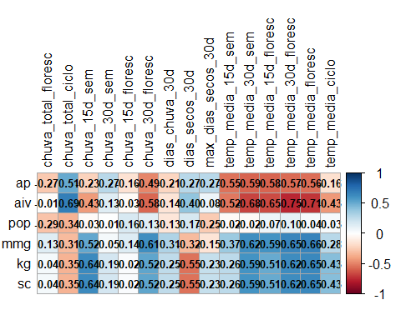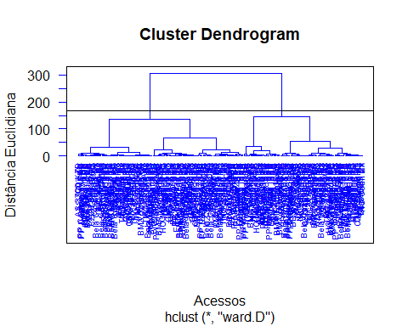

#> [1] "======== Análise de Componentes Principais ========== "  
#> [1] "==== Autovalores ===="  
#> [1] 8.750 3.342 2.239 2.126 1.157 0.829 0.631 0.538 0.328 0.308 0.226 0.159  
#> [13] 0.113 0.091 0.087 0.059 0.016 0.001 0.000 0.000 0.000  
#> [1] "==== % da variância explicada ===="  
#> [1] 0.4167 0.1591 0.1066 0.1013 0.0551 0.0395 0.0301 0.0256 0.0156 0.0147  
#> [11] 0.0108 0.0076 0.0054 0.0043 0.0042 0.0028 0.0008 0.0001 0.0000 0.0000  
#> [21] 0.0000  
#> [1] "==== % da variância explicada acumulada ===="  
#> [1] 41.67 57.58 68.24 78.37 83.88 87.83 90.83 93.39 94.95 96.42  
#> [11] 97.50 98.25 98.79 99.22 99.64 99.92 99.99 100.00 100.00 100.00  
#> [21] 100.00  
#> [1] "==== Poder Discriminante ===="

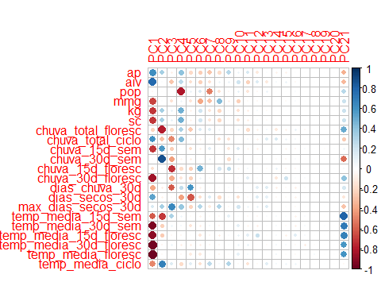

#> [1] "==== screeplot ===="  
#> [Grupo 1]: 76EA72  
#> 76EA72  
#> 78KA42  
#> 78KA42  
#> AS 3640 i2x  
#> AS 3640 i2x  
#> AS 3700 XTD  
#> AS 3700 XTD  
#> AS 3707 i2x  
#> AS 3707 i2x  
#> AS 3790 i2x  
#> AS 3790 i2x  
#> AS 3800 i2x  
#> AS 3800 i2x  
#> AS 3840 i2x  
#> B66C22  
#> B72C22  
#> B75C22  
#> BMX Desafio RR  
#> BMX Desafio RR  
#> BMX Olimpo IPRO  
#> BMX Olimpo IPRO  
#> BMX Sparta i2x  
#> BMX Tormenta CE  
#> BMX Tormenta CE  
#> BRS 1061 IPRO  
#> BRS 1075 IPRO  
#> BRS 774 RR  
#> BRSMG 534  
#> Bela Cultivar 03 i2x  
#> Bela Cultivar 61 i2x  
#> Bela Cultivar 64 i2x  
#> Bela Cultivar 65 i2x  
#> Bela Cultivar 66 CE  
#> Bela Cultivar 67 i2x  
#> CZ 37B07 i2x  
#> CZ 37B39 i2x  
#> CZ 37B43 IPRO  
#> CZ 37B51 IPRO  
#> CZ 37B66 i2x  
#> CZ 47B74 i2x  
#> CZ 48B01 i2x  
#> CZ 48B08 i2x  
#> CZ 48B18 IPRO  
#> CZ 48B32 IPRO  
#> CZ 48B32 IPRO  
#> CZ 58B23 i2x  
#> CZ 58B48 i2x  
#> Ellas Dani i2x  
#> Ellas Lynda IPRO  
#> GH 2282 IPRO  
#> GH 2282 IPRO  
#> GH 2376 IPRO  
#> GH 2376 IPRO  
#> GH 2478 IPRO  
#> GH 2478 IPRO  
#> GH 2483 IPRO  
#> GH 2483 IPRO  
#> HO Coari i2x  
#> HO Coxim IPRO  
#> HO Maracaí IPRO  
#> HO Maracaí IPRO  
#> HO Mogi i2x  
#> HO Mutum i2x  
#> M 7601 i2x  
#> M 8220 i2x  
#> M 8220 i2x  
#> NK 7010 IPRO  
#> NK 7010 IPRO  
#> PP Atenas IPRO  
#> PP Atenas IPRO  
#> PP Bagual IPRO  
#> PP Bagual IPRO  
#> PP Brutus IPRO  
#> PP Brutus IPRO  
#> PP Campeira IPRO  
#> PP Campeira IPRO  
#> PP Colibri IPRO  
#> PP Colibri IPRO  
#> PP Destaque IPRO  
#> PP Destaque IPRO  
#> PP Grandeza IPRO  
#> PP Grandeza IPRO  
#> PP Lenda IPRO  
#> PP Lenda IPRO  
#> PP Peleia IPRO  
#> PP Peleia IPRO  
#> ST 711 i2x  
#> ST 752 i2x  
#> ST 822 i2x  
#> TMG 22-206 E  
#> TMG 22-206 E  
#> TMG 22-210 i2x  
#> TMG 22-210 i2x  
#> TMG 22-213 i2x  
#> TMG 22-213 i2x  
#> TMG 22X77 i2x  
#> TMG 22X77 i2x  
#> TMG 22X83 i2x  
#> TMG 22X83 i2x  
#> UFVS 77 C10  
#> VA 7209 IPRO  
#> VA 7310 IPRO  
#> WS 053 IPRO  
#> WS 054 IPRO  
#>   
#> [Grupo 2]: 76EA72  
#> 76EA72  
#> 78KA42  
#> 78KA42  
#> AS 3640 i2x  
#> AS 3640 i2x  
#> AS 3700 XTD  
#> AS 3700 XTD  
#> AS 3707 i2x  
#> AS 3707 i2x  
#> AS 3790 i2x  
#> AS 3790 i2x  
#> AS 3800 i2x  
#> AS 3800 i2x  
#> AS 3840 i2x  
#> AS 3840 i2x  
#> B66C22  
#> B66C22  
#> B72C22  
#> B72C22  
#> B75C22  
#> B75C22  
#> BMX Desafio RR  
#> BMX Desafio RR  
#> BMX Olimpo IPRO  
#> BMX Olimpo IPRO  
#> BMX Sparta i2x  
#> BMX Sparta i2x  
#> BMX Tormenta CE  
#> BMX Tormenta CE  
#> BRS 1061 IPRO  
#> BRS 1061 IPRO  
#> BRS 1075 IPRO  
#> BRS 1075 IPRO  
#> BRS 774 RR  
#> BRS 774 RR  
#> BRSMG 534  
#> BRSMG 534  
#> Bela Cultivar 03 i2x  
#> Bela Cultivar 03 i2x  
#> Bela Cultivar 61 i2x  
#> Bela Cultivar 61 i2x  
#> Bela Cultivar 64 i2x  
#> Bela Cultivar 64 i2x  
#> Bela Cultivar 65 i2x  
#> Bela Cultivar 65 i2x  
#> Bela Cultivar 66 CE  
#> Bela Cultivar 66 CE  
#> Bela Cultivar 67 i2x  
#> Bela Cultivar 67 i2x  
#> CZ 37B07 i2x  
#> CZ 37B07 i2x  
#> CZ 37B39 i2x  
#> CZ 37B39 i2x  
#> CZ 37B43 IPRO  
#> CZ 37B43 IPRO  
#> CZ 37B51 IPRO  
#> CZ 37B51 IPRO  
#> CZ 37B66 i2x  
#> CZ 37B66 i2x  
#> CZ 47B74 i2x  
#> CZ 47B74 i2x  
#> CZ 48B01 i2x  
#> CZ 48B01 i2x  
#> CZ 48B08 i2x  
#> CZ 48B08 i2x  
#> CZ 48B18 IPRO  
#> CZ 48B18 IPRO  
#> CZ 48B32 IPRO  
#> CZ 48B32 IPRO  
#> CZ 58B23 i2x  
#> CZ 58B23 i2x  
#> CZ 58B48 i2x  
#> CZ 58B48 i2x  
#> Ellas Dani i2x  
#> Ellas Dani i2x  
#> Ellas Lynda IPRO  
#> Ellas Lynda IPRO  
#> GH 2282 IPRO  
#> GH 2282 IPRO  
#> GH 2376 IPRO  
#> GH 2376 IPRO  
#> GH 2478 IPRO  
#> GH 2478 IPRO  
#> GH 2483 IPRO  
#> GH 2483 IPRO  
#> HO Coari i2x  
#> HO Coari i2x  
#> HO Coxim IPRO  
#> HO Coxim IPRO  
#> HO Maracaí IPRO  
#> HO Maracaí IPRO  
#> HO Mogi i2x  
#> HO Mogi i2x  
#> HO Mutum i2x  
#> HO Mutum i2x  
#> M 7601 i2x  
#> M 7601 i2x  
#> M 8220 i2x  
#> M 8220 i2x  
#> NK 7010 IPRO  
#> NK 7010 IPRO  
#> PP Atenas IPRO  
#> PP Atenas IPRO  
#> PP Bagual IPRO  
#> PP Bagual IPRO  
#> PP Brutus IPRO  
#> PP Brutus IPRO  
#> PP Campeira IPRO  
#> PP Campeira IPRO  
#> PP Colibri IPRO  
#> PP Colibri IPRO  
#> PP Destaque IPRO  
#> PP Destaque IPRO  
#> PP Grandeza IPRO  
#> PP Grandeza IPRO  
#> PP Lenda IPRO  
#> PP Lenda IPRO  
#> PP Peleia IPRO  
#> PP Peleia IPRO  
#> ST 711 i2x  
#> ST 711 i2x  
#> ST 752 i2x  
#> ST 752 i2x  
#> ST 822 i2x  
#> ST 822 i2x  
#> TMG 22-206 E  
#> TMG 22-206 E  
#> TMG 22-210 i2x  
#> TMG 22-210 i2x  
#> TMG 22-213 i2x  
#> TMG 22-213 i2x  
#> TMG 22X77 i2x  
#> TMG 22X77 i2x  
#> TMG 22X83 i2x  
#> TMG 22X83 i2x  
#> UFVS 77 C10  
#> UFVS 77 C10  
#> VA 7209 IPRO  
#> VA 7209 IPRO  
#> VA 7310 IPRO  
#> VA 7310 IPRO  
#> WS 053 IPRO  
#> WS 053 IPRO  
#> WS 054 IPRO  
#> WS 054 IPRO

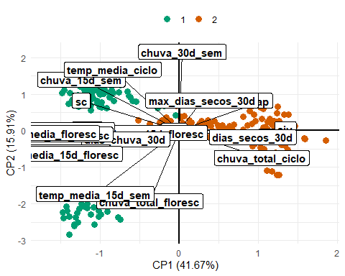

#> [1] "==== Tabela da correlação dos atributos com cada PC ===="  
#> PC1 PC2 PC3 PC4  
#> chuva_30d_sem 0.02419680 0.8759313405 -0.413386270 -0.053356849  
#> pop -0.03746856 -0.0001219106 0.007561463 -0.801340868  
#> chuva_15d_floresc -0.16503289 -0.0254702581 -0.735474010 -0.185237558  
#> max_dias_secos_30d 0.16645506 0.3385352780 0.642871239 0.386026084  
#> chuva_total_floresc -0.21288990 -0.7855251900 -0.207055945 0.326924289  
#> dias_chuva_30d -0.38942505 -0.0947075281 -0.612840040 0.248578279  
#> temp_media_ciclo -0.48434610 0.6795544919 0.145601194 -0.185958131  
#> dias_secos_30d 0.53750196 -0.0685473992 -0.026723265 -0.409725346  
#> chuva_total_ciclo 0.60219904 -0.2999899615 -0.487511284 0.439262355  
#> temp_media_15d_sem -0.61396617 -0.7027838490 0.310921134 0.065006101  
#> ap 0.61432456 0.3323233618 -0.080703761 0.406724205  
#> mmg -0.67163906 0.0188256844 -0.159245031 0.060886786  
#> kg -0.71276082 0.3337229893 0.102647114 0.480337023  
#> sc -0.71284165 0.3335780446 0.102588335 0.480371687  
#> chuva_15d_sem -0.71383662 0.5701022833 -0.249295504 0.003231462  
#> aiv 0.77523133 0.0165942108 -0.276985177 0.262213683  
#> chuva_30d_floresc -0.84502785 0.0098183499 -0.367800705 -0.132552391  
#> temp_media_15d_floresc -0.89709786 -0.2564584503 -0.033483709 -0.048934420  
#> temp_media_30d_sem -0.93411563 -0.2363814495 0.072423207 0.047425560  
#> temp_media_30d_floresc -0.96582950 -0.0405552762 0.078286904 -0.085104274  
#> temp_media_floresc -0.97636205 -0.0264001831 0.003448492 -0.030155680  
#> PC5  
#> chuva_30d_sem -0.09206325  
#> pop 0.08053275  
#> chuva_15d_floresc -0.23391303  
#> max_dias_secos_30d -0.21237233  
#> chuva_total_floresc -0.26511269  
#> dias_chuva_30d 0.59032930  
#> temp_media_ciclo 0.12430943  
#> dias_secos_30d -0.62379206  
#> chuva_total_ciclo -0.06351100  
#> temp_media_15d_sem -0.02889140  
#> ap -0.19939393  
#> mmg -0.13635547  
#> kg -0.06976683  
#> sc -0.06985318  
#> chuva_15d_sem -0.16620726  
#> aiv -0.16371416  
#> chuva_30d_floresc -0.22603954  
#> temp_media_15d_floresc -0.01275111  
#> temp_media_30d_sem -0.13843131  
#> temp_media_30d_floresc -0.09527950  
#> temp_media_floresc -0.10992376  
#> [1] "================================================================="  
#> [1] "ANALISE PARA SAFRA: 2024/2025"  
#> [1] "================================================================="

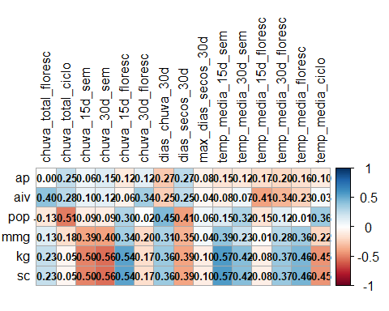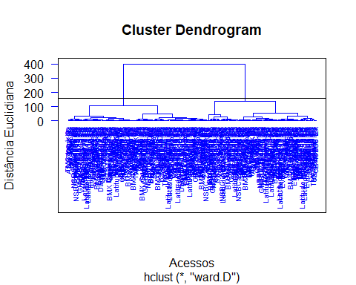

#> [1] "======== Análise de Componentes Principais ========== "  
#> [1] "==== Autovalores ===="  
#> [1] 9.032 3.566 2.340 1.369 1.217 0.918 0.778 0.501 0.386 0.265 0.229 0.137  
#> [13] 0.117 0.071 0.027 0.025 0.015 0.007 0.000 0.000 0.000  
#> [1] "==== % da variância explicada ===="  
#> [1] 0.4301 0.1698 0.1114 0.0652 0.0579 0.0437 0.0370 0.0239 0.0184 0.0126  
#> [11] 0.0109 0.0065 0.0056 0.0034 0.0013 0.0012 0.0007 0.0003 0.0000 0.0000  
#> [21] 0.0000  
#> [1] "==== % da variância explicada acumulada ===="  
#> [1] 43.01 59.99 71.13 77.65 83.44 87.82 91.52 93.90 95.74 97.00  
#> [11] 98.09 98.74 99.30 99.64 99.77 99.89 99.96 100.00 100.00 100.00  
#> [21] 100.00  
#> [1] "==== Poder Discriminante ===="

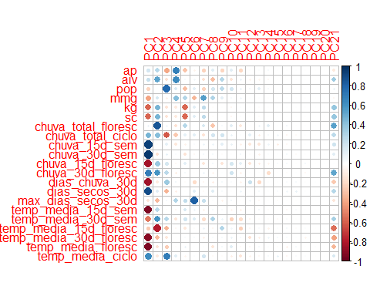

#> [1] "==== screeplot ===="  
#> [Grupo 1]: 76KA72  
#> 76KA72  
#> 78KA42  
#> 78KA42  
#> 79KA72  
#> 79KA72  
#> 80KA72  
#> 80KA72  
#> AS 3640 i2x  
#> AS 3640 i2x  
#> AS 3700 XTD  
#> AS 3700 XTD  
#> AS 3707 i2x  
#> AS 3707 i2x  
#> AS 3715 i2x  
#> AS 3715 i2x  
#> AS 3790 i2x  
#> AS 3790 i2x  
#> AS 3800 i2x  
#> AS 3800 i2x  
#> AS 3840 i2x  
#> AS 3840 i2x  
#> B66C22  
#> B66C22  
#> B72C22  
#> B72C22  
#> B75C22  
#> B75C22  
#> B76C23  
#> B80C23  
#> B80C23  
#> BMX Cobre i2x  
#> BMX Cobre i2x  
#> BMX Cruzada CE  
#> BMX Desafio RR  
#> BMX Desafio RR  
#> BMX Guepardo IPRO  
#> BMX Guepardo IPRO  
#> BMX Mítica CE  
#> BMX Mítica CE  
#> BMX Olimpo IPRO  
#> BMX Olimpo IPRO  
#> BMX Raptor i2x  
#> BMX Raptor i2x  
#> BMX Sparta i2x  
#> BMX Sparta i2x  
#> BMX Tormenta CE  
#> BMX Tormenta CE  
#> BRS 1061 IPRO  
#> BRS 1061 IPRO  
#> BRS 1075 IPRO  
#> BRS 1075 IPRO  
#> C 2740 CE  
#> C 2740 CE  
#> C 2790 CE  
#> C 2790 CE  
#> C 2810 CE  
#> C 2810 CE  
#> CZ 37B07 i2x  
#> CZ 37B07 i2x  
#> CZ 37B51 IPRO  
#> CZ 37B51 IPRO  
#> CZ 37B60 IPRO  
#> CZ 37B60 IPRO  
#> CZ 37B66 i2x  
#> CZ 37B66 i2x  
#> CZ 47B74 i2x  
#> CZ 47B74 i2x  
#> CZ 47B91 i2x  
#> CZ 47B91 i2x  
#> CZ 48B32 IPRO  
#> CZ 48B32 IPRO  
#> CZ 48B08 i2x  
#> CZ 48B08 i2x  
#> DM 72IX74 i2x  
#> DM 72IX74 i2x  
#> DM 74K75 CE  
#> DM 74K75 CE  
#> DM 75I74 IPRO  
#> DM 75I74 IPRO  
#> DM 76IX78 i2x  
#> DM 76IX78 i2x  
#> DM 78IX80 i2x  
#> DM 78IX80 i2x  
#> DM 79K80 CE  
#> DM 79K80 CE  
#> Dagma 6824 i2x  
#> Dagma 6824 i2x  
#> Dagma 7924 i2x  
#> Dagma 7924 i2x  
#> Dagma 8121 IPRO  
#> Dagma 8121 IPRO  
#> Ellas Dani i2x  
#> Ellas Dani i2x  
#> Ellas Manu IPRO  
#> Ellas Manu IPRO  
#> Ellas Paula IPRO  
#> Ellas Paula IPRO  
#> Evolui 7901 IPRO  
#> Evolui 7901 IPRO  
#> GH 2478 IPRO  
#> GH 2478 IPRO  
#> GH 2483 IPRO  
#> GH 2483 IPRO  
#> GH BC2284143 i2x  
#> GH BC2284143 i2x  
#> HO Arari i2x  
#> HO Arari i2x  
#> HO Garças i2x  
#> HO Garças i2x  
#> HO Guapó i2x  
#> HO Guapó i2x  
#> HO Mogi i2x  
#> HO Mogi i2x  
#> HO Mutum i2x  
#> HO Mutum i2x  
#> HO Nobres i2x  
#> HO Nobres i2x  
#> Latitude Amplia IPRO  
#> Latitude Amplia IPRO  
#> Latitude Eleva IPRO  
#> Latitude Eleva IPRO  
#> Latitude Maximiza IPRO  
#> Latitude Maximiza IPRO  
#> Latitude Otimiza IPRO  
#> Latitude Otimiza IPRO  
#> M 6620 i2x  
#> M 6620 i2x  
#> M 7601 i2x  
#> M 7601 i2x  
#> M 8220 i2x  
#> M 8220 i2x  
#> NEO 801 CE  
#> NEO 801 CE  
#> NS 7902 IPRO  
#> NS 7902 IPRO  
#> NSBC 2180022 IPRO  
#> NSBC 2180022 IPRO  
#> NSBC 228112 i2x  
#> NSBC 228112 i2x  
#> P 97Y70 CE  
#> P 97Y70 CE  
#> TMG 24408 i2x  
#> TMG 24408 i2x  
#> TMG 24409 i2x  
#> TMG 24409 i2x  
#> TMG 24410 i2x  
#> TMG 24410 i2x  
#> TMG 24411 i2x  
#> TMG 24411 i2x  
#> TMG 24424 i2x  
#> TMG 24424 i2x  
#> TMG 24427 i2x  
#> TMG 24427 i2x  
#> TMG 24429 i2x  
#> TMG 24429 i2x  
#> TMG Bálsamo i2x  
#> TMG Bálsamo i2x  
#> TMG Ingá i2x  
#> TMG Ingá i2x  
#> TMG Jatobá i2x  
#> TMG Jatobá i2x  
#> TMG Murici i2x  
#> TMG Murici i2x  
#> UFVS 77 C10  
#> UFVS 80 C10  
#> VA 7310 IPRO  
#> VA 7310 IPRO  
#> VA 8108 IPRO  
#> VA 8108 IPRO  
#> WS 052 IPRO  
#> WS 052 IPRO  
#>   
#> [Grupo 2]: 78KA42  
#> 78KA42  
#> 80KA72  
#> 80KA72  
#> AS 3640 i2x  
#> AS 3640 i2x  
#> AS 3700 XTD  
#> AS 3700 XTD  
#> AS 3707 i2x  
#> AS 3707 i2x  
#> AS 3715 i2x  
#> AS 3715 i2x  
#> AS 3790 i2x  
#> AS 3790 i2x  
#> AS 3800 i2x  
#> AS 3800 i2x  
#> AS 3840 i2x  
#> AS 3840 i2x  
#> B66C22  
#> B66C22  
#> B72C22  
#> B75C22  
#> B75C22  
#> B80C23  
#> B80C23  
#> BMX Cobre i2x  
#> BMX Desafio RR  
#> BMX Desafio RR  
#> BMX Mítica CE  
#> BMX Olimpo IPRO  
#> BMX Olimpo IPRO  
#> BMX Raptor i2x  
#> BMX Sparta i2x  
#> BMX Tormenta CE  
#> BMX Tormenta CE  
#> BRS 1061 IPRO  
#> BRS 1061 IPRO  
#> BRS 1075 IPRO  
#> BRS 1075 IPRO  
#> C 2740 CE  
#> C 2790 CE  
#> CZ 37B07 i2x  
#> CZ 37B07 i2x  
#> CZ 37B51 IPRO  
#> CZ 37B51 IPRO  
#> CZ 37B60 IPRO  
#> CZ 37B60 IPRO  
#> CZ 37B66 i2x  
#> CZ 37B66 i2x  
#> CZ 47B74 i2x  
#> CZ 47B74 i2x  
#> CZ 47B91 i2x  
#> CZ 47B91 i2x  
#> CZ 48B32 IPRO  
#> CZ 48B32 IPRO  
#> CZ 48B08 i2x  
#> CZ 48B08 i2x  
#> DM 72IX74 i2x  
#> DM 72IX74 i2x  
#> DM 74K75 CE  
#> DM 74K75 CE  
#> DM 75I74 IPRO  
#> DM 75I74 IPRO  
#> DM 76IX78 i2x  
#> DM 76IX78 i2x  
#> DM 78IX80 i2x  
#> DM 78IX80 i2x  
#> DM 79K80 CE  
#> Ellas Dani i2x  
#> Ellas Manu IPRO  
#> Ellas Paula IPRO  
#> Evolui 7901 IPRO  
#> Evolui 7901 IPRO  
#> GH 2478 IPRO  
#> GH 2478 IPRO  
#> GH 2483 IPRO  
#> GH 2483 IPRO  
#> GH BC2284143 i2x  
#> GH BC2284143 i2x  
#> HO Arari i2x  
#> HO Garças i2x  
#> HO Guapó i2x  
#> HO Mogi i2x  
#> HO Mutum i2x  
#> HO Nobres i2x  
#> Latitude Amplia IPRO  
#> Latitude Amplia IPRO  
#> Latitude Eleva IPRO  
#> Latitude Eleva IPRO  
#> Latitude Maximiza IPRO  
#> Latitude Maximiza IPRO  
#> Latitude Otimiza IPRO  
#> Latitude Otimiza IPRO  
#> M 6620 i2x  
#> M 6620 i2x  
#> M 7601 i2x  
#> M 7601 i2x  
#> M 8220 i2x  
#> M 8220 i2x  
#> NEO 801 CE  
#> NS 7902 IPRO  
#> NS 7902 IPRO  
#> NSBC 2180022 IPRO  
#> NSBC 2180022 IPRO  
#> NSBC 228112 i2x  
#> NSBC 228112 i2x  
#> P 97Y70 CE  
#> TMG 24408 i2x  
#> TMG 24408 i2x  
#> TMG 24409 i2x  
#> TMG 24409 i2x  
#> TMG 24410 i2x  
#> TMG 24410 i2x  
#> TMG 24411 i2x  
#> TMG 24411 i2x  
#> TMG 24424 i2x  
#> TMG 24424 i2x  
#> TMG 24427 i2x  
#> TMG 24427 i2x  
#> TMG 24429 i2x  
#> TMG 24429 i2x  
#> TMG Bálsamo i2x  
#> TMG Bálsamo i2x  
#> TMG Ingá i2x  
#> TMG Jatobá i2x  
#> TMG Jatobá i2x  
#> TMG Murici i2x  
#> TMG Murici i2x  
#> VA 7310 IPRO  
#> VA 7310 IPRO  
#> VA 8108 IPRO  
#> VA 8108 IPRO  
#> WS 052 IPRO  
#> WS 052 IPRO

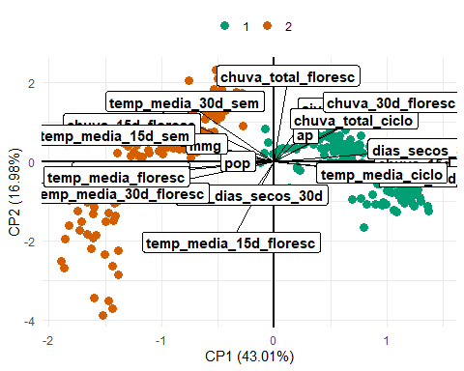

#> [1] "==== Tabela da correlação dos atributos com cada PC ===="  
#> PC1 PC2 PC3 PC4  
#> chuva_total_floresc 0.08042951 0.851323625 0.06088279 -0.156735110  
#> max_dias_secos_30d -0.13267701 -0.329512561 0.03404366 0.290915401  
#> ap 0.18650978 0.278398382 -0.38246337 0.689845136  
#> pop -0.21413868 0.001442221 0.78466090 0.154375555  
#> aiv 0.22630714 0.533573511 -0.15803276 0.633492796  
#> temp_media_15d_floresc -0.25256085 -0.797438397 -0.34230307 -0.049926368  
#> mmg -0.39863732 0.171825651 -0.08389412 0.428528470  
#> chuva_total_ciclo 0.46867996 0.424123709 -0.61344128 -0.265721113  
#> temp_media_30d_sem -0.52546977 0.596820461 0.27724338 -0.130343662  
#> kg -0.58136902 0.460968692 -0.14192714 -0.119452451  
#> sc -0.58147436 0.460929270 -0.14175867 -0.119429272  
#> temp_media_ciclo 0.63339109 -0.113644725 0.69469861 0.127601841  
#> chuva_30d_floresc 0.69256923 0.591935944 0.26292932 -0.103167127  
#> chuva_15d_floresc -0.83811535 0.375563641 0.17673515 -0.032305223  
#> dias_chuva_30d -0.84633448 -0.105665964 0.36104517 0.051910018  
#> dias_secos_30d 0.89618958 0.124613119 -0.34367875 -0.089957313  
#> temp_media_30d_floresc -0.90966314 -0.310327900 -0.12959914 -0.009803248  
#> temp_media_floresc -0.93084783 -0.147380770 -0.24493507 -0.013377496  
#> temp_media_15d_sem -0.93471629 0.266065942 -0.01989986 -0.046719630  
#> chuva_15d_sem 0.93894914 -0.014382351 0.10691567 -0.120214847  
#> chuva_30d_sem 0.96418143 -0.153721961 0.10143049 0.024424218  
#> PC5  
#> chuva_total_floresc 0.282640104  
#> max_dias_secos_30d 0.248304229  
#> ap -0.289032605  
#> pop -0.304602557  
#> aiv 0.033267034  
#> temp_media_15d_floresc -0.121206872  
#> mmg 0.299198556  
#> chuva_total_ciclo 0.105596978  
#> temp_media_30d_sem 0.193834354  
#> kg -0.576881643  
#> sc -0.576912668  
#> temp_media_ciclo -0.057009563  
#> chuva_30d_floresc 0.049448945  
#> chuva_15d_floresc 0.113537666  
#> dias_chuva_30d -0.018574538  
#> dias_secos_30d -0.002458393  
#> temp_media_30d_floresc 0.022935931  
#> temp_media_floresc 0.083703421  
#> temp_media_15d_sem 0.164960055  
#> chuva_15d_sem -0.066689306  
#> chuva_30d_sem -0.144541554