# **1 Introduction**

At the point when utilized legitimately, online networking can be a profitable expansion to a division's interchanges system. Since numerous workers have communicated an enthusiasm for creating and keeping up a web-based social networking nearness in individual and expert limits, the Office of University Communications and Marketing has made the accompanying prologue to web-based social networking. It would be ideal if you read this diagram before building up your web-based social networking nearness.

Online networking is a web based type of correspondence. Online networking stages enable clients to have discussions, share data and make web content. There are numerous types of web-based social networking, including websites, smaller scale web journals, wikis, interpersonal interaction locales, photograph sharing destinations, texting, video-sharing destinations, podcasts, gadgets, virtual universes, and that's just the beginning.

Billions of individuals around the globe utilize online networking to share data and make associations. On an individual level, online networking enables you to speak with loved ones, learn new things, build up your interests, and be engaged. On an expert level, you can utilize web-based social networking to widen your insight in a specific field and fabricate your expert system by interfacing with different experts in your industry. At the organization level, online networking enables you to have a discussion with your gathering of people, pick up client input, and lift your image.

With such huge numbers of new web-based social networking locales propelling every year, choosing which one is ideal for your specialization can be overpowering. It is critical to know about rising web-based social networking locales, and see how they could fit into your correspondences technique. In any case, not every social medium locale will be helpful for your specialization's image or promoting objectives.

Before you dispatch an official record on another online networking webpage for your area of expertise, attempt it on an individual level. Make a record for yourself, and afterward utilize it. Concentrate how different people and organizations utilize the site. What sort of substance is posted on the site? Which posts are the most famous on the site? How regularly are clients and organizations posting?

At that point, consider how your area of expertise would fit in. Because you can be on a web-based social networking website, doesn't really mean you ought to be. Spreading yourself crosswise over an excessive number of online networking locales could weaken your social methodology, keeping you from utilizing any of them successfully. Rather, center on the online networking locales that enable you to impart your substance to the proper crowd.

# **2 ABSTRACT**

The Social Media AdderNet features the expanding significance of web-based social networking and systems in the public arena. It is required to give an important chance to scientists and engineers to share their discoveries in this new region and include increasingly highlight in the years to come.An online networking like adderNet gives heaps of highlights to share data about individuals over the globe. It is extremely inaccurate to state it being just an informal organization that associates with individuals. It has highlights which if fused accurately can possibly tumble a portion of the best netting web-based social networking. The adderNet has totally fused a music relax where individuals can enjoy a reprieve from the informal community and hear some out music, make playlist and download music for positively no charge by any stretch of the imagination. The adderNet likewise may execute some Machine Learning calculation that will recognize some content from a bit of picture and yield the content. It might be actualized utilizing the python modules, however for the present, the element is forgotten. The adderNet has a component of Trending post that enables clients to see which post is inclining. The equations and different references are clarified later. Addernet can possibly aggregate a great deal of client and if oversaw accurately, it might never come up short on client space. Designers at adderNet have created calculations and techniques that may keep a repetitive client from reproducing a record. Generally speaking the AdderNet is a decent to attempt long range interpersonal communication site which is free and dependably would be. The project is open source and available at github, anaybody can fork this project and contribute to it, here is the link to download the project : - <https://github.com/arpanpathak/adderNet/>,

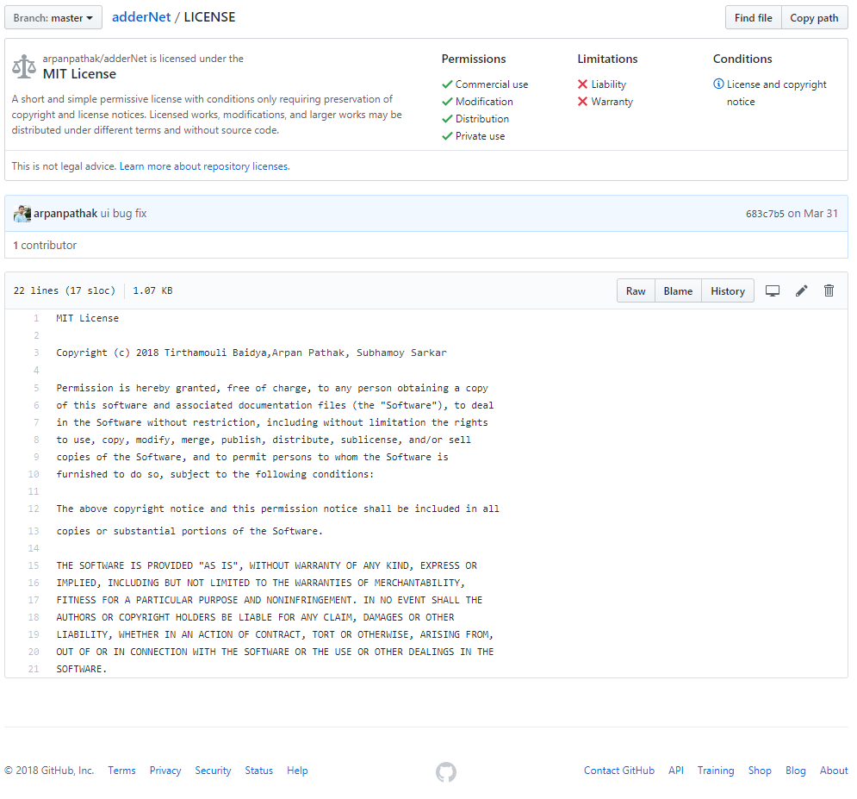

# **3 Review of literature**

A social media like adderNet provides lots of features to share information about people across the globe. It is very incorrect to say it being only a social network that connects to people. It has features which if incorporated correctly has the potential to tumble some of the top grossing social media.

The adderNet has completely incorporated a music lounge where people can take a break from the social network and listen to some music, create playlist and download music for absolutely no charge at all.

The adderNet also may implement some Machine Learning algorithm that will detect some text from a piece of picture and output the text. It may be implemented using the python modules, but for now, the feature is yet to be implemented.   
  
The adderNet has a feature of Trending post that allows users to see which post is trending. The formulas and other references are explained later.

Addernet has the potential to accumulate a lot of user and if managed correctly, it may never run out of user space. Developers at adderNet have developed algorithms and methodologies that may prevent a redundant user from recreating an account.

Overall the AdderNet is a good to try social networking site which is free and always would be.

# **4 project objectives**

* Primary objective is to create an account which is secured and there is no information leak of any sort from the website
* Registration can be done through existing Google or Facebook or GitHub ids.
* The registered users will be allowed to connect to the other users. There would be a follow option which allows users to follow each other’s posts.
* There is a messaging option that allows two users to connect and converse using plain text or even using media like pictures and videos.
* Posts may be of some text type, or pictures or videos or all combined.
* Posts can be followed or, liked and reacted.
* adderNet features a free music lounge that allows registered users to listen and download unlimited music. Customizable playlists can also be created.
* It will implement character detection through machine learning so that documents and such artifacts could be easily transported between organizations, just with a click of a button.
* There is a newsfeed which will show all the trending posts as well as posts of all followers/following
* This project may help others to collect real user data for Machine Learning classifier and many useful predictions can be performed such as sentiment analysis, spam detection and filtering, fake user detection and so on.
* There is an OTP authentication API which prevents fake account creation.

# **5 system design**

# **6 Methodologies for implementation**

1. **AdderNet Social Media**

We followed MVC(Model View Controller) design pattern for implementing adderNet. The view layer is completely isolated from everything and it only renders the component/UI to input and output data. Each element in view is called an abstract component. We used reactJS for creating each and every component. Each component has its own controller. The controller communicates to expressJS API server through AJAX request API calls and data is send in form of JSON back and forth. In this way, we are completely following the restAPI paradigm. The advantage of using restAPI is it makes other native app development like android/iOS a lot easier task. The reactJS User Interface made in a way that it’ll properly work in mobile/tablets too. The UI is mobile friendly/responsive.

We are using two API servers one is written is expressJS( nodejs framework ) and the other is written in django( python framework). All the user data, online users and session data is stored in remotely hosted MongoDB cluster. We are using Mongoose ODM for database management. ODM is very useful because we can add schema to a database like NoSQL.

django(python framework)API server

expressJS API server

reactJS view

MongoDB

Data Store

android/iOS view

Server socket

Client sockets

List of all the functionalities and their implementation : -

* Logging In Strategy

The implementation is pretty straight forward. Since the user has many ways to login, care had to be taken that the models should have correct values irrespective of the type of login he/she uses. If the user uses normal registration through addernNet and not using Google or Facebook, the information is migrated to the remote MongoDb database. If using Google OAuth or Facebook OAuth, using the reacts passport functionality we can get the information from Google or Facebook in a form of JSON object that gets pushed into the database.Once a user is logged in,they can use any API calls which requires authentication. The user session is persistent and stored in remotely hosted MongoDB. MongoDB is a NoSQL database which provides scalability. We can easily increase no of clusters to distribute user data into as many clusters as we want. It enforces scalability and great performance in data query.

* Creating posts

In creating posts, a dedicated React component pops up and it presents the users with an option of posting only texts or pictures or videos with caption. This was implemented using multipart AJAX submission/ multipart form data. There is a dedicated model in MongoDB that will contain the post after it has been pushed into the database.The uploade files are stored in separate expressJS static file hosting server.Currently there is a limit of 25mb.

Create post uses a ‘/main/createPost’ API call to expressJS server which creates a post as par given data with the help of AJAX.

here is the create post API implementation snippet :-

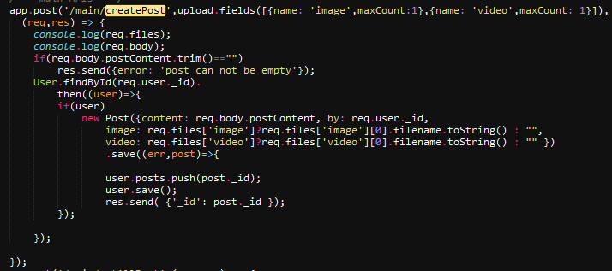

* Implementation of messenger

The messenger allows user to chat with each other. User can chat with the people they are following. We used socket.io for message send and received notification which helps us to create a relative instant messaging service which is socke.io event driven. It’s not required to refresh the page to see the new message; socket.io is always listening for new events. A technology called ajax polling is used to update a part of a web page on any change without refreshing the entire page. The same socket can use used by all the other component for live notification which is not completed yet so far because nodejs socket.io has a memory leak issue. Currently there are better websockets but they works only on secured socket layer or SSL. We don’t have fund to buy a webhosting server with https ( SSL certificate ).

* Implementation of Timeline

The timeline is a component which displays all the information and activity of a user. Anybody can goto his timeline url and see their posts, shares, profile picture, cover picture, followers.

The timeline component is using 4 small AJAX api calls to server to fetch user information and they are :-

a), fetching basic user information like name,email,date created and so on,

b) fetching all the post sorted by time stamp ,

c) fetching all the shared post shorted by timestamp,

d) fetching all the followers

* Implementation of search USER

Users can search and follow other users in adderNet. Our search query matches all the fields such as user id, name, surname, email id, phone no,

* Implementing the news feed

Newsfeed is currently display all the post of the users currently the user following sorted by time stamp.

* Nearest Friend Notification **[ unable to implement without SSL Certificate ]**

We planned to implement finding out nearest friend within 1 km radius and inform user according to their location if they want with the help of google geolocation api. But google geolocation/map API requires a secured server with https which is not possible without buying a domain, server and SSL Certificate.

# **APPENDIX ( Code with appropriate comments )**

**Code ( ExpressJS api server core APIS )**

/*** ALL APIS, @author: arpanp_athak,tirthamouli_baidya,subhamoy_sarkar ***/

/*** import your models here ***/

/*** | =======================================IMPORTS============================================================== |***/

const mongoose = require('mongoose');

const User=mongoose.model('user');

const Post=mongoose.model('post');

const Comment=mongoose.model('comment'),

Message=mongoose.model('Message');

const Conversation=mongoose.model('Conversation');

const config=require('./config/keys');

const helpers=require('./lib/helpers');

const multer = require('multer');

const path = require('path');

var storage = multer.diskStorage({

destination: function (req, file, cb) {

cb(null, 'uploads/')

},

filename: function (req, file, cb) {

console.log(file.originalname);

cb(null, Date.now() + "."+file.mimetype.split("/")[1]) //Appending extension

}

})

let upload = multer({ storage: storage });

/*** ============================================================================================================ ***/

/* internal API */

// this piece of code is moved to /lib/helpers.js file

/* end of this section */

// all server API ..

module.exports = (app,passport,io) => {

require('./sockets/socket-routes.js')(io);

const Online=require('./models/online-model');

Online.remove({},()=>{

console.log("Cleared Online");

});

/// NOTE : -- socket.io added to this file.. you can emit any method to connected socket..

// an API to get all the details about the developers/creators ...

app.get('/creators', (req, res) => {

const creators = [

{id: 1, firstName: 'Arpan', lastName: 'Pathak'},

{id: 2, firstName: 'Tirthamouli', lastName: 'Baidya'},

{id: 3, firstName: 'Subhamoy', lastName: 'Sarkar'},

];

res.json(creators);

});

// an API to see whether the user is authenticated and authorized to view certain api or not...

app.get('/authenticated',(req,res) => {

// if user is authenticated then user will not be null in request object...

res.json({authenticated: req.isAuthenticated(), user: req.user, maxAge: req.session.cookie.maxAge });

});

//User Registration API...

app.post('/registerUser',(req,res) => {

User.findOne({ $or:[ {email: req.body.email},

{$and: [{aadharNo: {"$ne":""}},{aadharNo: {"$ne":null}},{aadharNo: req.body.aadharNo} ] },

{phone: req.body.phoneNo.toString()} ]} ,

//check if email Id already registered

(err,user)=>{

if(user){

let msg="";

if(user.email==req.body.email) msg+='email,';

if(user.aadharNo!=null && user.aadharNo!='' && user.aadharNo===req.body.aadharNo.toString()) msg+='aadharNo,';

if(user.phone===req.body.phoneNo.toString()) msg+='phone no,';

msg+=' already registered';

res.json({"status":"failed","error": msg});

}

else{

//Sanity check

var email = req.body.email.match(/^[a-zA-Z0-9.!#$%&’*+/=?^_`{|}~-]+@[a-zA-Z0-9-]+(?:\.[a-zA-Z0-9-]+)*$/) !== null ? req.body.email : false;

var password = typeof(req.body.password) == 'string' && req.body.password.length > 7 ? req.body.password : false;

var phone = req.body.phoneNo.toString(),aadharno,aadharNo=req.body.aadharNo.toString(),

name=req.body.firstName+" "+req.body.lastName;

// after sanity checking....

if(name && email && password && phone ){

//hashing password

var hash = helpers.hash(password);

//Store user

new User({'name': name,'email':email,'password':hash,'aadharNo': aadharNo,

date_created: Date.now(),'phone': phone})

.save((newUser)=>{

// if new uer is null then there is a problem in database...

!newUser? res.json({"status" : "success","error":""}) :

res.json({"error" : "Unable to create user"});

}

);

}else{

res.json({"error" : "Invalid email and password type"});

}

}

}

);

});

// use this as auth failed callback URL....

app.get('/authFailed',(req,res)=>res.json({'error': 'authentication failed!'}));

// API to send OTP... currently using free twilio message service...

app.get('/sendOTP',(req,res)=> helpers.sendTwilioSms("+919099994016","apni vogoban dada, ei nin OTP ="+helpers.RandomStringGenerate(6),

(err)=> res.send(err?err:'sent') )

);

/*** =================================================================== ===============================================***/

/*** authentication API ***/

// this is the login api, here use passportJS callbacks to authenticate using

// any strategy you want.. to add OAuth strategy , edit the required setup file...

// EmailOTP will be added after implementing sendEmail( ) helper function...

app.post('/login',passport.authenticate(['email-local','phone-local'],{failureRedirect: '/authFailed' }),

(req,res) => {

res.json( {'loggedin' : true } );

});

// logout api

app.get('/logout',(req,res) => {

req.session.destroy();

req.logout();

res.json({ message: 'logged out','status': 'logged out'}) ;

io.emit('logout',{data: 'test'});

});

//implementing music api

app.get('/music',(req,res) => {

//res.json({authenticated: req.isAuthenticated(), 'usern': req.user.name });

res.json({usernm: "", userem: req.user.email });

//res.json({'email':req.user.email});

});

// google oauth API

app.get('/auth/google', passport.authenticate('google', {

scope: ['profile','email']

}));

// google OAuth callback URI

app.get('/auth/google/callback',

passport.authenticate('google',{ failureRedirect: '/authFailed',successRedirect: 'http://localhost:3000/profile' }),

// This part of code will only be executed if successRedirect is not set in passport.authenticate()

(req,res) => res.send(helpers.json_to_html(req.user))

);

// facebook OAuth API

app.get('/auth/facebook',passport.authenticate('facebook'));

// facebook OAuth callback URI...

app.get('/auth/facebook/callback',

passport.authenticate('facebook', { failureRedirect: '/authFailed',successRedirect: 'http://localhost:3000/profile' }),

// This part of code will only be executed if successRedirect is not set in passport.authenticate()

(req,res)=> { req.session.save((err)=>res.send(helpers.json_to_html(req.user)) ) }

);

/*** =========================================================================================================== ***/

/*** user info API ***/

app.post('/user/changeDp',upload.fields([{name: 'image',maxCount:1}]),(req,res)=>{

User.findByIdAndUpdate( req.user._id, { profilePic: req.files['image'][0].filename.toString() }).

then((user)=>res.send( { 'changed': true,profilePic: req.files['image'][0].filename.toString()} ));

});

app.post('/user/changeCoverPic',upload.fields([{name: 'image',maxCount:1}]),(req,res)=>{

User.findByIdAndUpdate( req.user._id, { coverPic: req.files['image'][0].filename.toString() }).

then((user)=>res.send( { 'changed': true,coverPic: req.files['image'][0].filename.toString()} ));

});

app.post('/user/addFriend',(req,res)=>{

User.findById(req.user._id).then((user)=>{

user.friends.push(req.body._id);

user.friend_requests_send.push(req.body._id);

User.findById(req.body._id).

then((friend_request_user)=>{

friend_request_user.friend_requests.push(req.user._id);

friend_request_user.save();

user.save().then(res.send({added: true}));

});

});

});

/*** ====================================================================================end of this section ***/

/*** user post APIs ***/

app.get('/allPost',(req,res)=> {

// Post.remove({},(err)=>{ res.send({fuck: true}) });

Post.find({}).then((posts)=>res.send(posts));

});

/*** main APIs ***/

app.post('/main/createPost',upload.fields([{name: 'image',maxCount:1},{name: 'video',maxCount: 1}]),

(req,res) => {

console.log(req.files);

console.log(req.body);

if(req.body.postContent.trim()=="")

res.send({error: 'post can not be empty'});

User.findById(req.user._id).

then((user)=>{

if(user)

new Post({content: req.body.postContent, by: req.user._id,

image: req.files['image']?req.files['image'][0].filename.toString() : "",

video: req.files['video']?req.files['video'][0].filename.toString() : "" })

.save((err,post)=>{

user.posts.push(post._id);

user.save();

res.send( {'_id': post._id });

});

});

});

app.get('/main/getAllPost',(req,res) => {

User.findById(req.user._id).populate( [

{ path: 'posts',

populate: {

path: 'comments',

populate: {path: 'by', select: 'name profilePic'}

}

},

{ path: 'posts',

populate: {

path: 'by',

select: 'name profilePic'

}

},

]).

then((user)=>{

if(user)

res.send(user.posts);

});

});

app.post('/main/getAllSharesById',(req,res) => {

User.findById(req.body._id).populate( [

{ path: 'shares',

populate: {

path: 'comments',

populate: {path: 'by', select: 'name profilePic'}

}

},

{ path: 'shares',

populate: {

path: 'by',

select: 'name profilePic'

}

},

]).

then((user)=>{

if(user)

res.send(user.shares);

});

});

app.post('/main/getAllPostById',(req,res) => {

User.findById(req.body._id).populate( [

{ path: 'posts',

populate: {

path: 'comments',

populate: {path: 'by', select: 'name profilePic'}

}

},

{ path: 'posts',

populate: {

path: 'by',

select: 'name profilePic'

}

},

]).

then((user)=>{

if(user)

res.send(user.posts);

});

});

app.post('/main/sharePost',(req,res)=>{

User.findById(req.user._id).then((user)=>{

user.shares.push(req.body._id);

user.save();

Post.findById(req.body._id).then((post)=>{

post.shared_by.push(req.user._id);

post.save().then(res.send( { 'shared': true}));

});

});

})

app.post('/main/addComment',(req,res)=>{

Post.findById(req.body._id).then((post)=>{

var comment = new Comment({postId: req.body.id,content: req.body.content, by: req.user._id});

new Comment({content: req.body.content, by: req.user._id})

.save((err,comment)=>{

post.comments.push(comment._id);

post.save().then(()=>

res.send({added: true, content: comment.content, by: req.user.name})

);

});

});

});

app.post('/main/addLike',(req,res)=>{

Post.findById(req.body._id).then((post)=>{

post.likes.push(req.user._id);

post.save().then(()=>res.send({added: 'added'}));

})

});

app.post('/main/addDislike',(req,res)=>{

Post.findById(req.body._id).then((post)=>{

post.dislikes.push(req.user._id);

post.save().then(()=>res.send({added: 'added'}));

})

});

app.post('/main/sharePost',(req,res)=>{

User.findById(req.user._id).then((user)=>{

user.shares.push(req._id);

post.save().then(()=>res.send({added: 'added'}));

})

});

app.post('/main/updatePost',(req,res) => {

Post.findByIdAndUpdate(req.body._id,{content: req.body.content})

.then(res.send({updated: 'true'}));

});

app.post('/main/updatePost',(req,res) => {

Post.findByIdAndUpdate(req.body._id,{content: req.body.content})

.then(res.send({updated: 'true'}));

});

app.post('/main/deletePost',(req,res) => {

Post.findByIdAndRemove(req.body._id,()=> {

User.findById(req.user._id).then((user)=>{ user.posts.pull({_id: req.body._id})

user.save();

Comment.remove({postId: req.body._id});

res.send({deleted: 'true'})

});

});

});

/** ================================================================ **/

/** end of this section **/

/*** ___________________message sending and retreiving APIs.____________________________ ***/

app.get('/main/getAllMessages',(req,res) => {

User.findById(req.body._id).populate('messages').then((messages)=>{ res.send(messages)});

});

app.get('/t',(req,res)=> Conversation.find({}).then(conversation=>res.send(conversation)) );

app.post('/main/getConversation',(req,res) => {

let conversation_id= (req.user._id<req.body.to)?

(req.user._id+"_"+req.body.to) : (req.body.to+"_"+req.user._id);

console.log(conversation_id);

console.log(req.body.to);

Conversation.findById(conversation_id).populate('messages').then(conversation=>{

if(!conversation){

conversation=new Conversation({_id: conversation_id });

conversation.save();

}

res.send(conversation.messages );

} );

});

app.post('/main/sendMessage',(req,res)=>{

let conversation_id= (req.user._id<req.body.to)?

(req.user._id+"_"+req.body.to) : (req.body.to+"_"+req.user._id);

if(req.body.to.trim()=="")

conversation_id=req.user._id; //

var msg=new Message({data: req.body.data,by: req.user._id,to: req.body.to });

msg.save();

Conversation.findById(conversation_id).then(

conversation=>{

conversation.messages.push(msg);

conversation.save().then( ()=>{

Online.find({id: req.body.to}).then((onlineData)=>{

onlineData.forEach((onlinePerson)=>{

io.to(onlinePerson.socket).emit('message-received',msg);

});

});

Online.find({id: req.user._id}).then((onlineData)=>{

console.log('emiting to '+req.user._id);

onlineData.forEach((onlinePerson)=>{

io.to(onlinePerson.socket).emit('sent',msg);

});

});

res.send({ sent: true })

});

}

)

});

/*** ======================END======================================***/

app.get('/currentUser',(req,res)=> User.findById(req.user._id).then((user)=>res.send(user)));

app.post('/getUserById',(req,res)=> User.findById(req.body._id).then((user)=>res.send(user)));

app.post('/main/getAllFriends', (req,res)=>{

User.findById(req.body._id).populate({

path: 'friends',

select: 'name profilePic coverPic'

}).then((user)=>res.send(user.friends));

});

app.post('/main/getAllFriendsId', (req,res)=>{

User.findById(req.body._id).

then((user)=>res.send(user.friends));

});

app.get('/newsFeed',(req,res)=>{

User.findById(req.user._id).populate({

path: 'friends',

select: 'posts'

}).then(user=>res.send(user.friends)); // user.friends is now populated list of posts of all the friends...

});

app.get('/searchUser',(req,res)=>{

let name=req.query.name;

User.find({$or:[{name: new RegExp(name, "i")},{email: new RegExp(name, "i")}]},null,{sort:'_id'})

.select('name').select('profilePic')

.then((users)=>{

res.send(users);

} );

})

/*** ......................... **/

// Test API

//importing the unit test file....

require('./tests.js')(app);

}

/*

* Search for friend below here

*

*/

// app.get('/searchFriend',(req, res)=>{

// name = typeof(req.query.name) == 'string' && req.query.name.trim().length > 0 ? req.query.name.trim() : false;

// if(name){

// helpers.searchFriend(name, (err, data)=>{

// if(!err && data){

// res.json(data);

// }else{

// res.send("No data found");

// }

// });

// }else{

// res.send("Error: Please enter valid search name");

// }

// });

The remaining portion of code is confedential and it can not be