**Screenshots of the implementation:**

**URL** - <http://localhost:9090/NetsTestApplicationDevelopment/>

1. Below is the home page of the implementation where I am pulling the header text (Welcome to the ……) from the REST service through a REST call.

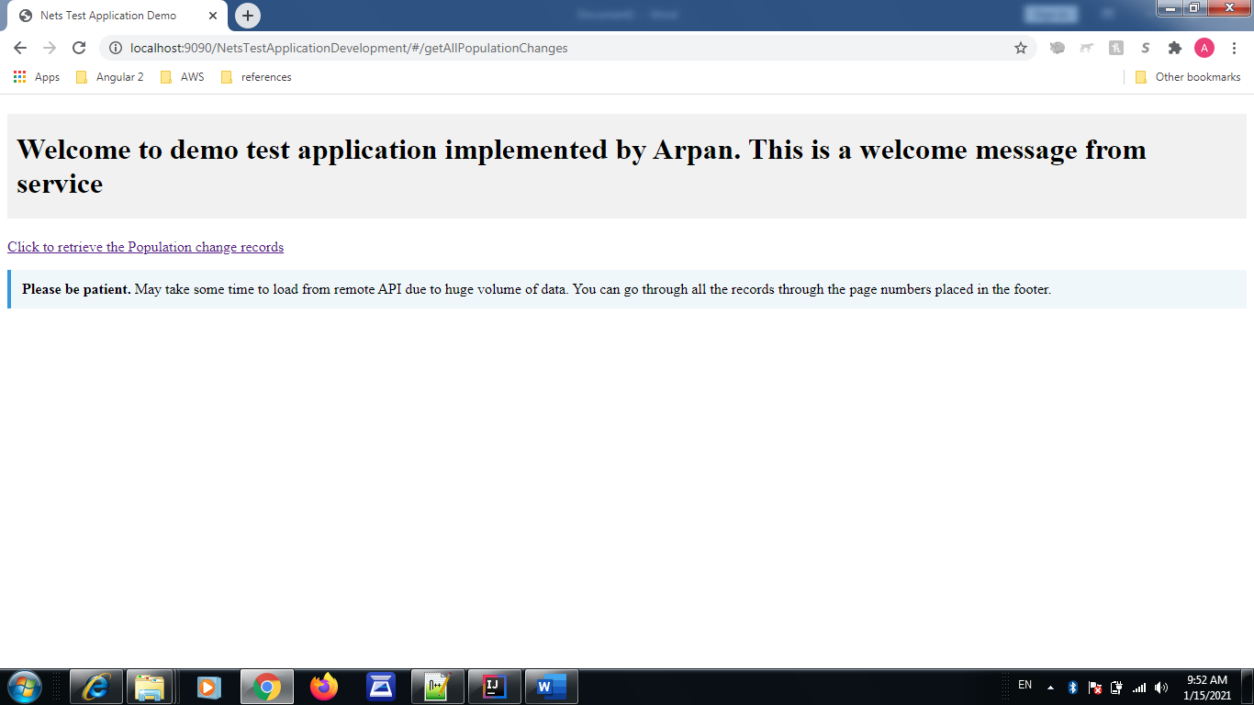

1. Next, on clicking the hyperlink (Click to retrieve…), I have implemented a service which gets invoked and fetches the data from remote API (*used the same API as given in problem statement*) > Parses the data and draws a table below with respective rows.

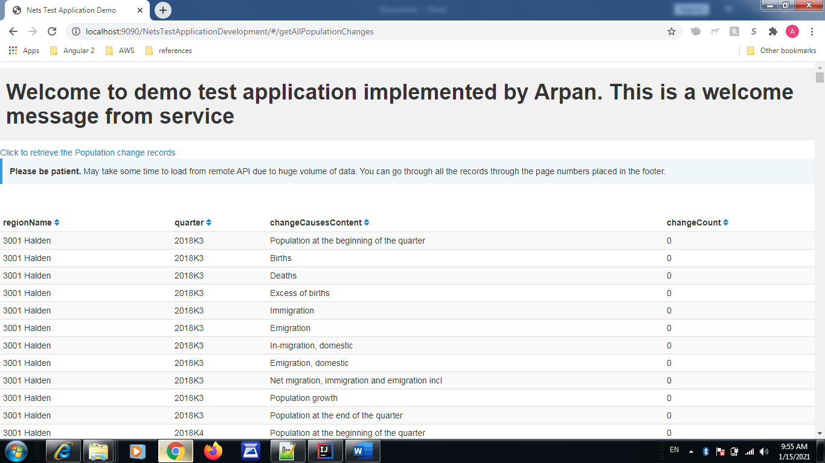

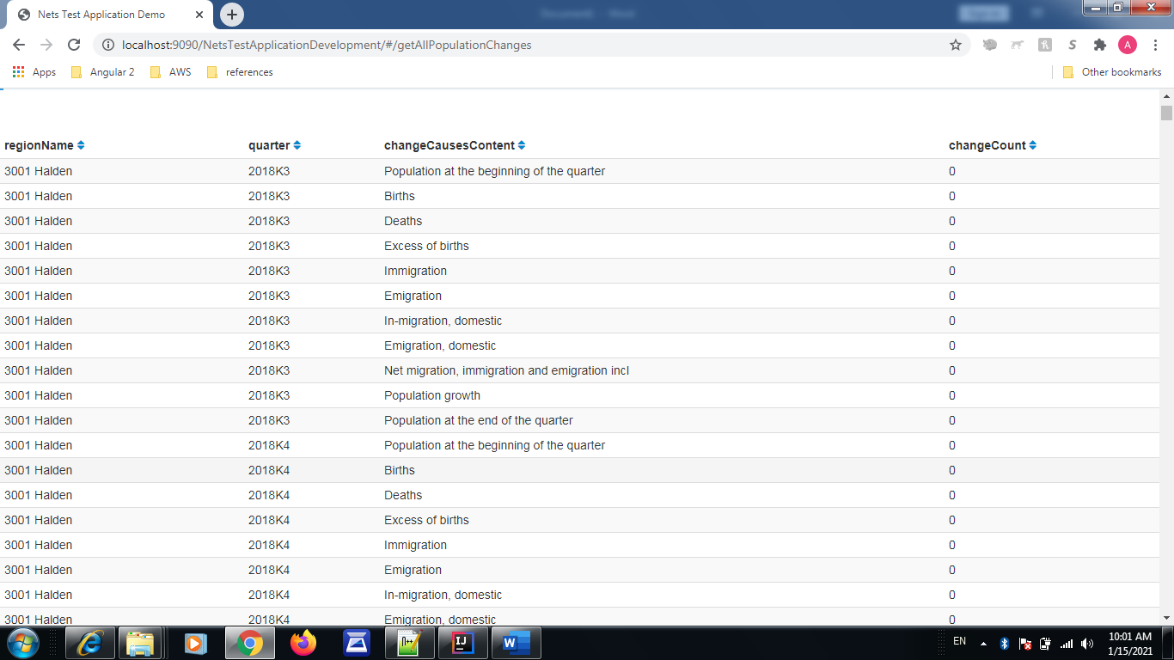



1. Since, the volume of data fetched from given remote API is very huge (around 66000 approx.), I have implemented with pagination to scroll through pages, distributing 1000 records on each page.

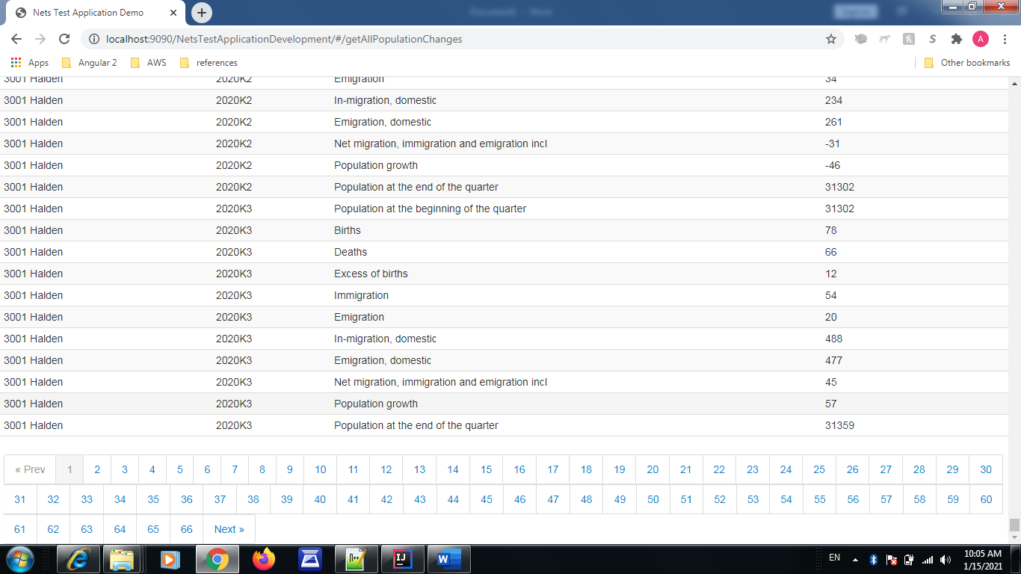

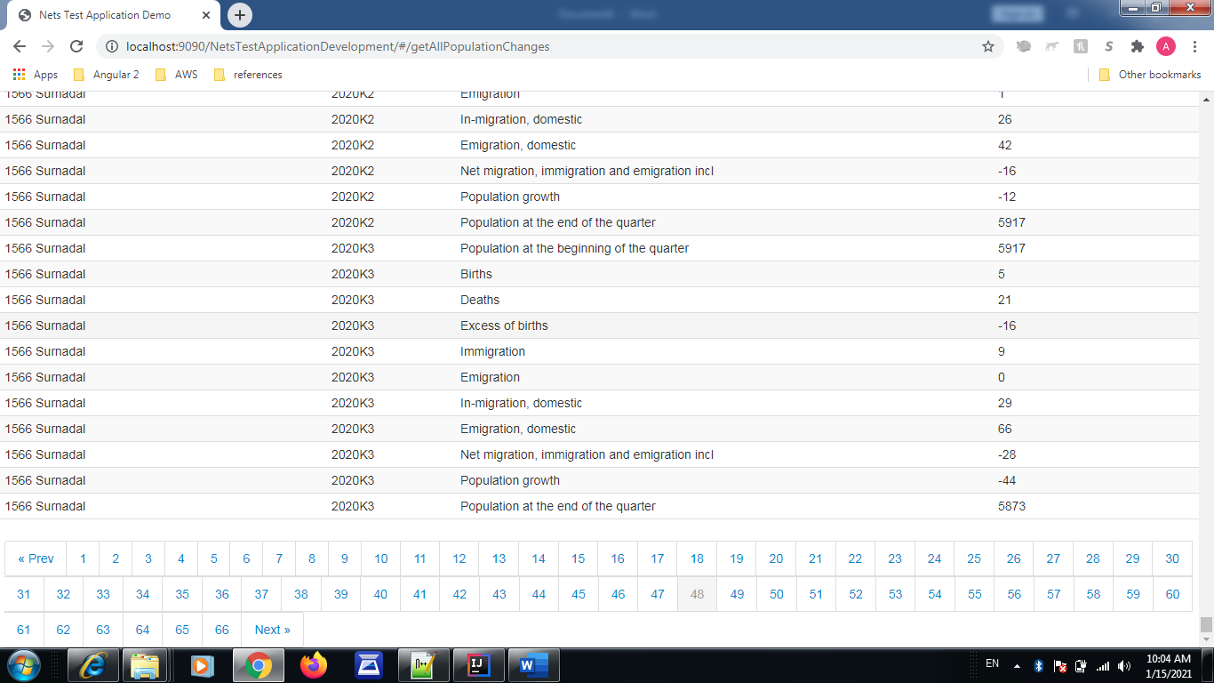

1. To have a good user experience and better data review, I have also implemented with sorting

(with up/down arrow) on each column header. With these up/down arrows each respective columns can get sort in ascending or descending order on a records populated in a current page.

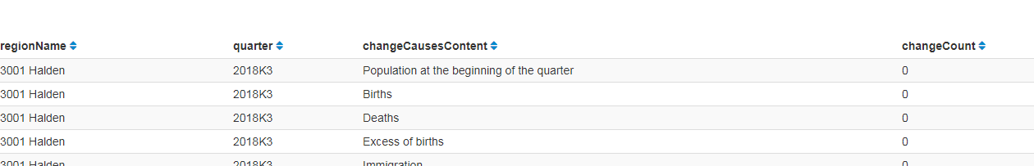

1. Also implemented with the page with a responsive behavior using bootstrap libraries so that the page can be adjusted as per device screen size. Below is screenshot taken reducing the size of the page (you can see the contents of the page got adjusted to the screen area accordingly). Though I understand that the accurate testing can be done through device emulator.

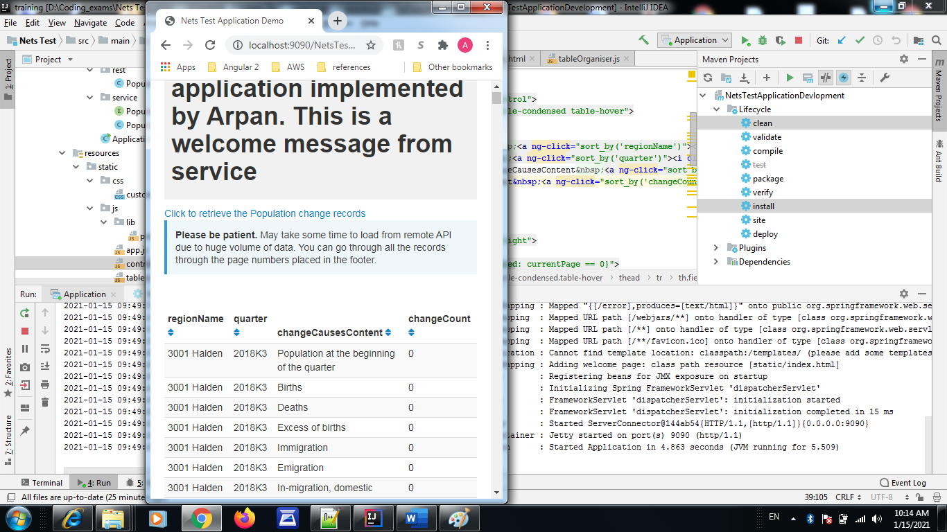

**Tech screenshots:**

Code structure:

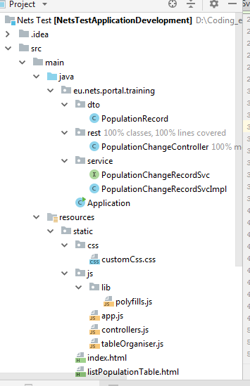

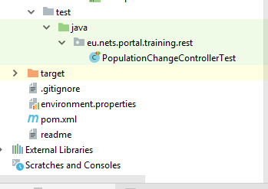

Controller test case run with coverage as 100%:

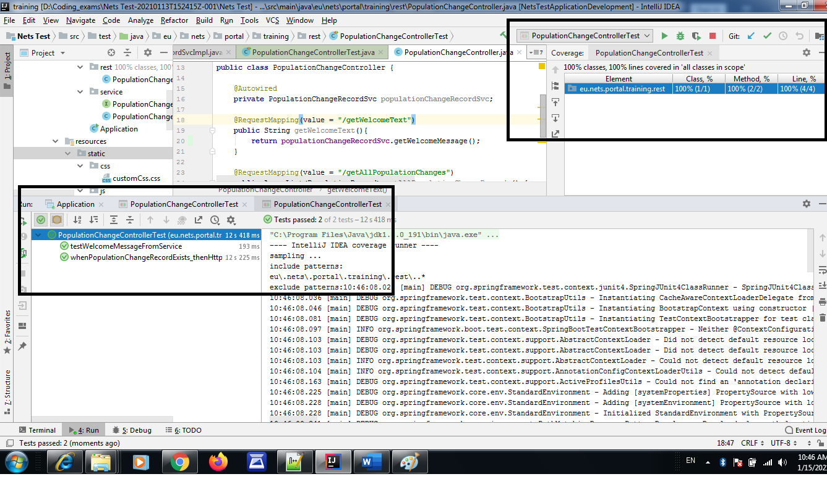

Server run:

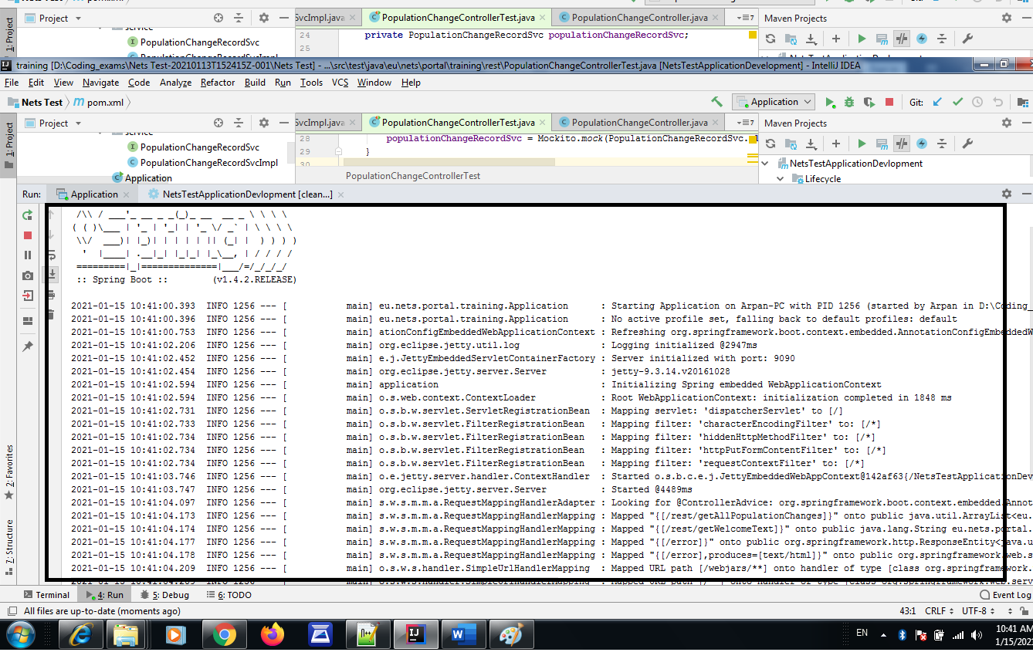

Application build:

