ABC RETAIL SOLUTIONS
Data Engineering Pipeline

  - PROJECT DOCUMENTATION
Platform | Microsoft Fabric (Trial)
Language | PySpark / SQL
Storage | Delta Lake (OneLake)
Dashboard | Power BI (DirectLake)
Client | ABC Retail Solutions
Assessment | NeoStats Data Engineering Internship

Table of Contents

- Executive Summary

- Architecture
  - Diagram
  - Medalion Architecture
  - Tech Stack

- Data Flow Diagram

- Data Model

- Assumptions Made

- Pipeline Stages
  - Stage 1: Ingestion
  - Stage 2: Transformation and Cleaning
  - Stage 3: PII Masking
  - Stage 4: Enrichment
  - Stage 5: Revenue Calculations
  - Stage 6: Aggregation (Gold tables)

- Power BI Stage
  - KPIs
  - Visual Insights

- Notebook Cell Reference

- Scalability and Production Considerations

- GitHub Repository Structure

Executive Summary:
ABC Retail Solutions, a multinational retail company, operates across multiple cities through both online and offline sales channels. The organization collects transactional retail data from various systems; however, inconsistencies in the dataset such as duplicate transactions, missing values, inconsistent product naming conventions, invalid quantities, and varying date formats have created challenges in generating accurate business insights. Without a standardized and reliable data pipeline, the company faces difficulties in analysing revenue trends, identifying bestselling products, monitoring category performance, and making data-driven business decisions.
This project delivers a complete end-to-end data engineering pipeline built entirely within Microsoft Fabric. The pipeline ingests raw Excel files into a Lakehouse, applies a comprehensive cleaning and transformation workflow using PySpark, masks Personally Identifiable Information using SHA-256 hashing, and produces five pre-aggregated Gold Delta tables that power an interactive Power BI dashboard. The total pipeline processes 8,401 transactions and yields a verified total revenue of 1.24 billion across four product categories and five cities.

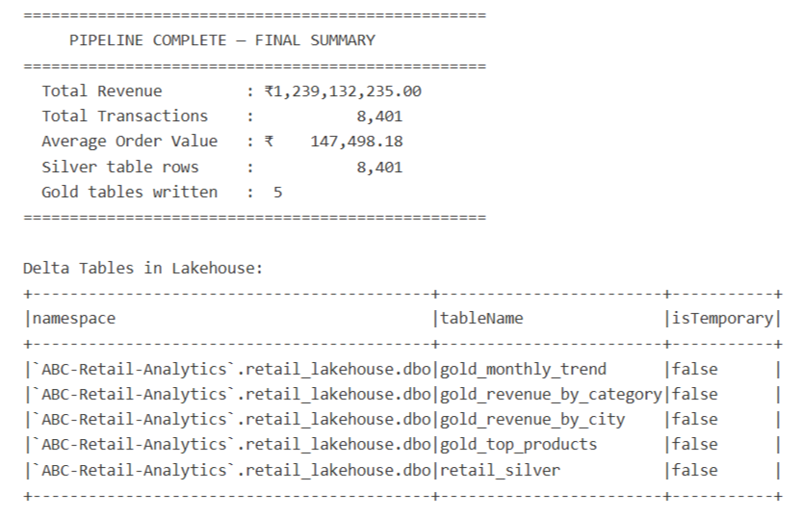
Pipeline Summary:
(retail_transformation_notebook.ipynb)

Architecture:
The solution uses an entirely Fabric-native architecture. Every component such as storage, compute, SQL serving, and reporting, lives within a single Microsoft Fabric workspace.
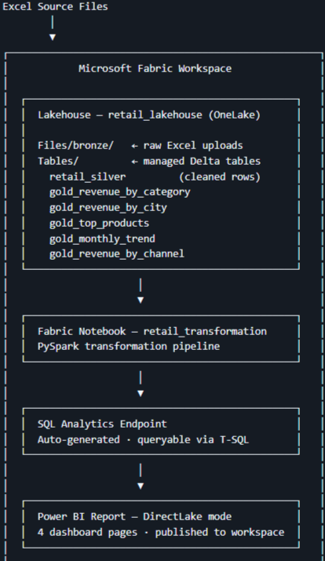
- Diagram: (Github Screenshot)
- Medalion Architecture:
Zone | Location | Description
Bronze | Files/bronze/ | Raw Excel files exactly as received. No transformations applied. Serves as the immutable source of truth.
Silver | Tables/retail_silver | Cleaned, deduplicated, PII-masked, enriched, and revenue-calculated dataset. One row per valid transaction.
Gold | Tables/gold_* | Pre-aggregated KPI tables grouped by category, city, product, month, and sales channel. Directly consumed by Power BI.

(Claude Generated)

- Tech Stack:
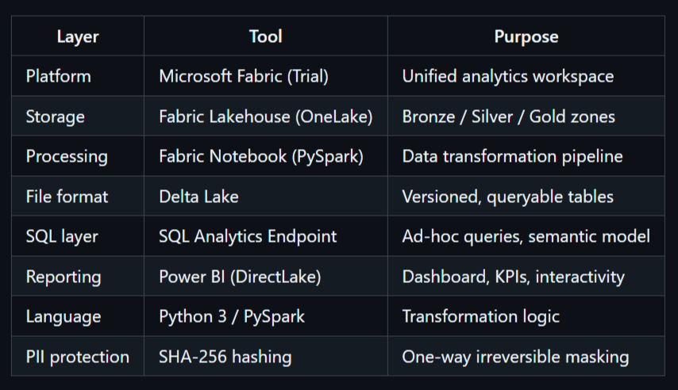
(From Github README.md, Screenshot)

Data Flow Diagram:

[retail_data1.xlsx] [retail_data2.xlsx] [product_details.xlsx]
| | |
+--------------------+ |
| |
pandas read_excel() |
| |
spark.createDataFrame() |
| |
unionByName() <-- stacks both sources |
| |
dropDuplicates() |
| |
fillna() + filter(qty > 0) |
| |
initcap(trim()) + date parsing |
| |
category mapping (Elec->Electronics etc.) |
| |
sha2(email, 256) + sha2(phone, 256) |
| |
+------- LEFT JOIN -----------------+
| (on product_id)
|
revenue = (price - discount*price) * qty
|
filter(revenue >= 0)
|
saveAsTable('retail_silver') [Silver zone]
|
+--------+--------+----------+----------+
| | | | |
gold_ gold_ gold_ gold_ gold_
category city products monthly channel
| | | | |
+--------+--------+----------+----------+
|
Power BI DirectLake (reads Delta live)
|
[3-page interactive dashboard]
(Claude Generated)

Data Model:
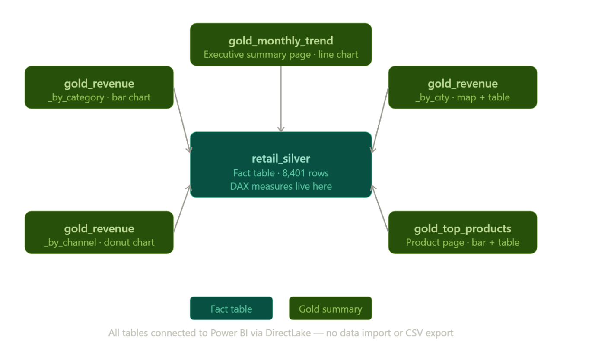
(Claude generated)

Assumptions Made:
- Rows with quantity <= 0 are treated as returns or invalid entries and excluded from analysis.
- Missing city, category, and ‘payment_method’ values are filled with 'Unknown' rather than dropped, to preserve transaction revenue records.
- Where “price” is missing, the “standard_product_price” from the product dimension table is used as a substitute.
- Date strings in GregorianCalendar object format (YEAR=2024,MONTH=0,...) are parsed separately and merged with standard date formats.
- Category abbreviations ("Elec", "Furn") are treated as data entry errors and mapped to their full standard names.
- The pipeline is designed to be idempotent — re-running it always produces the same output (Delta tables use overwrite mode).

Pipeline Stages:

(from github)

Stage 1 Ingestion
Raw Excel files are uploaded manually into the Files/bronze/ folder of the Fabric Lakehouse. This simulates a production ingestion layer where files would arrive from source systems automatically. Files are read into PySpark DataFrames using pandas (for reliable .xlsx support) and then converted to Spark DataFrames via spark.createDataFrame().

Stage 2 Transformation and Cleaning
The following cleaning operations are applied in sequence:
Issue | Resolution
Inconsistent column names | Stripped, lowercased, spaces replaced with underscores
Duplicate rows | Removed using dropDuplicates()
Missing categorical values | Filled with 'Unknown' (city, category, payment_method)
Missing customer info | Filled with 'Not Provided'
Invalid quantity (≤ 0) | Rows removed — represent returns or data entry errors
Inconsistent text casing | Standardized to Title Case using initcap(trim())
Abbreviated category values | Mapped to full names (e.g. "Elec" → "Electronics")
Mixed date formats | Parsed using coalesce() across multiple to_date() patterns
GregorianCalendar date strings | Extracted with regexp_extract() and reconstructed with make_date()

Stage 3 PII Masking
Customer email and phone columns are masked using SHA-256 hashing via PySpark's built-in sha2(col, 256) function. The original columns are dropped and replaced with email_masked and phone_masked. SHA-256 was chosen over simple redaction because it is:
- One-way — cannot be reversed to recover the original value
- Consistent — the same input always produces the same hash (useful for counting unique customers without exposing PII)
- Standards-compliant — satisfies data protection requirements including India's DPDP Act
Stage 4 Enrichment
The cleaned transaction data is left-joined with the product_details dimension table on product_id. This adds standardized product names and category information. Missing unit prices are back-filled from the standard_product_price column in the dimension table.

Stage 5 — Revenue Calculation
revenue = (price – discount*price) × quantity
Rows with negative revenue (returns or errors) are removed after calculation.

Stage 6 — Aggregation (Gold tables)
Five Gold Delta tables are written for direct Power BI consumption:
Table | Grain | Key Metrics
gold_revenue_by_category | Category | total_revenue, transaction_count, avg_order_value
gold_revenue_by_city | City | total_revenue, transaction_count, unique_customers
gold_top_products | Product | units_sold, total_revenue
gold_monthly_trend | Year + Month | monthly_revenue, transaction_count
gold_revenue_by_channel | Sales channel | total_revenue, transaction_count

Power BI Stage:
KPIs:
- Total Revenue = SUM(retail_silver[revenue])
- Total Transactions = COUNTROWS(retail_silver)
- Avg Order Value = DIVIDE([Total Revenue], [Total Transactions], 0)
- Revenue MoM % = VAR cur = [Total Revenue]
VAR prev = CALCULATE([Total Revenue], DATEADD(retail_silver[transaction_date], -1, MONTH))
RETURN DIVIDE(cur - prev, prev, 0)
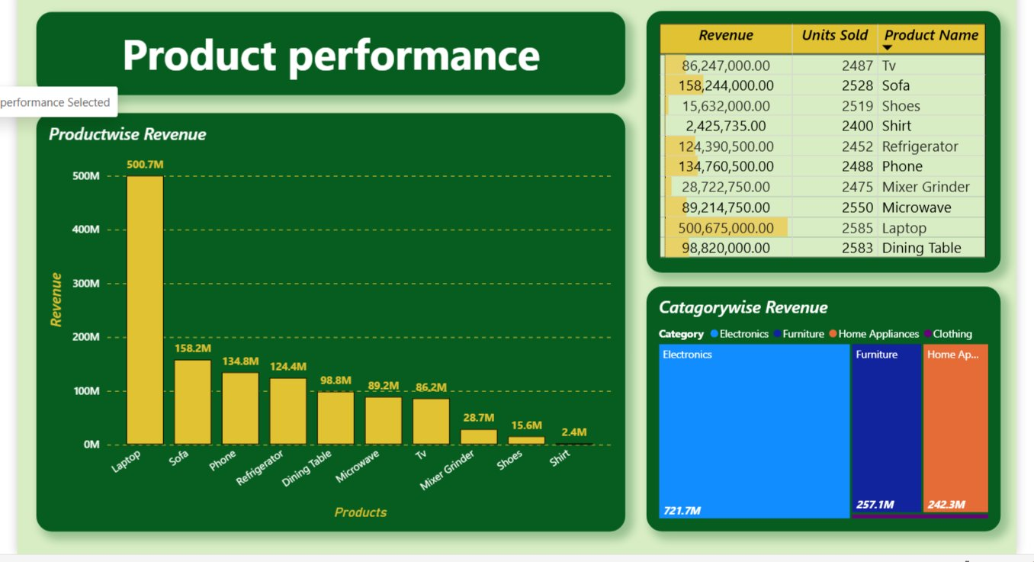
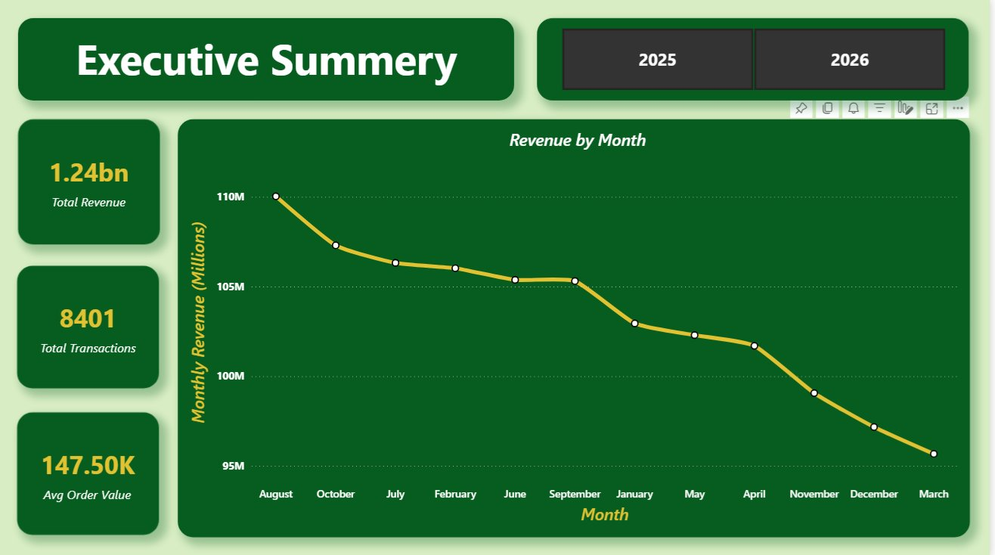
Visuals:
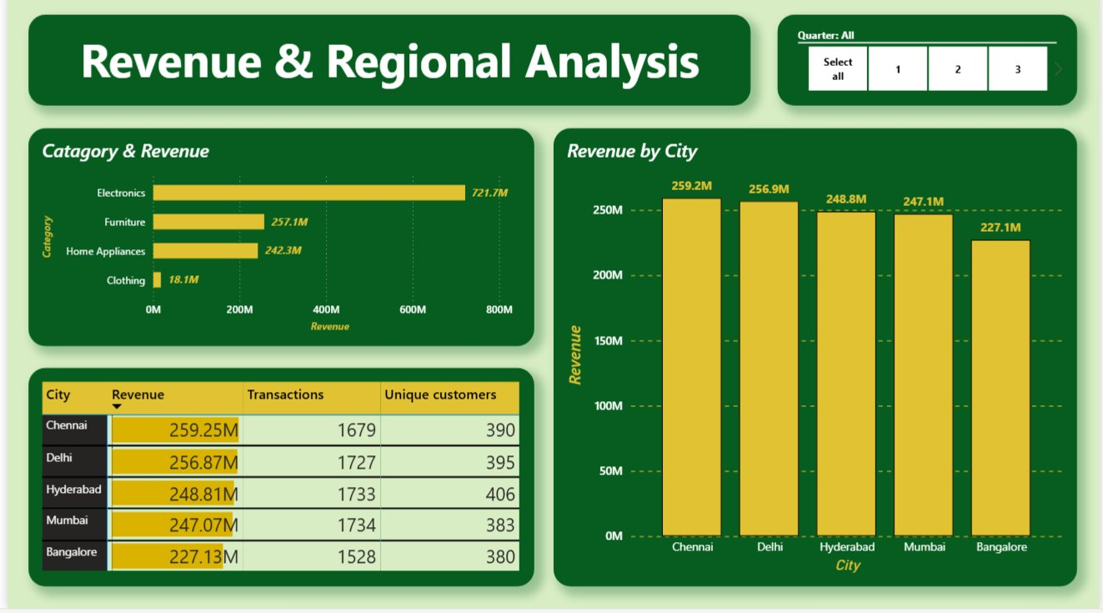

Notebook Cell Reference:
(from Github)
Cell | Purpose
Cell 1 | Read Bronze Excel files using pandas
Cell 2 | Convert pandas → Spark DataFrames
Cell 3 | Standardize column names
Cell 4 | Union retail_data1 and retail_data2
Cell 5 | Remove duplicate rows
Cell 6 | Handle missing values and invalid quantities
Cell 7 | Standardize text, parse mixed date formats
Cell 7b | Standardize category abbreviations
Cell 8 | PII masking — SHA-256 hash email and phone
Cell 9 | Enrich with product dimension table
Cell 10 | Calculate revenue column
Cell 11 | Write Silver Delta table
Cell 12 | Write all Gold aggregation tables
Cell 13 | Final summary and validation printout

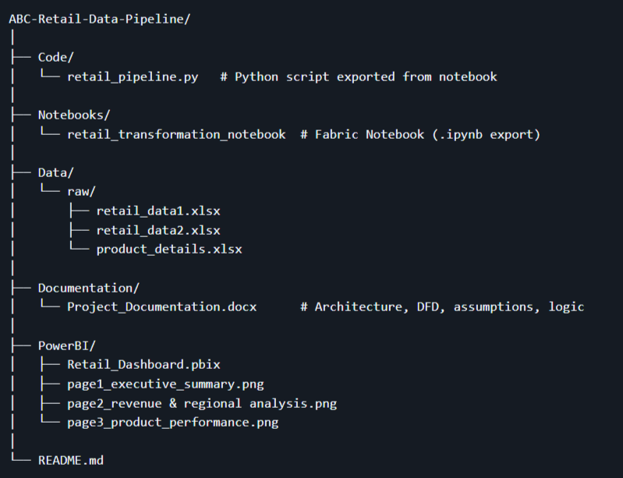
GitHub Repository Structure:

