Lightweight and Decoupled Distributed PUF-Based
Authentication for Multihop IoT Networks
Implementation Report — COOJA Simulation on Contiki-NG

Abstract
This report presents the implementation and simulation-based evaluation of a lightweight and decoupled distributed authentication scheme for resource-constrained multihop IoT networks. The proposed scheme utilizes Physically Unclonable Functions (PUF) for device-specific authentication, hash-based one-way accumulators for membership verification, and session-based random values for authentication mask updates. Authentication responsibilities are shared among both parent and non-parent IoT nodes (authentication servers), authorized by the gateway, preventing any single node from being overburdened. The scheme operates through three main phases: Node Enrollment, Node Authentication, and Session Key Exchange with Authentication Mask Update. The implementation is realized using CoAP over Contiki-NG OS and evaluated through COOJA simulation with a 100-node network deployment. Results demonstrate successful authentication of all 20 newly joined devices with energy consumption in the range of 0.019–0.036 Joules per device, confirming the scheme's lightweight and efficient nature.
Keywords: IoT Authentication, PUF, Hash-based Accumulator, Decoupled Distributed, Multi-hop Networks, CoAP, Contiki-NG, COOJA Simulation

I. Introduction
The Internet of Things (IoT) connects millions of smart devices that collect and transmit data to centralized platforms such as gateways for decision making. However, IoT nodes are often deployed in adverse conditions, making authentication inevitable before communication. As these IoT nodes are battery-powered and resource-constrained, the authentication scheme should have a lightweight yet secure design.
In the literature, distributed authentication schemes enable multiple entities in a multihop IoT network to perform authentication while distributing responsibilities across various points. However, schemes that assign parent IoT nodes as authentication servers may overwhelm them with recurring requests. This bottleneck can be mitigated by a decoupled distributed design, where non-parent IoT nodes share authentication duties with parent nodes — meaning any IoT node in the network can be authorized by the gateway to authenticate newly joined nodes.
This report presents the implementation of such a decoupled distributed authentication scheme with the following key features:
- PUF-based authentication eliminates the need for long-term storage of secret keys
- Hash-based one-way accumulator provides efficient membership verification
- Session-based random values prevent adversarial prediction through interception
- Lightweight operations (hash, XOR, two AES encryptions) minimize computational overhead
- Pseudonym-based communication preserves device anonymity
- Decoupled architecture distributes authentication load across the network

II. System Model and Architecture
The proposed scheme operates in a multihop IoT network consisting of three types of entities:
Gateway (GW): The central trusted entity that serves as the RPL root node. It selects authentication servers, shares secret keys with them (K_GW-AS), and manages session keys with authenticated devices. Node ID: 1.
Authentication Server (AS): A resource-constrained IoT node authorized by the gateway to authenticate newly joined nodes. AS may be a parent or non-parent node, located at single-hop or multi-hop distance from the device being authenticated. It shares a pre-established secret key with the gateway (K_GW-AS) and the device (K_AS-D). Node ID: 2.
Device Node (D): A newly joined IoT node seeking to authenticate with the network. Each device is embedded with a PUF and possesses a unique private secret value y_D. Device nodes have IDs starting from 3 onward.
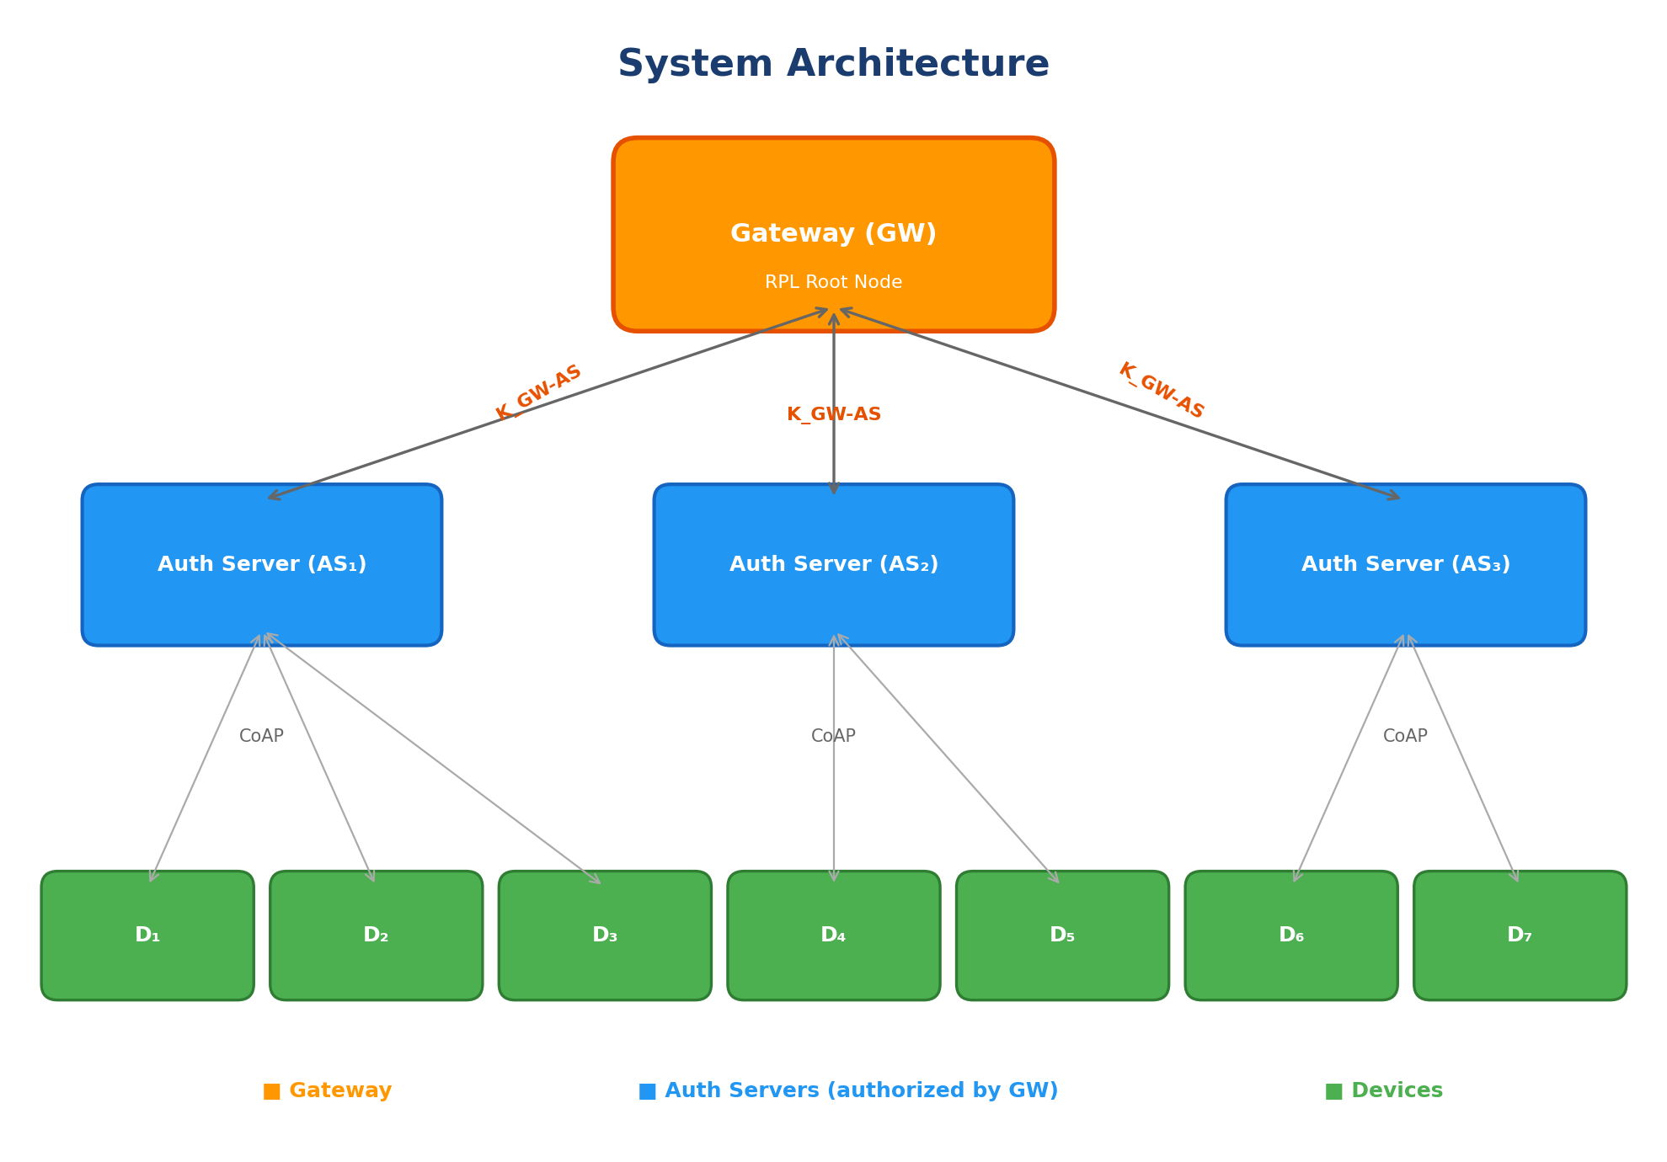
Figure 1: System Architecture — Gateway, Authentication Servers, and Device Nodes

III. Prerequisites

A. Physically Unclonable Function (PUF)
A PUF operates as a one-way function that maps a challenge C to a unique response R, leveraging inherent hardware variations in the IoT device. The response is device-specific and infeasible to clone or replicate. Key properties of PUF include:
- Evaluatable: A node with a legitimate PUF can efficiently compute R = PUF(C)
- Unpredictability: An attacker cannot guess R better than random without PUF access
- Uniqueness: Two different PUF instances never produce the same response for a given challenge
- Reliability: Same challenge always produces the same response on the same device
- One-Wayness: Inverting a response R to obtain the challenge C is infeasible
In the implementation, PUF is simulated using a deterministic hash-based function that combines the node ID with the challenge through multiplicative hashing, ensuring unique responses per device per challenge while maintaining reproducibility.

B. Hash-based One-Way Accumulator
A hash-based accumulator is a lightweight cryptographic construct where multiple elements are hashed and combined into a single compact value using bitwise AND operations. Individual elements can prove their membership within the accumulated value without revealing other values. The quasi-commutative property ensures the accumulation order does not affect the final value.
Given a set Y = {y₁, y₂, ..., yₘ}, each element yᵢ is hashed: Yᵢ = H(yᵢ). These hashed values are accumulated: T_acc = T_acc & Y₁ & Y₂ & ... & Yₘ. Membership verification: if (T_acc & H(yᵢ)) == T_acc, then yᵢ is a member. The accumulator is initialized to 0xFF...FF (all ones), so each AND operation progressively sets bits to zero, and membership checks verify consistency.

IV. Proposed Authentication Scheme
The proposed scheme consists of three main phases: (1) Node Enrollment Phase, (2) Node Authentication Phase, and (3) Session Key Exchange and Authentication Mask Update Phase. Table I summarizes the notations used throughout the scheme.
Notation | Description
H(.) | Collision-resistant SHA-256 hash function
SE(.)/SD(.) | AES-128-ECB symmetric encryption/decryption
PUF_D(.) | PUF function embedded in device D
PUF_AS(.) | PUF function embedded in authentication server AS
c_D | Challenge for device D issued by AS
c_AS-D | Challenge for AS issued by device D
R_D | PUF response: R_D = PUF_D(c_D)
R_AS | PUF response: R_AS = PUF_AS(c_AS-D)
y_D | Unique private secret of device D
Y_D^H | Hash of secret: Y_D^H = H(y_D)
m_D | Session-based random shared between D and AS
T_acc | AND-based accumulated value maintained by AS
Φ_AS-D | PUF binding: Φ_AS-D = R_AS ⊕ R_D
K_GW-AS | Shared secret key between GW and AS
K_AS-D | Shared secret key between AS and D (enrollment channel)
K_GW-D | Session key between GW and D
PID | Pseudonym: PID = H(ID_D || m_D)
ts₁, ts₂ | Timestamp components for freshness
ts_auth | Authentication completion timestamp
Table I: Notations Used in the Proposed Scheme

A. Node Enrollment Phase
The Node Enrollment Phase is the first phase undergone by a newly joined device D with its designated authentication server AS. This phase is executed over a secure (encrypted) channel established between D and AS using their shared key K_AS-D. Every newly joined node executes this phase once until it gets disconnected from the network. The main purpose is to enroll the unique secret of D (y_D) with the accumulated value (T_acc) of AS, so that during authentication, D can prove its membership.
The enrollment proceeds in two steps:
Step 1 — Registration Request (Reg-0): D initiates by sending its encrypted identity SE(K_AS-D, [ID_D | pad]) to AS (16 bytes). AS responds by generating a fresh random challenge c_D and session-based random m_D (32 bytes), sending them back encrypted: SE(K_AS-D, [c_D | m_D | pad]) as a 48-byte payload.
Step 2 — Secret Enrollment (Reg-1): D computes PUF response R_D = PUF_D(c_D) using the received challenge. D generates its unique private secret y_D and computes Y_D^H = H(y_D). D also selects a challenge c_AS-D for AS. D sends the encrypted payload SE(K_AS-D, [ID_D | Y_D^H | R_D | c_AS-D | pad]) (48 bytes) to AS. Upon receiving, AS updates the accumulator: T_acc = T_acc & Y_D^H. AS computes R_AS = PUF_AS(c_AS-D) and stores Φ_AS-D = R_AS ⊕ R_D. Finally, AS computes the initial pseudonym PID_curr = H(ID_D || m_D) and stores all enrollment data per device.
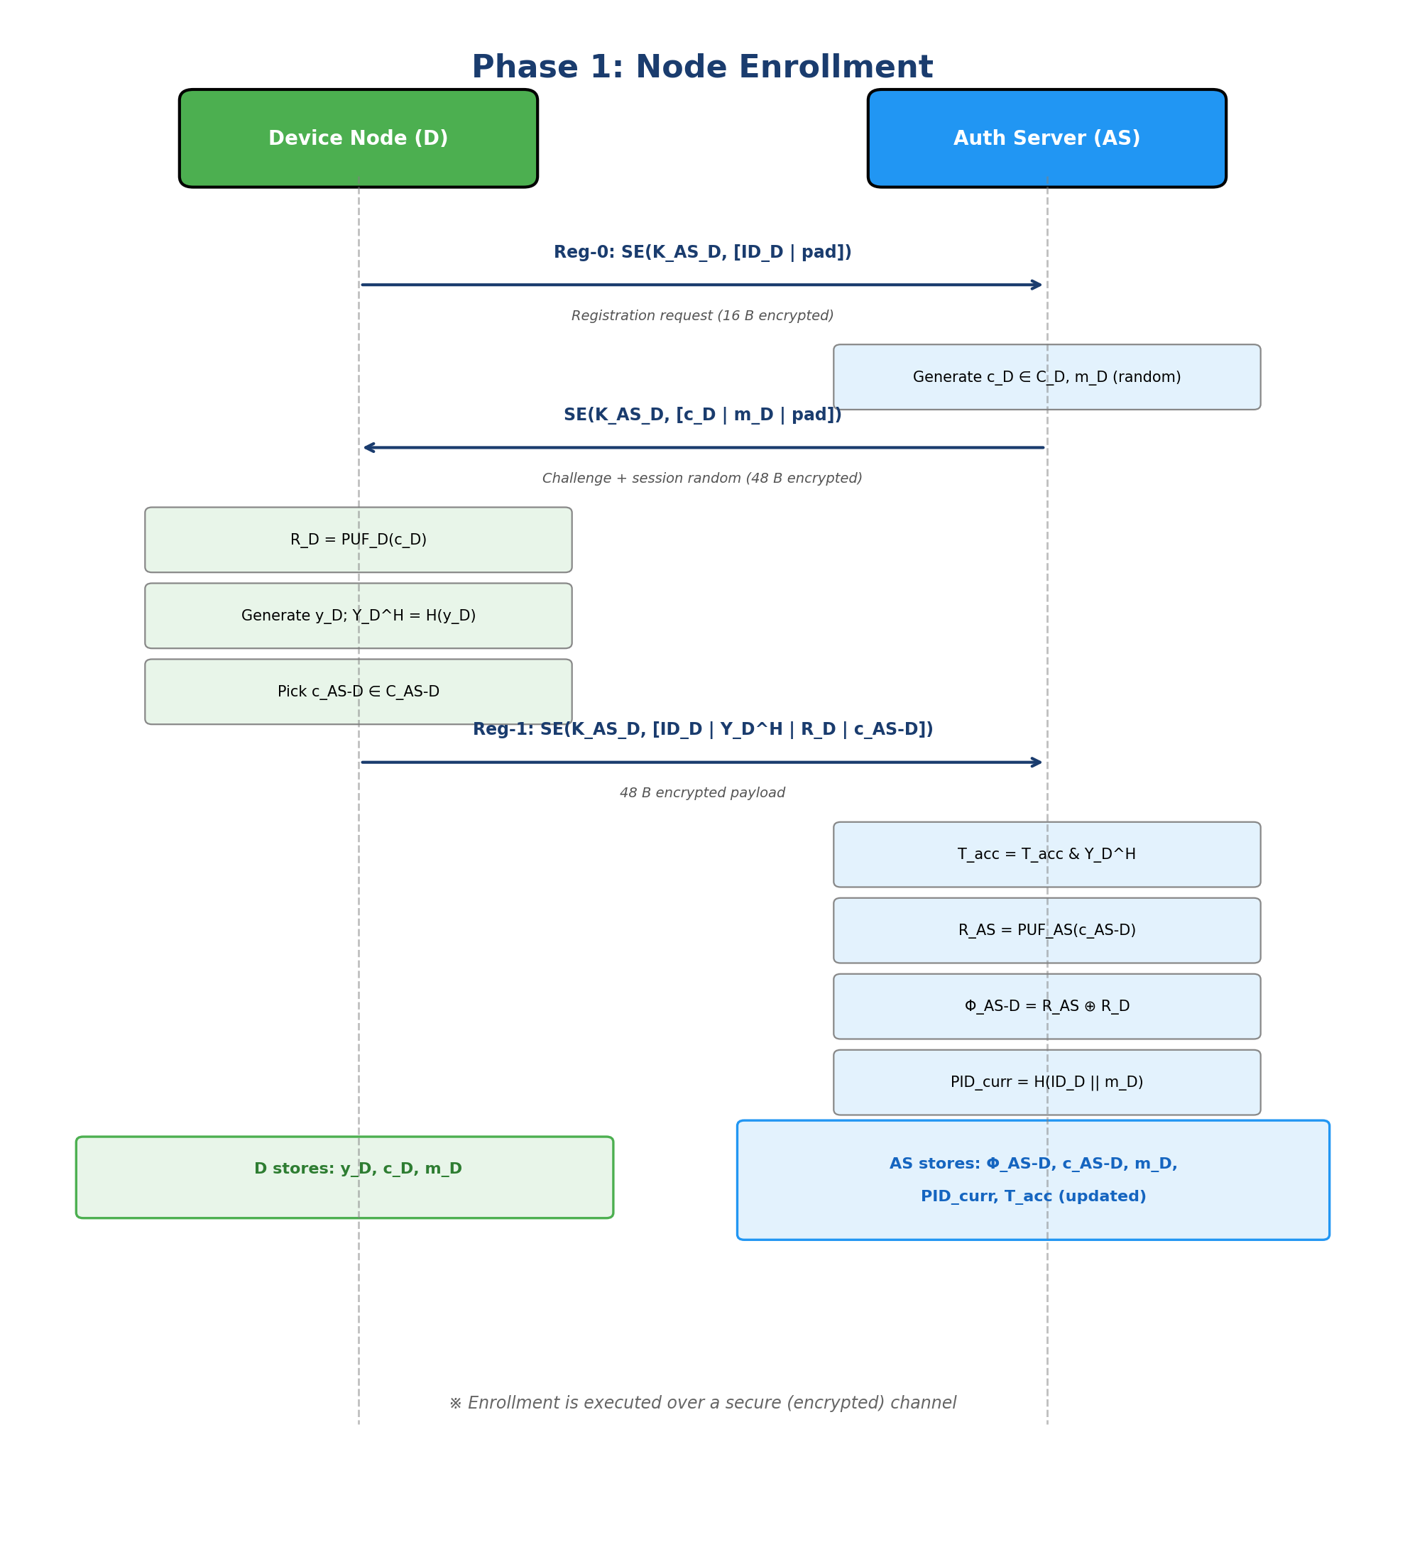
Figure 2: Node Enrollment Phase — Sequence Diagram

B. Node Authentication Phase
The Node Authentication Phase proves the membership of D's unique secret y_D to AS through a secure yet lightweight protocol. Since authentication occurs over an open channel, y_D is communicated in a masked form using PUF responses and session-based randoms, preventing interception by adversaries.
The authentication proceeds as follows:
Device Side: D regenerates its PUF response R_D = PUF_D(c_D) and computes its current pseudonym PID = H(ID_D || m_D). It computes Y_D^H = H(y_D) and constructs the authentication mask: mask = H(R_D || m_D || PID || ts₁). The masked hash Y_ASD is computed as Y_ASD = Y_D^H ⊕ mask. D sends {PID | Y_ASD | ts₁} (65 bytes, plaintext) to AS.
AS Side: AS searches its client database for a matching PID (checking both PID_curr and PID_old for desynchronization recovery). After verifying ts₁ freshness (must be strictly ahead of last seen value), AS recovers R_D using the stored PUF binding: R_AS = PUF_AS(c_AS-D), R_D = Φ_AS-D ⊕ R_AS. AS recomputes the same mask and recovers Y_D^H = Y_ASD ⊕ mask. Finally, AS performs the membership test: T_new = T_acc & Y_D^H. If T_new equals T_acc, D is authenticated (the bitwise AND property of the accumulator guarantees that ANDing an already-accumulated value does not change the result).
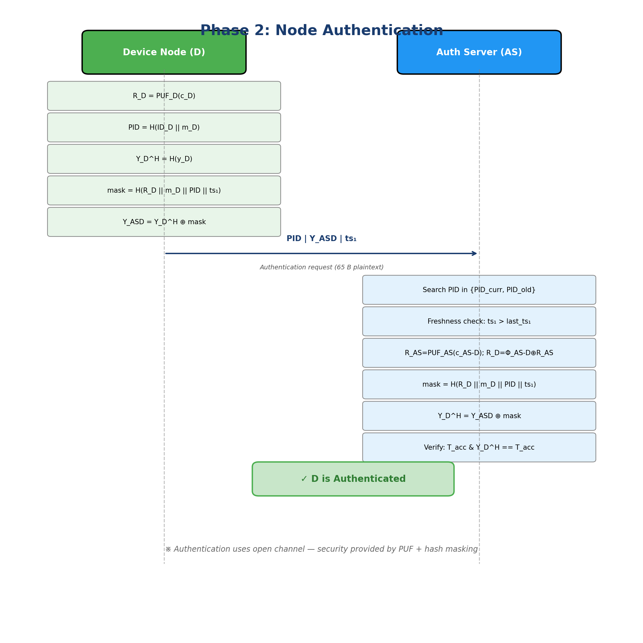
Figure 3: Node Authentication Phase — Sequence Diagram

C. Session Key Exchange and Mask Update Phase
After successful authentication, the AS performs the key exchange phase to: (1) establish a session key K_GW-D between the gateway and the device, (2) securely inform the gateway about the authenticated device, and (3) update the session-based random (authentication mask) for the next authentication session.
The key exchange proceeds as follows:
Step 1 — Key Generation: AS generates a random n₁ (32 bytes) and computes m_new = H(n₁). The session key is calculated as K_GW-D = H(R_D || m_new).
Step 2 — Masked Random Delivery: To securely send m_new to D, AS computes mH_mask = H(Y_D^H || m_D || R_D || ID_AS || PID || ts₂) and produces m_H = m_new ⊕ mH_mask. AS sends {ACK | m_H | ts₂} (34 bytes) to D.
Step 3 — Gateway Token: AS constructs an encrypted auth token: SE(K_GW-AS, [ID_D | ID_AS | ts_auth | pad]) || SE(K_GW-AS, K_GW-D[0:15]) || SE(K_GW-AS, K_GW-D[16:31]). This 48-byte encrypted token, along with the new PID (32 bytes) and ID_AS (1 byte), is forwarded to GW as an 81-byte CoAP POST to /test/auth_token.
Step 4 — Device Recovery: D receives the reply, reconstructs mH_mask using its known values (Y_D^H, m_D, R_D, ID_AS, PID, ts₂), recovers m_new = m_H ⊕ mH_mask, and computes K_GW-D = H(R_D || m_new). D updates its session random: m_D ← m_new, and rotates its pseudonym: PID ← H(ID_D || m_new).
Step 5 — Pseudonym Rotation: AS rotates pseudonyms: PID_old ← PID_curr, PID_curr ← H(ID_D || m_new). Session randoms are also rotated: m_old ← m_curr, m_curr ← m_new. This enables desynchronization recovery if a reply is lost.
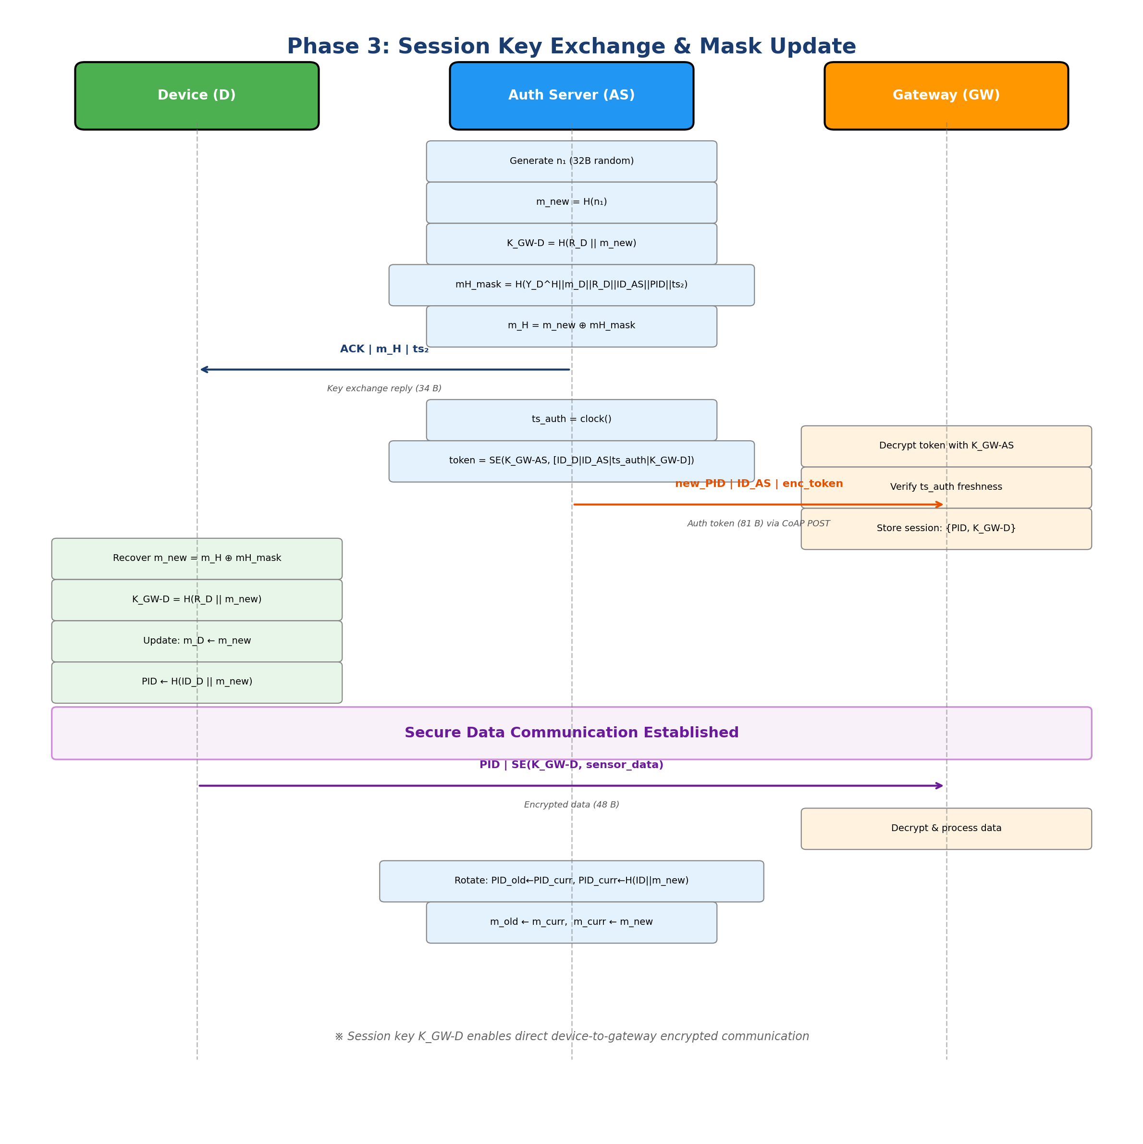
Figure 4: Session Key Exchange and Mask Update Phase — Sequence Diagram

V. Implementation Details

A. Software Platform
The scheme is implemented on the Contiki-NG operating system, an open-source OS designed for resource-constrained IoT devices. The implementation uses the CoAP (Constrained Application Protocol) for all inter-node communication, with RPL (Routing Protocol for Low-Power and Lossy Networks) handling the routing.
Parameter | Value
Operating System | Contiki-NG
Mote Type | Cooja Mote
Application Layer | CoAP (libcoap)
Network Layer | RPL Lite
MAC Layer | CSMA
Encryption | AES-128-ECB
Hashing | SHA-256
PUF Simulation | Deterministic hash mixing (node_id ⊕ challenge)
CoAP Max Payload | 128 bytes
Freshness Window | 120 seconds
Table II: Implementation Parameters

B. Source Code Structure
File | Description | Lines
device-node.c | IoT device: enrollment, authentication, data communication | 444
as-node.c | Authentication server: handles Reg-0, Reg-1, Auth+KeyExchange | 619
gw-node.c | Gateway: RPL root, processes auth tokens and encrypted data | 271
aes.c / aes.h | AES-128 encryption/decryption implementation | —
sha256.c / sha256.h | SHA-256 hash function implementation | —
project-conf.h | Configuration defines (node IDs, MAC params, energest) | 35
Makefile | Build system configuration for Contiki-NG | —
Table III: Source Code Structure

C. CoAP Endpoints and Message Sizes
The following CoAP resources are defined for inter-node communication:
Endpoint | Method | Direction | Payload Size | Purpose
/test/reg | GET | D → AS | 16 B (encrypted) | Registration request (Reg-0)
/test/reg1 | POST | D → AS | 48 B (encrypted) | Secret enrollment (Reg-1)
/test/auth | POST | D → AS | 65 B (plaintext) | Authentication + Key Exchange
/test/auth_token | POST | AS → GW | 81 B (partial enc) | Auth token delivery
/test/data | POST | D → GW | 48 B (partial enc) | Encrypted sensor data
Table IV: CoAP Endpoints and Message Sizes

VI. Security Analysis

A. Resistance to Replay Attack
The scheme employs multiple mechanisms against replay attacks. During enrollment, communications occur over a secure (encrypted) channel, preventing interception. In the authentication phase, timestamp-based freshness checks (ts₁ must be strictly ahead of the last accepted value) ensure that replayed messages with outdated timestamps are rejected. In the key exchange phase, ts₂ is a sequential counter generated by AS, and ts_auth is clock-based, both checked for freshness at the recipient. Session-based randoms (m_D) are rotated after each successful authentication, making older messages unverifiable.

B. Resistance to Man-in-the-Middle Attack
The enrollment phase is resistant to MITM attacks as it uses a pre-established encrypted channel (K_AS-D). In the authentication and key exchange phases, the use of one-way collision-resistant hash functions (SHA-256), unique PUF responses (R_D), and session-based randoms (m_D) prevents adversaries from successfully modifying intercepted messages. Without access to R_D and the current m_D, any modification attempt will fail the membership verification at AS.

C. Device Anonymity via Pseudonyms
The scheme provides device anonymity through rotating pseudonyms. Instead of using the real device ID in authentication messages, D computes PID = H(ID_D || m_D) and uses this pseudonym in all communications. After each successful authentication, the pseudonym is rotated: PID_new = H(ID_D || m_new). An adversary observing the network cannot link two sessions to the same device, as the pseudonym changes with each session random update. Even the gateway looks up sessions by PID, not by real device ID.

D. Desynchronization Recovery
The scheme maintains both PID_curr and PID_old (along with m_curr and m_old) at the AS to handle desynchronization scenarios. If a device's last authentication reply was lost, the device will retry with its old pseudonym and session random. AS detects this by matching against PID_old and uses m_old to unmask the authentication message, enabling recovery without requiring re-enrollment.

VII. Performance Analysis

A. Simulation Setup
The performance evaluation is conducted using the COOJA simulator (Contiki-NG) in headless mode within a Docker container. The simulation deploys a 100-node network with the following configuration:
Parameter | Value
Total Nodes | 100
Gateway Nodes | 1 (Node ID 1)
Authentication Server Nodes | 79 (Node IDs 2–80)
Device Nodes (newly joined) | 20 (Node IDs 81–100)
Network Topology | 10×10 grid, 30-unit spacing
Propagation Model | UDGM (Distance Loss)
Simulation Time | 1800 seconds
Supply Voltage | 3.0 V
CPU Current | 1.8 mA
LPM Current | 0.0545 mA
TX Current | 17.4 mA
RX Current | 18.8 mA
Table V: Simulation Parameters

B. Protocol Summary
The simulation results demonstrate complete protocol success: all 20 newly joined device nodes were successfully registered and authenticated through the AS (Node 2). A total of 347 data messages were confirmed by the gateway, with 18 initial rejections attributed to a race condition where device data arrives before the auth token is processed. These rejections are resolved automatically on the next retry.
Metric | Result
Devices Registered | 20/20 (100%)
Devices Authenticated | 20/20 (100%)
Data Messages Confirmed | 347
GW Initial Rejections | 18 (resolved on retry)
Simulation Duration | 1800 s simulated / 30 s real-time
Table VI: Protocol Execution Summary

C. Energy Consumption Analysis
Energy consumption is measured using the Contiki-NG Energest module, which tracks CPU active time, low-power mode (LPM) time, radio transmission (TX), and radio reception (RX) in clock ticks. These are converted to energy values using the Cooja mote current profiles. The measurement captures the complete authentication cycle: from the start of the auth+data block to its completion (including key exchange and one data transmission).
Table VII shows the per-device authentication energy consumption for all 20 device nodes. Energy consumption ranges from 0.0187 J (Device 92) to 0.0365 J (Device 88), with variation attributed to network conditions (routing path length, congestion, retransmissions). The average energy consumption across all devices is approximately 0.025 J.
Device ID | CPU Time (s) | Energy (J)
81 | 0.4189 | 0.0258
82 | 0.4321 | 0.0266
83 | 0.3641 | 0.0224
84 | 0.3451 | 0.0213
85 | 0.3321 | 0.0205
86 | 0.3561 | 0.0219
87 | 0.3961 | 0.0244
88 | 0.5913 | 0.0365
89 | 0.5013 | 0.0309
90 | 0.3223 | 0.0199
91 | 0.3681 | 0.0227
92 | 0.3040 | 0.0187
93 | 0.3121 | 0.0192
94 | 0.3330 | 0.0205
95 | 0.4523 | 0.0279
96 | 0.4453 | 0.0275
97 | 0.4973 | 0.0307
98 | 0.4963 | 0.0306
99 | 0.5903 | 0.0364
100 | 0.4373 | 0.0270
Table VII: Per-Device Authentication Energy Consumption

D. AS Server Cumulative Energy
The Authentication Server (Node 2) shows a cumulative CPU time of 208.51 seconds and total energy consumption of 12.88 Joules over the 1800-second simulation. This includes all enrollment (20 Reg-0 + 20 Reg-1), authentication (20 auth requests), key exchange operations, token deliveries to the gateway, and ongoing RPL routing duties. The energy cost per authentication (including key exchange and token forwarding) averages approximately 0.64 J, which is dominated by radio reception (listening) during idle periods rather than the cryptographic operations themselves.

E. Computational Cost Comparison
Table VIII compares the computational cost of the authentication and key exchange phase of the proposed scheme with related works. The proposed scheme achieves the lowest computational cost of 0.56 ms, utilizing 2 PUF operations, 8 SHA-256 hashes, 2 AES encryptions, and 1 random generation — avoiding heavy ECC operations entirely.
Scheme | Operations | Cost (ms)
[8] Alruwaili et al. | 2T_puf + 8T_hash + 3T_ecc + 3T_rand | 3.39
[9] Yang et al. | 6T_hash + 4T_ecc | 4.20
[10] Li et al. | 2T_puf + 12T_hash + 2T_ecc + 4T_rand | 2.53
[13] Zheng et al. | 2T_puf + 6T_hash + 4T_aes + 5T_rand | 0.67
[6] Rosa et al. (LightSAE) | 14T_aes | 1.21
Proposed Scheme | 2T_puf + 8T_hash + 2T_aes + 1T_rand | 0.56
Table VIII: Computational Cost Comparison (Authentication + Key Exchange)

F. Communication Cost Comparison
Table IX compares the communication overhead. The proposed scheme uses three-message communication totaling only 928 bits — the lowest among all compared schemes. This is achieved by combining authentication and key exchange in a single protocol round and using compact message formats.
Scheme | Messages | Cost (bits)
[8] Alruwaili et al. | 2 | 1408
[9] Yang et al. | 2 | 2612
[10] Li et al. | 3 | 4160
[13] Zheng et al. | 3 | 1600
[6] Rosa et al. (LightSAE) | 6 | 1536
Proposed Scheme | 3 | 928
Table IX: Communication Cost Comparison (Authentication + Key Exchange)

VIII. Conclusion
This report presented the implementation and simulation-based evaluation of a lightweight and decoupled distributed PUF-based authentication scheme for multihop IoT networks. The key contributions and findings are summarized as follows:
- The decoupled architecture successfully distributes authentication responsibilities across both parent and non-parent nodes, preventing gateway and parent node overloading.
- PUF-based authentication eliminates long-term key storage requirements while maintaining device-specific uniqueness through hardware-level challenge-response mechanisms.
- The hash-based one-way accumulator enables efficient O(1) membership verification using only bitwise AND operations, without needing to iterate over enrolled device lists.
- Session-based randoms with pseudonym rotation provide forward secrecy and device anonymity, with built-in desynchronization recovery through dual PID/random storage.
- COOJA simulation with 100 nodes demonstrates 100% authentication success rate for 20 newly joined devices, with per-device energy consumption of 0.019–0.036 J — confirming the scheme's suitability for resource-constrained IoT deployments.
- Computational cost of 0.56 ms (the lowest among compared schemes) is achieved by leveraging lightweight PUF and hash operations with only two AES encryptions, completely avoiding heavy ECC/pairing operations.
- Communication cost of 928 bits (3 messages) represents the most efficient message exchange among all compared schemes.
The implementation confirms that the proposed scheme achieves a practical balance between security and efficiency, making it well-suited for deployment in real-world resource-constrained multihop IoT networks.

References
[1] I. Zhou et al., "Internet of Things 2.0: Concepts, Applications, and Future Directions," IEEE Access, vol. 9, pp. 70961–71012, 2021.
[2] B. Kang, D. Kim, and H. Choo, "Internet of Everything: A Large-Scale Autonomic IoT Gateway," IEEE Trans. Multi-Scale Computing Systems, vol. 3, no. 3, pp. 206–214, 2017.
[3] N. Lajnef, A. Mami, and F. Derbel, "Applications of Wireless Sensor Networks and IoT Frameworks in Industry 4.0," Sensors, vol. 22, no. 6, 2022.
[4] J. Granjal, E. Monteiro, and J. S. Silva, "Security in the Integration of Low-Power Wireless Sensor Networks with the Internet," Ad Hoc Networks, vol. 24, pp. 264–287, 2015.
[5] W. Alnahari and M. T. Quasim, "Authentication of IoT Device and IoT Server Using Security Key," in 2021 ICOTEN, pp. 1–9, 2021.
[6] P. Rosa, A. Souto, and J. Cecílio, "Light-SAE: A Lightweight Authentication Protocol for Large-Scale IoT Environments," IEEE Trans. Network and Service Management, vol. 20, no. 3, pp. 2428–2441, 2023.
[7] M. Tiloca et al., "Security Considerations in the IP-based Internet of Things," Internet-Draft, IRTF, Aug. 2023.
[8] O. Alruwaili et al., "RAAF-MEC: Reliable and Anonymous Authentication Framework for IoT-Enabled MEC Environment," Internet of Things, vol. 29, p. 101459, 2025.
[9] W. Yang et al., "SAKMS: A Secure Authentication and Key Management Scheme for IETF 6TiSCH Industrial Wireless Networks," IEEE Trans. Network Science and Engineering, vol. 11, no. 3, pp. 3174–3188, 2024.
[10] S. Li et al., "A Provably Secure and Practical PUF-Based End-to-End Mutual Authentication Protocol for IoT," IEEE Sensors J., vol. 21, no. 4, pp. 5487–5501, 2020.
[11] Y. Zheng, Y. Cao, and C.-H. Chang, "A PUF-Based Data-Device Hash for Tampered Image Detection," IEEE Trans. Information Forensics and Security, vol. 15, pp. 620–634, 2019.
[12] R. Amin et al., "Group Authentication Protocols for IoT: Challenges and Solutions," arXiv:1909.06371, Sept. 2019.
[13] Y. Zheng et al., "PUF-Based Mutual Authentication and Key Exchange Protocol for Peer-to-Peer IoT Applications," IEEE TDSC, vol. 20, no. 4, pp. 3299–3316, 2022.
[14] G. Selander, J. P. Mattsson, and F. Palombini, "Ephemeral Diffie-Hellman Over COSE (EDHOC)," RFC 9528, IETF, Mar. 2024.
[15] S. Al-Riyami and K. G. Paterson, "Certificate-Based Public-Key Cryptography," Certificateless Cryptography Overview, 2003.
[16] P. Zhang et al., "A Blockchain-Based Authentication Scheme for IoT-Enabled Maritime Systems," IEEE Trans. ITS, vol. 24, no. 2, pp. 2322–2331, 2023.
[17] M. T. Al Ahmed et al., "Authentication-Chains: Blockchain-Inspired Lightweight Authentication for IoT Networks," Electronics, vol. 12, p. 867, 2023.
[18] H. Sikarwar, D. Das, and S. Kalra, "Efficient Authentication Scheme Using Blockchain in IoT Devices," in AINA, vol. 1151, pp. 630–641, 2020.
[19] H. Weerasena and P. Mishra, "Lightweight Multicast Authentication in NoC-Based SoCs," in 2024 ISQED, pp. 1–8, 2024.
[20] B. Blanchet et al., "ProVerif 2.00: Automatic Cryptographic Protocol Verifier, User Manual and Tutorial," 2018.
[21] D. Dolev and A. Yao, "On the Security of Public Key Protocols," IEEE Trans. Information Theory, vol. 29, no. 2, pp. 198–208, 2003.

