Shell as a Service Version 1 by ARPHost

1. Extact shellasaservice-1.0.zip to shellaservice.
2. Upload shellasaservice to your addons folder under modules in your whmcs directory. 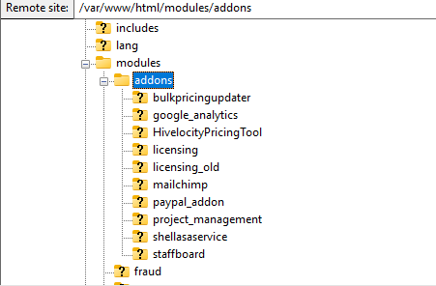
3. Login to WHMCS and go to System Settings

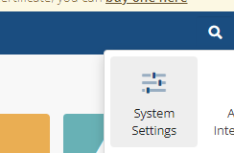

1. Next, go to Add-on Modules.

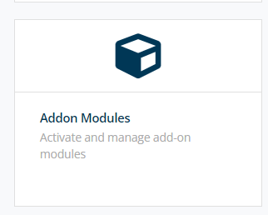

1. Next Activate Shell as a Service, Set Access controls, enter your license, and save changes. 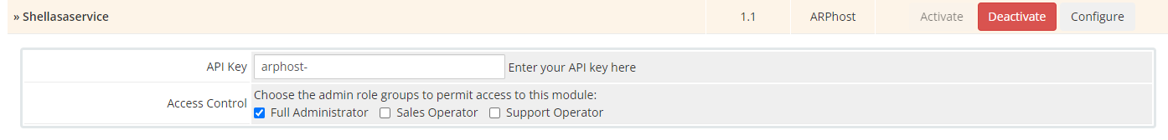
2. Now you can setup a product or product add-on with a shell script. Go to Product/Services. 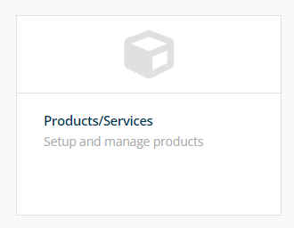
3. Add a new Product Group or use an existing.
4. Create a new product.
5. Go to the Modules settings tab of the product.
6. Select Shellasaservice from the Module Name dropdown.
7. In createbash put the path to your shell script including the script that you want to run on order.
8. In suspendbash put the path to your shell script including the script that you want to run on suspension.
9. In unsuspendbash put the path to your shell script including the script that you want to run on unsuspension.
10. In terminatebash put the path to your shell script including the script that you want to run on termination.

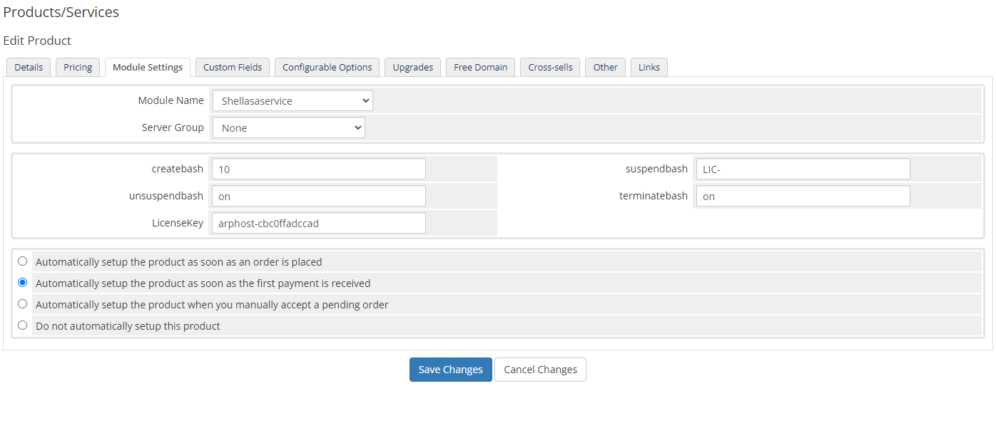

You are now ready to run just about any shell script you want to from your whmcs server when an order is completed. All you have to do is select one of the following options. You can always accept order manually as well.

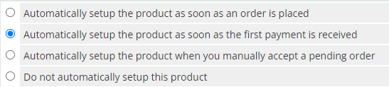

You can also do the same thing from a Product add-on. You could use one module to deploy a VM then you could run an Ansible playbook after using our module if you wanted.

Here is how you add a Product Add-on.

1. Go to System Settings



1. Go to Product Addons

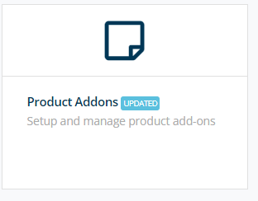

1. Add New Add-on
2. Select Shellasaservice as the module. 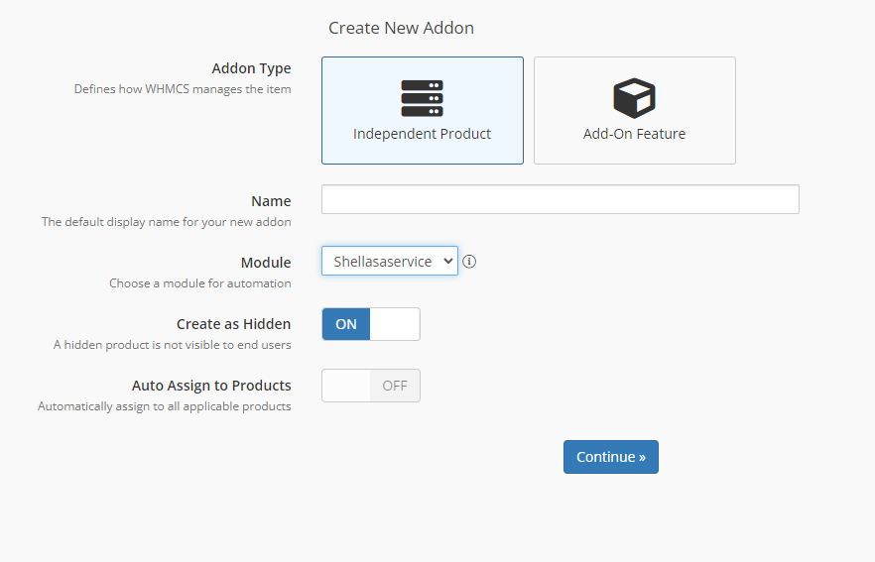
3. Give it a name select Independent Product then click Continue
4. Once created you have the same options as a Product/Service

You can apply the add-on to a Produc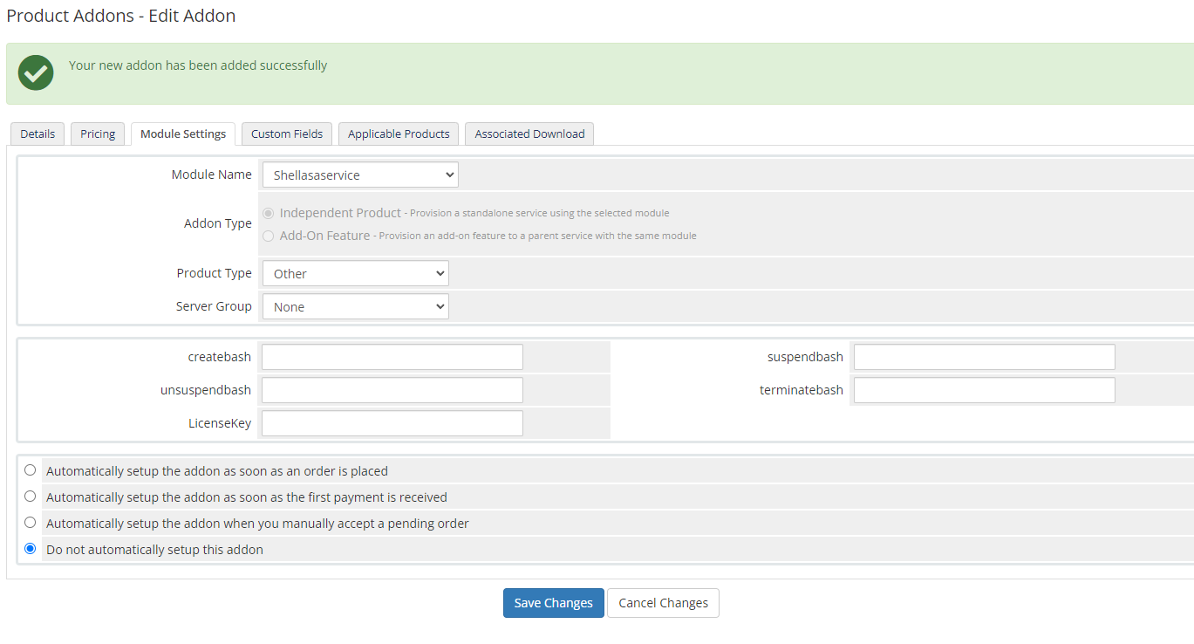

You can apply the add-on to a product. This can be used all kinds of way.